Chapter 1
COMPANY PROFILE

  - Introduction

The following report describes the activities carried out during the four weeks full time internship at AVOHI pvt. Ltd. The document contains information regarding the organization and the responsibilities performed throughout July-August 2018.
The first part of the report tells about the organization, followed by the working plan initially agreed upon by the federation and approved by the University of VTU as a suitable internship. Following, it proceeds to describe in some detail about the department and the most relevant task performed. Finally, the reports wraps-up with the outcome.
Build solution to fulfill the societal needs by integrating contemporary technologies by devoting all are resources by leveraging skills, process and resource efficiencies through meritocracy and thereby delighting customers and stake holders.
Vision
The Customers first choice as technology provider. Envision to be a leader in the information technology services arena. Growth as a leader in the IT services shall be guided by organizational values and customer needs.
Mission
AVOHI will provide high quality technology services and solutions at affordable cost in the information, internet and ubiquitous communication and supplementary services related to our core business.

1.2 Overview of the Organization
- AVOHI is a global software application development and IT services company.
- Rendered services to 500 “happy customers” across the globe.
- People, technology and process driven. ISO 9001:2008 certification under pipeline, six sigma projects being undertaken to achieve efficiencies.
- Deep industry and functional expertise powered by leading technology practices. Contemporary global delivery model to help address customer need and enhance their business performance, productivity and profitability.
.1.3 About the Company
- AVOHI founded in year 2004.
- Registered as a “software entity” under directorate of industries and commerce.
- Based in Bangalore: “The Silicon Valley of India”.
- Founded by Rajesh Kumar, Entrepreneur. Led and guided by Alumnus of IIM’s and Xavier’s.
- Initial thrust on internet and web technology
- People are our pillars of strength
- Post Graduates, Engineers constitute majority of our team in all the strategic business units.
- Median Age of Team is 27.
- Average Tenure of people with organization is 3.5 years.
1.4 Services by AVOHI Information Technology Private Limited
- Web development
- Mobility
- Portals and content management
- Analytical reporting
1.5 Search Engine Optimization

Search engine optimization is the process of increasing the quality and quantity of website traffic by increasing the visibility of a website or a web page to users of a web search engine.

SEO refers to the improvement of unpaid results and excludes direct traffic/visitors and the purchase of paid placement.

SEO may target different kinds of searches, including image search, video search, academic search, news search, and industry-specific vertical search engines.

Optimizing a website may involve editing its content, adding content, and modifying HTML and associated coding to both increase its relevance to specific keywords and remove barriers to the indexing activities of search engines like Google, Yahoo etc. Promoting a site to increase the number of backlinks, or inbound links, is another SEO tactic. By May 2015, mobile search had surpassed desktop search.
As an Internet Marketing Strategy, SEO considers hoe search engines work, the computer programmed algorithms that dictate search engine behavior, what people search for the actual search terms or keywords typed into search engines are preferred by their targeted audience. SEO is performed because a website ranks in the search engine results page (SERP).
These visitors can then be converted into customers.
SEO differs from local search engine optimization in that the latter is focused on optimizing a business online presence so that its web pages will be displayed by search engines when a user enters a local search for its products or services. The former instead is more focused on national or international searches.

1.6 Application Development
Drive efficiency and efficiency and effectiveness with agile application solution from this company. The proven methodology ensures you get products and solutions faster, at reduced cost and bets quality assurance.
It is the process of creating a computer program or a set of programs to perform the different tasks that a business requires. Every app building process follows the same steps: gathering requirements, designing prototypes, testing, implementation and intergration.

1.7 Company Contact

Website
https://www.avohi.com
Address:
No.1/2 ,3rd floor, Venus Building,
Kalyana mantapa Road, Jakkasandra Block,
Koramangala , Bangalore 560034
Phone No-080-25502343

Email:connect@avohi.com

Chapter 2
TASK PERFORMED BY YOU

2.1 HTML
Hypertext Markup Language (HTML) is the standard markup language for creating web pages and web applications. With Cascading Style Sheets (CSS) and JavaScript, it forms a triad of cornerstone technologies for the World Wide Web.
Web browsers receive HTML documents from a web server or from local storage and render the documents into multimedia web pages. HTML describes the structure of a web page semantically and originally included cues for the appearance of the document.
HTML elements are the building blocks of HTML pages. With HTML constructs, images and other objects such as interactive forms may be embedded into the rendered page.
HTML provides a means to create structured documents by denoting structural semantics for text such as headings, paragraphs, lists, links, quotes and other items. HTML elements are delineated by tags, written using angle brackets. Tags such as <img/> and <input /> directly introduce content into the page. Other tags such as <p> surround and provide information about document text and may include other tags as sub-elements. Browsers do not display the HTML tags, but use them to interpret the content of the page.
HTML can embed programs written in a scripting language such as JavaScript, which affects the behavior and content of web pages. Inclusion of CSS defines the look and layout of content. The World Wide Web Consortium (W3C), maintainer of both the HTML and the CSS standards, has encouraged the use of CSS over explicit presentational HTML since 1997.
First developed by Tim Berners-Lee in 1990, HTML is short for Hyper Text Markup Language. HTML is used to create electronic documents that are displayed on the World Wide Web. Each page contains a series of connections to other pages called hyperlinks. Every web page you see on the Internet is written using one version of HTML code or another.
HTML code ensures the proper formatting of text and images so that your Internet browser may display them as they are intended to look. Without HTML, a browser would not know how to display text as elements or load images or other elements. HTML also provides a basic structure of the page, upon which Cascading Style Sheets are overlaid to change its appearance. One could think of HTML as the bones (structure) of a web page, and CSS as its skin (appearance)
HTML is most commonly used as the format of online certificate we call web pages. When you create a set of finish HTML documents that look and relate to each other, this is known as a website.
In addition to creating complete web pages, you can also use snippets of HTML code to create specific aspect within an existing page. For example, some blogs and discussion panels allow you to include HTML formatting in your posts or comments, allowing you to add emphasis to keywords, insert links, create bulleted lists or use any other HTML element allowed by site administrators Web. If you collaborate on the content of your organization's website, the website designer may have set up a content management system that allows you to add articles or page sections within a larger HTML page structure that controls the page layout and site navigation.
HTML is also used as the document format of the help and the offline documentation (stored on your computer) along with the applications installed on your computer.
When you activate the help of an application, usually through its "Help" menu or a question mark icon, the content of the help can appear in your web browser or in a specialized help viewer. The email also uses HTML as the format of rich text messages that include links, stylized text, tables and other elements that cannot be represented in plain text.
However, most email applications do not allow you to edit HTML directly, but instead provide tools to create elements and generate the corresponding HTML internally.
HTML is the standard markup language for creating Web pages.
- HTML stands for Hyper Text Markup Language
- HTML describes the structure of Web pages using markup
- HTML elements are the building blocks of HTML pages
- HTML elements are represented by tags
- HTML tags label pieces of content such as "heading", "paragraph", "table", and so on
- Browsers do not display the HTML tags, but use them to render the content of the page
2.2 CSS

2.2.1 What is CSS?
- CSS stands for Cascading Style Sheets
- CSS describes how HTML elements are to be displayed on screen, paper, or in other media
- CSS saves a lot of work. It can control the layout of multiple web pages all at once
- External stylesheets are stored in CSS files.

2.2.2 Why Use CSS?
CSS is used to define styles for your web pages, including the design, layout and variations in display for different devices and screen sizes.

2.2.3 CSS Solved a Big Problem
HTML was created to describe the content of a web page, like:
<h1>This is a heading</h1>
<p>This is a paragraph</p>
When tags like <font>, and color attributes were added to the HTML 3.2 specification, it started a nightmare for web developers. Development of large websites, where fonts and color information were added to every single page, became a long and expensive process.
To solve this problem, the World Wide Web Consortium (W3C) created CSS. CSS removed the style formatting from the HTML page!

2.2.4 CSS Saves a Lot of Work!
The style definitions are normally saved in external .css files. With an external stylesheet file, you can change the look of an entire website by changing just one file.
Cascading Style Sheets (CSS) is a style sheet language used for describing the presentation of a document written in a markup language like HTML. CSS is a cornerstone technology of the World Wide Web, alongside HTML and JavaScript.
CSS is designed to enable the separation of presentation and content, including layout, colours, and fonts. This separation can improve content accessibility, provide more flexibility and control in the specification of presentation characteristics, enable multiple web pages to share formatting by specifying the relevant CSS in a separate .css file, and reduce complexity and repetition in the structural content.
Separation of formatting and content also makes it feasible to present the same markup page in different styles for different rendering methods, such as on-screen, in print, by voice (via speech-based browser or screen reader), and on Braille-based tactile devices. CSS also has rules for alternate formatting if the content is accessed on a mobile device.
The name cascading comes from the specified priority scheme to determine which style rule applies if more than one rule matches a particular element. This cascading priority scheme is predictable.
The CSS specifications are maintained by the World Wide Web Consortium (W3C). Internet media type (MIME type) text/css is registered for use with CSS by RFC 2318 (March 1998). The W3C operates a free CSS validation service for CSS documents. In addition to HTML, other markup languages support the use of CSS, including XHTML, plain XML, SVG, and XUL.

2.2.5 Advantages
Separation of content from presentation: CSS facilitates publication of content in multiple presentation formats based on nominal parameters. Nominal parameters include explicit user preferences, different web browsers, the type of device being used to view the content (a desktop computer or mobile Internet device), the geographic location of the user and many other variables.
Site-wide consistency
When CSS is used effectively, in terms of inheritance and "cascading", a global style sheet can be used to affect and style elements site-wide. If the situation arises that the styling of the elements should be changed or adjusted, these changes can be made by editing rules in the global style sheet. Before CSS, this sort of maintenance was more difficult, expensive and time-consuming.
Bandwidth
A stylesheet, internal or external, specifies the style once for a range of HTML elements selected by class, type or relationship to others. This is much more efficient than repeating style information inline for each occurrence of the element. An external stylesheet is usually stored in the browser cache, and can therefore be used on multiple pages without being reloaded, further reducing data transfer over a network.
Page reformatting
With a simple change of one line, a different style sheet can be used for the same page. This has advantages for accessibility, as well as providing the ability to tailor a page or site to different target devices. Furthermore, devices not able to understand the styling still display the content.
Accessibility
Without CSS, web designers must typically lay out their pages with techniques such as HTML tables that hinder accessibility for vision-impaired users.
2.3 Bootstrap
Bootstrap is a free and open-source front-end framework for designing websites and web applications. It contains HTML- and CSS-based design templates for typography, forms, buttons, navigation and other interface components, as well as optional JavaScript extensions. Unlike many earlier web frameworks, it concerns itself with front-end development only. Bootstrap is the second most-starred project on GitHub, with more than 126,000 stars.
2.3.1 Origins
Bootstrap, originally named Twitter Blueprint, was developed by Nirav Panchal and Jacob Thornton at Twitter as a framework to encourage consistency across internal tools. Before Bootstrap, various libraries were used for interface development, which led to inconsistencies and a high maintenance burden. According to Twitter developer Mark Otto: "A super small group of developers and I got together to design and build a new internal tool and saw an opportunity to do something more. Through that process, we saw ourselves build something much more substantial than another internal tool. Months later, we ended up with an early version of Bootstrap as a way to document and share common design patterns and assets within the company."
After a few months of development by a small group, many developers at Twitter began to contribute to the project as a part of Hack Week, a hackathon-style week for the Twitter development team. It was renamed from Twitter Blueprint to Bootstrap, and released as an open source project on August 19, 2011. It has continued to be maintained by Mark Otto, Jacob Thornton, and a small group of core developers, as well as a large community of contributors.
On January 31, 2012, Bootstrap 2 was released, which added a twelve-column responsive grid layout system, inbuilt support for Glyph icons, several new components, as well as changes to many of the existing components.
On August 19, 2013, Bootstrap 3 was released, which redesigned components to use flat design, and a mobile first approach.
On October 29, 2014, Mark Otto announced that Bootstrap 4 was in development. The first alpha version of Bootstrap 4 was released on August 19, 2015. The first beta version was released on 10 August 2017. The stable version of Bootstrap 4 was released on January 18, 2018 basically improving print styles, border utilities and provides more control over the flexbox.

2.3.2 Features
Bootstrap 3 supports the latest versions of the Google Chrome, Firefox, Internet Explorer, Opera, and Safari (except on Windows). It additionally supports back to IE8 and the latest Firefox Extended Support Release (ESR).
Since 2.0, Bootstrap supports responsive web design. This means the layout of web pages adjusts dynamically, considering the characteristics of the device used (desktop, tablet, mobile phone). Starting with version 3.0, Bootstrap adopted a mobile-first design philosophy, emphasizing responsive design by default.
Version 4.0 added Sass and flexbox support.

2.3.3 Structure and function
This section may need to be rewritten entirely to comply with Wikipedia's quality standards. You can help. The discussion page may contain suggestions.
Bootstrap is modular and consists of a series of less stylesheets that implement the various components of the toolkit. These stylesheets are generally compiled into a bundle and included in web pages, but individual components can be included or removed. Bootstrap provides a number of configuration variables that control things such as colour and padding of various components.
Since Bootstrap 2, the Bootstrap documentation has included a customization wizard which generates a customized version of Bootstrap based on the requested components and various settings.
Grid system and responsive design comes standard with an 1170-pixel-wide grid layout. Alternatively, the developer can use a variable-width layout. For both cases, the toolkit has four variations to make use of different resolutions and types of devices: mobile phones, portrait and landscape, tablets and PCs with low and high resolution. Each variation adjusts the width of the columns.

2.3.4 Advantages of Using Bootstrap
If you have had some experience with any front-end framework, you might be wondering what makes Bootstrap so special. Here are some advantages why one should opt for Bootstrap framework:
- Save lots of time — You can save lots of time and efforts using the Bootstrap predefined design templates and classes and concentrate on other development work.
- Responsive features — Using Bootstrap you can easily create responsive websites that appear more appropriately on different devices and screen resolutions without any change in markup.
- Consistent design — All Bootstrap components share the same design templates and styles through a central library, so the design and layout of your web pages will be consistent.
- Easy to use — Bootstrap is very easy to use. Anybody with the basic working knowledge of HTML, CSS and JavaScript can start development with Bootstrap.
- Compatible with browsers — Bootstrap is created with modern web browsers in mind and it is compatible with all modern browsers such as Chrome, Firefox, Safari, Internet Explorer, etc.
- Open Source — And the best part is, it is completely free to download and use.
2.4 JAVASCRIPT
JavaScript is often abbreviated as JS, is a high-level, interpreted programming language. It is a language which is also characterized as dynamic, weakly typed, prototype-based and multi-paradigm.
Alongside HTML and CSS, JavaScript is one of the three core technologies of the World Wide Web. JavaScript enables interactive web pages and thus is an essential part of web applications. The vast majority of websites use it, and all major web browsers have a dedicated JavaScript engine to execute it.
As a multi-paradigm language, JavaScript supports event-driven, functional, and imperative (including object-oriented and prototype-based) programming styles. It has an API for working with text, arrays, dates, regular expressions, and basic manipulation of the DOM, but the language itself does not include any I/O, such as networking, storage, or graphics facilities, relying for these upon the host environment in which it is embedded.
Initially only implemented client-side in web browsers, JavaScript engines are now embedded in many other types of host software, including server-side in web servers and databases, and in non-web programs such as word processors and PDF software, and in runtime environments that make JavaScript available for writing mobile and desktop applications, including desktop widgets.
Although there are strong outward similarities between JavaScript and Java, including language name, syntax, and respective standard libraries, the two languages are distinct and differ greatly in design; JavaScript was influenced by programming languages such as Self and Scheme.
Because JavaScript code can run locally in a user's browser (rather than on a remote server), the browser can respond to user actions quickly, making an application more responsive. Furthermore, JavaScript code can detect user actions that HTML alone cannot, such as individual keystrokes. Applications such as Gmail take advantage of this: much of the user-interface logic is written in JavaScript, and JavaScript dispatches requests for information (such as the content of an e-mail message) to the server. The wider trend of Ajax programming similarly exploits this strength.
A JavaScript engine (also known as JavaScript interpreter or JavaScript implementation) is an interpreter that interprets JavaScript source code and executes the script accordingly. The first JavaScript engine was created by Brendan Eich at Netscape, for the Netscape Navigator Web browser. The engine, code-named Spider Monkey, is implemented in C. It has since been updated (in JavaScript 1.5) to conform to ECMAScript 3. The Rhino engine, created primarily by Norris Boyd (formerly at Netscape, now at Google) is a JavaScript implementation in Java. Rhino, like Spider Monkey, is ECMAScript 3 compliant.
A Web browser is by far the most common host environment for JavaScript. Web browsers typically create "host objects" to represent the DOM in JavaScript. The Web server is another common host environment. A JavaScript Web server would typically expose host objects representing HTTP request and response objects, which a JavaScript program could then interrogate and manipulate to dynamically generate Web pages. Because JavaScript is the only language that the most popular browsers share support for, it has become a target language for many frameworks in other languages, even though JavaScript was never intended to be such a language. Despite the performance limitations inherent to its dynamic nature, the increasing speed of JavaScript engines has made the language a surprisingly feasible compilation target.

2.5 jQuery

2.5.1 What is jQuery?
jQuery is a lightweight, "write less, do more", JavaScript library. The purpose of jQuery is to make it much easier to use JavaScript on your website. jQuery takes a lot of common tasks that require many lines of JavaScript code to accomplish, and wraps them into methods that you can call with a single line of code. jQuery also simplifies a lot of the complicated things from JavaScript, like AJAX calls and DOM manipulation.
The jQuery library contains the following features:
- HTML/DOM manipulation
- CSS manipulation
- HTML event methods
- Effects and animations
- AJAX
- Utilities

2.5.2 Why jQuery?
There are lots of other JavaScript frameworks out there, but jQuery seems to be the most popular, and also the most extendable. Many of the biggest companies on the Web use jQuery.
The jQuery team knows all about cross-browser issues, and they have written this knowledge into the jQuery library. jQuery will run exactly the same in all major browsers.
jQuery is a cross-platform JavaScript library designed to simplify the client-side scripting of HTML.^{[3]} It is free, open-source software using the permissive MIT License. Web analysis indicates that it is the most widely deployed JavaScript library by a large margin.
jQuery's syntax is designed to make it easier to navigate a document, select DOM elements, create animations, handle events, and develop Ajax applications. jQuery also provides capabilities for developers to create plug-ins on top of the JavaScript library. This enables developers to create abstractions for low-level interaction and animation, advanced effects and high-level, theme able widgets. The modular approach to the jQuery library allows the creation of powerful dynamic web pages and Web applications.
The set of jQuery core features—DOM element selections, traversal and manipulation—enabled by its selector engine (named "Sizzle" from v1.3), created a new "programming style", fusing algorithms and DOM data structures. This style influenced the architecture of other JavaScript frameworks like YUI v3 and Dojo, later stimulating the creation of the standard Selectors API.
Microsoft and Nokia bundle jQuery on their platforms. Microsoft includes it with Visual Studio for use within Microsoft's ASP.NET AJAX and ASP.NET MVC frameworks while Nokia has integrated it into the Web Run-Time widget development platform.
jQuery, at its core, is a Document Object Model (DOM) manipulation library. The DOM is a tree-structure representation of all the elements of a Web page. jQuery simplifies the syntax for finding, selecting, and manipulating these DOM elements. For example, jQuery can be used for finding an element in the document with a certain property (e.g. all elements with an h1 tag), changing one or more of its attributes (e.g. color, visibility), or making it respond to an event (e.g. a mouse click).
jQuery also provides a paradigm for event handling that goes beyond basic DOM element selection and manipulation. The event assignment and the event callback function definition are done in a single step in a single location in the code. jQuery also aims to incorporate other highly used JavaScript functionality (e.g. fade ins and fade outs when hiding elements, animations by manipulating CSS properties).
2.6 AngularJS
AngularJS is a JavaScript framework. It can be added to an HTML page with a <script> tag. AngularJS extends HTML attributes with Directives, and binds data to HTML with Expressions. AngularJS is a JavaScript framework. It is a library written in JavaScript. AngularJS is distributed as a JavaScript file, and can be added to a web page with a script tag.

2.6.1 AngularJS Extends HTML
AngularJS extends HTML with ng-directives. The ng-app directive defines an AngularJS application. The ng-model directive binds the value of HTML controls (input, select, text area) to application data. The ng-bind directive binds application data to the HTML view.

2.6.2 AngularJS Applications
AngularJS modules define AngularJS applications. AngularJS controllers control AngularJS applications. The ng-app directive defines the application, the ng-controller directive defines the controller.
AngularJS (also written as Angular.js) is a JavaScript-based open-source front-end web application framework mainly maintained by Google and by a community of individuals and corporations to address many of the challenges encountered in developing single-page applications. The JavaScript components complement Apache Cordova, a framework used for developing cross-platform mobile apps. It aims to simplify both the development and the testing of such applications by providing a framework for client-side model–view–controller (MVC) and model–view–view model (MVVM) architectures, along with components commonly used in rich Internet applications. (This flexibility has led to the acronym MVW, which stands for "model-view-whatever" and may also encompass model–view–presenter and model–view–adapter.) In 2014, the original AngularJS team began working on the Angular application platform.
The AngularJS framework works by first reading the HTML page, which has additional custom tag attributes embedded into it. Angular interprets those attributes as directives to bind input or output parts of the page to a model that is represented by standard JavaScript variables. The values of those JavaScript variables can be manually set within the code, or retrieved from static or dynamic JSON resources.
According to JavaScript analytics service Libscore, AngularJS is used on the websites of Wolfram Alpha, NBC, Walgreens, Intel, Sprint, ABC News, and about 12,000 other sites out of 1 million tested in October 2016. AngularJS is currently in the top 100 of the most starred projects on GitHub. AngularJS is the frontend part of the MEAN stack, consisting of MongoDB database, Express.js web application server framework, Angular.js itself, and Node.js server runtime environment.
AngularJS's design goals include:
- to decouple DOM manipulation from application logic. The difficulty of this is dramatically affected by the way the code is structured.
- to decouple the client side of an application from the server side. This allows development work to progress in parallel, and allows for reuse of both sides.
- to provide structure for the journey of building an application: from designing the UI, through writing the business logic, to testing.
AngularJS implements the MVC pattern to separate presentation, data, and logic components. Using dependency injection, Angular brings traditionally server-side services, such as view-dependent controllers, to client-side web applications. Consequently, much of the burden on the server can be reduced.
  - Node JS
Node.js is an open source server environment. Node.js is free. Node.js runs on various platforms (Windows, Linux, Unix, Mac OS X, etc.). Node.js uses JavaScript on the server

2.7.1 Why Node.js?
A common task for a web server can be to open a file on the server and return the content to the client.
Here is how PHP or ASP handles a file request:
- Sends the task to the computer's file system.
- Waits while the file system opens and reads the file.
- Returns the content to the client.
- Ready to handle the next request.
Here is how Node.js handles a file request:
- Sends the task to the computer's file system.
- Ready to handle the next request.
- When the file system has opened and read the file, the server returns the content to the client.
Node.js eliminates the waiting, and simply continues with the next request. Node.js runs single-threaded, non-blocking, asynchronously programming, which is very memory efficient.

2.7.2 What Can Node.js Do?
- Node.js can generate dynamic page content
- Node.js can create, open, read, write, delete, and close files on the server
- Node.js can collect form data
- Node.js can add, delete, modify data in your database

2.7.3 What is a Node.js File?
- Node.js files contain tasks that will be executed on certain events
- A typical event is someone trying to access a port on the server
- Node.js files must be initiated on the server before having any effect
- Node.js files have extension ".js"
Node.js is an open-source, cross-platform JavaScript run-time environment that executes JavaScript code outside of a browser. Historically, JavaScript was used primarily for client-side scripting, in which scripts written in JavaScript are embedded in a webpage's HTML and run client-side by a JavaScript engine in the user's web browser. Node.js lets developers use JavaScript to write Command Line tools and for server-side scripting—running scripts server-side to produce dynamic web page content before the page is sent to the user's web browser. Consequently, Node.js represents a "JavaScript everywhere" paradigm,^{[6]} unifying web application development around a single programming language, rather than different languages for server side and client side scripts.
Though .js is the conventional filename extension for JavaScript code, the name "Node.js" does not refer to a particular file in this context and is merely the name of the product. Node.js has an event-driven architecture capable of asynchronous I/O. These design choices aim to optimize throughput and scalability in web applications with many input/output operations, as well as for real-time Web applications (e.g., real-time communication programs and browser games).
2.8 Mongo dB
MongoDB is a free and open-source cross-platform document-oriented database program. Classified as a NoSQL database program, MongoDB uses JSON-like documents with schemata. MongoDB is developed by MongoDB Inc., and is published under a combination of the GNU Affero General Public License and the Apache License.
2.8.1 Main features

Ad hoc queries
MongoDB supports field, range query, and regular expression searches. Queries can return specific fields of documents and also include user-defined JavaScript functions. Queries can also be configured to return a random sample of results of a given size.

Indexing
Fields in a MongoDB document can be indexed with primary and secondary indices.

Replication
MongoDB provides high availability with replica sets. A replica set consists of two or more copies of the data. Each replica set member may act in the role of primary or secondary replica at any time. All writes and reads are done on the primary replica by default. Secondary replicas maintain a copy of the data of the primary using built-in replication. When a primary replica fails, the replica set automatically conducts an election process to determine which secondary should become the primary. Secondaries can optionally serve read operations, but that data is only eventually consistent by default.

Load balancing
MongoDB scales horizontally using sharding. The user chooses a shard key, which determines how the data in a collection will be distributed. The data is split into ranges (based on the shard key) and distributed across multiple shards. (A shard is a master with one or more slaves.). Alternatively, the shard key can be hashed to map to a shard – enabling an even data distribution.
MongoDB can run over multiple servers, balancing the load or duplicating data to keep the system up and running in case of hardware failure.

File storage
MongoDB can be used as a file system, called GridFS, with load balancing and data replication features over multiple machines for storing files.
This function, called grid file system, is included with MongoDB drivers. MongoDB exposes functions for file manipulation and content to developers. GridFS can be accessed using mongo files utility or plugins for Nginx and lighttpd. GridFS divides a file into parts, or chunks, and stores each of those chunks as a separate document.^{[14]}

Aggregation
MongoDB provides three ways to perform aggregation: the aggregation pipeline, the map-reduce function, and single-purpose aggregation methods.
Map-reduce can be used for batch processing of data and aggregation operations. But according to MongoDB's documentation, the Aggregation Pipeline provides better performance for most aggregation operations.
The aggregation framework enables users to obtain the kind of results for which the SQL GROUP BY clause is used. Aggregation operators can be strung together to form a pipeline – analogous to Unix pipes. The aggregation framework includes the $lookup operator which can join documents from multiple documents, as well as statistical operators such as standard deviation.

Server-side JavaScript execution
JavaScript can be used in queries, aggregation functions (such as MapReduce), and sent directly to the database to be executed.

Capped collections
MongoDB supports fixed-size collections called capped collections. This type of collection maintains insertion order and, once the specified size has been reached, behaves like a circular queue.

Transactions
Support for multi-document ACID transactions were added to MongoDB with the General Availability of the 4.0 release in June 2018.

2.8.2 Architecture

Programming language accessibility
MongoDB has official drivers for major programming languages and development environments. There are also a large number of unofficial or community-supported drivers for other programming languages and frameworks.

Serverless access
MongoDB Stitch provides serverless access to MongoDB and other services. Client libraries are available for JavaScript, iOS, and Android.
Management and graphical front-ends
Record insertion in MongoDB with Rob mongo 0.8.5. The primary interface to the database has been the mongo shell. Since MongoDB 3.2, MongoDB Compass is introduced as the native GUI. There are products and third-party projects that offer user interfaces for administration and data viewing.

Licensing
MongoDB is available at no cost under the GNU Affero General Public License, version 3.^{[26]} The language drivers are available under an Apache License. In addition, MongoDB Inc. offers proprietary licenses for MongoDB.

2.8.3 Bug reports and criticisms

Security
Due to the default security configuration of MongoDB, allowing anyone to have full access to the database, data from tens of thousands of MongoDB installations has been stolen. Furthermore, many MongoDB servers have been held for ransom.

Technical criticisms
In some failure scenarios where an application can access two distinct MongoDB processes, but these processes cannot access each other, it is possible for MongoDB to return stale reads. In this scenario it is also possible for MongoDB to roll back writes that have been acknowledged. This issue was addressed since version 3.4.0 released in November 2016 (and back-ported to v3.2.12).
Before version 2.2, concurrency control was implemented on a per-server process basis. With version 2.2, concurrency control was implemented at the database level. Since version 3.0, pluggable storage engines were introduced, and each storage engine may implement concurrency control differently. With MongoDB 3.0 concurrency control is implemented at the collection level for the MMAPv1 storage engine, and at the document level with the WiredTiger storage engine. With versions prior to 3.0, one approach to increase concurrency is to use sharding. In some situations, reads and writes will yield their locks. If MongoDB predicts a page is unlikely to be in memory, operations will yield their lock while the pages load. The use of lock yielding expanded greatly in 2.2.
Up until version 3.3.11, MongoDB could not do collation-based sorting and was limited to byte-wise comparison via memcmp, which would not provide correct ordering for many non-English languages when used with a Unicode encoding. The issue was fixed on August 23, 2016.
MongoDB queries against an index are not atomic and can miss documents which are being updated while the query is running and match the query both before and after an update.

MongoDB World
MongoDB World is an annual developer conference hosted by MongoDB

Chapter 3
TECHNICAL AND NON-TECHNICAL ACTIVITIES
3.1 Non-Technical Activities
There is a broad consensus amongst employers and educational practitioners that they must ensure the workforce equipped not only with disciplinary knowledge but a skill set that enables them to use and apply the disciplinary knowledge in a work setting. The ability to apply disciplinary knowledge using the skill set significantly influences the extent to which a graduate is employable; that being their ability to effectively practice / implement their technical capabilities.
The skill set is commonly perceived tube generic, its required composition the name across different disciplines and workplace contents. The increased demand from employers for non-technical skills in business graduates can largely be attributed to three factors. First, changing attitude of the perceived role of higher education, second, changes in business practices and, third, changes in job roles. In consideration of changing attributes, there has been a gradual shift in expected undergraduate outcomes. The overarching goal of graduate business education has traditionally been considered to rigorously develop the ability to analyze, reason and evaluate relevant disciplinary information/data to enhance disciplines.
The development of non-technical skills is not without challenge as some perceive it detracts from the fundamental and unique goal of graduate business education; reducing its worth and likening it to business management vocational education programs. There has been a gradual shift towards the commercialization of business degrees whereby higher education providers are increasingly expected to develop both cognitive and non-cognitive capabilities and mold graduate curricula to industry requirements. A number of reports show that relevant professional associations and are dissatisfied with the level of non-technical skills of many business graduates. Some of the non-technical activities learnt during my internship are below.
Data Collection and Data Set:
The data for the project was collected from the google search engine. All the data present in the project include the images, text and content describing the images. The images present and used in the project were taken from google and were downloaded in the.png, .jpeg and .jpg format. The description of the text for various privacy and disclaimer policies was noted down from various e-commerce websites. The main reference of data collection was obtained by referring to w3schools website and big basket website.

The entire project’s data is basically designed on the basis of the big basket (i.e., ecommerce) website. The basic designing of the pages was done by using html, CSS, JavaScript, bootstrap technologies; where the coding part was done referring the w3schools website. Our Instacart project contains the GPS location tracker also, whose data was collected using Stack Overflow.
The backend of the project was designed using NodeJS express framework. Mongo dB was the backend used where all the data was stored and then retrieved. The retrieved data was used in order to make the webpages dynamic in nature. So that the customers could easily place orders for their products and have a reference in the future.
Oral Communication Skills
Making a speech or presentation before a large group of people such as manager, customer, your peers. The need to effectively communicate technical information about our particular discipline to others and the need to maintain a friendly work environment. We must have a good communication skill in any organization today. My internship taught me of how to communicate effectively both within the team and outside the team.
How to Work with Co-Workers
Everyone is different and getting along with co-workers isn’t always easy. We often come across unusual characters at work. My internship helped me learn how to interact with different types of people in a professional setting, this can take some getting used to but will help me to settle in at new jobs faster.

Time Management Skills
To be an effective employee and successful we must be able to manage our time efficiently. Most people have fairly good time management skills from school or university experience. In the workplace however, it can be quite different, often with a much higher tempo of tasks needing to be completed and usually unforeseen variations during the day. My internship taught me techniques of how to manage time better.
Teamwork
Being able to work with other people in the department and office is key. Interns were encouraged to work together and brainstorm ideas to help the company gain followers and ultimately receive more donation for their cause. Being able to work together and help one another was vital to the department’s success. Teamwork is such an important aspect of running successful company and my internships have taught me how to do this on a business level.
How to take Directions from Line manager
Most people listen to their boss as they know they should or just because they’re the boss. But it is also important to note what they are saying and more important why they are saying it. We should always remember that not everyone is a good boss or a good communicator and we have to learn how to listen to people that we might not like on a personal level.
Learn how to Network
Networking is one of the top looked for skills within business as it is the key to start-up, growth and investment within companies. Networking is all about building relationships; that can be with people we work with currently or are looking to hire or other businesses that we might come in contact with or perhaps a potential new client. Regardless of our sector the ability to network will help us in the future. The more connections we have the easier it is to find someone suitable for a problem we need solving.

3.2 Technical Activities
Software
Atom is a free and open-source text and source code editor for macOS, Linux, and Microsoft Windows with support for plug-ins written in Node.js, and embedded Git Control, developed by GitHub. Atom is a desktop application built using web technologies. Most of the extending packages have free software licenses and are community-built and maintained. Atom is based on Electron (formerly known as Atom Shell), a framework that enables cross-platform desktop applications using Chromium and Node.js. It is written in Coffee Script and Less. It can also be used as an integrated development environment (IDE). Atom was released from beta, as version 1.0, on 25 June 2015. Its developers call it a "hackable text editor for the 21st Century".

Packages
Like most other configurable text editors, Atom enable users to install third-party packages and themes to customize the features and looks of the editor. Packages can be installed, managed and published via Atom's package manager apm.
Working
Atom has shell there we write a code of the program, then we install the package related to that language of the code then execute the program and atom gives output of the program. How it happen?
Step 1: Writhed program has a special extension of that file that is processed by the package of the language.
Step 2: The processed part of program go to the Atom application and then go to the OS.
Step 3: The program saved to hard disk of the system.
Step 4: The all process done by processor of the CPU.
Step 5: The output shown on the monitor.

Firefox

Mozilla Firefox (or simply Firefox) is a free and open-source web browser developed by Mozilla Foundation for Windows, macOS, Linux, and BSD operating systems. Its sibling, Firefox for Android, is available for Android. Firefox uses the Gecko layout engine to render web pages, which implements current and anticipated web standards. In 2016, Firefox began incorporating new technology under the code name Quantum to promote parallelism and a more intuitive user interface. An additional version, Firefox for iOS, was released on November 12, 2015, due to platform restrictions, it uses the Web Kit layout engine instead of Gecko, as with all other iOS web browsers.
Firefox was created in 2002 under the codename "Phoenix" by the Mozilla community members who desired a standalone browser, rather than the Mozilla Application Suite bundle. During its beta phase, Firefox proved to be popular with its testers and was praised for its speed, security, and add-ons compared to Microsoft's then-dominant Internet Explorer 6. Firefox was released on November 9, 2004, and challenged Internet Explorer's dominance with 60 million downloads within nine months. Firefox is the spiritual successor of Netscape Navigator, as the Mozilla community was created by Netscape in 1998 before their acquisition by AOL.

Firefox usage grew to a peak of 32% at the end of 2009, temporarily making version 3.5 the world's most popular browser. Usage then declined in competition with Google Chrome. As of March 2018, Firefox has 11.6% usage share as a "desktop" browser, according to Stat Counter, making it the second most popular such web browser; usage across all platforms is lower at 5.44% (and then 4th most popular overall). Firefox is still the most popular desktop browser in Cuba (even most popular overall at 62.77%) and Eritrea with 78.3% and 91% of the market share, respectively. According to Mozilla, as of December 2014, there were half a billion Firefox users around the world.
Bootstrap
Bootstrap is an HTML, CSS, and JS framework for building responsive and mobile-first websites. It makes the front-end design and development much quicker. Originally introduced by Twitter.

Configuration
Configuration design is a kind of design where a fixed set of predefined components that can be interfaced (connected) in predefined ways is given, and an assembly (i.e. designed artifact) of components selected from this fixed set is sought that satisfies a set of requirements and obeys a set of constraints.

Chapter 4
OUTCOME OF INTERNSHIP
4.1 Learning from Internship Program
The Internship program was beneficial for us. It helped us in improving our various technical skills and enhanced my knowledge in new areas.
- We gained knowledge in the area of Web Development, the various issues involved and mechanisms in the systems etc.
- By studying Web Development, I also learnt that how development function and what are the various issues one need to be aware of while looking for web development
- I was working on a development project for the first time and I got introduced to this important area of development the look and feel of a website.
- I brushed up my knowledge on HTML, CSS as it was required to develop applications on top of web development.

Work Experience
Our Internship was quite satisfactory in terms of work environment. The team with which we worked with was very friendly and helped us in solving our problems. New experiences include

- Team work

In this project 6-7 people work together thus providing enough opportunity for team work and coordination. This was a good experience for us as the team was very cooperative and understanding.

- Responsibility and Keeping Commitments

The importance of keeping commitments and the time of others was an important thing, which I learnt as an intern.

4.2 Technical Outcomes
4.2.1 Knowledge of web technologies
Web technology is a collective name for technology primarily for the World Wide Web. This does; however, tend to focus more specifically towards technology that aides in the creation, maintenance and development of web-based applications.
From a developers point of view, these are things like languages and frameworks, data storage mechanisms, services and products to allow us to create platforms and applications for the web to build websites and web applications (a web application is a website that offers functionality, storing data - text, images, etc. - that can be processed and return a useful output to you, or that you can come back to later, such as Facebook or Quora).
On the other side, you have client-side web technologies, which include things like HTML, CSS, JavaScript (which includes JavaScript Frameworks like jQuery, Angular and React). These execute run from the web page that a user loads, but actually run on the users (clients) computer.
However, web technology is not limited to the developers. Web browsers, for example, are in the category of web technology as it is technology that allows a user to access the web.
4.2.2 Web Development
Web development broadly refers to the tasks associated with developing websites for hosting via intranet or internet. The web development process includes web design, web content development, client-side/server-side scripting and network security configuration, among other tasks
Project: Designing an E-Commerce Website.
Industry: Web Development
Data: The source for the platform will be the customer requirement. The main requirement is to produce an interactive web application for the user to purchase products.
Problem Statement:
1. To produce an interactive web application for the user to purchase products through e commerce website.
2. The problem must be explicitly stated down and discussed with the team in question
3. Define a scope for the project.
4. Assembling the project charter.
Using the web technologies such as HTML, CSS BOOTSTRAP, JAVASCRIPT, MONGODB I have analyzed the problem statement and successfully developed a web application.
4.2.3 Using profession specific terminology appropriately
One of the most important things is that writing must be appropriate for others to understand. I have learnt to use the terminology that makes sense to my readers. When we become a professional in a particular field, we have to learn language of that field. As a professional, people hire us to work on their behalf because we have the knowledge and skills that they don’t possess. Therefore, we find our self-communicating in writing with people who don’t know the language of our field; our writing must make sense to people to read it.
4.2.4 Effectively using software
As with any great endeavour, web design is about both inspiration and perseverance. Back in the day, creating web pages was the sole province of hardcore coders, but that’s not the case anymore given that there are numerous tools to simplify the process. Some of these even have a visual interface, allowing you to drag and drop links, text and images as if you were designing a poster or presentation.
Other web design tools are geared towards programmers, acting as advanced text editors, and allowing for building a website line-by-line. However, most web design tools exist somewhere between these two extremes.
Some of the best web tools which we are using in our internship project are discussed below
Described by its developer as a "hackable text editor for the 21st Century", the free and open source Atom comes to us from the team at GitHub.
Atom is a dedicated desktop app and supports a variety of programming languages such as HTML, JavaScript, Java, PHP, CSS and XML. The text editor automatically recognizes the language you are using and will color-coded and arrange it accordingly. Atom also has a useful autocomplete feature for writing code. You can manage multiple files at once via the excellent 'minimap' in the left-hand pane.
As the interface is text-only Atom is geared towards more advanced users. However, there are a number of freely downloadable extensions, such as 'packages', which can make this text editor a joy to use. Available packages include Emmet, which allows you to write HTML and CSS using abbreviated code. Another is Pigment which scans your script for colour codes and displays these automatically in the background colour.
Atom is truly cross-platform as it is available for Windows, Linux and macOS. This makes it ideal for working on copyrighted material. And because it's open source the development community can quickly respond to any bugs or security flaws which are discovered.
4.2.5 Applying Knowledge to the Task
In knowledge intensive environment, task in an organization is typically performed by a group of people who have task related knowledge and expertise. Each group may require task-related knowledge on different topic domains and documents to accomplish its tasks. Document recommendation methods are very useful to resolve the information overload problem and proactively support knowledge workers in the performance of tasks by recommending appropriate documents to meet their information needs.
A worker’s document referencing behavior can be modeled as a knowledge flow (KF) to represent the evolution of his information needs over time. However, the information needs of workers and groups may change over time. Additionally, most traditional recommendation methods which provide personalized recommendation do not consider worker’s KFs, or the information needs of majority of workers in a group to recommend task knowledge. In this work, I, integrate the KF mining method and propose group-based recommendation method, including group based collaborative filtering (GCF) and group content- based filtering (GCBF), to actively provide the task related documents for group. Experimental results show that the proposed methods have better performance than the personalized recommendation methods in recommending the needed documents for groups. Thus, the recommended documents can fulfill the groups task needs and facilitate knowledge sharing among groups.
4.3 Non-Technical Outcomes
4.3.1 Verbal and Written Communication Skills
We have demonstrated and learnt our strong communication skills, both verbal and written, throughout the internship, while working for training and development.
4.3.2 Personality Development
Personality development plays an imperative role at workplace as it decides the way an individual interacts with his fellow workers and responds to various situations. How an individual behaves at the workplace depends on his/her personality. Personality development helps in polishing and grooming individuals and makes them better and efficient resources for the organization. Personality development also reduces stress levels and teaches an individual to face even the worst situations with a smile. Personality reflects how one conducts himself/herself in the professional environment. Never carry your personal problems to work. Personality development helps an individual to keep his personal life separate from his professional life.
Differences in opinions and views often lead to conflicts and arguments among employees. Employees with different attitudes and mindsets find it extremely difficult to adjust with each other and work in unison. Personality development sessions motivate an individual to think positively and eventually reduce stress at the workplace. Individuals as a result of personality development tend to behave in a mature way; making the organization a much better place to work. Personality development is essential to bring a change in an individual’s attitude, thinking, behavior and mindsets. It also strengthens the relationship among co -workers.

4.3.3 Time Management

Proper time management at work place has a number of positive effects, ranging from making you more focused and valuable employee of reducing the stress of your job. Employers appreciate employees who can get the maximum amount of good works done in minimum amount of time. It also strengthens the relationship among co- workers.

4.3.4 Resource Utilization Skills

Effective management of resources is essential tasks of companies that are managing different projects. It is important for them to efficiently organize allocate personal as well as equipment for different projects, same time avoiding idle resources. Having the information of availability of resource and have them available at the right time for the activities plays the vital role in managing the costs and smoothly executing the project activities.

4.3.4 Time Managing Skills

To be an effective employee and successful we must be able to manage our time efficiently. Most people have effectively good tome management skill from school or university experience. We had an opportunity to improve our time management skills such that we could apply it both in our professional and personal life. Oftentimes we were tested for time management with tasks to be performed within schedule that helped us to complete the tasks within scheduled time.

4.3.5 Teamwork

Teamwork is such an important aspect of running a successful company and our internship has thought us how to do this on a business level. Key techniques adopted in our internship for effective team work:
- Communication Process: exchange contact details, establishing rules and regulations and limits on communication forms (Email, Texts, Mobile Facebook), maximum length of time responses, when face-to-face meetings were held.
- Task Analysis and distribution of workload: dividing up questions or parts of questions into equal proportions, going off to work individually to return the day before the task is due to put it all together.
- Meeting Schedule: Meetings were conducted frequently (once in 4 days) to know the status of the task being completed. This allowed us maintain our pace completing the assignedwork.

Chapter 5
SNAPSHOTS

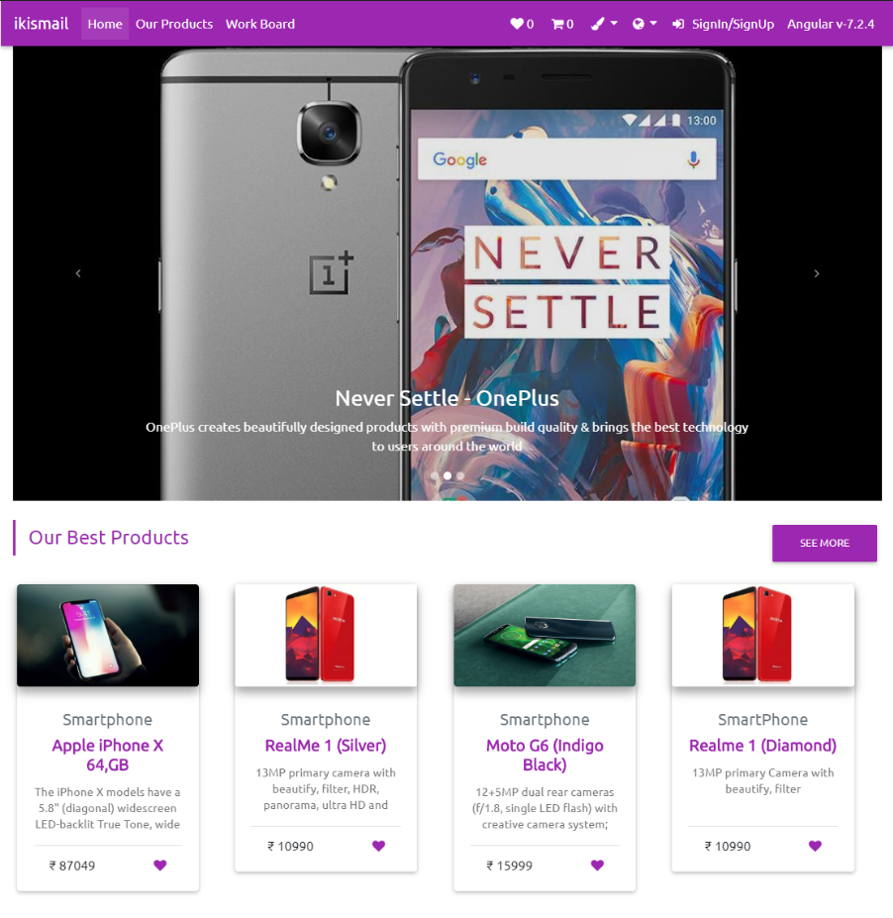

Figure 5.1: Home Page

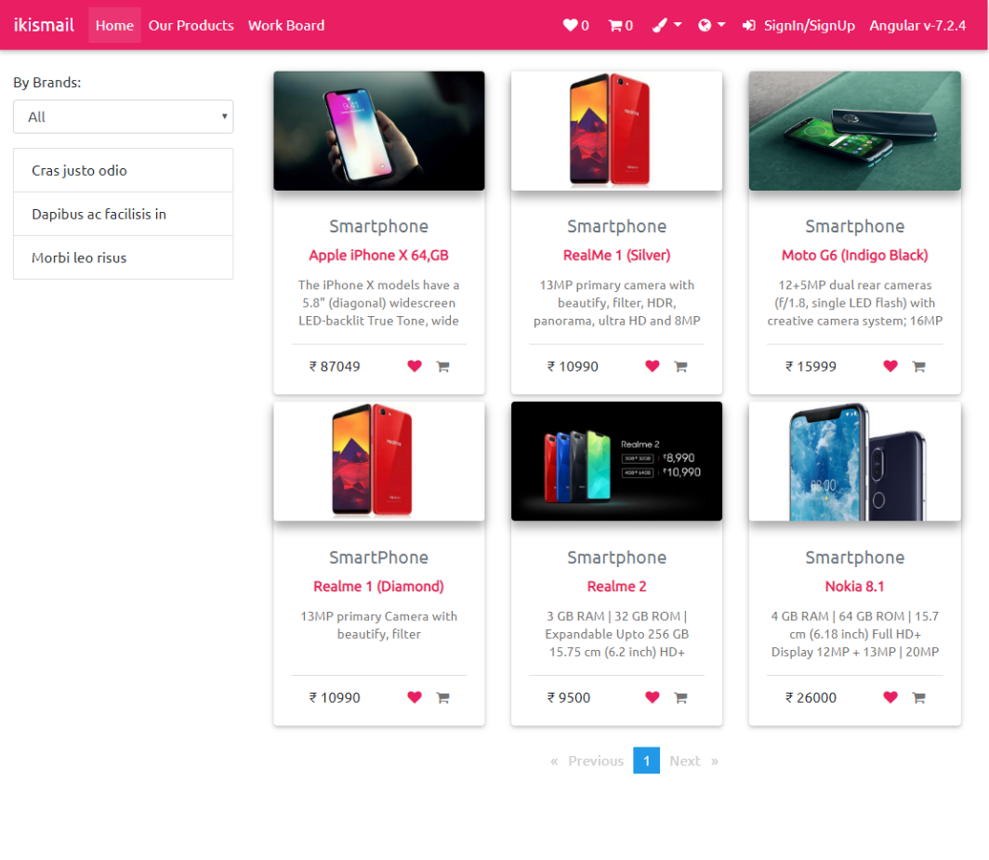
Figure 5.2: Products Page

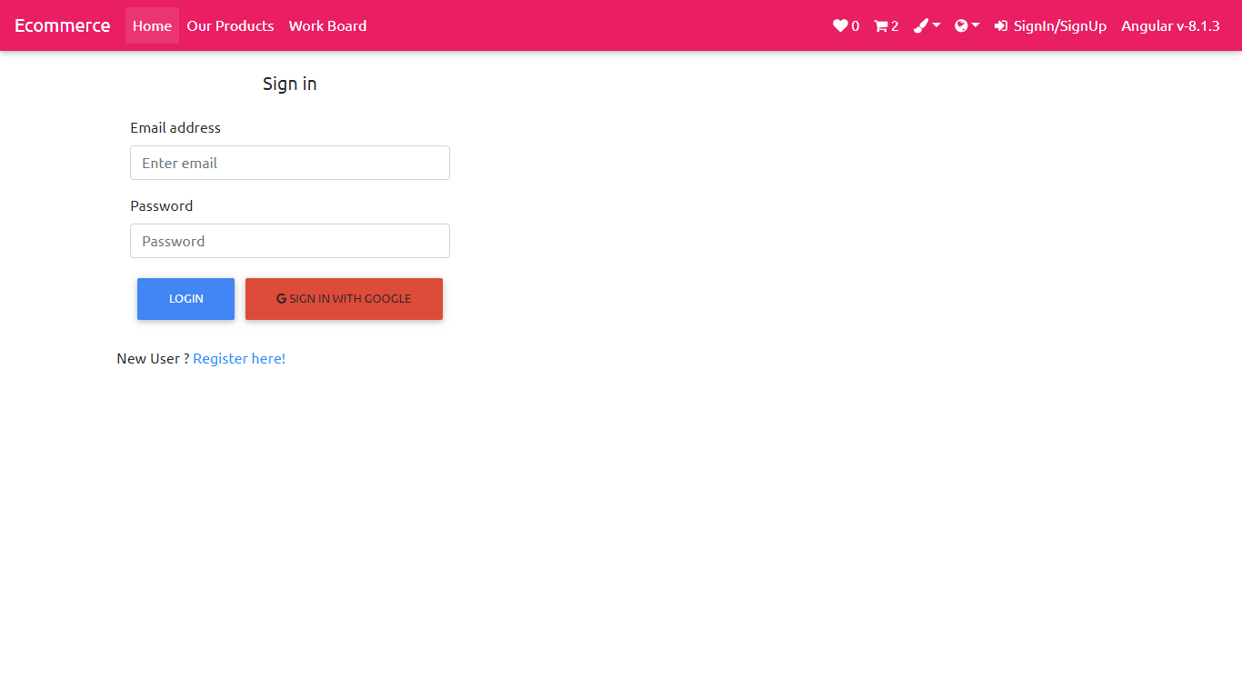
Figure 5.3: Login Page

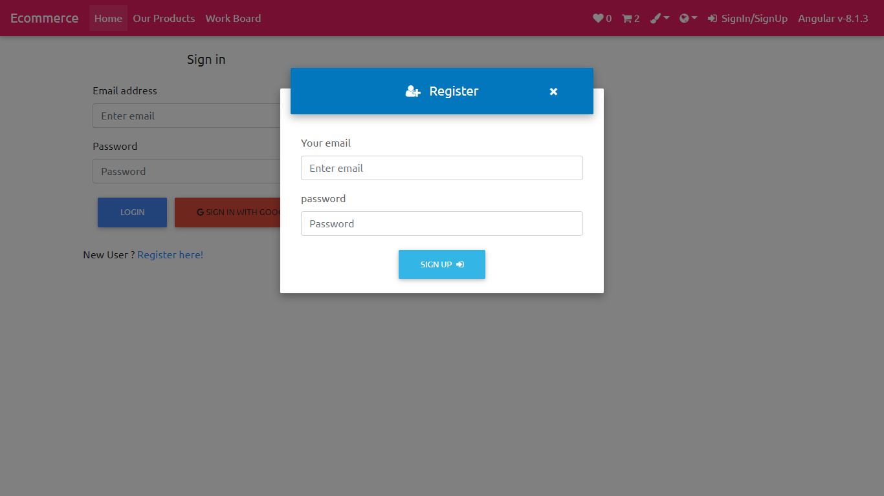

Figure 5.4: Register Page

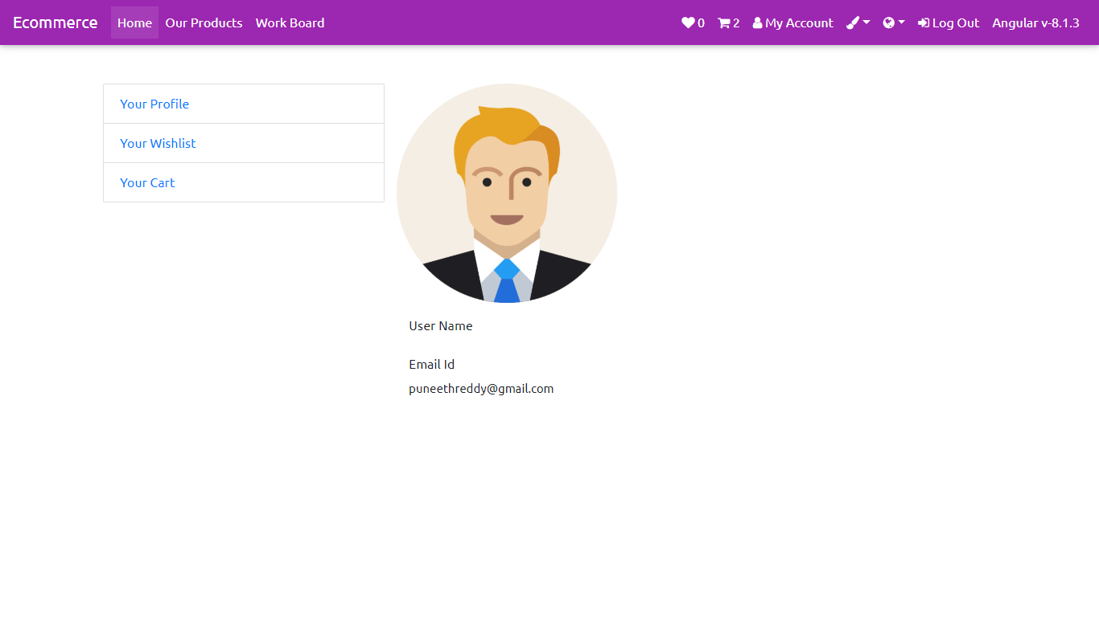
Figure 5.5: Profile Page
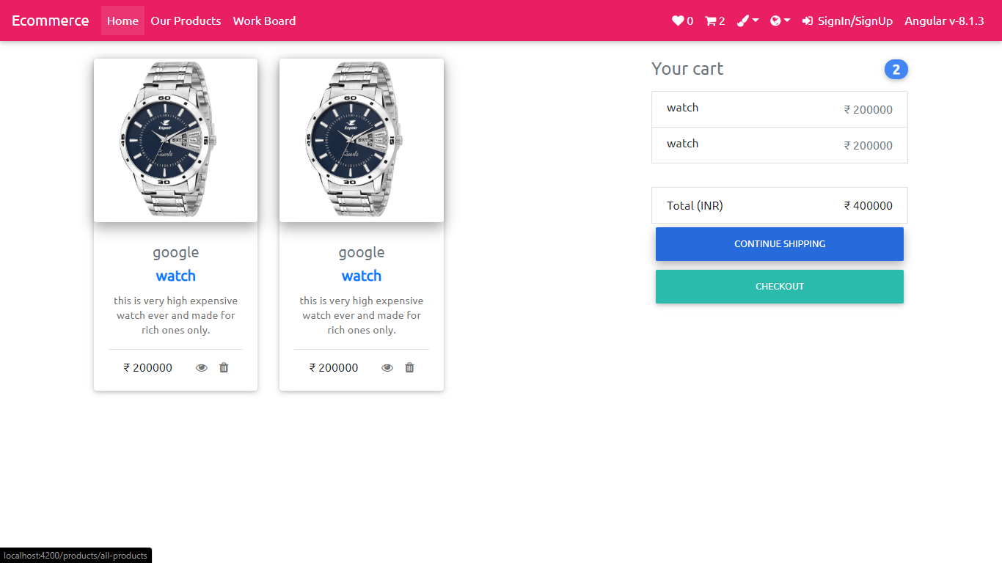
Figure 5.6 : Cart Page

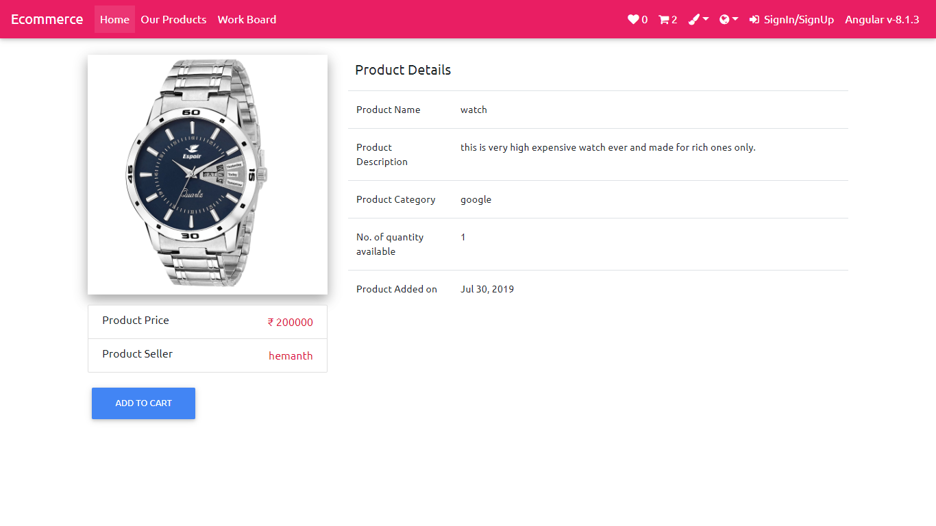
Figure 5.7 : Details Page

REFERENCES

- http://sookshmachetas.com/
- https://www.bigbasket.com
- www.naturesbasket.co.in/
- www.grofers.com
- https://www.w3schools.com/
- https://stackoverflow.com/
- https://www.mongodb.com/
- https://www.google.com/

