«Advanced Programming»

Practice lesson

week 6

Understand what Servers and Testing on GO are and how they work (GO, Server and Testing)

**TCP Server with Testing (testing application) GO Project**

**Step 1: Set Up the Project**

Github full code - ***`https://github.com/WebDiyar/assigment3_golang2`***

**Step 2: Run the Application**

1. **go test -v**

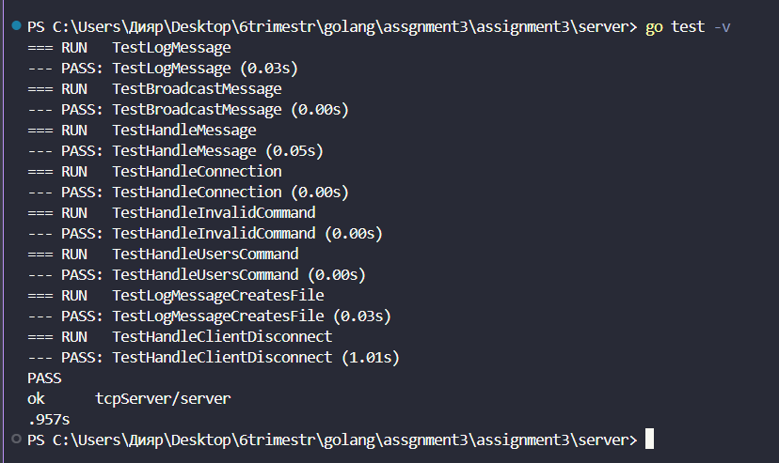

1. **go test -v -failfast**

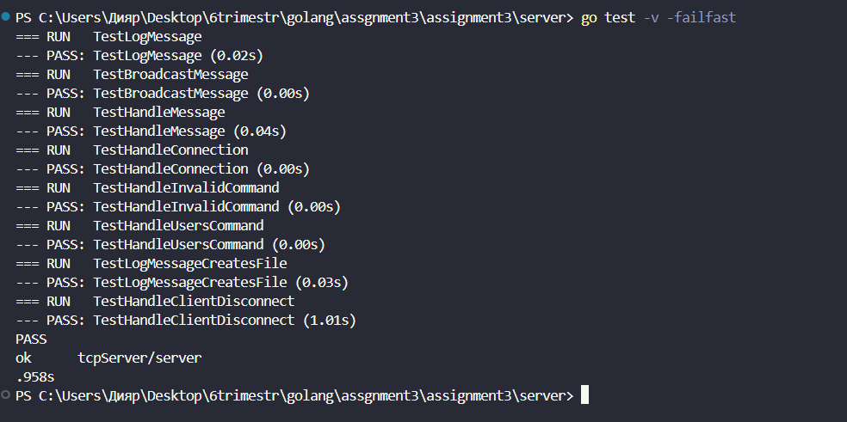

1. **go test -coverprofile=data_test**

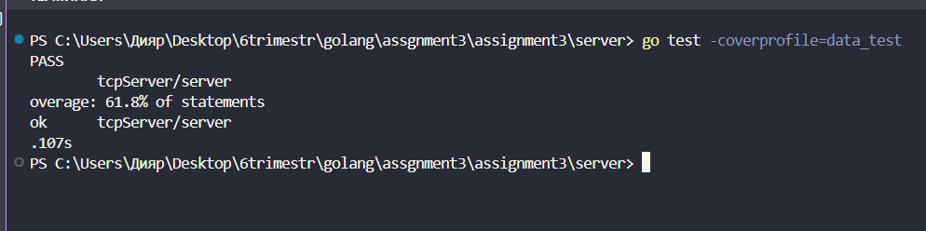

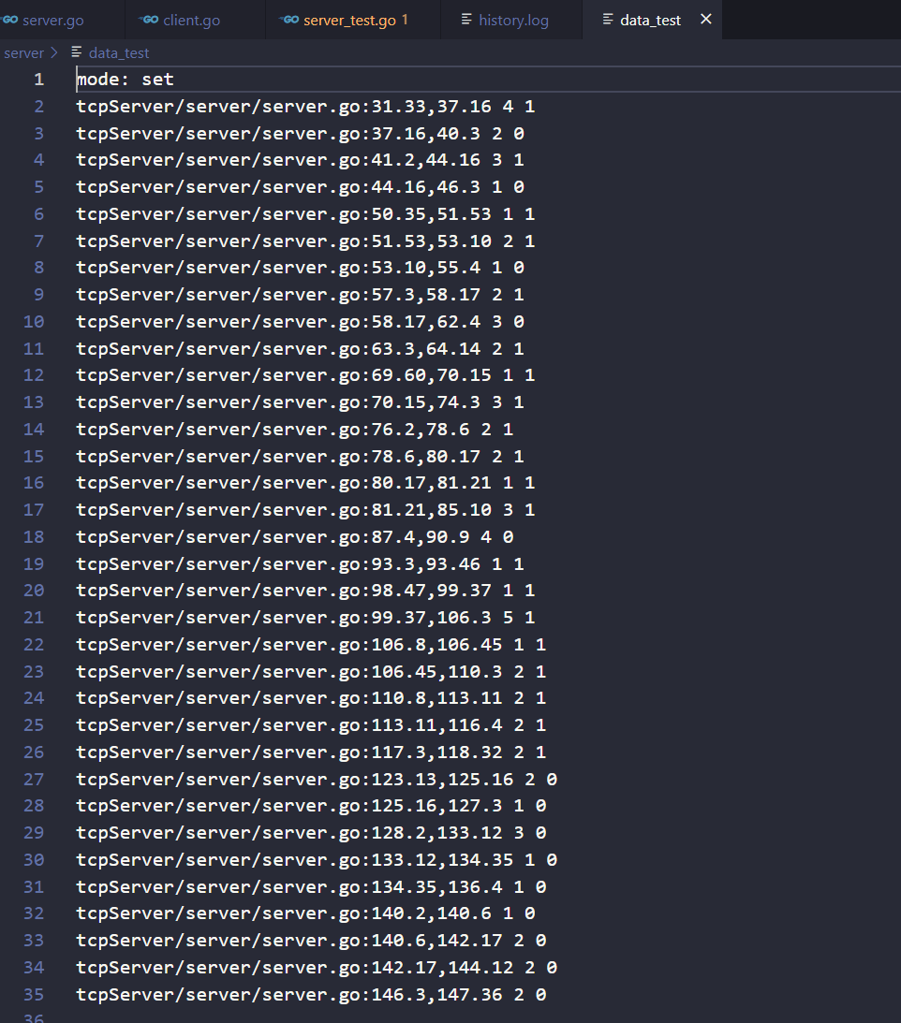

1. **go tool cover -html=data_test**

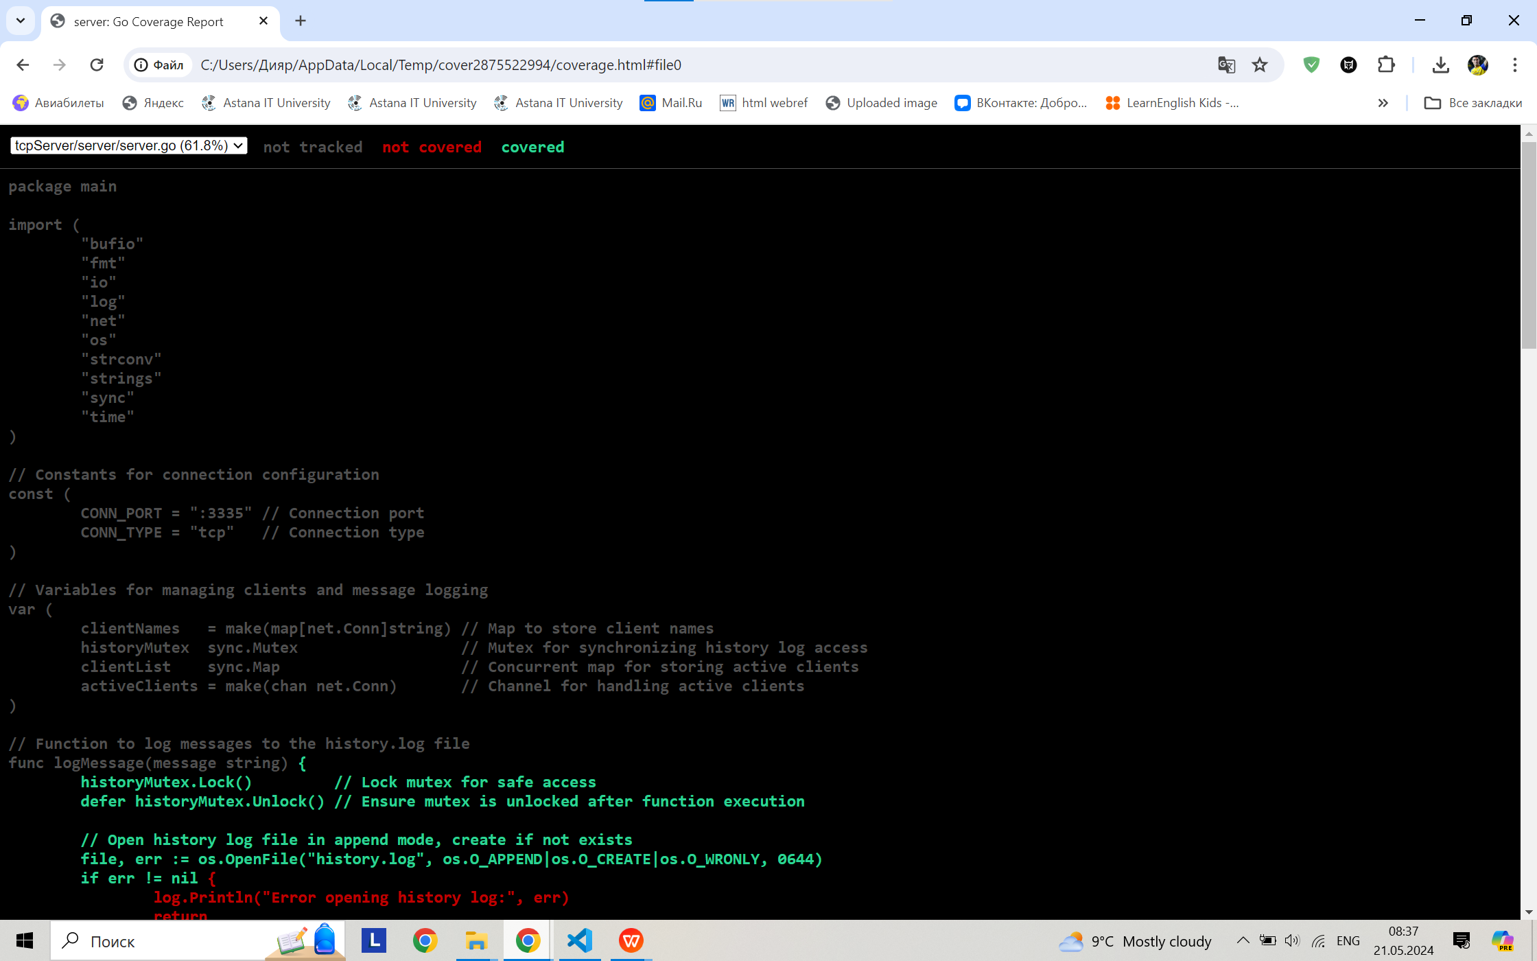

1. **go test -short -v**

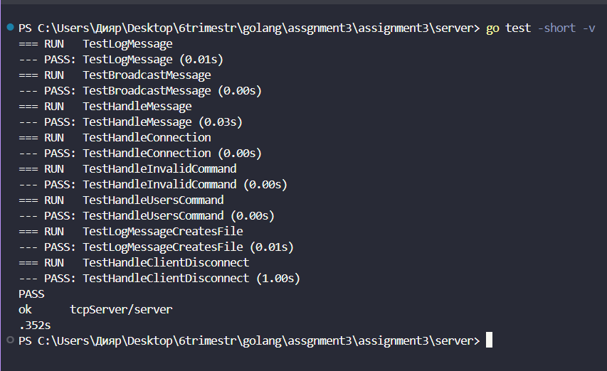

1. **go test -list “.*”**

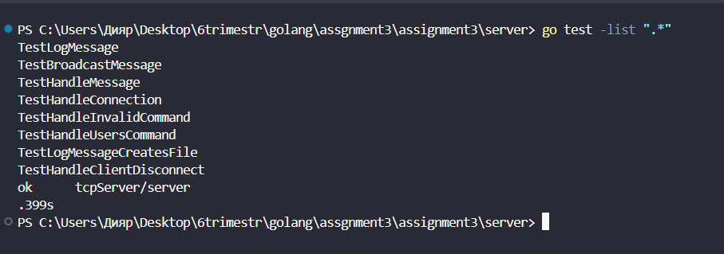

1. **go test -race**

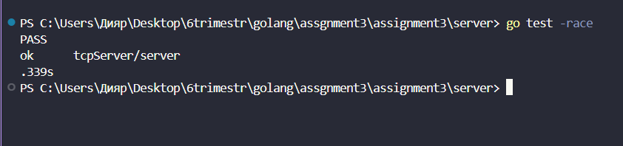

1. **go test -short -v -json -cpu 4**

