1. Download and install Microsoft Visual Studio 2015 or later.

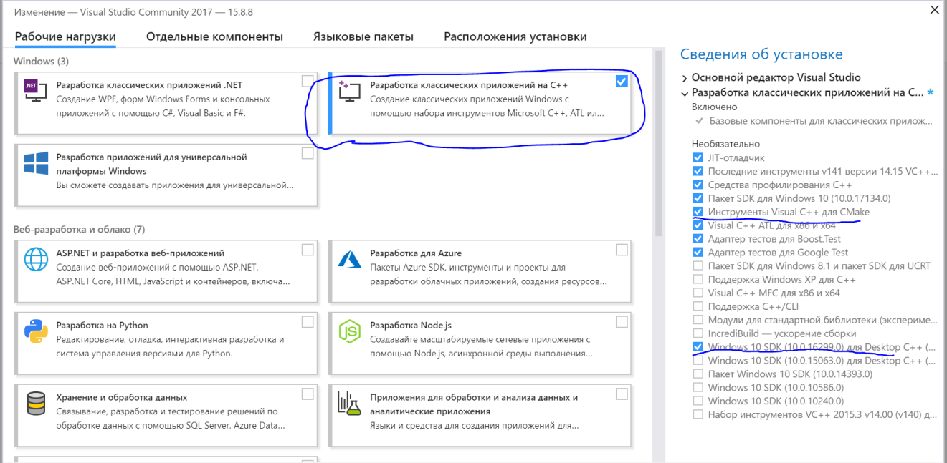

Install English language pack.

1. Download and install [gperf](https://sourceforge.net/projects/gnuwin32/files/gperf/3.0.1/). Add the path to gperf.exe to the PATH environment variable.
2. Install [vcpkg](https://github.com/Microsoft/vcpkg#quick-start).

> git clone https://github.com/Microsoft/vcpkg.git

> cd vcpkg

PS> .\bootstrap-vcpkg.bat

Then, to hook up user-wide [integration](https://github.com/Microsoft/vcpkg/blob/master/docs/users/integration.md), run

PS> .\vcpkg integrate install

Install any packages with

PS> .\vcpkg install sdl2 curl

1. Run the following commands to install TDLib dependencies using vcpkg:

cd <path to vcpkg>

.\vcpkg.exe install openssl:x64-windows openssl:x86-windows zlib:x64-windows zlib:x86-windows

1. Download and install [CMake](https://cmake.org/download/); choose "Add CMake to the system PATH" option while installing.
2. Build TDLib with CMake

git clone <https://github.com/tdlib/td.git>

cd <path to TDLib sources>

mkdir jnibuild

cd jnibuild

cmake -DCMAKE_BUILD_TYPE=Release -DTD_ENABLE_JNI=ON

-DCMAKE_INSTALL_PREFIX:PATH=../example/java/td .. –A x64 -DCMAKE_TOOLCHAIN_FILE=<VCPKG_DIR>/scripts/buildsystems/vcpkg.cmake

cmake --build . --target install --config Release

Example:

Cmake –A x64 -DCMAKE_BUILD_TYPE=Release -DTD_ENABLE_JNI=ON -DCMAKE_TOOLCHAIN_FILE="F:\Program Files (x86)\vcpkg\scripts\buildsystems\vcpkg.cmake" -DCMAKE_INSTALL_PREFIX:PATH=..\example\java\td ..

Build java example:

cd <path to TDLib sources>/example/java

mkdir build

cd build

cmake -DCMAKE_BUILD_TYPE=Release -DTd_DIR=<full path to TDLib sources>/example/java/td/lib/cmake/Td -DCMAKE_INSTALL_PREFIX:PATH=.. ..

cmake --build . --target install --config Release

cmake -DCMAKE_BUILD_TYPE=Release -A x64 DCMAKE_TOOLCHAIN_FILE="F:\Program Files (x86)\vcpkg\scripts\buildsystems\vcpkg.cmake" -DTd_DIR=F:\Program Files\td\example\java\td\lib\cmake\Td -DCMAKE_INSTALL_PREFIX:PATH=.. ..

1. Add Release folder to classpath. Example: F:\Program Files\td\example\java\build\Release
2. Run Example:

cd <path to TDLib sources>/example/java/bin

java -Djava.library.path=. org/drinkless/tdlib/example/Example