Web Engineering

WS 14/15

Lecturer: A.Univ.-Prof. DI Dr. Birgit Pröll

Exercise 5

Documentation
Date: 15.01.2015.

Group I

Andreea Muscalagiu
k1456893

Lucie Triskova
k1456884

Bordi Eszter
k1456866

Sorin-Adrian-Robert Davidoi
k1456867

a) Specification of your feature
The website of the Karden Museum in Katsdorf should contain a route planner that is always available for the users, whose use is intuitive and which provides information about the public transportation means that can get those interested to visit this museum to Katsdorf.
This should be incorporated in a Wordpress plugin, so that the website’s maintainability will be increased and no technical background will be needed to update information on the website. The installation of the plugin should be easy, straight-forward.
Several other plugins for route planning already exist, this plugin, however, should be focused on public transport means and, in addition, personalized to the purpose of the website: how to get to the Karden Museum. Users should be able to specify the place, time and date of departure/arrival and then receive a list of possible routes along information about the transportations means.
First of all, it should be useful for English-speaking users. However, it links to the main transportation site of Austria, so it should be understandable for German-speaking users, too.
Its response time should be minimal. It should run on any of the most used web browsers: Internet Explorer, Google Chrome, Firefox, Safari and Opera. The plugin should comply with all the conditions of ÖBB Scotty Route Planner.

b) Concept and detailed technical description of your implementation, including choice and integration of Plugins
For the development of our plugin we used as environment PHP Storm that has direct support for Wordpress plugins and its use is straight-forward. Also, the use of a version control system was eased by this development tool, as it had it already integrated. For version control we chose Git, more precisely, GitHub. Our repository’s URL is: https://github.com/WebEngineering14/museum.git.

The plugin is implemented as a WordPress widget. The widget can be placed in a Widget Area (such as the sidebar). This reduces the need for having a separate page for this function (which the user will have to discover in the menu) by placing it on all pages. We think this will increase awareness of the feature and encourage people to use it. If it is desired, it can be easily modified to appear on only one page.
Regarding the technical implementation, we made use of the ÖBB Scotty Route Planner. This allows the administrator of the website to generate a form and embed it into the website. However, it does not allow the users to choose the date and time of the trip. These details are set by the administrator when he creates the form and are hard-coded into the code of the form. We chose to extend it by implementing these features. We added two input fields (one for date and one for time) and used the jQuery UI Datepicker Widget and the jQuery Timepicker Addon to allow the user to easily choose the date and time (the use of these add-ons is optional; without them the users would manually input data into the fields but we think their use is justified by the increased usability).
When the user selects the date and time of the trip, we modify the code of the ÖBB Scotty Route Planner to incorporate this information. When the user clicks on the “Search connections” button, a new tab with the ÖBB page containing the means of transportation opens and he can choose a way how to get to the museum.
One current caveat of the implementation is that one needs to modify the Wordpress theme in order for the plugin to work (at least until we find a better solution to the issue described shortly). This is because we need to import some Javascript and CSS files (the jQuery widgets we use) and the current solution is to import them in the theme. For this, a few lines of code need to be added to the file “functions.php” found in the theme directory.
For example, in the Twenty Twelve theme the following lines need to be added to the “twentytwelve_scripts_styles” function in the “functions.php” file:
// Added to support OBB Planner
// jQuery UI
wp_enqueue_script('jquery-ui', 'https://code.jquery.com/ui/1.11.2/jquery-ui.min.js', array(), '1.11.2', 'no');
wp_enqueue_style('jquery-ui-style', 'https://code.jquery.com/ui/1.11.2/themes/smoothness/jquery-ui.css');

// jQuery UI TimePicker Addon
wp_enqueue_script('jquery-ui-timepicker-addon', '//cdn.jsdelivr.net/jquery.ui.timepicker.addon/1.4.5/jquery-ui-timepicker-addon.js', array('jq$
wp_enqueue_script('jquery-ui-timepicker-addon-style', '//cdn.jsdelivr.net/jquery.ui.timepicker.addon/1.4.5/jquery-ui-timepicker-addon.css')
The usage of the ÖBB Scotty Route Planner is conditioned with respect to the linkage conditions. While we believe that our usage of it complies with their terms, further inquiry should be made in order to confirm this, especially regarding the first condition specifying the modification of the design.

c) “User Manual” including Screenshots of your feature How to add the plugin to a webpage:
Login to the WordPress Dashboard and click on “Plugins”. Then choose “Add new” and “Upload plugin”. Then upload the .zip file with plugin and click “Install now”. After that, you have to activate it by clicking “Activate plugin” link.
Now, the plugin is ready to use. But first, you have to place it somewhere to your webpage. Go to “Appearance” and click “Widgets”. Then choose the widget “ÖBB Scotty Planner” from the “Available Widgets” area, drag it and move to a desired place in some of the Widget Areas, for example “Main Sidebar” and save it.
In “Appearance” > “Customize” you can define, where this widget area should be displayed.

How to use the plugin:
After adding the personalized ÖBB Scotty Route Planner Plugin to the Wordpress web page, the form for entering further information will appear on the side in the widget area:
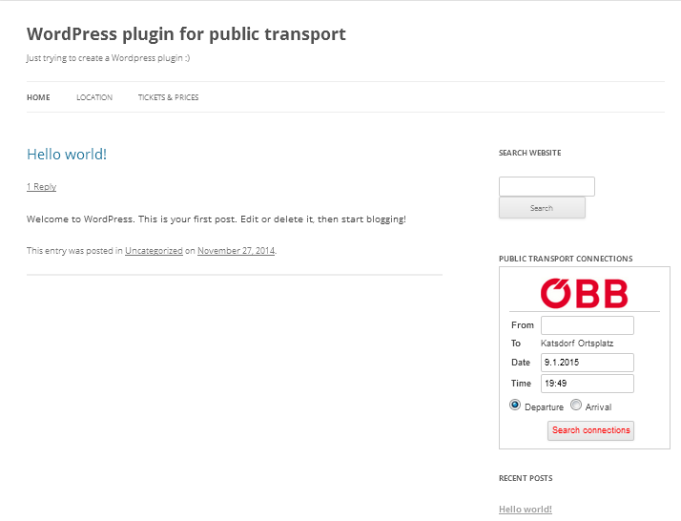
One of the features that makes this plugin special is that it is personalized to the purpose of the web page. As its target is to provide users with information regarding public transportation to the museum, the field of "To" cannot be modified, it is always "Katsdorf Ortsplatz". By clicking in the field of “From” the user can specify the place of departure by choosing from the list that appears.
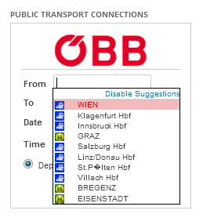
The user can also pick the date of the travel.
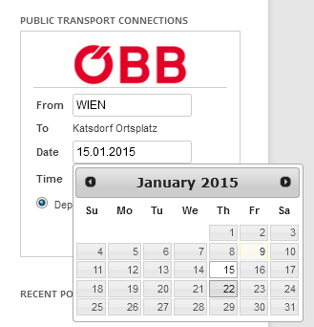
Also, the time of the travel can be chosen. By clicking on the button “Now” the current time of the system is specified.
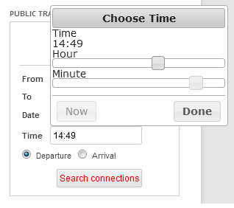
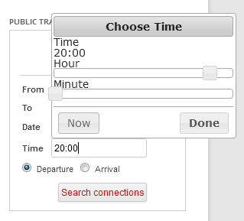
The time and date specified can refer to the departure’s time and date or to the arrival’s time and date. It is highly intuitive, that by choosing “Departure” or “Arrival”, the user can easily specify this detail. By clicking on the button “Search connections”, the different possibilities are listed in a different tab, as specified in the usage conditions of the ÖBB Scotty Route Planner.
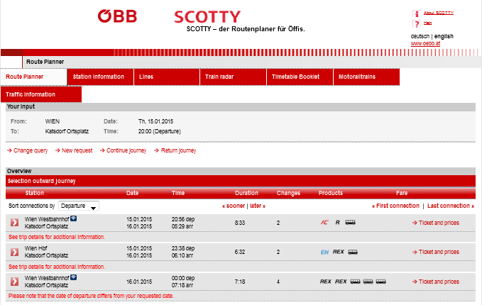

d) Experiences from working with Wordpress with regard to your implementation

Regarding the plugin implementation, the biggest problem we faced was the confusing documentation. While it is abundant, it is many times confusing and not easy to find. Snippets of code are provided but often there is no mention on where should that snippet be placed. For instance, much time was lost figuring out where to import the Javascript and CSS files needed and the solution was not found in the official documentation but on a forum. Other times it is outdated and lacks sufficient detail.

Another issue is that if one of the theme files contains an error you can not longer access Wordpress through a browser and it does not say what is the reason. We had to blindly revert the changes we made or start from scratch with a new copy of one of the default theme. Most of this was caused by our unfamiliarity with it. Once you get through a few bumps it can be quite a pleasant experience. If you have some experience with PHP writing plugins is not a big deal.

Once a plugin is imported, you can easily change it directly in Wordpress environment (Plugins > Editor > Choose a plugin and start editing). So you do not have to import and activate it after every change to see the result. However, it has also some drawbacks - it is not a real development environment, just a simple editor. And if you make an typing error and then push the Update File button, it can happen, that the whole wordpress crashes and you cannot access your neither Wordpress Dashboard nor the website via internet browser anymore (there is only a line of error message displayed). A solution is to access the server via sftp and delete the plugin file (but first, you need to get the permission to do it!) manually. After deletion of the wrong file, wordpress just says that the plugin was disabled because it is no longer present in plugin folder. Then, you can upload the plugin once more and continue working (however, all changes made in the plugin editor before the crash are lost). In my opinion, this behaviour (complete crash of wordpress) is probably a bug and should be fixed. Because when importing zip file with plugin that contains any error, it shows an error message that there is some compiling problem and the plugin is not imported. The same functionality would be useful also for plugin editor.

http://fahrplan.oebb.at/bin/help.exe/en?tpl=inputgen_start
http://api.jqueryui.com/datepicker/
https://github.com/trentrichardson/jQuery-Timepicker-Addon
http://fahrplan.oebb.at/bin/help.exe/en?ld=21&tpl=inputgen_terms

