COMPARATIVE DESIGN REPORT
Tactical RPG Benchmarks
Final Fantasy Tactics, Fire Emblem, Shining Force, and adjacent tactics games
A feature comparison and design implications report for Mirexis
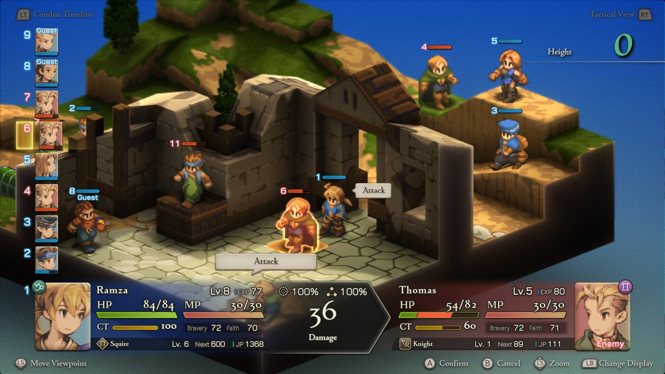
Final Fantasy Tactics - The Ivalice Chronicles: elevation, unit order, and projected combat outcomes are visible in one tactical view. Screenshot: Square Enix / Steam
Prepared 9 August 2026

Executive summary
The strongest tactics games do not win through complexity alone. They make a small number of recurring decisions emotionally legible: who acts next, what a move exposes, what a character may become, and what a defeat will cost. The benchmark set divides into three broad traditions: build-driven isometric tactics, character-driven army tactics, and campaign-driven survival tactics. Mirexis already combines all three.
Core finding Mirexis should keep its readable player/enemy phases, then borrow depth from Final Fantasy Tactics in character builds, Fire Emblem in unit identity and prediction, Shining Force in accessibility and roster warmth, and XCOM/Battle Brothers in persistent consequences.

The benchmark traditions
Design feature | How it works and why it matters
Build-driven | Final Fantasy Tactics and Tactics Ogre turn class combinations, ability inheritance, initiative, and elevation into the main source of mastery.
Character-driven | Fire Emblem and Shining Force make recruitment, promotion, relationships, and the survival of named units the emotional engine of battle.
Campaign-driven | XCOM 2 and Battle Brothers connect wounds, equipment, resources, timing, and strategic pressure to every tactical outcome.
Choice-driven | Triangle Strategy ties battle composition and political narrative to decisions, while using terrain interactions and fixed character roles to keep encounters authored.

High-value lessons for Mirexis
- Show combat forecasts, enemy threat, objective progress, and turn consequences before confirmation.
- Let mutations define positioning and ability interactions; keep raw stat bonuses secondary.
- Use class training to express player authorship, but preserve each recruit's identity through aptitudes, mutation, relationships, and a limited carry-over budget.
- Treat injuries as stories and build changes, not only downtime penalties; reserve permanent death for clear, player-readable failure states.
- Make colony construction tactically visible during defence missions. This is Mirexis's clearest differentiator from the benchmark set.
- Prefer objective pressure, reinforcements, extraction, and environmental hazards over routine defeat-all missions.

1. Final Fantasy Tactics
Final Fantasy Tactics is the benchmark for build expression in a compact tactical squad. Its battlefields are small but vertically dense, and its Charge Time model means movement, spells, and unit speed are evaluated against a visible order of action rather than alternating army phases. The result is a game about constructing specialists and predicting timing.
Design feature | How it works and why it matters
Turn model | Individual initiative through Charge Time. The player plans around the next actors rather than completing an entire faction phase.
Jobs and abilities | More than 20 jobs and 300 abilities in The Ivalice Chronicles. Learned skills can be equipped across jobs, enabling deliberate hybrid builds.
Terrain | Height affects movement, range, line of sight, and some abilities. Facing and positional access create further value.
Action timing | Many spells and techniques resolve after a delay, creating prediction, interruption, and friendly-fire questions.
Roster stakes | A small deployed party concentrates attention on each build. Incapacitated units face a delayed permanent-loss state rather than instant death.
Narrative | Political conflict, class struggle, and personal betrayal give tactical battles a strong dramatic frame.

Why the formula works
- Progression choices create new tactical verbs, not only stronger numbers: teleportation, reactions, delayed magic, equipment breaks, and terrain-dependent attacks change how a map is read.
- A small deployment makes every job pairing visible and encourages the player to understand a handful of specialists deeply.
- The interface treats timing and prediction as core information, which lets a complicated system feel learnable.

The combat forecast integrates action order, height, hit chance, damage, health, resource values, and job identity before commitment. Screenshot: Square Enix / Steam
Mirexis takeaway Adopt the preview discipline and limited cross-class inheritance. Avoid importing a full initiative system unless a prototype proves that it adds more than it costs in readability, AI complexity, and campaign pacing.
Feature source: Square Enix launch overview

2. The Fire Emblem series
Fire Emblem's enduring strength is the fusion of clean phase-based tactics with attachment to named characters. The battlefield is usually readable at army scale: movement ranges, weapon matchups, projected damage, counterattacks, and death risk are shown before a move. Character supports and promotion systems make the roster feel like a cast rather than an inventory.
Design feature | How it works and why it matters
Turn model | Player and enemy phases support broad coordination, rescue plays, formations, and fast map reading.
Combat forecast | Projected damage, hit chance, critical chance, follow-up attacks, and counters expose the important consequences before confirmation.
Unit identity | Named units have authored growth tendencies, classes, portraits, relationships, and narrative context.
Weapon relationships | Many entries use a weapon triangle; Engage turns advantage into Break, temporarily denying the target's counterattack.
Loss modes | Classic mode preserves permanent death, while modern Casual modes restore fallen allies after battle. Rewind tools soften avoidable restarts.
Supports | Repeated deployment and proximity can develop relationships, providing character scenes and often modest mechanical bonuses.

Why the formula works
- The forecast converts uncertain combat math into a readable commitment decision while still leaving room for risk.
- Permanent death gains meaning because recruits have names, portraits, histories, and relationships; modern modes preserve that identity for players who prefer lower punishment.
- Phase-based control makes coordinated formations and rescue plays easy to express even with a larger deployed army.
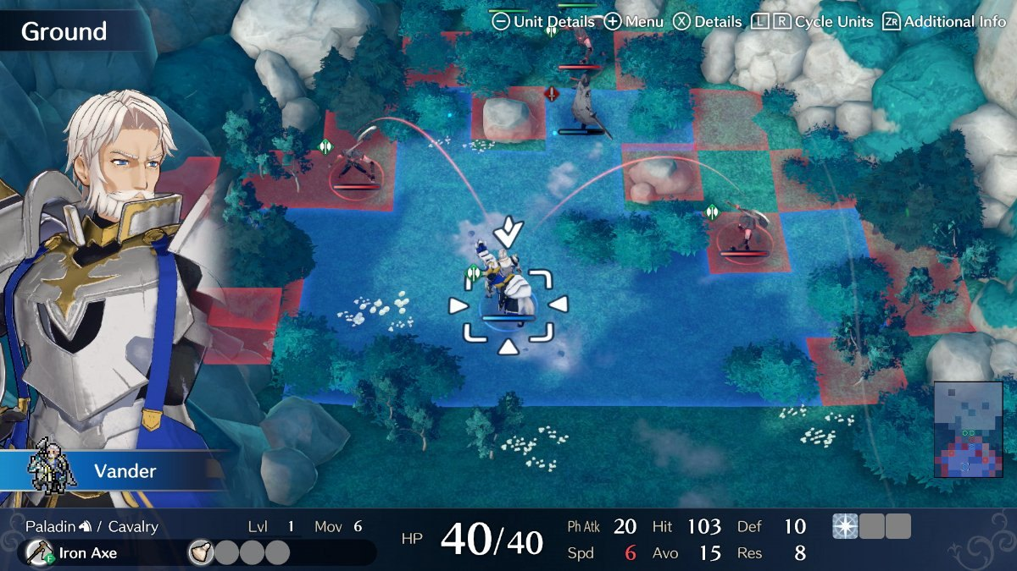
Fire Emblem Engage overlays movement, enemy threat, terrain, unit statistics, and map position without leaving the tactical field. Screenshot: Nintendo
Mirexis takeaway Keep the existing player/enemy phase structure. Build stronger pre-commit forecasts and threat overlays, then let relationships, injuries, mutation events, and authored backgrounds maintain identity even when classes remain flexible.
Feature sources: Nintendo game overview; Ask the Developer: Fire Emblem Engage

3. Shining Force
Shining Force demonstrates how a tactics RPG can remain approachable while supporting a large, colourful cast. Town exploration, conversations, shops, headquarters management, and battlefield encounters form a traditional RPG journey. The tactical rules are lighter than Final Fantasy Tactics, but recruitment variety and vivid battle cut-ins make each unit feel distinct.
Design feature | How it works and why it matters
Turn model | Units act according to agility-influenced individual order, producing a looser rhythm than fixed faction phases.
Roster scale | The first game features roughly 30 recruitable warriors, with a smaller active force chosen at headquarters.
Exploration | Players walk through towns, speak to people, search environments, shop, and recruit between tactical battles.
Promotion | Characters advance into stronger classes after reaching a level threshold, giving progression an easy-to-understand milestone.
Battle presentation | Attacks cut to side-view animated scenes. This separates strategic readability from character spectacle.
Accessibility | Straightforward movement, clear archetypes, and a forgiving campaign structure make the genre welcoming without removing roster strategy.

Why the formula works
- Recruitment continually refreshes the player's tactical options and gives exploration an emotional reward.
- Promotion is legible as a major character milestone even when the underlying statistics are comparatively simple.
- Battle vignettes make each unit feel heroic without forcing the strategic map to carry all visual spectacle.
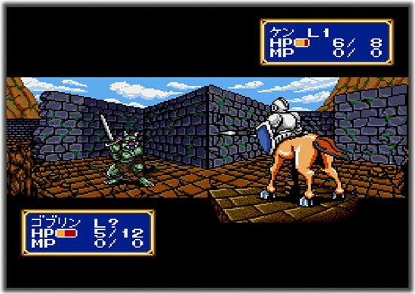
Shining Force switches from the map to a side-view battle vignette, giving simple attacks strong character and spectacle. Screenshot: Sega
Mirexis takeaway Use short, high-impact combat presentation selectively - portraits, mutation flashes, injury reactions, and faction-specific effects - while keeping the grid view authoritative. The colony can provide Shining Force's warmth and conversation rhythm at greater systemic depth.
Feature sources: Sega title page; Sega instruction manual

4. Adjacent tactical benchmarks
The following games clarify design spaces that the three core references touch only partially. They are especially relevant to Mirexis's branching campaign, destructible environments, injuries, and strategic colony pressure.

Tactics Ogre: Reborn
Distinctive features: individual Recovery Time turns; three-dimensional battlefields; unit-by-unit levels; flexible classes, equipment, skills, and magic; branching decisions and multiple endings; adaptive enemy AI.
Useful contrast: Compared with Final Fantasy Tactics, deployments are larger and political choice is more structurally tied to routes and endings.
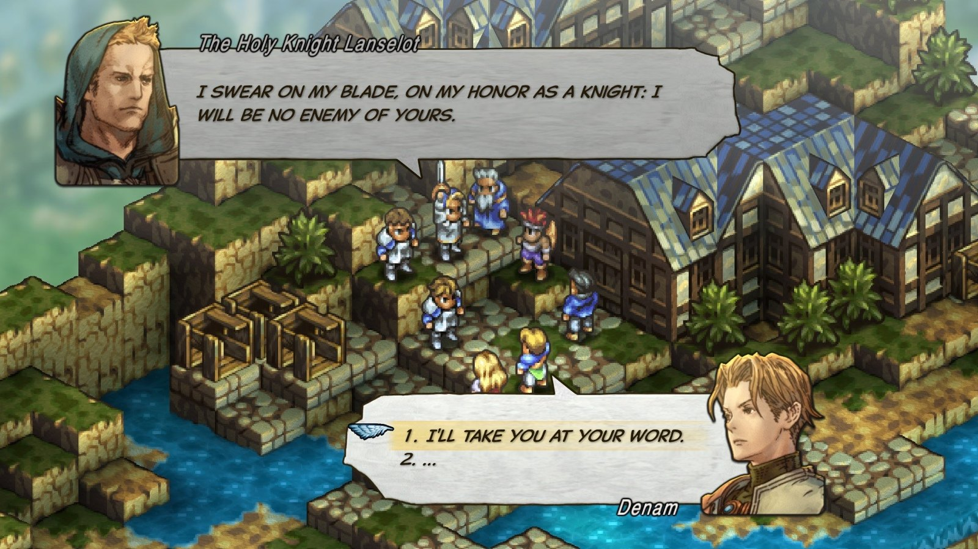
Tactics Ogre places story decisions directly over a layered isometric world, linking political choice to tactical space. Screenshot: Square Enix / Steam

Triangle Strategy
Distinctive features: fixed-role characters; visible turn order; back attacks and coordinated follow-ups; height advantages; elemental terrain combinations; exploration; conviction-driven votes and branching story paths.
Useful contrast: It sacrifices broad class freedom so encounter design can rely on authored toolkits. Its fire, water, ice, and lightning interactions show how terrain can become a temporary system rather than static cover.
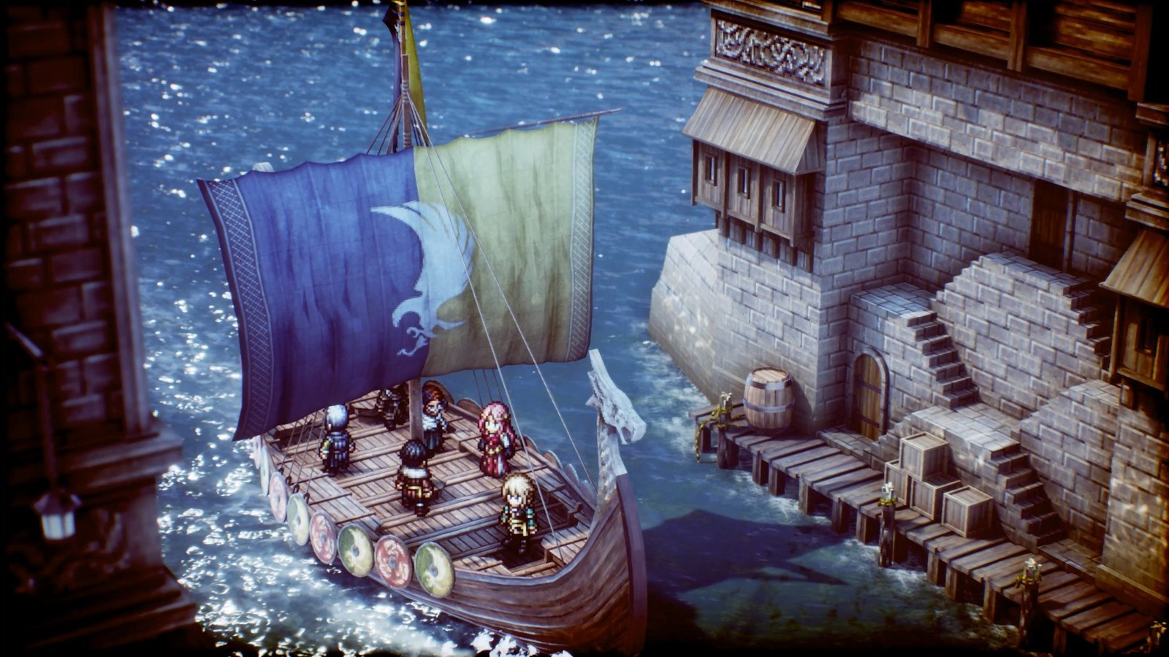
Triangle Strategy uses detailed multi-level environments and story staging to make location itself part of the campaign's identity. Screenshot: Square Enix / Steam

XCOM 2
Distinctive features: two-action turn economy; cover and flanking; concealment, overwatch, destructible battlefields, timed objectives, extraction, soldier classes, wounds and permanent death, research and facility management, and escalating global pressure.
Useful contrast: Its strategic and tactical layers repeatedly exchange consequences: mission timing changes who is available, wounds change the next squad, research changes battlefield options, and tactical failure accelerates strategic danger.
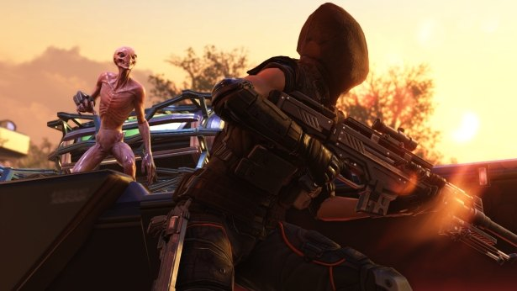
XCOM 2 pairs cinematic combat with persistent soldiers, equipment, wounds, and a strategic resistance campaign. Screenshot: 2K / Steam

Battle Brothers
Distinctive features: procedural open campaign; contract selection; hiring, training, and equipping a mercenary company; morale; armour layers; temporary and permanent injuries; severe economic pressure; and late-game crises.
Useful contrast: Its recruits begin as generated people rather than authored heroes, yet backgrounds, scars, injuries, equipment, and survival create strong emergent biographies.
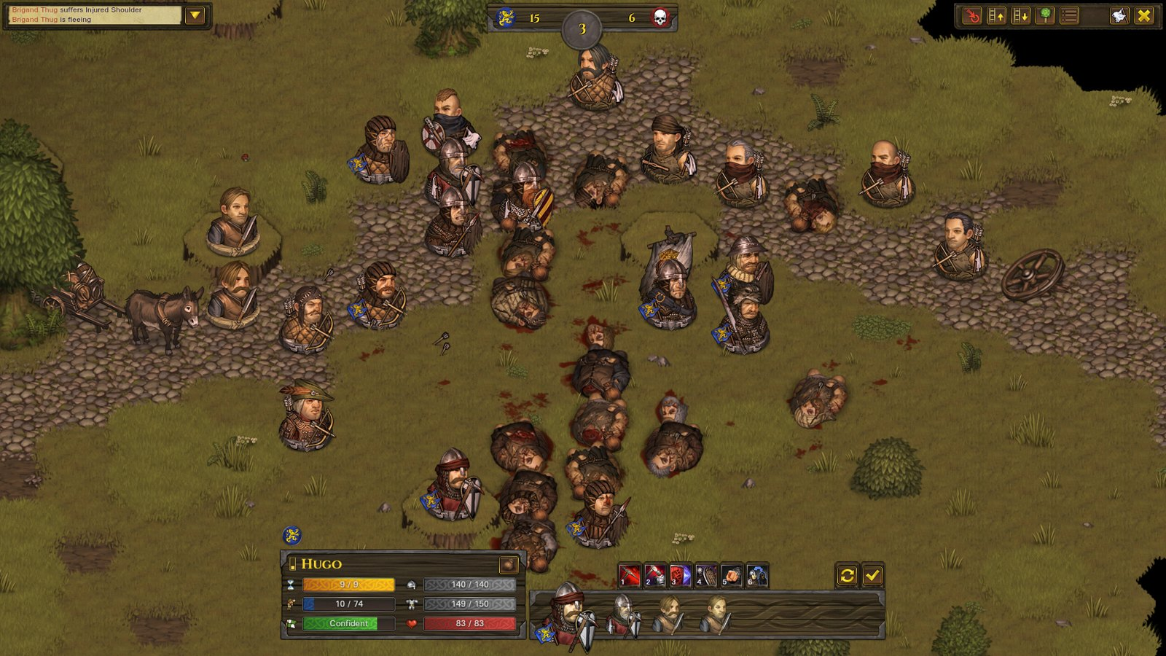
Battle Brothers turns visible wounds, equipment, morale, and survival into the history of a procedurally assembled company. Screenshot: Overhype Studios / Steam

5. Feature comparison
The matrix highlights each game's primary design emphasis rather than cataloguing every system in every entry.
Game | Turn structure | Character growth | Campaign consequence
Final Fantasy Tactics | Individual CT order | Jobs plus cross-class abilities | Small-squad loss, story progression
Fire Emblem | Player/enemy phases | Authored units, classes, supports | Permadeath or Casual recovery
Shining Force | Agility-based order | Recruitment and promotion | Roster selection; light exploration loop
Tactics Ogre | Individual RT order | Unit levels, classes, skills | Branching routes and endings
Triangle Strategy | Visible individual order | Mostly fixed-role characters | Convictions, voting, recruits, routes
XCOM 2 | Squad phase with two actions | Classes, gear, bonds, traits | Wounds, death, research, global pressure
Battle Brothers | Alternating individual turns | Perks, gear, backgrounds | Injuries, death, economy, crises
Mirexis direction | Readable faction phases | Aptitudes, flexible classes, mutations | Injury, colony, faction pressure, defence

What the matrix suggests
- No benchmark combines maximum class freedom, maximum authored identity, and maximum procedural consequence without trade-offs.
- Mirexis can reconcile flexible builds and memorable characters by limiting skill carry-over while letting mutations and aptitudes remain permanent identity anchors.
- Faction phases are a sound baseline for a browser-scale game with three-character deployments; tactical depth should come from information, objectives, terrain, and ability interactions before turn-order complexity.
- The colony layer should create tactical assets and liabilities on defence maps, making strategic choices spatially concrete.

6. Recommendations for Mirexis

Keep and strengthen
Design feature | How it works and why it matters
Faction phases | They support coordinated three-colonist turns and align with the current implementation. Improve forecasts and threat communication before changing the model.
Named roster | Keep authored recruits and relationships as the emotional layer, while using injuries and mutations to create campaign-specific stories.
Flexible classes | Allow experimentation, but cap retained off-class skills through slots, loadout weight, doctrine points, or mutual exclusions.
Mutation identity | Make each mutation alter movement, targeting, resource flow, survivability, or ability rules. Give the complication equal interface visibility to the gift.
Physical colony | Continue making structures appear in defence missions. Let placement affect cover, deployment, escape routes, power fields, and mission objectives.

Prototype next
Unified combat forecast: Display hit, damage, armour absorption, cover, retaliation, statuses, objective effects, and mutation interactions before confirmation.
Danger and intent overlay: Show tiles enemies can attack next phase, likely targets or roles where appropriate, reinforcements, and objective countdowns.
Carry-over budget: Test two or three retained class skills plus one mutation evolution branch. The constraint should create builds, not merely slow completionism.
Incapacity pipeline: Use healthy -> wounded -> incapacitated -> evacuated/lost. Make additional damage and mission abandonment the clearest routes to death.
Environmental combinations: Prototype a small matrix: biomass can spread or burn; water can conduct; shields can redirect; volatile machinery can be hacked or detonated.
Objective pressure: Add turn-limited rescue, moving extraction, escalating reinforcements, capture-without-killing, and protect-a-colony-structure variants.

Defer or avoid
- A wholesale switch to CT/RT initiative before forecasting, AI intent, and objective readability are mature.
- An unrestricted job web that lets every long-serving colonist converge on the same optimal toolkit.
- Frequent instant permanent death from ordinary attacks; it conflicts with the named-character pillar unless strongly telegraphed.
- A colony simulation so granular that tactical preparation becomes administration. Buildings should change choices, missions, or battlefield geometry.
- Combat cutaways for every attack. Reserve spectacle for mutations, critical events, injuries, promotions, and major enemies.

7. Prioritised design roadmap
This sequence preserves the current slice while testing the benchmark lessons with the highest player-facing value first.
Design feature | How it works and why it matters
Now: tactical clarity | Specify the combat forecast, danger overlay, cover/elevation rules, retaliation, and objective countdown language. Validate these against every current class action and mutation gift.
Next: build grammar | Define base and advanced class families, ability slot limits, cross-class carry-over, aptitude efficiency, respec cost, and mutation evolution timing.
Next: consequence model | Define incapacity, evacuation, injury generation, recovery, permanent loss, replacement recruits, and how scars or mutation instability can create opportunities.
Then: terrain systems | Add two or three environmental interaction families with strong faction identities and deterministic AI handling.
Then: colony defence | Expand the mapping from saved colony structures to defence-map cover, interactables, power zones, failure conditions, and civilian routes.
Later: campaign branching | Connect faction attention, research doctrines, recruits, and colony identity to mutually exclusive operations and endings.

Design test After each prototype, ask whether the feature produces a memorable colonist story, a meaningful tactical decision, or a visible colony consequence. If it does none of the three, it is probably outside Mirexis's strongest design space.

Suggested success criteria
- A new player can predict the important outcome of a move without opening a secondary rules screen.
- Two colonists in the same class still play differently because of mutation, aptitude, equipment, injury, and retained skills.
- At least half of authored missions create pressure beyond eliminating all enemies.
- A colony building decision visibly changes at least one later defence-map choice.
- Losing or saving a colonist changes the player's story without routinely invalidating the campaign.

Sources and screenshot credits
This report uses publisher pages, developer material, official manuals, and official storefront screenshots for comparative design research. Game names, screenshots, and trademarks remain the property of their respective owners.
Final Fantasy Tactics - Square Enix launch overview
Final Fantasy Tactics screenshot - Square Enix Steam storefront
Fire Emblem Engage - Nintendo game overview
Fire Emblem series design - Nintendo Ask the Developer
Shining Force - Sega Mega Drive Mini title page
Shining Force systems - Sega instruction manual
Tactics Ogre: Reborn - Square Enix product features
Triangle Strategy - Nintendo game overview
XCOM 2 - 2K extended manual
Battle Brothers - Overhype Studios feature overview

