MIREXIS / RESEARCH SERIES
TACTICAL RPG
GRAPHICS REPORT
Final Fantasy Tactics • Fire Emblem across four generations • Triangle Strategy
PURPOSE Identify the graphical choices that make tactical battlefields readable, characters memorable and attacks satisfying—and translate those lessons into a practical visual direction for Mirexis.
SCOPE
Battlefield rendering / unit presentation / camera / lighting / effects / interface / production scope
Prepared for WebHatchery • 9 August 2026

01 / EXECUTIVE VIEW

Three graphical models
All three families separate tactical information from spectacle—but they choose different places to spend detail.
Model | Representative games | Core visual idea | Primary strength | Main risk
Isometric sprite diorama | Final Fantasy Tactics | 2D characters inhabit compact, height-rich environments. | Depth and character charm coexist at modest asset scale. | Walls and elevation can occlude tiles.
Generational split view | Fire Emblem | A strategic map carries decisions; portraits and combat views carry identity and drama. | Readability survives major changes in hardware and rendering. | Separate battle presentation can become expensive or repetitive.
HD-2D diorama | Triangle Strategy | Pixel characters sit inside 3D sets with modern light, particles and post-processing. | Distinctive atmosphere with a deliberately authored miniature look. | Bloom and depth of field can soften tactical information.

The common grammar
- Faction is encoded redundantly: unit colour, base marker, portrait framing and movement/range overlays reinforce one another.
- The battlefield view prioritises position; portraits, dialogue art and close combat restore faces and emotion lost at tactical scale.
- Action previews convert a visually dense scene into an explicit decision: target, hit chance, damage, range and turn order remain legible.
- Spectacle is temporary. Effects flare during confirmation, then clear so the player can read the next state.
MIREXIS THESIS Use a readable layered battlefield as the permanent view, then reserve zoom, portraits, lighting pulses and large effects for high-value moments such as mutations, critical hits, faction powers and colony damage.

02 / FINAL FANTASY TACTICS

A compact isometric stage
FFT treats each battlefield as a small architectural model: height is dramatic, sprites are expressive and almost every surface carries tactical meaning.
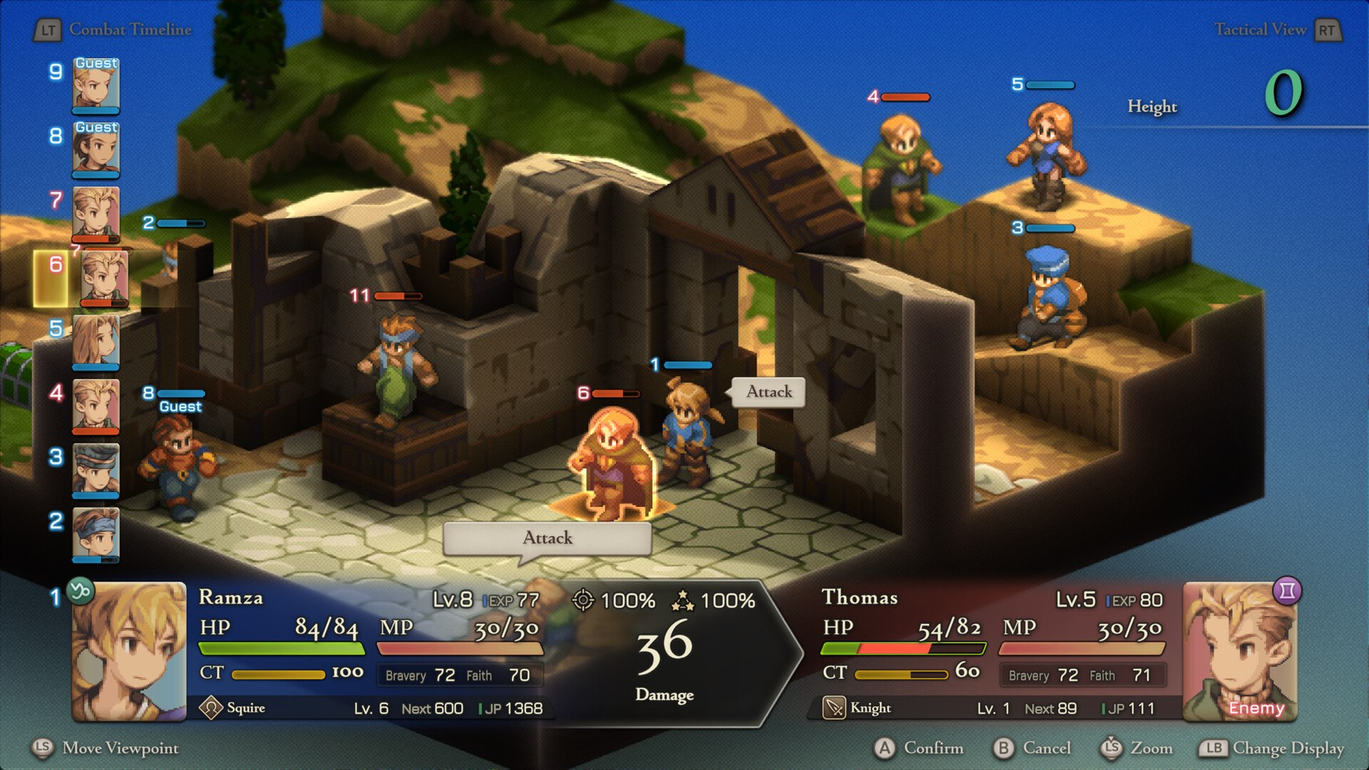
Enhanced edition: sprite characters remain visually dominant against readable stepped architecture and a comprehensive action forecast. Source: Square Enix / Steam

What the image is doing
- Chunked elevation turns terrain into silhouette. Platforms, stairs and rooflines are readable before the player studies numbers.
- Characters use exaggerated heads, hands and stances, which survive the tactical zoom better than realistic anatomy would.
- Muted stone and earth create a low-frequency background; saturated clothing, outlines and coloured status bars carry unit information.
- The interface occupies clear edge zones and uses portraits to reconnect tiny sprites with named characters.

03 / FINAL FANTASY TACTICS

Graphic strengths and constraints
The style feels richer than its raw geometric complexity because composition, palette and sprite animation do most of the work.
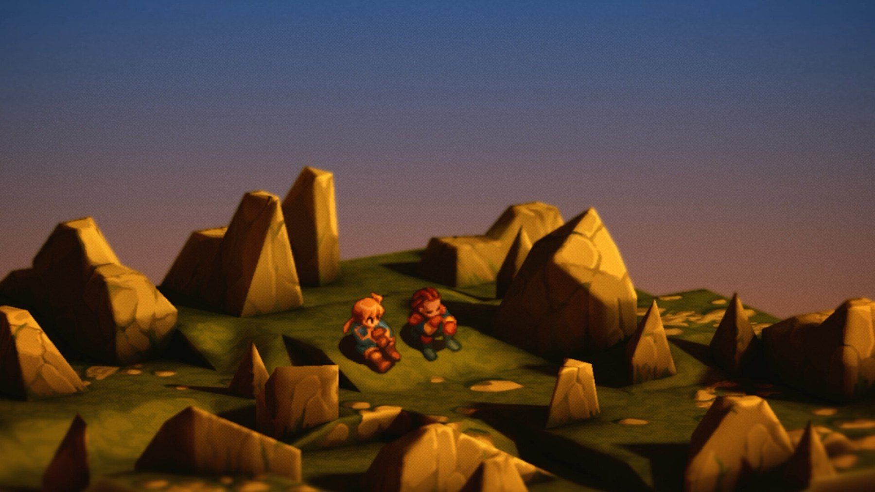
An FFT story vignette demonstrates the same reusable grammar outside combat: orthographic blocks, directional sprites and shallow, painterly environmental detail. Source: Square Enix / Steam
Graphic feature | Why it works | Mirexis translation
Orthographic/isometric camera | Parallel lines keep the map model-like and reduce perspective distortion. | Use a fixed or lightly rotatable camera; never make the player hunt for a playable tile.
Directional sprites | A small number of facings communicates orientation and character without full 3D rigs. | Use crisp silhouettes and faction-specific idle language for soldiers, drones and biotech units.
Vertical architecture | Height changes the shape of the scene and the tactical problem simultaneously. | Give roofs, gantries, cliffs and alien growth visible level bands plus explicit height UI.
Painterly restraint | Background texture supports mood without competing with units. | Keep industrial clutter around tile edges; protect clean centres for selection and occupancy.
WATCH-OUT Isometric charm does not excuse hidden information. Occlusion controls, roof fading, strong selection outlines and an optional flat tactical overlay should be designed from the start.

04 / FIRE EMBLEM

Four generations, one visual contract
The series is most useful as a longitudinal study: technology changes, but the hierarchy of map → unit → portrait → combat remains recognisable.
Game / era | Battlefield | Character layer | Spectacle layer | Readability signature
The Blazing Blade (GBA, 2003) | Top-down tile art | Tiny class sprites + illustrated portraits | Side-view sprite combat | Pure colour blocking and silhouettes
Awakening (3DS, 2012/13) | 3D terrain with grid overlays | Small 3D map models + portraits | Full 3D combat cutaways | Bright reach tiles and compact touch-era UI
Three Houses (Switch, 2019) | Full 3D terrain and battalions | Proportional 3D units + anime portraits | Close camera, crowds and gambit effects | Portrait diamonds, base rings and broad overlays
Engage (Switch, 2023) | Polished full 3D maps | High-colour models + large portraits | Fast cuts, Emblem transformations and saturated VFX | Strong threat red, cyan allies and high-contrast HUD

The durable contract
- Map sprites/models are tokens first and actors second.
- Portrait art carries the emotional and narrative burden at low cost per scene.
- Blue and red remain functional colours even when lighting, setting and rendering style change.
- Combat presentation can grow independently from tactical-map complexity.
DESIGN LESSON A visual system is more valuable than a single rendering trick. Mirexis needs rules for allegiance, selection, danger, cover, mutation and interactable terrain that remain stable across every biome and campaign phase.

05 / FIRE EMBLEM: THE BLAZING BLADE

Pixel clarity through separation
The GBA era makes a hard separation between abstract planning and expressive combat. That constraint produces unusually clean tactical screens.
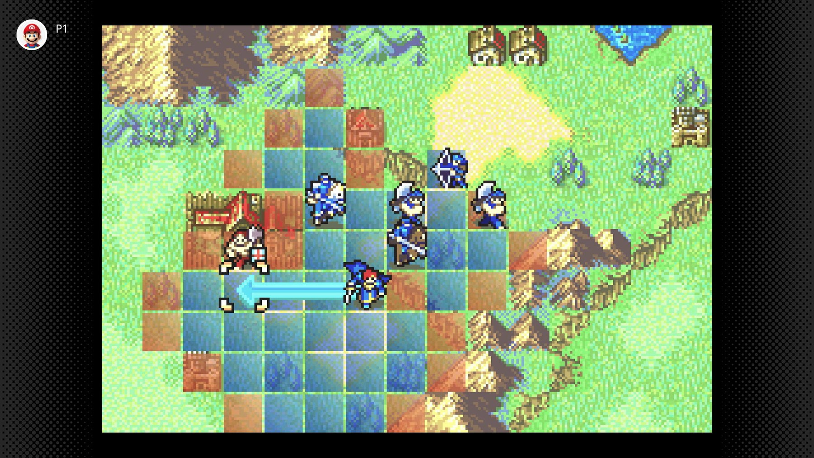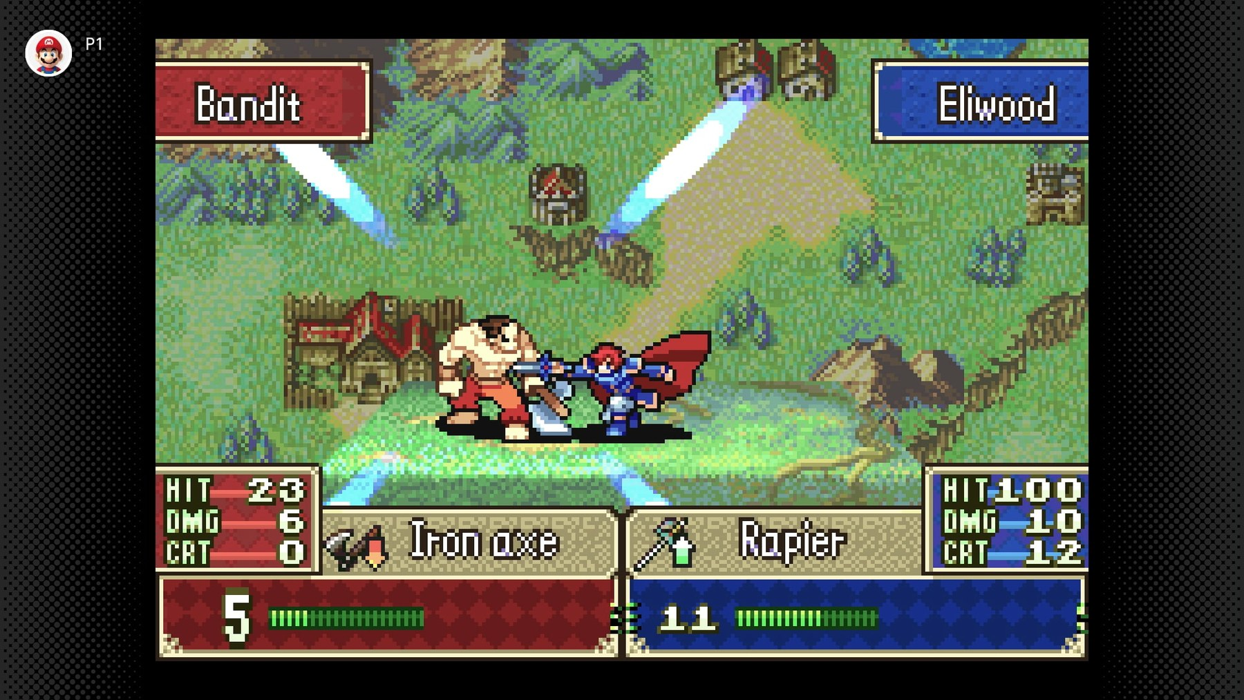
Left: tactical state is reduced to colour, terrain tiles and class silhouettes. Right: the same units expand into large, high-impact battle sprites. Source: Nintendo

Graphic features
- Terrain tiles communicate type through pattern and edge shape as well as colour—forest, mountain, road and fort remain distinguishable on a small screen.
- Map sprites are class icons with personality. They do not try to reproduce portrait-level detail.
- Combat animation uses anticipation, smear-like poses and impact frames to create force from a limited frame count.
- Large red/blue panels, health bars and weapon icons make the forecast readable without parsing the background art.
BEST FIT FOR MIREXIS This is the lowest-risk production model: inexpensive map tokens, high-quality portraits and a small library of authored combat flourishes. It scales well to many recruits and equipment variants.

06 / FIRE EMBLEM AWAKENING

The hybrid transition
Awakening keeps the familiar grid but replaces most sprite work with 3D models, using camera cutaways to make personal attacks feel cinematic.
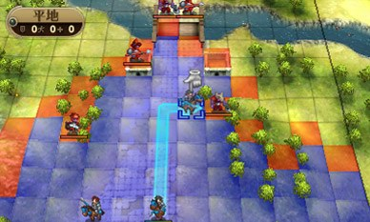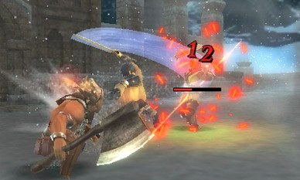
Left: a 3D map remains abstract under a dominant blue/red grid. Right: a close camera turns an attack into a character moment. Source: Nintendo

Graphic features
- The grid is more visually important than the underlying terrain. Translucent reach colours flatten a dimensional map into a dependable planning surface.
- Simplified tactical models and fuller combat models let the game spend detail where the camera can actually show it.
- Bright hit sparks, damage numerals and short camera motion provide confirmation without requiring elaborate environmental destruction.
- Portraits and illustrated dialogue maintain a cohesive anime identity when 3D hardware is comparatively limited.
MIREXIS ADAPTATION A full cutaway for every attack would be costly and slow. A practical browser-scale variant is a one-second push-in, enlarged attacker portrait/sprite, directional recoil and a faction-specific impact effect.

07 / FIRE EMBLEM: THREE HOUSES

Scale, place and battlefield population
Three Houses presents battles as inhabited spaces. Proportional characters and supporting battalions sell war at a larger scale, but increase visual competition.
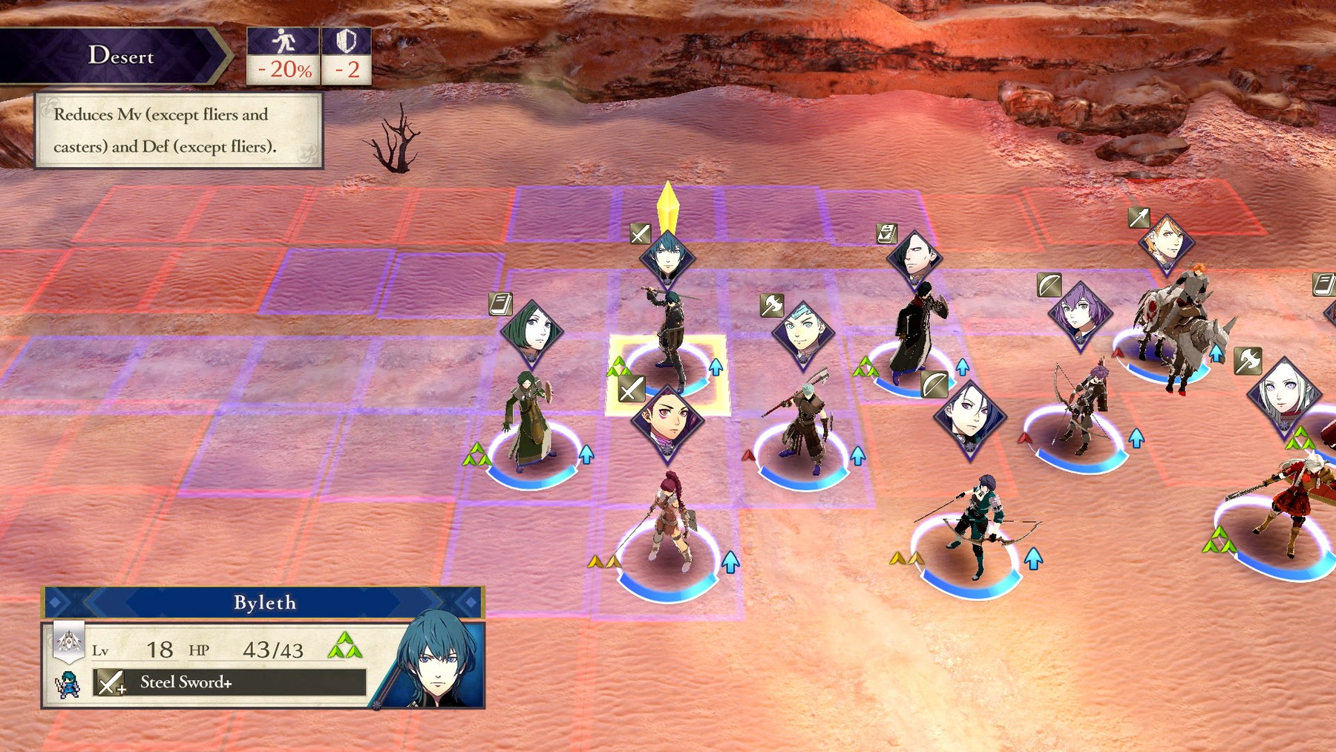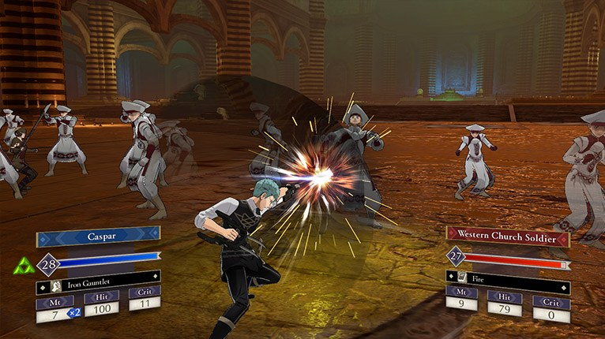
Left: portrait markers and coloured bases rescue unit identity on a broad 3D map. Right: battalions turn one mechanical unit into a visible formation. Source: Nintendo

Graphic features
- Naturalistic ground materials and broad environments give maps a sense of geography rather than a board-game edge.
- Floating portrait diamonds compensate for small, similarly proportioned characters viewed from above.
- Battalions add narrative scale and motion, especially during gambits, while the primary officer remains the gameplay anchor.
- A subdued, weathered palette supports the academy-and-war tone, but sandy or low-contrast scenes lean heavily on overlays for clarity.
MIREXIS ADAPTATION Represent squads, drones or Brood swarms as short-lived support formations around a primary unit. This suggests scale without requiring every background body to become a selectable actor.

08 / FIRE EMBLEM ENGAGE

Saturation as interface
Engage treats colour and material response as navigational tools. The world is vivid, but allegiance and selection remain more vivid still.
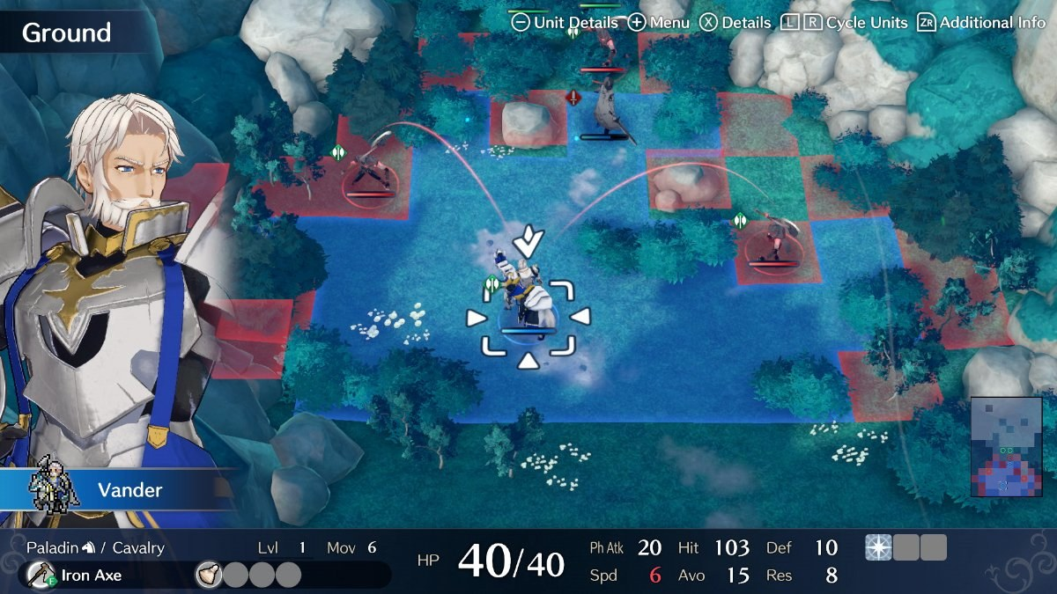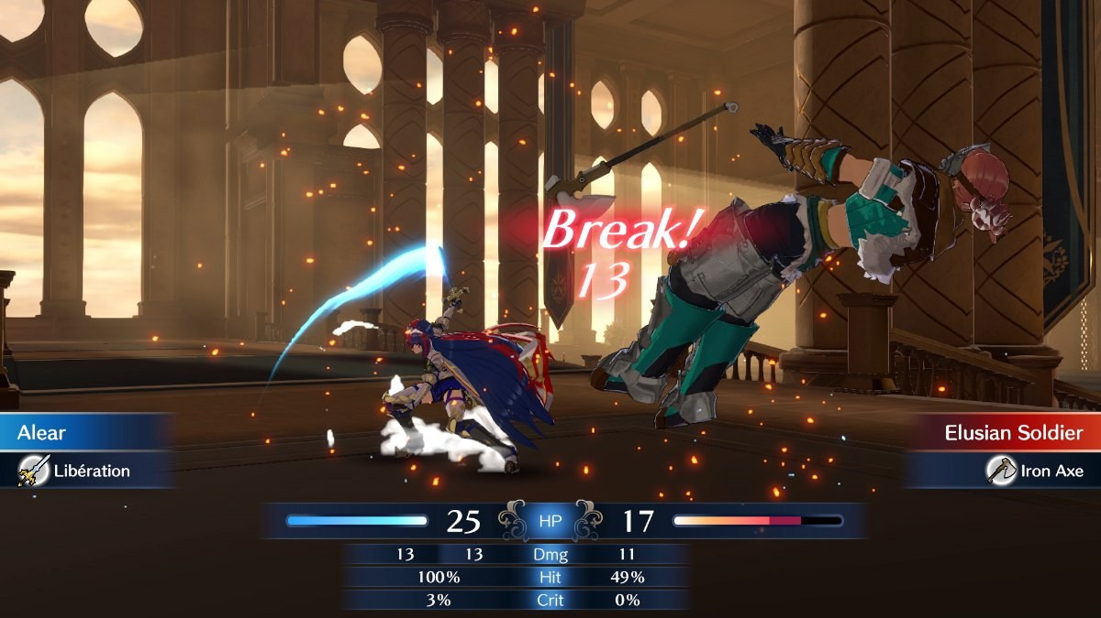
Left: cyan environment, red enemy range and white focus markers form distinct information layers. Right: close combat retains strong team colour and forecast contrast. Source: Nintendo

Graphic features
- High-saturation hair, costumes and magical materials make individual heroes readable against comparatively restrained ground planes.
- White selection brackets, cyan ally rings and red threat fields create a clear priority order independent of local lighting.
- Large illustrated portraits appear directly beside the tactical field, reducing the identity gap between model and character.
- Emblem effects use intense glow and colour transformation as a temporary state change—the character visually advertises new rules.
MIREXIS ADAPTATION Mutations and stolen faction technology should change a unit’s silhouette or colour channel, not merely add an inventory icon. The visual transformation can teach the mechanic before the player opens the details panel.

09 / FIRE EMBLEM SYNTHESIS

What improved—and what became expensive
More rendering power adds scale, animation and atmosphere. It does not automatically improve tactical comprehension.
Dimension | Blazing Blade | Awakening | Three Houses | Engage
Map clarity | Excellent; discrete tile art | Excellent with overlay | Good; marker-dependent | Very good; strong colour hierarchy
Character identity | Portraits + class sprites | Portraits + compact 3D | Portraits + proportional 3D | Portraits + distinctive models
Combat impact | Authored sprite animation | 3D cutaway and hit VFX | Close formations and gambits | Fast camera, transformation and glow
Environment | Symbolic tile patterns | Simple 3D scenes | Large naturalistic spaces | Polished, colourful set pieces
Asset burden | Low–medium | Medium–high | High | Very high
Best lesson | Separate token from portrait | Use overlays to flatten 3D | Suggest force scale around heroes | Make state changes visually unmistakable

The production curve
- Moving from sprites to 3D creates rigging, animation, camera, material, lighting and equipment-compatibility work for every class and body type.
- Background fidelity raises the need for stronger selection markers; realistic ground alone rarely communicates movement cost, cover or hazard.
- A portrait library has unusually high value: it supports dialogue, tactical identification, promotion, injury, mutation and relationships.
- Selective spectacle is more sustainable than universal spectacle. Critical events deserve bespoke treatment; routine attacks need fast, reusable feedback.
RECOMMENDATION Mirexis should target the clarity economics of the GBA/3DS games, the terrain depth of FFT, and the state-change confidence of Engage—not the full character-and-battalion asset load of modern Fire Emblem.

10 / TRIANGLE STRATEGY

HD-2D as authored diorama
Triangle Strategy preserves pixel characters while using modern 3D light, particles, water and architecture to make each map feel like a miniature theatrical set.
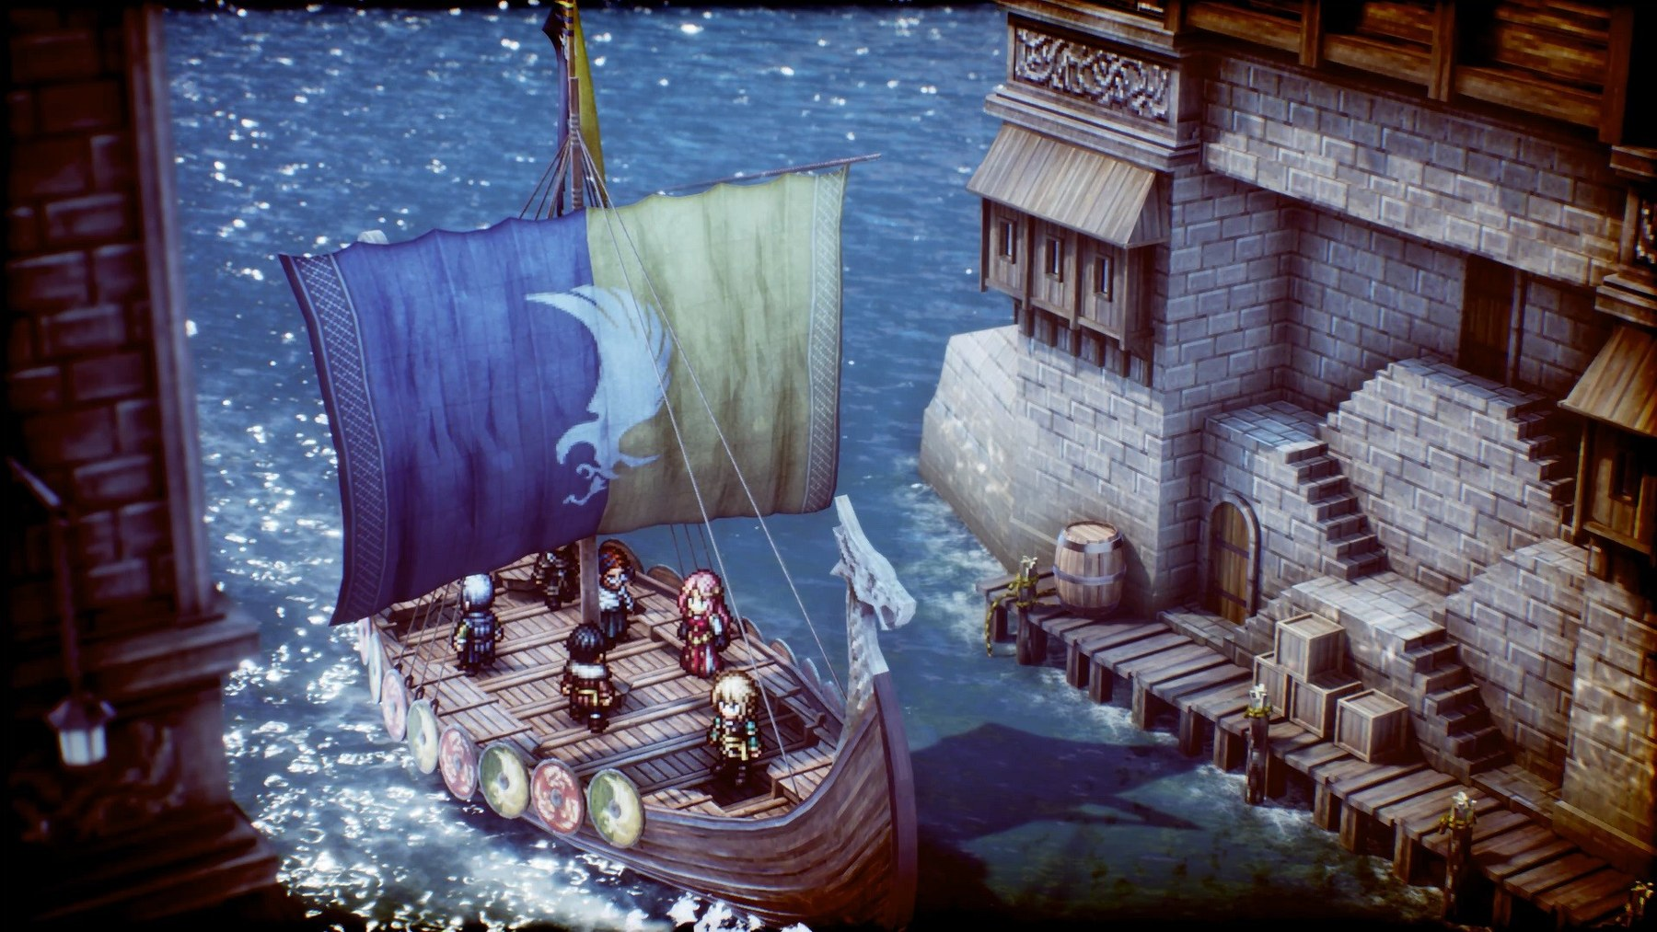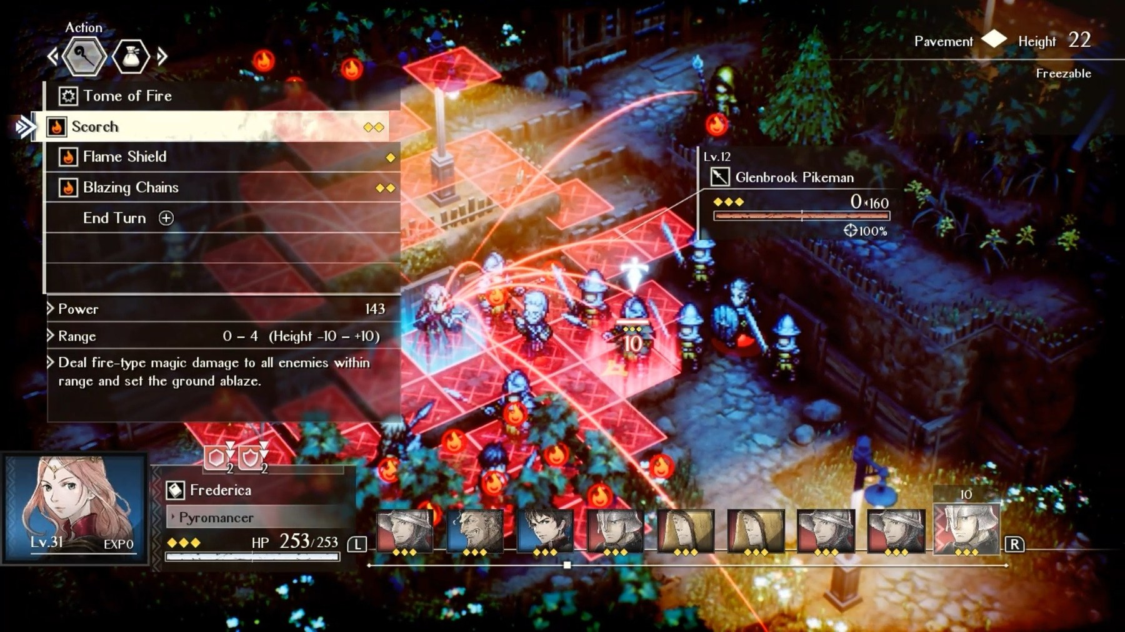
Left: reflective materials and shallow focus create a crafted diorama. Right: overlays, turn order and target lines reassert tactical information when the scene becomes busy. Source: Square Enix / Steam

Graphic features
- Pixel sprites act as deliberately flat graphic marks inside dimensional spaces; the contrast is part of the identity rather than a technical compromise.
- Volumetric light, bloom, reflections and particles make small environments feel materially rich.
- Tilt-shift-like depth of field reinforces the miniature aesthetic and directs attention during scenes and attacks.
- Elevation and surface state matter visibly: stairs, rooftops, water, ice and burning ground are both scenic and tactical.

11 / TRIANGLE STRATEGY

When atmosphere competes with information
HD-2D is strongest when modern effects frame the board. It is weakest when post-processing obscures the pieces.
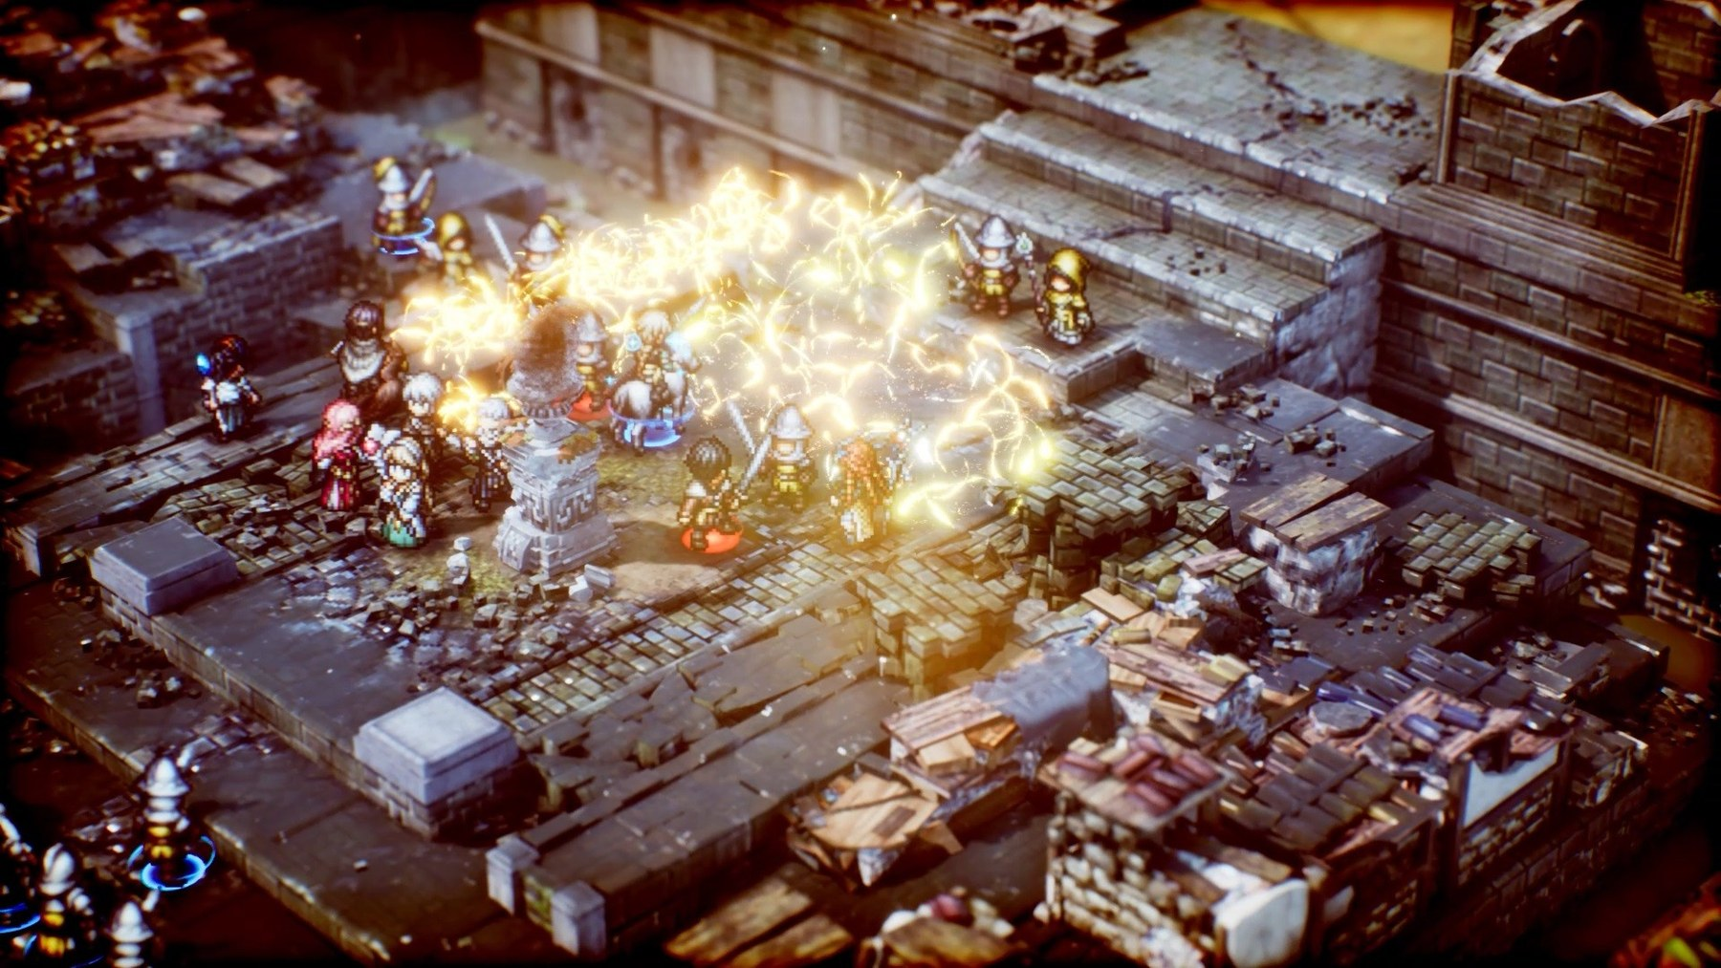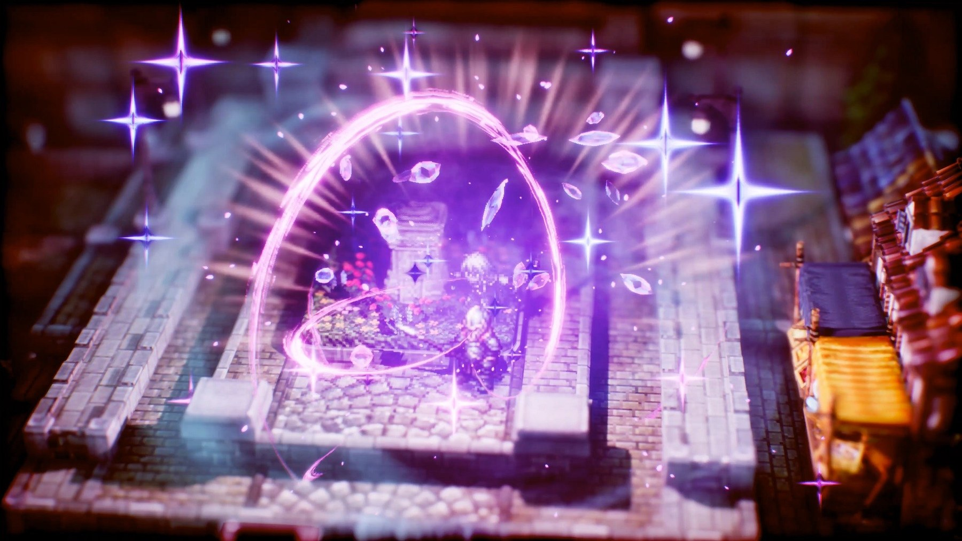
Effects demonstrate the appeal and the danger: spectacular light communicates power, but temporarily hides silhouettes, tile edges and unit count. Source: Square Enix / Steam
Use freely | Use selectively | Avoid in planning state
Material contrast; water motion; edge lights; particles that rise away from tiles | Bloom; vignette; camera shake; screen-space distortion; depth of field | Persistent blur; effects that share enemy-range red; dense particles over occupied cells
Directional shadows that clarify height | Large spell decals and temporary colour grading | High-frequency ground texture beneath text or range overlays
MIREXIS RULE During planning, every occupied tile and legal destination must remain sharp. During resolution, the game may briefly break that rule to sell impact—then restore clarity immediately.

12 / MIREXIS DIRECTION

A readable frontier-biotech hybrid
The art direction should evolve from recognisably human industrial survival toward an unstable mixture of Directorate technology, Brood biology and Ascendant geometry.
Visual layer | Permanent battlefield language | Campaign evolution
Terrain | Large value shapes, clean tile centres, visible edges, height bands | Prefab plates acquire growth, alien inlays, jury-rigged cabling and repaired damage
Units | Distinct silhouettes; faction-coloured base rings; readable facing | Mutations and stolen systems alter silhouette, emissive channel and idle motion
Hazards | Pattern + icon + colour; animated edge; explicit tooltip | Brood spread pulses organically; Ascendant fields use impossible symmetry; Directorate zones scan mechanically
Structures | Readable footprint and roof-fade state | Colony defences visibly reflect what the player built between missions
UI | Neutral dark panels; cyan selection; amber warning; red lethal threat | Faction accents may decorate panels but never redefine core meanings
Effects | Short, directional and state-specific | Late-game hybrid attacks combine incompatible motion languages without covering decision data

Recommended visual target
- Camera: fixed three-quarter or isometric view with a one-button flat tactical mode and automatic roof/foreground fading.
- Characters: high-contrast 2D or low-complexity directional sprites, supported by illustrated portraits and a small number of decisive animation poses.
- Environment: modular dimensional-looking tiles with authored edge clutter; height, cover and destructibility must read before decoration.
- Lighting: restrained industrial base lighting, selective emissive faction colours and high-value flashes only during resolution.
- Identity: ordinary human forms should remain legible underneath increasingly strange equipment and mutation layers.
NORTH STAR At a glance, the player should understand the fight. At a second glance, they should see what the colony has become.

13 / PRODUCTION PLAN

Build the visual hierarchy before the spectacle
A phased asset plan keeps the macroquad/browser implementation focused on what players read most often.
Phase | Deliverables | Acceptance test
1 — Tactical readability | Camera and scale; tile grid; allegiance rings; selection/hover; movement, attack and threat overlays; height/cover icons; colour-blind patterns | A grayscale screenshot still distinguishes units, passable terrain, hazards and current selection.
2 — Character identity | Directional base sprites; portraits; class silhouettes; damage, selection and death poses; equipment attachment rules | Every recruit is recognisable at tactical zoom and in the HUD without reading the name.
3 — Faction motion language | Directorate scan/beam effects; Brood organic pulses and spread; Ascendant geometric distortion; consistent impact timing | Effects identify their source faction in silhouette or motion before colour is considered.
4 — Colony evolution | Modular structure variants; repair states; biome blending; campaign-stage mutation/technology overlays | A defence-map screenshot communicates the player’s strategic choices without opening colony UI.
5 — Selective spectacle | Critical-hit push-ins; major mutation reveals; boss entrances; structure breach effects; end-of-mission tableau | Routine play remains fast; rare moments look materially different and justify the pause.

Practical constraints for Macroquad
- Prefer atlas-based sprites, additive or alpha-blended particles and palette/material channels over a large unique-animation library.
- Keep post-processing optional and conservative; browser performance and legibility should survive its removal.
- Author overlays in screen space so their contrast is stable across biomes, weather and faction lighting.
- Validate at common desktop browser sizes and at the smallest supported tactical zoom, not only in asset close-ups.
FIRST PROTOTYPE One industrial map, three height levels, eight readable unit silhouettes, two hazards and one dramatic critical-hit treatment are enough to validate the complete visual hierarchy.

14 / SOURCES AND METHOD

Screenshot and reference notes
Visual observations are based on publisher-hosted screenshots and official product pages. Release labels identify the versions shown, not every historical release.
- Final Fantasy Tactics — The Ivalice Chronicles official site
- Final Fantasy Tactics — Steam product page and screenshots
- Fire Emblem: The Blazing Blade — Nintendo Switch Online announcement and screenshots
- Fire Emblem Awakening — Nintendo Japan official site
- Fire Emblem Awakening — Nintendo UK product description
- Fire Emblem: Three Houses — Nintendo UK official page
- Fire Emblem Engage — Nintendo UK official page
- Triangle Strategy — Nintendo Australia official page
- Triangle Strategy — Steam product page and screenshots
- Mirexis game design document — Art Direction and Hybrid Colony sections — local project source

Method
The comparison evaluates what is visibly communicated by the screenshots: composition, value grouping, colour hierarchy, character scale, camera, depth, animation staging, effects and interface layering. Recommendations are design inferences for Mirexis, not claims about the cited developers’ internal production methods.
USAGE NOTE Screenshots remain the property of their respective publishers and are reproduced here for internal comparative research and design discussion.

