**Functional requirements of my site**

Our site is a online-concierge service which purchases products and services for consumers for a fee and ensures their delivery. We only accept payment in Bitcoins. The domain name for the site is mysivana.com.

We do not anticipate lot of interactions with the users on the website. The site will have initial landing page, where they can submit their order. It should have the following pages.

1. Sign-up Page
2. Home
3. Invoice page ( This is not a Static page, but generated by the link)
4. About US -> about us AND In the Press sub pages
5. Contact US
6. FAQ Page
7. How-it-works Page ( initially just an explanation with pictures)
8. Blog (ability for me to Post every day)
9. Admin interface

All the pages should have a header and footer. In the footer, we should have links to Facebook page, Twitter feed, Youtube channel of the company. I will provide the content for all the pages.

**Business process on the site:** The user comes to the site and requests a product or service to delivered to them via the first page. They could ask for flowers delivered to someone, or book hotels or cruise trip . They could also ask for some products to be shipped from say amazon.com or some other website. We assess the cost of delivering this product or service. We send an invoice to the end user showing the cost of delivering this product/service to them, plus an additional $25 concierge fee. We then present this invoice to the user in his user page, after he logs in as well as a link in an email. The amount will be converted on the basis of the last BTC price. Once the user pays the amount in BTC, this will go into a Escrow account(A). After the confirmation of the payment, we will process his order and place the order for his product/service. If a product is shipped we provide the tracking number to the user. If a service is purchased ( like a hotel room) we send a confirmation email of the booking to their email. Once this part is completed, we transfer the amount from an escrow account (A) to another account owned by the company(B). Admin will periodically check to see if the products that were shipped were delivered or not. If they are delivered, we update the order status to 'Delivered'. Once this status is updated, they system should automatically send them another email to confirm the receipt of the product and review their experience. After they complete the review of their experience order status will change to 'Completed'.

Web Pages descriptions:

**Sign-up page:**

1. Users can submit requests without actually signing in. However, once we accept the request we need to have the user login in order to pay invoice. Users cannot pay invoice unless they login.

When a user clicks on Sign-up link, we can give the user 3 options.

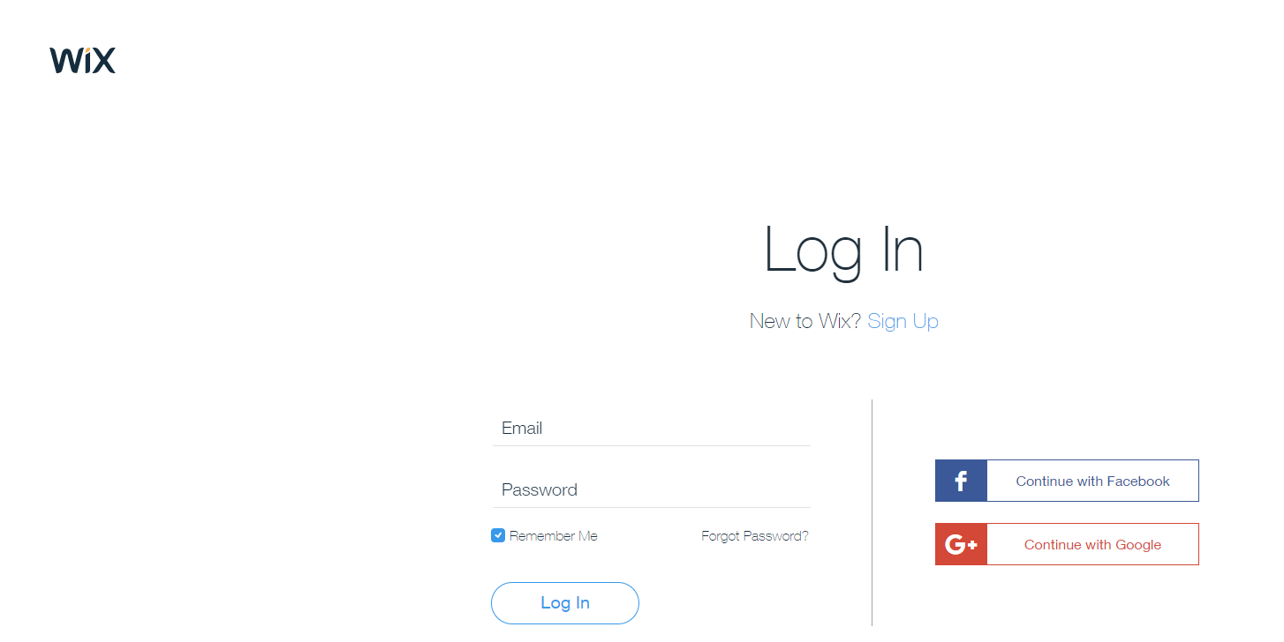

If the user chooses Sign up with email, Show the following screen and send a confirmation email to their email address.

This email confirmation will look as follows:

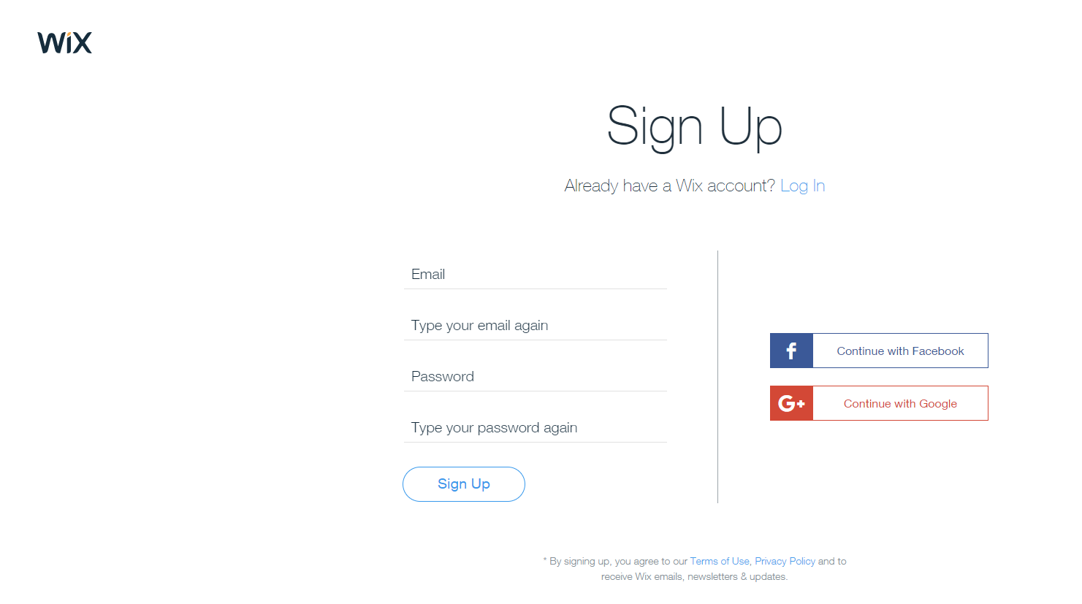

Once the user confirms the account, activate the user. Once the user logs in with the account, we should allow them to enter their shipping address, phone number including the international code, their preferred shipping carrier in their country, Date of birth.

The user will also have a tab called, 'My orders' where he can see the orders that he has already placed and it also shows the status of the past orders. If a order is in the 'Invoiced' state, he should be able to click on it and it should open to 'Invoice' page. This page will show same content as Section 3 that is described below.

Once he opens the order, he will see the BTC amount owed and a QR code and the Wallet address to remit payment.

2. **Home page**: The home page contains the fields for the user to submit an order. This page contains the following fields.

* First name, Last name
* email
* phone number (international code - phone number)
* Order Description
* Attach a file ( we should allow users to provide additional info via documents)
* CAPTCHA ( That says, "I am not a Robot", where the user clicks a small check box)
* Small check box to agree to the terms of the service.

A Big button, that says, "Submit order".

I am not particular about including the CAPTCHA if it takes lot of effort to build this functionality. It is optional. I will be ok, even if the CAPTCHA button is not included. Once the "Submit Order' button is submitted, I should receive an email to admin inbox which generates a order number and sends the confirmation email to the user.

If the user has not logged in, and his email is not yet confirmed, send a email to confirm that he really put this request in. After the confirmation of the email, the order status will change from Initial to Confirmed.

The 'order status' from the user will go through these stages, once an order number is created.

1. Initial (when the order was submitted)
2. Confirmed ( when the order was confirmed by the user via email)
3. Accepted ( if the admin accepts the order based on our assessment)
4. Rejected ( if the admin rejects the initial order based on our assessment)
5. Invoiced ( once we send the invoice to the user)
6. Paid ( once we receive payment confirmation in BTC from our payment processor like Blockchain.info website)
7. Processed ( once we place the order, site admin changes the state)
8. Delivered ( Product shipment was completed based on the tracking)
9. Feedback (customer feedback received)
10. Completed ( Order process is completed)
11. Refund (Customer requests refund)

Once the order is received, show a message to user to check their email and confirm the order.

The email confirmation will look as follows:

Send an email in this format.

**We've received your order!**

Thank you for order at mysivana.com! Your order #1173 has been successfully received to us. We are preparing its invoice you'll receive it within 24 hours in your mysivana account. Payment invoice includes cost of item, shipping cost and payment details.

**Your order number is #1173**

We'll also notify you on this email when it will be ready! So stay tuned

3. Invoice Page:

This is not a static page that exists on webpage. It is generated based on the order number. Once the admin accepts the order, they will have a interface to enter the cost of the product(s), shipping charges, delivery charges, concierge fee in the admin interface for that order. There is a line item for each product requested by the user. Admin will enter product description, quantity, price, total price for each item. Admin will also indicate whether the order is for product or service (like hotel booking). The system will show a page, all the product descriptions, qty, price, including shipping charges, delivery charges and concierge fees on the screen. It converts the total price into BTC. It will also indicate the bitcoin address of our site in order to complete the payment. We intend to use the wallet from www.blockchain.info.

https://blockchain.info/api/api_receive

another company we are considering is using www.bitpay.com.

Once this invoice is sent, order status should be set to 'invoiced'.

**4. About us page:**

This page should link us to About us and In the news sub pages. It can be simple as shown on wix. com site. I will provide the content. Only two pages needed

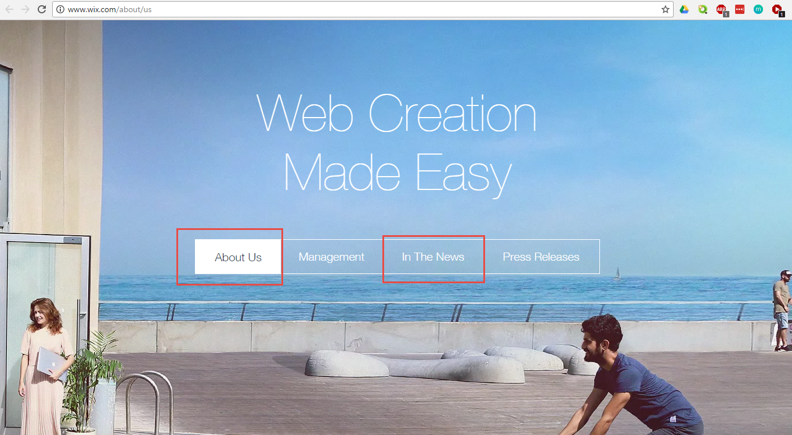

**5. Contact US:**

This section allows users to send us email. All email should be sent to 'info@mysivana.com' email. Good idea to include CAPTCHA that says, 'I am not a robot".

For phone number, show the site number is (813)333-1747.

Our business address is 7028 West Waters Av Suite 145, Tampa, FL 33634

**6. FAQ Page:**

It will be divided into sections with various questions and answers. I like to keep the layout simple with lot of white background. It would be nice to have a search feature. But if it is too difficult, it is not necessary. One sample, I like is the 99designs website, which looks as follows.

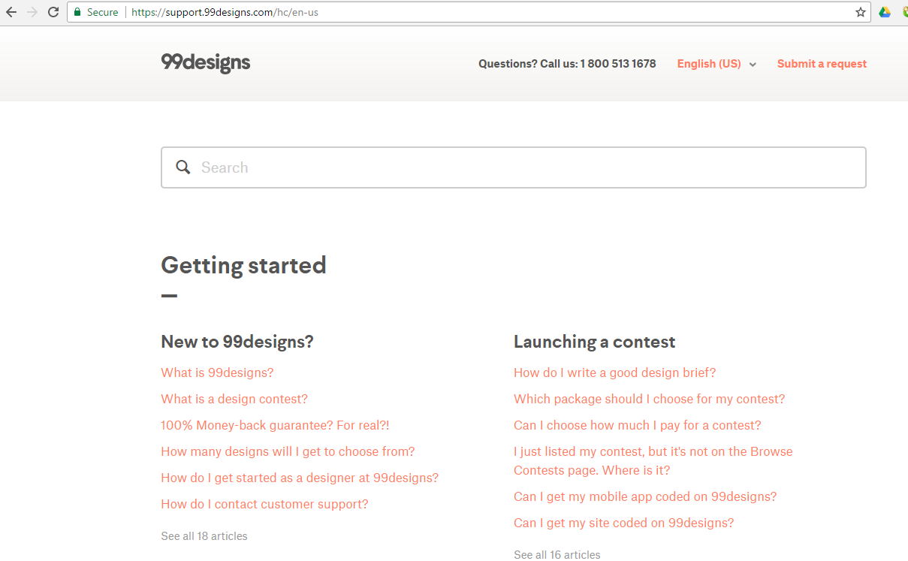

For phone number, show the site number is (813)333-1747.

**7. How-it-works page:**

We describe the 4 steps in our functional flow. We attach icons to each step with an arrow connecting these icons. We should have description below each icon.

1. You submit the product/service request

2.We assess your order and then send you a payment invoice to your account

3. You pay the amount according to the invoice

4. After we receive the payment, we will place an order for your product or service.

There should be a placeholder on this page to include a video later.

**8. Blog page**

It is section for me to post blog items via Wordpress. I currently use Hostgator. Wordpress plug-in is already installed.

**9. Admin interface**

This is the big portion of the site development. Most of the functionality happens via back-end interface. We should have two sections. One relates to Customers and second is about Orders. As admin I like to see the following functionality as part of this section.

Orders Section:

* ability to sort orders by Date
* Filter orders by the status.
* Change the status of the order
* Enter the components of invoice for a order ( This includes product description, qty, price, total price, shipping, delivery charges, concierge fees etc)
* see the full description of the order that was entered by the user on the first page
* Once the product is delivered admin should be able to update the tracking number of the product, which should flow through to the user. In other words, when user logs in and checks his orders from his User profile, he should see the status of his orders as well as the tracking number and the name of the shipping company ( Like Fedex and 1284662002 ) against the corresponding order.
* ability to run reports that show the total sales for a given day or for a month

Customer Section

* we should have a full list of Users, their phone numbers and all the orders placed by them.
* User in their own 'My Account' page should be able to see their orders and it should match what we see in the Admin side.

The exact interface is left for you to design.

If you are going to bid on this project, I would like you to answer these 3 questions in your reply.

1. In how many projects did you use PHP?
2. In how many projects did you work on bitcoin payment integration?
3. Describe the most challenging project you worked on? What have you done to differently to successfully complete this project?