Rebooting the Web of Trust
A WHITE PAPER FROM RWOT XI: THE HAGUE
Verifiable Issuers & Verifiers Enabling anyone to share information about the Issuers and Verifiers for whom they assure trust
by Manu Sporny, Oskar van Deventer, Isaac Henderson Johnson Jeyakumar, Shigeya Suzuki, Konstantin Tsabolov, Line Kofoed, Rieks Joosten
Designing the Future of Decentralized Self-sovereign Identity

RWOT XI Gold Sponsors:

Abstract
This work focuses on how a party or its agent can decide whether or not to engage with a counterparty in a transaction. The purpose of this work is to enable the sharing of a list of Verifiable Issuers and Verifiers in a way that is useful to a particular transaction. A set of use cases provide examples where verification of an Issuer (“Is that diploma from a recognized university?”) or Verifier (“Should the wallet block an unauthorized Verifier?”) is needed. The studied prior art highlights various solutions to verify Issuers and Verifiers and identifies a lack of standards. Important contributions from this paper include a unified set of requirements, a data model, and multiple serializations of the data model — including but not limited to Verifiable Credentials, DNSSEC, and blockchain-based serializations — that could then be incubated and sent onto the standards track at global standards setting organizations.

1. Introduction

1.1 General
The maintenance of lists of Verifiable Issuers, sometimes referred to as Trusted Registries, is a well-known concept from the pre-internet age. Whenever there is a diploma signed by a university, there are people and organizations that keep track of what universities exist and what methods can be used to confirm the authenticity of that diploma. A list could be maintained by HR staff for the purpose of hiring personnel based on qualifications asserted by particular Verifiable Issuers, and the governance of that list would be minimal. Another list could be maintained by a government, associated with well-governed accreditation procedures, for the purpose of assuring that a diploma represents a proper education. Lists of Verifiable Issuers support Verifiers in their decision to trust the Issuer of a Verifiable Credential that is presented by a Holder.
Digitally sharing lists of Verifiable Issuers and Verifiers is a relatively new concept. The list of parties that are allowed to use the digital fingerprint information on the chip of RFID-based digital passports is one example. This is cryptographically enforced: “chip-says-no” when an unauthorized party attempts to access this information on the chip. Also eIDAS v2 will have a Verifiable-Verifiers List that limits the access of Verifiers to credentials in a EUDI (EUropean Digital Identity) wallet. Verifiable-Verifiers Lists support Holders and holder implementations in their decision to trust a Verifier to share a Verifiable Presentation to that Verifier.
Lists of Verifiable Issuers and Verifiers help to automate the decision process of whether to engage with a counterparty in a transaction and make it more auditable by ensuring that software can note that a party was on a list before engaging with them. This paper contains the following sections that provide background on the problem space as well as a proposed set of solutions given the current state of the market:
- Section 2 presents a set of use cases in the digital age that explain the use of lists of Verifiable Issuers and Verifiers.
- Section 3 analyses prior art such as lists of Verifiable Issuers and Verifiers that have already been deployed, or that are being developed, as well as a gap analysis of the current solutions and desired outcomes.
- Section 4 highlights the unified requirements derived from the analysis of prior art and a conceptual model for sharing lists of Verifiable Issuers and Verifiers and the format of the entries in the list.
- Section 5 provides a concrete data model and possible serializations, which could serve as a starting point for future standardization.
- Section 6 discusses possible next steps towards future standardization.
- Section 7 concludes the paper and proposes future work.
The target audience of this paper is people that know the basics of Self-Sovereign Identity (SSI) such as the concepts of Issuer, Holder, Verifier, and Verifiable Credential. SSI developers may use this document as input and inspiration for their code and other products. Deployers of SSI use cases may use this document in the specification process of their deployment.

1.2 Terminology
This section defines key terminology used throughout this paper with references to W3C terminology.
Credential
A set of one or more claims made by an issuer. A verifiable credential is a tamper-evident credential that has authorship that can be cryptographically verified. Verifiable credentials can be used to build verifiable presentations, which can also be cryptographically verified. The claims in a credential can be about different subjects.
Electronic Identification, Authentication and Trust Services (eIDAS)
eIDAS (electronic IDentification, Authentication and trust Services) is an EU regulation on electronic identification and trust services for electronic transactions in the European Single Market. It was established in EU Regulation 910/2014 of 23 July 2014. All organizations delivering public digital services in an EU member state must recognize electronic identification from all EU member states from September 29, 2018.
European Digital Identity (EUDI)
The European Digital Identity is based on a European Commission document called “European Digital Identity Architecture and Reference Framework” that has established the functional and architectural requirements for an upcoming European Digital Identity Wallet.
Holder
A role an entity might perform by possessing one or more verifiable credentials and generating presentations from them. A holder is usually, but not always, a subject of the verifiable credentials they are holding. Holders store their credentials in credential repositories.
Issuer
A role an entity can perform by asserting claims about one or more subjects, creating a verifiable credential from these claims, and transmitting the verifiable credential to a holder.
Level of Assurance (LoA)
The degree of certainty that a relying party can have about the true identity of someone presenting an identity credential. Four levels of assurance were outlined by a 2006 document from the US National Institute of Standards and Technology (NIST 800-63). The level of assurance is measured by the strength and rigor of the identity proofing process, the strength of the token used to authenticate the identity claim, and the management processes the identity provider applies to it.
Sharing
The act of transferring information from one party to another. This paper uses the word "sharing" instead of "publishing" as the latter presumes a one-way and public transfer of information. The Verifiable Issuer/Verifier lists described in this paper are made available in some form or other. They might be pushed to a party or pulled from a party and might use a public communication channel or a private one.
Verifiable Issuer / Verifiable Verifier
A party that is verifiable might have different levels of trustworthiness associated with it by different parties. Note that “trusted” or “authorized” are sometimes used as synonyms for “verifiable”, as the purpose of some lists is to assure trust or authority. This paper uses the word “verifiable” as no presumption should be made about the application of the lists, or the trust/authority that they assure.
Verifiable Issuer/Verifier List
A container that consists of a set of Verifiable Issuers or Verifiers. The word “list” can be considered synonymous to “register”, depending on the amount of governance, assurances and authority associated with it. This paper uses the word “list” and presumes there will always be some form of governance, if only the establishment of its purpose and the format of its entries.
Verifier
A role an entity performs by receiving one or more verifiable credentials, optionally inside a verifiable presentation for processing. Other specifications might refer to this concept as a relying party.

1.3 Criteria
This section contains criteria that can be used to determine whether something does or does not fit a particular terminological definition in the previous section.

sharing
- Enables other parties to obtain a copy of a list entry about an Issuer or Verifier from the list, e.g. in VC format, through DNS query, or other mechanism.
- May or may not enable others to obtain a copy of the full contents of a list.
- Those others may be anyone in the world, or they may be only those who have access to the list or to a specific entry about an Issuer or Verifier.

list
- Contains zero-or-more entries about any party.
- A list entry contains data about one specific party. The data is specified by the party that governs the list.
- A list is associated with a policy containing one or more criteria that are used to determine whether or not a party qualifies for being registered in the list. Criterion may distinguish between parties, e.g., between parties that are trusted to issue or verify VCs of a specific kind.
- Other parties may use the data in a list entry as the basis for a decision, e.g., to share further information, or to engage in a transaction. The perceived use of list entries by other parties should guide the party that governs the list as it specifies the structure of list entries.

parties
- Are expected to perform the roles of issuer, holder, and verifier as well as other verifiable-credential-related roles (e.g., revocator).
- May or may not be a legal authority.
- The party that manages the list has to be able to precisely describe the thing that the list entry enables because software will act upon that machine-readable description. For example, "Issues Student ID cards for University X".

2. Use Cases
This section outlines use cases that highlight the need for the technology described in this paper by discussing the use cases in two categories:
- Verifiable Issuers
- Verifiable Verifiers
A final use case section then checks for commonalities and differences between the two categories
There are a number of other locations that have published use cases that are related to this paper. Rather than include those use cases in this document, they are included by reference:
- Authorized Issuer List Use Cases
- ESSIF-Lab Trust Management Infrastructure (TRAIN) Business Case

2.1 Verifiable Issuer Use Cases
- Acme Inc. is a producer of medical equipment. Twin Mountains Hospital decided to buy equipment from Acme Inc. The law says that medical equipment should be certified by a 3rd party certification body. Twin Mountains Hospital requests a certification from Acme, Inc.; Twin Mountains Hospital delivers it to them. The hospital then checks if Acme Inc. is in the Verifiable Issuer List of licensed 3rd party certification bodies to see if the Issuer of Acme Inc.'s certification is an approved certification body.
  - Note: The solution might need to convey a single item in a List vs. the entire List.
  - Note: Many similar certification/license use cases are out there.
- Walmay, Inc. is a wholesaler of drugs. John & Jane is a manufacturer of drugs. Walmay, Inc. finds out that a lot of Adenosine Triphosphate drugs has broken packaging and decides to return the lot to the manufacturer. It is required that all interactions in the drug market must be done only between authorized trading partners. John & Jane requests an authorized trading partner certificate from Walmay Inc. The certificate credential contains a link to the Issuer. John & Jane then verifies that the Issuer is a member of the Verifiable-Issuer List of Issuers authorized to issue ATP (Authorized Trading Partner) credentials.
- Elena is an IT Administrator in the hiring department of a mid-size company that would like to vet job applicants as having received their degrees from an accredited college or university. Elena configures their hiring software to refer to multiple lists (Verifiable-Issuer Lists) containing several hundred organizations that are curated by the various accreditation bodies that they trust.

- Line is elected treasurer of a Dutch church. In her role as treasurer, she goes online to open a bank account for the church. To comply with certain laws and adhere to internal risk mitigating policies, the bank needs to verify that Line has been authorized by the church to sign on its behalf. For companies, personal information about executive board members is registered by the Chamber of Commerce alongside the registration of the legal entity. However, due to the special sensitive nature of data regarding religious affiliations, the Chamber of Commerce in the case of religious institutions (mosque/synagogue/church) is prohibited from registering any data that can be correlated with a natural person. Instead of checking the Chamber of Commerce public register, the bank requests a credential from Line stating her mandate to sign, which she received from the church. The bank checks whether the church is on the Verifiable Issuer-List of Churches, which is maintained by the Chamber of Commerce. Finding the church on the list, the bank is now able to open a bank account for the church, which Line can administer.
Figure 1: A Verifiable-Issuer List helps verifying whether a diploma is genuine.

2.2 Verifiable Verifier Use Cases
See also Verify the Verifier - Anti-coercion by Design; October 2020 | TNO
- Yuri has a digital driver's license and is attempting to rent a car from CarMart. CarMart requests to see Yuri's age, motor vehicle class, and driver's license number. Yuri's software checks against a Verifiable-Verifier List to make sure that CarMart is a Verifiable authority for information of that type, so it can warn Yuri if CarMart isn't trusted to request that information from Yuri.
- Oskar joins a tennis club. The tennis club requests a government-issued proof of birth date. However, the tennis club does not have authorization to ask for this personal information. As a consequence, Oskar’s certified EUDI wallet refuses to present the information, based on the absence of the tennis club in the relevant Verifiable-Verifier List. The tennis club realizes that they cannot obtain this high-LoA information from the EUDI wallet and instead accepts a self-asserted date-of-birth by Oskar.
- Oskar was invited by the European Commission to become an evaluator. Even though Oskar would be paid only the equivalent of a book voucher, the EC requires a full contracting process, which includes an eIDAS LoA high identification and a recent authentic bank statement. Even though Oskar considers these requirements unreasonable, Oskar’s certified EUDI wallet accepts the request, as the EC is registered in the relevant Verifiable-Verifier List. This way, Oskar knows at least that the request is genuine, and that there exists a sufficiently-well-governed policy associated with the request.
- Oskar crosses the border to Dystopia. Immigration requests that Oskar surrender all Verifiable Credentials in his SSI wallet, including identification, driver’s license, diplomas, certifications and other records. Immigration of this country is not authorized to make such a wide request, as it is not included in the relevant Verifiable-Verifier List. As a consequence, Oskar’s certified EUDI wallet refuses to present this information. Even the threat of denial-of-entry or worse cannot change the situation, as neither immigration nor Oskar himself is physically able to compromise Oskar’s EUDI wallet to surrender the information.
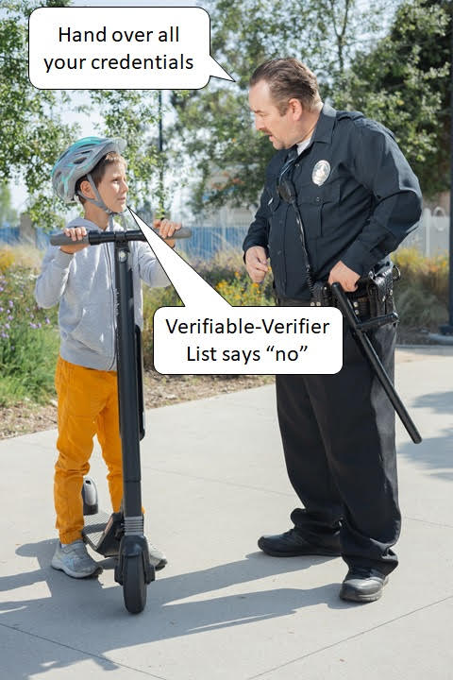
Figure 2: A properly-implemented wallet with Verifiable-Verifier List protects citizens against overzealous law enforcement.

2.3 Commonalities and Differences
Conceptually and technically, the two types of lists (Verifiable Issuer, Verifiable Verifier) are fairly similar. Each type is a governed list of parties with a role in SSI exchanges. Each type needs to provide some form of sharing (publication/access), so that the list is available to its users. This paper will presume that the types of lists themselves, as well as their sharing methods, can be technically identical. The only distinction is that a list could contain only Verifiable Issuers, only Verifiable Verifiers, or a mixture of both, so the data model should accommodate this.
Major differences arise in the applications surrounding the lists. Verifiable Issuer lists target Verifier implementations, whereas Verifiable Verifier lists target Holder (digital wallet) implementations. Also there may be major differences in the governance between the two types of lists, or whether/how the consulting of lists is implemented and enforced. All of these differences are out of the scope of this paper.

3. Analysis of Prior Art

3.1 Historic Perspective of lists of Verifiable Issuers and Verifiers
Verifiable Issuer lists pre-date the digital age. Governments have always maintained lists of organizations with accreditation. This includes educational accreditation (schools, universities), bank accreditations, and telecom-operator licenses. A chamber-of-commerce typically maintains a queryable register of companies. Many of those lists have become queryable via an electronic Application Programming Interface (API).
Verifiable-Verifier lists could be introduced in the digital age, ensuring that only authorized parties could access specific sensitive data. An example of this is the Extended Access Control of European biometric passport chips.
This example, as well as several other existing Verifiable-Issuer/Verifier Lists and technologies for these are described in the remainder of this section. Note that, as highlighted in the terminology section, different prior art uses different terminology, e.g., “trusted” or “register.”

3.2 EBSI Trusted Issuer Registry
EBSI, the European Blockchain Service Infrastructure, is a joint initiative from the European Commission and the European Blockchain Partnership. See also
https://api.preprod.ebsi.eu/docs/apis/trusted-apps-registry/latest#/
One of the services offered by EBSI is a Trusted Issuers Registry (TIR). The TIR is a generic decentralized registry holding information about trusted Issuers such as public information, accreditations, and other data. The TIR enables a Verifier to validate the identity and accreditations of Trusted Issuers. The TIR is an Ethereum smart contract that is deployed on the permissioned EBSI ledger for the purpose of being public while at the same time ensuring a high level of trust and transparency. The public smart contract methods are exposed via APIs: JSON-RPC for write operations and REST for read operations. The API of the EBSI TIR is published at https://api.preprod.ebsi.eu/docs/apis/trusted-Issuers-registry/latest#/. The authors could not find any public information about the governance of the TIR, e.g. how an organization could get itself registered on the EBSI TIR. The EBSI documentation states: “Accreditation of trusted Issuers domain-specific and is outside the EBSI scope”.
The authors asked EBSI about Trusted Verifier Registry, and got the following response: “At this moment, EBSI does not have a Verifier Register as the Use Cases we are currently working on don't require one. This means that Verifiers are not onboarded and they are not accredited either – in the sense of the accreditation given to Issuers. If needed be, we could replicate the Issuers’ trust model and apply it to Verifiers. However, before doing this, we would need to have a requirement from a Use Case.”

3.3 Biometric passport chip
Certain passports have a chip that stores biometric information (facial image and fingerprints). See https://home-affairs.ec.europa.eu/policies/schengen-borders-and-visa/document-security_en
The chip is cryptographically secured. Only authorized chip readers can read and verify the fingerprint information. This is enforced through technology and governance processes that include a VerifiableVerifier List. The so-called Extended Access Control (EAC), https://www.icao.int/Security/FAL/PKD/BVRT/Pages/Document-readers.aspx, is used to protect biometric data (fingerprint or iris) on the chip of the ePassport. EAC is used by states in the European Union and the Schengen-Area that wish to be able to share biometrics with other States. This is achieved through a more complex cryptographic infrastructure than is found in BAC/SAC and also implies an additional Public Key Infrastructure for its Verifiable-Verifier List.

3.4 Gaia-X trust registry
Gaia-X is a framework for European federated cloud infrastructure (https://docs.gaia-x.eu/framework/) within which many parties provide cloud-related federation services. Gaia-X includes Gaia-X Lab Registry, where one can verify the validity of signed claims (e.g., self descriptions) by checking the provided certificates against Gaia-X endorsed Trust Anchor certificates: see https://gitlab.com/gaia-x/lab/compliance. Gaia-X provides open-souce code for a personal credential manager (mobile wallet) and an organizational credential manager (https://gitlab.com/gaia-x/data-infrastructure-federation-services). Gaia-X also provides an associated Trust Framework (https://compliance.gaia-x.eu/).

3.5 eSSIF-Lab TRAIN

3.5.1 TRAIN (TRust mAnagement INfrastructure)
Fraunhofer IAO, a German Research Institute based in Stuttgart, Germany, has developed TRAIN (TRust mAnagement INfrastructure), which provides an infrastructure that allows to verify the trustworthiness of involved parties in an SSI Ecosystem. An example would be if a certain Issuer is trustworthy (e.g. is it a real bank or just a fake bank).
TRAIN aims to add a trust-component to an SSI ecosystem. This component enables the discovery and verification of lists of trustable parties in the ecosystems (Trust Registries), as well as the definition, consideration, and verification of eIDAS compliance (including LoAs) of involved parties. TRAIN provides a decentralized framework for the publication and querying of trust information. It makes use of the Internet Domain Name System (DNS, DNSSEC) with its existing global infrastructure, organization, governance and security standards to establish the trust discovery process.

3.5.2 Interoperability using ETSI Trust List
TRAIN leverages the European Telecommunications Standards Institute (ETSI) Technical Standard (TS) 119 612 [ETSI] for Trust Lists to facilitate interoperability and adoption. This standard is already in productive use for eIDAS Trust Lists for the identification and verification of Qualified Trust Service Providers (QTSP). eIDAS Trust List compiles different accredited Trust Service Providers along with their services in a machine-readable form. For the SSI ecosystem the Trust Service Providers’ equivalent will be trustable (according to the rules and accreditation processes of the respective Trust Scheme/Trust Framework) entities who operate as Issuers, Holders, and Verifiers. Entities and services can vary according to the respective requirements and application domains of a certain Trust Scheme. For example: a State authority can be a Trust Service Provider who offers different services like National identity credential issuance, social security number issuance, etc. These different services details are made available through TRAIN Trust Lists in a machine-readable form. Thereby other entities are able to verify the trustworthiness of these entities [TRAIN].

3.5.3 TRAIN Outcomes
An illustrative interoperability use case for the European Health Insurance Card (EHIC) has been realized and demonstrated with SICPA SA and Validated ID [TRUST]. The latest draft of OpenID Connect for Verifiable Presentations (OIDC4VC)[OPENID] contains informative implementation guidelines describing how Issuers, Holders, and Verifiers can utilize the TRAIN trust scheme approach. The TRAIN approach was also used to develop a Proof of Concept (PoC) for Global Covid Certificate Network (GCCN), an initiative by Linux Foundation for Public Health (LPFH) to identify the trustworthiness of Covid Credentials on a global scale[GCCN].

3.6 Ethereum-based

3.6.1 General
Spherity GmbH (https://www.spherity.com/), a German company, is working on a solution named CARO (https://www.caro.vc/), which enables trading partners in the US pharmaceutical industry to verify the Authorized Trading Partner (ATP) status of their business partners. During the verification process an ATP should check if the Issuer of the counterparty Verifiable Credential was issued by a trusted Issuer.
The implementation (https://github.com/Open-Credentialing-Initiative/trusted-Issuer-registry) implies the storage of the DIDs of trusted Issuers in a smart contract on the Ethereum blockchain. The application then makes a request to Ethereum in order to get the list of trusted Issuers and check if the party of interest is in the list.
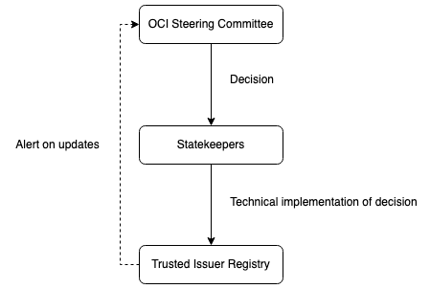
The governance of the list of trusted Issuers is done by Open Credentialing Initiative (https://open-credentialing-initiative.github.io/OCI-Governance/#trusted-issuer-registry-governance), who maintains a Trusted Issuer Registry. To this end, it employs an Ethereum smart contract managed by so-called Statekeepers. They execute the Steering Committee’s decisions concerning the Trusted Issuer Registry and report to the Steering Committee.
Figure 3: Maintaining an Ethereum-based Trusted Issuer Registry.
The approach aims to enforce the following policies:
- Always available
  - Calling the verifiable authorities list is an integral element in the verification of a counterparty identity or/and credentials, so it should be always available.
- Trustless
  - The architecture and the execution of the verifiable authorities list should not be owned and controlled by a single entity.
- Transparent
  - The code, state, and executions of the verifiable authorities list should be transparent to all parties in the ecosystem.
- Auditability
  - It should be possible to retrieve a previous state of the verifiable authorities list.
- Security
  - Changes to the verifiable authorities list should only be made by trusted entities. For this, a governance protocol is defined that relies on strong cryptography enforced by the Ethereum network.
- Privacy
  - Only the changes to the verifiable authorities list are visible (as events in the Ethereum network). Read operations are not recorded in the Ethereum network, so no one can trace if the list was retrieved or the frequency of such operations.

3.6.2 Architecture
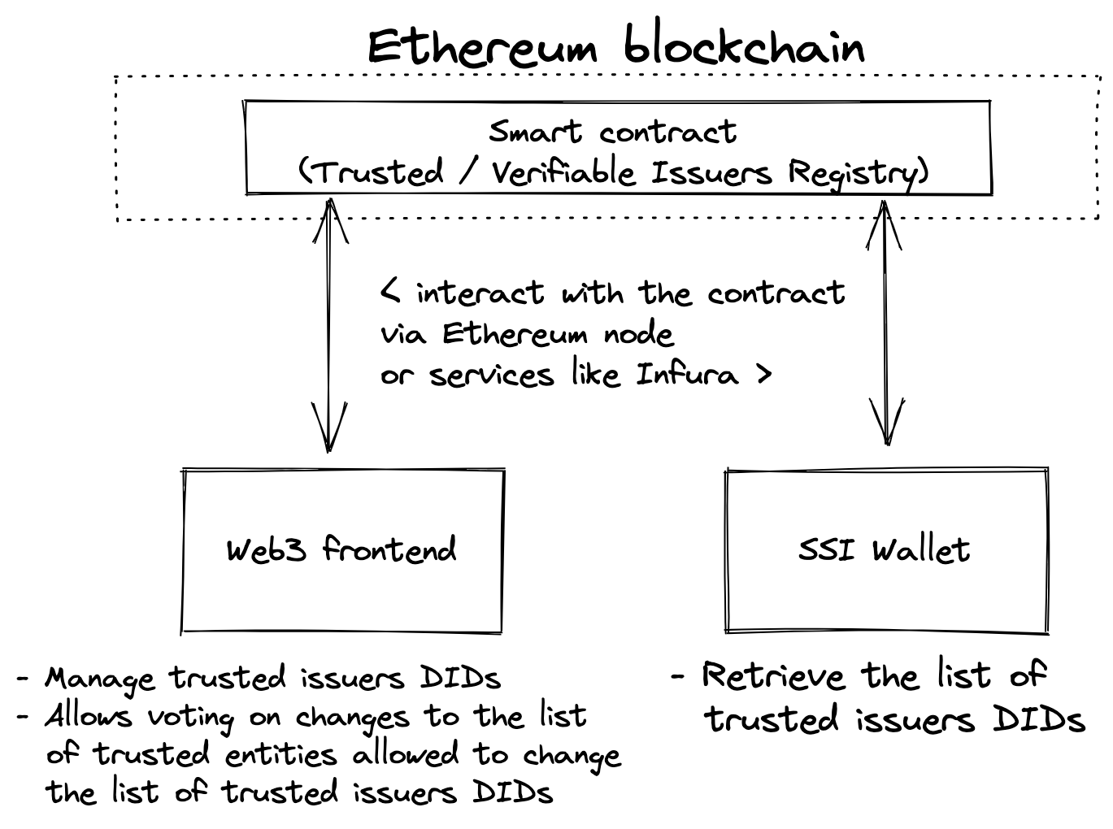
The smart contract containing the trusted Issuer registry is deployed to the Ethereum blockchain and acts as a backend. Its state and methods can be accessed via an Ethereum node, e.g., an OCI-owned one, that exposes all needed RPC methods or by a service such as Infura.
Figure 4: Interacting with the Ethereum blockchain.

3.7 Trust-over-IP Trust Registry Task Force
The Trust Registry Task force of Trust Over IP Foundation (ToIP) attempts to address the requirement of enabling interoperability in order to support transitive trust within and between different trust communities implementing the ToIP stack. In this case, the desired interoperability outcome is a common protocol that works between any number of decentralized peer trust registries operated by independent governing authorities representing multiple legal and business jurisdictions.
In the v1 specification of Trust Registry Protocol the trust registry was planned to include the authorized Issuers/Verifiers. The scope of the specification was restricted to query the current status of the entry in the trust registry. But the definition of other metadata types has been planned for the second version of the specification. And in the current specification the query works based on the REST APIs but it seems to be moved to DIDComm. There is also a swagger API available to describe what the query response looks like.
The specification also contains the details to include TrustService type Property in the DID Document, thereby allowing authorities to configure their trust registries in serviceEndpoint as HTTPS URI. Based on the current specification it seems like the trust registry supports DID serializations but there is not much clarity to accommodate different serializations such as x.509, VC etc.
Trinsic built technology to quickly establish SSI trust registries. This work was performed in NGI eSSIF-Lab: https://gitlab.grnet.gr/essif-lab/infrastructure_3/trinsic. The technology links to Fraunhofer TRAIN, which was also initiated in the eSSIF-Lab context. Both are documents published by the ToIP Foundation.

3.8 Expression as Verifiable Credential
In 2022, an advanced reading paper was submitted to the Rebooting the Web of Trust 11 conference in The Hague, Netherlands. The paper was based on work performed for the US Department of Homeland Security in 2020-2022 related to the publication of lists of authorized issuers for issuing Verifiable Credentials.
The primary focus of the paper was a technical solution that would be compatible with the W3C Verifiable Credentials ecosystem. As such, the paper proposed a data model and serialization format for the lists. An example of a serialized list is shown below:
EXAMPLE: An VerifiableIssuerCredential Verifiable Credential
{
"@context": [
"https://www.w3.org/2018/credentials/v2",
"https://w3id.org/vc/viv/v1"
],
"type": ["VerifiableCredential", "VerifiableIssuerCredential"],
"issuer": "did:web:authority.example",
"validFrom": "2023-02-13T00:18:30.053Z",
"credentialSubject": [{
"id": "did:web:issuer.example",
"type": "AuthorizedIssuer",
"authorizedToIssueCredential": [{
"type": "UniversityDegreeCredential",
"credentialSchema": {
"id": "https://issuer.example/degree.json",
"type": "JsonSchema2022"
}
}, {
"type": "StudentIdCredential",
"credentialSchema": {
"type": "AuthorizedIssuerJsonSchema2022",
"schema": "{\"properties\":\{\"credentialSubject.state\":\"NV\"}}"
}
}]
},
"proof": { ... }
}
The use cases and requirements outlined in the Authorized Issuer List paper have been merged into this paper. The base data model provided in the Authorized Issuer List paper has been analyzed and merged into the TRAIN work described in this paper in a way that the authors believe will be compatible with the ETSI standard (TS 119 612) for Trust Lists.

3.9 Governance of Verifiable-Issuers/Verifiers Lists
Governance of a Verifiable-Issuers/Verifiers List may include the following:
- Policies that determine what requirements Issuers and/or Verifiers need to satisfy and comply with in order to be registered on a Verifiable-Issuers/Verifiers List.
- Policies that determine how one can become a subscriber, and how they may access the List.
- Policies about the business model of the registry.
- Enforcement of these policies, e.g. what happens if an Issuer or Verifier starts violating the policies. Governance is about policies related to subscribers and whether/how they may access the List.
- Policies about how the policies are maintained, and who decides about those policies.
- Policies about the assurance community that governs the List, e.g. how to join or leave the assurance community.
A Verifiable-Issuers/Verifiers List also needs technical policies, which includes decisions about the data model of the List and its serialization. There is a paper which discusses the governance of important small data works [DADCGO]. The discussion of that paper fully applies to the focus of this paper. The rest of this section is an adaptation of the discussion for this paper.
The use of curated lists requires a mechanism to govern the value shared within the ecosystem by such lists in a manner that includes who curates the lists and what the policy for that curation will be, down to who benefits from the lists.
It is well known that using X.509 PKI requires root Certificate Authority certificates (root CA certificates) as the root of trust, and this information is built into each OS and browser as a "Trust Store." Which root CA certificate is included in the Trust Store is fully controlled by the organization that provides the software services depending on the Trust Store included in the software or services. In other words, Trust Stores are governed by operational rules predefined by the controlling authority. Examples of the Trust Store and operational rules include but are not limited to Microsoft [MS], Apple [Apple], Google [Gogle], and Mozilla [Mozilla] products.
Until now, ordinary users have not been aware of such a trust store, but from the perspective of constructing a self-sovereign system, such as the application using Decentralized Identifiers and Verifiable Credentials, it is crucial to understand its nature because it leads to the determination of what to trust. Therefore, it is necessary to fully understand the model of a system such as a trust store and to develop governance mechanisms and policies that are appropriate to the nature of the list.
In this section, we will explain the entities and their relationships and policies that define the management of the list discussed in this document, according to the perspectives described above.
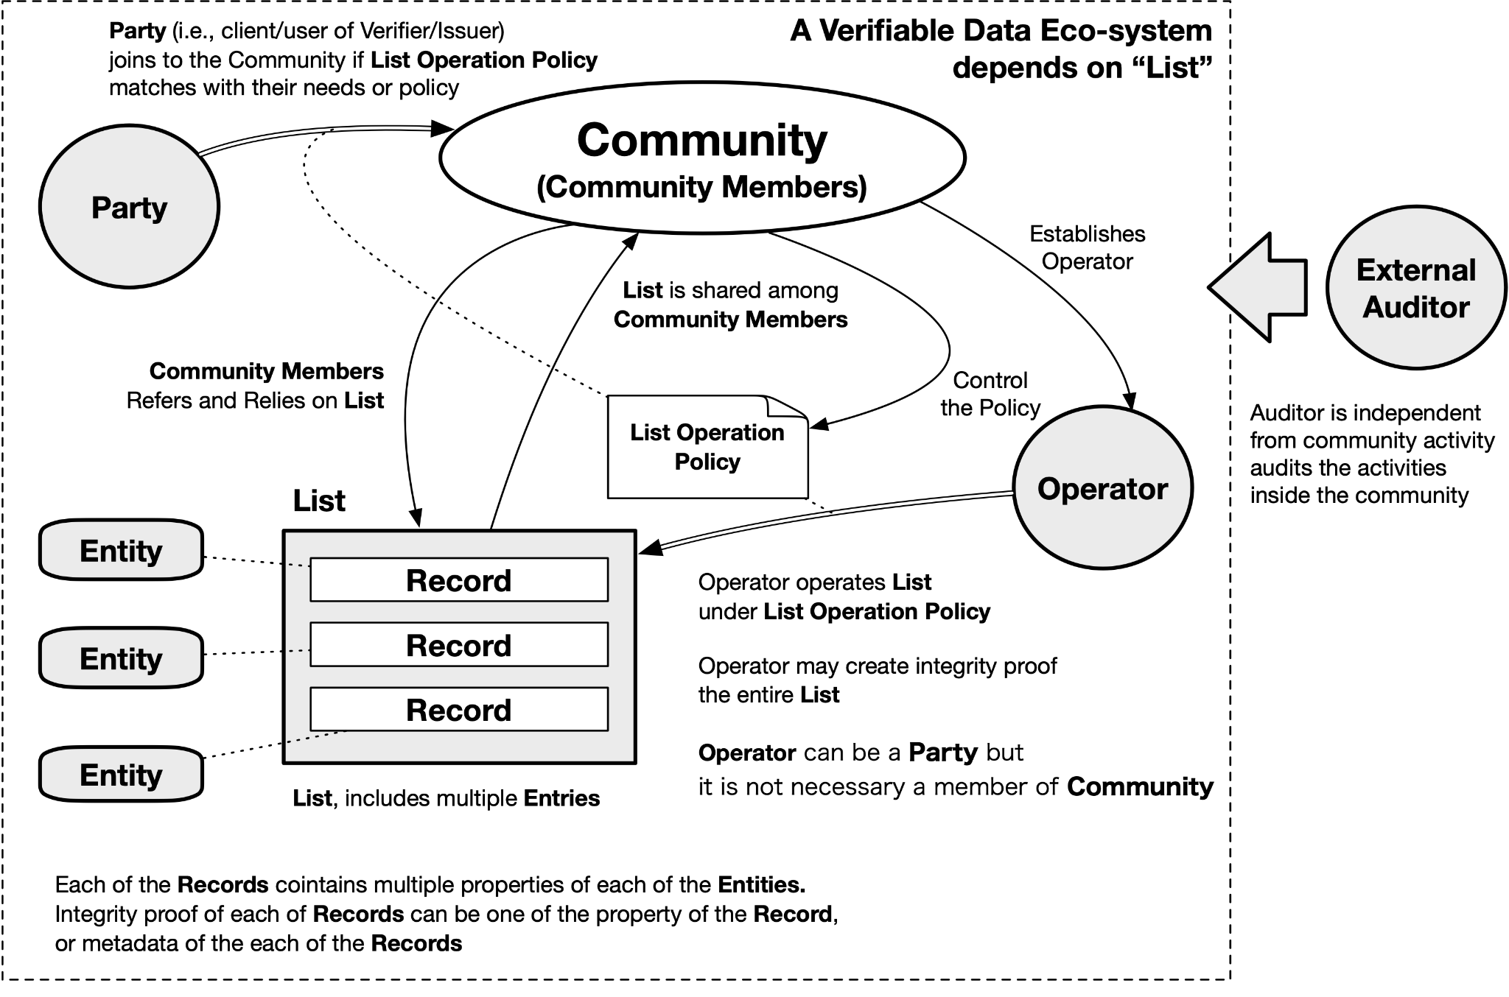
Figure 5: Governance of Verifiable-Issuers/Verifiers Lists.
First, assume a Verifiable Data Eco-System that uses this list together. Then, consider a community with Community Members who have decided to use this list.
It is crucial to note the perspective of whether governance is determined by the community or is external. As a driving principle, we are designing a decentralized system with Self-Sovereignty in mind. Thus, relying on external entities is not desirable. Even if governance is externally constituted, if the community consists of members agreeing to use the external governance, we can treat the external governance as part of the community. From these two perspectives, we can simplify the discussion that the governance mechanism is formed from within the community's perspective. Note that it is also possible to express governance in the form of a governance body within the community, such as ICANN's board of directors, but since this is not relevant to the essence of this discussion, it was omitted for the sake of brevity.
With the above context, the details of each of the entities in terms of the governance contexts are the following:
- A Party can choose whether or not to become a community member.
- To be a community member means to choose to use the list for the list's purpose.
- Leaving the community may be an option if the community member no longer agrees with the established policy.
- The List Operation Policy defines the nature of the list.
- The community member establishes the List Operation Policy establishes an operator, and the operator operates the list according to the List Operation Policy. In other words, the community governs the state of the list by the provisions of the List Operation Policy.
- Each community member refers to and uses the list.
- If needed, an external auditor might be necessary.

3.10 Gap Analysis: Missing Standards and Verifiable Credentials
The discussed prior art shows that, although there exist quite a few implementations of Verifiable-Issuers Lists, and fewer Verifiable-Verifiers Lists, all of them use proprietary APIs to access entries to those lists. This is limiting, as APIs require a “phone-home” API call for every verification, which is inefficient, time-consuming, a potential privacy risk, and impractical in offline scenarios. Moreover, the proprietary nature of the APIs imply significant integration cost for implementations that aim to support multiple lists, and that give users and stakeHolders viable choice and switching possibility between lists.
The proprietary nature of the APIs can be resolved through harmonization and standardization of both the data model and the serialization of Verifiable-Issuers/Verifiers Lists.
The time/efficiency, offline and privacy issues with the API approach can be resolved by including a standardisable serialization based on Verifiable Credentials and/or anonymous credentials (anoncreds).

4. Requirements

4.1 Conceptual Model
An Assurance Community is what governs a list of Verifiable Issuers and/or Verifiers. The community can consist of a single person, a group of people, an organization, a group of organizations, or any other relevant structure. The governing can be purely manual, partially automated, or completely automated through the use of APIs or smart contracts.
A list of Verifiable Issuers and/or Verifiable Verifiers contains entries with information about the Issuers and/or Verifiers that it verifies.This information can be as minimal as a single DID or public key per Verifiable Issuer or Verifiable Verifier, or it can also include metadata about each entity and the services that each entity performs.
An Interested Party is an entity that uses one or more entries from the List of Verifiable Issuers and/or Verifiable Verifiers in a decision making process. An interested party is typically software that is acting on behalf of an Issuer, Holder, or Verifier. The party might request the entire List, or portions of the List over either a public channel, or a private channel.
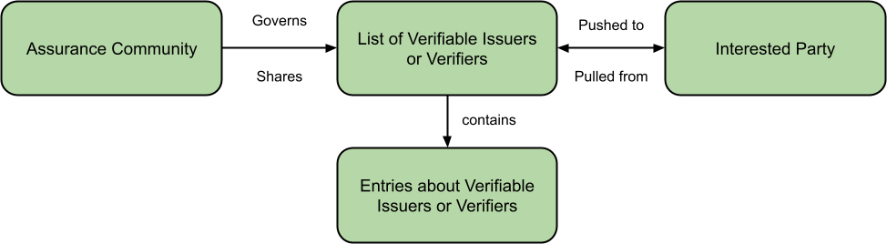
Figure 6: Conceptual model of sharing Lists of Verifiable Issuers and Verifiers.

4.2 Requirements
The following requirements have been specified by the authors. It includes both requirements on a Verifiable-Issuers/Verifiers List (“a list” in short) as a whole and its individual entries. These requirements may be updated in the future.
- A list may be created and governed by any individual, group of individuals, organization, group of organizations, or other.
- A list and/or its entries shall be made available to subscribers.
- A list and/or its individual entries shall be serializable in one or more formats such as a Verifiable Credential.
- Entries may be made available via a Wallet, a Website, a URI, a QR code, a DNS Resource Records, DNSSEC, on-chain Ethereum transactions, or other methods.
- A list and its entries shall be cryptographically verifiable.
  - A list shall accommodate Different cryptographic mechanisms (X.509, JWK etc.).
  - There shall be an ability to authenticate the list or an individual entry.
- A list and its entries shall have associated Governance Metadata Format, including:
  - Policies; and
  - Qualifier details.
- A list and its entries shall be publicly resolvable.
- A list and its entries shall be privately transmittable/retrievable.
- A list may have metadata associated with it, e.g., metadata that is applicable to all of its entries.
- A list may have different levels of privacy/confidentiality, ranging from fully public to for-authorized-yes-only.
- Entries shall be able to be created, read, and deleted.
- Entries may be updated, suspended and/or revoked.
- Entries may have an individual level of assurance associated with it.
- Entries may have an associated level of assurance.

5. Implementations

5.1 General
The following subsections provide a data model for entries to the Verifiable-Issuers/Verifiers List and their serialization and a view on its governance model.

5.2. Data Model(s)
The data model described in this section has been built using input from a variety of the prior art evaluated for this paper including input from the EBSI Trusted Issuer Registry, ETSI TS 119 612, eSSIF-Lab TRAIN, the Trust over IP Foundation Trust Registry Protocol, and Rebooting the Web of Trust input documents. The data model described in this section is capable of expressing many, but not all, of the concepts described in those other specifications.
The unified data model for this work can be represented as a list of entries that represent parties.
Each list entry, representing a party, contains the following mandatory information:
- An identifier
- The type, such as a "VerifiableIssuer" or "VerifiableVerifier"
- A human-readable name
Each list entry, representing a party, might contain the following optional information:
- A legal name
- An associated website
- An email address
- A set of identifiers that specify a human readable name for the property and its corresponding value
- A set of operational schemes, such as a trust scheme, under which it operates, stored as tuples of a URL to the operational scheme and a human-readable name.
- A set of accreditations that are identified by URL
- A set of credentials that the party is authorized to issue, verify, or otherwise process where each credential description MUST contain:
  - A type
  - A credential schema that can be used to match against a Verifiable Credential

5.3 Serialization(s)

5.3.1 Serialization for Smart Contract-enabled environments
The example here is one of many possible ways of maintaining a list on DLTs. This implementation was done for Ethereum blockchain and smart contracts. The example implies that only a portion of the data is actually stored on the ledger.
The minimally reasonable part of data would be a list of identifiers of the trusted/verifiable entities. The rest of the data would be resolved by a service whose duty is to dereference/resolve data and enrich it with data from external data sources including but not limited to databases, distributed ledgers, and 3rd-party APIs.
The following diagram illustrates the high-level architecture of the proposed methodology:
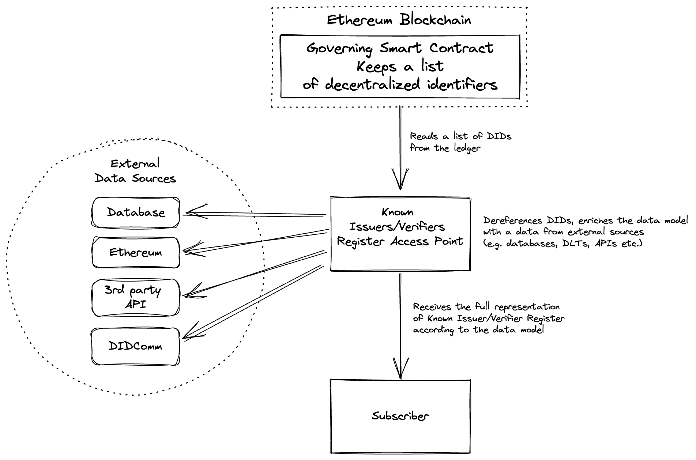
Figure 7: Serialization of Verifiable-Issuers/Verifiers Lists for smart contracts.
EXAMPLE: Response from the smart contract
[
"did:web:weboftrust.info",
"did:ethr:0x0..."
]

EXAMPLE: Minimal response from the List Access Point
[
{
"id": "did:web:weboftrust.info",
"type": "VerifiableIssuer"
},
{
"id": "did:ethr:0x0...",
"type": "VerifiableIssuer"
}
]

EXAMPLE: Rich response from List Access Point
[
{
"id": "did:web:weboftrust.info",
"type": "VerifiableIssuer",
"name": "Utopia University",
"legalName": "The Polytechnic University of Utopia",
"website": "https://utopia.edu.example/",
"email": "accreditation@neaau.org.example",
"identifier": [
{
"type": "PropertyValue",
"propertId": "Utopia Educational Institution ID",
"value": "123456789"
}
],
"usesOperationalScheme": [
{
"id": "http://oid-info.com/get/1.2.3.4.5",
"name": "Utopian Trust Scheme 819-4"
}
],
"accreditation": [
{
"id": "https://utopia.gov.example/accreditations/123"
}
],
"service": [
{
"id": "did:example:123456789",
"name": "University Diploma Service",
"authorizedToIssue": [
{
"type": "UniversityDegreeCredential",
"credentialSchema": {
"id": "https://Issuer.example/degree.json",
"type": "AuthorizedIssuerJsonSchema2022"
}
}
]
},
{
"id": "did:example:abcdefghij",
"name": "University Student Identity Services",
"authorizedToIssue": [
{
"type": "StudentIdCredential",
"credentialSchema": {
"type": "AuthorizedIssuerJsonSchema2022",
"schema": "{\"properties\":\{\"credentialSubject.state\":\"UA\"}}"
}
}
]
}
]
}
]

5.3.2 Verifiable List and Consortium
In this section, as an example of a method for sharing a Verifiable List, we show how DNS/DNSSEC can be combined to publish members of a consortium as Issuers and how the Consortium's rules can govern the list. This section focuses on high-level concepts and does not describe a serialization, which is elaborated upon in the next section.
First, we describe the relationship between the assumed parties, domain names, and labels. A label is a unique name in a domain name within a zone. See [RFC1034], [RFC1035], and [RFC4034] for more information.
- Consortium: A group of members who share a specific purpose. It consists of consortium members. A Consortium establishes and enforces rules for the operation of its members and lists. The Consortium is assumed to be a legal entity; thus, A Consortium is a Party.
- Consortium Member: A Consortium Member is a Party, such as a corporation or an individual. A Party becomes a Consortium Member by agreeing to the consortium rules and registering as a participant.
- Consortium Domain: A Consortium acquires and manages a dedicated domain name for its purpose. Each Consortium uses a different domain name. The zone belonging to the Consortium Domain is DNSSEC signed, and the Consortium manages the keys for the zones under its control. Here, as an example, the domain `Consortium.example` under the `example` top-level domain is used. Note that the `example` top-level domain does not currently exist.
- Member Labels: The Consortium allocates a unique label in the Consortium Domain's zone when a to-be Consortium Member applies for membership. Member Labels are assigned on a preemptive basis.
The above elements allow the relationship between the Consortium and the members to be expressed in the DNS/DNSSEC. Here, a Consortium owns Consortium Domain, a DNS zone bound to the Consortium Domain, and the Consortium manages both the DNS zone and the DNS zone signing key. Therefore, whether an FQDN domain-based issuer is a consortium member can be confirmed by the presence or absence of a member label. This relationship means they constitute a list, and the situation can be achieved where the Consortium enforces governance. Only those participants who agree to the terms of the agreement can participate.
Using this method, as long as the related DNS Resource Records are DNSSEC-verifiable, it is possible to verify whether an Issuer/Verifier belongs to a particular consortium from the FQDN and to derive the Issuer/Verifier's public key and other information. The serialization method is described in another section.
Note there are two ways of assigning DNS Resource Records (RRs) directly to member labels in the zone management of the Consortium Domain or delegating zones to Member Labels and managing the zones by each Consortium Member. These serializations are equivalent from a governance perspective and differ only in the serialization method.

5.3.3 Serialization with DNS using TRAIN

X.509 Certificates
In this approach qualified Domain Name will be used as Identifier of the entity and this will be included in the SubjectAltName attribute of the x.509 certificate. At the Verifier side the SubjectAltName is extracted from the x.509 certificate. The Issuer details can be a HTTPS URI or DID depending on the Issuer. The TRAIN infrastructure offers an API, which acts as a proxy service for trust list discovery and provider verification. The query of the TRAIN API looks as follows. An example of Swagger API can be found in the following link.
{
“Issuer”: “https://universityx.com/2142”,,
“Trust_Scheme_Pointer”: exams.universityx.com
}

Verifiable Credentials
In Verifiable Credentials the qualified Domain Name can be used to specify the trust scheme the provider trusts. For example: If the credential Issuer is issuing a Verifiable Credential, the trust scheme that the Issuer trusts can be included in the termsOfUse property of the VC. An example of how to use termsOfUse property is shown below. This is also published in detail in the following paper entitled “A novel approach to establish trust in verifiable credential issuers in Self-sovereign identity ecosystems using TRAIN”.
"termsOfUse": [{​
"type": "https://train.trust-scheme.de/info",​
"trustScheme": [“example.tso.com”, “ssi.company.uk”]​
}]​

At the Verifier side, the Verifier can fetch Issuer details and call the TRAIN to verify whether the Issuer has been listed in the trust-list that the Verifier trusts. The Source Code for TRAIN Verifier is available in open source as Apache 2.0 License under the following gitlab.

5.3.4 Serialization with DNSSEC and Web
In this section, we describe how to serialize the list into a DNS zone with a DNSSEC.
Prerequisites for serializing to DNSSEC include:
- An FQDN for the list. This FQDN points to a zone. (List Zone)
- The FQDN is at a zone apex.
- The zone is delegated from the parent zone.
- The maintainer of the list has control of the Zone Signing Key.
- An entry label is created for each of the entries.
- An Entry Owner controls the entry that the Entry Owner owns.
There are two options regarding record control delegation. Each of the options provides different controls:
- Adding RRs directly in the zone
  - The List Zone owner has complete control of adding/removing/updating any of the entries.
- Adding NS RR to delegate the control of the zone to another domain name server
  - The List Zone owner has control over adding/removing control of the entry for the entry owner
  - Update of the RRs bound the Entry Label is under the control of the entry owner.
  - Adding/removing/updating additional sub-label is under the control of the entry owner.
There are at least three options regarding the use of key material and metadata serialization:
- Store `did:key` encoded string as URI RR [DID-DNS]
- Store public key as KEY RR, additional materials in TXT RR, or externally on websites [DID-DNSSEC]
- Store DID document as TXT record [DID-DNSTXT]
If the whole entries are expressed as DNS RRs, it is just a simple DNS Zone maintenance. Note that each zone maintainer needs to re-sign in the event of Adding/Removing/Updating RRs. If there are resources externally available via websites, web sites need to be updated.
Following is a Zone Example for `consortium.example.` with option B with option two above. Note: Registration of keys used for non-DNS purposes in the DNS RR is a violation of the convention, and the KEY in the last line must be used in a TXT-based retention method to comply with the current convention. On the other hand, since the use of TXT records is inefficient, a better method may need to be explored.
@ IN SOA consortium.example. admin.consortium.example. (
2022122401 43200 300 3600000 36000 )

IN NS ns1.consortium.example.
IN NS ns2.consortium.example.
IN A 192.168.1.1
ns1 IN A 192.168.1.1
ns2 IN A 192.168.1.2

consortium.example. IN DNSKEY 256 3 8 AwEAA[...janSJw==
consortium.example. IN DNSKEY 257 3 8 AwEAAQ[...]1lHI4Q==
issuer.consortium.example. IN KEY 512 3 8 AwEAAQ[...]f2zRew==

5.3.5 Verifiable Credentials Serialization
The data model described in this section can be expressed as a Verifiable Credential as outlined in the example below:
{
"@context": [
"https://www.w3.org/2018/credentials/v2",
"https://w3id.org/verifiable-party/v1"
],
"issuer": {
"id": "did:web:authority.example",
"name": "National Education Accreditation Authority of Utopia"
},
"issuanceDate": "2023-02-13T00:18:30.053Z",
"type": ["VerifiableCredential", "VerifiablePartyCredential"],
"credentialSubject": [{
"id": "did:web:registrar.utopia.edu.example",
"type": "VerifiableIssuer",
"name": "Utopia University Registrar",
"legalName": "The Polytechnic University of Utopia Registrar",
"website": "https://utopia.edu.example/",
"email": "accreditation@neaau.org.example",
"identifier": [{
"type": "PropertyValue",
"propertyId": "Utopia Educational Institution ID",
"value": "123456789"
}],
"usesOperationalScheme": [{
"id": "http://oid-info.com/get/1.2.3.4.5",
"name": "Utopian Trust Scheme 819-4"
}],
"accreditation": [{
"id": "https://utopia.gov.example/accreditations/123"
}],
"authorizedToIssue": [{
"type": "UniversityDegreeCredential",
"credentialSchema": {
"id": "https://Issuer.example/degree.json",
"type": "AuthorizedIssuerJsonSchema2022",
"schema": "{\"properties\":\{\"credentialSubject.state\":\"UA\"}}"
}
}]
},
"proof": { ... }
}

6. Conclusions and Future Work
This paper identified previous work, use cases, and requirements for the management of Verifiable-Issuer/Verifier Lists. It establishes terminology that can be used to describe ecosystems that use these sorts of lists and proposes a common data model that might be useful across analyzed ecosystems today. Several serialization formats are proposed that could be used in future standardization work.
This paper was introduced for discussion at the 35th meeting of the Internet Identity Workshop. During that workshop, participants noted several deficiencies in the thinking around prior work, as well as this paper, and raised the following questions for further study:
- How does a list maintainer provide revoked DIDs per service?
- How are valid date ranges specified in the data model for specific entries?
- What items in the proposed data model are mandatory vs. optional?
- Are "DO NOT Trust" lists useful? If so, how are they managed?
The authors of this paper suggest that future work might include circulation of this paper among the other communities identified as prior art such that they might provide input into the next iteration of this work. For the data model and Verifiable Credential serialization, the W3C Credentials Community Group would be a good next step to incubate a technical specification that is compatible with the Verifiable Credentials ecosystem. Once incubated, the technical specification could follow the same process that standardized Verifiable Credentials and Decentralized Identifiers. Finally, discussions should be started with digital wallet, Issuer, and Verifier communities, such as within the Education sector, that already utilize paper-based processes and are currently transitioning to digital processes.

Appendix A: References
This section contains complete references to citations made throughout the paper:
[APPLE] Apple PKI. https://www.apple.com/certificateauthority/
[DADCGO] Shigeya Suzuki, Tatsuya Kurosaka, Jun Murai, Keio University, “Dependency among Data, Code, Governance, and Operation in Trust, Symposium on Designing the New Cyber Civilization”, Cyber Civilization Research Center, Keio University, January 2022. https://www.ccrc.keio.ac.jp/wp-content/uploads/2022/02/Suzuki-Kurosaka-Murai-Dependency-among-Data-Code-Governance-and-Operation-in-Trust.pdf.
[DID-DNS] did:dns Method Specification, Markus Sabadello, online https://danubetech.github.io/did-method-dns/ (Accessed 2022/11/8)
[DID-DNSSEC] Proposal on the Design and Implementation of a DID method over DNSSEC (did:dnssec), Shigeya Suzuki, online https://shigeya.github.io/did-dnssec-proposal/main/draft-suzuki-did-dnssec-proposal.html (Accessed 2022/11/8)
[DID-DNSTXT] Proposal for did:dns method specification, Tomislav Markovski, online memorandum https://hackmd.io/OkbxCmKIR7KacHRQqNPyrA?view (Accessed 2022/11/8)
[ETSI] ETSI: Electronic Signatures and Infrastructures (ESI), ‘General Policy Requirements for Trust Service Providers’. ETSI, Sophia Antipois Cedex, France, European Standard ETSI EN 319 401, 2016. Online
[GCCN] ‘Global COVID Certificate Network (GCCN)’, Linux Foundation Public Health, Jan. 12, 2022. https://www.lfph.io/global-covid-certificate-network/ (accessed Jan. 12, 2022).
[Google] Chrome Root Program Policy, Version 1.2 https://www.chromium.org/Home/chromium-security/root-ca-policy/
[Mozilla] https://wiki.mozilla.org/CA
[MS] Program Requirements - Microsoft Trusted Root Program. https://docs.microsoft.com/en-us/security/trusted-root/program-requirements
[MSGI] SUZUKI, Shigeya. MultistakeHolder Governance for the Internet. In: International Conference on Financial Cryptography and Data Security. Springer, Cham, 2020. p. 230-241. Online: https://link.springer.com/chapter/10.1007/978-3-030-54455-3_17
[OPENID] ‘OpenID Connect for Verifiable Presentations’. https://openid.net/specs/openid-connect-4-verifiable-presentations-1_0-07.html (accessed Feb. 11, 2022).
[RFC1034] Mockapetris, P., "Domain names - concepts and facilities", STD 13, DOI 10.17487/RFC1034, November 1987, https://www.rfc-editor.org/rfc/rfc1034.
[RFC1035] Mockapetris, P., "Domain names - implementation and specification", STD 13, DOI 10.17487/RFC1035, November 1987, https://www.rfc-editor.org/rfc/rfc1035.
[RFC4034] Arends, R., Austein, R., Larson, M., Massey, D., and S. Rose, "Resource Records for the DNS Security Extensions", RFC 4034, DOI 10.17487/RFC4034, March 2005, https://www.rfc-editor.org/info/rfc4034
[SGDFSUBT] “A Study on Governance for Decentralized Finance Systems Using Blockchain Technologies”, Joint Research of Keio University and Japan Financial Services Agency, May 2020,
https://www.fsa.go.jp/en/policy/bgin/information.html (at the very end of the page)
[TRAIN] I. H. J. Jeyakumar, D. W. Chadwick, and M. Kubach, ‘A novel approach to establish trust in verifiable credential issuers in Self-sovereign identity ecosystems using TRAIN’, In: Roßnagel, H., Schunck, C. H. & Mödersheim, S. (Hrsg.), Open Identity Summit 2022. Bonn: Gesellschaft für Informatik e.V.. (S. 27-38). DOI: 10.18420/OID2022_02.
[TRUST] V. M. Jurado, X. Vila, M. Kubach, I. H. Johnson, A. Solana, and M. Marangoni, ‘Applying assurance levels when issuing and verifying credentials using Trust Frameworks’, In: Roßnagel, H., Schunck, C. H. & Mödersheim, S. (Hrsg.), Open Identity Summit 2021. Bonn: Gesellschaft für Informatik e.V.. (S. 167-178)., p. 12.

Additional Credits
Lead Author: Konstantin Tsabolov (Spherity)
Authors: Manu Sporny (Digital Bazaar), Oskar van Deventer (TNO), Isaac Henderson Johnson Jeyakumar (University of Stuttgart, Fraunhofer IAO), Shigeya Suzuki (Keio University), Konstantin Tsabolov (Spherity), Line Kofoed (Bloqzone), Rieks Joosten (TNO)

Sample APA Citation
Sporny, M., van Deventer, O. , Jeyakumar, I., Suzuki, S., Tsabolov, K., Kofoed, L., and Joosten, R. (2022). Verifiable Issuers & Verifiers. Rebooting the Web of Trust XI. Retrieved from https://github.com/WebOfTrustInfo/rwot11-the-hague/blob/master/final-documents/verifiable-issuers-and-verifiers.pdf.
This paper is licensed under CC-BY-4.0.

About Rebooting the Web of Trust
This paper was produced as part of the Rebooting the Web of Trust XI design workshop. On September 26th to 30th, 2022, over 60 tech visionaries came together in The Hague, The Netherlands to talk about the future of decentralized trust on the internet with the goal of writing at least 5 white papers and specs. This is one of them.
• RWOT Board of Directors: Christopher Allen, Joe Andrieu, Erica Connell.
• RWOT11 Coordination Team: Will Abramson, Christopher Allen, Joe Andrieu, Shannon Appelcline, Erica Connell, Eric Schuh, Carsten Stöcker.
• Workshop Credits: Will Abramson (Producer), Christopher Allen (Founder), Shannon Appelcline (Editor-in-Chief), Erica Connell (Host), Amy Guy (Ombudsperson), Willemijn Lambert (Graphic Recorder), Eric Schuh (Ombudsperson), Carsten Stöcker (Co-Producer, Demo Organizer), Dorothy Zablah (Facilitator).
• Gold Sponsors: The City of the Hague, Digital Contract Design, Dutch Blockchain Coalition, The Hague University of Applied Sciences, eSSIF-Lab.
• Contributing Sponsors: Blockchain Commons, Legendary Requirements, Spherity.
Thanks to all our attendees and other contributors!

What’s Next?
The design workshop and this paper are just starting points for Rebooting the Web of Trust. If you have any comments, thoughts, or expansions on this paper, please post them to our GitHub issues page:
https://github.com/WebOfTrustInfo/rwot11/issues
The twelfth Rebooting the Web of Trust design workshop is scheduled for late 2022. If you’d like to be involved or would like to help sponsor the event, email: Leadership@WebOfTrust.info

A pre-digital-age example is a police uniform, which enables a citizen to distinguish a police officer from a mugger for the purpose of reducing misunderstandings that could lead to violence.
For forward compatibility, it should be assumed that other “known roles” could arise.
Joao Rodrigues Frade (EC DG DIGIT), personal communication

