Rebooting the Web of Trust
A WHITE PAPER FROM RWOT XII: COLOGNE
Composing Credentials via
LinkedClaims and Cryptographic Binding

by Phillip D. Long (T3 Innovation Network, Georgetown University & Arizona State University), Dmitri Zagidulin (MIT Digital Credentials Consortium) & Golda Velez (Cooperation.org)
Designing the Future of Decentralized Self-sovereign Identity

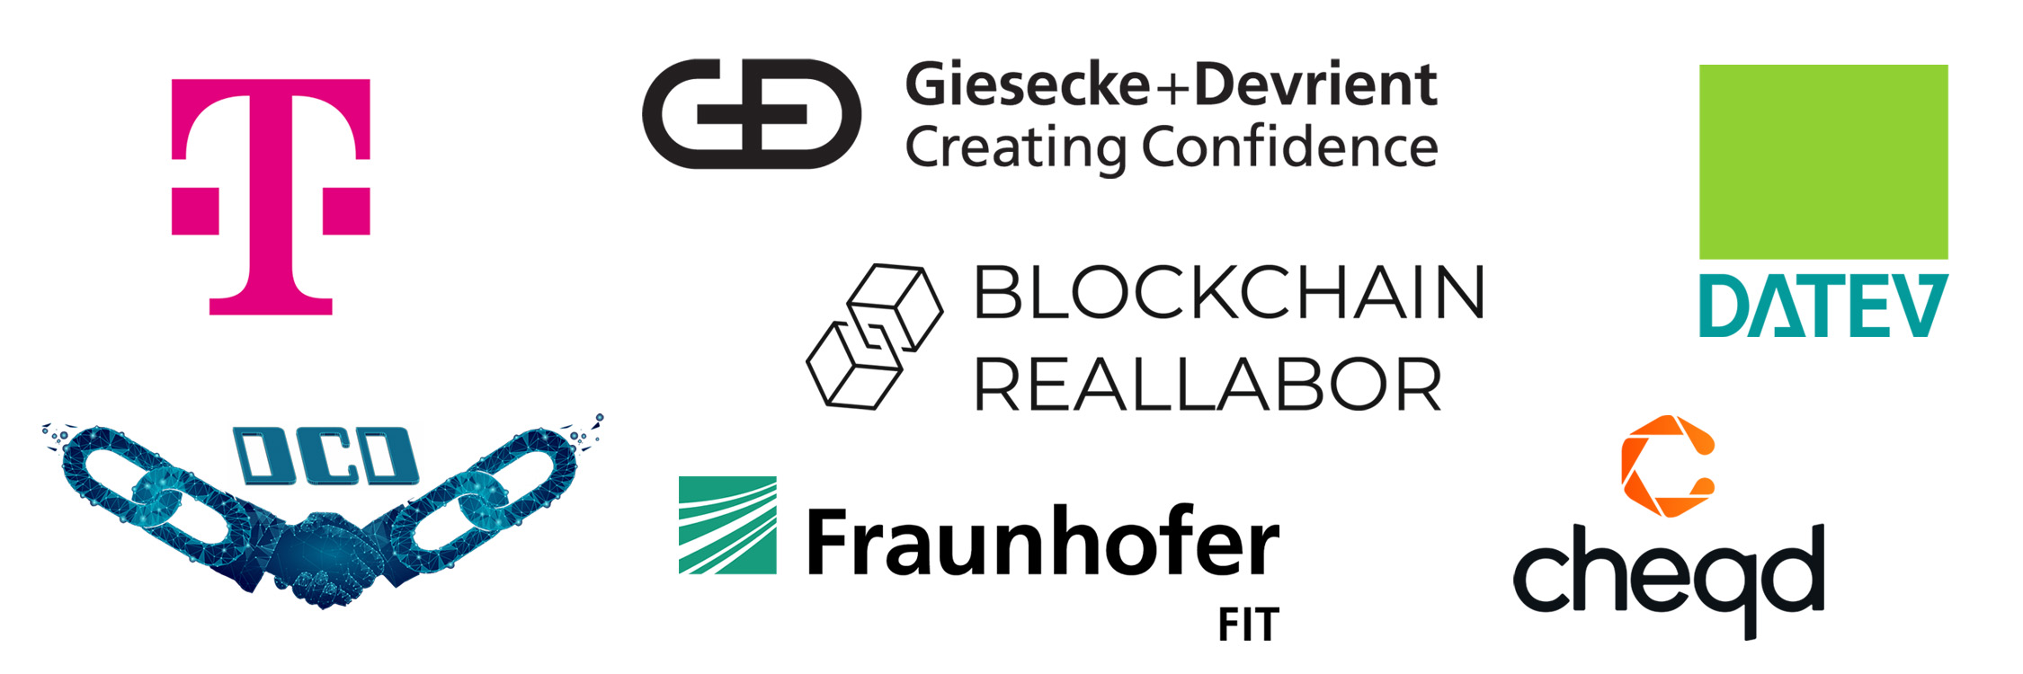
RWOT XII SPONSORS

Abstract
The Verifiable Credential (VC) ecosystem has encountered several use cases that require a third-party assertion, or a linked claim to an existing object (another VC, a PDF, a web page, etc). Whether it is product reviews, linked claims of self-created credentials, provenance of academic paper reviews, or some other general purpose third-party assertion, these use cases have several requirements in common. Each use case may also require a domain-specific set of fields.
We propose a minimal format for connecting (and optionally cryptographically binding) credentials that will allow each use of third-party assertions to be represented as a set of LinkedClaims. Such a data set will enable verifiers to evaluate the credibility of claims, including those sourced from outside the Verifiable Credential ecosystem.
Further, we propose to demonstrate the ability to compose several Verifiable Credentials into a single domain-specific credential using the LinkedClaim vocabulary that will satisfy the domain requirements of the likely users.
This approach will enable rich shared datasets to inform trust decisions while satisfying the requirements of domain-specific end users. One of the intentions of LinkedClaims Verifiable Credentials is to give individuals the agency to make such claims about themselves and others on their own terms.

Introduction

Additional Credits
Lead Author: Phillip D. Long
Authors: Phillip D. Long (T3 Innovation Network, Georgetown University & ASU), Dmitri Zagidulin (MIT Digital Credentials Consortium), and Golda Velez (Cooperation.org)

Sample APA Citation
Long, P., Zagidulin, D., and Velez, G. (2023). Composing Credentials via LinkedClaims and Cryptographic Binding. Rebooting the Web of Trust XI. Retrieved from https://github.com/WebOfTrustInfo/rwot11-the-hague/blob/master/final-documents/composable-credentials.pdf.
This paper is licensed under CC-BY-4.0.

About Rebooting the Web of Trust
This paper was produced as part of the Rebooting the Web of Trust XI design workshop. On September 26th to 30th, 2022, over 60 tech visionaries came together in The Hague, The Netherlands to talk about the future of decentralized trust on the internet with the goal of writing at least 5 white papers and specs. This is one of them.
• RWOT Board of Directors: Christopher Allen, Joe Andrieu, Erica Connell.
• RWOT11 Coordination Team: Will Abramson, Christopher Allen, Joe Andrieu, Shannon Appelcline, Erica Connell, Eric Schuh, Carsten Stöcker.
• Workshop Credits: Will Abramson (Producer), Christopher Allen (Founder), Shannon Appelcline (Editor-in-Chief), Erica Connell (Host), Amy Guy (Ombudsperson), Willemijn Lambert (Graphic Recorder), Eric Schuh (Ombudsperson), Carsten Stöcker (Co-Producer, Demo Organizer), Dorothy Zablah (Facilitator).
• Gold Sponsors: The City of the Hague, Digital Contract Design, Dutch Blockchain Coalition, The Hague University of Applied Sciences, eSSIF-Lab.
• Contributing Sponsors: Blockchain Commons, Legendary Requirements, Spherity.
Thanks to all our attendees and other contributors!

What’s Next?
The design workshop and this paper are just starting points for Rebooting the Web of Trust. If you have any comments, thoughts, or expansions on this paper, please post them to our GitHub issues page:
https://github.com/WebOfTrustInfo/rwot11/issues
The twelfth Rebooting the Web of Trust design workshop is scheduled for late 2022. If you’d like to be involved or would like to help sponsor the event, email: Leadership@WebOfTrust.info

