Rebooting the Web of Trust
A WHITE PAPER FROM RWOT XII: COLOGNE
Beyond did:web

by Hans Boone, Dan Carez, Mirko Mollik, Dr. Sebastian Schmittner, Dr. Carsten Stoecker
Designing the Future of Decentralized Self-sovereign Identity

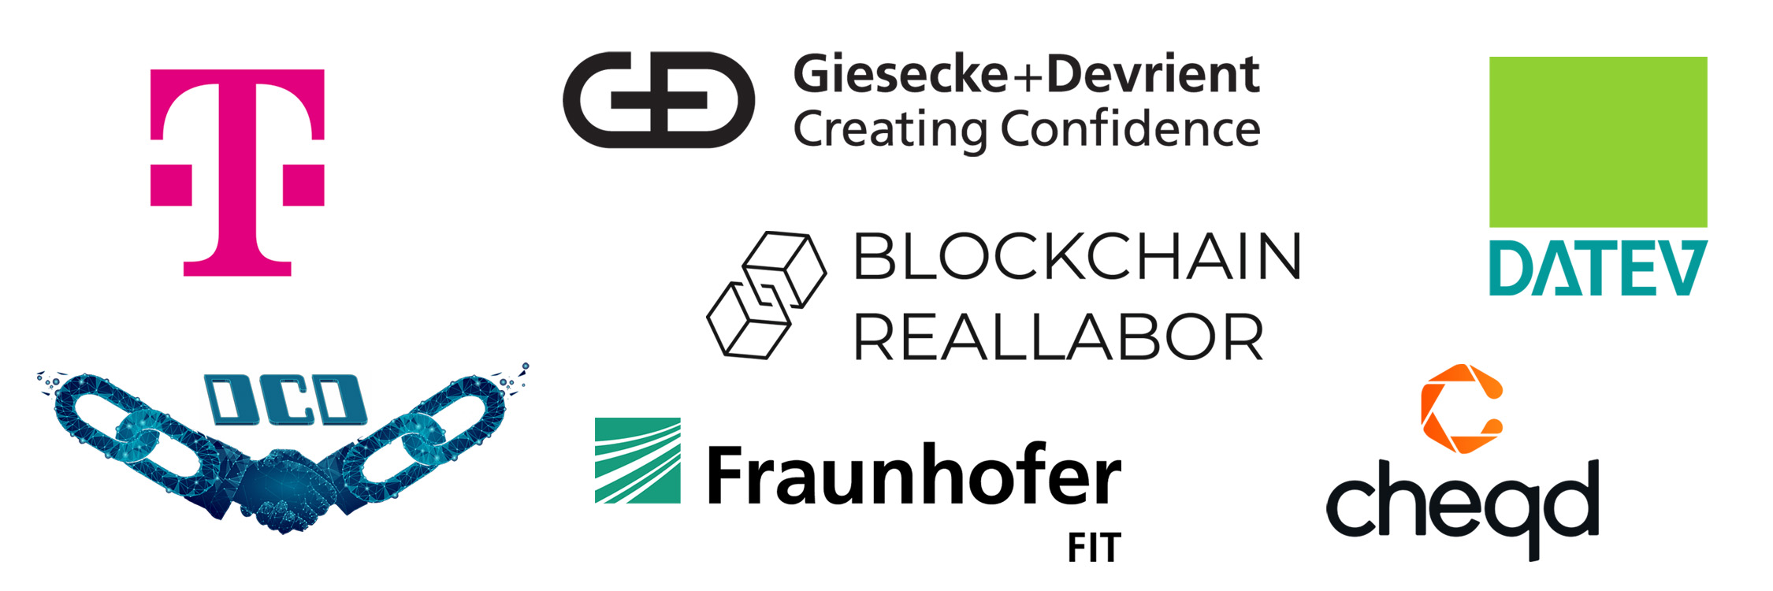
RWOT XII SPONSORS

Abstract
This paper will explore a few recent suggestions for enhancing the did:web method, in particular did:webplus and did:webs. Shortcomings of did:web are analyzed and a list of necessary features to overcome real problems is assembled. We strive to avoid the problem mentioned in the classic xkcd comic on standards and investigate whether the did:web method can be improved without creating yet another (few) DID methods.
To begin, we will evaluate the current did:web specification. We will use our shared experiences implementing did:web as well as published articles to create an exhaustive list of the feature set and known gaps or security implications. Understanding business requirements and use cases is important. This paper explains the practical applications and businesses needs that did:web aims to fill. A detailed discussion on the features of did:web is presented, drawing from experiences with existing working code and real-world applications.
Additionally, we explore other did:methods that might operate under different names but offer similar functionalities, particularly those that resolve via DNS and incorporate key rotation features. Our focus remains on non-DLT based approaches, ensuring a broader applicability. We also dive into the related standardization activities undertaken by Trust over IP (ToIP) and IETF, highlighting their contributions and guidelines that shape the future of did:web.
Lastly, if needed, we hope to provide a cursory feature set to make the new did:web\* the best it can be!

Introduction
In the Introduction section, we embark on a detailed exploration of the did:web method, beginning with its widespread adoption in organizational contexts. We delve into why organizations are increasingly turning to did:web for identity management, emphasizing its ease of use, simple discoverability, and compatibility with existing web infrastructure. Following this, we critically assess the main criticisms of did:web, highlighting its limitations in trustworthiness, historical DID document resolution, and DID document integrity. This examination sets the stage for the subsequent in-depth analysis and discussion of potential improvements and alternative methods, providing a foundational understanding of the current state and challenges of did:web.

Why are organizations using did:web?
As organizations navigate the evolving landscape of identity management, decentralized identifiers (DIDs) are emerging as a promising solution to enhance security, privacy, and user control. Among the various DID methods available, did:web serves as a practical starting point for those venturing into this decentralized realm. Easy to implement and compatible with existing web infrastructure, did:web enables organizations to familiarize themselves with the core concepts of decentralized identities before diving into more complex and specialized DID methods. Below, we explore the key advantages of starting with did:web.
Ease of Use: did:web is often considered simpler to understand and implement. It operates over standard HTTPS protocols and can be easily managed with familiar, widely available, robust and cheap web server technology.
Simple discoverability: Compared to ledger-based DID methods, which may require ledger-aware software not just for verification but even for basic discovery, resolving a DID to its DID document for did:web is straightforward. Discovering and resolving the did:web DID document relies on proven DNS technology. Compared to standalone approaches like did:key and did:jwk, the DID document can be requested by knowing only the identifier of the DID, reducing the size of the id and allowing for the update of the DID document in the future.
No Specialized Infrastructure: Unlike DID methods that require special nodes or decentralized networks, did:web works on existing web infrastructure.
Low Cost: Unlike ledger-based DID methods, did:web does not have an associated cost other than maintaining a web server.
Interoperability: did:web identifiers can be easily mapped to existing HTTPS URLs, making it straightforward to integrate with current web architectures.

Main criticisms
Although did:web is easy to use and provides a good entry point for the decentralized identity space, using did:web also has some limitations, the three most prominent limitations being:
No trustworthiness: The main criticism of the did:web method for decentralized identities is its inability to ensure trust for the information it handles. While did:web is beneficial for publishing and discovering DID documents, using familiar web mechanisms for this purpose is not suited for evaluating their trustworthiness. The current web infrastructure is rife with vulnerabilities such as website hacking, DNS hijacking, and unreliable certificate authorities.
The did:web method relies on DNS and TLS as trust anchors. While DNS resolves the domain name to an IP address and TLS secures the transport mechanism, they do not necessarily enhance the trustworthiness of the information. TLS merely verifies that the Fully Qualified Domain Name matches the common name in the certificate. Various levels of assurance can be achieved through different types of TLS certificates, ranging from no assurance with Let’s Encrypt, to medium assurance with extended validation certificates, and high assurance with QWAC certificates.
Even with different levels of assurance offered by various TLS certificates, this information is not factored into the trustworthiness of a DID document’s content. This is because in the current did:web method specification, the DID document itself does not require information about the type of TLS certificate and its corresponding level of assurance.
Historical DID document resolution: If a private key linked to a did:web DID document becomes lost, compromised, or outdated, it’s essential to rotate the existing keys and associate a new key with the DID. The goals of this key rotation are threefold: to maintain the validity of prior signatures, to nullify any signatures made with the faulty key, and to enable the DID controller to produce new signatures using the updated key.
In the order to prove the validity of prior signatures it’s essential to be able to retrieve a DID document that was valid in a particular moment of time. In order to prove that the controller is still the same, an immutable link between the different versions of the DID documents is required.
While the did:web specification allows for key rotation and historical versions, it doesn’t fully address all of the issues mentioned above.
DID document integrity: In the existing did:web specification, self-signing the DID document is not mandated. As a result, it becomes impossible to ascertain whether the content of the DID document is intact and unaltered or if it has been compromised. The DID core specification has a feature for integrity validation using hashlinks. But this feature will only work when the issuer of a verifiable credential does not update the DID document, otherwise the hashlinks won’t match anymore.

Beyond did:web
This paper aims to critically examine the most glaring drawbacks of the current did:web implementation: namely, the lack of trustworthiness, the absence of key rotation mechanisms, and concerns about DID document integrity. To address these limitations, we will analyze two existing works that attempt to rectify these issues: the did:webplus and did:webs specifications. Through this analysis, we will assess how these specifications tackle the inherent shortcomings of did:web. Moreover, we will propose an alternative solution that enhances the existing did:web specification in a fully compliant manner, targeting the rectification of the aforementioned drawbacks.

Feature requests: What is did:web lacking
The following section points out the features that are missing in the did:web method.

Cryptographic ownership binding
To prove the ownership of a DID, the owner performs a signature with the private key that is linked to the DID. The verifier can verify the signature with the public key that is published in the DID document. In cases such as did:key or did:jwk, the public key is bound to the ID of the DID. The same goes for did:ethr, where the verifier is able to validate the ledger. But did:web is missing the binding between the ID of the DID and the public keys to prove ownership. Here the owner or the controller of the DID document is the one who has access to either the web server where the DID document is hosted or to the DNS servers to point to another web server. The owner of these resources is able to publish a new DID document and therefore to change the public keys. An attacker could not get access to the old used private key of the DID, but can hijack the identity to sign new credentials or authenticate to other services with this ID.
On the other hand. this missing binding allows the owner to rotate the keys in case he lost access to the current private key, similar to the typical “password forget” functionality. Resolving the issue of being locked out by the private key is a feature other DID methods such as did:key or did:jwk are missing. But as mentioned the ownership to the DNS and web servers is a risk that has to be considered.

Unique identifiers for the objects
Each element inside the DID document has to have a unique identifier, because it needs to be referenced. In case a credential is signed by a key, the DID document including the public key can also include multiple public keys. A X.509 certificate does not need a specific identifier for the public key, because the certificate only includes one public key, so the identifier of the certificate and the public key is the same. It is also not a good way to loop over all the public keys in the DID document to check if the signature is valid with one of them. Instead the public key will be referenced in the issued credential like did:web:example.com#key-1. This will block the identifier key-1 in the future, because did:web is not supporting versioning of the documents. The owner is unable to publish a new public key under the same identifier because it would make the old public key unavailable. Other DID methods that support versioning allow for the querying of a public key by the identifier and the version id or time like did:ethr:123456#key-1?versionId=2 and a new public key like did:ethr:123456#key-1?versionId=2. This is important when a use case requires you to publish a public key under a specific identifier. For use cases like authentication this feature sounds irrelevant because you always need the latest public key to verify the response. But in case of auditability, you want to query older public keys to prove that the signature was valid at the time of issuance without forcing you to store the public key in your own archive.

did:web auditability
Audibitility goes beyond just a question of unique identifiers. In the area of software development for compliance solutions, the integrity, transparency, and verifiability of data are foundational requirements. Essential “compliance controls” such as Confidentiality, Integrity, Availability, Non-repudiation, Attributability, Tamper-proof Timestamping, Sequencing of Events, Long-term Archiving, and Proof Preservation form the backbone of a robust compliance solution. These controls ensure that sensitive information remains protected, actions are traceable to their sources, and evidence of events or decisions is preserved for future reference or audits. Specifically, the Auditability of DID documents plays a pivotal role in this context.
It guarantees that every piece of data, once entered, remains transparent and immutable, establishing a clear, verifiable record. This is especially vital for the assertions issued by the controller of a DID in regulated industries where the stakes for maintaining data integrity are exceptionally high, directly impacting public trust, safety, and the bottom line. Thus, for software aiming to provide compliance solutions, embedding these auditability features is not just about meeting regulatory standards; it’s about ensuring long-term trust, security, accountability, and operational excellence.
did:web, while being easy to implement, has inherent limitations when it comes to providing full auditability features for the entire DID lifecycle, especially concerning key rotations and DID document configuration events.

Here’s why:
- Centralized Nature: did:web identifiers are essentially URLs, and they rely on the traditional web infrastructure. This means that the data is stored on centralized servers or web domains. In decentralized systems such as blockchains the information get published on multiple servers that are not controlled by a single stakeholder. An end user is able to query multiple endpoints and can verify if he/she got equal results. Also, all the information is publicly available to read for everyone, providing more transparency. None of these features are necessarily available in centralized web infrastructure.
- Lack of Immutable History: In decentralized ledger systems, every change or transaction is recorded in a way that it cannot be altered, ensuring a permanent and transparent history. Immutability is created by linking the transactions in a chain, removing centralized ability to update peristent data. did:web, due to its reliance on the traditional web, doesn’t inherently provide this feature. If a DID document is updated or a key is rotated, the previous state might be overwritten without any immutable record of the change.
- Vulnerability to Tampering: Since did:web documents are hosted on web servers, they are susceptible to common web vulnerabilities. Malicious actors, if they gain access, can alter or delete historical data, making it challenging to audit the entire lifecycle of the DID.
- Dependence on Web Hosting Providers: The availability and integrity of did:web documents are tied to the reliability of web hosting providers. These providers can experience downtime, data losses, or even decide to terminate services, leading to potential loss of historical data.
- Absence of Native Timestamping: Unlike some decentralized systems that inherently timestamp every transaction, did:web doesn’t offer tamper-proof timestamping. This makes it impossible to verify the exact sequence and timing of events in the DID’s lifecycle.
- Potential for Data Inconsistency: Without a decentralized consensus mechanism, there’s a risk of data inconsistency in did:web. Different servers might have different versions of a DID document, complicating the audit process.

Achieving Long-Term Non-Repudiation
Integrating self-certifying identifiers with a robust microledger enhances the did:web method, transforming it from a rudimentary system to a comprehensive, auditable solution that includes timestamping and sequencing of DID document configuration events.
By storing snapshots of this microledger on an immutable, publicly accessible platform like “git”, vulnerabilities such as deletion and duplicity attacks can be effectively countered, ensuring long-term non-repudiation.
Achieving long-term non-repudiation involves:
- Taking snapshots of the microledger at regular intervals, such as every 15 minutes.
- Storing each snapshot in a git repository.
- Ensuring the system’s resilience, even in scenarios like company bankruptcy.
- Digitally signing each snapshot for added security.
- Granting all partners and auditors access to the did:web operator’s git repository, allowing them to clone and retrieve the microledger whenever necessary.
This methodology is accepted as a compliance solution in Germany and is considered to ensure long-term non-repudiation as an interim solution for productive systems.

More on Long-term Non-repudiation
KERI’s introduction of witness networks offers a more abstract and sophisticated approach for achieving long-term non-repudiation. However, its implementation can be more challenging compared to the aforementioned method.
Adding self certifying identifiers and a robust microledger to did:web transforms did:web from a very basic approach to an auditable solution including tamper-proof timestamping and sequencing of DID document configuration events.
When snapshots of such a micro-ledger are stored on an immutable, publicly accessible system such as “git”, deletion and duplicity attacks can be mitigated. KERI introduced the concept of witness networks which is a more abstract and advanced approach.
This combination leverages the ease of web-based systems with the trustworthiness, security, and transparency of decentralized ledgers. It addresses the inherent challenges of the traditional did:web method, offering a more robust and reliable solution for digital identity management.

Solving Problems
In the next section, we address the key challenges of the did:web method. We begin by exploring efficient strategies for key rotation, highlighting the importance of maintaining key histories and versioning. Next, we discuss the implementation of a micro-ledger approach for DID Document Versioning. We conclude with an examination of embedding self-signatures and enhancing DID document validation, focusing on maintaining integrity and trustworthiness within the system.

Key Rotation
When the private key of a DID becomes unusable, the DID document needs to be updated to publish a new public key. In order to fulfill the requirements listed above, the old private key must still be accessible, but it must be made clear during which time period signatures are still to be considered valid and at what point they are to be considered invalid.
Having a version history of keys inside a DID document with published validity intervals is a perfectly valid solution to this problem and could be achieved by simply adding valid-from and valid-until time stamps to the DID documents verification methods. (See did core specification of verification methods)
However, since key rotation is only one reason to change a DID document, we conclude that rather than coming up with a way to only having a version history of keys, we would rather have versioned DID documents.

Did Document Versioning - Micro-Ledger Approach
The best:tm: approach to versioning is what is nowadays known as a “micro ledger”, i.e. hash-linked data blocks. Notice that this is the data structure used in a block chain, but none of the methods discussed in this paper actually requires a distributed ledger to store/share the data.
- did:webs uses KERI to have this micro ledger in form of an KERI event log.
- The did:web2.0 proposal has the backward links as resolvable DID URIs, including the hash (id), which are placed directly in the DID document in a new "previous" field.
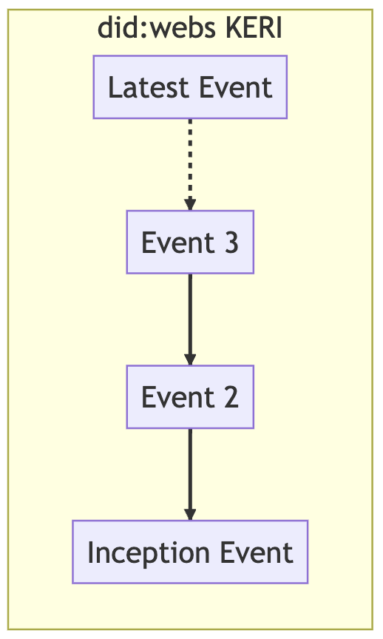
- did:webplus links to the previous DID document by including a prevDIDDocumentSelfSignature field, which is the most traditional form of linking blocks (e.g. in the bitcoin data structure).

In the did:webs approach (above), the DID documents are generated by processing the full or partial KERI log. To get a historical version by version id/time stamp, only the KERI log up to this time/version is processed, to generate the historical DID document. The DID documents themselves do not maintain any of the micro-ledger structure in did:webs.
In contrast, did:webplus builds the micro ledger directly from the DID documents. The DID web 2.0 proposal is very similar to did:webplus in this respect.

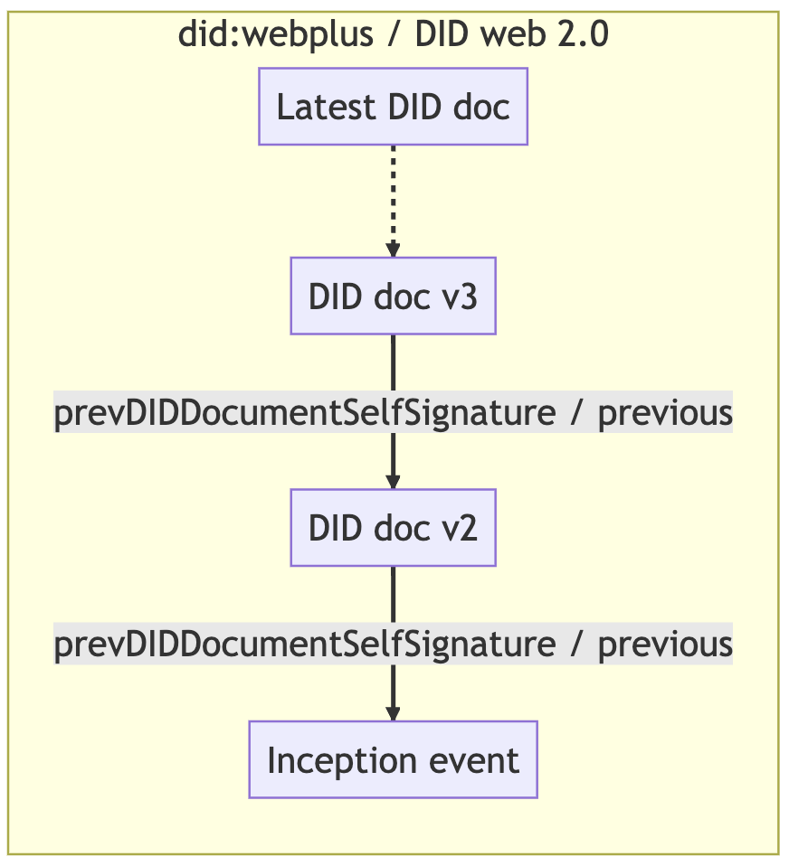
Referencing versions
We have to distinguish between
- The DID being an identifier of an entity (person/organization/thing/…)
- The DID being a resolvable URI that yields a DID document
  - The DID document at least associates public key(s) with the DID
  - Usually the DID document also publishes service endpoints that allow others to discover how to interact with the DID’s subject
When the DID is used to refer to a DID document, mentioning the version of that document might be necessary. This could be specified in the form of a version number/hash id. (See naming things with hashes for the general idea. There a lots of concrete variants on the theme.)
A very important use case for accessing a historical DID document is this: When verifying a credential, the verifier most likely does not want to get the latest version of the issuer’s DID doc, but the version that was current at the time he issued the credential. So after requesting the DID document, the following checks need to pass:
- the issuance date of the credential is after the createdAt date of the DID document of the issuer, to ensure that the DID document was already valid at the time of issuance
- the next DID document issuance date has to be greater than the issuance of the credential. This ensures that the key was not revoked at the time of issuance. There could be the case that the key is still in the new version of the document resulting in a valid signature. But then the correct usage version information was not provided by the issuer. In case there is no next version, the current version is the latest one and the key is still valid.
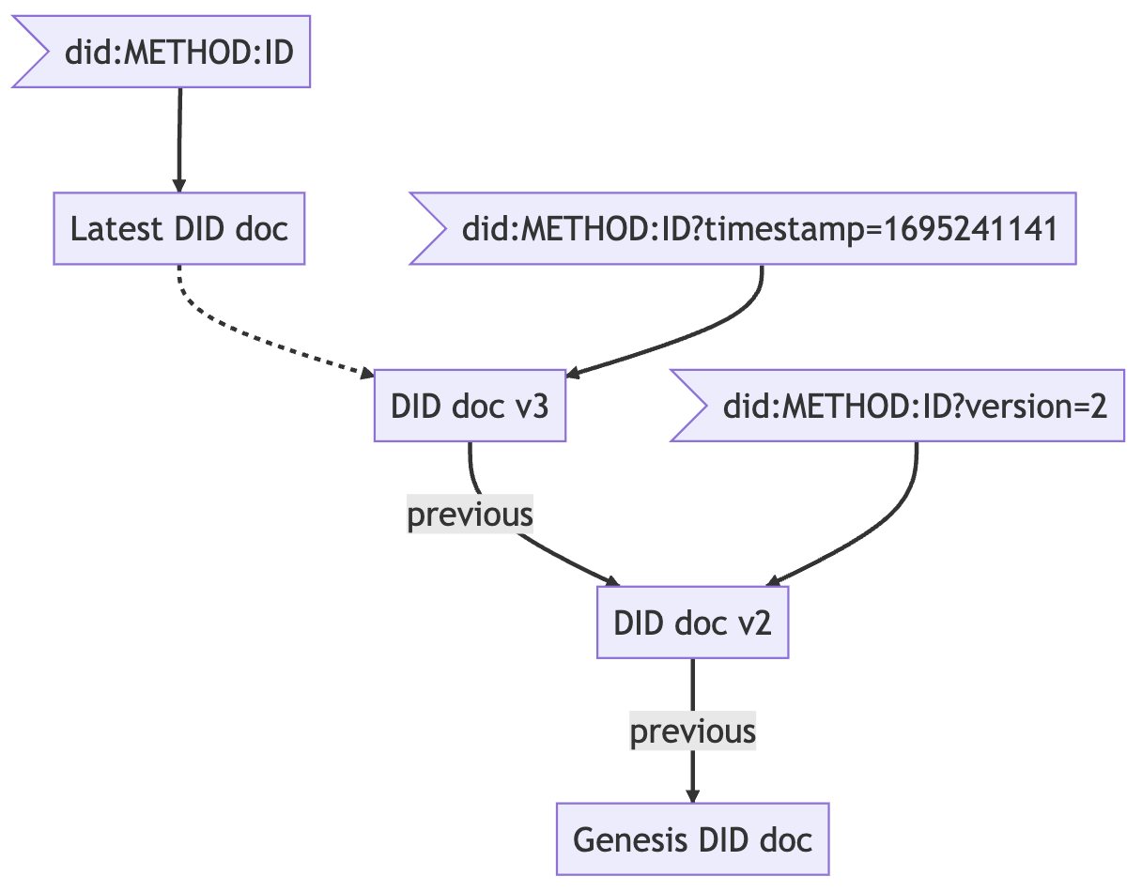

Summary of did:web improving DID methods
This section introduces existing proposals that aim to solve some of the limitations of did:web.

did:webs
The did:webs method aims to benefit from the discoverability of did:web while providing a separate trust anchor based on KERI (Key Event Receipt Infrastructure).
did:webs identifiers follow a structure similar to did:web, with an additional KERI Autonomic Identifier (AID) appended at the end, for example: did:webs:example.com:some:path:12124313423525
In KERI, an inception event creates the initial key pair that establishes the root of trust, and the Autonomic Identifier (AID) is derived from the inception event’s hash. The AID is self-certifying and becomes the first item in an append-only chain of events known as the Key Event Log (KEL). The KEL provides a secure mechanism to perform updates in the DID document that are chained together and can be validated against the inception event that is encoded in the DID itself.
Like did:web, did:webs uses the HTTPS protocol to provide access to DID documents. URLs are constructed using the domain name and path in the form https://domain.tld/some/path/aid, then appending /did.json to obtain the latest version of the DID document. Additionally, did:webs publishes the entire stream of KEL events on a separate URL (/keri.cesr), making it possible for DID resolvers to reconstruct and validate the content of the DID document at any point in time.
Since the AID represents the inception event tied to the subject’s identity, the AID together with the KEL are sufficient to generate the DID document associated with the subject, independently from the did:webs’s DID itself. This property makes it possible to, for example, migrate a did:webs to another web domain, or even to another DID method by using the AID as the unique identifier and the KERI event stream for validation. From this perspective, did:webs could be seen as a method for exposing a set of KERI mechanisms via HTTPS.

did:webplus
The did:webplus method augments did:web by maintaining an immutable and auditable history of DID document versions.
This is realized by implementing a micro ledger in which the signature of the initial document is incorporated into the DID itself, with each subsequent document referencing the signature of its predecessor. Documents also contain additional attributes, including a monotonically increasing version number and a start of validity timestamp, which effectively establish a totally ordered sequence of DID documents with non-overlapping periods of validity.
Identifiers in did:webplus are similar to the ones in did:web, with an additional field corresponding to the self-signature of the initial document, for example:
did:webplus:example.com:0B2LYBZ06Bn0dq7ALo3kG5ie20sQKvv7yzmbA8KtKExC4PRiZ2io-hPxxOy-mQ2qb4yuGdAK0eKvipqcBlZSArDg.
When the DID controller produces a signature, the DID URL specifying the signing key must include the standard query parameters versionId, versionTime and hl. This uniquely identifies the document version within the ledger.
To our knowledge, a draft method specification of did:webplus has not yet been published, but an overview of the method and a prototype implementation are available.

Embedding self-signatures
To uniquely identify and link document versions, a self-signature of the document content is computed and embedded in the document itself. This creates a circular dependency problem: the signature should only be computed once the content will not be further modified, so it is not possible to then modify the document to include the signature inside it.
did:webplus solves this problem by reserving “slots” in the document that are filled with zeroes. The signature is then generated on this data, and the zeroes are then replaced with the computed signature to build the final self-signed structure. During the signature verification process the inverse operation is performed, extracting the signature first, then filling the slots with zeroes and computing the signature.

DID Web with attached validation
During the Rebooting Web of Trust event we also tried to find a way to make the DID documents verifiable without breaking the actual schema of a valid did:web document, like did:webplus is doing. Another requirement was to only use technologies that already have a high adoption.
The did:web can be used either as the issuer in the credential or as the holder/owner.

Using the DID to identify the issuer of a verifiable credential
In this case, the verifier needs access to the public key, even when the private key is not actively used to sign new credentials anymore. To make this possible, the issuer has to add either the versionId or versionTime query parameter to its identifier. It would look something like this: did:web:example.com?versionId=2 or did:web:example.com?versionTime=2023-09-21T10:08:26.047Z. This allows us to have multiple versions of a DID document and therefore to update the key material or the service points.
To guarantee the content integrity protection, the issuer adds a hashlink of the DID document to the identifier. The final identifier looks like this did:web:example.com?versionId=2&hl=zQmWvQxTqbG2Z9HPJgG57jjwR154cKhbtJenbyYTWkjgF3e.
After checking the integrity of the DID document, we need to make sure that the used public key was valid during the issuance process. Compared to other formats, like X.509 certificates, DID documents do not have fields defining the lifespan of a DID document and the validity of the content. To solve this problem, we can use the DID document metadata. In this object the field nextUpdate can include a time stamp. If so, a newer version of the DID document exists and this time stamp has to be compared with the issuance date inside the credential. If the date inside the credential is greater than the date of the nextUpdate field, the signature is invalid. To query the metadata, we need to add a service endpoint to the DID document like:
{
"service": [
{
"id": "did:web:example.com#metadata",
"type": "didDocumentMetadata",
"serviceEndpoint": "https://example.com/metadata"
}
]
}
A versionId or versionTime query can be passed to the endpoint to get the DID document metadata for a specific version. If none is passed, the metadata from the latest DID document are returned. The type didDocumentMetaData is not yet included in the DID spec registry. Using the metadata endpoint we are not required to define the versionId as an incrementing number to discover the next version. The value nextVersionId is giving us this information we need to request the next version if there is any. If we get none, we can be sure that we have the latest version of the DID document.
Using only the already defined parameters from the did-core, we don’t need to add extra fields to the DID document. So being compliant to the schemas "https://www.w3.org/ns/did/v1", "https://w3id.org/security/suites/jws-2020/v1" that are used by the did:web, we are not forced to create a new DID method like did:webplus It also reduces the the required requests we need to make to the server, since we only request one version of the DID document and its metadata.

Using the DID as the holder of verifiable credential
The method can also be used for the holder binding when issuing a credential. Since did:web allows for the update of the DID document, the holder is able to perform key rotations to get rid of compromised keys. When binding a credential to a holder (or more generally using the holder’s DID as a reference to the holder anywhere) the un-versioned DID should be used, exactly as did:web is used today. When the identity of a holder (or any person) at the present time of the validation is to be checked, sending the DID without a version specification and hence receiving the most up to date DID document is appropriate.
For added security, the issuer of a holder-bound VC might add a version + hash link parameter to the DID and use this as the subject ID, hence signing that he checked that a certain version of the DID document belonged to the holder DID. This enables the verifier to check that there is a certificate chain going back from the current version of the DID document to the one that was committed in the VC. This chain of certificates is build of JWTs, each one signed with a valid key from the old DID document and referring to the next DID document via a hash link:
Payload
{
// hashlink of the next version, in this case version 8
"sub": "c4c09b07e9c46fae3d53bc9282425d0a8b4025e0dbce2a8dc176ce1912c88983",
// reference to the key used for signing
"iss": "did:web:example.com?versionId=7#key-0"
}
We do not need to include a hashlink in the issuer reference since we already validate this document. To follow the principles of least privilege we can limit the usage of possible keys by defining that these credentials should be signed by a keys that is in the list for authentication. To get access to the signed credentials, one more service endpoint has to be defined where the credentials are stored:
{
"service": [
{
"id": "did:web:example.com#proofs",
"type": "UpdateProofs",
"serviceEndpoint": "https://example.com/proofs"
}
]
}
The endpoint will either return a list of all proofs or just the proof that is required to validate the next version. In case one of the signature is invalid, the whole chain of trust is broken and the validation process has failed.

Known drawbacks
The storage of DID documents needs more space than just storing the changes in case only one key is rotated but the other nine keys are still included. Is is a downside for the owner of the DID but also for the holder. It has to request all DID documents step by step instead of downloading all DID documents in a list. This could be done via another service endpoint, requesting a list of DID documents and proofs so that it can be validated online.
In some scenarios the amount of validation can be huge when the holder had made a lot of key rotations after it got its credential. For this case it would be more effective to make jumps in the chain of versions. But to do so, the owner has to sign a claim that version five is in the trust chain of version two, when it got signed by a key of version two. But this would violate the lifespan of the key from version two since it got rotated when creating version three. And it’s also not good practice to not rotate the key that is allowed to update a DID document.

Outlook / Future Research
In this paper we did a high level comparison of the did:webs and did:webplus methods and compared them to what we think would be possible to achieve with augmented did:web alone. We deliberately did not do a deep comparison of e.g. performance KPIs of the involved algorithms, neither is this a solid security analysis of any of the mentioned methods. Such a more thorough analysis of the methods is left for future research.

Acknowledgements
We would like to thank Dmitri Zagidulin, Benjamin Goering, and Juan Caballero for writing the advance reading paper “DID Web 2.0” for RWOT 12, which sparked the work on this paper at RWOT 12.
We would also like to thank all the organizers of RWOT 12 for organizing and facilitating this great conference, which enabled us to work on this paper.

Additional Credits
Lead Author: Mirko Mollik (mirko.mollik@fit.fraunhofer.de)
Authors: Hans Boone (hans.boone@unifiedpost.com), Dan Carez (carezd@gmail.com), Mirko Mollik (mirko.mollik@fit.fraunhofer.de), Dr. Sebastian Schmittner (sebastian.schmittner@eecc.de), Dr. Carsten Stoecker (carsten.stoecker@spherity.com)

Sample APA Citation
Boone, H., Carez, D., Mollik, M., Schmittner, S., and Stoecker, C. (2024). Beyond did:web. Rebooting the Web of Trust XII. Retrieved from https://github.com/WebOfTrustInfo/rwot12-cologne/blob/master/final-documents/beyond-did-web.pdf.
This paper is licensed under CC-BY-4.0.

About Rebooting the Web of Trust
This paper was produced as part of the Rebooting the Web of Trust XII design workshop. On September 18th to 22nd, 2023, dozens of tech visionaries came together in Cologne, Germany to talk about the future of decentralized trust on the internet with the goal of writing 3-5 white papers and specs. This is one of them.
• RWOT12 Board of Directors: Christopher Allen, Joe Andrieu, Erica Connell, Shigeya Suzuki, Zaïda Rivai
• Workshop Credits: Zaïda Rivai (Producer), Christopher Allen (Founder), Shannon Appelcline (Editor-in-Chief), Erica Connell (Host), Willemijn Lambert (Graphic Recorder), Eric Schuh (Ombudsperson), Carsten Stöcker (Demo Organizer), Dorothy Zablah (Facilitator).
• Gold Sponsors: cheqd, DATEV, Deutsche Telekom, Digital Contract Design, Fraunhofer FIT, Giesecke + Devrient,
• Contributing Sponsors: Blockchain Commons, Blockchain Reallabor, Danube Tech GmbH, Legendary Requirements.
Thanks to all our attendees and other contributors!

What’s Next?
The design workshop and this paper are just starting points for Rebooting the Web of Trust. If you have any comments, thoughts, or expansions on this paper, please post them to our GitHub issues page:
https://github.com/WebOfTrustInfo/rwot12/issues
The thirteenth Rebooting the Web of Trust design workshop is planned for 2024-2025. If you’d like to be involved or would like to help sponsor the event, email: Leadership@WebOfTrust.info

did:web method. https://w3c-ccg.github.io/did-method-web/.
https://yes.com/docs/qes/2.5/index.html#_long_term_non_repudiation.
did:webs method. https://trustoverip.github.io/tswg-did-method-webs-specification.
Key Event Receipt Infrastructure (KERI). https://weboftrust.github.io/ietf-keri/draft-ssmith-keri.html.
did:webplus method. https://github.com/LedgerDomain/did-webplus.
Did Core W3C Specification. https://www.w3.org/TR/did-core/.

