What Users Really Want
A paper of the Rebooting the Web of Trust workshop, Paris, 2017
By Joe Andrieu <joe@legendaryrequirements.com>, Frederic Engel <market.engel@gmail.com>, Adam Lake <creatinglake@gmail.com>, Moses Ma <moses.ma@futurelabconsulting.com>, Olivier Maas <olivier.maas@worldline.com>, Mark van der Waal <mark.vanderwaal@sovalacc.com>
We consider five fictional personas to explore the obstacles and opportunities for self-sovereign identity. For one, Rutu Shah, we describe an illustrative day in her life.

Five Personas, Five Opportunities
The following five individuals represent a diverse sampling of normal, everyday people whose lives could be improved by self-sovereign identity. Today, these five aren’t using enhanced digital identity. For each, we describe their current lack of engagement and provide at least one opportunity that could reframe self-sovereign identity as a clear win for them.

Renée Moreau
Mme. Renée Moreau is a seventy-eight-year-old grandmother living in the town of Amiens, France. She has a low level of understanding about information technology, but fears being hacked and losing what meager savings she has left. To the extent that she has discussed it with her children, Renée Moreau feels “fancy” identity solutions are just too complicated for her to use.
Reframing: FamilyPix secure picture sharing enables Renee to receive photos of her grandchildren without exposing them to pedophiles or marketers.
Bonus Reframing: A friends-of-family web of trust enables support when emergencies arise. Family-of-friends and friends-of-family are discretely recruited for real-time on-demand response to minor emergencies and quality-of-life interactions such as getting locked out of the house, trip-and-fall incidents, and needing a ride to a doctor visit.

Jack Smith
Mr. Jack Smith is the fifty-seven-year-old Chief Information Officer of a Fortune 1000 company in the United States. He lives in Portland, Oregon with his wife and ten-year-old son. He has earned a reputation as a shrewd debunker of silver bullet initiatives that promise miracle results but rarely deliver. As a rule, he has found identity solutions too burdensome for integrated deployment throughout the hundreds of applications deployed across his company. Instead, core corporate applications are managed through a centralized Active Directory service and departmental applications are free to implement their own identity approach. He underestimates his company risk for regulatory compliance and tends to avoid technical topics where his aging expertise might appear dated. Employees spend as much as 15 minutes per day dealing with logins at both intranet and Internet sites. Phishing is a significant, but overlooked security risk.
Reframing: Super Sign-On brings corporate identity data into compliance while unifying secure logins for applications across the enterprise and beyond the corporate boundary at online services like Trello, Atlassian (Jira, Confluence, etc), and Dropbox.

Mayumi Takamasa
Miss Mayumi Takamasa is a seventeen-year-old female student in Tokyo, Japan. In conversations about privacy risks, she is dismissive and doesn’t care about advanced identity management. Online she has seen cyberbullying among her peers and goes to some effort to create boundaries between what she and her friends post for each other and what her mother can see.
Reframing: The MySociety social game creates independent identity across social network platforms — without exposing content to uninvited eyes. The game creates pseudonymous social spaces with built-in privacy, disappearing messages, and points, levels, and badges based on social interactions.

Joram Hadad
Mr. Joram Hadad is a twenty-five-year-old Syrian refugee from Damascus, traveling through Greece on his way to resettlement in France. He fears reprisal against his family should the Syrian government discover he made it out of the country. He has no technology to speak of and has provided authorities with a fake name. He needs health care and basic human services.
Reframing: MyID, a biometric-and-PIN-secured digital datastore in a USB thumb drive, gives Joram physical control over identity data that only he has the power to share.

Rutu Shah
Ms. Rutu Shah is a thirty-eight-year-old Mayor of a modest city in India, Ahmedabad. In her daily life she is wary of phishing attacks and security risks, but social and economic issues have taken priority over pushing for better identity across city services. She understands the value, but struggles to push for change, as commitments to drinkable water, better education, and sustainable jobs got her elected. She is particularly concerned about online predators and children’s safety.
Reframing: SafetyNet creates personalized peer-to-peer, independent trust networks where parents, educators, mentors, and social workers vet and connect trusted resources for children. The same service also allows professional networks to flourish through phish-proof, trusted introductions, connecting entrepreneurs with business development, mentors, and funding sources.

The Magic of Reframing
Reframing is a powerful tool, based on the work of George Lakoff, linguist, former Distinguished Professor of Cognitive Science and Linguistics at the University of California at Berkeley, and current Director of the Center for the Neural Mind & Society. We use it here to avoid the common pitfall of point-by-point refutation of obstacles and misconceptions, to instead discover a transformative, indisputable win for individuals from self-sovereign identity systems.
The process of reframing is based on finding blind spots. When you detect blind spots, either in the user or in the self, you unveil the potential for flipping the system. Useful techniques include ethnography, empathy, design-thinking and design sprints. Rather than fighting existing references, create a new one, framed indisputably in terms of something individuals clearly want. Eschew obscure technical jargon for emotionally impactful and concise trigger phrases that immediately resonate. When you illuminate a blind spot with emotionally desirable terminology, listeners naturally align their mental model and find it hard to challenge the excitement and possibility. By focusing on a single win for each individual, we further simplify the message and focus positive resonance. Reframing greatly increases the possibility for substantive engagement and adoption.

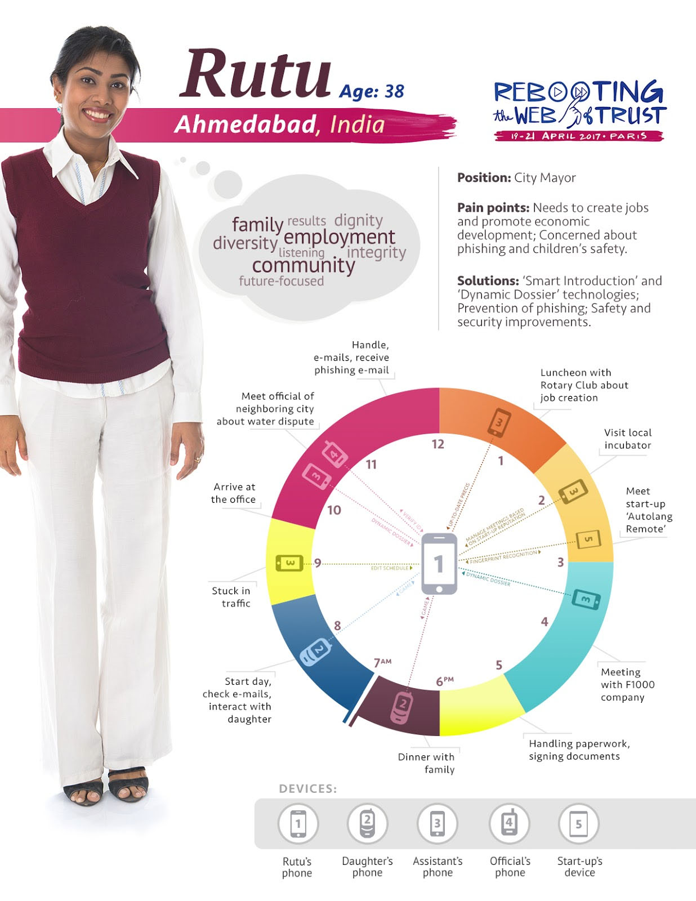
A Day in the Life of Rutu Shah
A fictional persona, Ms. Rutu Shah is the mayor of a modest city, Ahmedabad, India. Here we envision a day in her live, enhanced by self-sovereign identity.

Additional Credits
White Paper Authors: Joe Andrieu <joe@legendaryrequirements.com>, Frederic Engel <market.engel@gmail.com>, Adam Lake <creatinglake@gmail.com>, Moses Ma <moses.ma@futurelabconsulting.com>, Olivier Maas <olivier.maas@worldline.com>, Mark van der Waal <mark.vanderwaal@sovalacc.com>
Lead Editor: Joe Andrieu

About Rebooting the Web of Trust
This paper was produced as part of the Rebooting the Web of Trust IV design workshop. On April 19th through April 21st, 2017, over 40 tech visionaries came together in Paris, France to talk about the future of decentralized trust on the internet with the goal of writing 3-5 white papers and specs. This is one of them.
Workshop Sponsors: Ævatar, Blockstream, Digital Contract Design, Microsoft, Protocol Labs, U Change
Workshop Producer: Christopher Allen
Workshop Facilitators: Christopher Allen and Betty Dhamers, graphic recording by Benoit Pacaud, additional paper editorial & layout by Shannon Appelcline.

What’s Next?
The design workshop and this paper are just starting points for Rebooting the Web of Trust. If you have any comments, thoughts, or expansions on this paper, please post them to our GitHub issues page:
https://github.com/WebOfTrustInfo/rebooting-the-web-of-trust-spring2017/issues
The next Rebooting the Web of Trust design workshop is scheduled for Fall 2017 in Boston, Massachusetts. If you’d like to be involved or would like to help sponsor these events, email:
ChristopherA@LifeWithAlacrity.com

https://en.wikipedia.org/wiki/Amiens
http://en.wikipedia.org/wiki/Ahmedabad
https://georgelakoff.com/
http://cnms.berkeley.edu

