Driving Adoption with Focus on Basic Human Needs: Safety and Security
a white paper from Rebooting the Web of Trust VIII
by Sam Mathews Chase, Joni McKervey, Carsten Stöcker, and Daniel C. Burnett
How safety and security credentials are ideal building blocks for the adoption of larger SSI-based systems of proof and authorization.
Keywords: human needs, safety, security, adoption, decentralized identity, credential system, verifiable credentials, identity, self-sovereign, decentralized identifier

Abstract
This paper investigates two primary forces that have the potential to drive adoption of decentralised technology by both individuals and enterprises: safety and security. Among the most basic human needs, safety and security are fundamental to the functioning of society, and without them collective existence would fall into chaos. By protecting the sovereignty of each individual and ensuring access to secured shared resources, governments maintain a state in which its citizens may thrive.
In many areas, existing systems used to uphold safety and security regulations are outdated, inefficient, and vulnerable to fraud or abuse. Through four distinct use cases this paper proposes to demonstrate that measurable improvements can be made to many safety and security-related systems with the use of verifiable credentials. The implementation of these use cases offers a unique opportunity to design efficient, accurate, secure systems for information exchange that benefit both the individuals and organizations using the system, while simultaneously laying the foundation for broader adoption of personal data wallets.
In this paper we will examine four use cases: updating fire safety training with spatial computing; reducing fatigue-related workplace accidents with sleep data; issuing security clearances for journalists through background checks; and managing trust in accident-prevention systems for autonomous driving programs. Each of these use cases will track a user’s journey and highlight the implementation of verifiable credentials as a means to increase trust and efficiency while also protecting personally identifying information (PII).
Our goal is to outline systems using self-sovereign principles that provide mutual benefit to system administrators and users and that have a net positive impact on process efficiencies. Each use case describes a decentralised-credential system model that can be further adopted at scale.

Verifiable Credentials
The original motivation behind the Verifiable Credentials (VC) standardization work (https://w3c.github.io/vc-data-model/) was twofold: to provide equivalents to the physical credentials we carry around with us such as driver’s licenses, passports, and diplomas; and to solve the problems that people claim they need identity to solve, but without creating a new, restrictive notion of identity.
VCs have both a simple idea and a simple structure. A VC contains:
- An identifier (ID) for the VC
- An Issuer (also represented as an ID)
- A Subject (also represented as an ID)
- One or more claims, each listing a claimed property of the Subject and its claimed value, according to the Issuer
- A proof section containing cryptographic evidence to prove that the Issuer actually issued the listed claims. This evidence could be a signature over the whole credential or a zero-knowledge proof that has the same effect. Note that VCs don’t provide verification of the truth or falsehood of the claims, just verification that the claims were made.
Although VCs have other properties, such as revocation or expiration of claims, timestamps, the ability to make claims about multiple Subjects, etc., those are all optional.
Note something very important aboveL there is a Subject identifier (the ID), but no claimed identity assumption. While personally-identifiable information can be provided as claims in a VC, many use cases (including some of ours) do not require that.

Why Start Here?
As a technology intended to benefit humanity rather than just being “another way to create a commercial identity”, adoption of verifiable credentials will depend on utility beyond pure commercial drivers. Safety and security are matters that transcend politics and preferences systems of critical infrastructure, safety, and security impact governments, organizations, and individuals in different ways, but with equal necessity. Technology-driven complexity and growth are changing the world around us, and we can all agree that legacy systems of safety and security are due for an update; too many safety and security measures continue to hinge on inefficiencies like clipboards, checklists, intermittent inspections, and easily forged paper credentials.
Changes to safety and security practices require both widespread public adoption (grassroots) and organizational support (commercial, governmental). Both can be spurred into action by demonstrating the value of digital credentials to increase accuracy and efficiency in these legacy systems, while using only the absolute minimum user PII and reducing risk for all groups involved.
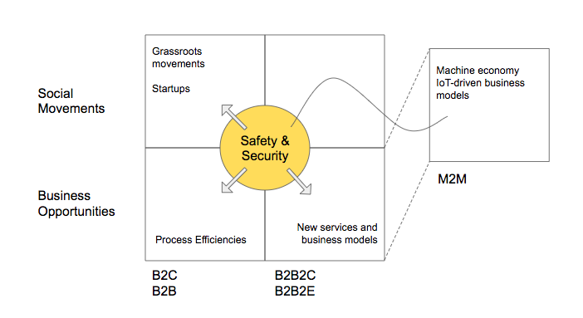Illustration 1: Spurring adoption of SSI and decentralized information sharing by covering the spread

Implementation: Fire Safety Credentials

The Problem
Fire safety protocol commonly requires building owners to post maps of safe evacuation routes and run periodic (often infrequent) evacuation drills.
Due to information overload and a growing reliance on mobile GPS guidance, the average person’s ability to navigate in an emergency is on the decline. As a result, maps and signs are no longer sufficient safety measures. In addition to needing a better way of preparing people for an emergency, liability is a growing burden for anyone responsible for people’s well being in a public capacity (e.g., employers, transportation authorities, live events managers, public buildings). Insurance costs are ballooning, populations are growing and urban/exurban areas are increasing in complexity. There is a growing need to better prepare people for an emergency, and to prove that the greatest safety measures possible are being taken as well.

The Solution
A system that uses WebXR gaming and groundbreaking neuroscience to teach emergency evacuation routes and safety exits to people. The game issues a VC for each successful completion of a game. The VCs are posted to the liable organization’s ledger and verified by a trusted third party (e.g., Local Fire Department). This ledger can be used as proof of compliance, and may be used to leverage reductions in insurance rates based on proof that building or transport occupants are better trained to respond safely in an emergency.
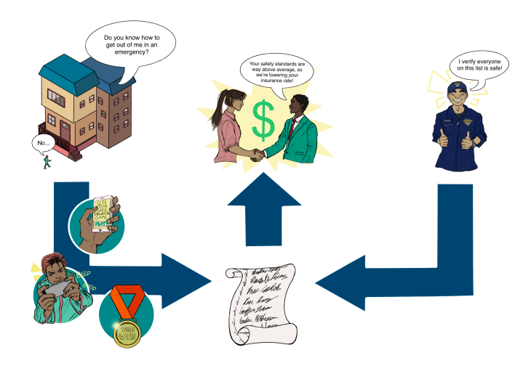Illustration 2: Safety ecosystem with Verifiable Credentials

Safety Game Overview
The Holder (Liable Entity) sends a safety training game to anyone for whom the Holder is liable to protect (Employee, Occupant). The individual registers their unique game ID, plays the safety training game to its completion and is issued a credential by the game software. The credential gets sent directly to the Credential Storage Software (in this case, there is no need for the Employee/Occupant to actually carry it around), where it is stored until verification is required. The ledger of credentials is presented to the Verifier (Fire Department, Government, Insurance Broker) by the Holder, and the Verifier validates the list of proofs on the ledger.
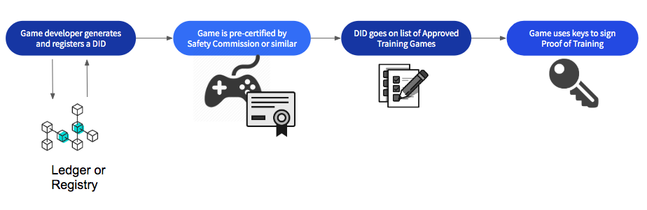Illustration 3: Safety game overview: game verification
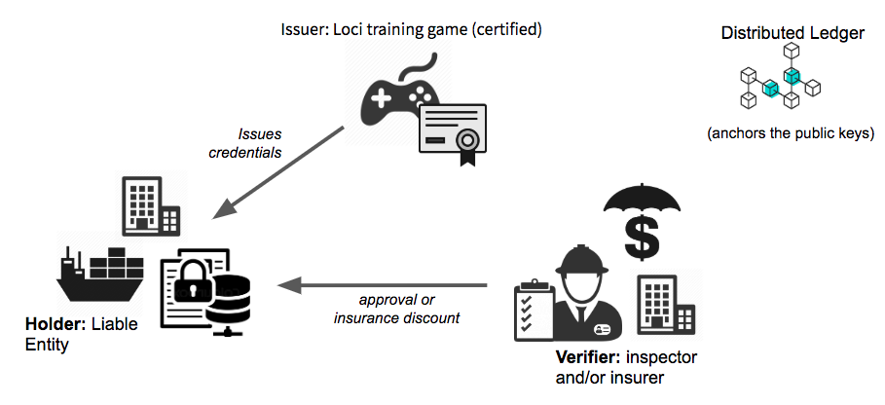Illustration 4: Safety game overview: workflow

Employee/Occupant benefits:
- Increased safety: Site-specific safety training that combines spatial memory and cognitive learning tools to reinforce critical safety information creates a safer work environment and reduction in workplace death and injury.
- Non-surveillant: VCs provide path to participation for any and all building occupants without disclosing PII.
Liable Entity Benefits:
- Accuracy: Training ledgers provide detailed and up-to-date records of compliance with safety code regulations and organizational due-diligence.
- Lowered overhead: Safer spaces lead to less frequent claims and lower insurance rates.
- Non-surveillant: VCs eliminate risks (and costs) associated with collecting, holding and protecting PII.

Use Case: Safety Credentials for Sleep
For construction companies wanting to incentivize positive sleep habits and overall health and wellness for employees to reduce on-the-job accident and injury rates, we propose a sleep credential system that uses verified credentials to reward employees for achieving sleep goals.
Unlike the current option, where employers collect employees’ raw health data from wearable devices like FitBits, this system does not collect or share employees’ personally identifying information.

The Problem
Lack of sleep is a leading cause of death and injury on construction and manufacturing job sites in Canada. More than 43% of workers are sleep-deprived, and construction and manufacturing report the highest number of workplace injuries and death out of all occupations tracked by the Association of Workers' Compensation Boards of Canada.
To support the creation of a culture of health, wellness, and safety, companies are adopting the practice of collecting employee health data from wearable devices to credit positive health practices and lower the occurrences of death and injury.

While the motivation is noble at its core, the practice is surveillant and invasive. Sharing your personal health data should not be a condition of your employment. These companies, however, have no other way to verify an employee’s sleep data. Additionally, companies who collect employee data are also taking on the cost and liability that comes with storing, managing, and protecting it.

The Solution
Use VCs to provide employees a way of attesting their sleep habits meet the minimum safety requirements set out by their employer without disclosing any of their raw health data. Use an intermediary (e.g. WorkSafe BC) as verifier for the credentials. Employees who share VCs attesting they’ve met sleep thresholds are rewarded for contributing to improved job site safety and wellbeing. Employee’s private information is protected, and employers do not take on the liability and costs of collecting personal data.

Use Case: Journalist Accreditation for Security Sensitive Events

The Problem
In journalism, accreditation refers to the admission of media representatives to certain events. Accreditation requirements (and related security requirements) are increasingly important at high-profile conferences such as G20 or WEF. Participants attend from countries all over the world and multiple security organisations are involved, making background checks and clearances complex and labour-intensive. Most security and clearance certificates are still based on paper processes, leaving a concerning margin for error and vulnerability to fraud.
The range of accreditation requirements extends from the simple issue of a press admission ticket without prior registration to authentication and a security check in advance, as well as agreements as to which journalist will attend which part of an event in which way (photojournalism, written reporting, television or radio recordings).
The accreditation is often based on proof that the media representative is actually a journalist. This can be done by means of an editorial confirmation, work samples, or a press card. The bases for accreditation are determined by the organiser, so they are not uniform in nature.
In most cases, accreditation is associated with the issue of special badges to media representatives.
Today, when a journalist arrives at a high-profile conference, on-site security teams must determine admissibility — permission to enter the conference — rapidly and accurately. A security employee then determines the class of admission (e.g. temporary access, access to specific parts of the conference), the need for further scrutiny, or the reason for a refusal of entry such as false authentication, revoked editorial confirmation, revoked security clearance, or void conference ticket. For example, at the last G20 summit in Hamburg, Germany, policemen used paper lists of the names of people who had their security clearance revoked prior to the conference, cross-referencing the list with the names of each person entering the conference.

The Solution
Digitise the accreditation and clearance process for journalists to reduce costs and increase event security.
Journalists employed by approved media companies or publications have their identity and employment verified by a security clearance agency, issued as a VC to their personal wallet. Upon registering for a conference, the journalist’s credentials are verified and they are issued a digital media pass and clearance status as temporary (time-constrained) VCs that can be revoked if necessary. Revocation eliminates the problem illustrated above, wherein changes in clearance status were handled manually by cross-referencing all arriving attendees with a printed list of those whose status had been downgraded.
The benefits of using VCs in the use case of journalist accreditation are:
- Digitisation of the accreditation process prior to the event as well as on-site registration and verification of the journalist
- Increased security in issuing, revoking, and verifying accreditation-related claims
- Increased efficiency through automation and cost reduction

Building a “Known Journalist” Credential Status
Washington Post (WP) employs a journalist and the journalist accredits as a WP staff member for G20 summit. The journalist receives a conference accreditation together with access restrictions from the organizer.
Journalists can only be admitted to the respective conference during the on-site registration process if:
- They can prove their identity.
- The identity card is verifiably stored under its digital identity claim from the authentication provider.
- They can prove that they are still employed, by a DPA Claim from DPA (editorial confirmation);
- that they have a positive OSiP review Claim of the OSiP procedure;
- that they are accredited and have access permission to parts of the event as claimed by the organizer; and
- that their accreditation fulfills further requirements according to the accreditation bases for further claims.
Media companies and organizers can validate the entire set of claims including their revocation prior to the conference as well.
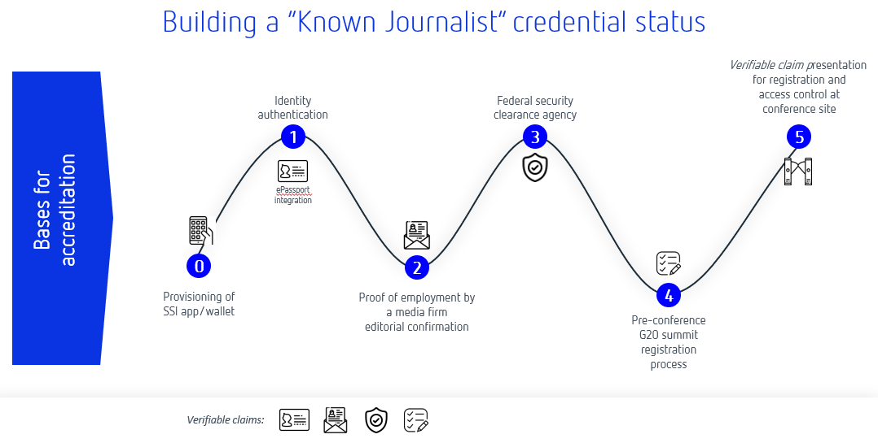Illustration 5: Building a "known journalist" credential status

Use Case: Verifiable Driving Event Data Chain
In addition to systems that focus on attestations about people (ID, clearances, certifications etc), cyber-physical systems like automated driving and driver assistance require highly trustable information chains to function safely.

The Problem
The analysis of dangerous driving situations and calculation of control signals to prevent dangerous situations is an important capability that requires data from different sources to be processed by different algorithms.
Dangerous driving events can be divided into two groups: (1) the interaction between a driver’s vehicle and the road environment, and (2) the interaction between a driver’s vehicle and nearby vehicles.
Diverse methods for enhancing driving safety have been proposed. Such methods can be roughly classified as passive or active. Passive methods (e.g., seat-belts, airbags, and anti-lock braking systems), which have significantly reduced traffic fatalities, were originally introduced to diminish the degree of injury from an accident. By contrast, active methods are designed to prevent accidents from occurring. Driver assistance systems (DAS) are designed to alert the driver, or an autonomous driving module, as quickly as possible to a potentially dangerous situation.
The two classes of driving events may occur simultaneously and lead to certain serious traffic situations. The automotive industry is working on active methods and systems including machine learning algorithms to analyze these two kinds of events and determine dangerous situations from data collected by various sensors and data from external sources. The machine learning output labels, about dangerous curves, road obstacles, or poor vehicle conditions, are fed into control, transaction, and risk systems. In distributed mobility systems the trustworthiness and accuracy of the output labels must be independently verifiable.
The ultimate question is: How can I trust vehicle identity data, third party data, and machine learning labels that are created and processed along a distributed mobility value chain?

The Solution
To achieve trustworthiness of output labels we are planning to blend the verifiable data chain concept with historic driving event data and black box algorithms to build a verifiable agile driving solution:
- Interoperable decentral identity and verifiable digital twinning protocol
- Cryptographically secured and blockchain-enabled data chains
- E2E integration of remote sensing (telematics) data and machine learning algorithms
This approach demonstrates how the following trust problems can be addressed with decentralised identity systems:
- Vehicle provenance and configuration
- Provenance, verifiability, and integrity of the driving event input data (or telematics data)
- Integrity and transparency of driving event data chain when multiple 3rd party intermediaries are involved
- Credentials about benchmarking of ML algorithms and training data
- Aggregated accuracy and trustworthiness of predicted ML labels and attributes

Conclusion
Safeguarding human life and ensuring our shared environments (city streets, workplaces, homes, gathering spaces) are secure are critical parts of a functioning society. Solutions that improve safety and security processes are not only needed at this time, but have the potential to operate at massive scale as well.
Verifiable credentials offer key upgrades to the systems addressed in these use cases, above that which other tech-related solutions cannot provide (e.g., minimum disclosure, protection of PII, and trustless exchanges).This makes VCs ideally suited for adoption by governments and liable entities like employers, whose management of peoples’ information and responsibility for their safety exposes them to high amounts of risk.
The use cases in this paper represent viable, real-world opportunities to spread adoption of self-sovereign tech without relying on mass adoption of personal data wallets or “one platform to save us all” types of solutions. In most cases these systems can be deployed without requiring the use of personal wallets -- at least to start -- allowing the systems themselves to be improved by the use of VCs as managed at the infrastructure/oversight level and paving the way for the use of personal wallets down the road.

Additional Credits
Lead Authors: Joni McKervey (joni@venn.agency)
Authors: Sam Mathews Chase (samantha@venn.agency), Carsten Stöcker (carsten.stoecker@spherity.com), and Daniel C. Burnett (daniel.burnett@consensys.net)

Sample APA Citation:
Chase, S., McKervey, J. Stöcker, C., and Burnett, D. (2020). Driving Adoption with Focus on Basic Human Needs: Safety and Security. Rebooting the Web of Trust VIII. Retrieved from https://github.com/WebOfTrustInfo/rwot8-barcelona/blob/master/final-documents/driving-adoption-needs.pdf.
This paper is licensed under CC-BY-4.0.

About Rebooting the Web of Trust
This paper was produced as part of the Rebooting the Web of Trust VIII design workshop. On March 1st to 3rd, 2019, over 80 tech visionaries came together in Barcelona, Spain to talk about the future of decentralized trust on the internet with the goal of writing at least 5 white papers and specs. This is one of them.
RWOT Board of Directors: Christopher Allen, Joe Andrieu, Kim Hamilton Duffy
Silver Sponsors: Caelum Labs, Digital Contract Design, Generalitat de Catalunya, Protocol Labs, Venn Agency
Additional Sponsors: Validated ID, PTB Ventures
Community Sponsors: Blockchain Commons, Digital Bazaar, In Turn Information Management Consulting, Learning Machine, Legendary Requirements
Workshop Credits: Christopher Allen (Founder), Joe Andrieu (Producer and Facilitator), Shannon Appelcline (Editor-in-chief), and Carlotta Cataldi (Graphical Recorder)
Thanks to our other contributors and sponsors!

What’s Next?
The design workshop and this paper are just starting points for Rebooting the Web of Trust. If you have any comments, thoughts, or expansions on this paper, please post them to our GitHub issues page:
https://github.com/WebOfTrustInfo/rwot8/issues
The eleventh Rebooting the Web of Trust design workshop is hopefully planned for 2021. If you’d like to be involved or would like to help sponsor the event, email:
rwot-leadership@googlegroups.com

Fatigue – You're More Than Just Tired. (n.d.). Retrieved from https://www.nsc.org/work-safety/safety-topics/fatigue
http://awcbc.org/?page_id=14
Richardson, S., & Mackinnon, D. (2017, April). Left to Their Own Devices? Privacy Implications of Wearable Technology in Canadian Workplaces. Retrieved from https://www.sscqueens.org/projects/other-projects/wearables
The Known Traveller: Unlocking the potential of digital identity for secure and seamless travel. Retrieved from: http://www3.weforum.org/docs/WEF_The_Known_Traveller_Digital_Identity_Concept.pdf
Stoecker, C., & Ruther, M. (2018) A DID for every thing - Driving Event Data Chain. Retrieved from: https://github.com/WebOfTrustInfo/rwot8-barcelona/blob/4317971a7a5c72c7b630148e790b674f4c7618a2/topics-and-advance-readings/A-DID-for-every-thing---Agile-Driving-Data-Chain.md
Fang, C-Y, & Hsueh, H.L. (2006) Dangerous Driving Event Analysis System by a Cascaded Fuzzy Reasoning Petri Net. Retrieved from: https://www.researchgate.net/publication/224650669_Dangerous_Driving_Event_Analysis_System_by_a_Cascaded_Fuzzy_Reasoning_Petri_Net

