Advanced Web Programming Final Group Project:

Website: Blog Awesome



Written By: Kevin Kan

Group 8: Matthew Rowlandson, Calin Cohan, Kevin Kan

Date: December, 9 2013

Table of Contents

Site Description: 1

Wire Frame: 1

Screen Capture: 7

Potential Future Additions: 8

# Site Description:

This site is a blogging site. Upon first entrance to the blogging site, the user sees the ten most recent blogs for all users. The user can navigate to the next ten and so forth if there are more blogs to look at. The user can also navigate back by ten blogs if they exist as well. If the user logs in. If the user logs in the navigation menu appears. Otherwise the navigation keeps you to either index.php, contactus.php or login.php. The contactus page is a simple e-mail form to send a quick message to the site administrators. At the login page, you can register as well. Once logged in the user can manage their profile, blogs (create, update, open/close or hide them). Opening or closing a blog either allows or disallows registered users from posting comments linked to the blog respectively.

# Wire Frame:

Login.php

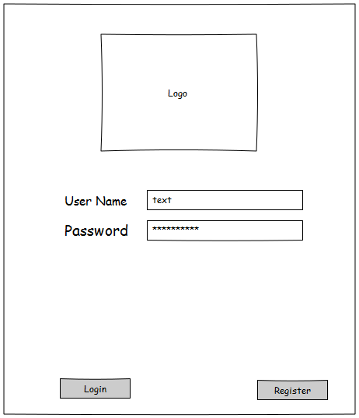

Index.php (logged in) 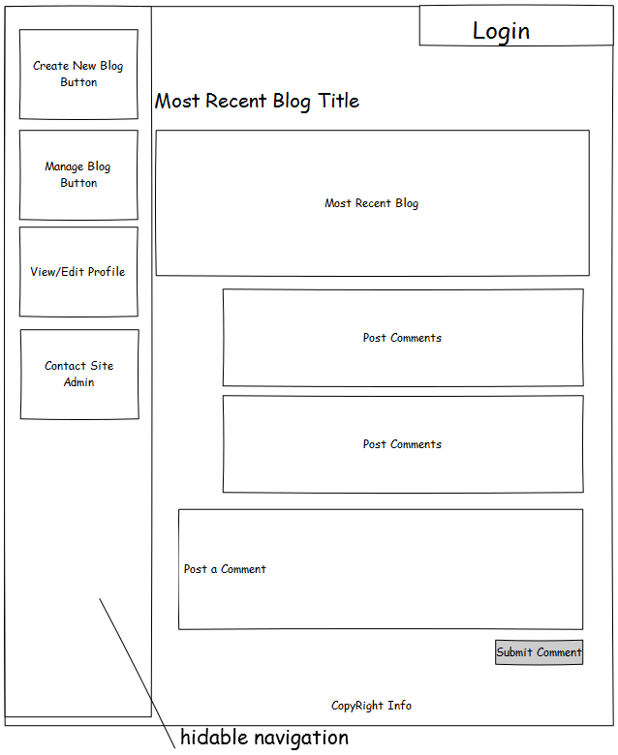

Index.php (not logged in or specified to a page)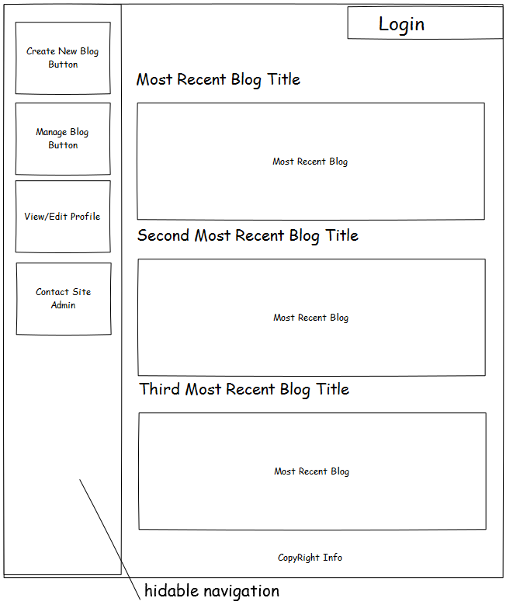

manageBlog.php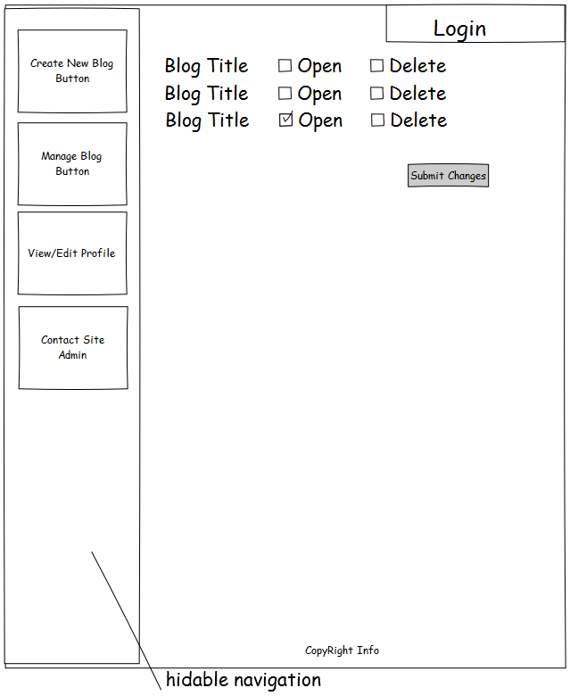

profile.php

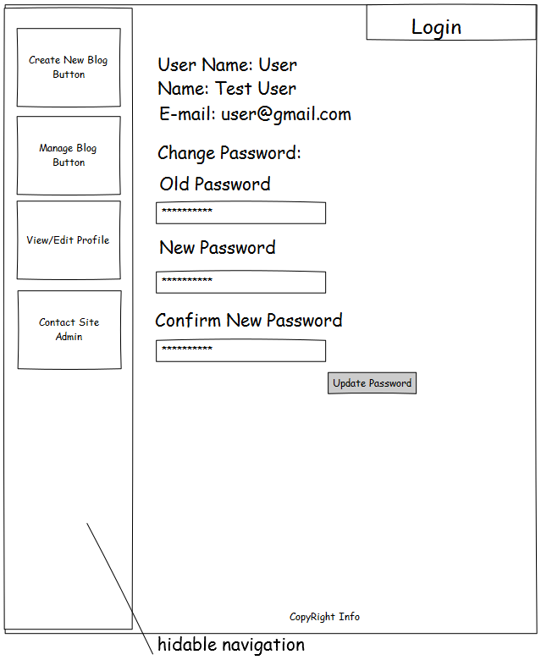

Contactus.php

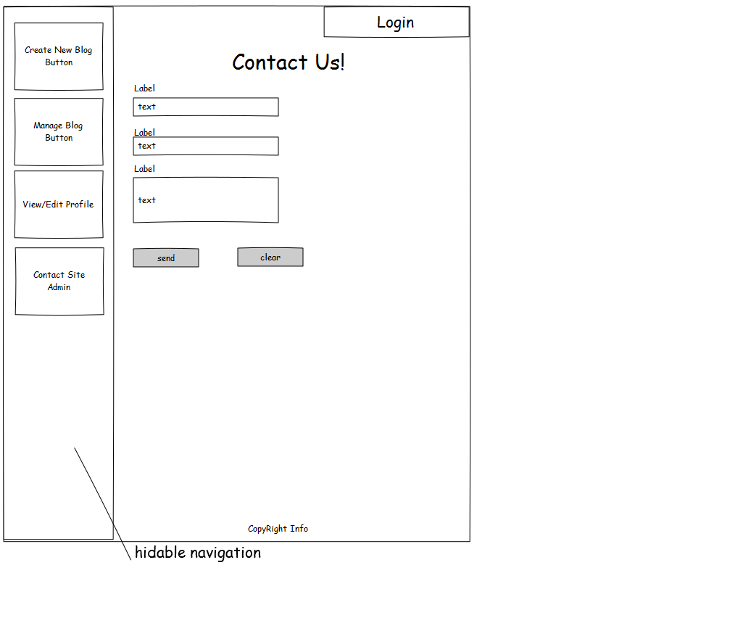

# Screen Capture:

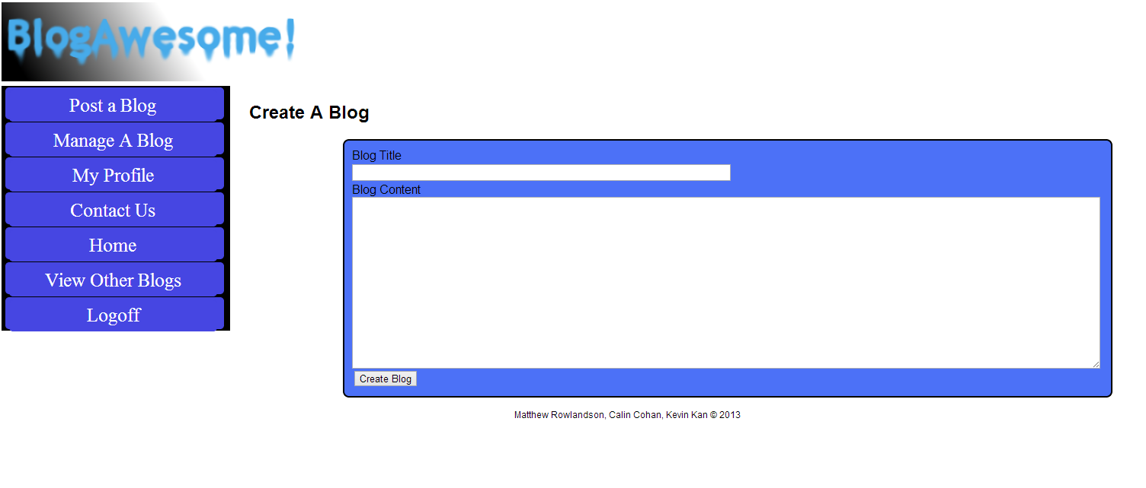Create or Edit Blogs page

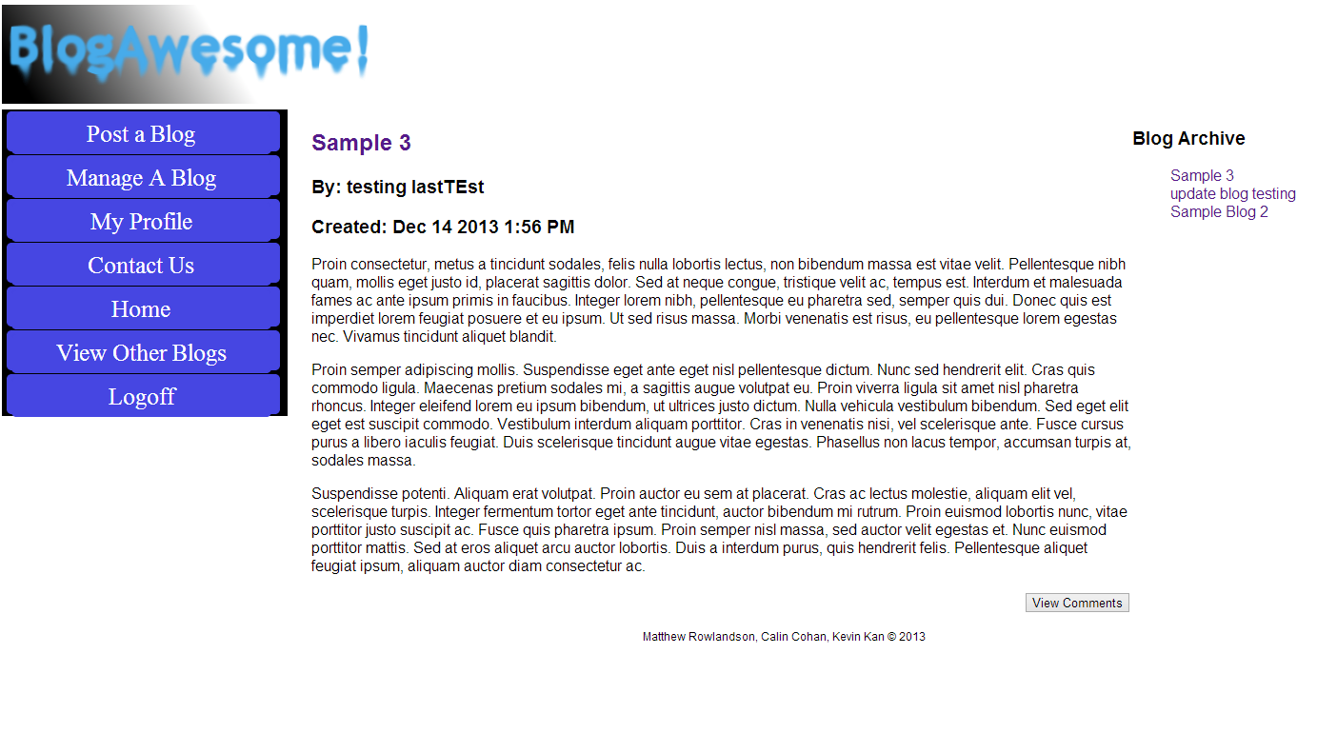index.php

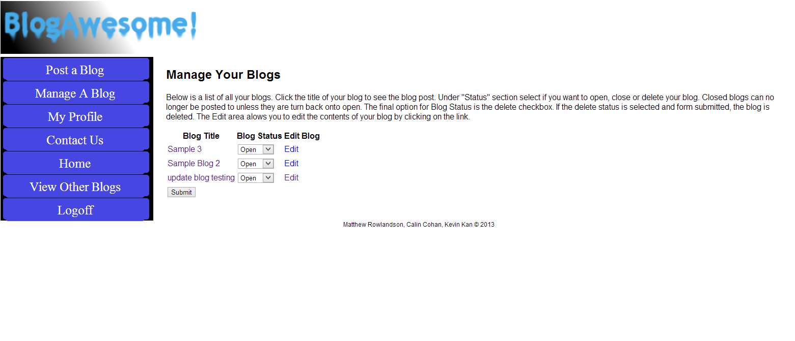manageBlog.php

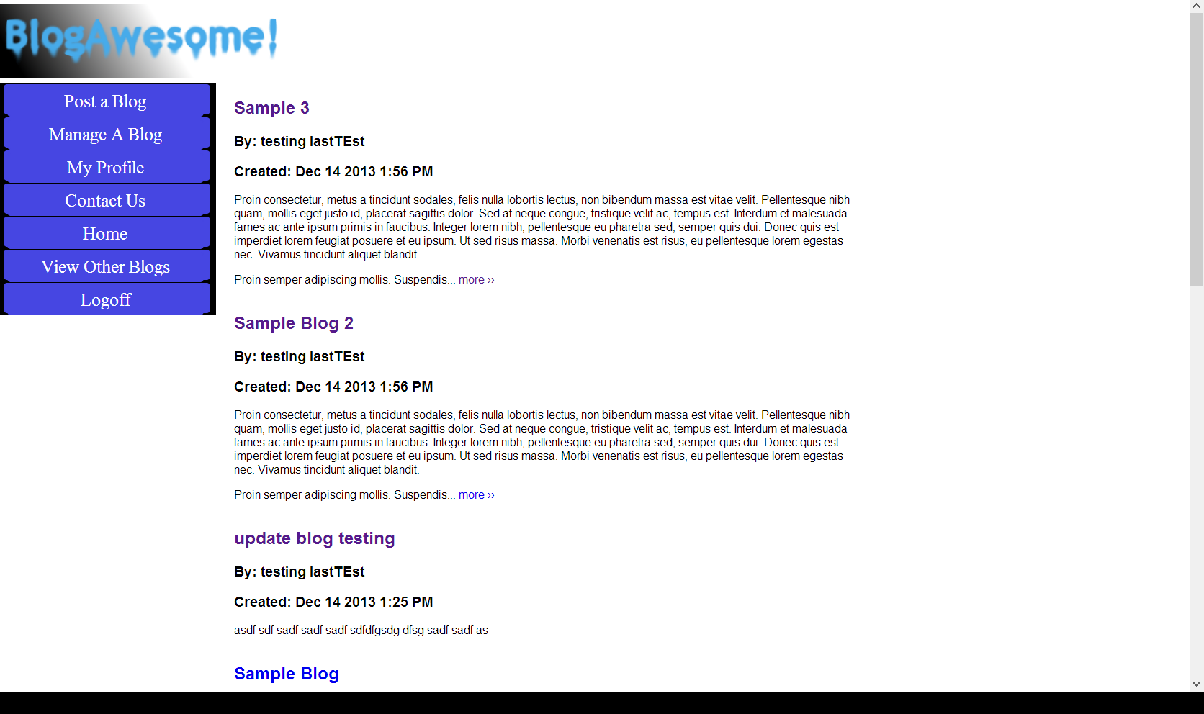View Other Blogs

Profile.php

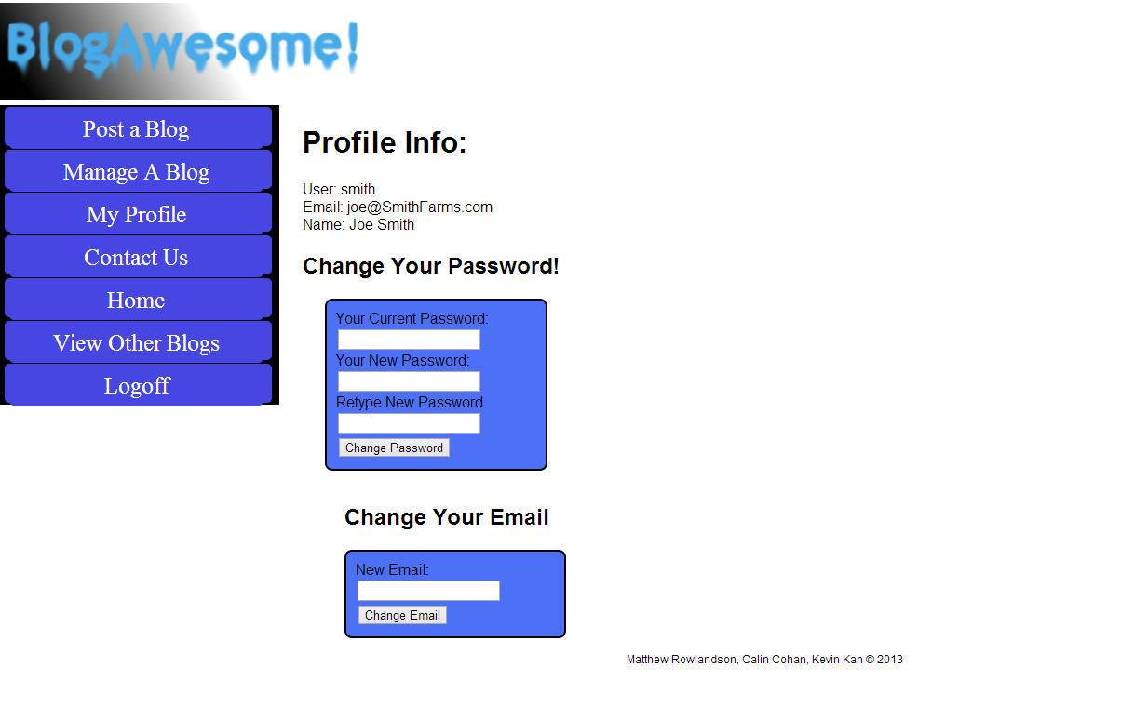

Contactus.php

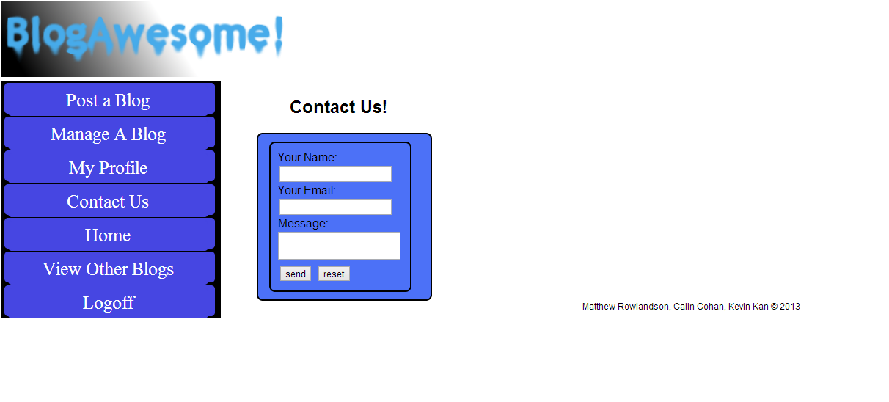

# Potential Future Additions:

* Upload photos and compressed files
* url handling
* wordpress like packaging
* account moderators
* statistical evaluations for site visiting, blog post views etc.