**WEB DATABASES PROJECT**

#### **DELIVERABLE # 1**



1. **PROJECT BRIEF/DESCRIPTION**

My project is based on Restaurant. This is a web application that I am going to create for a restaurant.

* This application will have restaurant menu which obviously will have all the food items listed with their names, descriptions, prices and other few details.
* It will also have an option for users to register or create an account for restaurant where they can have their own space.
* After registration users can login, they can save their contact information in the account.
* There will be a login for the administrator or restaurant owner which will provide him different privileges on the web application such as admin can add, delete and edit the name, description, price and other details about the food items.
* There will be a search box provided for the users so that they can search the food items by their names or by using some other possible keywords.

1. **LIST OF FEATURES/ESTIMATE SHEET**

1. **SITEMAP**

* User Entrance page
  + Login
  + Register
  + User Page
    - Search Book
    - My Account
      * Edit Information
      * Check loan status
    - Contact Us
* Admin Entrance Page
  + login
  + Admin Page
    - My Account
    - User Management
    - Book Management
      * Add New Book
      * Edit Book information

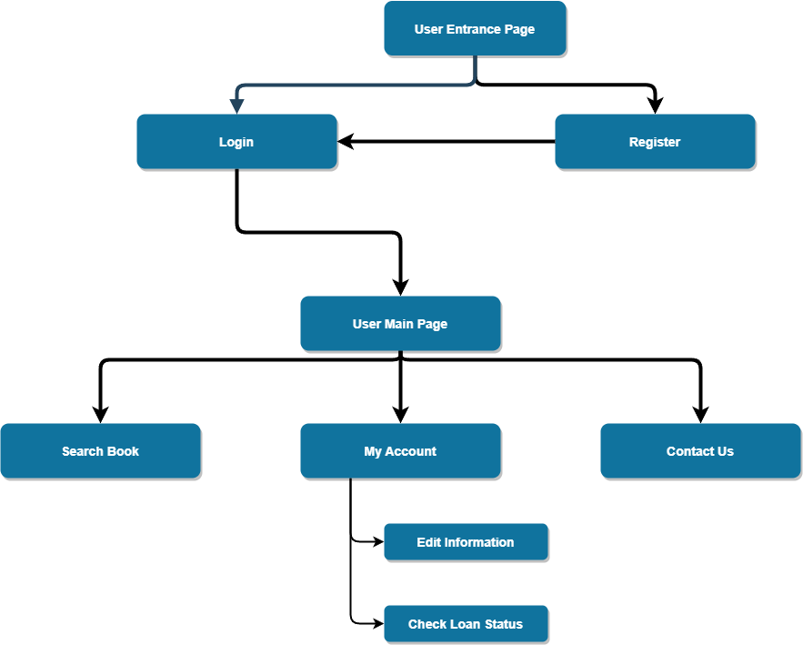

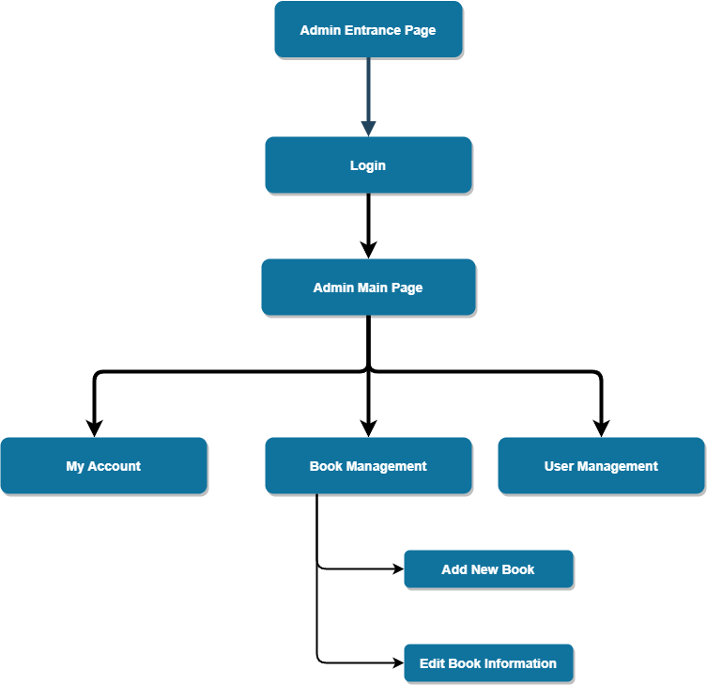

1. **WIREFRAMES**

**Main Login Page**

**Registration Page**

**Home Page**

**Menu Page**

The EDIT option will only be available for admin.

**Edit Form Page**

