



1. **PROJECT BRIEF/DESCRIPTION**

* This application is designed for a school of a library to manage the books.
* The user interface has homepage, registration page, login page, personal information modify page, inquiry page.
* As a user, he can register, log in, modify his personal information, inquire books, log out,

borrow and return books.

* The background interface has admin login page, password modify page, user management page, book management page, book storage page, book inquiry page, book statistic page,
* As an admin, he can

log in the background, change the password, manage users, log out, modify book information, delete books, store books, inquire books, get book statistics.

1. **LIST OF FEATURES/ESTIMATE SHEET**

| **NO** | **Title** | **Design** | **Front-end** | **Back-end** | **Description** |
| --- | --- | --- | --- | --- | --- |
| 1 | Home page | 1 hour | 2 hours | 2 hours |  |
| 2 | Registration page | 3 hours | 10 hours | 10 hours |  |
| 3 | Login page | 1 hour | 2 hours | 2 hours |  |
| 4 | Profile page | 1 hour | 5 hours | 5 hours |  |
| 5 | Inquiry page | 3 hours | 10hours | 10 hours |  |
| 6 | Admin login page | 1 hour | 2 hours | 2 hours |  |
| 7 | Password page | 1 hour | 2 hours | 2 hours |  |
| 8 | User management page | 1 hour | 5 hours | 5 hours |  |
| 9 | Book management page | 3 hours | 10 hours | 10 hours |  |
| 10 | Book storage page | 3 hours | 10 hours | 10 hours |  |
| 11 | Book inquiry page | 3hours | 10 hours | 10 hours |  |
| 12 | Book statistic page | 3 hours | 10 hours | 10 hours |  |
| 13 | Database | 3 hours | 5 hours | 10 hours |  |

1. **SITEMAP**

* User Entrance page
  + Login
  + Register
  + User Page
    - Search Book
    - My Account
      * Edit Information
      * Check loan status
    - Contact Us
* Admin Entrance Page
  + login
  + Admin Page
    - My Account
    - User Management
    - Book Management
      * Add New Book
      * Edit Book information

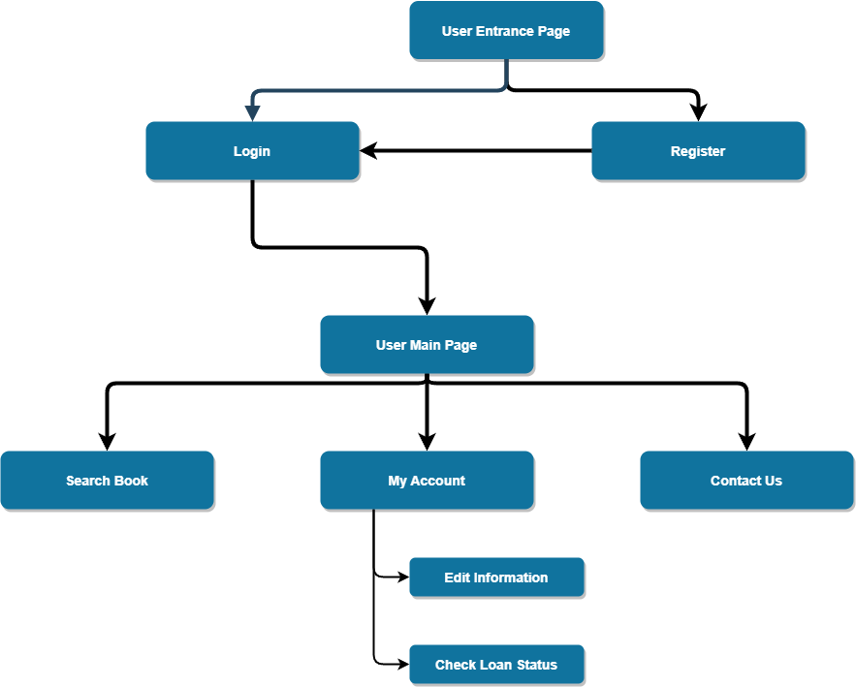

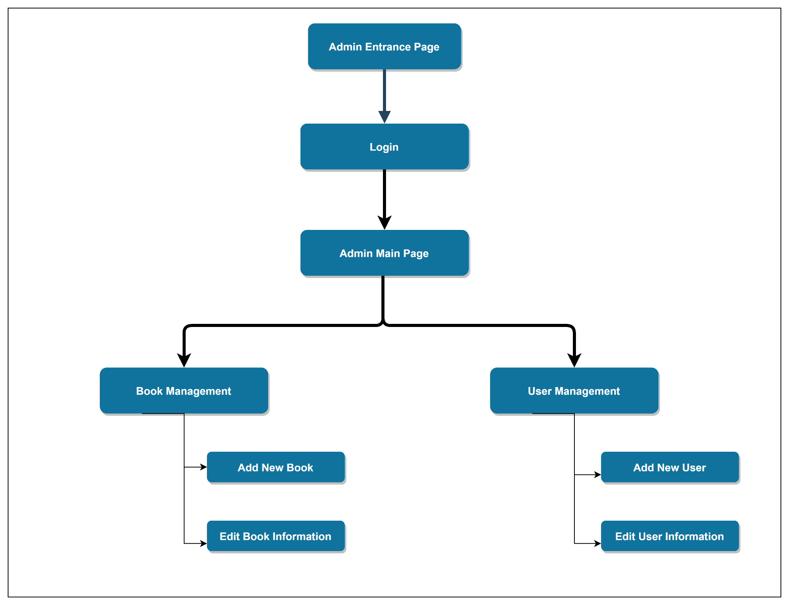

1. **WIREFRAMES**

**User Login Page**

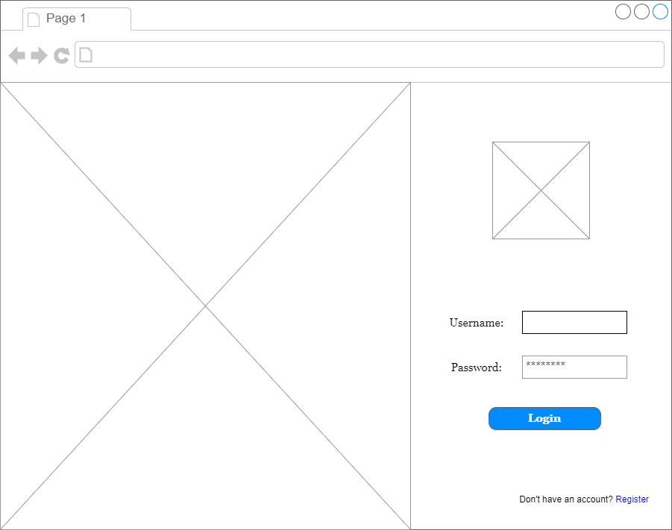

**User Registration Page**

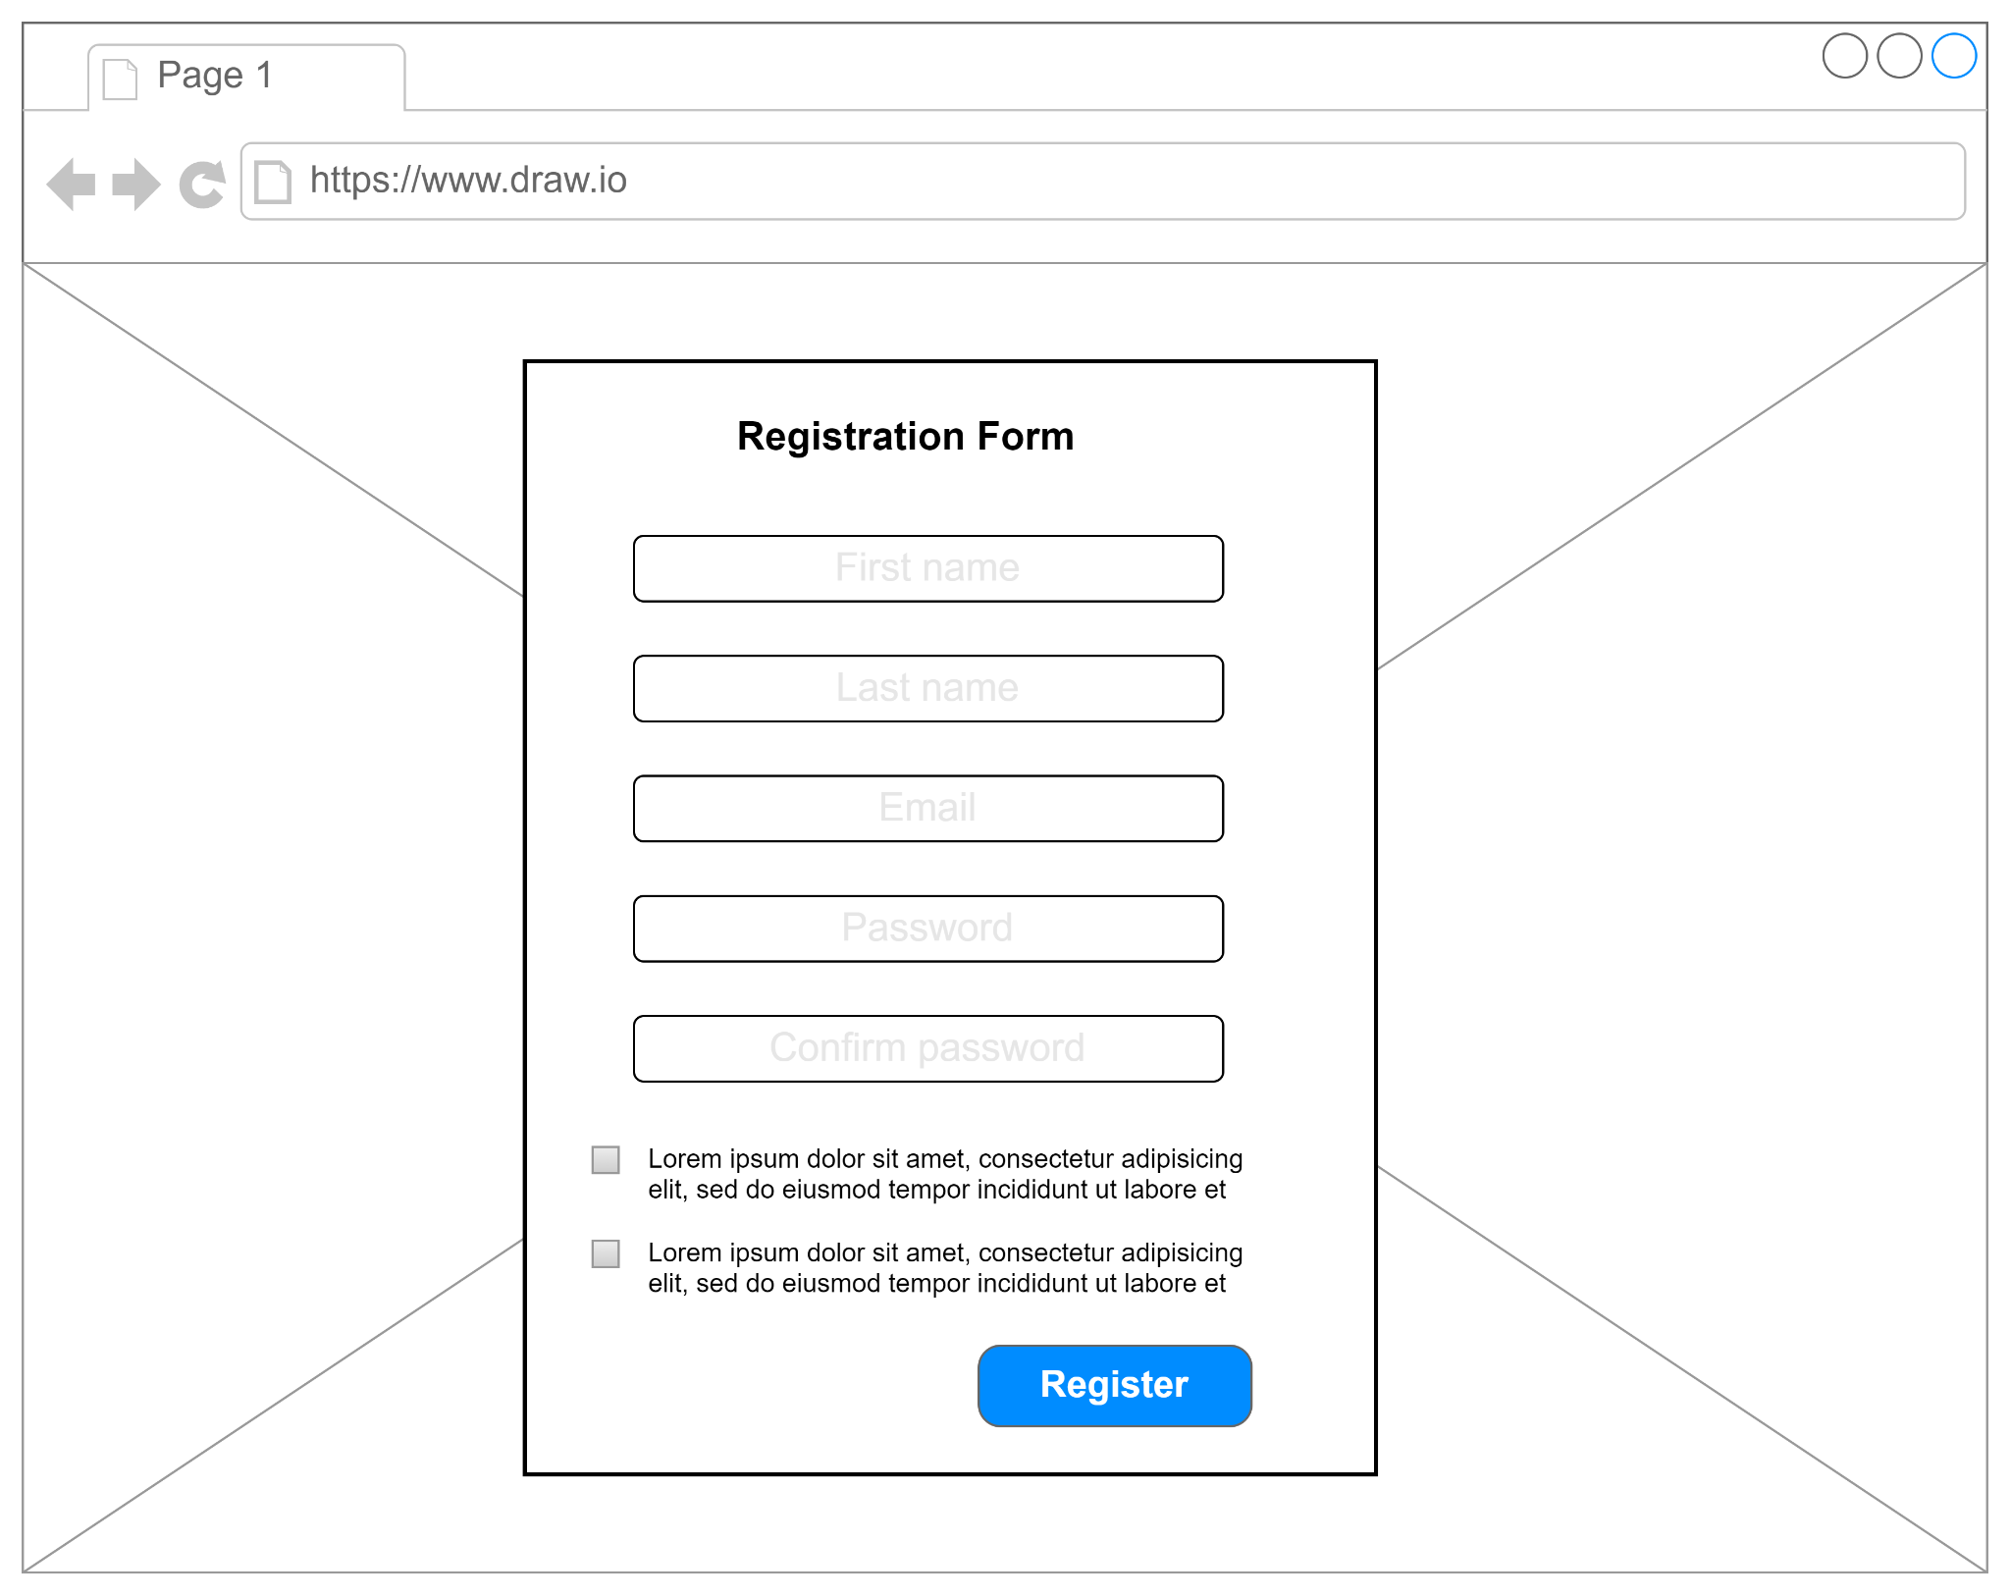

**User Home Page**

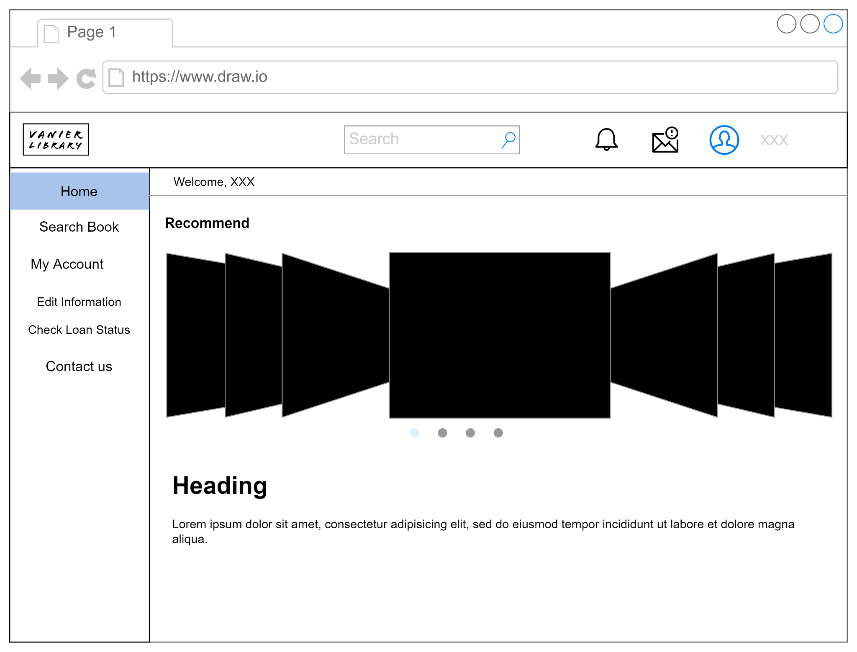

**Search Book Page**

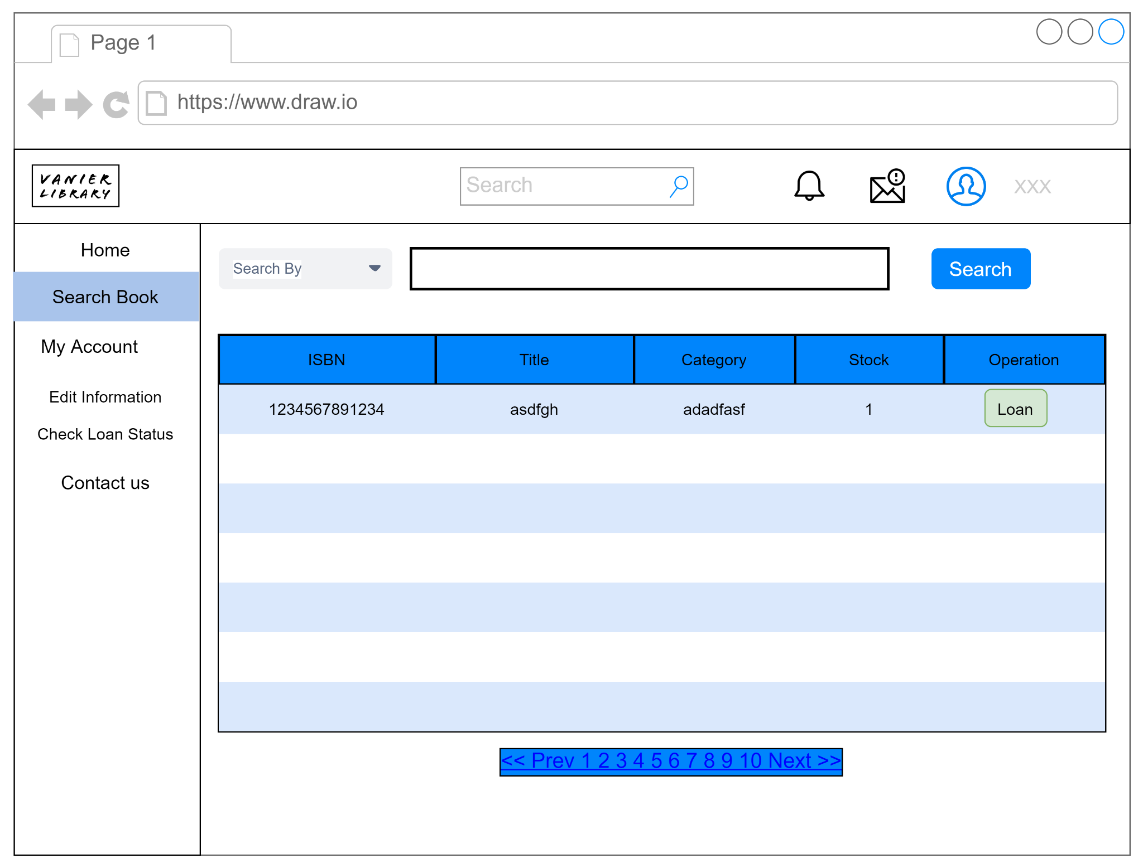

**Edit Information Page**

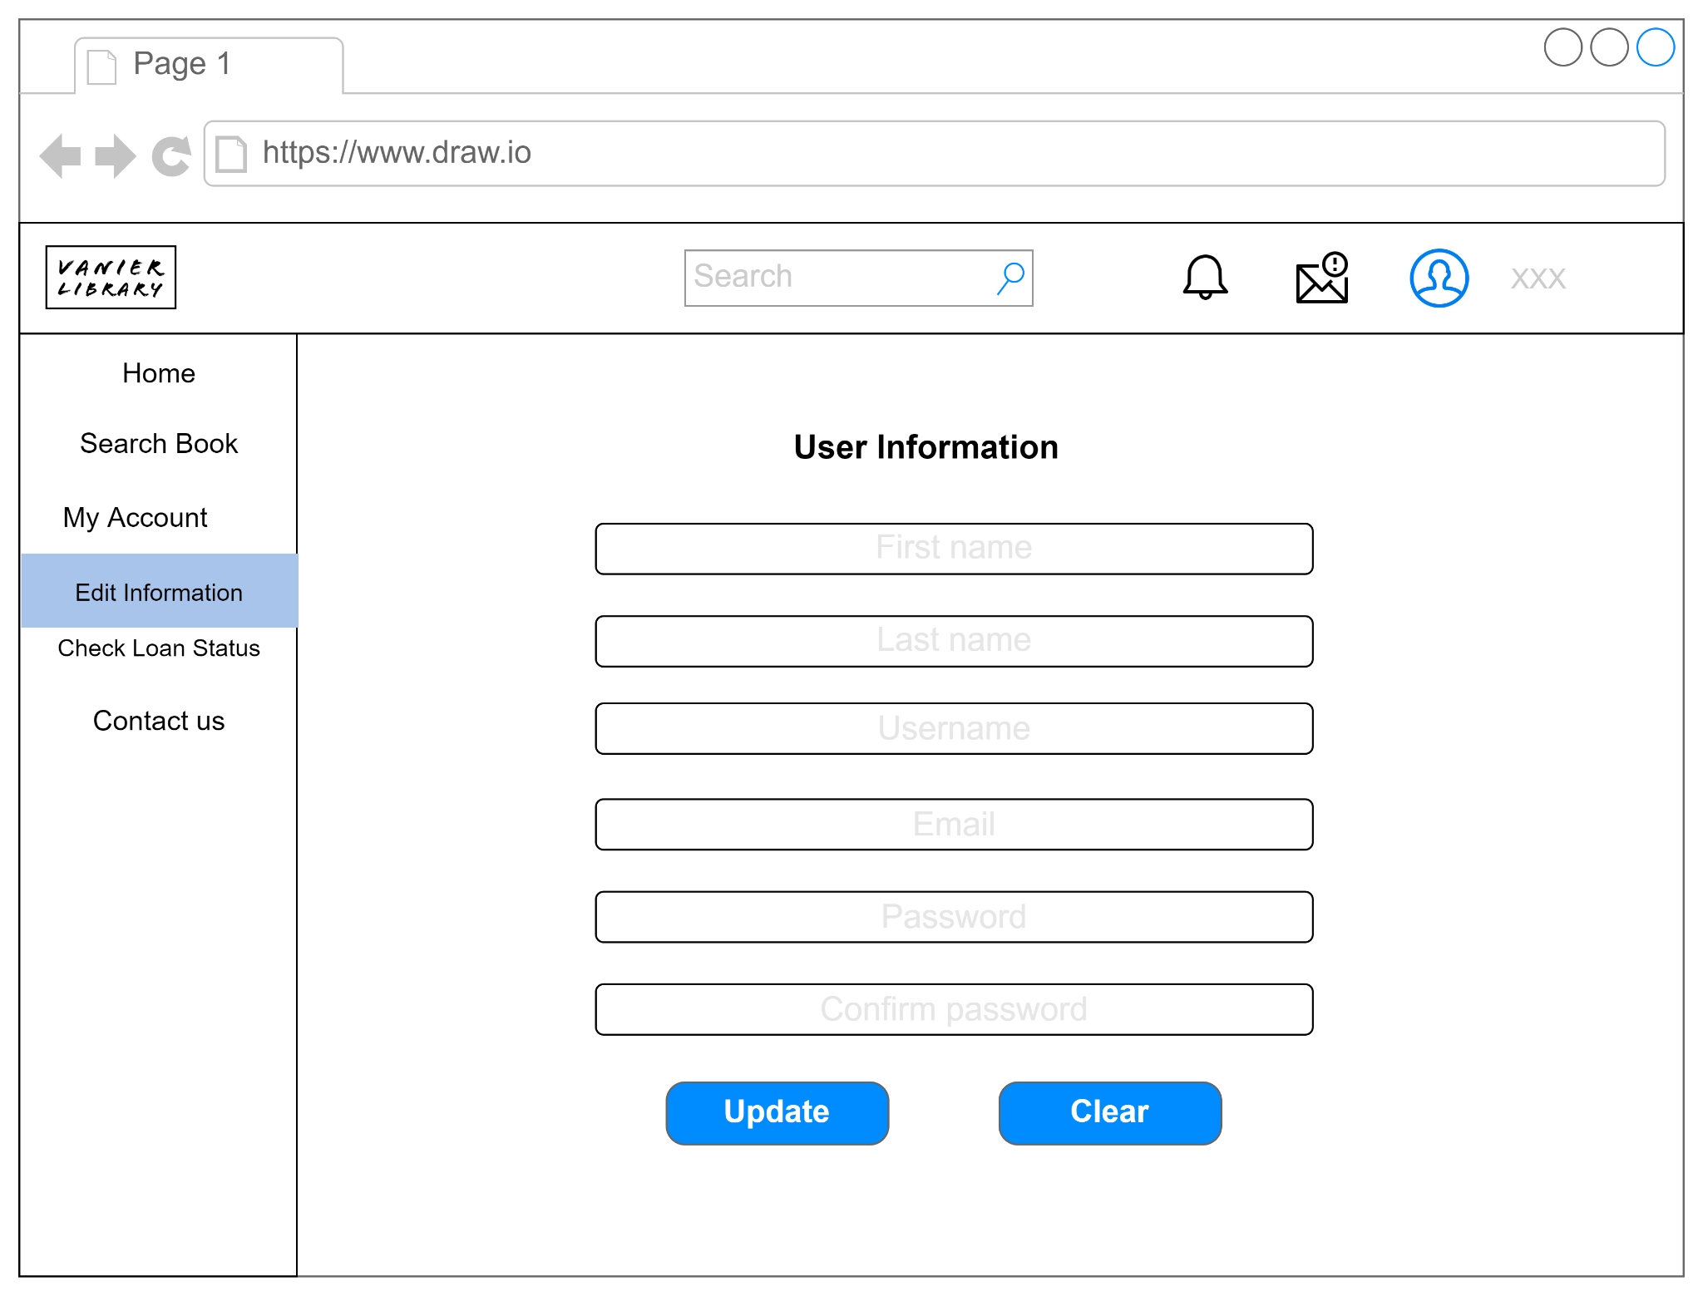

**Check Loan Status Page**

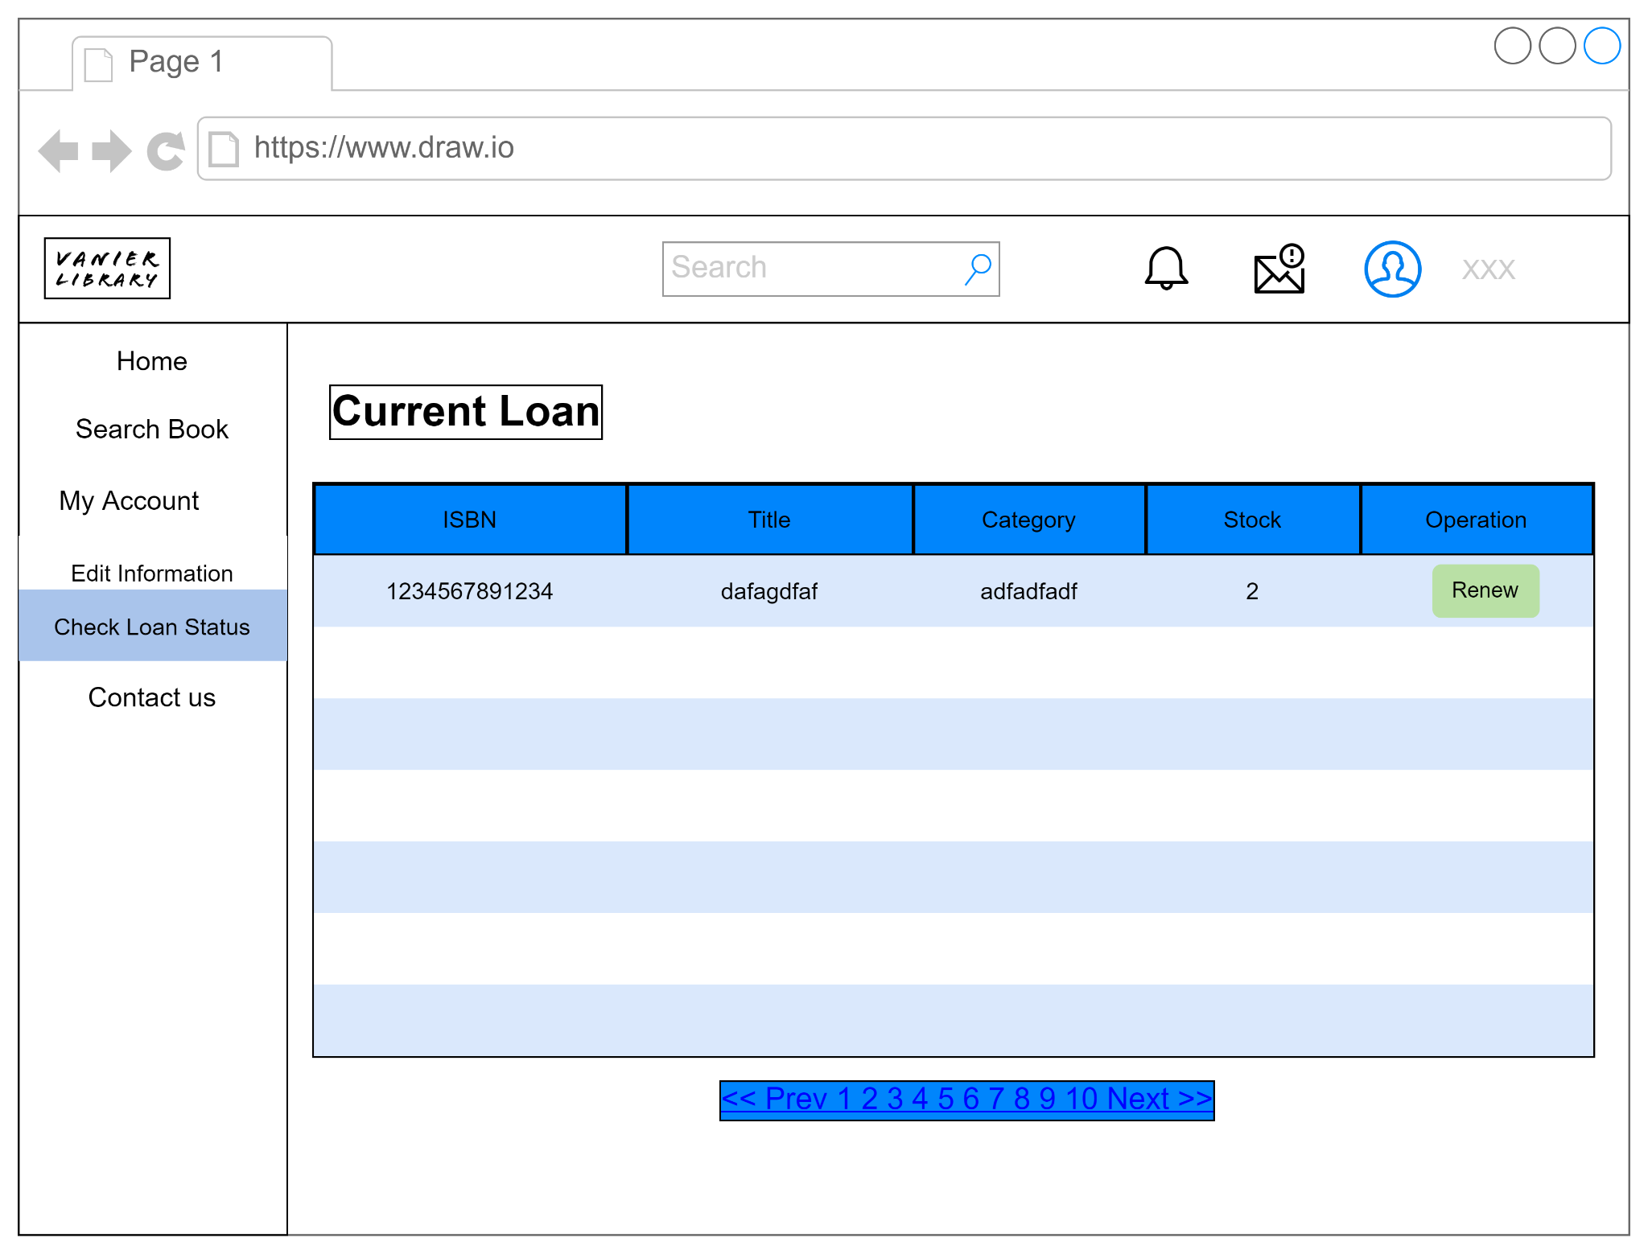

**Contact Us Page**

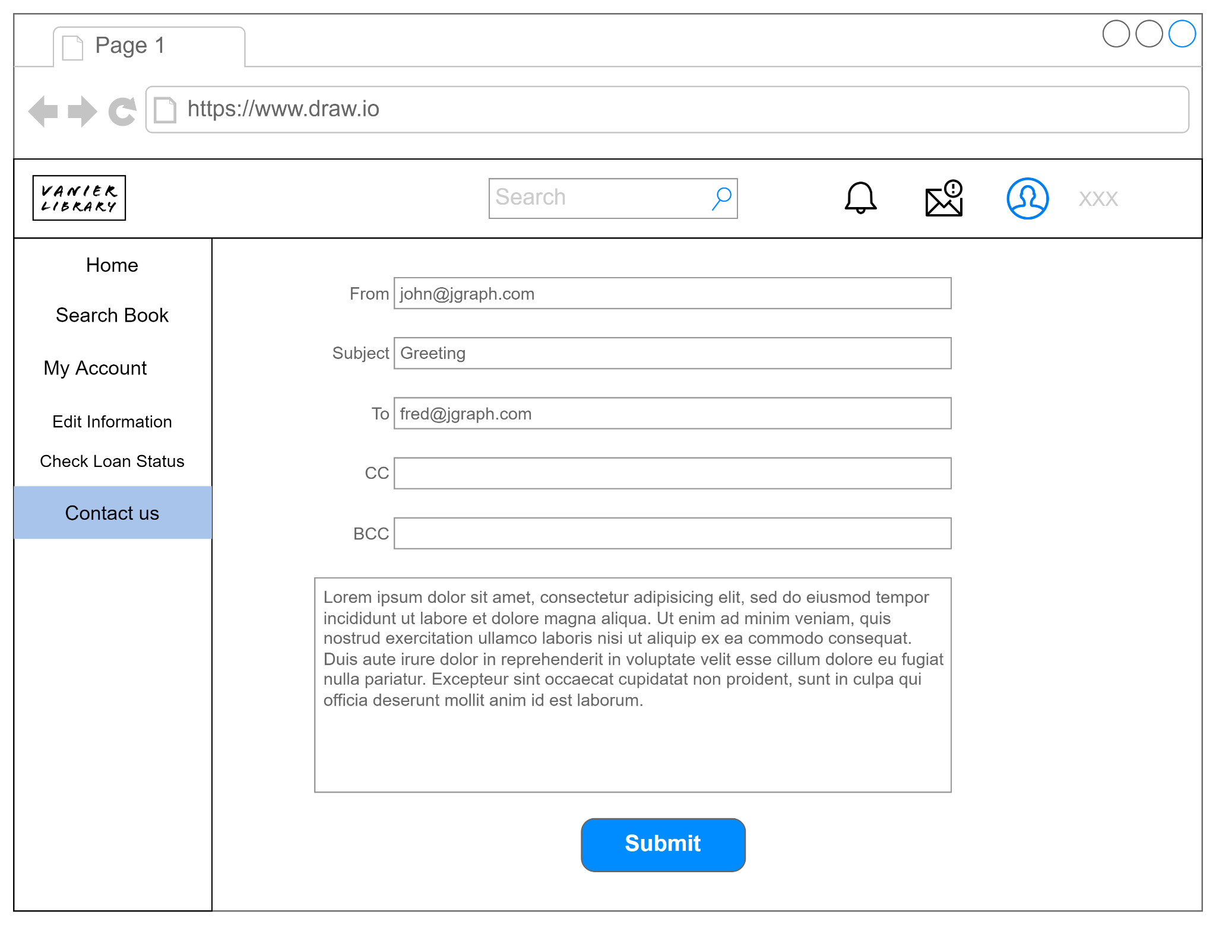

**Admin Login Page**

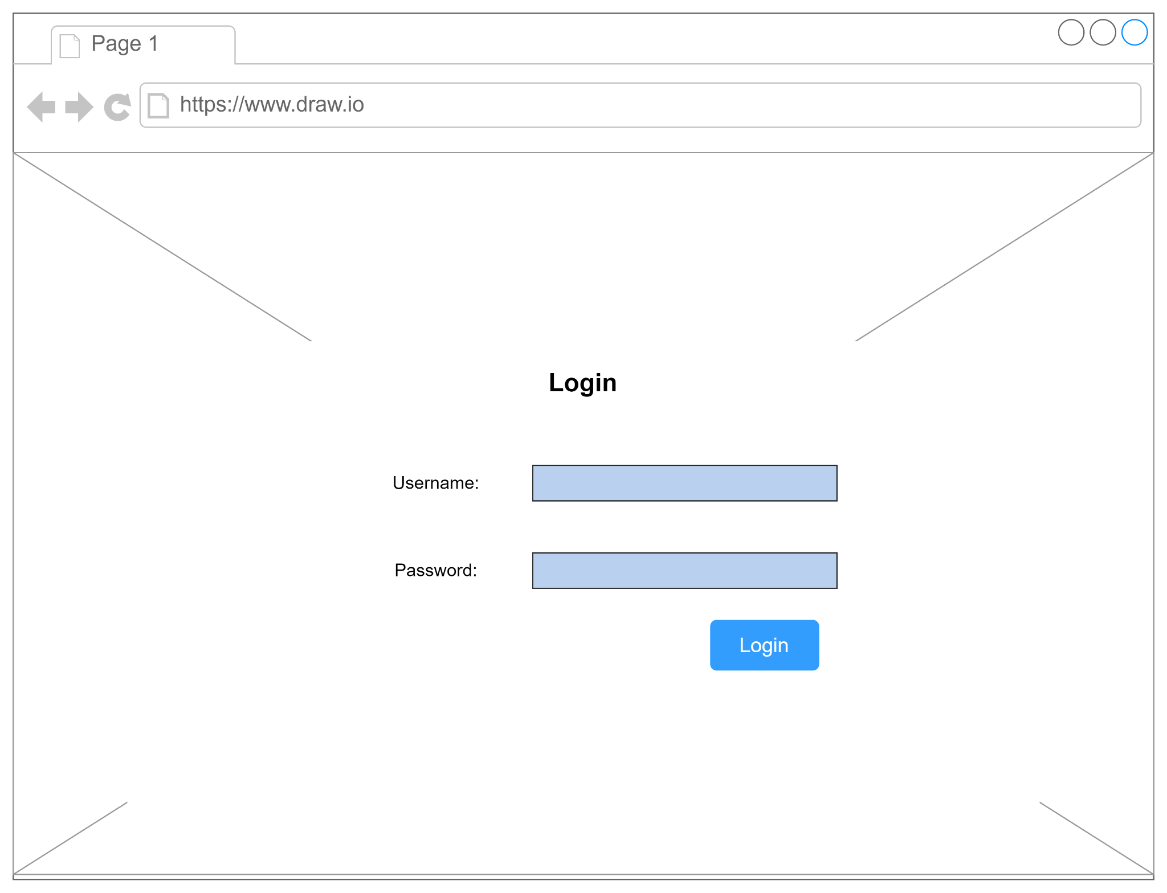

**Add New Book Page**

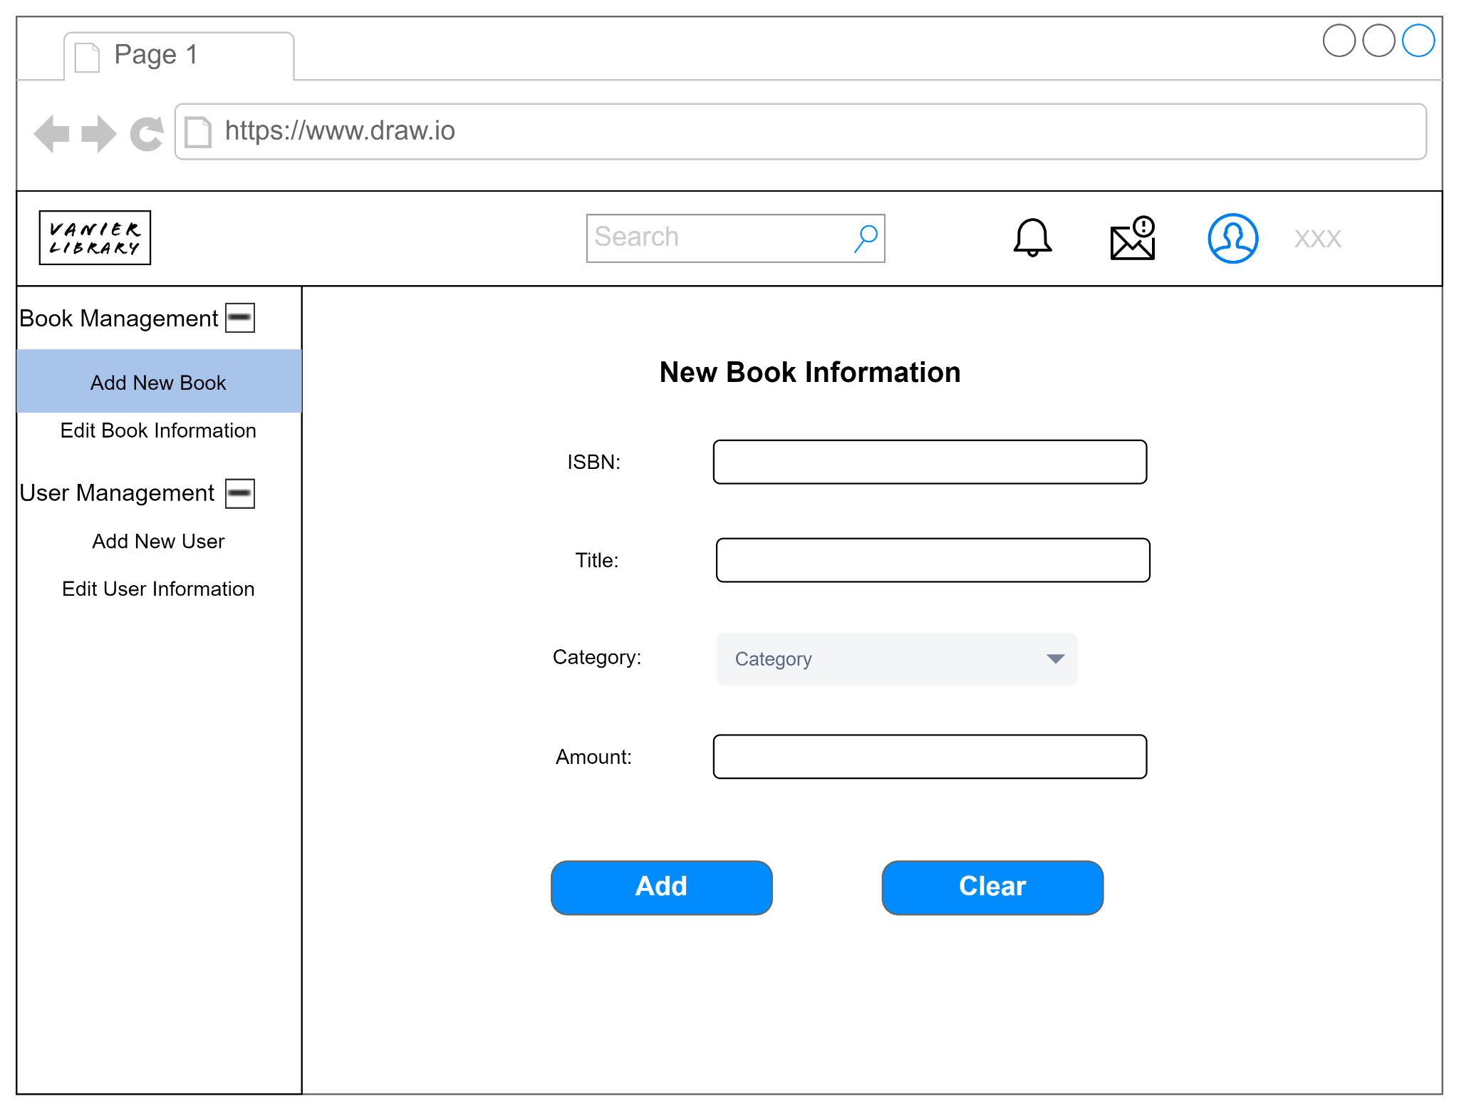

**Edit Book Information**

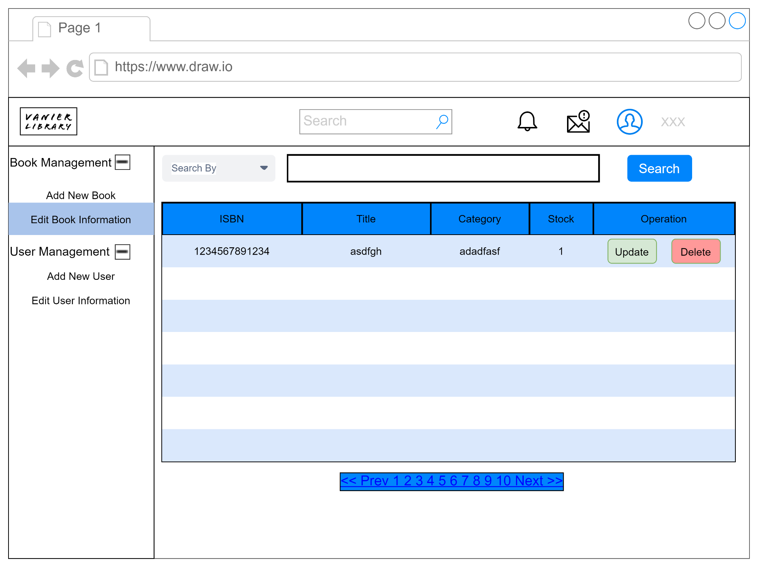

**Add New User**

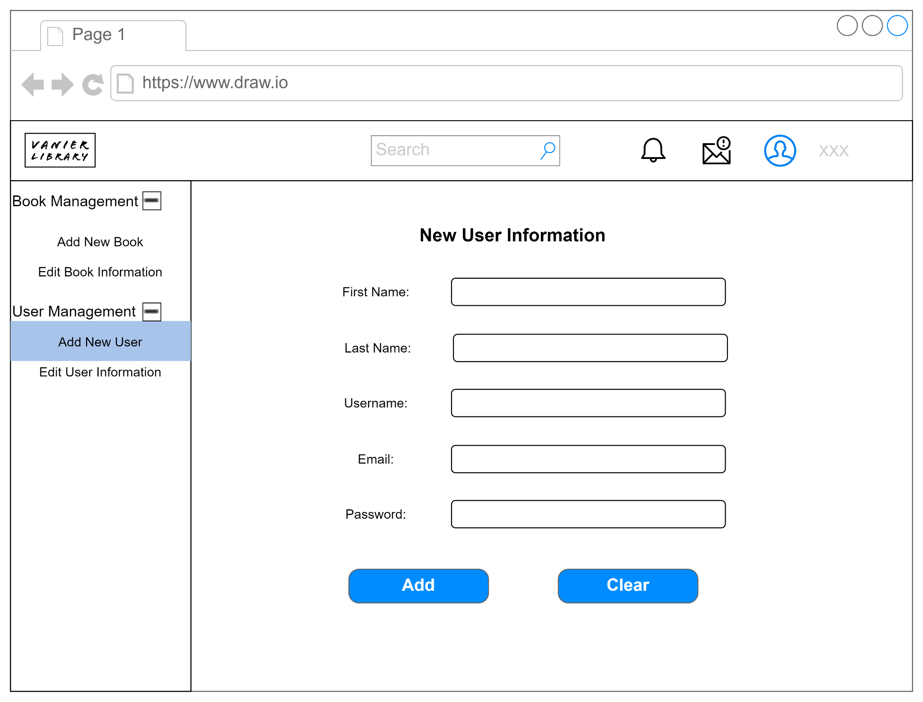

**Edit User Information**

