Final report Web Technology – 2ID60 – group 7

Coen de Vente, Max van Hattum, Enzo Lucas and Thijs Visser

Hosted on: restaurantwebapp.pe.hu

Motivation

For our final project we decided to create a web app which allows users to retrieve information of restaurants, place reviews and place orders at the queried for restaurants. We also allow restaurant owners to create a page for their own restaurant and add certain information, including a menu and on online order for. The motivation for this came to our group while we were exploring the different functionalities API services offer. The way we see it a restaurant is basically a combination of different kinds of information. It has a place in the real world, it has a variety of food to offer and it is a business. A business which wants to attract customers and make profit. In the old days, attracting potential costumers was done by word of mouth; visitors would tell their friends and family about their experience at the restaurant. But, since we now have the internet, visitors can tell of their experience at the restaurant to a much bigger audience online. Sites like Tripadvisor and Yelp offer this possibility of letting people know of your experience and it were these sites we used as inspiration. However, we wanted to extend this functionality. We also allow for user to place orders directly to the particular restaurant.
Moreover, as previously mentioned we enable restaurant owners to create a page describing their restaurant and place an online menu there.

Data

For our web app we use multiple API’s. The most important one is the Yelp API, this is used to get the information of most of the currently existing restaurants. We use 2 datasets from Yelp, one for searching restaurants in a specific location, this is the Yelp search API: http://www.yelp.com/developers/documentation/v2/search_api; The other one is the Yelp business API, this is used to get more elaborated information regarding a specific restaurant:
http://www.yelp.com/developers/documentation/v2/business.

To give a livelier feel to the restaurant pages, we also use the Flickr API to provide a picture related to the restaurant in question. Where possible, we want to use a picture of the actual restaurant, but if this is not possible, we go down different alternatives, for example, we search for city or food.
https://api.flickr.com/services/rest/ .

We also use the Google.maps API, which allows us to display a map with the queried restaurant in order to give a clear view of its location. Additionally, we check the user’s location with this API, which enables us to let the user decide how far away the restaurant should be from his current position.
http://maps.googleapis.com/maps/api/geocode/output?parameters

Furthermore, we use our own user generated data set, containing user information, reviews, restaurants, menus and orders. This dataset can be found at:
http://www.db4free.net/ and is called restaurantwebapp.

Technical architecture

Because specific style of technical architecture was mentioned in the assignment, I have generated a table which shows how the different interfaces lock together.

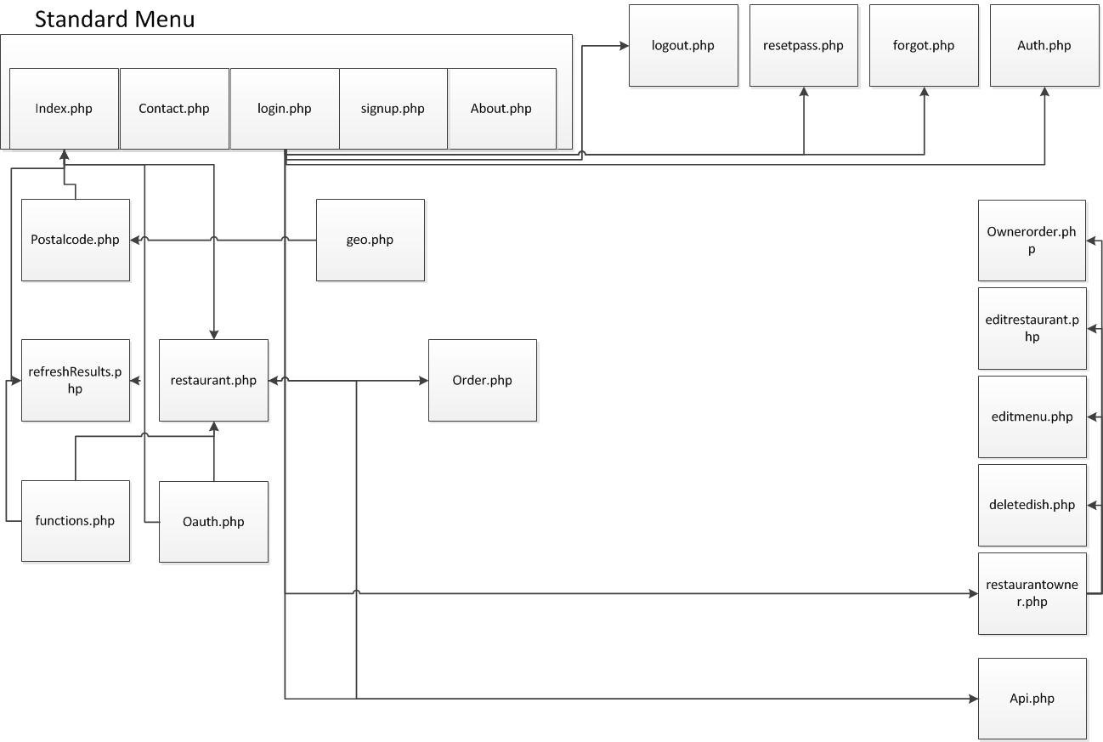
The key concept here is that there is a central menu, accessible from all pages. And that when you are signed in, lots of extra functions become available. When you are on specific restaurant page, you will be made aware of this.

User data

As mentioned a couple times before, we track the user information on several occasions. This start the moment the user visits our site. The site lets you search by location, and is able to find the location the user currently is. Also, we let user create an account, which offers extended functionality. A registered user can write reviews, and can become a restaurant owner and add information to his or hers own restaurant page. Also, users are able to place orders directly to restaurant which allow for this.

Reflection

I believe this course has succeeded in transmitting its learning objectives. I think I speak for my entire group when I say that all of us have learned interesting new concepts regarding web development. Because for each team member their background knowledge was different, some of use learned more than others of course, but overall I would say it was a successful experience.
I do want to mention that in my opinion the lectures were not really contributing to my knowledge of web technology. It was moving too much matter in a too small amount of time and in the end, most of the information I needed I would find online anyway. Therefore, I would like to suggest that for this course a list of tutorials is posted online (on Sakai for example) instead of lectures and focus more on the workshops. I believe this would be more efficient.

Effort

When it comes to effort, I can honestly say we spend a lot of time on this project. Far more than the usual amount of time spend on other courses. I do have to be honest when I say that we did not contribute equally to this project, mainly because of different levels of background knowledge among team members.
If I were to make an estimation, I would look something like this:
Coen: 40%
Max: 30%
Enzo: 20%
Thijs: 10%

However, this is based on results delivered, not per se on time spend on the assignment, because for some this assignment was more challenging than others.

