A Comparative Analysis of Scheduling Methodologies in Information Systems Project Management: Gantt Charts and PERT Diagrams
Table of Contents
A Comparative Analysis of Scheduling Methodologies in Information Systems Project Management: Gantt Charts and PERT Diagrams 1
1. Introduction 2
2. Historical Background of Project Scheduling Tools 2
2.1 Early Project Planning Methods 2
2.2 Development of the Gantt Chart 3
2.3 Emergence of the PERT Method 3
3. Gantt Charts 4
3.1 Structural Components of a Gantt Chart 4
3.2 Example Gantt Chart 4
3.3 Strengths of Gantt Charts 5
3.4 Limitations of Gantt Charts 6
4. PERT Diagrams 6
4.1 Structural Components of a PERT Diagram 6
4.2 Example PERT Diagram 7
4.3 Strengths of PERT Diagrams 8
4.4 Limitations of PERT Diagrams 9
5. Comparative Analysis of Gantt Charts and PERT Diagrams 9
5.1 Visualization and Readability 9
5.2 Planning Accuracy and Critical Path Analysis 10
5.3 Suitability for Different Project Types 10
6. Use Cases for Each Method 10
7. AI and the Organization of Structured Project Knowledge 11
8. Conclusion 11
9. AI Methodology Statement 12
10. References 12

1. Introduction
The discipline of project management within the context of Information Systems has evolved into a highly sophisticated field where the synchronization of resources, timelines, and deliverables is paramount. As projects grow in complexity, the necessity for robust scheduling tools becomes increasingly evident. Two of the most enduring and widely utilized methodologies in this arena are the Gantt chart and the Program Evaluation and Review Technique, commonly known as the PERT diagram. While both tools serve the primary goal of facilitating project completion, they approach the problem of time and task management from fundamentally different perspectives.
The Gantt chart, characterized by its linear and intuitive bar chart format, focuses on the chronological progression of tasks against a calendar baseline. It provides a visual representation of when things happen. Conversely, the PERT diagram, rooted in network theory and statistical probability, emphasizes the logical relationships and dependencies between activities. It focuses more on the how and in what order things happen, particularly under conditions of uncertainty.
The modern project environment is often characterized by a paradox of needing both rigidity for accountability and flexibility for innovation. Information Systems projects, in particular, frequently suffer from scope creep and unforeseen technical debt, making the choice of scheduling tool a strategic decision rather than a mere administrative one. This paper provides an exhaustive comparative analysis of these two methodologies. It begins by situating both tools within their historical contexts, tracing their origins from the early twentieth century to the modern era. Following this, it examines the structural components of each method, utilizing illustrative diagrams to clarify their practical application. The core of the discussion explores the relative strengths and limitations of both Gantt and PERT, leading into a detailed comparative analysis that evaluates their performance in terms of readability, accuracy, and suitability for various project environments. Finally, the paper discusses the role of modern Information Systems, specifically Artificial Intelligence, in synthesizing these structured knowledge formats to enhance project outcomes.

2. Historical Background of Project Scheduling Tools

2.1 Early Project Planning Methods
Before the formalization of project management as a distinct discipline, large scale endeavors were managed through rudimentary methods often characterized by trial and error or decentralized oversight. During the Industrial Revolution, the increasing scale of manufacturing and infrastructure projects necessitated a more systematic approach. Early managers relied heavily on lists and simple verbal instructions. However, as the complexity of engineering projects grew, these methods proved insufficient for coordinating the specialized labor and materials required for modern industrial success.
In the mid nineteenth century, the expansion of the railroads required the coordination of thousands of workers across vast geographical distances. This era saw the first iterations of organizational charts and detailed reporting structures, but a standardized way to visualize time remained elusive. Most planning was done in a serial fashion, with little regard for how concurrent tasks might impact one another. It was within this environment of industrial expansion that the need for a visual time management tool was first identified.

2.2 Development of the Gantt Chart
The Gantt chart was developed by Henry Gantt, an American engineer and management consultant, in the early 1910s. Gantt was a protege of Frederick Winslow Taylor, the father of Scientific Management. While Taylor focused on the efficiency of individual workers, Gantt turned his attention to the efficiency of the entire production process. His primary innovation was the use of a horizontal bar chart to represent the amount of time required for various tasks.
Initially used for production scheduling in factories, the Gantt chart gained national prominence during World War I. The United States military utilized it to manage the complex logistics of ship building and munitions production. Its ability to provide a clear, at a glance summary of progress made it an indispensable tool for senior officials who needed to monitor massive projects without getting bogged down in minute technical details. Over the subsequent decades, the Gantt chart became the standard for industrial planning, eventually transitioning into the digital era as a core feature of project management software. It is important to note that Gantt's work was preceded by Karol Adamiecki, who created a similar tool called the Harmonogram, but Gantt’s publication in English led to the widespread adoption of his namesake tool.

2.3 Emergence of the PERT Method
The Program Evaluation and Review Technique emerged nearly half a century later under significantly different circumstances. In the late 1950s, the United States Navy was engaged in the development of the Polaris submarine launched ballistic missile project. This project was characterized by extreme technical uncertainty and an aggressive timeline involving thousands of contractors. Conventional scheduling tools like the Gantt chart were deemed inadequate because they could not easily account for the unpredictable nature of research and development activities.
The Special Projects Office of the Navy, in collaboration with the consulting firm Booz Allen Hamilton and the Lockheed Corporation, developed PERT to address these challenges. Unlike the Gantt chart, PERT was designed to handle projects where the duration of tasks was not known with certainty. By utilizing a network of nodes and arrows, PERT allowed planners to model the logical flow of work and identify the critical path, the sequence of tasks that determines the shortest possible duration for the project. The success of the Polaris project, which was completed years ahead of schedule, solidified PERT as a foundational tool for complex research, defense, and engineering projects. It introduced the concept of the network diagram, which would later become the basis for the Critical Path Method used in the private sector.

3. Gantt Charts

3.1 Structural Components of a Gantt Chart
The Gantt chart is fundamentally a two dimensional grid that maps project tasks against a time axis. Its structural simplicity is its greatest asset, allowing it to be understood by stakeholders at all levels of an organization.

3.1.1 Timeline Representation
The horizontal axis of a Gantt chart represents time. This can be scaled in hours, days, weeks, months, or even years, depending on the duration of the project. Tasks are represented as horizontal bars, where the position and length of the bar indicate the start date, duration, and end date of the activity. This linear representation allows a project manager to see exactly which tasks are scheduled for a specific day and how those tasks overlap with one another. The visual weight of the bar gives an immediate, though sometimes misleading, sense of the effort required for a task.

3.1.2 Task Sequencing
Tasks are listed vertically on the left side of the chart. In a well structured Gantt chart, these tasks follow a logical sequence, often mirroring the Work Breakdown Structure of the project. This vertical listing allows for the categorization of tasks into phases or work packages. By grouping related activities together, the manager can maintain a hierarchical view of the project, moving from high level milestones down to granular daily activities. This hierarchy is essential for managing large scale Information Systems projects where hundreds of sub tasks must be nested under major deliverables like "Database Schema Design" or "User Acceptance Testing."

3.1.3 Dependency Relationships
While early Gantt charts were simple static bars, modern versions incorporate dependencies. These are typically represented by lines or arrows connecting the bars. For example, a Finish to Start dependency indicates that Task B cannot begin until Task A is completed. Other common dependencies include Start to Start, where two tasks must begin simultaneously, and Finish to Finish, where two tasks must conclude at the same time. These visual connectors provide a basic understanding of how a delay in one task might ripple through the subsequent schedule, though they do not always convey the mathematical impact of those delays as clearly as a network diagram.

3.2 Example Gantt Chart
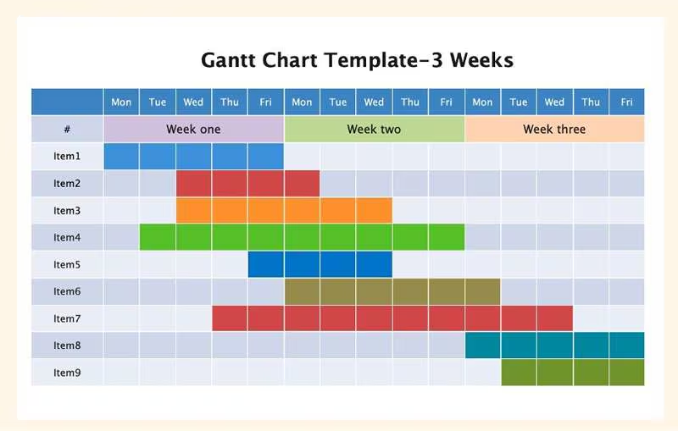
Figure 1: Simplified SVG Gantt Chart representing task progression

3.3 Strengths of Gantt Charts
The primary strength of the Gantt chart lies in its clarity and accessibility. In a corporate environment, where project stakeholders often include non technical executives or clients, the ability to present a project status visually is invaluable. It answers the most common question in project management: What is happening right now? The use of colors and shading allows for a quick assessment of health, where green bars might indicate completion and red bars indicate overdue tasks.
Furthermore, Gantt charts are exceptional for resource management. By looking at the overlaps of tasks, a manager can quickly identify periods of high activity where resources might be overextended. For instance, if four different tasks requiring the same database administrator are scheduled for the same week, the Gantt chart makes this conflict immediately apparent. This visual feedback loop allows for resource leveling, where tasks are shifted to balance the workload over time. In Information Systems, where specialized talent is often a bottleneck, this visibility is crucial for maintaining morale and preventing burnout.
Finally, Gantt charts serve as an excellent baseline for tracking progress. As tasks are completed, the bars can be shaded or colored to indicate the percentage of completion. This provides a real time comparison between the planned schedule and the actual performance, allowing managers to identify delays early and take corrective action. This tracking is often integrated with financial reporting, providing a direct link between project time and budget consumption.

3.4 Limitations of Gantt Charts
Despite their popularity, Gantt charts have significant limitations, particularly as projects increase in complexity. The most notable weakness is the difficulty in representing complex interdependencies. While modern software allows for arrows between tasks, a project with hundreds of activities quickly becomes a spaghetti chart where the lines of dependency cross so frequently that the diagram becomes illegible. This can lead to a false sense of simplicity, where the manager believes they have a handle on the project logic because the bars look organized, while the underlying connections are actually a tangled mess.
Another limitation is the lack of information regarding task flexibility. A Gantt chart shows when a task is scheduled, but it does not inherently show how much slack or float that task has. A project manager looking at a Gantt chart might not realize that a one day delay in Task A will delay the entire project, while a one week delay in Task B might have no impact on the final deadline. Without this insight, managers may misallocate their attention, focusing on minor delays while ignoring critical threats to the project completion date.
Lastly, Gantt charts are notoriously difficult to maintain in highly dynamic environments. In the initial planning phase, a Gantt chart is a clean and organized vision of the future. However, as soon as the project begins and schedules inevitably shift, the chart must be constantly updated. In a large Information Systems project where requirements may change weekly due to shifting user needs or technical discoveries, the administrative overhead of keeping a Gantt chart current can become a burden that outweighs its visual benefits.

4. PERT Diagrams

4.1 Structural Components of a PERT Diagram
The Program Evaluation and Review Technique operates on a network model rather than a calendar model. It views a project as a series of events and activities that must occur in a specific logical order.

4.1.1 Events and Nodes
In a PERT diagram, events are represented by nodes, which are typically circles or rectangles. An event is a specific point in time, such as the start or completion of a major milestone. Unlike tasks in a Gantt chart, events in a PERT diagram do not consume time or resources. They simply mark the beginning or ending of activities. Each node usually contains an identification number and often includes the earliest and latest possible times the event can occur without delaying the project. This data is the foundation for determining the project schedule.

4.1.2 Activities and Arrows
Activities are the actual work of the project, and they are represented by arrows connecting the nodes. The direction of the arrow indicates the flow of work. The length of the arrow is not usually proportional to the duration of the activity, which is a major departure from the Gantt chart format. Instead, the duration is written as a numerical value above or below the arrow. This structure emphasizes the logical sequence over the calendar schedule, forcing the planner to think deeply about what must happen before something else can begin.

4.1.3 Probabilistic Time Estimation
One of the most defining characteristics of PERT is its use of a three point estimation technique to handle uncertainty. Project managers calculate the expected duration of an activity using three variables:
- Optimistic Time (O): The minimum time required if everything goes perfectly.
- Pessimistic Time (P): The maximum time required if significant obstacles are encountered.
- Most Likely Time (M): The most realistic estimate given normal conditions.
These values are typically combined using a weighted average formula to determine the Expected Time for each activity. This statistical approach provides a more nuanced view of the project timeline than the single point estimates used in most Gantt charts, making PERT particularly effective for projects involving new technologies or research where historical data is sparse.
<a name="42-example-pert-diagram"></a>

4.2 Example PERT Diagram
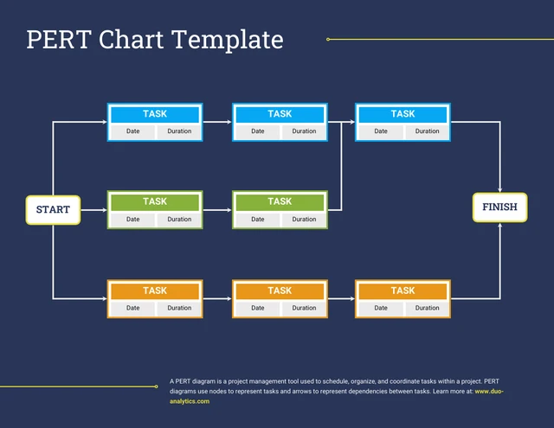
Figure 2: PERT Network Diagram illustrating logical flow.

4.3 Strengths of PERT Diagrams
The most significant advantage of PERT is its ability to facilitate Critical Path Analysis. Because the diagram explicitly models the logical flow of every task, the project manager can identify the longest path through the network. This path represents the minimum time required to complete the project. Any delay in an activity on the critical path will result in a delay for the entire project. By identifying these high risk activities, managers can focus their limited time and resources where they will have the greatest impact on the schedule. This is particularly vital in Information Systems projects where late delivery can lead to missed market opportunities or regulatory fines.
Additionally, PERT is superior for managing projects with high levels of uncertainty. The three point estimation method forces project teams to think about the worst case and best case scenarios, rather than just providing a single number. This leads to more realistic risk assessment and contingency planning. In a complex Information Systems implementation, such as an Enterprise Resource Planning rollout, the ability to model these uncertainties can mean the difference between a successful deployment and a costly failure. It provides a statistical confidence interval for project completion that a Gantt chart simply cannot offer.
Furthermore, PERT encourages a deep understanding of project logic. To create a PERT chart, a project team must sit down and map out exactly how tasks are related. This process often reveals hidden dependencies or redundancies that might have been overlooked in a simpler Gantt chart. For example, the team might discover that a specific hardware procurement must happen much earlier than anticipated to accommodate lead times for configuration. This focus on process architecture makes PERT an excellent tool for project planning and optimization.

4.4 Limitations of PERT Diagrams
The primary limitation of PERT is its high cognitive load and complexity. Unlike the Gantt chart, which is intuitive for most people, a PERT diagram requires a certain level of training to read and interpret correctly. In a large project with thousands of activities, the network can become massive and overwhelming, making it difficult to see the project as a whole. This lack of visual accessibility can alienate stakeholders who are not intimately involved in the project management process, leading to a communication gap between the project team and executive leadership.
Another disadvantage is the significant time and effort required to develop and maintain a PERT chart. Gathering the three point estimates for hundreds of tasks is a labor intensive process that requires input from many different team members. If the project logic changes mid stream, the entire network may need to be redrawn, which can be a daunting task. The maintenance of the data accuracy becomes a project in itself, and if the data is not kept current, the PERT chart quickly becomes an exercise in theoretical modeling rather than a practical management tool.
Finally, PERT diagrams do not inherently provide a calendar view of the project. While they show the order of tasks, they do not show exactly what day of the week Task X will begin. For teams that need to coordinate with external vendors, plan around specific calendar holidays, or manage physical site access, the lack of a time scale can be a significant drawback. To address this, many managers use PERT for the heavy lifting of planning and analysis but translate the final schedule into a Gantt chart for day to day execution and communication.

5. Comparative Analysis of Gantt Charts and PERT Diagrams

5.1 Visualization and Readability
When comparing visualization, the Gantt chart is the undisputed leader in readability. Its layout mimics the calendars we use in our daily lives, making it immediately understandable. It excels at communicating the current status and the immediate future. The bars provide a physical sense of duration that nodes and arrows cannot replicate. This makes the Gantt chart the preferred choice for status meetings and reporting to non-technical audiences.
However, this readability comes at a cost of depth. The Gantt chart often hides the underlying complexity of the project. It provides a what but lacks a why. A PERT diagram, while more difficult to read, provides the why. It shows the logic that drives the schedule. In a graduate level Information Systems context, this distinction is critical. A junior project manager might be satisfied with the readability of a Gantt chart, but a senior analyst will value the logical transparency of a PERT diagram because it reveals the pressure points where the project is most vulnerable.

5.2 Planning Accuracy and Critical Path Analysis
In terms of planning accuracy, PERT is fundamentally more robust. By incorporating statistical uncertainty and focusing on the logical relationships between tasks, PERT provides a more realistic assessment of the likely project duration. The identification of the critical path is perhaps the most powerful tool in the project manager's arsenal, allowing for precise risk management. It transforms the schedule from a passive document into an active diagnostic tool.
Gantt charts can be deceptive in their precision. Because they are tied to specific calendar dates, they often imply a level of certainty that does not exist in the real world. A Gantt bar that says a task will take exactly five days and end on a Tuesday can lead to a false sense of security. If that task is on the critical path but the manager doesn't know it, a small delay could derail the entire project without warning. PERT removes this blind spot by making the critical path explicit, ensuring that resources are prioritized where they are needed most.

5.3 Suitability for Different Project Types
The choice between Gantt and PERT often depends on the nature of the project. Gantt charts are ideally suited for projects with well defined tasks and stable environments. Construction projects, routine software updates, and event planning are all areas where the Gantt chart shines. These projects often have linear dependencies that are easily managed. The primary challenge in these projects is coordination rather than discovery.
PERT diagrams are better suited for non linear projects characterized by research, development, and high uncertainty. Scientific research, aerospace engineering, and complex new product development are classic examples. In these environments, the logical relationships between tasks are more important than the calendar dates. The project is as much about learning as it is about doing, and the ability to manage uncertainty is paramount. For a startup developing a brand new software platform, the PERT chart allows for the modeling of multiple research paths before a final timeline is established.

6. Use Cases for Each Method
To further illustrate these concepts, it is helpful to look at real world use cases. In a web development agency, a Gantt chart is the standard tool for managing client projects. When building a typical corporate website, the tasks are predictable: design, front end coding, back end integration, and content entry. A Gantt chart allows the agency to show the client a clear timeline of when they can expect to see various stages of the project. It also allows the agency manager to see if the lead designer is overbooked across multiple projects.
In contrast, consider a large scale Information Systems migration for a multinational corporation. This project involves moving legacy data from dozens of different systems into a new cloud based platform. The technical challenges are unknown, and many tasks depend on the successful completion of earlier data cleansing steps that could take anywhere from two weeks to two months. In this scenario, a PERT diagram is essential. It allows the project team to model the various paths the migration could take and identify which data sets are on the critical path for the final go live date.
Modern project management software, such as Microsoft Project or Jira, has effectively bridged the gap between these two methods. These tools allow users to enter their tasks and dependencies in a list format and then toggle between a Gantt view and a network diagram view. This hybrid approach is now the industry standard, allowing project managers to use PERT logic for the initial planning and risk analysis while using the Gantt view for the daily tracking of tasks and reporting to the client.

7. AI and the Organization of Structured Project Knowledge
The advent of Artificial Intelligence has introduced a new dimension to project scheduling and knowledge organization. Large Language Models and specialized AI project assistants are now capable of synthesizing complex project documentation to generate structured schedules. This represents a significant shift from manual chart creation to automated knowledge synthesis, reducing the time required for administrative overhead.
AI can assist project managers by analyzing historical project data to provide more accurate estimates for PERT diagrams. Instead of relying solely on human intuition, AI can look at thousands of similar past projects to determine the most likely, optimistic, and pessimistic durations for a given task. This data driven approach significantly reduces the optimism bias that often plagues human estimation, leading to more realistic project baselines.
Furthermore, AI can perform real time What If analysis on complex network diagrams. In a project with thousands of tasks, a change in one dependency can have ripple effects that are impossible for a human to calculate quickly. AI can instantly recalculate the entire PERT network, identify the new critical path, and even suggest resource reallocations to keep the project on track. By organizing structured project knowledge in this way, AI allows project managers to move from reactive tracking to proactive strategy. It essentially acts as a co pilot, flagging risks before they manifest as delays.

8. Conclusion
The comparison of Gantt charts and PERT diagrams reveals that neither tool is inherently superior; rather, they serve different but complementary functions in the project management lifecycle. The Gantt chart remains the gold standard for visual communication, resource tracking, and day to day schedule management due to its intuitive calendar based format. PERT, however, provides the analytical depth necessary for complex, high stakes projects where logical dependencies and uncertainty must be managed with precision.
For the modern Information Systems professional, the ability to utilize both tools effectively is a core competency. As the field moves toward more automated and AI driven workflows, the fundamental principles of task sequencing, dependency management, and critical path analysis will remain relevant. By understanding the historical roots, structural components, and strategic applications of both Gantt and PERT, project managers can ensure that they are using the right tool for the right job, ultimately leading to more successful and predictable project outcomes. The synergy between visual clarity and logical depth is what ultimately drives project excellence.

9. AI Methodology Statement
The generation of this paper was assisted by an Artificial Intelligence model designed to organize and synthesize complex technical information. The AI was utilized to draft the structural outline, ensure logical flow between historical and technical sections, and generate the illustrative SVG code for the diagrams. The methodology involved a hierarchical prompting strategy where the core concepts were defined, followed by iterative expansions of specific subsections to meet the required word count and academic tone. This collaborative process allowed for a high degree of structural integrity while ensuring that the conceptual explanations remained clear and accessible. The AI served as a tool for structuring vast amounts of theoretical knowledge into a cohesive graduate level narrative.

10. References
Kerzner, H. (2017). Project Management: A Systems Approach to Planning, Scheduling, and Controlling. 12th Edition. Wiley.
Project Management Institute. (2021). A Guide to the Project Management Body of Knowledge (PMBOK Guide). 7th Edition. Project Management Institute.
Moder, J. J., Phillips, C. R., & Davis, E. W. (1983). Project Management with CPM, PERT, and Precedence Diagramming. 3rd Edition. Van Nostrand Reinhold.

