**The Vehicle Page: Our Fleet**

**Requirements:** A page listing of the past vehicles.

1. 201? Chevrolet Camaro
2. 2013 Chevrolet Malibu
3. 2009 Saturn Vue
4. 2005 Chevrolet Equinox
5. 1999 Chevrolet Silverado

**Technologies used:**

* PHP
* HTML5
* Bootstrap Framework

**Page Author:**  Chanthida Pao

**Overview:**

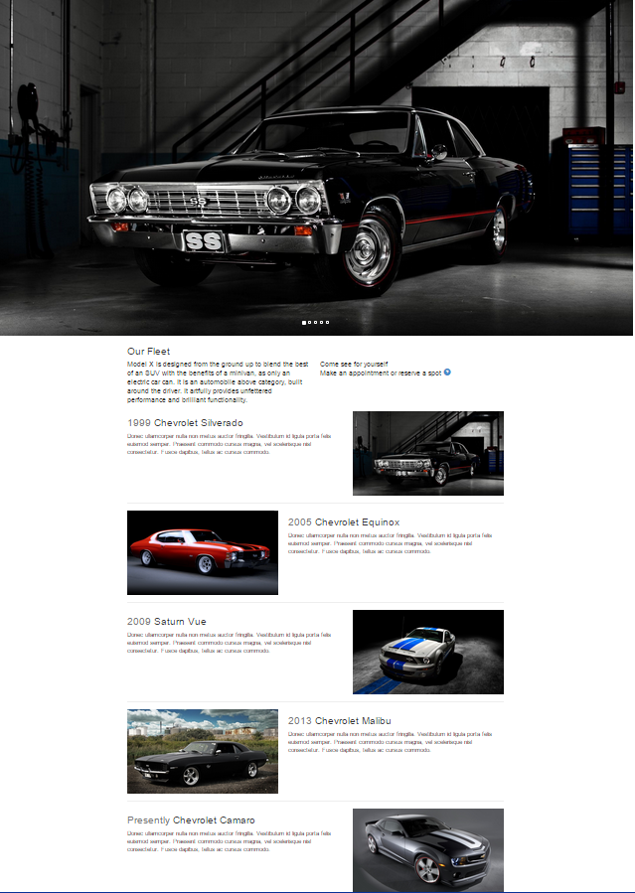

**Features:**

Carousal view of the vehicles featured. Placeholder images are used for now to represent the 5 vehicles in the requirements. The carousal will automatically scroll but the images can be manually changed with the right and left arrows on the sides of the image. The bootstrap carousal template was used to create this effect.

Introduction to the fleet is a short paragraph under the carousal images.

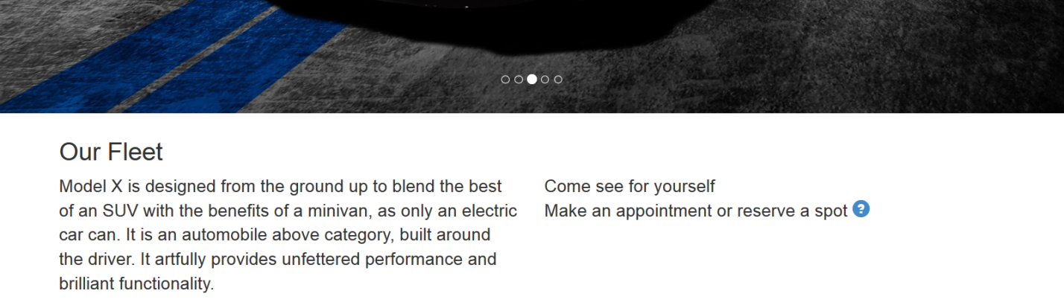

Timeline feature:

Vehicles are placed in a vertical line to represent time in a more visual appealing fashion. Inspired by the Facebook timeline the comments, which are lorem ipsum at the moment, are anchored to a line with car related Bootstrap glyphs.

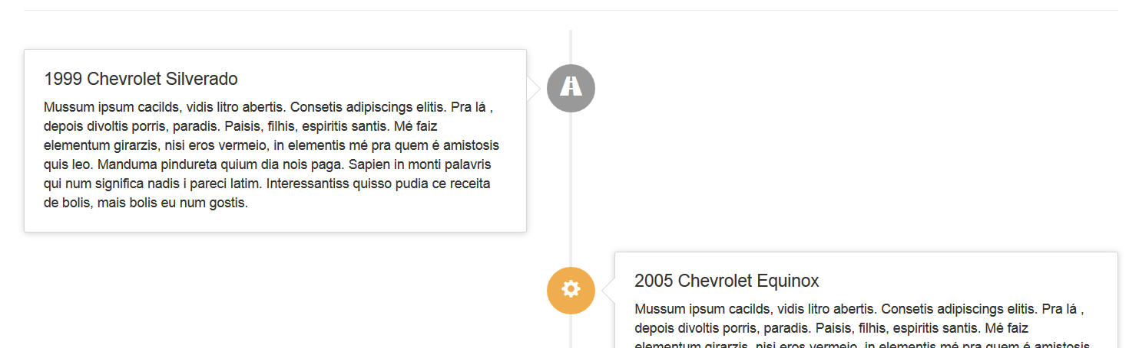

The vehicles are fully described in more detail: 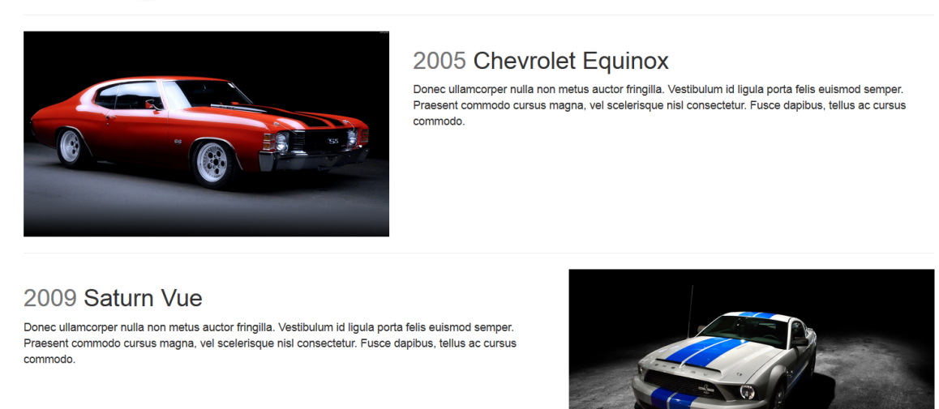

**The Team Page:**

**Requirements:** The team should be a single tab. It should have a picture of the entire team and then underneath it a window that has tabs that could switch between: Technical, Project Management, and Communications. This is mostly for internal relations and to try to build a single unified team

Master team document provided with images.

**Technologies used:**

* PHP
* HTML5
* Bootstrap Framework
* MySQL
* CSS Animation

**Page Author**: Chanthida Pao

**Overview:**

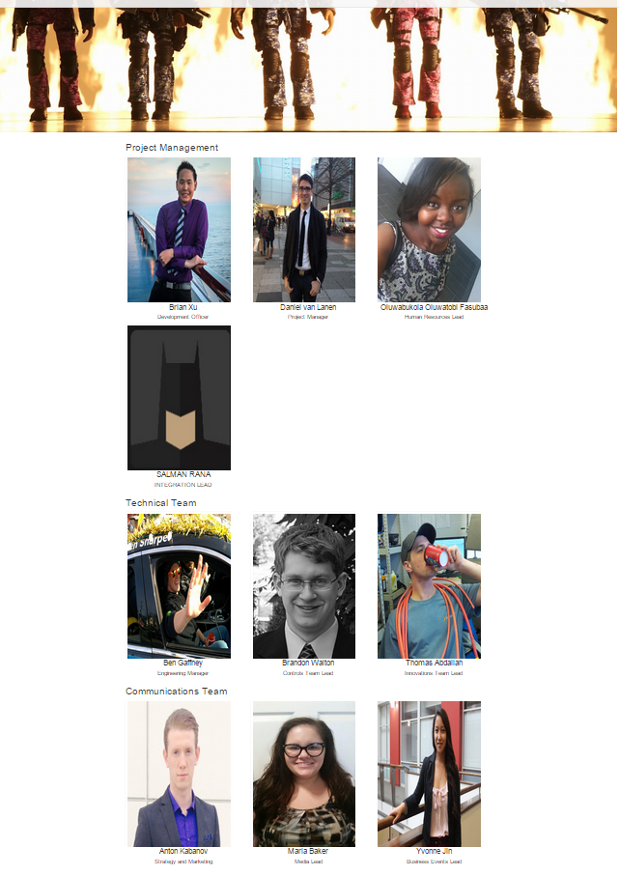

**Features:**

Picture of the entire team wasn’t provided and is currently a placeholder image.

Team members are divided into three categories; Technical, Project Management, and Communications. Each team member has their name posted with their position on the team page. Additional details are displayed with mouse over:

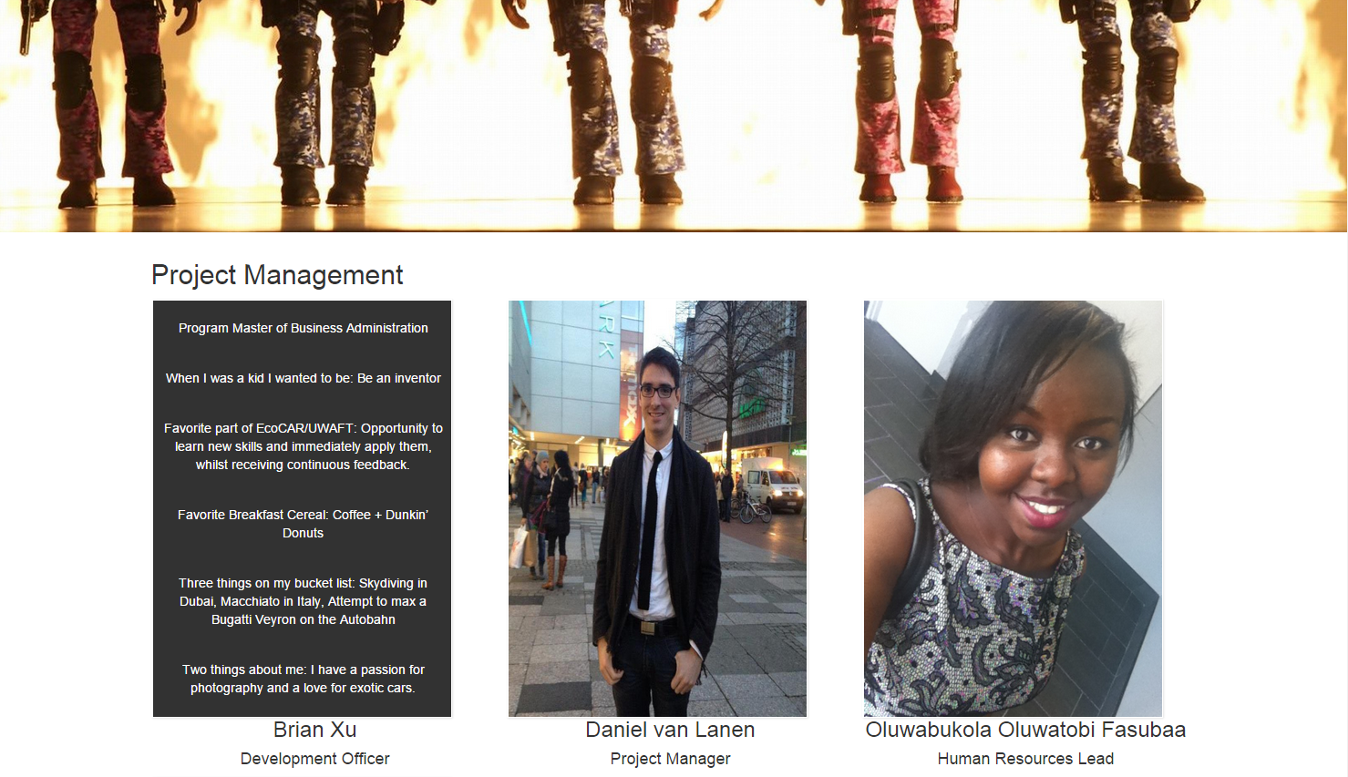

Members are managed on the team form page. This page holds the current team members in their respective categories and can be removed from the page if necessary. The form questions are based from the team master document.

