

**Documentation By:-**

**LTVIP2025TMID21037**

**Team Size :** 4

**Team Leader :** Puppala Harsha Vardhan

**Team member :** Thanneeru Ankammarao

**Team member :** Pasupuleti Ujwala Sri Durga

**Team member :** Metla Beswant Kumar

**Global Energy Trends: A Comprehensive Analysis of Key Regions and Generation Modes using Power BI**

**Introduction:-**Energy plays a vital role in various aspects of modern life, and its importance is expected to increase further as electric vehicles and heat pumps become more prevalent for transportation and heating. Although power generation currently accounts for a significant portion of global CO2 emissions, it is also leading the way in transitioning to net-zero emissions by rapidly adopting renewable energy sources like solar and wind power.

The energy landscape is undergoing a substantial transformation with a strong focus on sustainability and effectiveness. In this context, incorporating renewable energy sources and optimizing energy usage are crucial. Enhancing energy efficiency and integrating renewable generation are key elements in moving towards a more sustainable energy future. Utilizing data analysis techniques within the energy sector holds considerable promise for achieving these goals.

**Scenario 1:Smart Grid Implementation in Urban Areas:**

 In a bustling urban city, the local government has embarked on a project to upgrade its energy infrastructure to meet the increasing demands sustainably. They have implemented a smart grid system that integrates renewable energy sources like solar and wind power into the existing grid. This system allows for more efficient distribution of electricity, minimizing energy loss during transmission. Moreover, smart meters installed in households provide real-time data on energy consumption, enabling residents to monitor and adjust their usage patterns. As a result, the city experiences reduced reliance on fossil fuels, lower CO2 emissions, and increased resilience to power outages.

**Scenario 2:Industrial Energy Management in Manufacturing Plants:**

A large manufacturing plant recognizes the importance of optimizing energy usage to enhance its sustainability and cost-effectiveness. Leveraging data analysis techniques, the plant implements an advanced energy management system that monitors energy consumption across various processes in real-time. Through predictive analytics, the system identifies areas of inefficiency and suggests optimization strategies, such as scheduling production during off-peak hours or upgrading equipment to more energy-efficient models. Additionally, the plant integrates renewable energy sources like rooftop solar panels to offset its reliance on grid electricity further. This initiative not only reduces the plant's carbon footprint but also leads to substantial cost savings over time.

**scenario 3:Rural Electrification Project in Developing Countries:**

In a remote rural community in a developing country, access to reliable electricity has been a longstanding challenge. To address this issue sustainably, a non-profit organization initiated a rural electrification project focused on utilizing renewable energy sources. They install solar microgrids to power homes, schools, and community centers, providing access to clean and affordable electricity for the first time. Data analytics are employed to optimize the operation of these microgrids, ensuring efficient energy distribution and minimal wastage. As a result, the community experiences significant improvements in living standards, with enhanced educational opportunities, better healthcare facilities, and economic empowerment through small-scale enterprises powered by electricity. This project serves as a model for sustainable development in similar rural areas worldwide, demonstrating the transformative potential of renewable energy and data-driven solutions.

**Technical Architecture:**

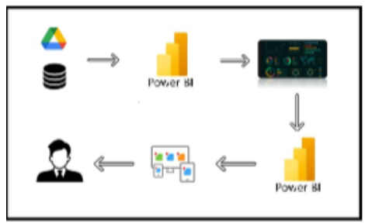

**Project Flow:-**

1. Data Collection

* Collect the dataset

* Connect Data with Power Bl

1. Data Preparation

* Prepare the Data for Visualization

1. Data Visualizations

*Number of UniqueVisualizations

1. Dashboard

* Responsive and Design of Dashboard

1. Report

* Report Creation

1. Performance Testing

* Utilization of Data Filters

*No. of Calculation fields/Columns/Measures

*No. of Visualizations/Graphs

1. Project Demonstration & Documentation

* Record explanation Video for project end to end solution

* Project Documentation Step by step project development procedure

* Investigate the contribution of various types of sources to the total energy produced.

**Milestone 1:-Data Collection**

* **Collect the dataset:-**We collect data set from the website called “Kaggle”.

Link:-<https://www.kaggle.com/datasets/jamesvandenberg/renewable-power-generation>

Data contains all the meta information regarding the columns described in the Excel files.

Column Description of the Dataset:  
**1)Continent Consumption TWH:**

1. Year
2. World
3. OECD
4. BRICS
5. Europe
6. North America
7. Latin America
8. Asia
9. Pacific
10. Africa
11. Middle East
12. CIS

**2) Country Consumption TWH.**

Columns in the dataset:

1. Year
2. China
3. United States
4. Brazil
5. Belgium
6. Czechia
7. France
8. Germany
9. Italy
10. Netherlands
11. Poland
12. Portugal
13. Romania
14. Spain
15. Sweden
16. United Kingdom
17. Norway
18. Turkey
19. Kazakhstan
20. Russia
21. Ukraine
22. Uzbekistan
23. Argentina
24. Canada
25. Chile
26. Colombia
27. Mexico
28. Venezuela
29. Indonesia
30. Japan
31. Malaysia
32. South Korea
33. Taiwan
34. Thailand
35. India
36. Australia
37. New Zealand
38. Algeria
39. Egypt
40. Nigeria
41. South Africa
42. Iran
43. Kuwait
44. Saudi Arabia
45. United Arab Emirates

**3)Non-Renewable – Total Power Generation.**

Columns in the dataset:

1. Mode of Generation
2. Contribution (TWH)

**4) Non-Renewable – Total Power Generation.**

Columns in the dataset:

1. Mode of Generation
2. Contribution (TWH)

**5)Renewable Power Generation 1997-2017.**

Columns in the dataset:

1. Year
2. Solar (TWH)
3. Biofuel (TWH)
4. Hydro (TWH)
5. Geothermal (TWH)

**6) Top 20 Countries Power Generation**.

 Columns in the dataset:

1. Country
2. Solar PV (TWH)
3. Biofuel (TWH)
4. Hydro (TWH)
5. Geothermal (TWH)
6. Total (TWH)

**Explaination video link:**-[Link1](https://drive.google.com/file/d/1JMjR4fSZBcwvlb_fxA7BnGbaShkfmKFC/view)

* **Connect Data with Power Bl:-**

Open Power BI ----> click “Get Data” ----> Select option either “CSV/EXCEL” ----> Then choose file from your computer ----> Finally click “Load”.

**Milestone 2:-Data Preparation**

Data preparation is a critical stage in the data analysis process, encompassing activities aimed at cleaning, transforming, and organizing raw data into a structured format suitable for analysis. This process involves identifying and addressing issues such as missing values, outliers, inconsistencies, and inaccuracies in the dataset, ensuring data quality and reliability.

Preparing the data for visualization involves cleaning the data to remove irrelevant or

missing data, transforming the data into a format that can be easily visualized, exploring the data to identify patterns and trends, filtering the data to focus on specific subsets of data, preparing the data for visualization software, and ensuring that the data is accurate and complete.

Data processing can be done at “**Transform state”**. Preparing the data for visualization involves cleaning the data to remove irrelevant or missing data, transforming the data into a format that can be easily visualized, exploring the data to identify patterns and trends, filtering the data to focus on specific subsets of data, preparing the data for visualization software, and ensuring the data is accurate and complete. This process helps to make the data easily understandable and ready for creating visualizations to gain insights into the performance and efficiency. Since the data is already cleaned, we can move to visualization.

* **Before data Transforming:-**

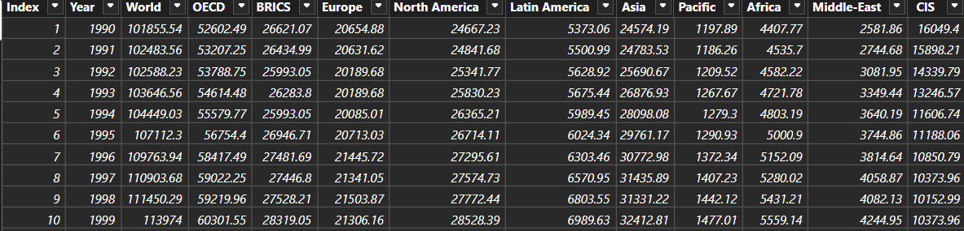

* **After data Transforming:-**

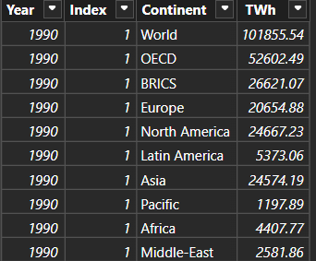

**Explaination video linkfor the Data Visualization :**[Link2](https://drive.google.com/file/d/156ffF275TKDEnW-k3jEdQQmn4OJ0APMf/view)

**Explaination video linkfor the Data Transformation:**[Link3](https://drive.google.com/file/d/177bYqailideZk-P9phsVJui3_37127Xv/view)

**Milestone 3:-Data Visualization**

Data visualization is the process of creating graphical representations of data to help people understand and explore the information. The goal of data visualization is to make complex data sets more accessible, intuitive, and easier to interpret. By using visual elements such as charts, graphs, and

maps, data visualizations can help people quickly identify patterns, trends, and outliers in the data.

**Country wise consumption:**

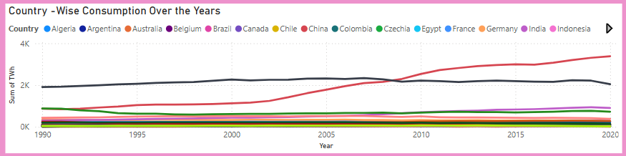

**Continent Consumption:**

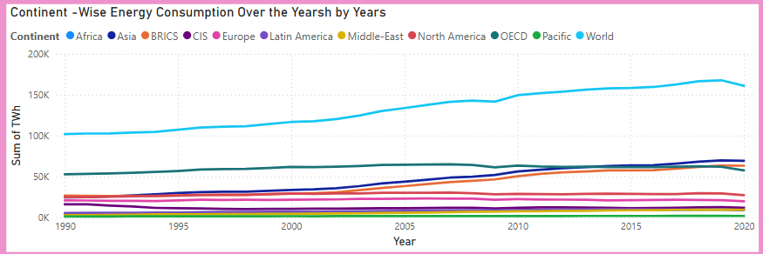

**Continent Average:**

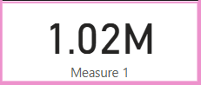

**Country Average:**



**Non-Renewable Sources:**

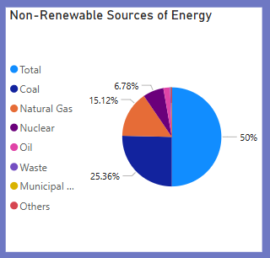

**Renewable Generation 1997-2017: `**

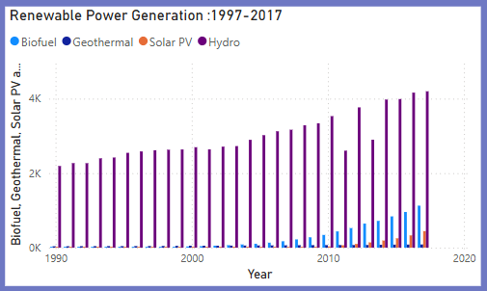

**Cards- Sum, Median, Standard Deviation and Variance of Contribution:**

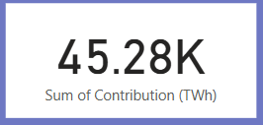 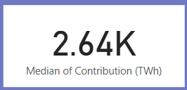

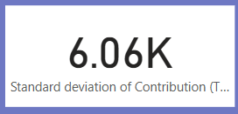 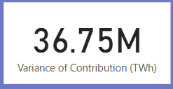

**Renewable Sources:**

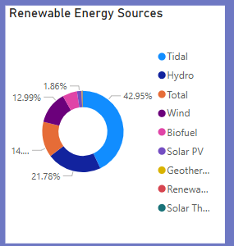

**Cards - Geothermal, Biofuel, Hydro and Solar PV:**

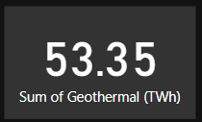 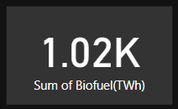

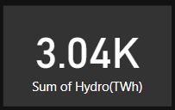 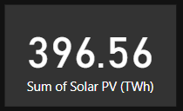

**Report Narrative:**

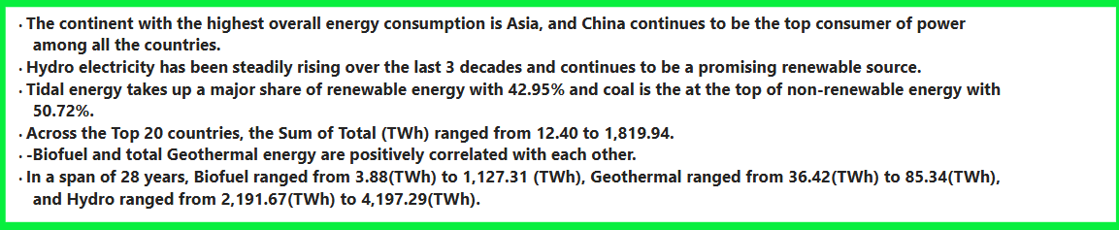

**BRICS, OECD and CIS:**

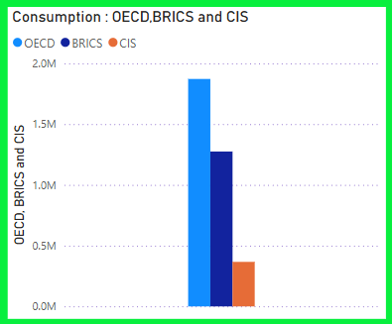

**Energy Consumption in Africa:**

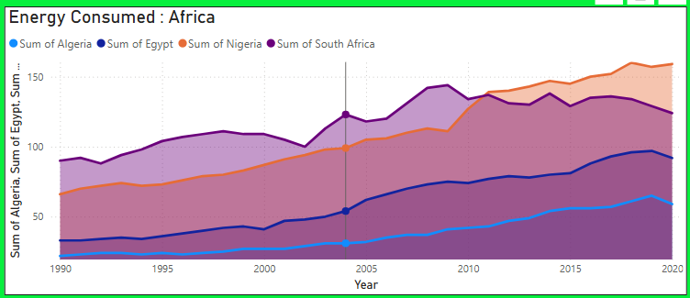

**Milestone 4:-Dashboard**

A dashboard is a graphical user interface (GUI) that displays information and data in an organized, easy-to-read format. Dashboards are often used to provide real-time monitoring and analysis of data and are typically designed for a specific purpose or use case. Dashboards can be used in a variety of settings, such as business, finance, manufacturing, healthcare, and many other industries. They can be used to track key performance indicators (KPIs), monitor performance metrics, and display data in the form of charts, graphs, and tables.

### Responsive and Design of Dashboard:

**Design-1:**

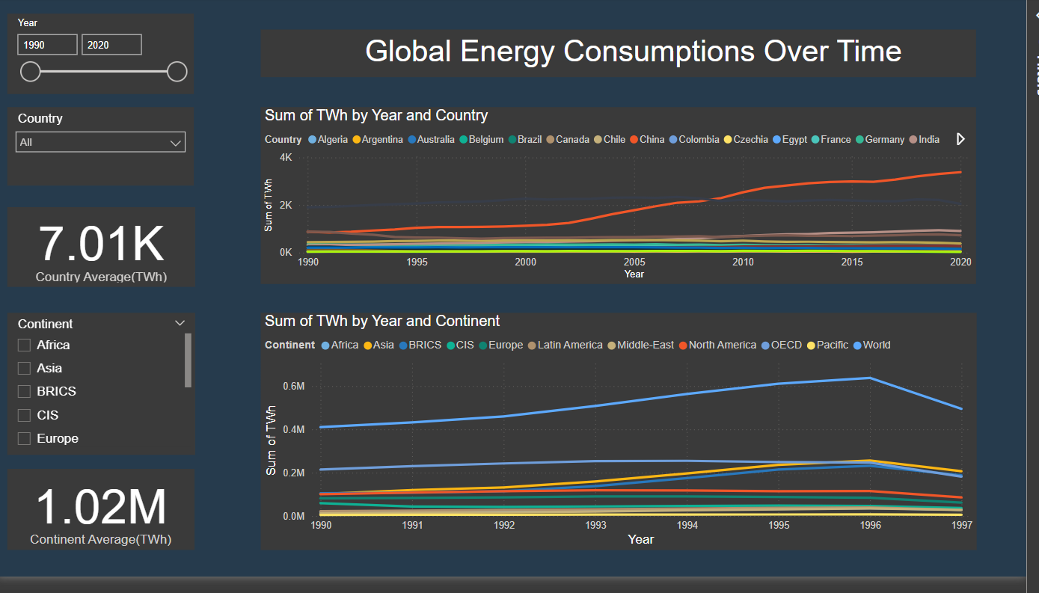

**video link:**[Link4](https://drive.google.com/file/d/1WEEcxqgX8M-HzOZq_xMYqIA54vPtoSjQ/view)

**Design-2:**

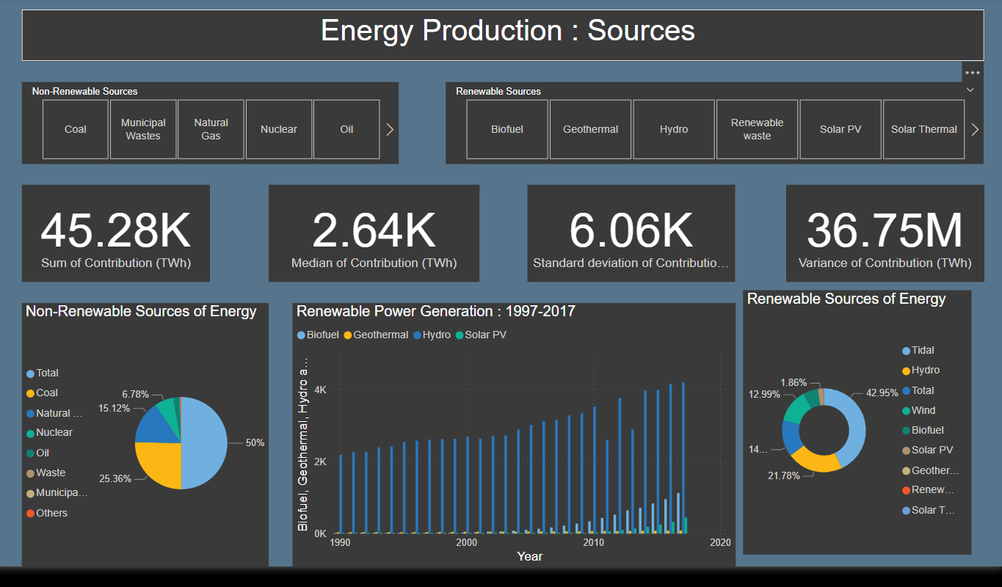**video link:**[Link5](https://drive.google.com/file/d/13QKsxtdoXoEkWZmsWjmta1DLSE_WmaAM/view)

**Design-3:**

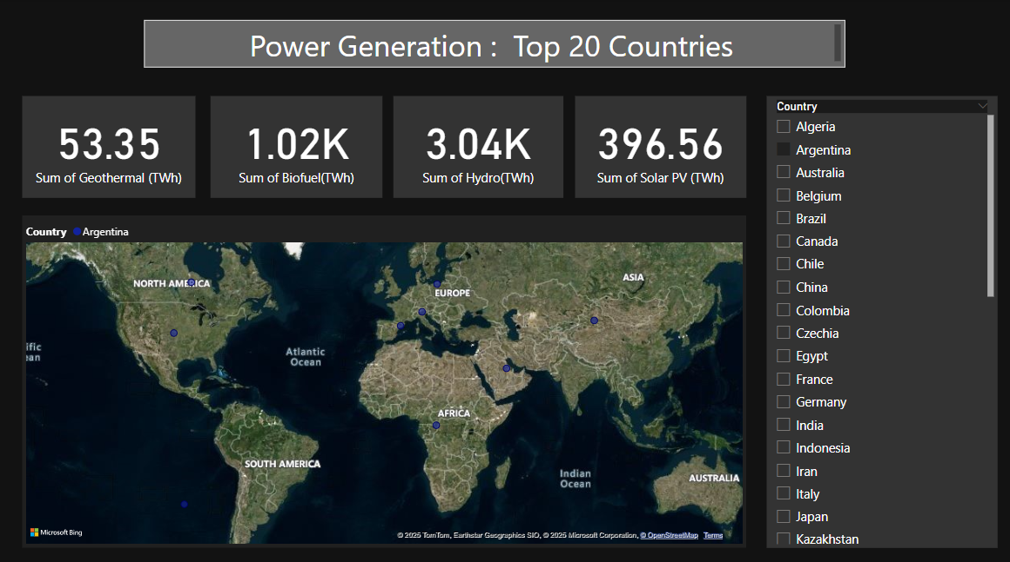

**video link:**[Link6](https://drive.google.com/file/d/13VKpVGkDQqK_ZBGYhIBv-jTDCcpuMX9r/view)

**Milestone 5:-Report**

A report is a comprehensive document that provides a detailed and structured account of data analysis, findings, and insights. It is typically used for in-depth analysis, documentation, and communication of results. Reports are suitable for a diverse audience, including decision-makers, analysts, and stakeholders who need a comprehensive understanding of the data.

A report is a way of presenting data and analysis in a narrative format, with the goal of making information more engaging and easier to understand. It typically includes a clear introduction that sets the stage and explains the context for the data, a body that presents the data and analysis in a logical and systematic way, and a conclusion that summarizes the key findings and highlights their implications. Data stories can be told using a variety of media, such as reports, presentations, interactive visualizations, and videos.

### Design of Report

Designing a report in Power BI involves connecting to data sources, creating visualizations like charts and graphs, customizing their appearance and interactivity, organizing them logically on the canvas, formatting elements for consistency and clarity, and optionally creating dashboards for a summarized view. Throughout the process, it's essential to consider the audience's needs and ensure the report effectively communicates insights from the data. Finally, iterate based on feedback to continually improve the report's design and usefulness.

**Video ExplainationLink:-**[Link7](https://drive.google.com/file/d/1ICvooAcaK_TYm4av7HgaIuq5As_oE_kX/view)

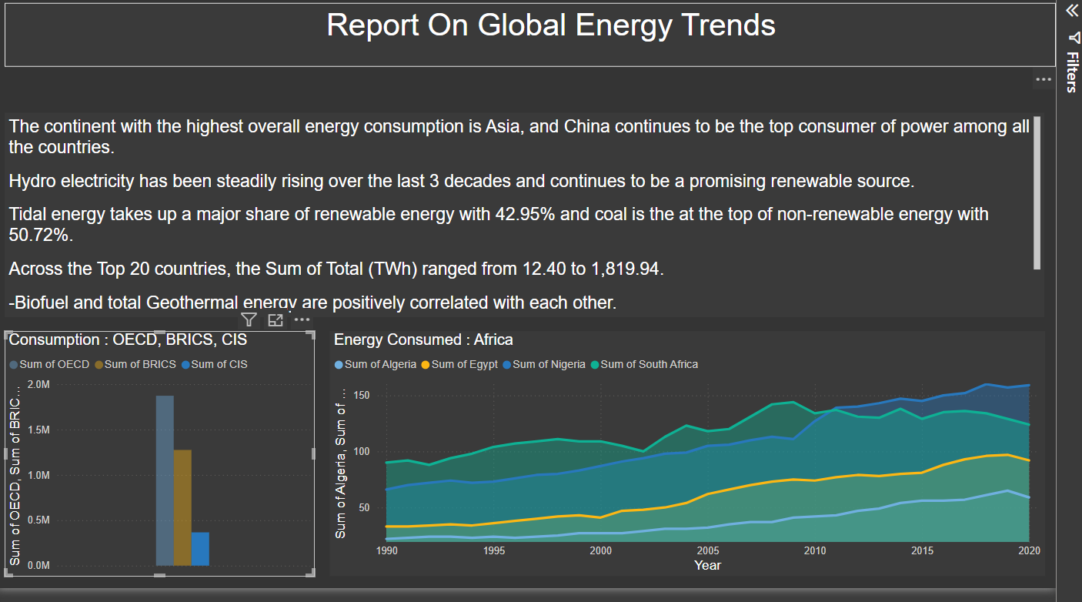

Performance testing is a critical component of software development aimed at evaluating the speed, responsiveness, and stability of an application under varying load conditions. By simulating real-world scenarios, such as heavy user traffic or high data volumes, performance testing helps identify potential bottlenecks, weaknesses, and areas for optimization within the system.

**Milestone 6 :Performance Testing**

For the aforementioned energy project focusing on incorporating renewable energy sources and optimizing energy usage, performance testing plays a critical role in ensuring the effectiveness and reliability of the implemented systems. Performance testing involves assessing various aspects, including the efficiency of energy generation from renewable sources, the effectiveness of energy distribution through smart grids or microgrids, and the accuracy of data analytics algorithms in identifying optimization opportunities.

1. **Application of Data Filters**

Selections within the data allow users to filter data based on individual fields or dimensions. Users can choose specific values within a field to include or exclude from analysis. Complex filters based on predefined conditions and logic can also be created.

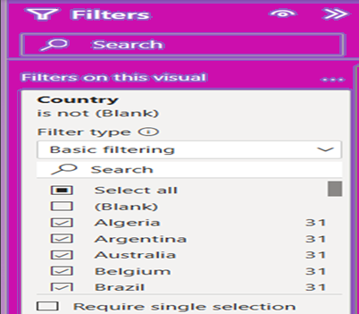

### b)Use of Measures/Calculated Columns

Power BI allows the creation of reusable filter objects like Measures, and Calculated Columns which can simplify the process of applying consistent filters across multiple visualizations and dashboards.

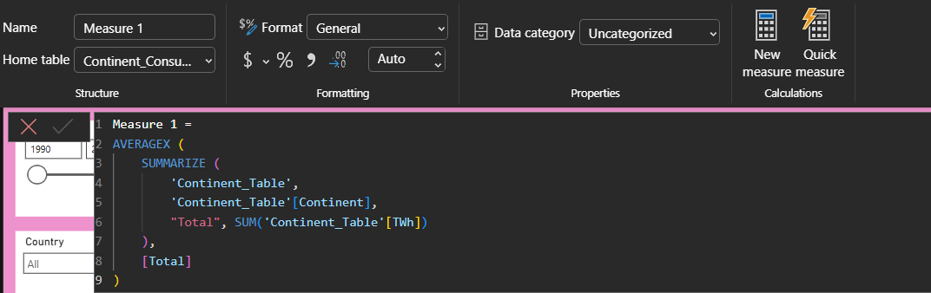

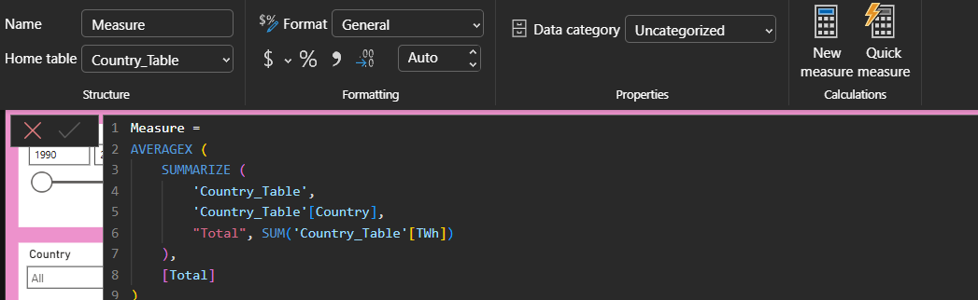

1. **Number of Graphs/ Visualizations**
   1. Country-wise energy consumption.
   2. Continent Energy Consumption.
   3. Continent Average(TWh).
   4. Country Average(TWh).
   5. Non-renewable sources of Energy.
   6. Renewable Generation 1997-2017 (TWh).
   7. Cards - Sum, Median, Standard Deviation and Variance of Contribution(TWh).
   8. Renewable Sources of Energy.
   9. Cards - Geothermal, Biofuel, Hydro and Solar PV.
   10. BRICS, OECD, and CIS Comparison.
   11. Report Narrative.
   12. Energy Consumption in African countries.

**Milestone 7 :Project Demonstration**

* **Record explanation Video for project end to end solution**

Creating a record explanation video for a project's end-to-end solution is crucial for ensuring clarity and transparency in its implementation. This video serves as a comprehensive guide, detailing every aspect of the project from inception to completion.

**Drive Link:-**

<https://drive.google.com/file/d/1gGXwIwnOwL2H51Gx1Gq-juJHFi38PyjU/view?usp=sharing>