GLORENTECH™ / GRT™
Global Renaissance Technology SARL — Messassi, Yaoundé, Cameroon
OAZILAND
Complete UML & Data Model Design Specification
Class · Use Case · Sequence · Activity · State Machine Diagrams
Conceptual, Logical & Physical Data Models · Flowchart · Pseudocode
Cameroon Property Type Taxonomy & Market-Specific Fields
Prepared for: Oaziland Product & Engineering Team
Approach: Object-Oriented Programming (OOP)
Document Version 2.0 · July 2026
Classification: Internal / Investor Ready

Table of Contents
1 Introduction & How to Read This Document
2 Class Diagram — Identity, Roles & Access
3 Class Diagram — Property Type Taxonomy: Residential Units
4 Class Diagram — Property Type Taxonomy: Commercial, Hospitality & Land
5 Class Diagram — Listings, Cameroon Market Fields & Verification Badges
6 Class Diagram — Transactions, Contracts & Payments
7 Class Diagram — Social, Engagement & Referral Model
8 Class Diagram — Advertising, Monetization & Agency Benefits
9 Class Diagram — Trust, Safety & Content Moderation
10 Class Diagram — Authentication, MFA & KYC
11 Class Diagram — Content Lifecycle & Personalization
12 Class Diagram — Taskln Integration: Technician Services Subset
13 Navigation & Dashboard Architecture
14 Use Case Diagram — Actors & System Capabilities
15 Sequence Diagram — "Rent a House" End-to-End
16 Activity Diagram — Renting a House (Business Process View)
17 State Machine Diagram — Booking Lifecycle
18 Conceptual Data Model
19 Logical Data Model
20 Physical Data Model (PostgreSQL)
21 Flowchart — Payment & Escrow Decision Logic
22 Pseudocode — Reservation & Escrow Release Algorithm
23 Additional Platform Considerations
24 Conclusion & Next Steps

1. Introduction & How to Read This Document
This document is the complete Unified Modeling Language (UML) and data-model design specification for Oaziland — the pan-African, Cameroon-first real estate super-app covering property rental and sale, hospitality, a student marketplace, technician services, and a social layer, built on a mobile app and a web app sharing one common backend and database.
The domain model in this version is deliberately split across several focused class diagrams (Sections 2–7) rather than one dense diagram, so that every class, attribute, and relationship stays readable at page size. Each diagram is a coherent slice of the same object model: identity and roles, then the property taxonomy, then listings and market-specific fields, then transactions, then the social layer.

Running Example: "Rent a House in Any Neighborhood"
To keep every diagram concrete and coherent rather than abstract, this document follows one consistent, representative scenario throughout: any registered person — anywhere in Cameroon — opens the Oaziland app, searches for houses in a specific neighborhood (quarter), selects one, reserves it, pays a deposit through Mobile Money, and receives a confirmed booking. The same underlying model also supports renting a room, a studio, a shop, an office, a warehouse, agricultural land, or any of the fifteen Cameroon property categories detailed in Sections 3 and 4.

Document Structure
- Sections 2–7 — the core Object-Oriented domain model, split into six focused class diagrams
- Sections 8–10 — Advertising/Monetization, Trust & Safety, and Authentication/MFA/KYC class diagrams
- Sections 11–13 — Content Lifecycle & Personalization, Taskln Integration, and Navigation & Dashboard Architecture
- Section 14 — Use Case Diagram: actors and system capabilities
- Sections 15–17 — Sequence, Activity, and State Machine diagrams for the running example
- Sections 18–20 — Conceptual, Logical, and Physical data models
- Section 21 — Flowchart: the payment and escrow decision logic
- Section 22 — Pseudocode: the reservation algorithm
- Section 23 — Additional Platform Considerations
- Section 24 — Conclusion & Next Steps

2. Class Diagram — Identity, Roles & Access
User is the single source of identity and authentication for the entire platform. Every other actor type — Landlord, Agent, Agency, Student, Technician, Admin — is a Role attached to a User rather than a separate account, because one real person (an agent who is also a student, for example) can hold several roles at once.
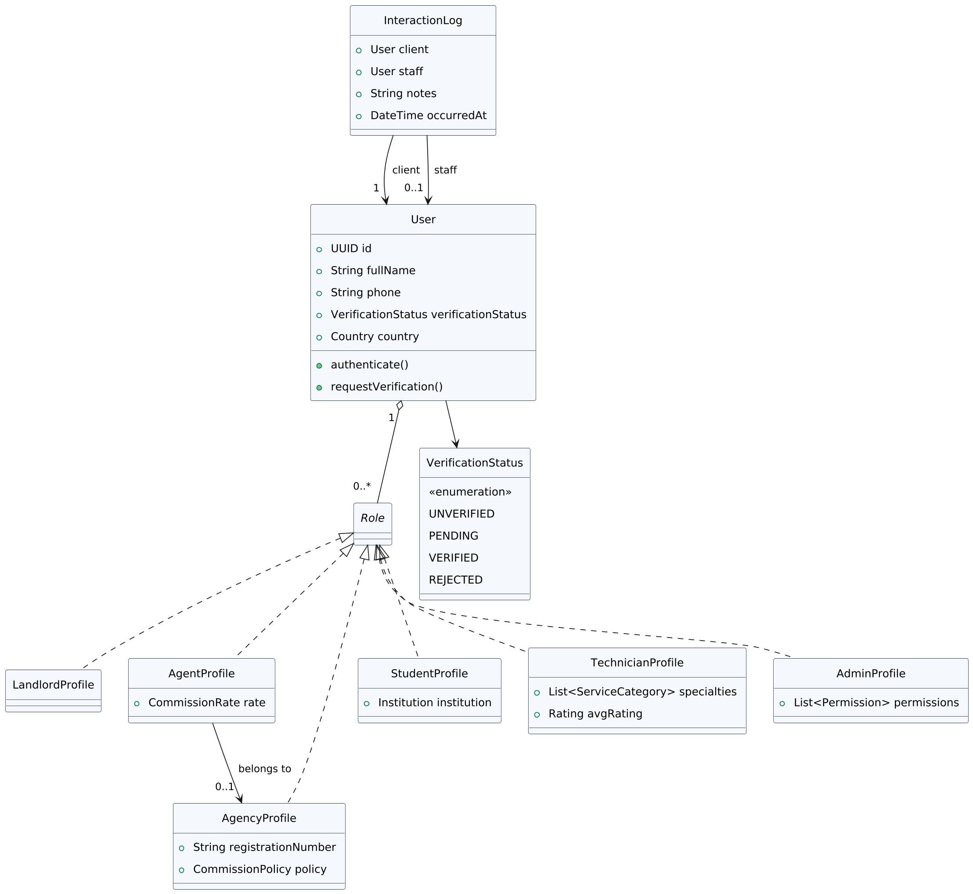
Figure 1 — Identity, Roles & Access Class Diagram

Explanation
- Role is modeled as an interface, not a base class — LandlordProfile, AgentProfile, AgencyProfile, StudentProfile, TechnicianProfile, and AdminProfile each implement it independently, and a User can hold any combination of them simultaneously.
- AgentProfile optionally belongs to an AgencyProfile — this single association is what distinguishes an independent agent from one operating under an agency, and it is what the commission logic in Section 6 reads to decide whether an agency share applies.
- InteractionLog is the shared CRM record: every conversation staff has with a client, regardless of which module it concerns, is captured here rather than in a separate system per module.

3. Class Diagram — Property Type Taxonomy: Residential Units
Room, Studio, and Apartment are modeled as genuinely distinct Unit subtypes — not variations of one generic "unit" — because they differ in what a Cameroonian tenant actually gets: a Room has no dedicated kitchen, a Studio has one shared living/kitchen area, and an Apartment has a fully separate salon.
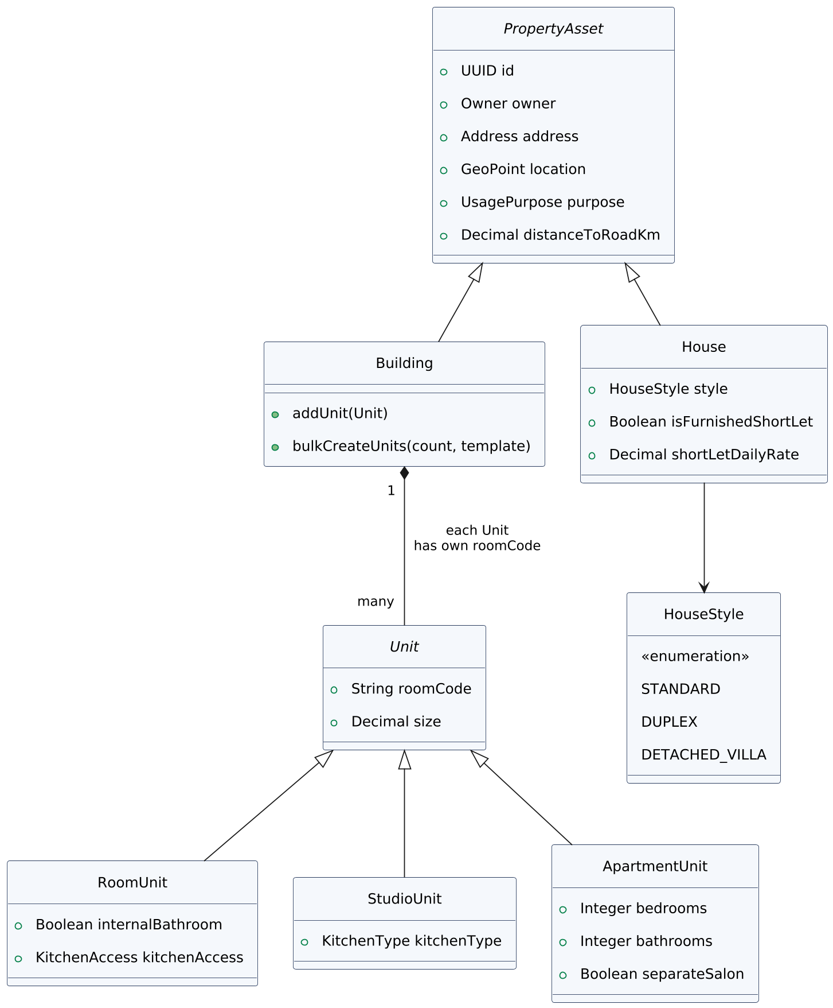
Figure 2 — Residential Property Taxonomy Class Diagram

Explanation
- RoomUnit (Chambre Moderne) has an internal bathroom but a kitchenAccess field rather than a kitchen of its own — tenants typically cook on a veranda or in a shared outdoor corridor.
- StudioUnit (Studio Américain) carries a kitchenType (open "American style" or partitioned) — the one field that most distinguishes it from both a Room and an Apartment.
- ApartmentUnit (Appartement Standard) is the only residential unit type with a separateSalon flag and multiple bedrooms/bathrooms as first-class fields, reflecting that it targets families and long-term tenants rather than single occupants.
- Every Unit inside a Building carries its own unique roomCode (e.g. A-101, Block-B-12), and Building.bulkCreateUnits() lets a landlord or agency generate many identical units — say, 40 studios in one compound — in a single operation instead of one at a time.
- House carries a HouseStyle (Standard, Duplex, or Detached Villa) and an isFurnishedShortLet flag — a Furnished Short-Let is modeled as a listing-time attribute of a House or Unit, not a separate property type, since the same physical unit can be offered either as a long-term rental or a short-let.

4. Class Diagram — Property Type Taxonomy: Commercial, Hospitality & Land
The remaining Cameroon property categories — Shop, Corporate Office, Event Center, Guest House/Lodge, Mixed-Use Building, Land, and Warehouse — each extend PropertyAsset directly, since they don't share the room/studio/apartment distinctions that residential units need.
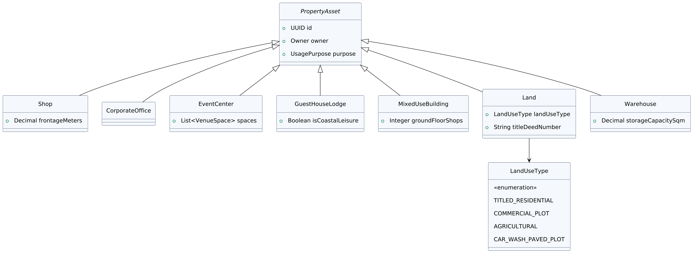
Figure 3 — Commercial, Hospitality & Land Property Taxonomy Class Diagram

Explanation
- Shop (Boutique) and CorporateOffice (Bureau) are kept as separate classes despite their similarity, because a Shop's frontageMeters (street frontage) is a meaningful search filter that an office never needs.
- MixedUseBuilding (Immeuble de Rapport) tracks groundFloorShops as a field of its own — this is the compound where a landlord rents shops on the ground floor and apartments above, all under one PropertyAsset record with a shared address.
- Land carries a landUseType enumeration — Titled Residential, Commercial Plot, Agricultural, or Car Wash/Paved Plot — rather than four separate classes, because all four share the exact same title-deed verification machinery (Section 5) and only differ in intended use.
- Warehouse (Entrepôt) is the one purely industrial type in this taxonomy, tracking storageCapacitySqm as its distinguishing field for import-export and wholesale search filters.

5. Class Diagram — Listings, Cameroon Market Fields & Verification Badges
A Listing carries two Cameroon-specific value objects that generic real estate platforms don't need: CameroonMarketDetails (legal status, rent advance, caution, agency fees, utilities, road access) and SecurityFeatures — plus a generalized VerificationBadge that replaces a fixed set of boolean columns with an extensible badge type.
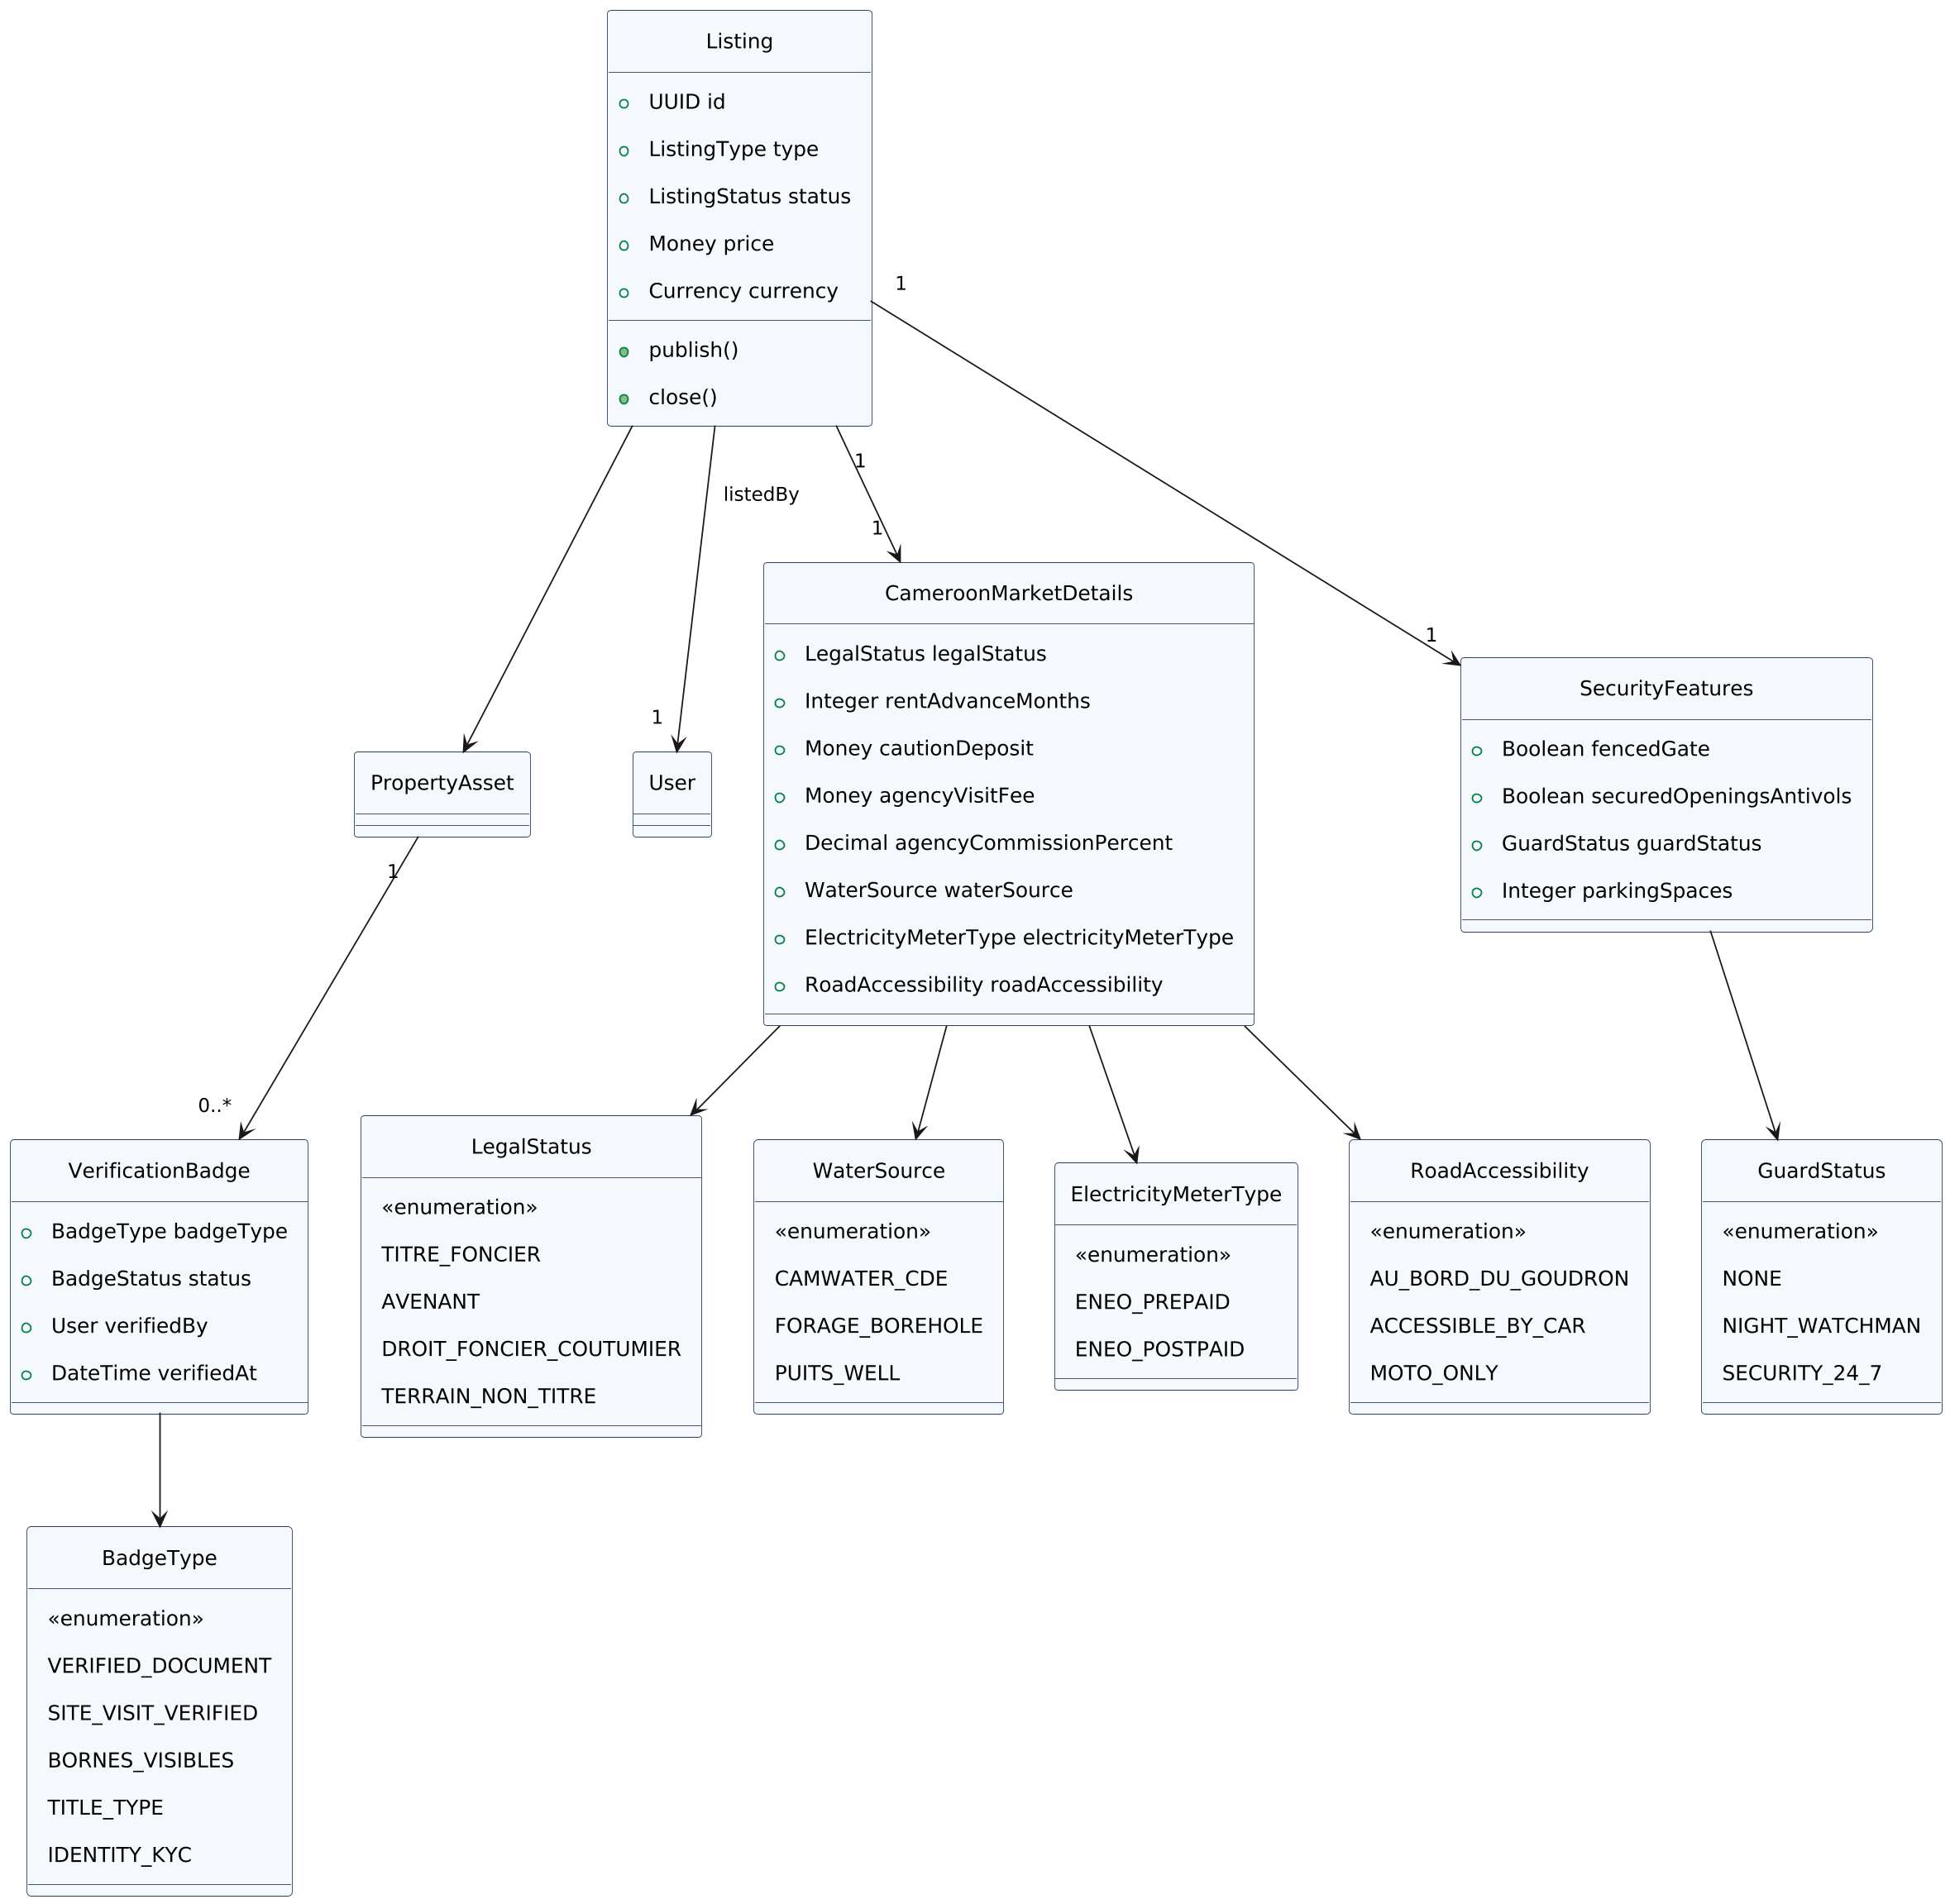
Figure 4 — Listing, Market Fields & Verification Badge Class Diagram

Explanation
- CameroonMarketDetails.legalStatus distinguishes Titre Foncier (titled), Avenant, Droit Foncier Coutumier (customary), and Terrain Non Titré (untitled) — the single most important trust signal for a Cameroonian buyer, shown before price on any listing.
- rentAdvanceMonths and cautionDeposit capture the local norm of 6–12 months' rent paid upfront plus a separate damage deposit — fields that simply don't exist in a Western-market rental listing schema.
- waterSource and electricityMeterType are modeled as enumerations (Camwater/Forage/Puits; Eneo Prepaid/Postpaid) because frequent utility interruptions make these decisive factors in a Cameroonian renter's decision, not minor amenities.
- SecurityFeatures.guardStatus (None / Night Watchman / 24/7) and fencedGate/securedOpenings (antivols) reflect that physical security is a primary search filter in major Cameroonian cities, not an afterthought.
- VerificationBadge is generic — badgeType is an open enumeration (Verified Document, Site Visit Verified, Bornes Visibles, Title Type, Identity KYC) attached to any PropertyAsset, so new badge types can be introduced without a schema migration.

6. Class Diagram — Transactions, Contracts & Payments
This is the transactional core shared by every property type and every module: a Booking always produces exactly one PaymentEscrow, optionally a Contract once terms are agreed, and optionally a Commission when an Agent or Agency is involved.
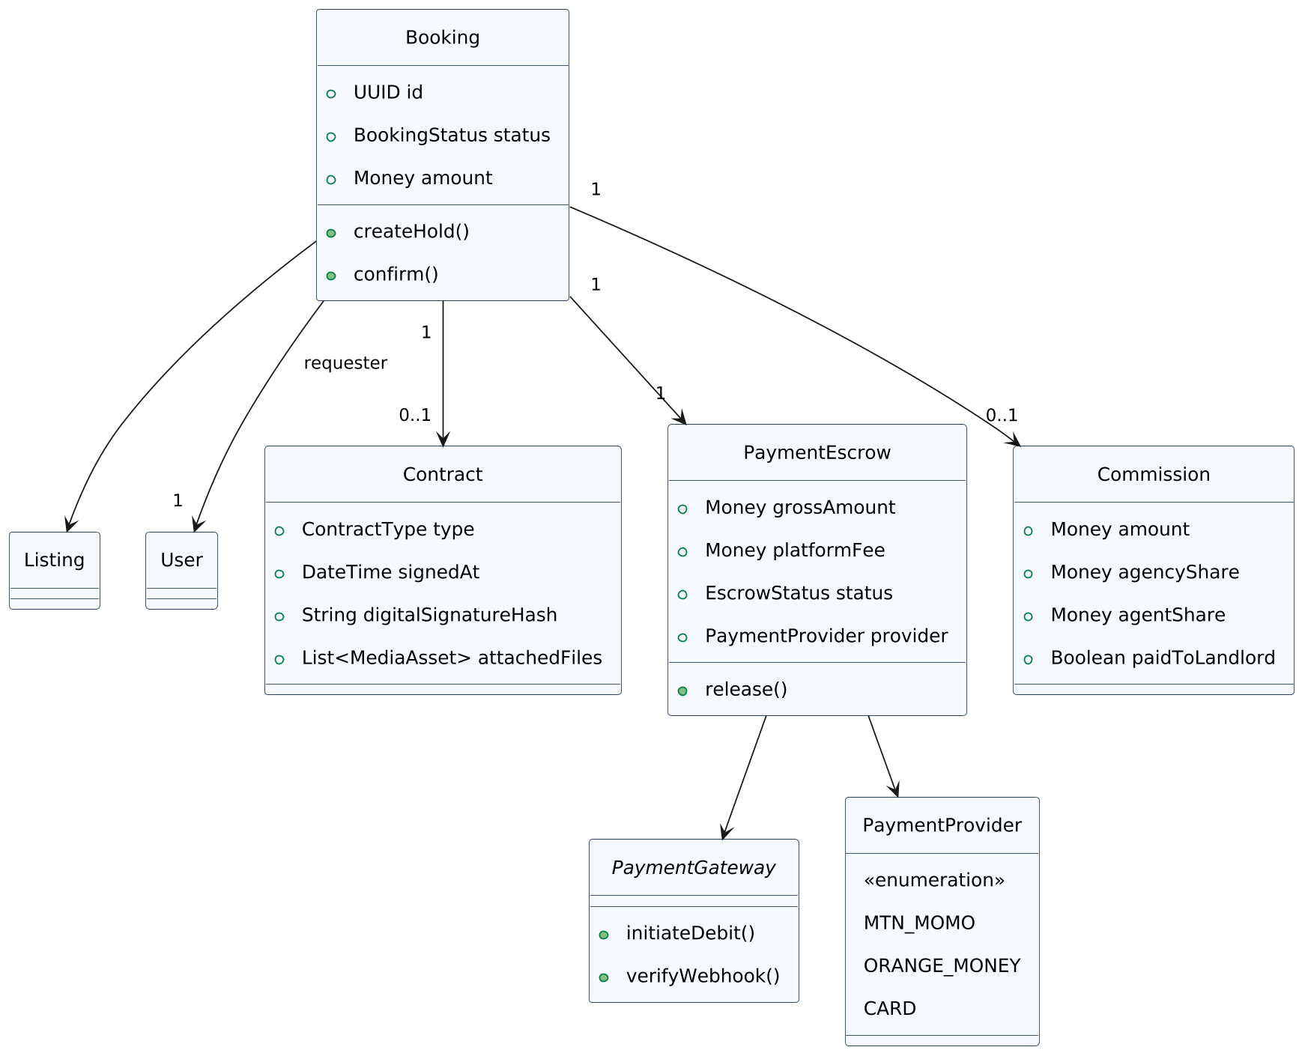
Figure 5 — Transactions, Contracts & Payments Class Diagram

Explanation
- Contract attaches to a Booking once terms are agreed, carrying a digital signature hash and attached files (lease or sale agreement) — consistent with the in-app document hub and digital signing already specified for the platform.
- PaymentGateway is modeled as an interface, not a single class, so MTN MoMo, Orange Money, and card processors are interchangeable implementations behind the same PaymentEscrow flow — adding a new payment provider never touches the Booking or Escrow logic.
- Commission is optional on Booking (0..1) by design — a booking made directly with a landlord, with no agent or agency involved, simply has no Commission record, rather than one with zero values.

7. Class Diagram — Social, Engagement & Referral Model
Oaziland's social layer draws deliberately on TikTok, Facebook, and LinkedIn conventions: users follow each other, react and comment on posts, share listings across WhatsApp/SMS/Facebook/TikTok/LinkedIn, and earn rewards for referring new users.
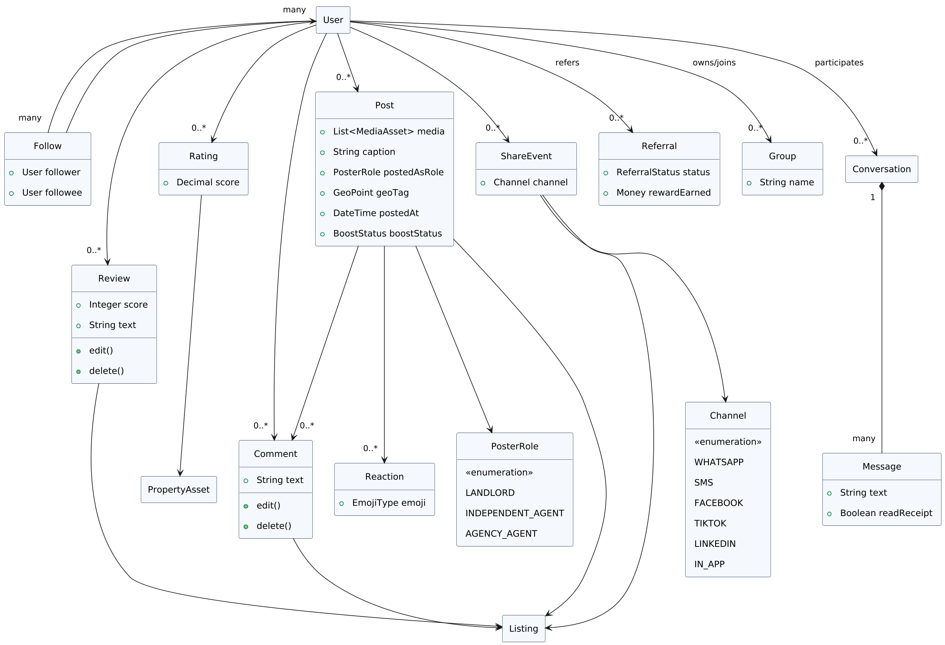
Figure 6 — Social, Engagement & Referral Class Diagram

Explanation
- Review, Comment, and Rating all carry edit() and delete() operations directly on the object — users can edit or delete their own reviews and comments, not just create them.
- ShareEvent records which Channel a listing or post was shared through (WhatsApp, SMS, Facebook, TikTok, LinkedIn, or in-app) — this is what lets Oaziland measure which social channel actually drives bookings, not just that sharing happened.
- Referral is a first-class object with its own reward tracking, not just a promo code — a referrer earns a recorded Money reward once the referredUser completes a qualifying action, giving Admin a clean audit trail for payouts.
- Group and Conversation support both public community-building and private one-to-one deal negotiation, reusing the same Message/InteractionLog pattern used elsewhere in the platform rather than a separate chat system.

8. Class Diagram — Advertising, Monetization & Agency Benefits
Agents, agencies, and landlords can pay to boost a listing or a video post above organic reach. Every ad spend, and every ordinary transaction elsewhere in the platform, is billed through the same generalized PlatformFeePolicy. This diagram also settles two open questions from earlier: what an agency actually offers its agents, and what every post must display about who posted it.
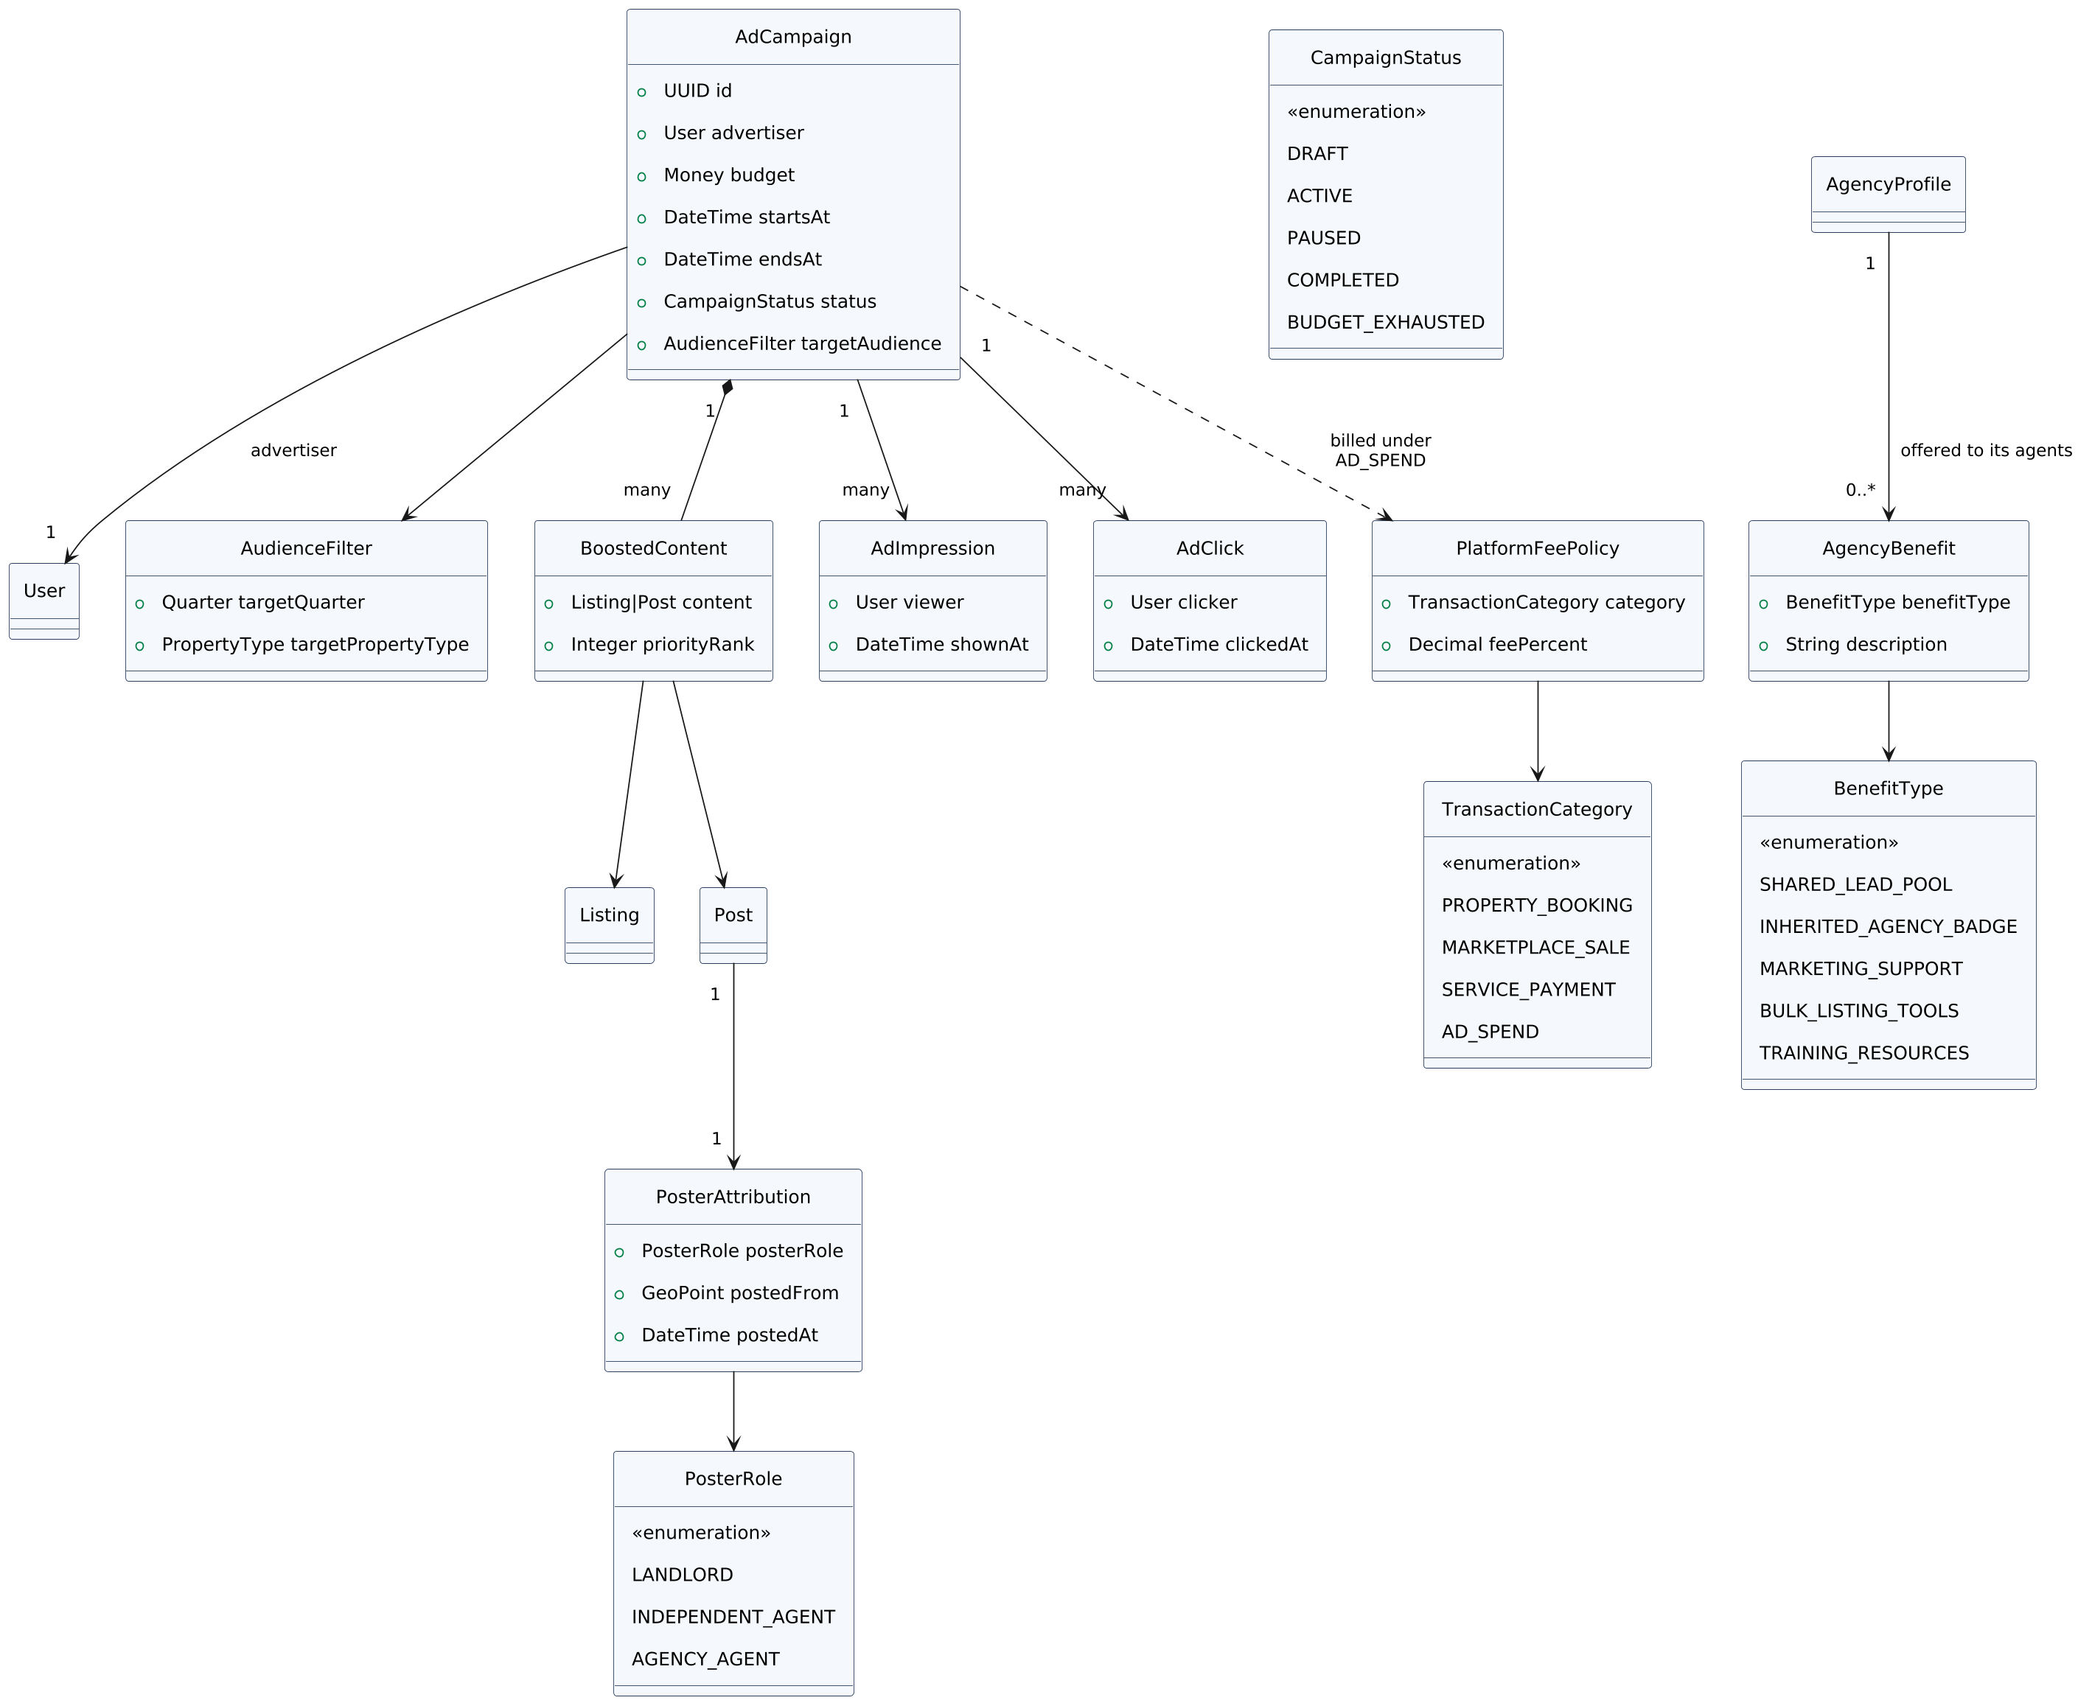
Figure 7 — Advertising, Monetization & Agency Benefits Class Diagram

Explanation
- AdCampaign is owned by any User (landlord, agent, or agency) and targets an AudienceFilter (quarter and property type) — an agent in Bastos can boost only to users searching Bastos, rather than paying to reach the whole country.
- BoostedContent wraps either a Listing or a Post, giving priorityRank in the feed — this is the mechanism behind "the algorithm should suggest posts and videos," combined with the recommendation logic in Section 11.
- PlatformFeePolicy.feePercent is set per TransactionCategory (property booking, marketplace sale, service payment, ad spend) — the platform earns a small, deliberately unnoticeable percentage everywhere money moves, using one shared mechanism rather than four separate billing systems.
- AgencyBenefit answers "why join an agency": a BenefitType enumeration (shared lead pool, inherited agency badge, marketing support, bulk listing tools, training resources) attached to each AgencyProfile — an agent weighing independence against agency membership can see exactly what's on offer, and the platform can display it during onboarding.
- PosterAttribution is now mandatory on every Post — it records the PosterRole (Landlord, Independent Agent, or Agency Agent) alongside the location and timestamp the post was made, so a viewer always knows who they're dealing with before they message.

9. Class Diagram — Trust, Safety & Content Moderation
Any user can report a post, listing, or comment. Separately, an AI moderation pass scans text and media for profanity, nudity, and hate speech — the two systems feed the same warning/strike record on a user's account.
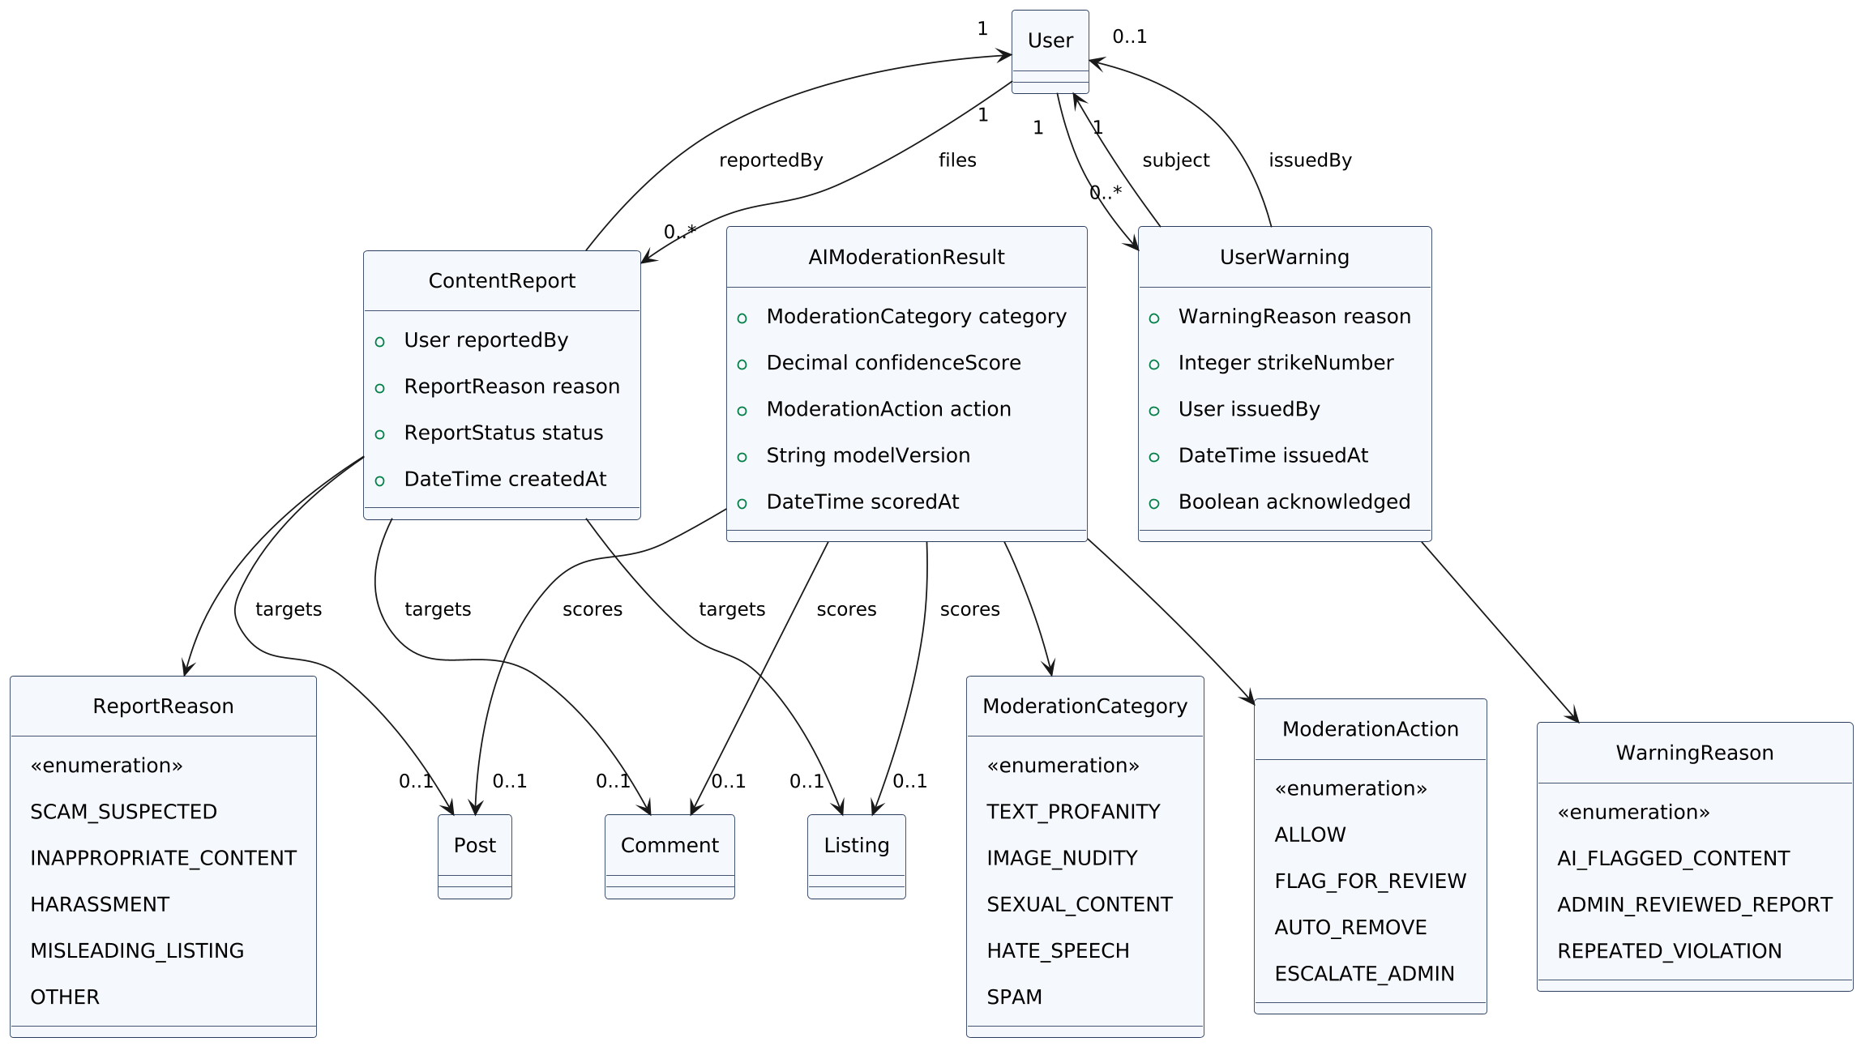
Figure 8 — Trust, Safety & Content Moderation Class Diagram

Explanation
- ContentReport generalizes the ScamFlag pattern already used for Land listings (Section 4) to any Post, Listing, or Comment platform-wide, with a ReportReason that includes inappropriate content and harassment, not just suspected scams.
- AIModerationResult is a separate, automated pass — it does not require a human report to fire. A ModerationCategory of IMAGE_NUDITY or TEXT_PROFANITY above a confidence threshold can trigger an AUTO_FLAGGED or AUTO_REMOVED action without waiting for a user complaint.
- Both ContentReport and AIModerationResult can independently trigger a UserWarning — the strikeCount on a user's account accumulates regardless of whether the violation was caught by a human report or the AI scanner, so repeat offenders can't avoid consequences by staying just under the AI's detection threshold.
- Admin (Section 2) is the actor who reviews ESCALATED_TO_ADMIN cases — the AI never has final authority to ban an account, only to flag, remove content, or escalate.

10. Class Diagram — Authentication, MFA & KYC
A user can register normally, or via Google or Facebook — either path lands in the same User record, and either path requires multi-factor authentication and a mandatory KYC profile before the account is fully active.
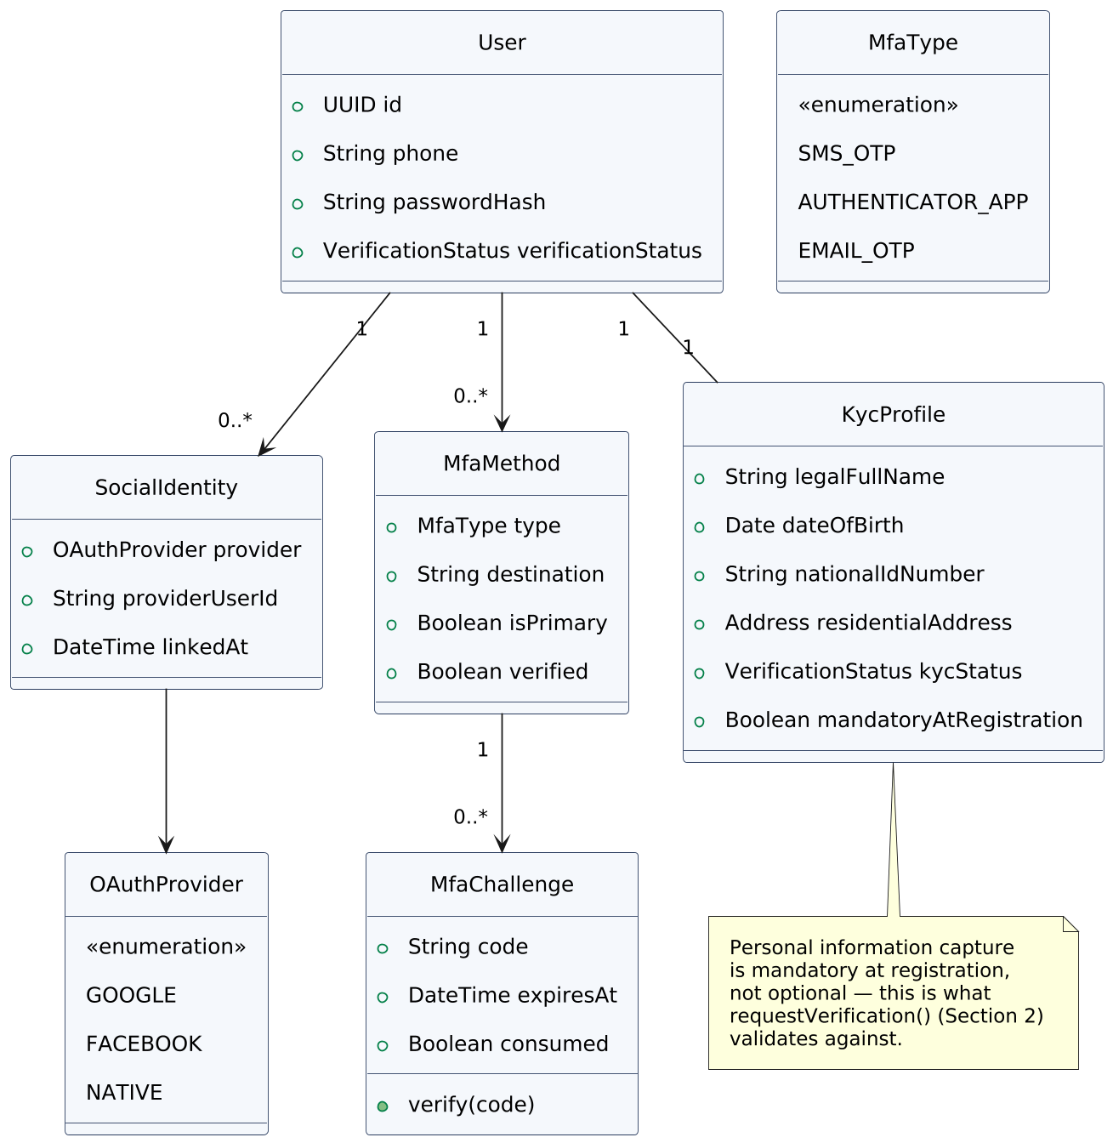
Figure 9 — Authentication, MFA & KYC Class Diagram

Explanation
- OAuthAccount links a User to a GOOGLE or FACEBOOK identity — a user can have both a password and one or more linked social accounts simultaneously, so switching login methods never creates a duplicate account.
- MfaMethod supports SMS OTP, an authenticator app, or email OTP; MfaChallenge is the specific one-time code issued for a login attempt, with its own expiry and attempt count to prevent brute-forcing.
- KYCProfile is mandatory — a 1-to-1 relationship with User, not optional — reflecting that personal information (national ID, date of birth, address, ID document, selfie) is always collected, consistent with the platform-wide KYC requirement.

11. Class Diagram — Content Lifecycle & Personalization
A Listing or Post isn't simply published or not — it can be saved as a draft, scheduled for future publication, saved/favourited by other users, and surfaced through a personalized recommendation feed. This diagram also covers the automated birthday, New Year, and national-holiday greetings.
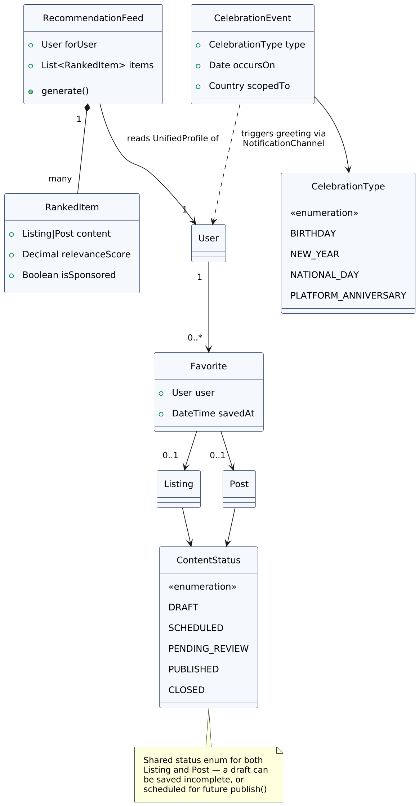
Figure 10 — Content Lifecycle & Personalization Class Diagram

Explanation
- ContentStatus is shared between Listing and Post — DRAFT lets a landlord or agent start a listing and finish it later; SCHEDULED holds a completed post until a chosen publish time, reusing the same publish() method defined back in Section 5, just deferred.
- Favorite is deliberately separate from Follow (following a person) and ShareEvent (sharing to others, Section 7) — it's a private save, not a social signal to anyone else.
- RecommendationFeed generates a ranked, personalized list of RankedItem — each one flagged isSponsored so an organically-ranked listing and a paid BoostedContent placement (Section 8) can sit in the same feed without the user being misled about which is which.
- CelebrationEvent covers birthdays (read from KYCProfile.dateOfBirth, Section 10), New Year, and national holidays (scoped per Country, so this isn't hardcoded to Cameroon) — each one triggers a greeting through the same shared NotificationChannel used for every other alert in the platform.

12. Class Diagram — Taskln Integration: Technician Services Subset
Oaziland's Technician module is a deliberately scoped-down subset of Taskln, Glorentech's separate general workforce platform — not a full merge, and not a simple link-out. Only real-estate-relevant professions surface inside Oaziland; Taskln's full breadth of skilled and unskilled work stays on its own platform.
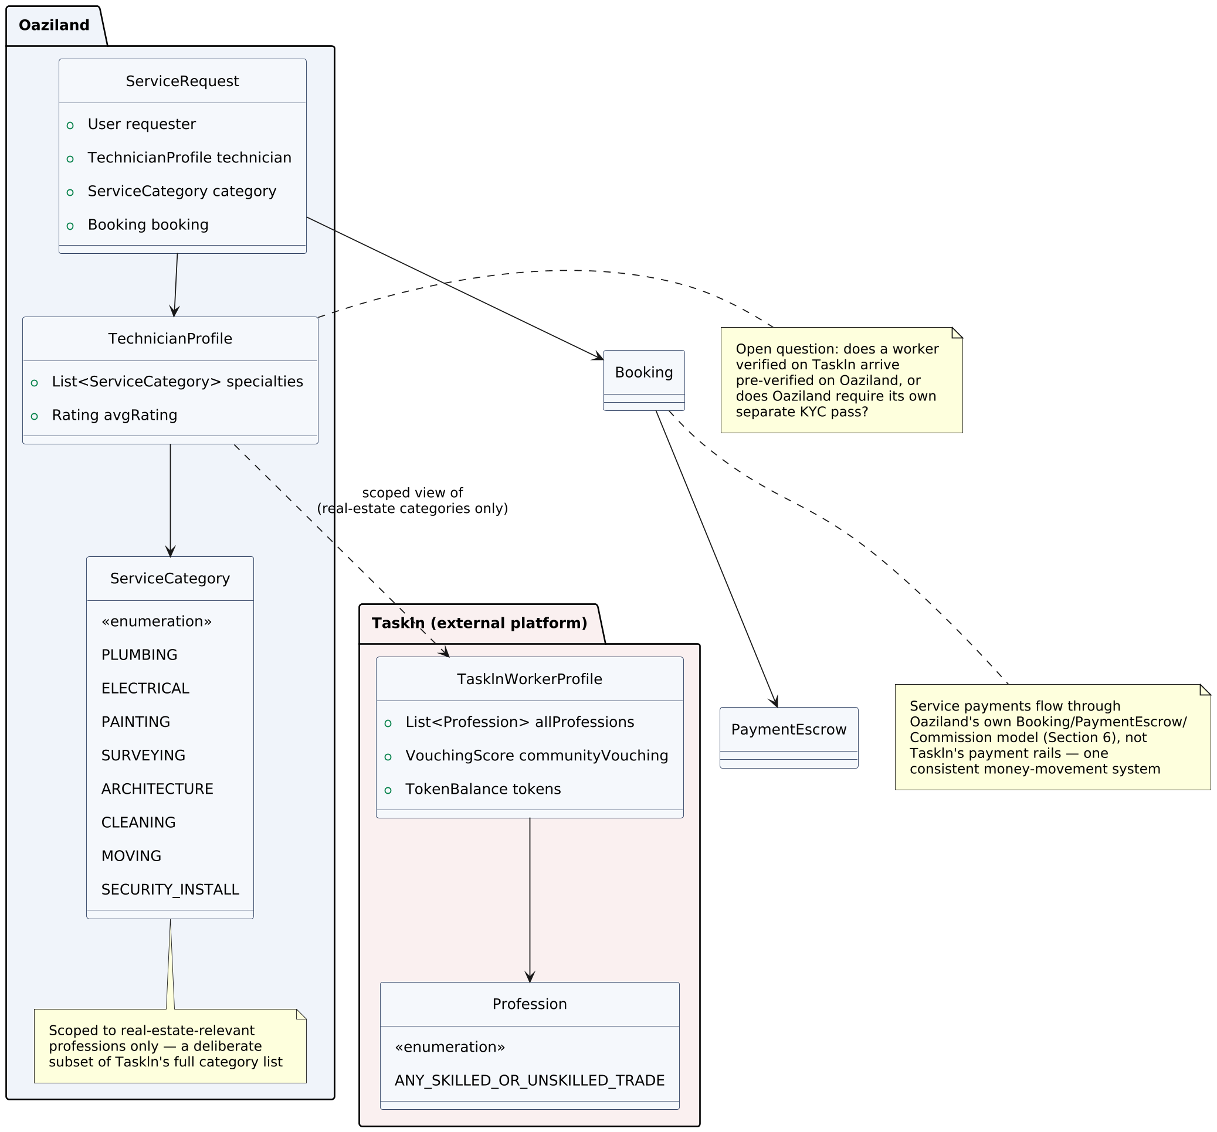
Figure 11 — Taskln Integration Class Diagram

Explanation
- TechnicianProfile.specialties is restricted to a fixed ServiceCategory enumeration (plumbing, electrical, painting, surveying, architecture, cleaning, moving, security installation) — a deliberate filter over Taskln's much larger, open-ended profession list.
- ServiceRequest still resolves to Oaziland's own Booking and PaymentEscrow (Section 6) — a service payment made through Oaziland never touches Taskln's payment rails, keeping one consistent money-movement and commission system across the whole platform.
- The dependency from TechnicianProfile to TasklnWorkerProfile is intentionally a read-only "scoped view of" relationship, not an inheritance or a shared table — Oaziland can display a Taskln worker's real-estate-relevant credentials without inheriting Taskln's token economy or community-vouching mechanics wholesale.
- One question remains genuinely open and is flagged directly on the diagram: whether a technician already verified on Taskln arrives pre-verified on Oaziland, or whether Oaziland's own KYC/VerificationBadge process (Section 10) always runs independently. This affects both onboarding friction and the trust story, and needs a decision before the integration is built.

13. Navigation & Dashboard Architecture
Every role gets a distinct, well-developed dashboard, and the public-facing navigation is state-aware — it reconfigures based on whether the visitor is logged out, a tenant, a landlord/host, a technician, an agent, or an agency.
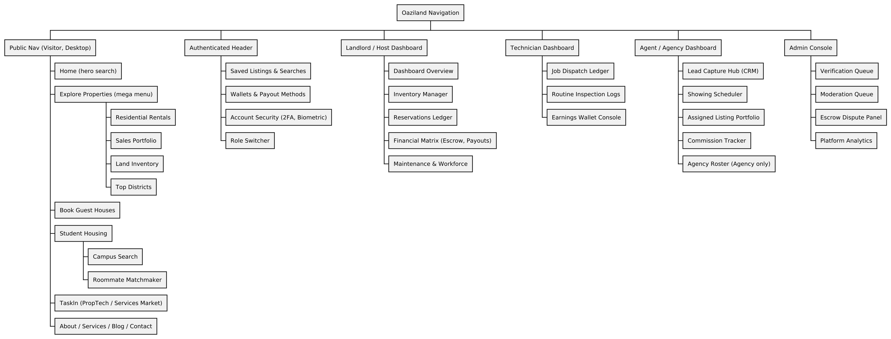
Figure 12 — Navigation & Dashboard Architecture (Work Breakdown Structure)

Explanation
- The Public Nav branch includes Taskln as a top-level entry (the PropTech/Services Market, Section 12) alongside property discovery — service-seeking and property-seeking are equally first-class entry points, not one buried inside the other.
- Landlord/Host, Technician, and Agent/Agency dashboards are structurally distinct, not the same dashboard with a few labels changed — a Technician's Job Dispatch Ledger and Earnings Wallet Console have nothing in common with an Agent's Lead Capture Hub and Commission Tracker, and each surfaces only the data that role needs.
- The Role Switcher in the Authenticated Header is what moves a user between these dashboards without logging out — one account, several dashboard views, exactly matching the multi-Role User pattern from Section 2.
- Every dashboard that handles money (Host's Financial Matrix, Technician's Earnings Wallet, Agent's Commission Tracker) reads from the same underlying PaymentEscrow/Commission model (Section 6) — three different views onto one consistent ledger, not three separate accounting systems.

Responsive Design: Desktop vs. Tablet/Mobile
The desktop landing page is deliberately different from smaller screens — desktop has room to sell the platform (mega-menus, trust badges, multiple carousels), while mobile has to get someone to a search result as fast as possible.
Landing Page Element | Desktop | Tablet / Mobile
Hero search bar | Full advanced search: property type + location + price + dates, inline | Single search box; filters open in a bottom sheet on tap
Mega-menu previews (Explore Properties, Taskln) | Rich dropdown with thumbnails and sub-categories on hover | Collapsed entirely into a hamburger drawer
"Top Districts" quick-link chips | Horizontal chip row, always visible | Hidden — surfaced inside the search filter sheet instead
Trust/verification badge strip | Visible in hero (e.g. "10,000+ Verified Listings") | Hidden — moved to About page / footer mention
Institutional nav (About, Services, Blog, Contact) | Full text links in secondary nav | Footer-only; not in main nav
Role Switcher / Wallet / Language | Full-width dropdown, icon + label | Icon-only, opens a bottom sheet
Featured/sponsored listings carousel | Multi-card carousel, 4–5 visible (Section 8 BoostedContent) | Single-card swipeable carousel

14. Use Case Diagram — Actors & System Capabilities
This diagram answers "who can do what." Seven actor types interact with the platform, and their capabilities overlap deliberately — a Student, for example, is also a Guest/Tenant/Buyer for the purposes of renting a house.
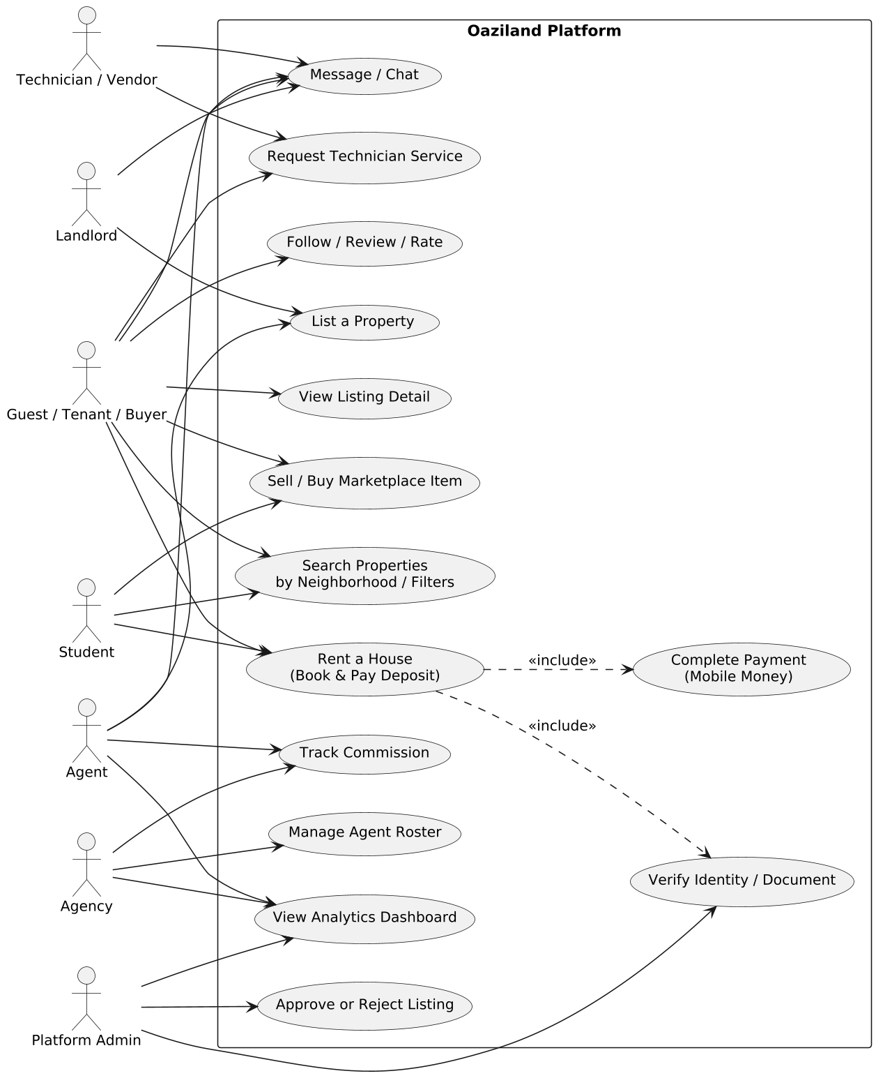
Figure 13 — Oaziland Use Case Diagram

Explanation
- "Rent a House (Book & Pay Deposit)" is the central use case for our running example, available to any Guest, Tenant, Buyer, or Student. It always includes two other use cases, shown with the <<include>> relationship: "Complete Payment" and "Verify Identity/Document".
- Landlord and Agent both reach "List a Property," but only Agent and Agency reach "Track Commission" — landlords who deal directly with tenants do not generate a commission record.
- Admin is the only actor who can "Approve or Reject Listing" — every listing, regardless of property type or who created it, passes through this verification gate before it becomes publicly bookable.

15. Sequence Diagram — "Rent a House" End-to-End
This diagram shows the running example unfolding over time across the app, the backend, the distributed lock layer, the database, the payment gateway, and the notification channel — the exact sequence of messages a guest's phone triggers when they rent a house in Bastos.
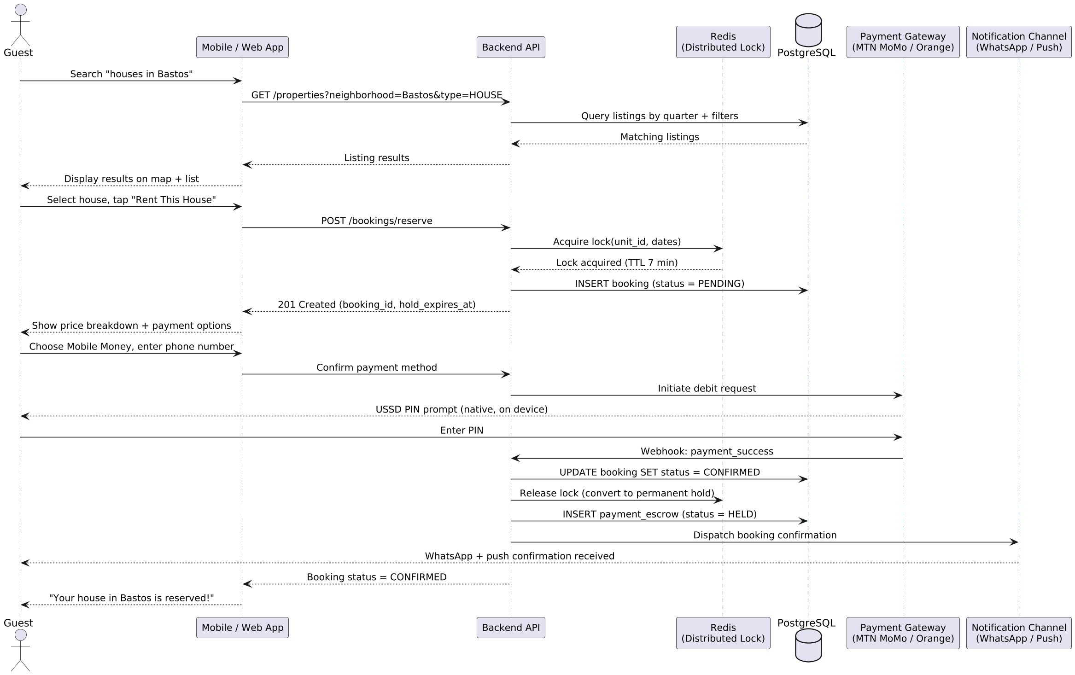
Figure 14 — Sequence Diagram: Renting a House via Mobile Money

Explanation
- The search step queries listings filtered by neighborhood (quarter) and property type — the same geographic-hierarchy search used across every one of the fifteen property categories in Sections 3–4.
- The moment the guest taps "Rent This House," the backend acquires a distributed lock in Redis before touching the database — this is what prevents two guests from being charged for the same house at the same time.
- Payment happens natively via a USSD PIN prompt on the guest's own device — the app never sees or stores the PIN; it only receives a signed webhook once the telecom processor confirms the debit.

16. Activity Diagram — Renting a House (Business Process View)
Where the Sequence Diagram shows technical messages between system components, this Activity Diagram shows the same journey from the perspective of the business process and the decisions made along the way.
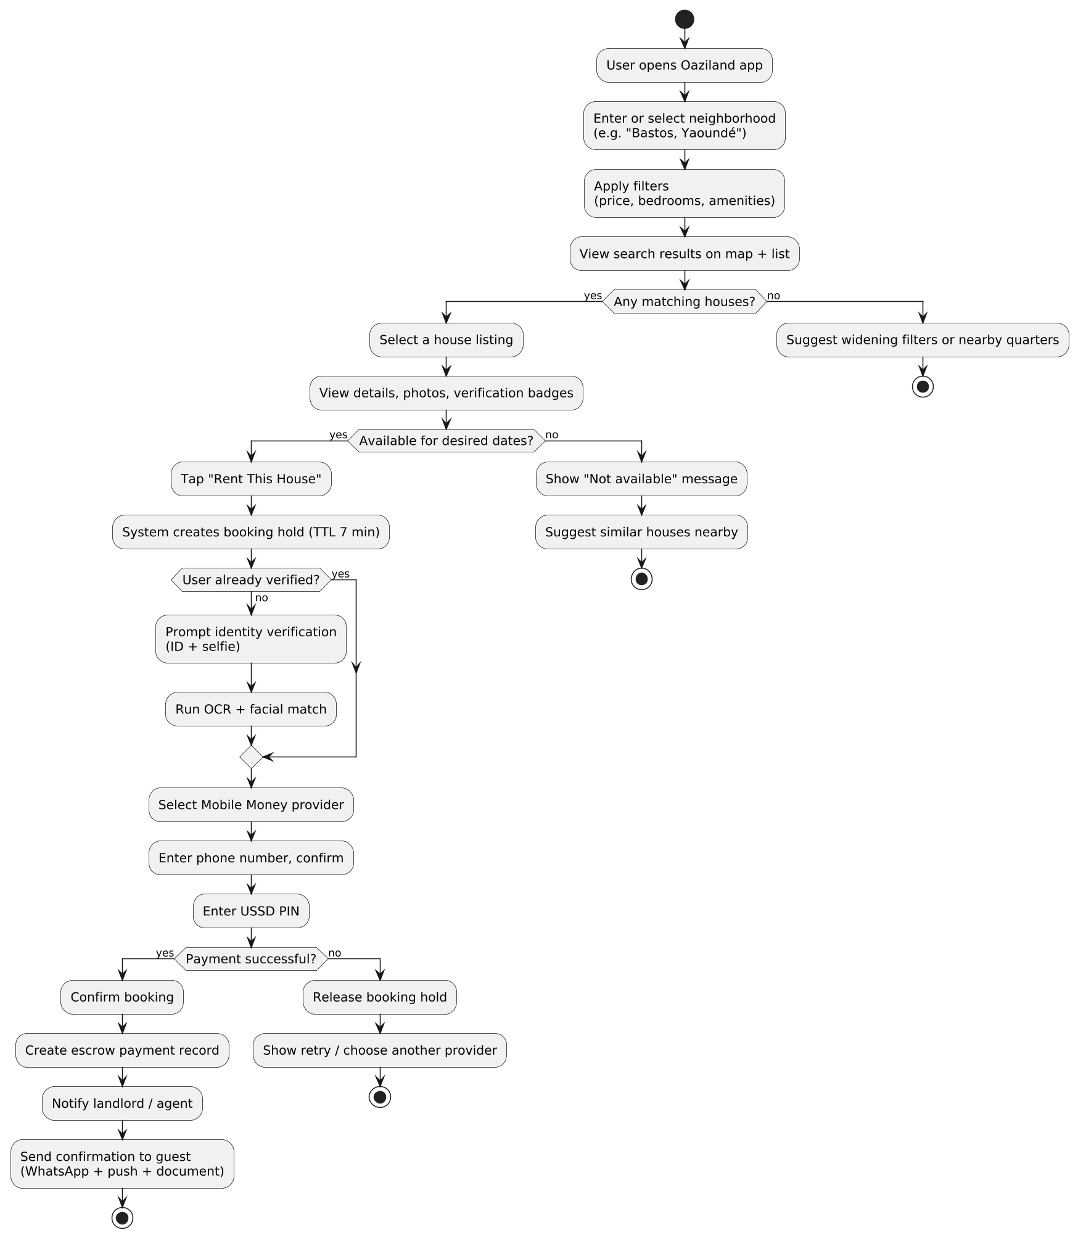
Figure 15 — Activity Diagram: House-Renting Business Process

Explanation
- Two decision points determine whether a search even reaches a bookable house: whether any listings match the neighborhood/filters at all, and whether the specific selected house is available for the desired dates.
- Identity verification is conditional — a returning, already-verified guest skips straight to payment, while a first-time renter is routed through OCR and facial-match verification before payment is offered.
- Every path through this diagram ends in a definite outcome — there is no path that leaves the guest in an ambiguous state.

17. State Machine Diagram — Booking Lifecycle
Every Booking object in the system — whether it is a room, studio, apartment, house, shop, warehouse, or land reservation — moves through this same set of states. This single state machine is reused across every property type rather than each one inventing its own.
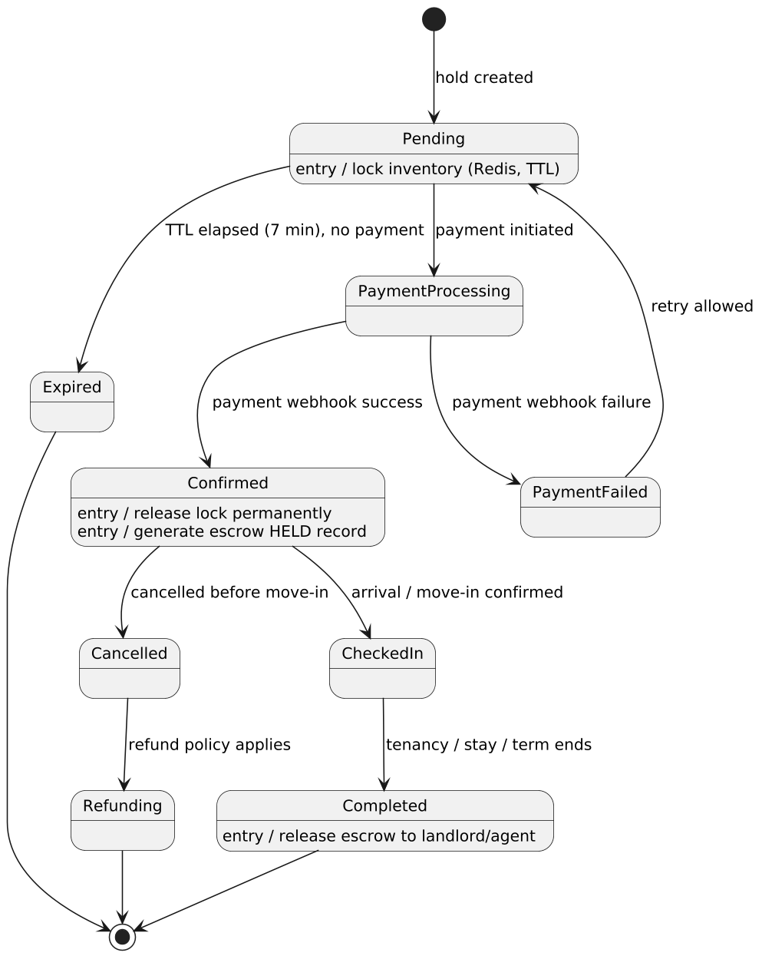
Figure 16 — State Machine Diagram: Booking Object Lifecycle

Explanation
- Pending is a transient, time-boxed state — the entry action locks the specific unit in Redis with a 7-minute expiry.
- PaymentFailed loops back to Pending rather than dead-ending, giving the guest a chance to retry with the same or a different Mobile Money provider.
- The transition into Completed triggers "release escrow to landlord/agent" — money only moves to the landlord once the tenancy has actually concluded, not at the moment of booking.

18. Conceptual Data Model
The conceptual model is the highest-level, non-technical map of the real-world business concepts and how they relate — deliberately free of attributes, data types, or keys. It is meant to be readable by a non-technical stakeholder.
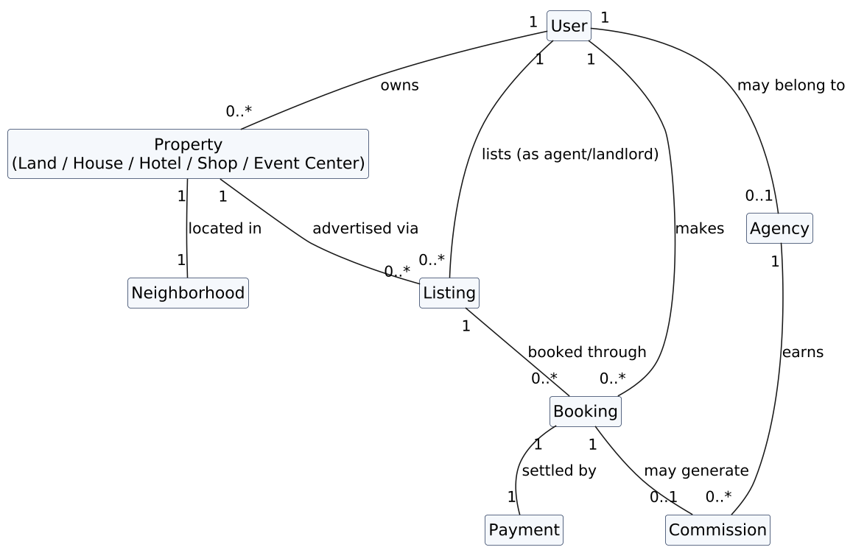
Figure 17 — Conceptual Entity-Relationship Diagram

Explanation
- This is the plain-English version of the class diagrams in Sections 2–6: a User owns Property, Property sits in a Neighborhood, Property is advertised through a Listing, and a Listing becomes a Booking, which is settled by a Payment and may generate a Commission for an Agency.
- This diagram is the right one for an investor conversation or a stakeholder workshop — it captures the shape of the business without requiring any technical background to read.

19. Logical Data Model
The logical model translates the conceptual entities into structured tables with attributes, primary keys, foreign keys, and cardinality — still independent of any specific database engine, but precise enough for a database engineer to begin physical design.
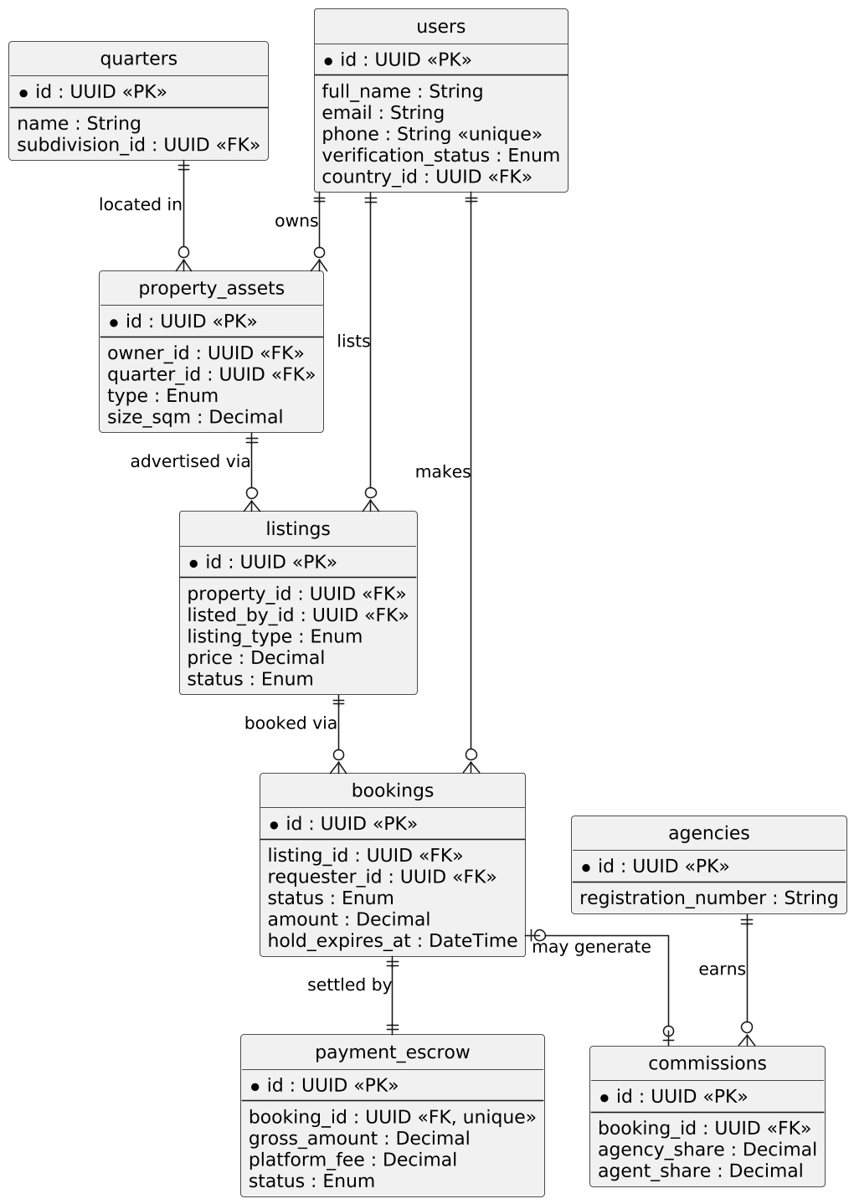
Figure 18 — Logical Entity-Relationship Diagram

Explanation
- Every relationship carries explicit cardinality: one user can own many property_assets, but a booking settles through exactly one payment_escrow record.
- The bookings |o--o| commissions relationship is intentionally optional on both sides: a booking made directly with a landlord produces zero commission rows, by design rather than by a null-check workaround.
- quarters (the neighborhood level) is a first-class table, not a free-text field, which is what makes "search houses in Bastos" a fast, indexed query rather than a text search.

20. Physical Data Model (PostgreSQL)
The physical model is production-ready: exact column types, constraints, defaults, and indexes for the PostgreSQL database engine. This is what an engineer copies directly into a migration file.
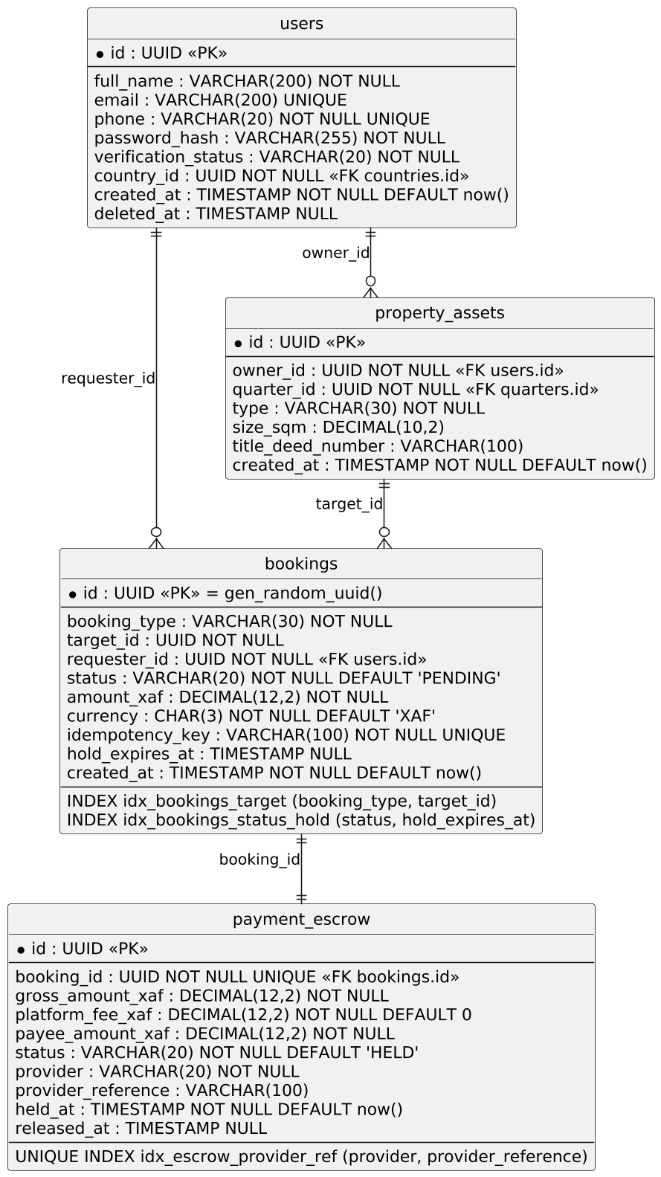
Figure 19 — Physical Entity-Relationship Diagram (PostgreSQL)

Explanation
- bookings.idempotency_key is UNIQUE NOT NULL — this makes it safe for the mobile app to retry a reservation request after a dropped connection without accidentally creating two bookings for the same unit.
- payment_escrow has a unique index on (provider, provider_reference) — this prevents the same Mobile Money webhook from being processed twice if the telecom aggregator sends it more than once.
- The partial index idx_bookings_status_hold (status, hold_expires_at) WHERE status = 'PENDING' keeps the background job that sweeps expired holds fast even once the bookings table has millions of historical rows.

21. Flowchart — Payment & Escrow Decision Logic
Where the Activity Diagram showed the guest-facing business process, this flowchart zooms into the specific technical decision logic that governs what happens to the guest's money from the moment a booking hold is created to the moment the landlord is paid.
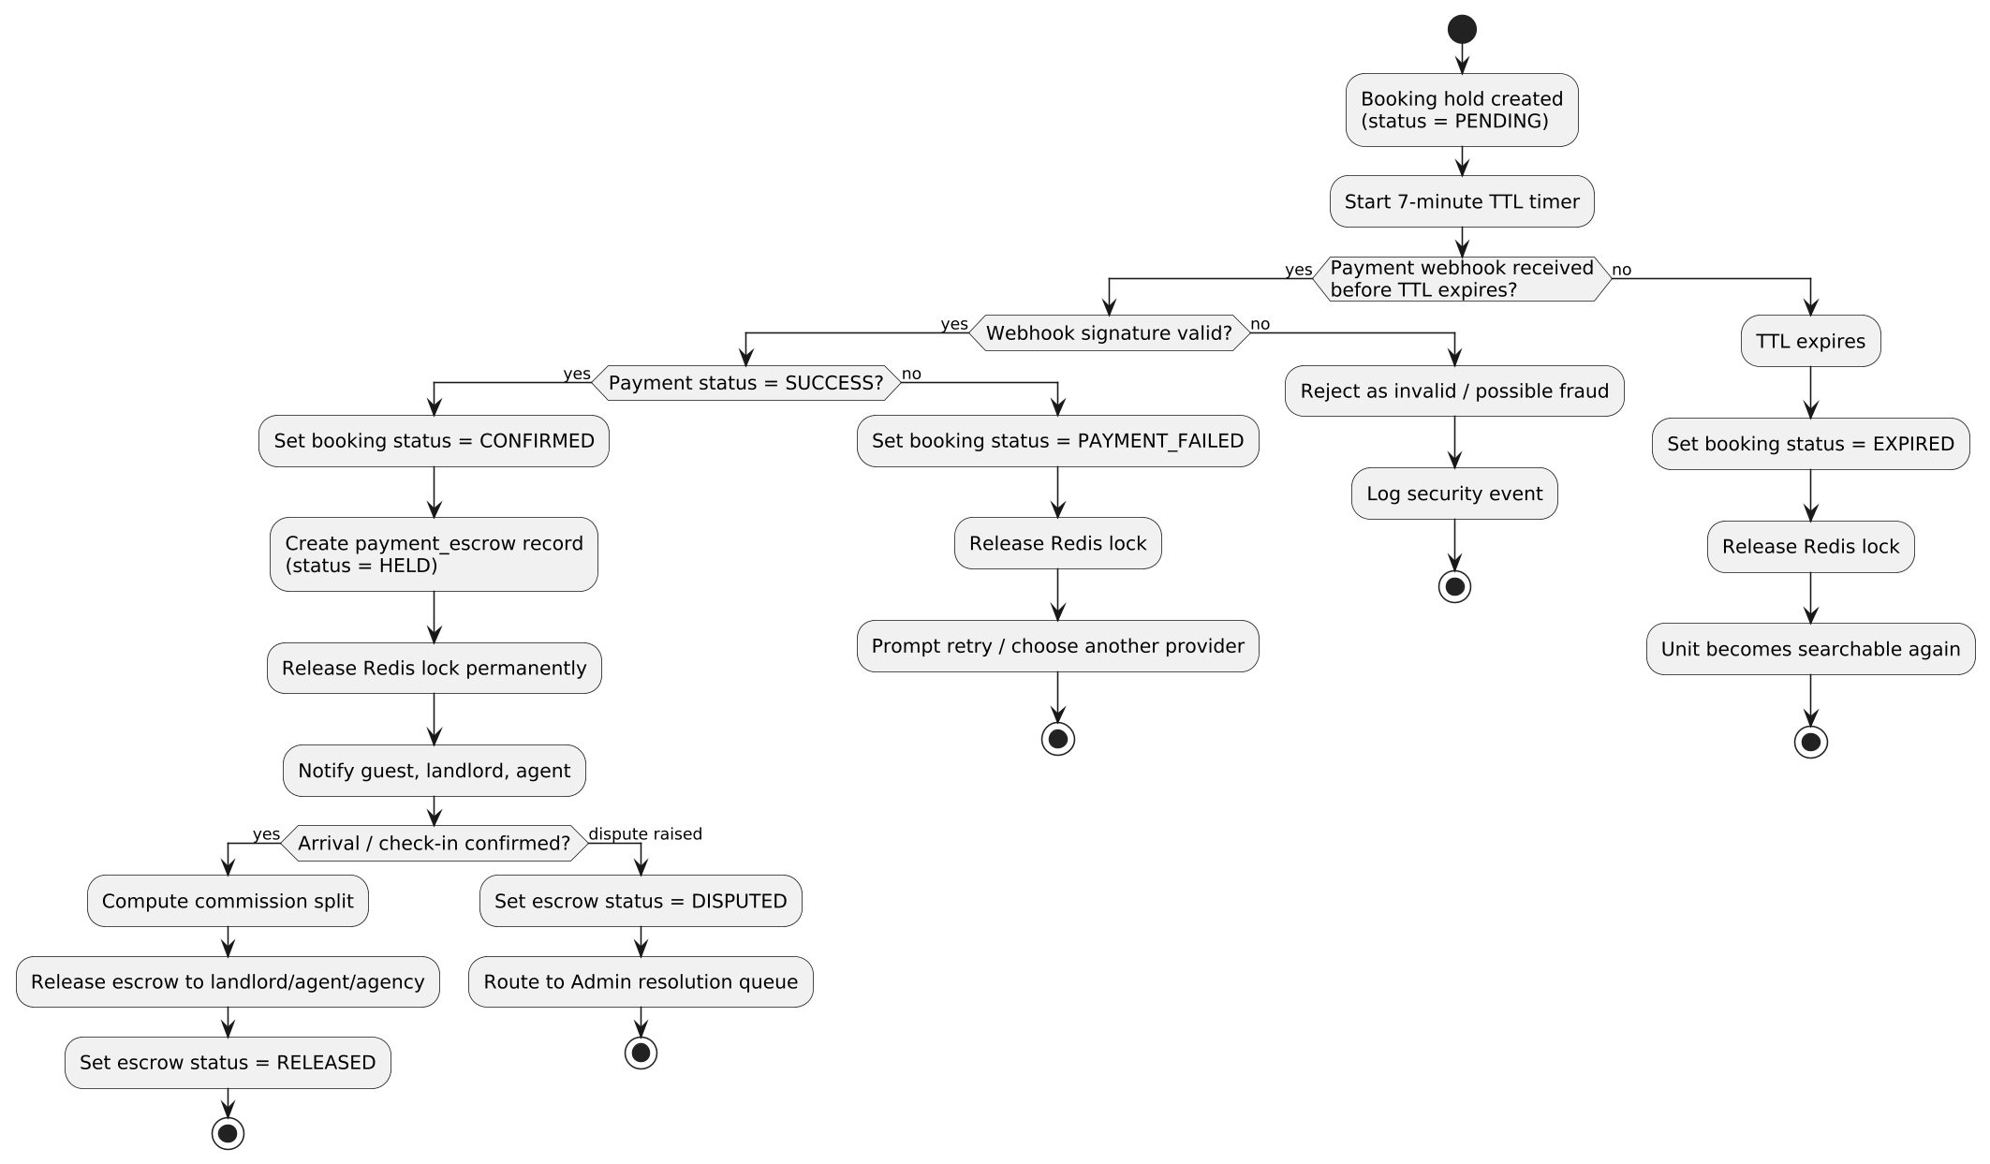
Figure 20 — Flowchart: Payment & Escrow Decision Logic

Explanation
- There are three distinct failure branches — invalid webhook signature (logged as a security event), declined payment (guest invited to retry), and TTL expiry (silent release, the unit simply becomes searchable again).
- The dispute branch after check-in confirmation exists because a guest may raise a legitimate complaint even after arrival — the escrow is not released automatically in that case; it is held pending Admin review.
- This flowchart applies unchanged across every property type in the taxonomy — only what triggers the "Arrival / check-in confirmed" decision differs (a front-desk check-in for a Guest House, a signed contract for a Land sale, and so on).

22. Pseudocode — Reservation & Escrow Release Algorithm
The pseudocode below is the algorithmic expression of the Sequence Diagram (Section 15), the Activity Diagram (Section 16), and the Flowchart (Section 21) combined into one coherent function. It uses the same object and field names defined in the class diagrams, so it can be translated directly into Django/Python or NestJS/TypeScript without renaming anything, and it applies unchanged across every property type in the taxonomy.
FUNCTION reserveBooking(userId, listingId, dateRange, paymentDetails):

listing <- findListing(listingId)
IF listing.status != AVAILABLE:
RETURN Error("Listing not available")

lockKey <- CONCAT(listing.unitId, dateRange)
lockAcquired <- Redis.acquireLock(lockKey, ttlSeconds = 420)
IF NOT lockAcquired:
RETURN Error(409, "This property is currently reserved by another user")

TRY:
booking <- Database.insertBooking(
requesterId = userId,
targetId = listingId,
status = PENDING,
amount = listing.depositAmount,
holdExpiresAt = NOW() + 420 seconds,
idempotencyKey = generateIdempotencyKey()
)

IF userId.verificationStatus != VERIFIED:
verificationResult <- runIdentityVerification(userId)
IF verificationResult != PASSED:
Redis.releaseLock(lockKey)
RETURN Error("Identity verification required")

paymentResult <- PaymentGateway.initiateDebit(
provider = paymentDetails.provider, // MTN_MOMO or ORANGE_MONEY
phoneNumber = paymentDetails.phoneNumber,
amount = booking.amount
)

WAIT FOR webhook OR TIMEOUT(420 seconds):
ON webhook RECEIVED:
IF NOT verifySignature(webhook):
logSecurityEvent("Invalid webhook signature", booking)
RETURN Error("Payment verification failed")

IF webhook.status == SUCCESS:
booking.status <- CONFIRMED
Database.update(booking)
Redis.releaseLock(lockKey, permanent = TRUE)

escrow <- Database.insertPaymentEscrow(
bookingId = booking.id,
grossAmount = booking.amount,
platformFee = calculatePlatformFee(booking),
status = HELD,
provider = paymentDetails.provider,
providerReference = webhook.transactionId
)

NotificationChannel.send(
recipients = [booking.requester, listing.landlord],
template = "BOOKING_CONFIRMED",
channel = [WHATSAPP, SMS, PUSH, EMAIL]
)
RETURN Success(booking)

ELSE:
booking.status <- PAYMENT_FAILED
Database.update(booking)
Redis.releaseLock(lockKey)
RETURN Error("Payment declined, please retry")

ON TIMEOUT:
booking.status <- EXPIRED
Database.update(booking)
Redis.releaseLock(lockKey)
RETURN Error("Reservation window expired")

CATCH anyError:
Redis.releaseLock(lockKey)
logError(anyError)
RETURN Error("An unexpected error occurred, please try again")

FUNCTION completeBooking(bookingId, arrivalConfirmed):

booking <- Database.findBooking(bookingId)
IF NOT arrivalConfirmed:
RETURN Pending("Awaiting check-in / move-in confirmation")

booking.status <- CHECKED_IN
... (on term/stay end) ...
booking.status <- COMPLETED

escrow <- Database.findEscrowByBooking(bookingId)
commission <- calculateCommission(booking) // zero if no agent/agency involved

escrow.payeeAmount <- escrow.grossAmount - escrow.platformFee - commission.total
escrow.status <- RELEASED
Database.update(escrow)
disburseToWallet(booking.listing.landlord, escrow.payeeAmount)
IF commission.total > 0:
disburseToWallet(booking.listing.listedBy, commission.agentShare)
disburseToWallet(booking.listing.listedBy.agency, commission.agencyShare)

RETURN Success(booking)

23. Additional Platform Considerations
Beyond the diagrams above, the following elements are necessary parts of the design that do not reduce to a single diagram but materially affect how the modeled objects behave in production.

Role Dashboards
Every role gets a dashboard scoped to what it actually needs — not a single generic screen with permissions toggled on or off. Agent, Agency, and Technician dashboards specifically include the ability to post video/photo content as advertising, feeding directly into the Post and AdCampaign objects from Sections 7 and 8.
Role | Dashboard Capabilities
Landlord | Owned properties, active listings, booking requests, earnings, direct messages, maintenance requests from tenants
Agent | Listings (own + agency-assigned), commission tracker, client interaction log, video/photo advertising posts, ad campaign manager, performance score
Agency | Full agent roster with individual performance, agency-wide commission and revenue reporting, branded listing pages, bulk upload tools, agency-wide ad campaigns
Technician | Service requests queue, coverage area settings, ratings/reviews, advertising posts for services offered, earnings tracker
Tenant / Guest / Buyer | Saved searches, booking history, payment/receipt history, saved favorites, messages, reviews written
Admin | Verification queue, content moderation queue (reports + AI-flagged content), dispute resolution, platform-wide analytics, ad campaign oversight

Benefits of an Agency vs. an Independent Agent
The commission split alone doesn't explain why an agent would join an agency — the actual trade-off is reputation, lead volume, and tooling versus full independence and full commission:
Independent Agent | Agent Under an Agency
Keeps 100% of the agent's commission share | Shares commission with the agency, but pays no marketing or lead-generation cost out of pocket
Builds reputation and verification badge from zero | Inherits the agency's existing verified badge and reputation immediately
Sources every lead independently | Draws from the agency's shared lead pool across all its listings
No access to agency-branded listing pages or bulk tools | Gets agency-branded listing pages, bulk upload tools, and training/support resources
Full control over pricing and client relationships | Subject to the agency's CommissionPolicy and service standards

Platform Fee on Every Transaction
PlatformFeePolicy (Section 8) applies a small, consistent percentage across every TransactionCategory — property bookings, marketplace item sales, technician service payments, and ad spend — rather than a special rule per module. The percentage is set deliberately low enough to be barely noticeable to any single user, while still applying universally.

The Fifteen-Category Property Taxonomy
Sections 3 and 4 model all fifteen Cameroon property categories requested: Room, Studio, Apartment, Furnished Short-Let, and Duplex/Villa under Residential (Section 3); Lock-Up Shop, Corporate Office, Event Center, Guest House/Lodge, and Mixed-Use Building under Commercial & Hospitality; and Titled Land, Commercial Plot, Warehouse, Agricultural Land, and Car Wash/Paved Plot under Land & Infrastructure (Section 4). Every one of these can be rented, sold, or — where applicable — offered as a short-let through the same Listing and Booking objects defined in Sections 5 and 6, since the transactional core is shared across the entire taxonomy rather than duplicated per category.

Verification Badge Types
VerificationBadge (Section 5) is a generic, reusable object carrying a badgeType rather than a fixed field per badge: Verified Document, Site Visit Verified, Bornes Visibles, Title Type, and Identity KYC. New badge types can be added without a schema change, since badgeType is an extensible enumeration, not a set of boolean columns.

Bulk vs. Individual Property & Unit Upload
A landlord or agent can create a single standalone unit or upload many properties of the same type at once — for example, an agency onboarding 40 studio apartments in one compound. Building.bulkCreateUnits() (Section 3) takes a count and a template Unit definition and generates that many Unit records in one operation, each automatically assigned its own unique roomCode.

Contracts & Payment Gateways
Contract (Section 6) attaches to a Booking once terms are agreed, carrying a digital signature hash and any attached files. PaymentGateway is modeled as an interface, not a single class, so MTN MoMo, Orange Money, and card processors are interchangeable implementations behind the same PaymentEscrow flow.

Media: Video, Image, Audio & File Uploads
MediaAsset already supports photos, video, and 3D/AR virtual tours; audio (voice notes on a listing, or an agent's spoken neighborhood walkthrough) and general file attachments (floor plans, inspection reports) extend the same media type list rather than requiring a parallel upload system.

Geolocation & Google Earth / Satellite View
Every PropertyAsset carries a GeoPoint location and a distanceToRoadKm field, and nearbyFacilities links to amenities (schools, markets, hospitals, transport) drawn from the map layer. Satellite/Google Earth-style imagery is a map-tile-provider choice at the presentation layer, not a data-model change.

Geographic Hierarchy
The "neighborhood" in "rent a house in any neighborhood" is not a free-text field. It is modeled as a full administrative hierarchy — Country -> Region -> Division -> Subdivision -> Village/District -> Quarter — so that search, filtering, and quarter-level price trend charts all run against structured, indexed data rather than string matching.

Security & Verification
Role-based access control is enforced at the API gateway, not just in the app's user interface. Identity verification (Section 16) is reused across account KYC, land title-deed review, and guest-house check-in, with different approval rules for each: automated approval is acceptable for account creation, but a land title deed always requires a human administrator's sign-off.

Notifications
Every confirmation, reminder, and alert in this document is dispatched through one shared Notification Channel supporting WhatsApp, SMS, push, and email — not a separate messaging system per module.

Recommendation Algorithm
The feed that suggests posts and videos to a user reads the same UnifiedProfile and SocialInteraction history described in the Pre-Development Design Package's AI layer, combined with BoostedContent's priorityRank (Section 8) — organic relevance and paid promotion feed the same ranked feed rather than two separate systems.

Currency, Country & Language
All monetary fields are stored as an (amount, currency code) pair rather than a bare number, since the platform operates across multiple African currencies and countries. The platform ships bilingual (English/French) at minimum, with additional local languages planned for later phases.

Web App & Mobile App Technology
The web app is built in React (Next.js for server-side rendering and SEO) and the mobile app in React Native — sharing component logic and, critically, sharing the same backend API and database defined throughout this document, so a listing created on mobile is instantly visible on web and vice versa.

24. Conclusion & Next Steps
This document, together with the companion Oaziland Technical Architecture & Data Model and the Pre-Development Technical Design Package, gives an engineering team everything needed to begin implementation: a complete object model split into readable, focused diagrams, the full fifteen-category Cameroon property taxonomy, the behavioral diagrams showing how those objects collaborate, a three-layer data model down to production SQL, and a directly-translatable algorithm for the platform's most critical transaction.

Recommended Next Steps
- Lock the backend framework choice (Django/Python vs. NestJS/TypeScript) so the pseudocode in Section 22 can be translated into real, runnable code.
- Extend the class diagrams in Sections 2–7 with the hospitality-module classes already defined in the Architecture document (Hotel, EventCenter, StudentHostel, GuestHouse) once the launch sequencing across modules is confirmed.
- Produce high-fidelity Figma wireframes for the core user journeys — this remains the one deliverable category that genuinely requires a design tool rather than a text or diagram specification.
- Begin physical database migration scripts directly from Section 20, extending the pattern shown there to the CameroonMarketDetails and SecurityFeatures tables introduced in Section 5.

