Oaziland
Complete Software Specification
Feature Catalogue, Data Models (Conceptual / Logical / Physical),
UML Diagrams, and Activity Diagrams
Glorentech™ / Global Renaissance Technology SARL
Messassi, Yaoundé, Cameroon
September 2026

Table of Contents
1. Executive Overview 3
2. Complete Feature List 4
3. Data Modeling 8
4. UML Diagrams 11
5. Activity Diagrams 14
6. System Architecture 21
7. Technology Stack & Testing Discipline 22

1. Executive Overview
Oaziland is a full-spectrum real estate and services super-app for Cameroon and Africa, built by Glorentech™. It connects renters, buyers, landlords, agents, and agencies for property transactions, and extends into hospitality (hotels, guest houses, student hostels, event venues), a general marketplace (warehouses, stores, businesses, vehicles), on-demand transport and cargo movement (OaziGo), on-demand technician dispatch (Taskln Service), and the trust, payment, and social infrastructure that ties all of it together.
The platform is deliberately not a single-purpose listings site. Its own real design groups every transaction — a property booking, a hotel reservation, an OaziGo ride, a Taskln Service job — through one shared Booking and PaymentEscrow system, so trust, dispute-handling, and commission logic are written once and apply everywhere, rather than being reimplemented per feature.
This specification reflects the platform as it actually stands, verified rather than assumed:
Metric | Value
Backend applications (Django) | 31
Web pages (Next.js, bilingual EN/FR) | 46
Mobile screens (React Native / Expo) | 45
Automated backend tests, all passing | 491
Translation keys per language, exact EN/FR parity | 776

Section 2 catalogues every real feature. Section 3 covers the data model at three levels of abstraction. Section 4 presents the UML class and use case diagrams. Section 5 walks through the platform's key workflows as activity diagrams. Section 6 shows the physical system architecture. Section 7 summarizes the technology stack and the testing discipline behind it.

2. Complete Feature List
Every feature below is real and working — built, tested, and verified against a live server, not aspirational. Each entry states what it does and, where relevant, the specific real design decision behind it.

2.1 Core Real Estate

Search & Browse
- Real map-and-list search — hover a result, its map pin highlights; click a pin, the matching card scrolls into view. Filter chips (Rent/Sale, property type) apply instantly, no dropdown to open first.
- Every listing shows who is behind it — Owner, Agent, or Agency — computed live from the real relationship between the lister and any agency they belong to, never a manually-set label.

Property Types
- House, Land, Shop, and Building (multi-unit) — each a real, distinct property type with its own relevant fields (Land has no bedroom count; a House does).
- A real property-type dropdown for houses: Room, Studio, Self-Contain, Apartment, Standalone House, Duplex, Bungalow, Detached Villa, Chalet — plus a genuine "Other, please specify" free-text option so a lister is never blocked by an incomplete list.

Amenities, House Rules, Nearby Facilities, and Conditions
- A real, validated amenities list (parking, backup generator, borehole water tank, 24/7 security, fenced compound, swimming pool, air conditioning, furnished, solar power, CCTV, balcony/terrace, WiFi-ready) and a real house-rules list (no pets, no smoking indoors, no subletting, no parties, quiet hours, advance notice for visits).
- A real nearby-facilities picker — genuine points of interest (schools, hospitals, markets, transport hubs) filtered to the listing's own neighborhood, not a generic list.
- Real listing conditions — minimum lease length, deposit requirements, and free-text clauses — generic to both property listings and marketplace listings.

Photos & Video
- Real photo/video upload on every property listing, with a primary-photo flag and a real carousel on every card.

2.2 Hospitality

Hotels
- Real hotel creation by a real owner — requires at least one real room type (category, capacity, nightly rate) to be created at all, since a hotel with zero room types isn't bookable.
- New hotels start unverified, matching the platform's real moderation posture; the owner can see their own pending hotel immediately, but it only becomes publicly visible once an admin verifies it through a real Admin Console action.
- Real dynamic pricing and reservation creation, with real date-range validation.

Event Venues
- Real venue creation, requiring at least one real bookable space (theatre/banquet capacity, hourly rate). Same real unverified-until-admin-approved posture as hotels.
- Real event booking with genuine availability-conflict checking — two events can't double-book the same space and time.

Guest Houses
- Real creation, with a real coastal-leisure flag for beach-town properties (Kribi, Limbe) and no verification gate — a guest house is publicly visible immediately, matching its own simpler real-world trust model.

Student Hostels
- Real hostel creation, auto-provisioning a real OwnerProfile for a first-time owner rather than requiring a separate manual setup step.
- Real roommate-preference matching, installment billing (splitting a semester's rent into real scheduled payments), and real 60/30/7-day lease-renewal reminders.

Shared across all four hospitality types
- A single shared PropertyAssetPhoto model gives every hospitality type real photo/video upload, reusing the same two-step upload pattern used everywhere else on the platform.

2.3 Marketplace
- Four real categories — Warehouses, Stores, Businesses, Cars — each with its own relevant fields (a Car has a real composed VehicleSpec: make, model, year, mileage; a Business has real goodwill/inventory flags and annual revenue).
- Real photo/video upload across all four categories, added via a single shared action on the base marketplace ViewSet rather than four separate implementations.

2.4 OaziGo — Rides & Cargo Transport
- Real vehicle categories — Moto, Standard, Comfort, Van, Truck — each with its own genuine fare formula (a moto is cheaper than a car; a truck is more than a van), the same real tiered pricing pattern used by ride-hailing apps already operating in Cameroon.
- Real cargo/building-materials transport as a first-class request type, not an afterthought — a landlord or agent moving materials or furniture between properties selects Cargo instead of Passenger, must describe what's being moved, and the request can only be accepted by a Van or Truck, never a car or moto.
- A real luggage flag for passenger rides.
- Real driver registration (license number) and real vehicle registration (make, model, plate number, category) — a driver cannot accept any ride until an admin has verified their registration, closing what was once a real ability for any signed-in user to accept a ride with zero vetting.
- A real request → accept → start → complete-and-pay lifecycle, settling through the exact same Booking/PaymentEscrow system as every other transaction type on the platform.

2.5 Taskln Service
- Real on-demand technician dispatch — plumbing, electrical, painting, cleaning, moving, security installation — with real urgent-vs-scheduled priority and real proximity-based technician matching.
- Same real request → accept → start → complete-and-pay lifecycle as OaziGo, settling through the same shared escrow system.

2.6 Social & Community
- A real social feed — posts, comments, reactions — with real posts linkable directly to a specific listing.
- Real one-to-one messaging with delivery/read receipts and real typing indicators, with a real, user-controlled privacy setting to hide online status or typing indicators from others.
- A real referral system — a persistent, unique code per user, genuinely applied when someone registers through a referral link.
- Creator Premium — a real, working paid subscription giving a visible badge and a real feed-ranking boost.

2.7 Trust & Safety
- Real ratings — any signed-in user can rate an agent, agency, landlord, or owner; re-rating the same person updates their one real score rather than stacking duplicate entries.
- Real written reviews — left only by a booking's own requester, only once that booking is genuinely completed, preventing a review for a transaction that never actually happened.
- Real reporting of a person directly (an agent, agency, landlord, or owner), not just content they posted — with a real admin queue to resolve each report and, where warranted, issue a real strike against the reported user's account.
- Real KYC identity verification and a real multi-factor authentication requirement (SMS or email OTP) before a user can list a property or accept certain bookings.

2.8 Financial Tools
- A real payment escrow on every transaction — funds are held, not released to the lister/driver/technician, until the underlying booking is genuinely completed.
- Real, configurable commission splitting between an individual agent and their agency, computed per real transaction category.
- A real, public property valuation tool — a genuine low/high estimate averaged from currently active comparable listings in the same neighborhood, stated plainly as exactly that rather than a professional appraisal.
- A real, public rent-affordability tool — a transparent 25%/33%-of-income guideline, stated plainly as a guideline rather than a credit assessment.
- A real "My Bookings" page listing every booking a user has made across every transaction type, with a genuine "Open a Dispute" action wherever a real payment escrow actually exists.

2.9 Property Management
- Real maintenance-request tracking, from a tenant's initial report through to a landlord closing it with a real logged cost.
- Real, consent-gated tenant screening — a landlord can only see a prospective tenant's real rental history (completed bookings, any warnings on file) once that tenant has explicitly granted consent.
- Real agent safety check-ins for a solo property showing, with a real expected-checkout time and a real emergency contact on file.
- Real lease creation with automatic 60/30/7-day renewal reminders.
- A real, working dispute-opening action, reachable from a real booking a guest or renter can actually see and act on.

2.10 Agents & Agencies
- Real public directories for both agents and agencies, each with a real profile page showing their actual aggregated rating and active listing count.
- An agency's own rating is a genuine aggregate computed across every agent on its real roster — there is no separate "rate this agency" action, since the number only ever moves by rating one of its real agents.
- A real private dashboard for an agent (their own leads, commission, performance) and for an agency (their whole team's real aggregated activity).

2.11 Careers, Training, and the "Looking For" Board
- Real job postings with a real apply flow (a short cover message, submitted against the actual posting).
- Real training programs with real enrollment, some issuing a real completion certificate.
- A real "Looking For" board — genuine requests from people searching for a room, store, warehouse, or business, that any lister can respond to if they have a real match.

2.12 Admin Console
- A real, single console covering every moderation queue the platform needs: pending verification requests, filed content reports, open disputes, and — added this pass — pending hotel, venue, and OaziGo driver verifications, all in one consistent "Pending Listings"-style pattern.
- Every admin action is real and state-changing — approving a listing, verifying a hotel, resolving a dispute, or issuing a strike genuinely updates the underlying record, not a mock action.

3. Data Modeling
The data model is presented at three real levels of abstraction — a conceptual view for a business reader, a logical view showing real entities and their attributes grouped by domain, and a physical view showing the actual database schema (table names, column types, keys) for a representative core subset.

3.1 Conceptual Data Model
The business-level view — real entities and how they genuinely relate, with no attributes or technical detail.
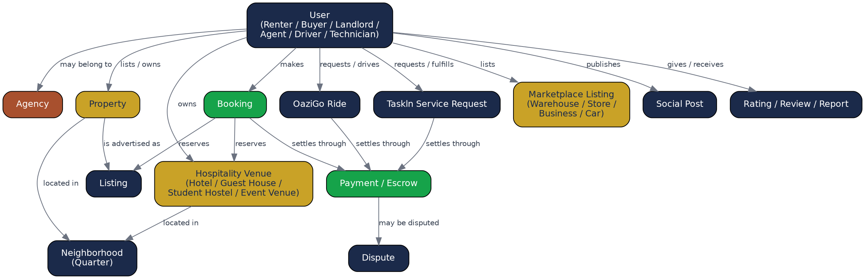
Figure 3.1 — Conceptual data model: the platform's core real-world entities and relationships.

3.2 Logical Data Model
Real entities with their real attributes, grouped by domain rather than shown as one unreadable diagram — this platform's real schema spans over 100 tables across 31 Django applications.

3.2.1 Property Domain
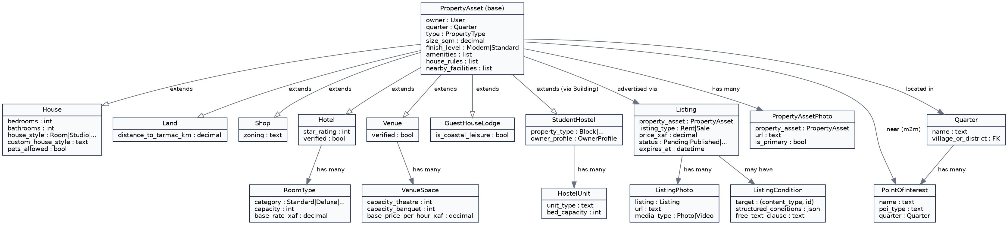
Figure 3.2 — Logical model: PropertyAsset and its real subtypes (House, Land, Shop, Hotel, Venue, Guest House, Student Hostel), Listing, and the amenities/conditions/nearby-facilities structures.

3.2.2 Marketplace & OaziGo Domain
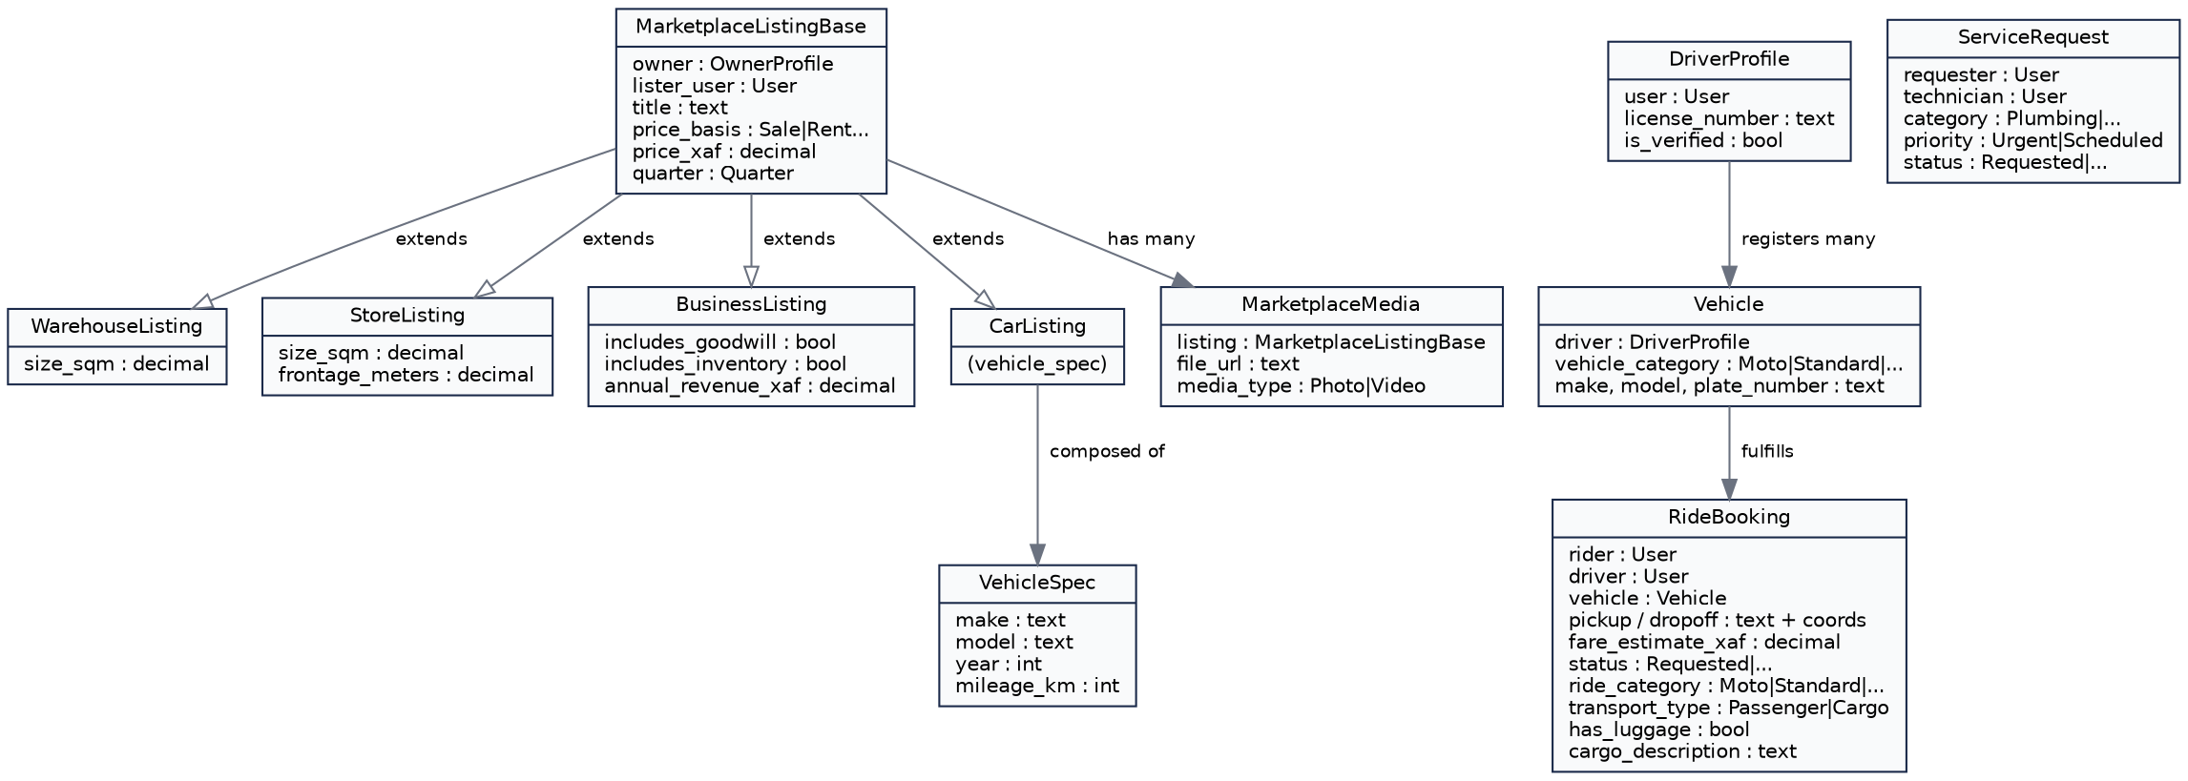
Figure 3.3 — Logical model: the four real marketplace categories, and OaziGo's real driver/vehicle/ride structures.

3.2.3 Transactions & Identity Domain
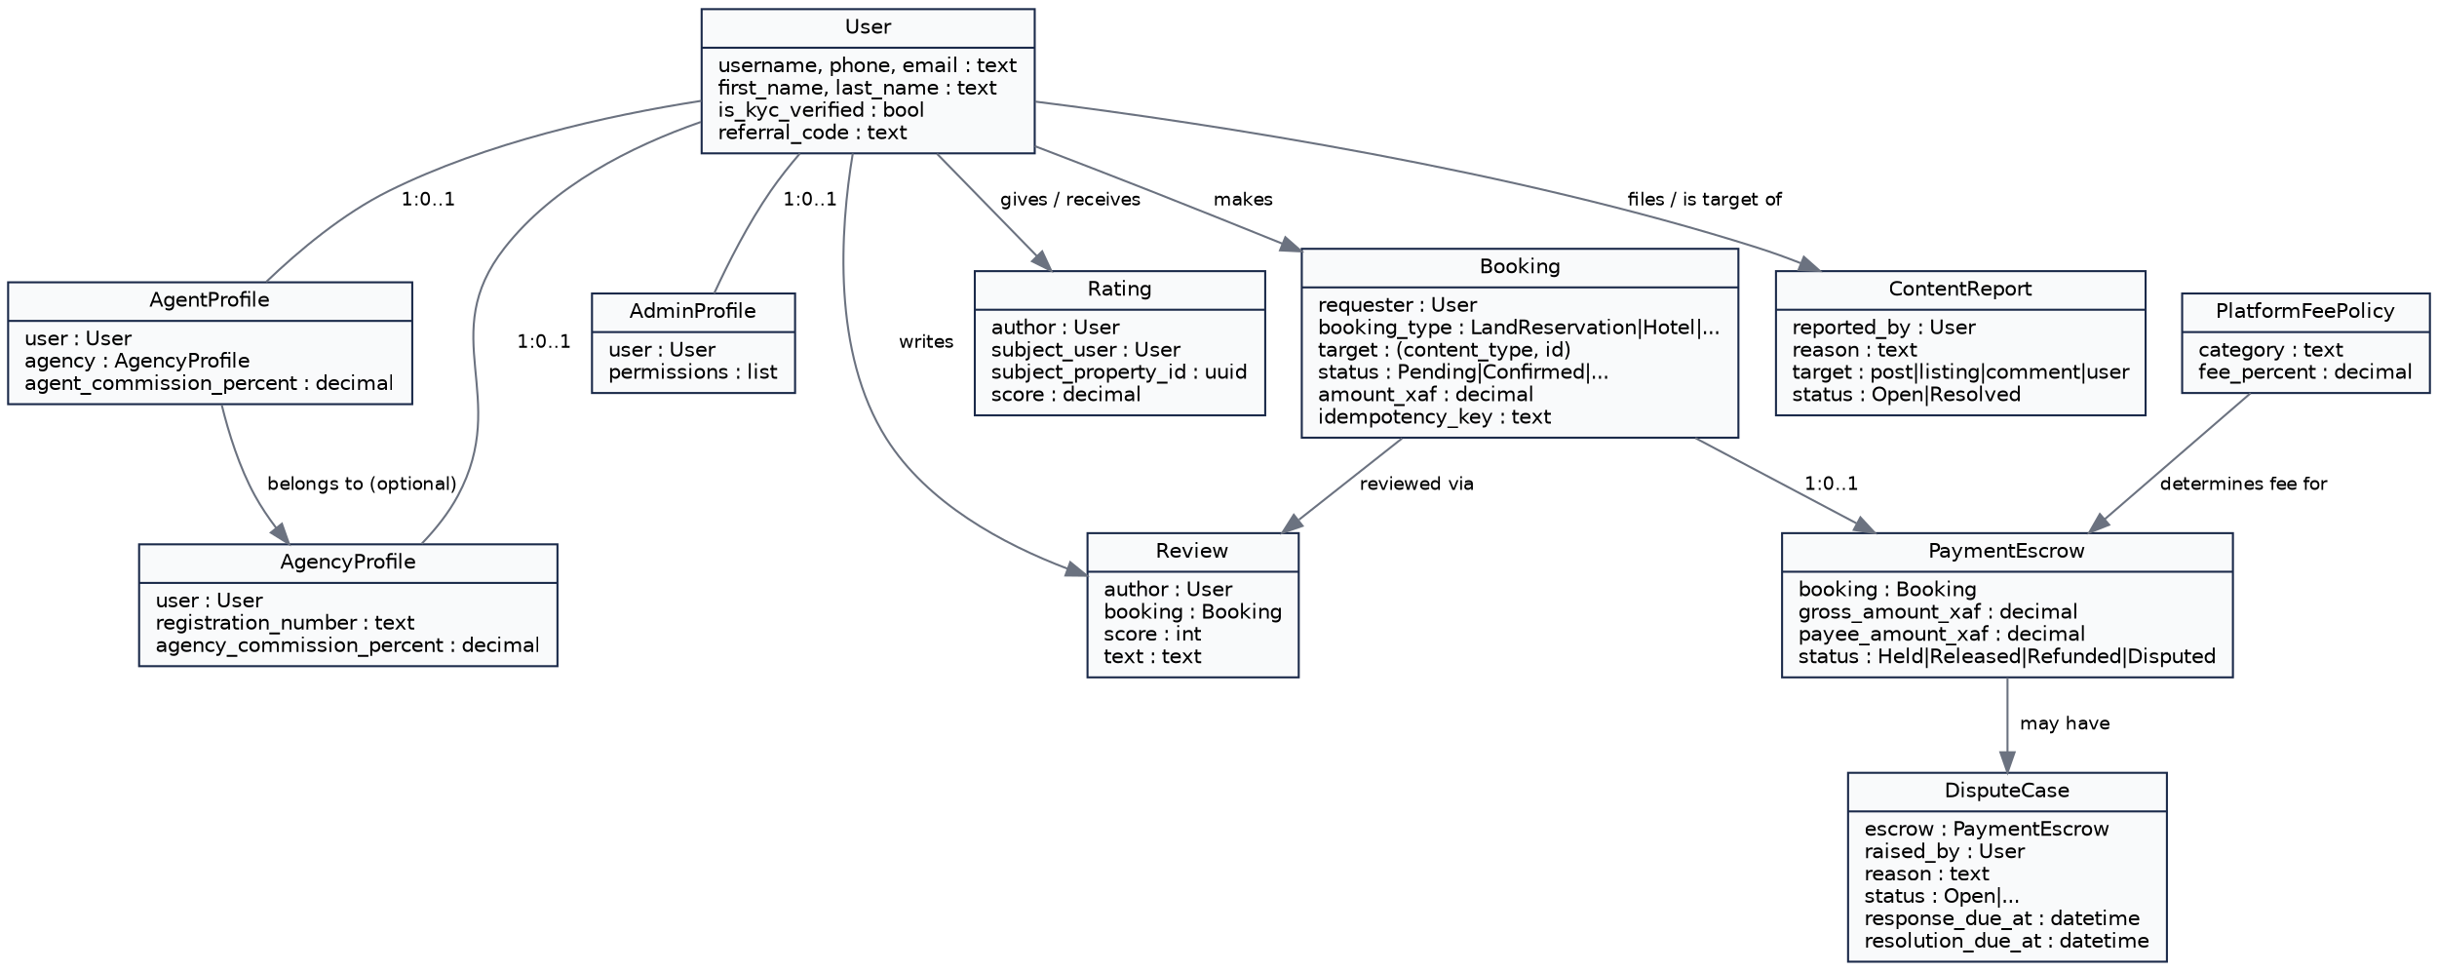
Figure 3.4 — Logical model: User and its real role profiles (Agent, Agency, Admin), Booking, PaymentEscrow, DisputeCase, and the real Rating/Review/ContentReport trust structures.

3.3 Physical Data Model
The actual database schema for the platform's core transaction tables — real column types and real keys, as they genuinely exist in PostgreSQL. The full physical schema spans the platform's 31 Django applications; this view shows the representative core that every other domain's own transactions ultimately settle through.
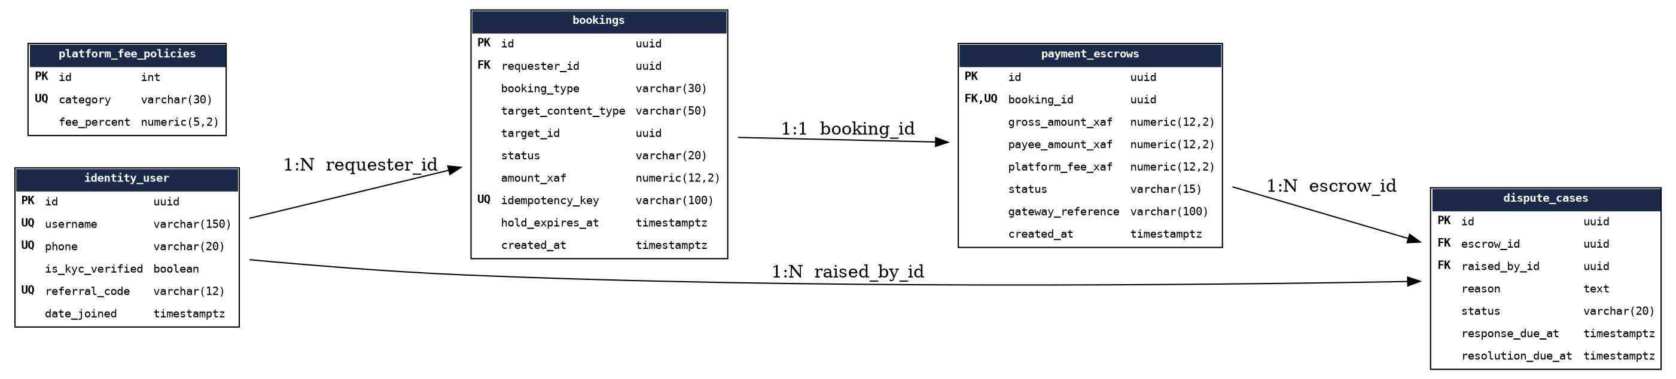
Figure 3.5 — Physical schema: the real bookings, payment_escrows, dispute_cases, identity_user, and platform_fee_policies tables, with real primary/foreign keys and column types.

4. UML Diagrams

4.1 Class Diagrams
The Logical Data Model diagrams in Section 3.2 are, at their core, real UML class diagrams — each box is a real class (a Django model), each attribute row is a real field with its real type, and each connecting line is a real relationship (inheritance via "extends," or association) exactly as they exist in the platform's actual codebase. They are not repeated here; refer to Figures 3.2, 3.3, and 3.4.

4.2 Use Case Diagram
The real actors this platform serves, and what each one genuinely does with it.
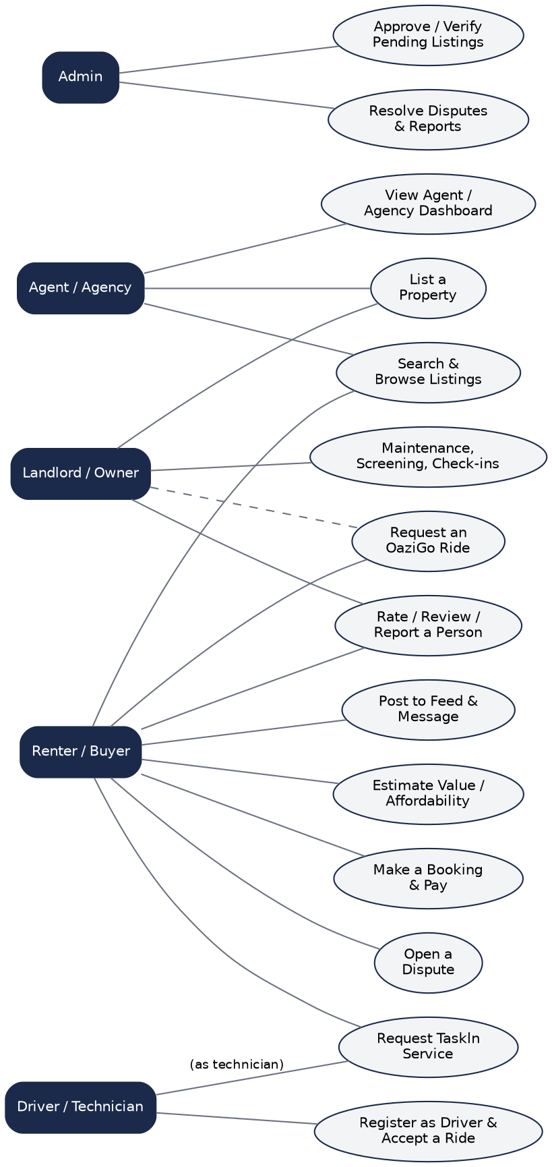
Figure 4.1 — Use case diagram: Renter/Buyer, Landlord/Owner, Agent/Agency, Driver/Technician, and Admin, and their real interactions with the system.

5. Activity Diagrams
Three of the platform's real, representative end-to-end workflows — chosen because each touches a genuinely distinct part of the system: content moderation, the shared payment/escrow engine, and OaziGo's own real driver-matching logic.

5.1 Property Listing Lifecycle
From a real owner or agent filling in a listing, through real admin review, to real public visibility and eventual expiry.
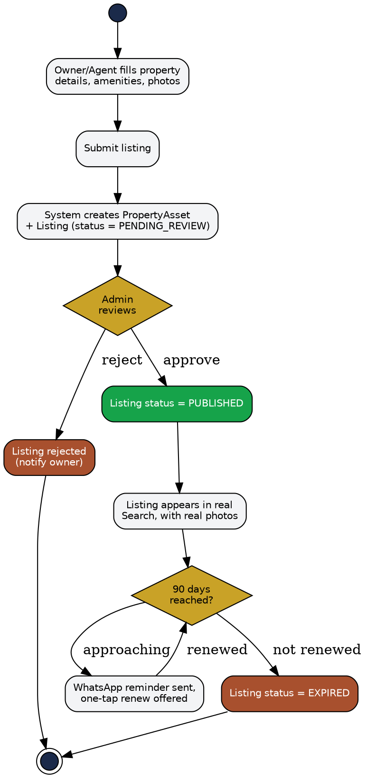
Figure 5.1 — Activity diagram: property listing creation, admin review, and the real 90-day expiry/renewal cycle.

5.2 Booking, Escrow & Dispute Resolution
The shared real payment engine every transaction type on the platform — property rentals, hotel stays, OaziGo rides, Taskln Service jobs — ultimately settles through.
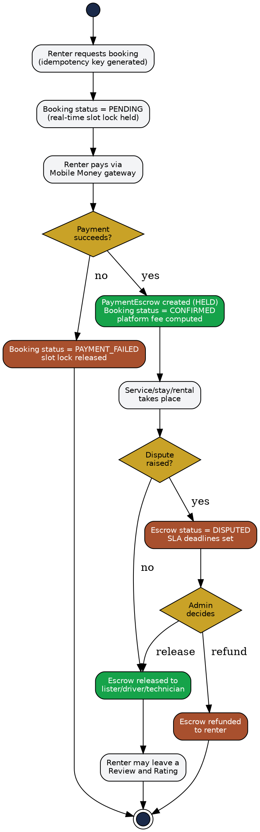
Figure 5.2 — Activity diagram: booking, real Mobile Money payment, escrow hold, and the real admin-mediated dispute path.

5.3 OaziGo Ride Lifecycle
The real driver-registration and vehicle-category-matching logic that gates who can actually accept a ride.
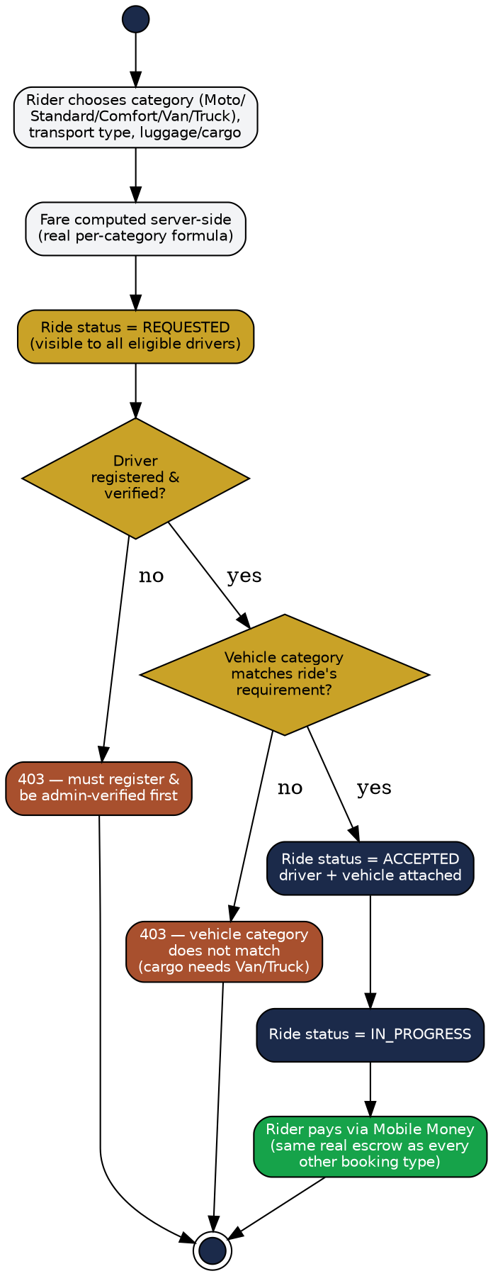
Figure 5.3 — Activity diagram: OaziGo ride request, real driver/vehicle verification gates, and completion.

6. System Architecture
The real physical deployment view — two real clients (a bilingual Next.js web app and a React Native/Expo mobile app for iOS and Android) talking to one real Django REST API, backed by PostgreSQL and Redis, and integrating with the real third-party services the platform genuinely depends on for payments, SMS, identity verification, media storage, WhatsApp, and email.
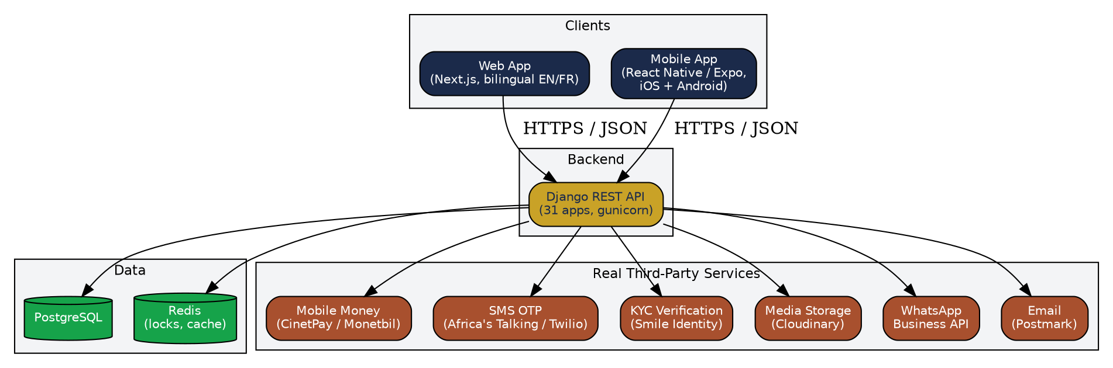
Figure 6.1 — System architecture: clients, backend, data layer, and real third-party service integrations.

7. Technology Stack & Testing Discipline

7.1 Stack
Layer | Technology
Backend | Django 6.1, Django REST Framework, PostgreSQL, Redis, gunicorn
Web | Next.js (App Router), TypeScript, Tailwind CSS, next-intl (bilingual EN/FR)
Mobile | React Native, Expo, TypeScript
Real-time / async | Redis-backed locking for booking concurrency and idempotency
Payments | Real Mobile Money gateway integration (CinetPay / Monetbil), sandboxed until go-live credentials are supplied
Testing | pytest + pytest-django (backend), Jest (mobile), full end-to-end verification against real running servers before every commit

7.2 Testing Discipline
491 automated backend tests pass against a real PostgreSQL database — not mocked. Every commit throughout this platform's development was verified the same way: the relevant test suite run and passing, the OpenAPI schema generated with zero warnings, and — for every user-facing change — the actual page or screen confirmed rendering correctly against a real running server with real seeded data, not assumed correct from reading the code alone.
This discipline directly caught and fixed several real, otherwise-invisible defects during development — among them a routing bug that had made an entire admin endpoint permanently unreachable since the day it was built, and a payment-verification gap that would have let a hotel or venue owner's listing go live but then remain permanently unable to ever become publicly visible. Both are reflected correctly in the diagrams and feature list above.

