**Profile component-homepage**

**Summary**

When I click on a previous post on my profile page it will change the route and show my post

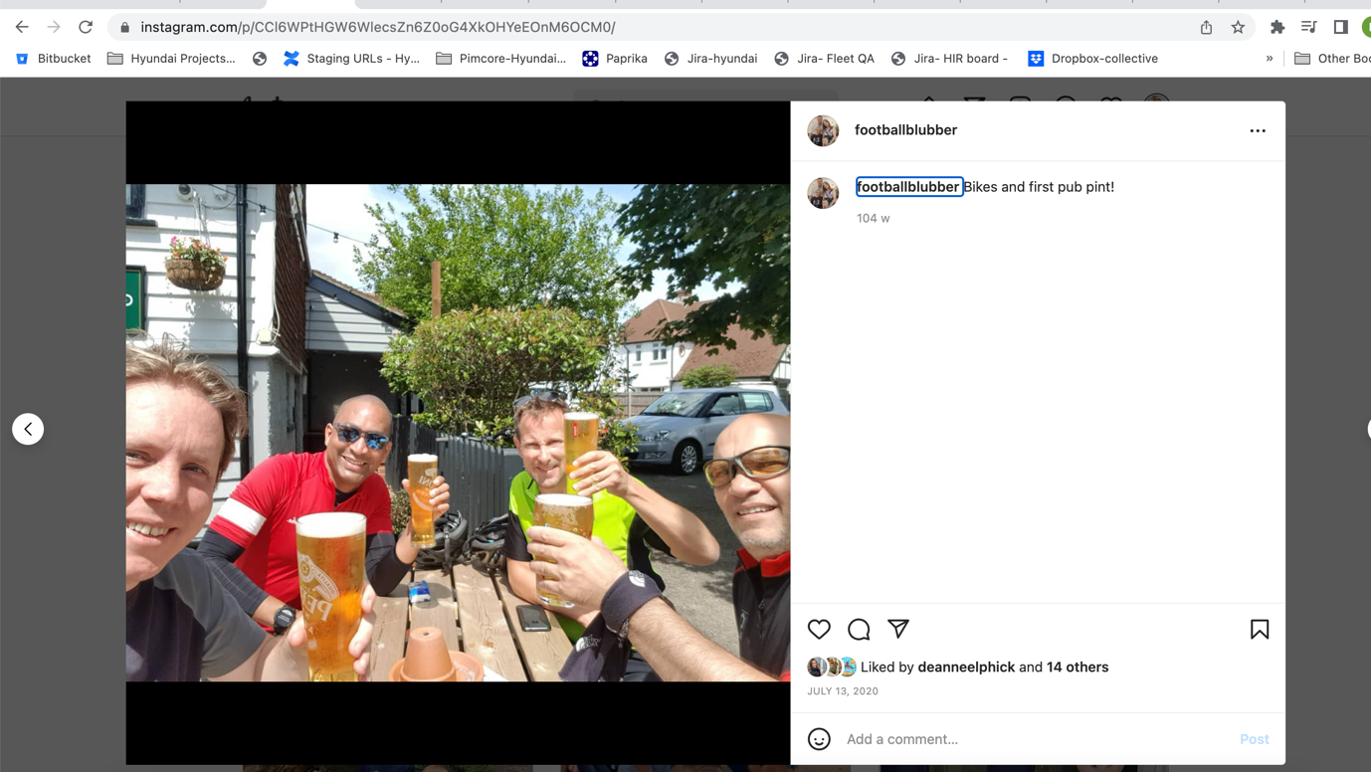

**Key functionality**

1. I can view my post and it will load the full page post modal window used in the homepage as well
2. If I click the cross button I am taken back to the profile page

**Route path, pop up or modal**

/p/id of the post

**Tests**

1. When this modal post window is loaded, I can see a large image, comments
2. I can like a comment
3. I can reply to a comment
4. At the bottom if I click the email button I am taken to a direct email with that person
5. I can add a comment to the post
6. I can see at the bottom how many people have liked this post
7. If I click outside of the modal or the cross button, the modal will close

**Components**

This is really just the post component in a slightly different format

**Any shared components**

The post component mentioned above