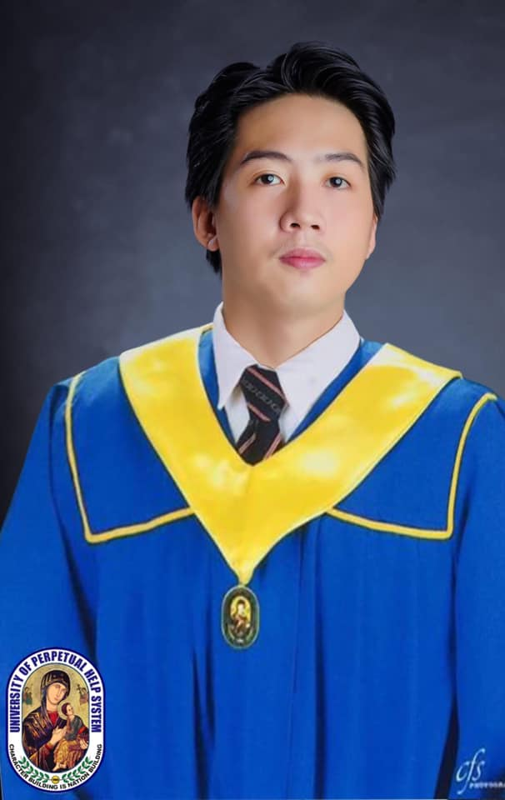

**PASTORES, ROBY JAY**

Email: [robipastores@gmail.com](mailto:robipastores@gmail.com)

Contact #: +639567387411

Address: #9 Paris St. Vista Real Classica, Quezon City, Philippines.

**CAREER OBJECTIVE:**

To obtain a challenging and rewarding position in a dynamic organization where I can utilize my skills and experience to contribute to the growth and success of the company.

# Areas Expertise

**WEB APP DEVELOPMENT**

* Web App Development
* Creative designer UI/UX
* System Application (Web based)

**VIDEO EDITING**

* Skilled in Film Video Editing such as a Cinematic Film.
* Managing Camera footage, dialogue and Sound effects.
* Conceptualize and produces video and designs with high visual impact.
* Proficient in Adobe Application such Adobe Premiere Pro, Adobe After Effects and Photoshop.

# PERSONAL

* Willing to accept responsibility for carrying our tasks and making sure things are done properly.
* Has zest for learning, high stress tolerance and willing to be trained.
* Proven team player, flexible, fast learner and alert.

**Education/ Qualifications**

**Primary**

**Cabatuan West Central School**

Elementary Diploma

2005**-**2011

**Secondary**

**Cabatuan National High School**

High School Diploma

2011-2015

**Tertiary**

**University of Perpetual Help System – Isabela Campus**

Bachelor of Science in Information Technology

2015 – 2020

**CAREER HISTORY**

1. **Company:** Technosite IT Solutions

**Position:** Jr. Web Developer

**Duration:** 2018 –2019

**Address:** Cauayan City, Isabela

# RESPONSIBILITIES:

* + Writing and reviewing code for sites, typically HTML, XML or Javascript.
  + Testing Web Applications.
  + Collaborating with designers, developers and stakeholders.

1. **Company:** BigBenta Pinoy E-commerce

**Position:** Digital Marketing

**Duration:** 2019 – 2020

**Location:** BF Homes, Paranaque City.

# RESPONSIBILITIES:

* + Providing Marketing Designs such as a website logo, product design and etc.
  + Providing Marketing video ads such as a promotional video for products
  + Designing materials for upcoming sales event promo.

1. **Company:** Nice Print Photography

**Position:** Film Video Editor

**Duration:** 2020 – 2022

**Address:** Brgy. Kapitolyo, Pasig City, Philippines

# RESPONSIBILITIES:

* + Provide and Conceptualize and Produces video design with high visual impact.
  + Collaborate with team to produce and finish the projects.
  + Editing video materials for clients.

1. **Freelance Video Editor**

Duration 2022 - 2023

**References**

**Former Supervisor**

June D. Vibieda

Brgy. Kapitolyo, Pasig City, Philippines

+63 915 404 4783

june@niceprintphoto.com

June Vibieda was my former Head/ Supervisor from 2020 to 2022

at Nice Print Photography.

**Former Colleague**

Jann Lorence Siarez

Brgy. Kapitolyo, Pasig City, Philippines

jannlorencesiarez@niceprintphoto.com

Jann Lorence Siarez was my former Senior Video Editor from 2020 to 2022

at Nice Print Photography.