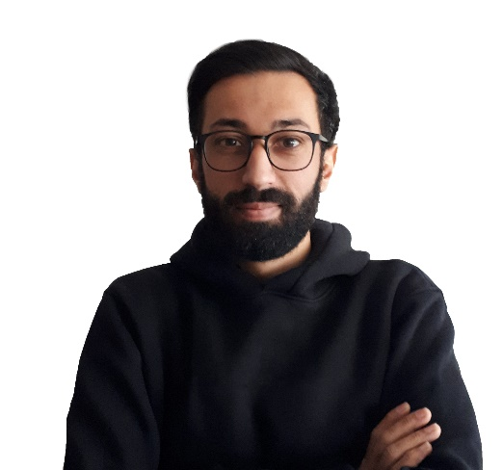Volkan COSKUN

UI Artist & Developer

TURKEY / Denizli / Merkezefendi

+90 533 142 6071

[webdvpv@gmail.com](mailto:webdvpv@gmail.com)

<https://volkancoskun.herokuapp.com/>

# Skills and Abilities

I can:

* design user interface
* make prototype
* code = ['responsive', 'clean', 'hierarchical folder structure', 'optimized files', 'maintainable', 'in accordance with SEO']
* make SPA, PWA with SSR

I know:

* HTML
* CSS = ['variables', 'flexbox', 'grid system', 'transition', 'animation']
* SASS = ['functions', 'built-in functions', 'conditions', 'mixins', 'all compiles into an optimized file', 'so, it means hierarchical folder structure']
* JAVASCRIPT = ['prototype', 'class', 'promise', 'async/await', 'ajax', 'fetch', 'local-session storage', 'cookie', 'rest api']
* JQUERY
* JQUERY UI
* VUE JS = ['vue cli', 'vue router', ' vuex ', ' axios ']
* NUXT JS
* NODE JS ['http', 'router', 'express', 'nodemailer', 'mysql', 'ejs']
* NPM
* WEBPACK
* GULP

I use:

* Github
* Adobe CC Photoshop, Illustrator, Animate, Xd
* Figma,
* Heroku,
* Filezilla

I have experience with:

* Agile
* Scrum

# Portfolio

* [Github](https://github.com/webdvpv)

* [Codepen.io](https://codepen.io/webdvpv)
* Customer: <http://agrofood.com.tr>
* Customer: <https://cheetahmac.com>
* My design portfolio: <https://www.behance.net/8bitlikadam>
* My main website: <https://volkancoskun.herokuapp.com/>
* My concept website: <https://8bitlikadam.volkancoskun.tk>
* [Figma Prototipi](https://www.figma.com/proto/wm0x5bdO26Y4Pc3YOCPJgx/Restaurant?page-id=0%3A1&node-id=12%3A31&viewport=241%2C48%2C0.04&scaling=contain&starting-point-node-id=10%3A92&show-proto-sidebar=1)
* Figma [Prototipi](https://www.figma.com/proto/07OBClCE71pA15McRaGqTa/Landing-Page-%2F-Weather-Forecast-Application?page-id=0%3A1&node-id=59%3A144&viewport=293%2C48%2C0.07&scaling=min-zoom&starting-point-node-id=1%3A2&show-proto-sidebar=1) 2
* [Figma UI](https://www.figma.com/file/0UlfJ8TUT1VWdDNxZYY43B/Weather-Application?node-id=0%3A1)

Note: These websites and prototypes are still developing. Therefore, I request you to ignore the errors and defects you see.

# Company Experiences

1. Company: [ENER OTOMASYON](https://enerotomasyon.com.tr)

Company CEO: Engin BAGDAS | +90 533 123 2811

Entry Date: 15.12.2020

Dismissal Date: 10.06.2021

My Title Was: Web Designer/Developer

# Salary Expectation

Varies by project. Also you can give me money per week or month.

**What makes me different from others?**

My awareness is very high. I definitely pay attention to the details. I think differently and innovatively. If I didn't think differently then I wouldn't be any different from Wordpress themes that look alike. Only a dedicated person can set himself apart from others. That's me. I think of a long-term working process. I pay a lot of attention to contrast, layout, colors and fonts in design (Please ignore old designs in my Behance portfolio, I will update them in this century).

**Note: My English level is Pre-Intermediate. Not fluent but I can introduce myself. Still learning.**

# Education

## VUE.JS

* Training Set Name: [Sıfırdan İleri Seviye Vue.JS Eğitimi ve Uygulama Geliştirme](https://www.udemy.com/sifirdan-ileri-seviye-vuejs-2-vuex-vue-router-egitim-seti/)
* Educator: Gökhan Kandemir
* Ders Sayısı: 397

## NUXT.JS

* Training Set Name: [Nuxt.js ile Vue.js Uygulamalarınızı Güçlendirin](https://www.udemy.com/course/sifirdan-nuxtjs-egitimi/)
* Educator: Gökhan Kandemir
* Total Lessons: 176

## JAVASCRIPT (ES6)

* Training Set Name:  [Modern Javascript Kursu: ES6/ES7|2019](https://www.udemy.com/modern-javascript-kursu/)
* Educator: Sadık Turan
* Total Lessons: 152

## JAVASCRIPT (ES6)

* Training Set Name: [Komple Modern JavaScript Kursu - ES6+ (2019)](https://www.udemy.com/sfrdan-ileri-seviyeye-modern-javascript-kursu/)
* Educator: Mustafa Murat Coşkun
* Total Lessons: 131

## EMMET FASTER HTML & CSS WORKFLOW

* Training Set Name: [EMMET Faster HTML & CSS workflow - Best Tool For Developers](https://www.udemy.com/emmet-start-coding-html-and-css-fast-and-easy/)
* Educator: Edwin Diaz, Coding Faculty Solutions
* Total Lessons: 20

## ENGLISH

* Training Set Name: [Özel Ders Formatında Sıfırdan Zirveye İngilizce Eğitim Seti](https://www.udemy.com/ingilizce-egitim-seti/)
* Educator: Serdar Hoca
* Total Lessons: 163

# Bad Habits

# Alcohol: Never

# Cigarette: Never

# Drugs: Never

# Computer Addiction: Since 2002

# Good Habits

* I like trying new things
* I sometimes get help from good people on Stackoverflow
* I follow UI design trends (flat, neumorphism, glassmorphism, minimalism, black-white, etc.)
* I have stopped playing League of Legends -,-

# Targets

* To turn all my accumulated experience since 2012 into Money and more experience,
* Meet new nice people,
* Getting references.

# Last

If you want me to work in your office, I will need sponsorship. Visa, passport, etc. It is not ready yet, but I can prepare it as soon as possible if you approve. After reviewing my resume, I would be grateful if you could indicate why I am or is not a suitable candidate. I want this information because this way I can make up for my shortcomings and maybe get the opportunity to work with you. Thanks.