THE WEBER COUNTY HIVE
What to Look At Before You Vote
Wasatch County, 2026 General Election

A records-based guide to choosing a candidate: what to check, where to find it, and what the public record shows for the Wasatch County races the Hive has reviewed.
Prepared for a community presentation, October 1, 2026. Records checked through September 30, 2026.

The Hive does not endorse candidates. Everything in this guide comes from public records and candidates’ own public statements. Where a candidate has publicly explained something, that explanation appears next to the record.

1. How this guide works
This guide has two jobs. The first is to show you what to look at when you choose a candidate, so you can check any race yourself, in any year. The second is to show what the public record says about the Wasatch County races the Hive has already reviewed.
A few ground rules run through all of it:
- Records, not rumors. Everything here comes from forms candidates filed, the state business registry, campaign finance reports, meeting records, hearing transcripts, and what candidates have said publicly. Tips, private messages, and social media claims are not used as facts.
- Their words next to the record. When a candidate has publicly explained something, their explanation is included, labeled as theirs.
- Not found is not the same as not there. When the Hive has not located a record, this guide says so and says where it looked. It does not treat a missing document as proof of anything.
- The deal, not the reputation. A candidate’s good or bad reputation doesn’t answer the question. What matters is whether their record on disclosure, money, and decisions holds up for the public.

Key voting dates (Wasatch County)
When | What
Starting Oct. 13 | Ballots mailed. Drop boxes open 24/7 (Charleston, Hideout, Heber City, Midway, Wallsburg).
Oct. 27 – Oct. 30 | Early in-person voting, 9 a.m.–4 p.m., County Administration Building, 25 N. Main St., Heber City.
Tue., Nov. 3 | Election Day, 7 a.m.–8 p.m. The County Administration Building is the only polling location. Drop boxes close at 8 p.m. Bring picture ID.
Source: Wasatch County Election & Voter Information page.

2. Six things to look at
None of these steps requires special training. Each one uses records that are already public and free to look at.

Check 1 — Read the conflict-of-interest form, then check it
What it is. Wasatch County officers and candidates file a one-page Conflict of Interest Disclosure Form. Its opening question asks the filer to describe:
“any relationships, transactions, positions you hold (volunteer or otherwise), or circumstances that you believe could contribute to a conflict of interest between Wasatch County and your personal interests, financial or otherwise.”
The filer then checks one of two boxes: “no conflict of interest to report,” or “the following conflict of interest to report.” Anyone checking the second box is asked to list boards they (and their spouse) sit on, for-profit businesses where they or an immediate family member are an officer, manager, director, or majority shareholder, their employer, and businesses they or a family member own.
How to check it. Put the form next to three other public sources:
- The Utah business registry (businessregistration.utah.gov). Search the candidate’s name. It lists businesses and nonprofits where they are an officer, manager, member, director, or registered agent.
- The candidate’s own words: campaign website, bio, social posts, and news interviews. Candidates often list their boards when they are campaigning.
- Board rosters posted by the bodies themselves (special service districts, MIDA, the Wasatch Open Lands Board, nonprofits).
What to keep in mind. The Wasatch form asks what the filer believes could contribute to a conflict. That is a judgment call. A “no conflict” answer is not automatically a rule violation. The voter’s question is whether that judgment was reasonable for an office that votes on land use, contracts, and funding — and whether the candidate says they would step aside on votes that touch their own interests.
Where to find it. The county’s Conflict of Interest Disclosure Forms page. But check the Declaration of Candidacy packets on the Election page too: some candidates’ forms are filed inside that packet rather than posted on their own. Check both before deciding a form is missing.

Check 2 — Follow the money
Where. County candidates’ reports are posted on the county Election page (March, June, and later reports). Legislative candidates’ reports are on disclosures.utah.gov.
What to look at:
- Individuals vs. organizations. How much comes from people, and how much from PACs, businesses, and party committees?
- Local vs. outside. Are the donors from the district, or from elsewhere?
- Who is behind a PAC. A PAC’s name tells you very little. Look up the PAC’s own report to see its officers and who funds it. Some PACs are funded mostly by transfers from nonprofits that are not required to name their donors.
- Timing. Money that arrives right after a primary, or right before a vote, is worth noticing.
- Self-funding and in-kind help. Loans from the candidate and donated services are part of the picture too.

Check 3 — Look for a record from before the campaign
Campaign promises are easy. A record shows what someone did when it counted. Look for: votes and meeting minutes if they have held office; public comments at hearings; letters to the editor; and past board service. For a first-time candidate, a public-hearing comment or a published letter may be the best record there is.

Check 4 — Map the boards and roles
County council members also sit on other boards: the Military Installation Development Authority (MIDA) and its public infrastructure districts, the Wasatch Open Lands Board, special service districts, tourism and economic development boards, and local nonprofits. Ask:
- Which boards does the candidate sit on, and who appointed them?
- Do any of those boards come before the county council for money, land, or approvals?
- Does the candidate say they would disclose and step aside when those matters come up?

Check 5 — Compare what they say with what the record shows
Candidates describe their own records in campaign materials. Treat those descriptions as claims until you can match them to minutes, votes, or filings. This guide labels candidates’ descriptions of their own records as “in their own words.”

Check 6 — Ask the questions that matter to everyone
The Hive grades decisions with five questions. They work just as well for choosing a candidate. Ask them of the candidate’s record and of their answers at forums:
Question | What to ask a candidate
Power | Would you add or remove a check on decisions the public has no say over? Name one board or process you would open up.
Transparency | Will you disclose your conflicts in writing and out loud before votes? Will hearings, budgets, and contracts be itemized and posted?
Financial accountability | On deals like tax-increment financing, public infrastructure districts, and sole-source contracts: who pays, who is protected from paying, and will you show the numbers plainly?
Environmental impact | How will water, wetlands, open space, and wildlife weigh in your land-use votes — as a real limit, or a box to check?
Community impact | Who bears the cost of growth decisions, and how will residents get real standing before decisions are made?

How the Hive grades
Each candidate and topic is graded on those five questions, using one scale. Grades judge the record, not the person. Meeting the legal minimum earns a C, not a B. Each topic is graded on its own, and “Overall” averages only the questions that could be graded.
Grade | What it means
A | Goes well beyond what the law requires, in ways the record shows
B | Goes beyond the requirement
C | Meets what the law requires, and no more
D | Required information is there, but the key part is vague or lumped into a catch-all
F | Required information is missing, or a public check is removed with nothing in its place
N/A | The question doesn’t fit the topic, for example when no office has been held yet

Cautions
- Check the date on everything. Board lists, websites, and business filings change. A page may be out of date.
- One reading method is not enough for an absence. A scanned form read by a computer can come back looking blank when it isn’t. Look at the actual page before concluding something wasn’t filled in.
- Social media is a lead, not a source. A claim on Facebook tells you where to look, not what’s true.

3. Your 2026 Wasatch County ballot
From the Wasatch County Clerk/Auditor’s 2026 General Election Certification and Write-In Candidate Certification. Ballots differ by district, so check your own sample ballot on the county Election page or at vote.utah.gov.
Office | Printed on the ballot | Certified write-ins
County Council Seat A (at-large) | Rachel Kahler (Republican)  Robert Duncan McNeill (Democratic) | Shawn Taylor  Jami Hewlett
County Council Seat C | Erik K. Rowland (Republican) | Alex Folmer
County Council Seat F | Michael Murphy (Republican)  Joseph A. Tugaw (Democratic) | —
County Attorney | Lauren Forsyth (Democratic)  Jon Woodard (Republican) | —
County Clerk/Auditor | Michelle Kellogg (Republican) | —
County Sheriff | Jeremy M. Hales (Republican)  Paul Moore (Unaffiliated) | —
School Board Seat C (Heber North) | Erin Sabey | —
School Board Seat D (Heber South) | Jacob Collett | —
Utah House District 59 | Celeste T. Johnson (Democratic)  Luke Searle (Republican) | —
Utah Senate District 20 | Ronald M. Winterton (Republican)  Annette McRae (Forward) | —
U.S. House District 3 | Kent S. Udell (Democratic), Cassie Easley (Constitution), Celeste Maloy (Republican), Ayden Scott (Unaffiliated), Michael R. Stoddard (Libertarian), Adonis Hooslyn (Unaffiliated) | —
Judicial retention | Supreme Court, Court of Appeals, and Fourth District judges | —
Constitutional Amendments | Amendment A and Amendment B | —

Changes since the primary, per the county’s own filings page: Patrick Saucier (D) withdrew from Seat A and Robert McNeill was named the Democratic replacement. Clerk/Auditor Joey Granger and Sheriff Jared Rigby were eliminated in the June primary. Steve Farrell was eliminated at the GOP convention for Seat A. Karl McMillan and Bruce Zollinger withdrew from Seat F; Eric Mainord withdrew from the sheriff’s race; Josh Cieslewicz withdrew from School Board Seat C.
Voting for a write-in: write the name in the write-in space for that office and fill in the target next to it. Only certified write-in candidates are counted.

4. What the records show: races the Hive has reviewed
These five races have been reviewed, and each has a full Hive case file online with every source. Links are at the end of each race. Each candidate section follows the same order: who they are, their disclosure form, what other public records show, their own explanation if they gave one, and the money.

County Council Seat A (at-large)
Open seat. The current holder, Luke Searle, is running for the Utah House instead. In the June 23 Republican primary, Rachel Kahler won 2,722 votes (51%) to William “Brett” Vance’s 2,584 (49%).

Rachel Kahler (Republican)
Who she is. Served one term on the Heber City Council (2020–2023). Executive Director of the Community Alliance for Main Street (CAMS), a Heber nonprofit. Heber City contracts with CAMS for downtown events at $39,900 a year for three years (approved Jan. 20, 2026; ratified 3–2 on April 21, 2026).
Her disclosure form. Her Conflict of Interest Disclosure Form is filed inside her January 2026 Declaration of Candidacy packet. She checked “I have no conflict of interest to report.” The three lines below are blank.
Other public records:
- Employer: CAMS, which holds the Heber City contract above.
- Red White and Blue Festival Inc. (state nonprofit filing): listed as a Director. Other listed officers include Heber City Manager Matt Brower and Dallin Koecher.
- 5 In The Hive, LLC (state filing): listed as Manager and registered agent. Its 2023 Certificate of Organization, which she signed, states the purpose is “to acquire, own, sell, and otherwise manage real estate investments.”
- Boards named in her own campaign post: North Village Special Service District and the Heber Light & Power Board.
In her own words (public response, Sept. 1, and a letter to the Hive, Sept. 15): The CAMS contract is with the organization, not with her personally, and she would disclose and step aside if a CAMS matter came before the council. Her festival role is unpaid. 5 In The Hive holds a family home she co-owns with her siblings and has been used as a long-term rental. She says she has no connection to MIDA.
Her letter, in full: https://weber-county-hive.github.io/Letters-Essays-to-the-Collective/L-2026-001.html
Every exchange with the Seat A candidates, word for word: https://weber-county-hive.github.io/candidates2026/wasatch-seat-a-on-the-record.html
Her description of her own council record: voted against the NVOZ, the Harvest Village (The Slopes) annexation, and the Wellberg annexation; voted for the Jordanelle Ridge master development agreement; supported reducing Main Street building heights from five stories to three (four with attainable housing). She supports the Heber Valley bypass.
Money: her March 31 and June 2026 campaign finance reports are posted on the county Election page.
The question for voters: was “no conflict” a reasonable judgment for a candidate whose employer holds a city contract and who has served on local utility and district boards — and do you accept her stated plan to disclose and step aside on CAMS matters?

Robert Duncan McNeill (Democratic)
Who he is. Named the Democratic replacement candidate after Patrick Saucier withdrew. Heber City resident since 2020. An actor, director and producer (about 200 television episodes directed, by his own account). Owns Here We Go Productions, Inc., in Heber City. First-time candidate.
His platform (Park Record profile, Sept. 11): growth is the top issue; he wants a formal process that gives the public more time to respond on major development decisions beyond the standard comment period.
Declaration of Candidacy: sworn and accepted Sept. 1, 2026. Disclosure form: not located as of Sept. 30. The Hive checked the county’s Conflict of Interest page and his Declaration of Candidacy packet, which contains the party declaration but no conflict-of-interest form (both read from the rendered pages). State law says the clerk may not accept a county candidate’s declaration until it receives a complete conflict-of-interest statement (Utah Code §17-70-304), so whether the county has one on file is a question for the Clerk/Auditor. Money: no report located yet.

Write-in: Jami Hewlett
Former Heber City Planning Commission member; ran for County Council Seat D as a Libertarian in 2024. Her Aug. 26 disclosure form, posted by the county, lists Hewlett Life & Health Insurance, Summit Cleaning, and a lot on 100 South. On Sept. 2 she filed an updated form adding a one-quarter interest in Twelve Point Muley LLC (an apartment in Wyoming she inherited with her siblings) and Wasatch Back Handyman LLC, which owns 191 W. 100 S. She fixed it within a week, nine days before the Hive’s Sept. 11 report and with no record of anyone pointing it out to her first; the county’s page still shows only the August form. She wrote to the Hive about it, explained the inherited apartment, confirmed the details and did not dispute the record; her letter is published in full.
Her letter: https://weber-county-hive.github.io/Letters-Essays-to-the-Collective/L-2026-002.html

Write-in: Shawn Taylor
Charleston resident; ran for Charleston mayor in 2025. His disclosure form checks “no conflict of interest to report.” His own campaign website says he currently serves on the Wasatch County GOP Board as Media Specialist, and that he and his wife have built several businesses (not named). Whether a political party board is the kind of board the form asks about is a fair question voters can weigh for themselves.

Seat A report cards (from the Hive’s case file)
 | Power | Transp. | Financial | Environ. | Community | Overall
Rachel Kahler | D | F | D | N/A | D | F · 4 of 5
Robert McNeill | — | — | — | — | — | Not gradable yet
Jami Hewlett | N/A | B | B | N/A | N/A | B · 2 of 5
Shawn Taylor | N/A | A | N/A | N/A | N/A | A · 1 of 5
Kahler’s grades also weigh her conduct in her paid CAMS role, including the Main Street Park email described in the case file. Hewlett was regraded on her Sept. 2 updated form: she fixed it within a week, before anyone is on record pointing it out, and answered openly. Not an A, because the first form was incomplete. (First graded D on the Aug. 26 form.) McNeill has no filings yet to grade.
Full case file: https://weber-county-hive.github.io/candidates2026/rachel-kahler-wasatch-seat-a.html

County Council Seat C
Covers northeastern Heber City and the Jordanelle Ridge area. Erik Rowland is the only printed name; Alex Folmer is a certified write-in.

Erik K. Rowland (Republican, incumbent)
Who he is. County Council chair; has held Seat C since 2023. Served on the Heber City Council 2012–2015. Appointed to the MIDA board in May 2026.
His disclosure form (Jan. 2, 2026): checked “I have no conflict of interest to report”; the three lines are blank. MIDA’s own website posts this same county form as his disclosure for the MIDA board and three MIDA public infrastructure district boards. The other MIDA board members whose forms MIDA posts filed MIDA’s own, longer state disclosure form, apart from Weber County Commissioner Gage Froerer, who also filed his county’s form.
Positions and businesses in other public records:
- MIDA board, plus the Mountain Village, Golf & Equestrian, and Cormont public infrastructure district boards (MIDA’s own board matrix).
- CAMS board (CAMS’s own website and Heber City staff reports).
- Wasatch Open Lands Board member. The county posts Open Lands Board forms for three of seven members; none is posted for him.
- Heber Valley Tourism and Economic Development Board and the North Village Special Service District board (his own words, Park Record, Jan. 30, 2026).
- Businesses in the state registry: JASE Medical / SignalRx LLC (founder and member), TimeMD Inc., Rowland Development LLC (sole member), and Triumph Assurance Group LLC (manager).
Record: signed on with the county council to ask UDOT to shift bypass Alternative B closer to US-40; described by Searle’s campaign as working with him on North Fields open space.
Money: his reports show $0 raised and $265.66 spent (the filing fee), as last checked.
The question for voters: the council chair also holds a MIDA seat, and MIDA oversees development districts inside Wasatch County. The form asks about positions held, “volunteer or otherwise.” Was “no conflict” a reasonable answer?

Write-in: Alex Folmer
Who she is. IT Software Engineer IV at the University of Utah (campus directory). First-time candidate; filed as a write-in in August.
Her disclosure form (Aug. 31, 2026): checked “the following conflict of interest to report” and listed her employer (University of Utah) and Runa Digital, LLC. The state registry confirms her as its registered agent and sole member. The LLC was formed Feb. 5, 2021 and renewed through Jan. 31, 2024; it missed its Feb. 28, 2025 renewal and was administratively dissolved July 21, 2025, about 13 months before she listed it. Two other LLCs that came up under her name in the same registry search, Into the Mystic Mountain LLC and Wild Utah Provisions LLC, are also administratively dissolved; her role in those two has not been confirmed from their full records.
Record before the campaign: a spoken comment at UDOT’s Jan. 28, 2026 Heber Valley Corridor hearing opposing both bypass alternatives, describing a 20-year background in tech and data consulting for state agencies, finding UDOT’s traffic projections overstated, and committing to “continue to make GRAMA requests, pull the data, and get a different perspective on where we are today with this bypass”; and a Feb. 4, 2026 Park Record letter, “Please don’t build,” asking the developer of The Slopes to pursue a conservation easement instead of building.
Money: no campaign finance report located yet.

Seat C report cards (from the Hive’s case files)
 | Power | Transp. | Financial | Environ. | Community | Overall
Erik Rowland | D | F | D | C | C | D
Alex Folmer | N/A | A | A | N/A | N/A | A · 2 of 5
Rowland is graded on all five questions because he has held county office since 2023. Folmer’s A covers only whether her disclosure was complete and true; it is not a prediction of how she would govern.
Full case files: https://weber-county-hive.github.io/candidates2026/erik-rowland-seat-c.html
and: https://weber-county-hive.github.io/candidates2026/rowland-folmer-seat-c.html

Utah House District 59
Open seat (Rep. Mike Kohler is retiring). Covers all of Wasatch County and part of Summit County.

Luke Searle (Republican)
Who he is. Current Wasatch County Council member, Seat A (2023–present). Business teacher at Wasatch High School’s CAPS program; former assistant Heber City manager. Won the GOP convention (56.5%) and the June primary over Jeffery Pierce.
Disclosure forms. His county form (Jan. 15, 2025) checks “the following conflict of interest to report” and lists his employer (Wasatch County School District) and his wife’s business, Heber Balloons. His state candidate disclosure also lists an ownership interest in Searle Bros. Construction Co., which is not on the county form. The two forms ask different questions, so compare them before drawing a conclusion.
Money: about $56,800 raised in 2026. About half, roughly $28,200, came from six PACs; about $25,400 from individuals and other sources; and about $3,200 from Searle himself.
- Jan. 1 – June 8, 2026: about $34,470 in contributions. Largest: All In For Utah PAC ($6,245.51 across three payments), Utah Chamber PAC ($5,000), Tyler Clancy ($3,682.41), Spencer Stokes ($2,054.62).
- June 21 – Aug. 17, 2026: $22,344.04 itemized. 72.7% came from four organizations: House Speaker Leadership PAC ($10,000), Utah House Republican Election Committee ($5,000), American Conservation Coalition PAC ($1,000), and Strata Networks ($250). The other $6,094.04 came from 31 individuals.
- About All In For Utah PAC: its primary-period report shows $50,000 of its roughly $50,000 arriving in one transfer from an entity also named All In For Utah, whose own donors don’t appear in any public filing. The PAC’s officers include Owen Fuller and Dan Hemmert, who became MIDA’s executive director in June 2026.
In his own words: voted against a sales-tax increase for transit; helped raise the income limit for the senior property-tax relief program; pushed for public budget software; opposed S.B. 197 (2025), which Gov. Cox vetoed on March 27, 2025.

Celeste T. Johnson (Democratic)
Who she is. Mayor of Midway for two terms (eight years); two open-space bonds passed during her tenure; has served on a statewide land conservancy board.
Her platform: protecting farms, open space, and community character; local control over decisions the state makes without knowing local impact; skepticism that “affordable” labels work in resort-area housing markets; community wellbeing without culture wars.
Money: about $61,500 raised as of the Hive’s last review. About 29%, roughly $18,000, came from three PACs: Way Back PAC ($8,000), Utah Women and Politics PAC ($5,000) and Utah Investment Network PAC ($5,000). The rest came mostly from individuals, including the Kem C. Gardner Family Partnership ($5,000) and about $7,500 from one out-of-state household (Falls Church, Va.). Neither HD-59 campaign shares a PAC donor with the other.
Disclosure form: her state candidate disclosure has not yet been reviewed by the Hive; it is posted on disclosures.utah.gov.
The HD-59 case file has not been graded yet.
Full case file: https://weber-county-hive.github.io/candidates2026/luke-searle-hd59.html

Utah Senate District 20
Covers Daggett, Duchesne and Uintah counties and parts of Summit and Wasatch. Sen. Ronald M. Winterton (R) of Roosevelt has held the seat since 2019. Annette McRae (Forward Party) of Duchesne is a first-time candidate.

Ronald M. Winterton (Republican, incumbent)
Who he is. State senator since 2019; former Duchesne County commissioner. In 2026 he chaired the Senate Government Operations and Political Subdivisions Committee, the committee that hears bills about counties and cities.
Money (Jan. 1, 2025 – June 7, 2026): raised $20,300; spent $68,155.08. One individual gave $50; the Utah Republican Senate Campaign Committee gave $5,000; the rest came from businesses, PACs and associations, including energy, health care and banking groups. His 2026 Primary Report begins at negative $91,381.94 and ends at negative $95,804.74. The filings read by the Hive don’t show who covers that balance.
- $15,259.03 reported to American Express across nine payments. State law (Utah Code 20A-11-101.5) and the Lieutenant Governor’s 2025 guidance call for listing the business actually paid, not the card company. No state finding on these reports was found.
- $12,000 to Outcry LLC, a Heber campaign firm, filed as “Constituent Services.”
His disclosure form: lists himself as retired, a previous employer (Civil Consulting & Funding LLC), and one board seat: Duchesne County Special Service District #3, which distributes mineral lease money. The item asking for businesses where he is an owner or officer reads “N/A.” Utah’s business registry lists him as a member or director of six active companies, including R & L Storage, Winterton Trucking and W M Enterprises. The form doesn’t explain the difference.
Bills on the record:
- S.B. 107 (2023): as passed by the Senate, above-trend oil and gas severance tax went to a new fund for communities affected by drilling. A House substitute replaced that with up to $88.5 million for the statewide Transportation Investment Fund; the Senate accepted it 19–7, with Winterton voting yes.
- S.B. 207 (2025): a state oil and gas road tax, returned to the county it came from, for production from 2026 through 2028. The same law bars counties from charging their own oil and gas mitigation fees, with no end date.
- S.B. 15 (2026): removed the requirement that county voters approve switching a county council or commission between full-time and part-time.

Annette McRae (Forward)
Money: $180 in cash from three people, one of them herself, plus $6,696.94 in voter data from the Forward Party, reported as in-kind help. One expense, $117.73, lists herself as the payee.
Her disclosure form: lists four jobs (Lyft driver, Mary Kay, dōTERRA, and her own business, Mommacrae LLC) and a seat on the Western Uintah Basin Mosquito Abatement District board ($200 per meeting). In the optional sections she disclosed that her husband works in crude oil transportation, and a timeshare.
Her claims about his record, checked: her ad on S.B. 107 matches the Legislature’s record. Her website’s claim about H.B. 540 names the right 2025 bill, but the House vote was 53–19, not 59–19, and it died on the Senate floor, not in committee.
In their own words: McRae’s plan centers on Basin water projects, tying housing approvals to water capacity and transportation, capturing gas instead of flaring, and rail. Winterton’s campaign site lists education, wildfire safety and prevention, and community development and infrastructure.

Senate 20 report cards (from the Hive’s case file)
 | Power | Transp. | Financial | Environ. | Community | Overall
Winterton — money | D | F | D | N/A | D | —
McRae — money | C | D | C | N/A | C | —
Winterton — form | N/A | F | D | N/A | N/A | —
McRae — form | N/A | B | C | N/A | N/A | —
Winterton’s bills, graded one by one: S.B. 107 (2023) D · S.B. 207 (2025) F · S.B. 15 (2026) F · H.B. 61 (2026) F · H.B. 330 (2026) D · H.B. 457 (2026) D · S.B. 227 (2026) C · S.B. 266 (2026) C · S.C.R. 4 (2026) C · H.B. 540 (2025, House version) B · H.B. 75 (2026) A.
Full case file: https://weber-county-hive.github.io/candidates2026/sd20-winterton-mcrae.html

U.S. House District 3
A new district under the court-ordered congressional map. It stretches from Morgan and Summit counties to the Arizona border and includes Park City, Provo and all five of Utah’s national parks (Utah News Dispatch, June 12, 2026). Six candidates are on the ballot: Celeste Maloy (R), Kent S. Udell (D), Cassie Easley (Constitution), Michael R. Stoddard (Libertarian), and Ayden Scott and Adonis Hooslyn (both unaffiliated).

Celeste Maloy (Republican, incumbent)
Who she is. In Congress since 2023, representing the old 2nd District; former Washington County official and lawyer for the area’s water conservancy district; chairs the Congressional Western Caucus. She won the June Republican primary over former state Rep. Phil Lyman, after splitting the April convention with him about 51% to 49%.
Money (FEC, Jan. 1, 2025 – June 30, 2026): $1,453,860.68 raised. About 49% came from individuals ($709,248.13), of which only $7,393.13 was in gifts under $200. About 46% came from PACs and other committees ($672,923.00). The rest, about 5%, came in transfers from her other committees. No money from her party or herself. She spent $1,238,502.69 and had $322,379.42 in cash on hand.
Outside money: outside groups have reported independent spending in this race. Those reports are separate from her campaign’s and are on fec.gov under independent expenditures.

The other candidates
The Hive has not reviewed the other five candidates’ records. Their federal filings, if any, are on fec.gov.
Not graded; there is no Hive case file for this race yet.

5. Races the Hive has not reviewed — where to look
These races are on Wasatch ballots, but the Hive has not reviewed the candidates’ records. Use the six checks above. Everything listed below is posted publicly.
Office | Candidates | What’s posted
Council Seat F | Michael Murphy (R, interim council member)  Joseph A. Tugaw (D) | Declarations of candidacy and March/June finance reports (county Election page).
County Attorney | Lauren Forsyth (D)  Jon Woodard (R) | Declarations and finance reports (county Election page).
Clerk/Auditor | Michelle Kellogg (R), unopposed | Declaration and finance reports. This office receives and posts the conflict-of-interest forms.
Sheriff | Jeremy M. Hales (R)  Paul Moore (Unaffiliated) | Declarations and finance reports; Moore’s conflict-of-interest form is on the county COI page. As of Sept. 30 the county’s finance-report list shows reports for Hales but none for Moore.
School Board C and D | Erin Sabey; Jacob Collett (both uncontested) | Declarations and June finance reports (county Election page).
Judges | Retention questions | Evaluations by the Judicial Performance Evaluation Commission at judges.utah.gov.
Amendment A | Would publish proposed constitutional amendments online for 60 days before the election instead of in newspapers. | Full text and arguments in the Voter Information Pamphlet at vote.utah.gov.
Amendment B | Would require 60% voter approval for citizen initiatives that raise taxes, instead of a simple majority. | Full text and arguments in the Voter Information Pamphlet at vote.utah.gov.

6. A question about the form itself
Part of this is not about any one candidate. State law (Utah Code §17-70-304) describes a candidate disclosure form divided into sections for each category of information — employers, businesses owned, income sources, boards, real property, and more — with space under each. The state candidate form Luke Searle filed for House District 59 has about eight sections. The Wasatch County form is a single question with two checkboxes and three blank lines.
What state law requires. Utah Code §17-70-304 says the county clerk’s form for county and local school board candidates must be divided into a separate section, with space to answer, for each item listed in §20A-11-1604(6):
- Every employer, now and in the past year, with occupation and job title
- Every business or entity the candidate owns or is an officer of, what it does, and their position
- Every source of income of $5,000 or more
- Stocks or bonds worth $5,000 or more
- Every board seat and leadership role, and what the organization does
- The spouse’s employment
- Any unrelated adult living in the household, and that person’s job if it could be a conflict
- Real property and any other conflict (optional)
- Date, a statement that it is true, and signature
The same law says the statement is filed with the Declaration of Candidacy, that the clerk “may not accept a declaration of candidacy” until it receives a complete statement, and that the clerk posts it on the county website through the canvass. A “private party in interest” can sue to enforce it, and the court may award costs and attorney fees. The one exception: an incumbent seeking reelection who already filed this year’s annual statement and confirms in writing that it is current. The Wasatch County form never asks about income sources, stocks or bonds, last year’s employers, property or household members.
Sources: Utah Code §17-70-304 (effective Nov. 6, 2025) and §20A-11-1604(6), le.utah.gov.
Same form, different answers. Five people filed the same one-page county form. Read from the filed pages:
Filer | Box checked | Other roles in public records
Luke Searle, Council Seat A (Jan. 15, 2025) | Conflict to report | Listed his employer and his wife’s business
Alex Folmer, Seat C write-in (Aug. 31, 2026) | Conflict to report | Listed her employer and her LLC
Jami Hewlett, Seat A write-in (Aug. 26, 2026) | Conflict to report | Listed three items; her Sept. 2 update adds two more
Erik Rowland, Council Seat C (Jan. 2, 2026) | No conflict | MIDA board and three MIDA districts, CAMS, Wasatch Open Lands Board, four businesses
Rachel Kahler, Seat A candidate (Jan. 2026) | No conflict | CAMS (employer), festival board, real estate LLC, North Village SSD and Heber Light & Power boards
A shorter form asks for less and leaves more to the filer’s judgment. Whether the county’s form meets the state’s description is a fair question for the Clerk/Auditor’s office — and a fair question to ask the unopposed candidate for that office.

What you can do: ask the county
What the Hive has found suggests the county’s form may not meet the state’s description. Voters can ask directly. Contact the Wasatch County Clerk/Auditor’s office (25 N. Main St., Heber City; 435-657-3190; ClerkAuditor@wasatch.utah.gov) and ask:
- State law (§17-70-304) says the county’s form needs a separate section for each item: employers, businesses, income, stocks and bonds, boards, spouse, household. Ours has one question. Why, and when will it change?
- State law says the clerk may not accept a declaration of candidacy without a complete statement. Robert McNeill’s declaration was accepted Sept. 1. Where is his statement, and when was it received?
- Who reviews each form when it is filed, and what happens when one looks incomplete?
- Will the county post every candidate’s form in one place, including write-in and replacement candidates?
- Will the county adopt clearer, category-by-category questions?

Better questions make better transparency
Today’s form asks one open question and lets the filer decide what counts. A clearer form would ask each of these every time, so a blank line means “none,” not “I didn’t think it mattered”:
Instead of this | Ask this
Any relationships you believe could be a conflict? | List every employer you and your spouse had this year and last.
Businesses you or a family member own | List every business, LLC or nonprofit where you are an owner, member, manager, officer or director, with its state entity number.
Other boards you sit on | List every board, district, authority or commission you sit on, paid or unpaid, including special service districts, utility boards, MIDA and nonprofits.
(not asked) | List every source of income over $5,000.
(not asked) | List property you own in the county other than your home.
(not asked) | Are you related to anyone running for or holding office in Utah, at any level, including relatives who don’t live with you?
(not asked) | Are you related to anyone who does business with the county, or who works for a company that does?
(not asked) | For each item: does it do business with, receive money from, or need approval from the county? Will you step aside on those votes?

Why the family questions matter: two Weber County examples
We used these two Weber County examples on purpose: they show real connections going unlisted because the disclosure forms don’t ask the questions that would let voters make educated decisions.
The Gibson family. Katrina Gibson ran for Weber County Commission Seat A in 2026. Her conflict-of-interest form listed her husband’s employer as “N/A.” Kerry Gibson is a registered lobbyist whose active clients, per the Utah Lobbyist Registry, include Ogden City, Plain City, Morgan County and Wolf Creek Management, John Lewis’s company. Rep. Ryan Wilcox is Kerry’s nephew, per family obituaries; Utah Forward PAC, where Katrina is CFO and registered agent, paid Wilcox $3,000 on Jan. 21, 2026, and Wilcox gave $500 to her campaign and endorsed her. The PAC also paid Steven Gibson $1,000, filed as “Donations” (July 29, 2025); Kerry wished him “happy birthday cuz” in a Facebook post. And it paid $7,158 to Politix LLC, which Kerry and Katrina own.
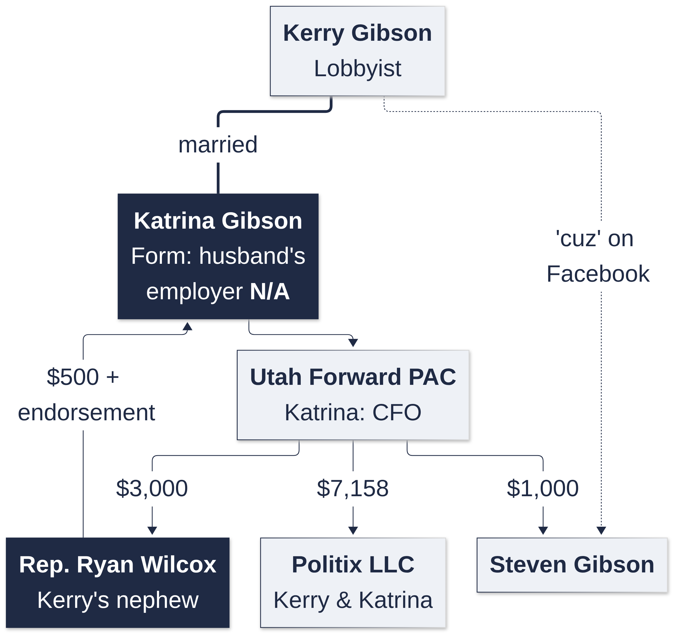
The Bolos family. Commissioner Sharon Bolos, West Haven mayor from 2014 to 2021, has a brother, Bryan Arrington, whom state corporate records list as manager of Nilson Land Holdings LLC. Nilson Homes came before her West Haven council more than 11 times from 2015 to 2018 and before the County Commission in 2023, 2024 and 2025, with no disclosure of the family tie in the minutes. She has said he no longer works there in that capacity; her brother Jeffrey Arrington wrote publicly on Facebook that Bryan “does still work there.” Her daughter, Alexis Bolos Jackson, was elected to the Roy City Council in 2025 and sits on the Weber County RAMP committee, a seat the Commission appoints.
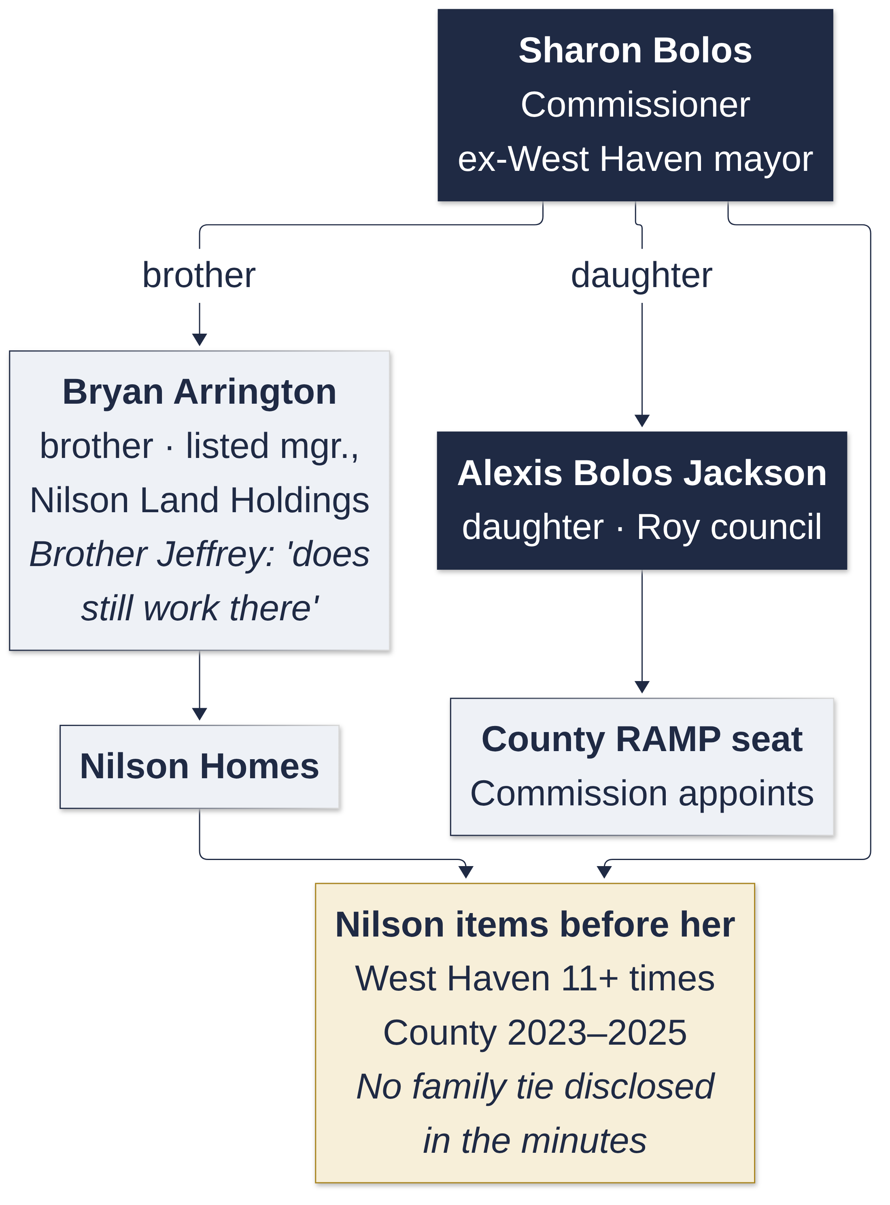
Both lost their June 2026 primaries. The point is the form: none of these relationships had to be listed on it.

7. Where to find the records
- Wasatch County Election & Voter Information (declarations, finance reports, sample ballots): https://www.wasatchcounty.gov/275/Election-Voter-Information
- Wasatch County Conflict of Interest Disclosure Forms: https://www.wasatchcounty.gov/276/Conflict-of-Interest-Disclosure-Forms
- Utah campaign finance and candidate disclosures: https://disclosures.utah.gov
- Utah business registry: https://businessregistration.utah.gov
- MIDA board members and disclosures: https://midaut.org/board-members
- Utah voter information, sample ballots, pamphlet: https://vote.utah.gov
- Judicial Performance Evaluation Commission: https://judges.utah.gov
- The Hive’s 2026 candidate case files: https://weber-county-hive.github.io/candidates2026/
- The Hive’s questionnaire for every candidate: https://weber-county-hive.github.io/candidates2026/six-questions-every-candidate.html
- Utah Legislature (bills and votes): https://le.utah.gov

Sources used in this guide
- Wasatch County Clerk/Auditor, 2026 General Election Certification and 2026 Write-In Candidate Certification.
- Wasatch County Election & Voter Information page (candidate filings, withdrawals, eliminations, finance reports), checked Sept. 30, 2026.
- Wasatch County Conflict of Interest Disclosure Forms page, checked Sept. 30, 2026; forms as filed (Kahler, Rowland, Folmer, Taylor, Hewlett, Searle), read from rendered pages.
- Utah Division of Corporations filings: Red White and Blue Festival Inc.; 5 In The Hive, LLC (Certificate of Organization); Runa Digital, LLC; Summit Cleaning, LLC; Twelve Point Muley LLC; Rowland-related entities.
- MIDA board members page and board/district matrix, midaut.org.
- Heber City Council staff reports and minutes, Jan. 20 and April 21, 2026 (CAMS agreement).
- Luke Searle and Celeste Johnson campaign finance reports (disclosures.utah.gov); Searle state candidate disclosure; Searle campaign website.
- UDOT Heber Valley Corridor Draft EIS comment record (Folmer, Jan. 28, 2026); Park Record letter (Folmer, Feb. 4, 2026).
- Senate District 20: Winterton and McRae DEX exports and conflict-of-interest forms (disclosures.utah.gov); le.utah.gov bill texts and votes for S.B. 107 (2023), S.B. 207 (2025), S.B. 15 (2026) and H.B. 540 (2025); Utah Code 20A-11-101.5; Utah business registry records; the Hive’s SD-20 case file.
- U.S. House 3: FEC candidate summary for Celeste Maloy, Celeste for Congress (H4UT02296), 2026 cycle through June 30, 2026; Utah News Dispatch, “Rural Utahns battle in GOP primary for Utah’s biggest new U.S. House district,” June 12, 2026.
- KPCW and Park Record reporting on candidate filings, the June 23 primary, and candidate profiles (2026).
- Candidates’ own public statements: Kahler (Sept. 1 public response; Sept. 15 letter; campaign post), Taylor (campaign website), Hewlett (Sept. 2 updated form and message to the Hive), Rowland (Park Record, Jan. 30, 2026).

