Overview

- The code is written as a Jupyter notebook in python 3. It is labelled ‘Data_Processing_Notebook.ipynb’.
- The notebook has been tested on Windows 11 version 10.0.22631 Build 22631, with python version 3.7.7.

Installation Instructions

- One way to access the notebook is to install Anaconda via this link: https://www.anaconda.com/download
- Other than software to run Jupyter notebooks like Anaconda, no special hardware or software is required.
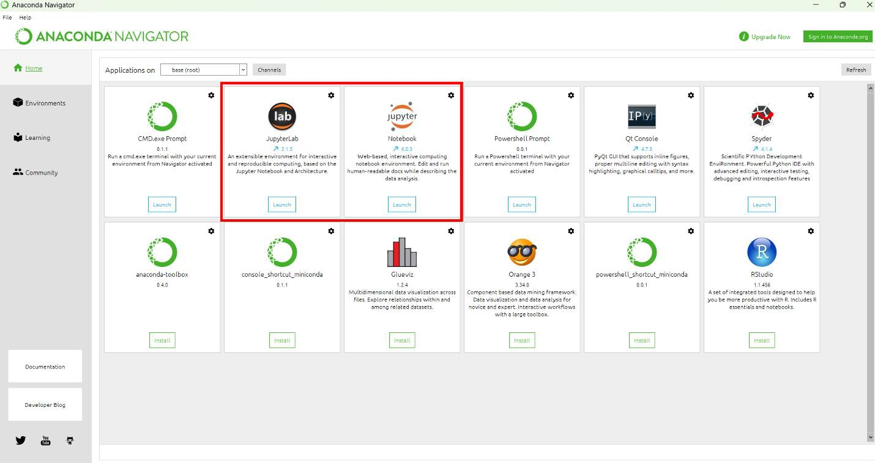
- Anaconda installation should take around 15 minutes. Once installed, open Anaconda, and access JupyterLab or Jupyter Notebook, shown in the picture below.
- Only a few python modules are required to run the notebook- numpy, scipy, and matplotlib are the most utilized modules. In the event that a module fails to load in or work though, it can be installed through the Environments tab in Anaconda:

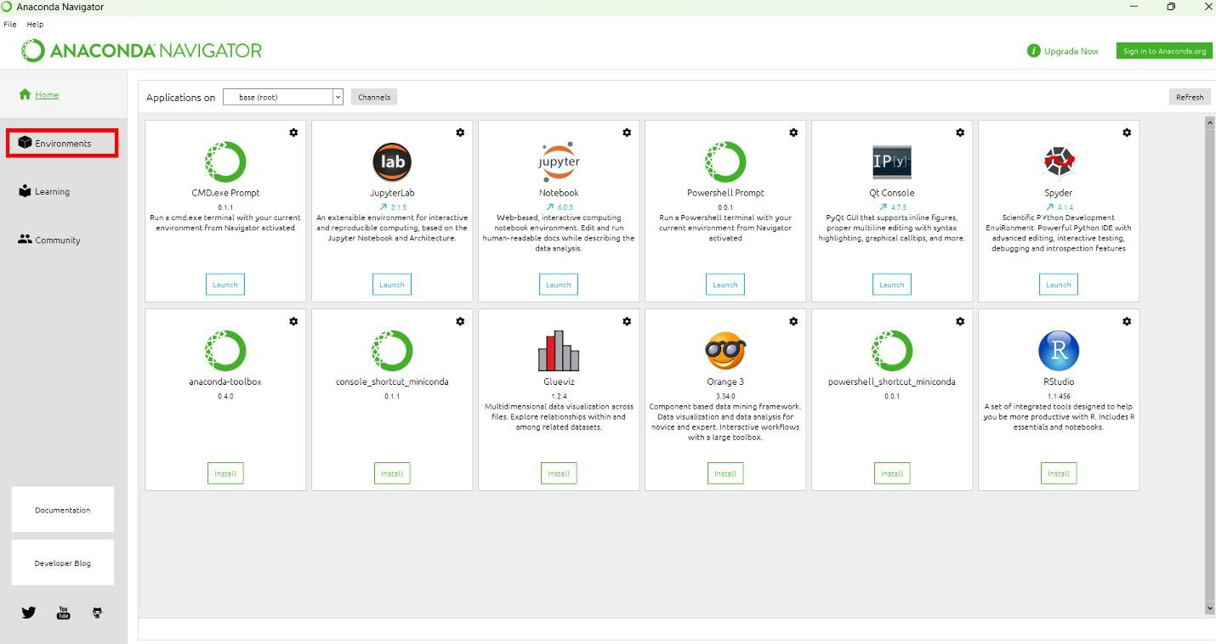
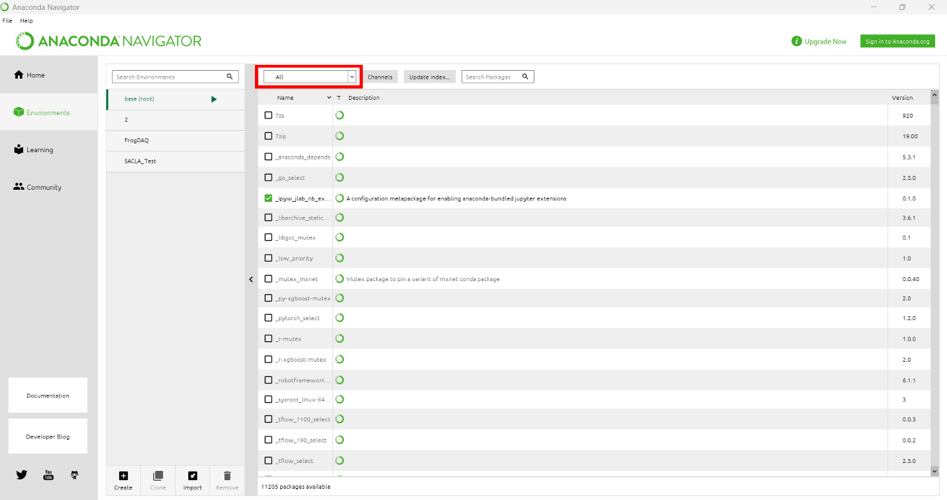
- From here, make sure the pulldown menu is set to ‘all’, and you will see the entire list of available modules. Many come pre-installed in the base environment, and your notebook will likely run without issue, but if a module is not present, it can be selected and installed from this pulldown menu. Through this tab, you can create multiple python environments, with different pre-installed modules, or running different versions of python:
Running The Notebook
- Unzip the data and code folder in a suitable location, and make sure
Data_Processing_Notebook.ipynb is in the same location as all the other files. In other words, keep it all together. Move to the appropriate folder through the Jupyter navigator and open up the data processing notebook.

- The modules in the Jupyter notebook either contain python code, or narration about what the next module does. A module can be run with shift + enter. To run the entire notebook, just hold shift down, and continually hit enter until you get to the end of the notebook, and wait for all the modules to run. It should take less than 5 minutes. When a module of code is running, the brackets next to the module have an asterisk (*). When the code has finished running, the asterisk is replaced with a number.

- The expected result is shown under each module before the notebook is run. If you wish to change the x or y limits of a plot, change the q bin, or make small changes like this, simply make the change in the module and press shift + enter again. In this way, small changes can be made without needing to rerun all of the code.
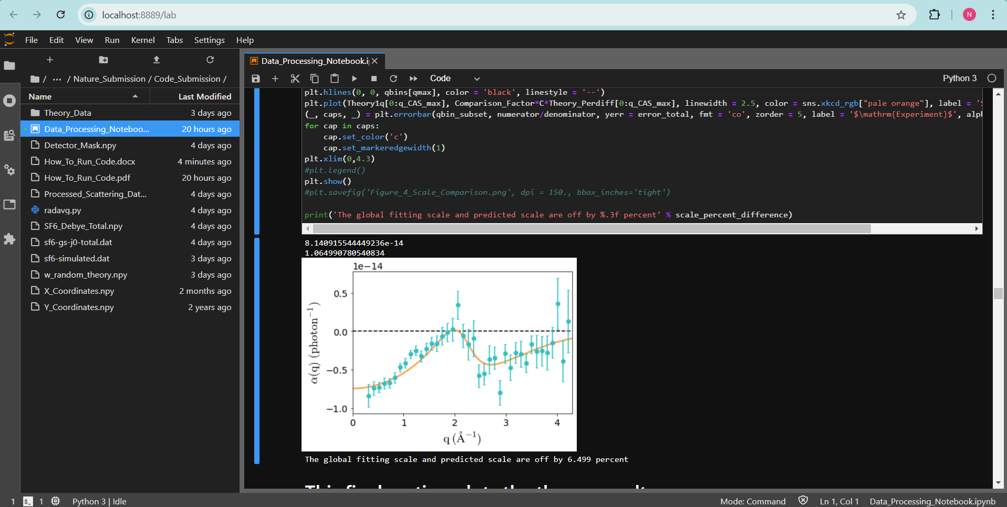
- If using JupyterLab, the interface should look similar to the picture below, with the file navigator on the left, the notebook on the right, and the expected result below the code module:

