A Hitchhiker’s Guide to Temporal Complexity for Resting State fMRI Analysis
Isabel Si-En Wilson
Andre Reza Zamani
Alexander Mark Weber
2025-12-03
Abstract
Cognitive and clinical neuroimaging have increasingly drawn on tools from complexity science to characterize the nonlinear dynamics of the brain. Temporal complexity metrics reflect a range of approaches to complexity in time series, including describing the system’s regularity and irregularity, predictability and unpredictability, information compressibility, and long-term memory. In functional magnetic resonance imaging (fMRI), applications of temporal complexity are scattered across siloed literatures with varying clarity, which limits accessibility and therefore prevalence. This review aims to bridge this gap by communicating the basics of temporal complexity to fMRI scientists. We offer a comprehensive guide to temporal complexity in fMRI, including an overview of fMRI temporal complexity metrics—Shannon entropy, variations of (multi-scale) sample entropy, Lempel-Ziv complexity, avalanche measures, and Hurst—followed by a comprehensive review of extant applications in fMRI.

Introduction
Hello (Beggs 2022)
See ?@fig-fmritempresolution
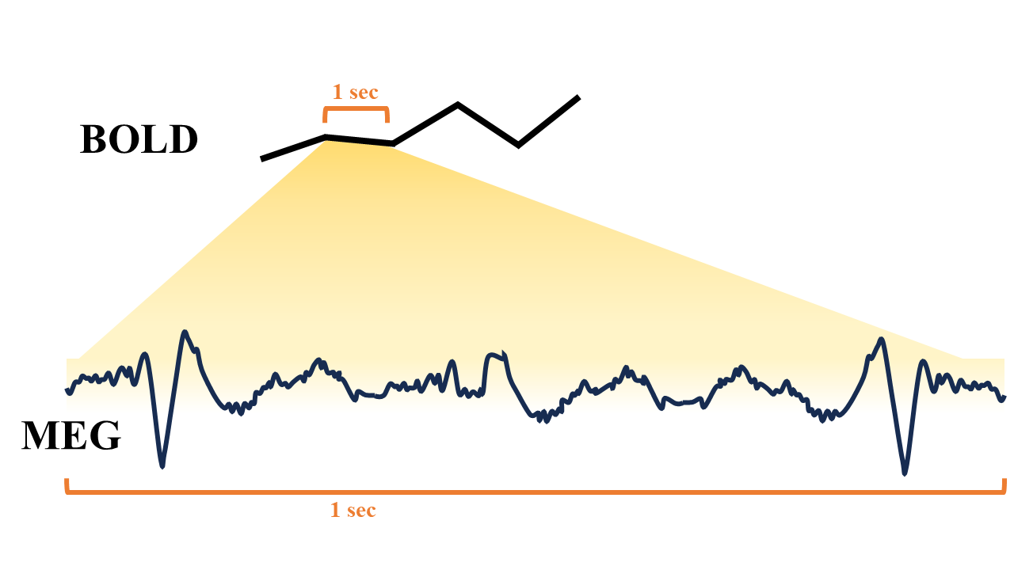
See Figure 1
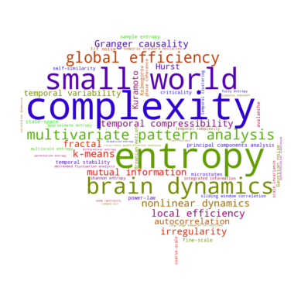
_{Source: Figures}
Figure 1: A variety of approaches to nonlinear analysis of fMRI data. A Python-generated word cloud of fMRI complexity terms, weighted by number of results in PubMed. Keywords were selected from reviews of nonlinearity/complexity (including Sarasso et al. (2021), Sun et al. (2020), Hernández et al. (2023), Keshmiri (2020), Donoghue et al. (2024), and Yang and Tsai (2013)).
See Figure 2
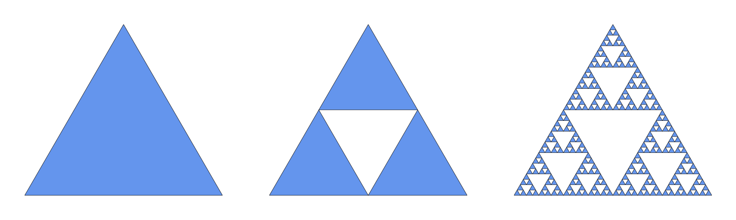
_{Source: Figures}
Figure 2: Ideal mathematical fractal. The 2D Sierpinski triangle starts with a simple equilateral triangle (left), and subdivides it recursively into smaller equilateral triangles. For every iteration, each triangle (in blue) is further subdivided it into four smaller congruent equilateral triangles with the central triangle removed. The first such iteration is shown in the centre, with the fifth iteration shown on the right.
See Figure 3
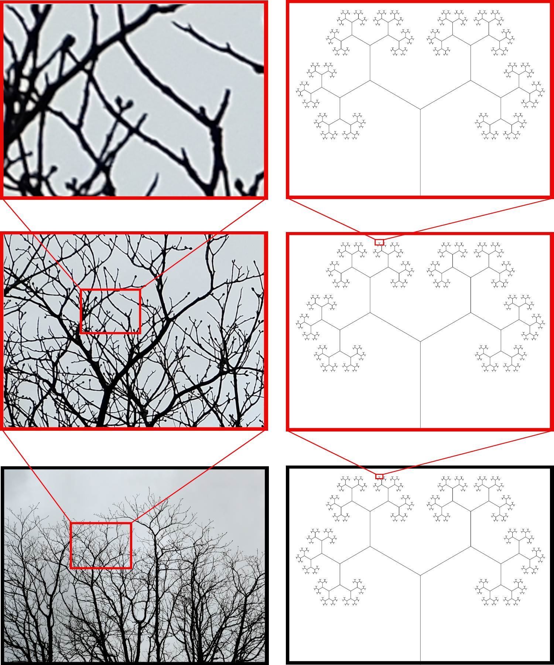
Figure 3: A comparison of statistical and exact fractal patterns. The two basic forms of fractals are demonstrated. Zooming in on tree branches (left), an exact self-similar element cannot be found. Zooming in on an exact fractal (right), exact replica of the whole are found. Photo by author. Branching fractal made in Python. Figure inspired by Taylor (2006)
See Figure 4
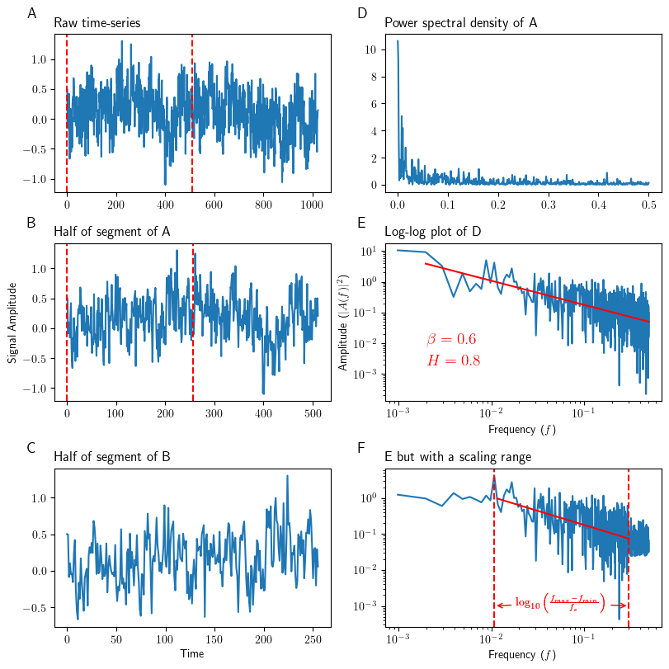
_{Source: Figures}
Figure 4: Main properties of a fractal time-series A-C show a raw time-series (fractional Gaussian noise in this example) at different scales: B is the first half of A (shown as vertical dashed lines in A), while C is half of B (shown in vertical dashed lines in B). D is a power spectral density plot of A. E shows D but on a log-log plot, demonstrating the linear nature of fractal signals when plotted on a log-log scale. The slope of E is $−β$. In this example, $β$ is calculated to be 0.6, which translates to an H of 0.8. F shows a modified version of E, which imagines that E only demonstrates a power law scaling relationship between two distinct frequencies. The equation for calculating the scaling range in decades is shown. Exact fractal time-series (A) was created using the Davies-Harte method.
See Figure 5
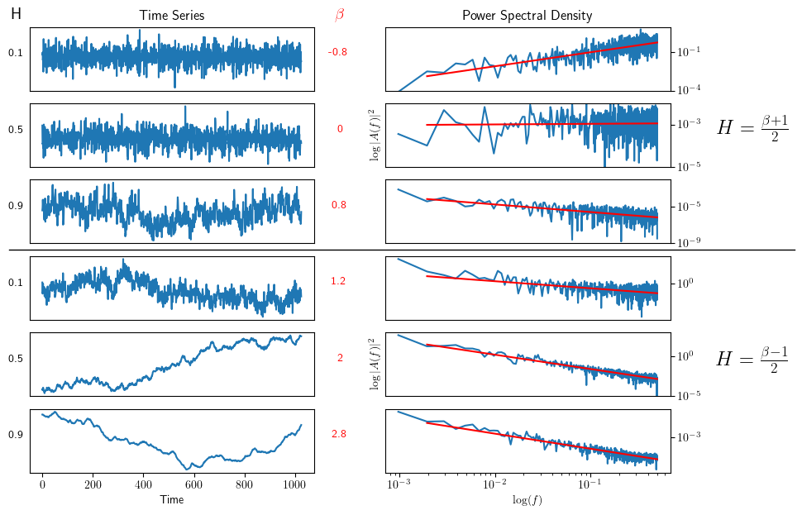
_{Source: Figures}
Figure 5: Simulated fractional Gaussian noise and fractional Brownian motion. Raw simulated time-series with 1,024 time-points and known Hurst values are plotted on the left. The top three time-series are fractional Gaussian noise, while the bottom three are fractional Brownian motion. H values are displayed on the left, while $β$ values are displayed on the right. Note how fractional Gaussian noise remain centered around a mean (i.e. stationary), while fractional Brownian motion wanders away from the mean (i.e. non-stationary). Log-log power spectral density plots of the signals on the left are shown on the right. Linear-regression fits are shown in red, which are used to calculate $β$ and H using the appropriate equation (on the right). Exact fractal time-series were created using the Davies-Harte method. Figure inspired by Eke et al. (2000).
See Table 1
Table 1: fMRI-Hurst studies. An attempt to gather all published fMRI studies that have used Hurst or Hurst-like analysis, some stats, and the main findings. Main findings are almost certainly more nuanced than how we have reported them here; we have attempted to condense the findings as succinctly as possible. n = number of subjects in the study; TR = repition time; MLWD = maximum likelihood wavelet; PSD_{Welch} = power spectral density Welch method; DMN = default mode network; DFA = detrended fluctuation analysis; DA = dispersional analysis; SWV = scaled window variance; RS = rescaled range; LW = local Whittle;
Study | n | Age range | Methods | Volumes | TR (s) | Results
Akhrif et al. (2018) | 103 | 19-28 | AFA | task: 425, resting: 350 | 2 | impulsivity: $↓$
Barnes, Bullmore, and Suckling (2009) | 14 | 21-29 | MLW | 2048 | 1.1 | cognitive effort: $↓$ H
Campbell, Vanderwal, and Weber (2022) | 72 | mean 29 | PSD_{Welch} | 900 | 1 | movie-watching: $↑$ H in visual, somatosensory, and dorsal attention; $↓$ frontoparietal and DMN
Churchill et al. (2015) | 97 (28 chemo; 37 radiation; 32 HC) | n/a | DFA, Wavelet | 285 | 1.5 | worry: $↓$ H
Churchill et al. (2016) | three datasets (98): 19; 49; 30 | 20-82 | DFA, PSD_{Welch} | $∼$ 300 | 2 | age, task novelty and difficulty: $↓$ H
Ciuciu, Abry, and He (2014) | 17 | 18-27 | Wavelet | 194 | 2.16 | networks
Dona, Hall, and Noseworthy (2017) | 71 (56 ASD; 15 HC) | mean 13 | PSD, DA, SWV | 300 | 2 | ASD: $↑$ H
Dona et al. (2017) | 110 (55 mTBI; 55 HC) | mean 13 | PSD, DA, SWV | 180 | 2 | mTBI: $↑$ H
Dong et al. (2018) | 116 | 19-85 | RS | 260 | 2.5 | age: $↑$ H frontal and parietal lobe; $↓$ H insula, limbic, occipital, temporal lobes
Drayne et al. (2024) | 98 | preterm | PSD_{Welch} | 100 | 3 | preterm: $↓$ H; differentiates networks
Erbil and Deshpande (2025) | 7 | 21-28 | Wavelet | 1,000; 1,000, 3,000 | 1; 0.6; 0.2 | microstates
Gao et al. (2018) | 110 | mean 21 | PSD, Wavelet | 232 | 2 | reappraisal scores: $↓$ H
Gao et al. (2023) | 195 (100; 95) | 18-28 | Wavelet | ? | 2 | rumination: $↑$ H
Gentili et al. (2017) | 31 | mean 25 | Wavelet | 512 | 1.64 | neuroticism: $↓$
Gentili et al. (2015) | 36 | mean 27 | Wavelet | 450 | 2 | social anxiety: $↑$ H
He (2011) | 17 | 18-27 | DFA, PSD | 194 | 2.16 | task: $↓$ H; differentiates networks; brain glucose metabolism and neurovascular coupling
Jäger et al. (2024) | 40 (20 task; 20 no task) | 20-32 | DFA | 512 | 1.13 | motor sequence learning: $↓$ H
Lai et al. (2010) | 63 (33 ASD; 3- HC) | n/a | Wavelet | 512 | 1.3 | ASD: $↓$ H
X. Lei, Zhao, and Chen (2013) | 17 | 18-29 | Wavelet | 200 | 1.5 | extroversion: $↓$ H in DMN
Y. Lei et al. (2021) | 75 (16 HMMD; 34 IMMD; 25 HC) | mean $∼$ 41 | RS | 240 | 2 | moyamoya disease: $↓$ H
Linke et al. (2024) | 83 | 1.5-5 | WML | 400 | 0.8 | age of children ASD: $↓$ H in vmPFC
Maxim et al. (2005) | 21 | n/a | LW, Wornell, MLW | 150 | 2 | AD: $↑$ H
Mella et al. (2024) | 716 | preterm | PSD_{Welch} | 2,300 | 0.392 | preterm: $↓$ H; H starts < 0.5 at preterm age ; differentiates networks
Omidvarnia et al. (2021) | 100 | 22-35 | PSD, DFA | min 250 | 0.72 | cognitive load: $↓$ H; H and entropy-based complexity highly correlated; H highest in frontoparietal network and default mode network
Rubin, Fekete, and Mujica-Parodi (2013) | 22 | ? | Many | ? | ? | HFFT and PSD_{Welch} outperform other methods
Sokunbi et al. (2014) | 29 (13 SZ; 16 HC) | ? | DA, DFA | ? | ? | SZ: $↓$ H
Suckling et al. (2008) | 22 (11 old; 11 young) | 22 and 65 | MLW | 512 | 1.1 | multifractal reanalysis of (Alle Meije Wink et al. 2006)
Tetereva et al. (2020) | 23 | mean 23.9 | DFA | 300 | 2 | fear: $↓$ H then $↑$ H
Uscătescu et al. (2022) | 124 (55 TD; 30 AT; 39 SZ) | ? | Wavelet | 947? | 0.475 | ASD and SZ: $↓$ H
Varley et al. (2020) | 33 (15 HC; 10 min conscious; 8 veg) | ? | HFD | ? | ? | Lower consciousness: $↓$ H
Von Wegner, Laufs, and Tagliazucchi (2018) | ? | ? | Wavelet, DFA | 1500 | 2.08 | multiscale variance effects produce Hurst phenomena without long-range dependence
Warsi, Molloy, and Noseworthy (2012) | 46 (33 AD; 13 HC) | ? | PSD, RD | 2,400 | 0.25 | AD: $↑$ H
Weber, Soreni, and Noseworthy (2014) | 14 | 22-38 | Wavelet | 512 | 2 | acute alcohol intoxication: mix of $uparrow$ and $downarrow$ H
Alle Meije Wink et al. (2006) | 22 (11 old; 11 young) | 22 and 65 | MLW | 512 | 1.1 | age: $↑$ H in bilateral hippocampus; scopolamine: $↑$ H; faster task: $↑$ H
Alle-Meije Wink et al. (2008) | 11 | mean 35 $±$ 10 | Wavelet | 136 | 1.1 | latency in fame decision task: $↓$ H
Xie et al. (2024) | 70 | ? | Wavelet | 700 | 0.6 | pharmaco-resistant TLE: $↓$ H

References
Akhrif, Atae, Marcel Romanos, Katharina Domschke, Angelika Schmitt-Boehrer, and Susanne Neufang. 2018. “Fractal Analysis of BOLD Time Series in a Network Associated With Waiting Impulsivity.” Frontiers in Physiology 9 (October): 1378. https://doi.org/10.3389/fphys.2018.01378.
Barnes, Anna, Edward T. Bullmore, and John Suckling. 2009. “Endogenous Human Brain Dynamics Recover Slowly Following Cognitive Effort.” Edited by Björn Brembs. PLoS ONE 4 (8): e6626. https://doi.org/10.1371/journal.pone.0006626.
Beggs, John M. 2022. The Cortex and the Critical Point. 1st ed. Cambridge, MA: MIT Press Direct.
Campbell, Olivia, Tamara Vanderwal, and Alexander Mark Weber. 2022. “Fractal-Based Analysis of fMRI BOLD Signal During Naturalistic Viewing Conditions.” Frontiers in Physiology 12 (January): 809943. https://doi.org/10.3389/fphys.2021.809943.
Churchill, Nathan W., Bernadine Cimprich, Mary K. Askren, Patricia A. Reuter-Lorenz, Mi Sook Jung, Scott Peltier, and Marc G. Berman. 2015. “Scale-Free Brain Dynamics Under Physical and Psychological Distress: Pre-Treatment Effects in Women Diagnosed with Breast Cancer.” Human Brain Mapping 36 (3): 1077–92. https://doi.org/10.1002/hbm.22687.
Churchill, Nathan W., Robyn Spring, Cheryl Grady, Bernadine Cimprich, Mary K. Askren, Patricia A. Reuter-Lorenz, Mi Sook Jung, Scott Peltier, Stephen C. Strother, and Marc G. Berman. 2016. “The Suppression of Scale-Free fMRI Brain Dynamics Across Three Different Sources of Effort: Aging, Task Novelty and Task Difficulty.” Scientific Reports 6 (1): 30895. https://doi.org/10.1038/srep30895.
Ciuciu, Philippe, Patrice Abry, and Biyu J. He. 2014. “Interplay Between Functional Connectivity and Scale-Free Dynamics in Intrinsic fMRI Networks.” NeuroImage 95 (July): 248–63. https://doi.org/10.1016/j.neuroimage.2014.03.047.
Dona, Olga, Geoffrey B. Hall, and Michael D. Noseworthy. 2017. “Temporal Fractal Analysis of the Rs-BOLD Signal Identifies Brain Abnormalities in Autism Spectrum Disorder.” Edited by Satoru Hayasaka. PLOS ONE 12 (12): e0190081. https://doi.org/10.1371/journal.pone.0190081.
Dona, Olga, Michael D. Noseworthy, Carol DeMatteo, and John F. Connolly. 2017. “Fractal Analysis of Brain Blood Oxygenation Level Dependent (BOLD) Signals from Children with Mild Traumatic Brain Injury (mTBI).” Edited by Radouil Tzekov. PLOS ONE 12 (1): e0169647. https://doi.org/10.1371/journal.pone.0169647.
Dong, Jianxin, Bin Jing, Xiangyu Ma, Han Liu, Xiao Mo, and Haiyun Li. 2018. “Hurst Exponent Analysis of Resting-State fMRI Signal Complexity Across the Adult Lifespan.” Frontiers in Neuroscience 12 (February): 34. https://doi.org/10.3389/fnins.2018.00034.
Donoghue, Thomas, Ryan Hammonds, Eric Lybrand, Leonhard Washcke, Richard Gao, and Bradley Voytek. 2024. “Evaluating and Comparing Measures of Aperiodic Neural Activity.” https://doi.org/10.1101/2024.09.15.613114.
Drayne, Johann P., Allison E. Mella, Mia M. McLean, Steven Ufkes, Vann Chau, Ting Guo, Helen M. Branson, et al. 2024. “Long-Range Temporal Correlation Development in Resting-State fMRI Signal in Preterm Infants: Scanned Shortly After Birth and at Term-Equivalent Age.” Edited by Kosmas Kosmidis. PLOS Complex Systems 1 (4): e0000024. https://doi.org/10.1371/journal.pcsy.0000024.
Eke, A., P. Hermán, J. Bassingthwaighte, G. Raymond, D. Percival, M. Cannon, I. Balla, and C. Ikrényi. 2000. “Physiological Time Series: Distinguishing Fractal Noises from Motions.” Pflügers Archiv - European Journal of Physiology 439 (4): 403–15. https://doi.org/10.1007/s004249900135.
Erbil, Nurhan, and Gopikrishna Deshpande. 2025. “Scale-Free Dynamics of Resting-State fMRI Microstates.” Fractal and Fractional 9 (2): 112. https://doi.org/10.3390/fractalfract9020112.
Gao, Wei, Bharat Biswal, Jiemin Yang, Songlin Li, YanQing Wang, Shengdong Chen, and JiaJin Yuan. 2023. “Temporal Dynamic Patterns of the Ventromedial Prefrontal Cortex Underlie the Association Between Rumination and Depression.” Cerebral Cortex 33 (4): 969–82. https://doi.org/10.1093/cercor/bhac115.
Gao, Wei, ShengDong Chen, Bharat Biswal, Xu Lei, and JiaJin Yuan. 2018. “Temporal Dynamics of Spontaneous Default-Mode Network Activity Mediate the Association Between Reappraisal and Depression.” Social Cognitive and Affective Neuroscience, October. https://doi.org/10.1093/scan/nsy092.
Gentili, Claudio, Ioana Alina Cristea, Emiliano Ricciardi, Nicola Vanello, Cristian Popita, Daniel David, and Pietro Pietrini. 2017. “Not in One Metric: Neuroticism Modulates Different Resting State Metrics Within Distinctive Brain Regions.” Behavioural Brain Research 327 (June): 34–43. https://doi.org/10.1016/j.bbr.2017.03.031.
Gentili, Claudio, Nicola Vanello, Ioana Cristea, Daniel David, Emiliano Ricciardi, and Pietro Pietrini. 2015. “Proneness to Social Anxiety Modulates Neural Complexity in the Absence of Exposure: A Resting State fMRI Study Using Hurst Exponent.” Psychiatry Research: Neuroimaging 232 (2): 135–44. https://doi.org/10.1016/j.pscychresns.2015.03.005.
He, Biyu J. 2011. “Scale-Free Properties of the Functional Magnetic Resonance Imaging Signal During Rest and Task.” The Journal of Neuroscience 31 (39): 13786–95. https://doi.org/10.1523/JNEUROSCI.2111-11.2011.
Hernández, Ronald Miguel, Jacqueline Cynthia Ponce-Meza, Miguel Ángel Saavedra-López, Walter Antonio Campos Ugaz, Roxana Monteza Chanduvi, and Walter Campos Monteza. 2023. “Brain Complexity and Psychiatric Disorders.” Iranian Journal of Psychiatry, September. https://doi.org/10.18502/ijps.v18i4.13637.
Jäger, Anna-Thekla P., Alexander Bailey, Julia M. Huntenburg, Christine L. Tardif, Arno Villringer, Claudine J. Gauthier, Vadim Nikulin, Pierre-Louis Bazin, and Christopher J. Steele. 2024. “Decreased Long-Range Temporal Correlations in the Resting-state Functional Magnetic Resonance Imaging Blood-oxygen-level-dependent Signal Reflect Motor Sequence Learning up to 2 Weeks Following Training.” Human Brain Mapping 45 (4): e26539. https://doi.org/10.1002/hbm.26539.
Keshmiri, Soheil. 2020. “Entropy and the Brain: An Overview.” Entropy 22 (9): 917. https://doi.org/10.3390/e22090917.
Lai, Meng-Chuan, Michael V. Lombardo, Bhismadev Chakrabarti, Susan A. Sadek, Greg Pasco, Sally J. Wheelwright, Edward T. Bullmore, Simon Baron-Cohen, and John Suckling. 2010. “A Shift to Randomness of Brain Oscillations in People with Autism.” Biological Psychiatry 68 (12): 1092–99. https://doi.org/10.1016/j.biopsych.2010.06.027.
Lei, Xu, Zhiying Zhao, and Hong Chen. 2013. “Extraversion Is Encoded by Scale-Free Dynamics of Default Mode Network.” NeuroImage 74 (July): 52–57. https://doi.org/10.1016/j.neuroimage.2013.02.020.
Lei, Yu, Yuzhu Li, Lianchun Yu, Longzhou Xu, Xin Zhang, Gaoxing Zheng, Liang Chen, et al. 2021. “Faded Critical Dynamics in Adult Moyamoya Disease Revealed by EEG and fMRI.” Edited by Aldrin Gomes. Oxidative Medicine and Cellular Longevity 2021 (1): 6640108. https://doi.org/10.1155/2021/6640108.
Linke, Annika C., Bosi Chen, Lindsay Olson, Michaela Cordova, Molly Wilkinson, Tiffany Wang, Meagan Herrera, et al. 2024. “Altered Development of the Hurst Exponent in the Medial Prefrontal Cortex in Preschoolers With Autism.” Biological Psychiatry: Cognitive Neuroscience and Neuroimaging, September, S2451902224002714. https://doi.org/10.1016/j.bpsc.2024.09.003.
Maxim, Voichiţa, Levent Şendur, Jalal Fadili, John Suckling, Rebecca Gould, Rob Howard, and Ed Bullmore. 2005. “Fractional Gaussian Noise, Functional MRI and Alzheimer’s Disease.” NeuroImage 25 (1): 141–58. https://doi.org/10.1016/j.neuroimage.2004.10.044.
Mella, Allison Eve, Tamara Vanderwal, Steven P Miller, and Alexander Mark Weber. 2024. “Temporal Complexity of the BOLD-signal in Preterm Versus Term Infants.” Cerebral Cortex 34 (10): bhae426. https://doi.org/10.1093/cercor/bhae426.
Omidvarnia, Amir, Raphaël Liégeois, Enrico Amico, Maria Giulia Preti, Andrew Zalesky, and Dimitri Van De Ville. 2021. “Assessment of Temporal Complexity in Functional MRI Between Rest and Task Conditions.” Bioengineering. https://doi.org/10.1101/2021.11.20.469367.
Rubin, Denis, Tomer Fekete, and Lilianne R. Mujica-Parodi. 2013. “Optimizing Complexity Measures for fMRI Data: Algorithm, Artifact, and Sensitivity.” Edited by Alejandro Raul Hernandez Montoya. PLoS ONE 8 (5): e63448. https://doi.org/10.1371/journal.pone.0063448.
Sarasso, Simone, Adenauer Girardi Casali, Silvia Casarotto, Mario Rosanova, Corrado Sinigaglia, and Marcello Massimini. 2021. “Consciousness and Complexity: A Consilience of Evidence.” Neuroscience of Consciousness 2021 (2): niab023. https://doi.org/10.1093/nc/niab023.
Sokunbi, Moses O., Victoria B. Gradin, Gordon D. Waiter, George G. Cameron, Trevor S. Ahearn, Alison D. Murray, Douglas J. Steele, and Roger T. Staff. 2014. “Nonlinear Complexity Analysis of Brain fMRI Signals in Schizophrenia.” Edited by Emmanuel A. Stamatakis. PLoS ONE 9 (5): e95146. https://doi.org/10.1371/journal.pone.0095146.
Suckling, John, Alle Meije Wink, Frederic A. Bernard, Anna Barnes, and Edward Bullmore. 2008. “Endogenous Multifractal Brain Dynamics Are Modulated by Age, Cholinergic Blockade and Cognitive Performance.” Journal of Neuroscience Methods 174 (2): 292–300. https://doi.org/10.1016/j.jneumeth.2008.06.037.
Sun, Jie, Bin Wang, Yan Niu, Yuan Tan, Chanjuan Fan, Nan Zhang, Jiayue Xue, et al. 2020. “Complexity Analysis of EEG, MEG, and fMRI in Mild Cognitive Impairment and Alzheimer’s Disease: A Review.” Entropy 22 (2). https://doi.org/10.3390/e22020239.
Taylor, Richard. 2006. “Personal Reflections on Jackson Pollock’s Fractal Paintings.” História, Ciências, Saúde-Manguinhos 13 (suppl): 109–23. https://doi.org/10.1590/S0104-59702006000500007.
Tetereva, Alina, Sergey Kartashov, Alexey Ivanitsky, and Olga Martynova. 2020. “Variance and Scale-Free Properties of Resting-State Blood Oxygenation Level-Dependent Signal After Fear Memory Acquisition and Extinction.” Frontiers in Human Neuroscience 14 (October): 509075. https://doi.org/10.3389/fnhum.2020.509075.
Uscătescu, Lavinia Carmen, Christopher J. Hyatt, Jack Dunn, Martin Kronbichler, Vince Calhoun, Silvia Corbera, Kevin Pelphrey, Brian Pittman, Godfrey Pearlson, and Michal Assaf. 2022. “Using the Excitation/Inhibition Ratio to Optimize the Classification of Autism and Schizophrenia.” https://doi.org/10.1101/2022.05.24.22275531.
Varley, Thomas F., Michael Craig, Ram Adapa, Paola Finoia, Guy Williams, Judith Allanson, John Pickard, David K. Menon, and Emmanuel A. Stamatakis. 2020. “Fractal Dimension of Cortical Functional Connectivity Networks & Severity of Disorders of Consciousness.” Edited by Francisco J. Esteban. PLOS ONE 15 (2): e0223812. https://doi.org/10.1371/journal.pone.0223812.
Von Wegner, Frederic, Helmut Laufs, and Enzo Tagliazucchi. 2018. “Mutual Information Identifies Spurious Hurst Phenomena in Resting State EEG and fMRI Data.” Physical Review E 97 (2): 022415. https://doi.org/10.1103/PhysRevE.97.022415.
Warsi, Mohammed A., William Molloy, and Michael D. Noseworthy. 2012. “Correlating Brain Blood Oxygenation Level Dependent (BOLD) Fractal Dimension Mapping with Magnetic Resonance Spectroscopy (MRS) in Alzheimer’s Disease.” Magnetic Resonance Materials in Physics, Biology and Medicine 25 (5): 335–44. https://doi.org/10.1007/s10334-012-0312-0.
Weber, Alexander M., Noam Soreni, and Michael D. Noseworthy. 2014. “A Preliminary Study on the Effects of Acute Ethanol Ingestion on Default Mode Network and Temporal Fractal Properties of the Brain.” Magnetic Resonance Materials in Physics, Biology and Medicine 27 (4): 291–301. https://doi.org/10.1007/s10334-013-0420-5.
Wink, Alle Meije, Frédéric Bernard, Raymond Salvador, Ed Bullmore, and John Suckling. 2006. “Age and Cholinergic Effects on Hemodynamics and Functional Coherence of Human Hippocampus.” Neurobiology of Aging 27 (10): 1395–1404. https://doi.org/10.1016/j.neurobiolaging.2005.08.011.
Wink, Alle-Meije, Ed Bullmore, Anna Barnes, Frederic Bernard, and John Suckling. 2008. “Monofractal and Multifractal Dynamics of Low Frequency Endogenous Brain Oscillations in Functional MRI.” Human Brain Mapping 29 (7): 791–801. https://doi.org/10.1002/hbm.20593.
Xie, Ke, Jessica Royer, Raul Rodriguez-Cruces, Linda Horwood, Alexander Ngo, Thaera Arafat, Hans Auer, et al. 2024. “Pharmaco-Resistant Temporal Lobe Epilepsy Gradually Perturbs the Cortex-Wide Excitation-Inhibition Balance.” https://doi.org/10.1101/2024.04.22.590555.
Yang, Albert C., and Shih-Jen Tsai. 2013. “Is Mental Illness Complex? From Behavior to Brain.” Progress in Neuro-Psychopharmacology and Biological Psychiatry 45 (August): 253–57. https://doi.org/10.1016/j.pnpbp.2012.09.015.

