Supplementary Material

Predicted Hct Values
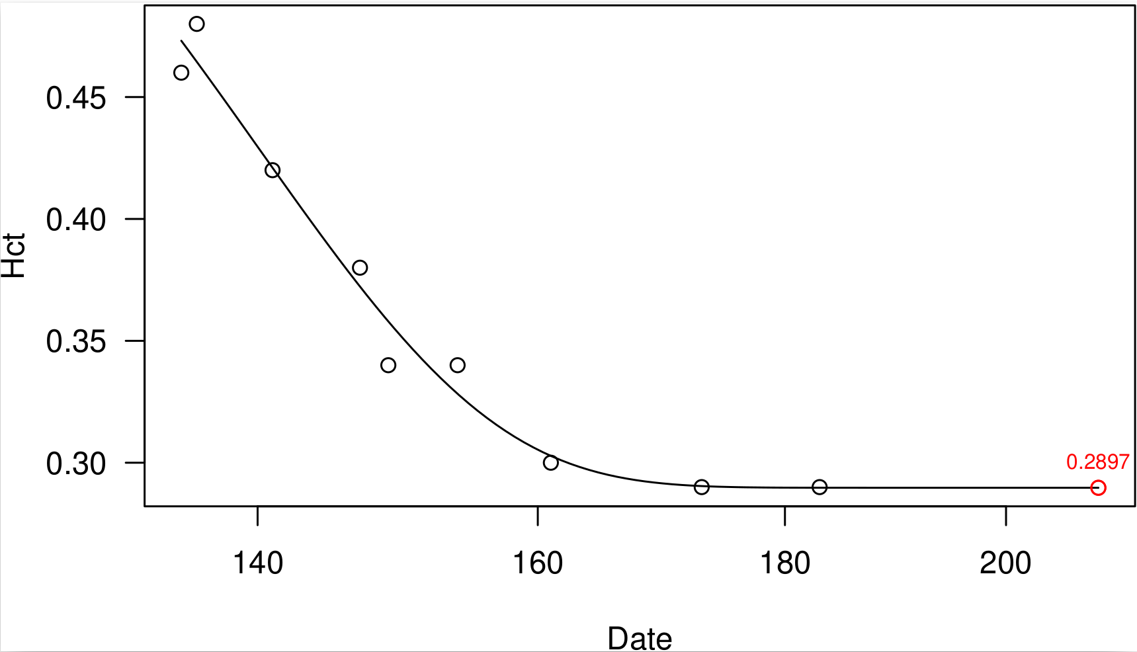
Supplementary Figure 1: Predicted Hct value (red) from previously acquired values (black) using a four-parameter Weibull function from a sample subject. X axis is day of year and y axis is Hct values (fraction).

