


Getting started with Webex Calling: Hands-on lab
LAB-11090

Table of Contents
1
Table of Contents 2
Lab overview & objectives 3
Example customer scenario 3
Basic Customer Information 4
Connectivity Requirements 4
Users 4
Call Flows 5
Using this workbook 6
Lab 1: Organization Settings 7
Lab 2: Location Settings 8
Lab 3: Users 10
Lab 4: Devices and workspaces 12
Lab 5: Configuring Calling Features 14
Lab 6: Creating Queues 16
Lab 7: Setting Customer Assist Supervisors and Features 20
Lab 8: Create the AA for the main number 22
Lab 9: User Configuration 24
Lab 10: User Experience 26
Lab 11: Test call routing 28
Useful links 31

Lab overview & objectives
Enhance your cloud-based calling skills with this interactive, accelerated hands-on lab focused on Webex Calling. Over a 4-hour session, you will engage in practical exercises including configuring PSTN connections, utilizing key features, and managing call routing through Webex Control Hub. This lab provides a simulated environment to practice efficient call handling, explore mid-call functions, and understand call flow management, empowering you to optimize your organization's telephony infrastructure and communication systems.
Lab objectives
- Configure Organization and Location Settings: Learn to navigate Webex Control Hub to establish foundational telephony settings, including internal dialing plans, PSTN connections, and business hour schedules for multiple office locations.
- Manage Users and Provision Devices: Gain practical experience in creating and managing user accounts, assigning Webex Calling licenses, and provisioning hardware devices (such as Cisco 8865 IP phones) to ensure effective communication across an organization.
- Implement Advanced Call Routing Features: Develop skills in configuring complex telephony features, including auto attendants, call queues, hunt groups, paging groups, and call park/pickup, to optimize call flow and improve organizational responsiveness.
- Administer Shared Workspaces and User-Level Preferences: Learn to manage shared resources and flexible working environments by configuring workspaces, hot desking, and hoteling, while also enabling users to manage their own calling preferences via the User Hub.

Example customer scenario
VitaCrunsh Foods, needs a calling solution without the need of additional equipment but also is flexible enough in case employees needs to work from home.


CMBasic Customer Information
Customer Name: VitaCrunch Foods
Location: Durham, North Carolina
Business Verticals: Manufacturer
About: VitaCrunch Foods creates fun, flavorful snacks made with wholesome ingredients. With vibrant flavors and a satisfying crunch, its products make healthier snacking easy and enjoyable for busy people and families.

Connectivity Requirements
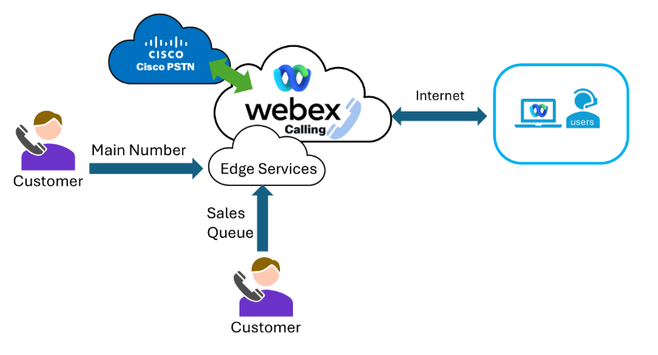
Basic Connectivity Image

Users
Department | Agents | Supervisors | Total
Sales | 3 | 1
Factory | 3
Logistics | 2
Totals | 8 | 1 | 8

Call Flows
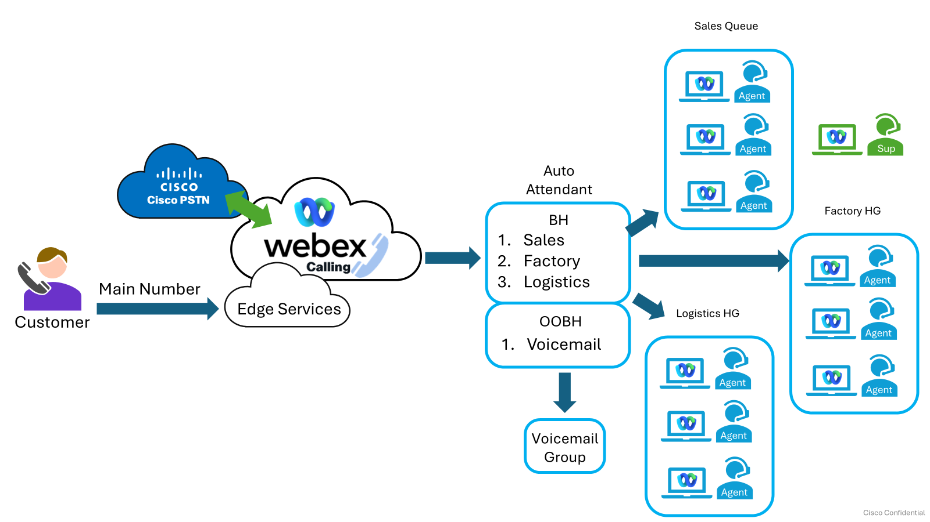

Additional information
  - Agents receive call on a skill basis
  - Supervisors monitor calls
  - Recording in performed

Using this workbook

Lab URL: admin.webex.com
Login credentials: Provided by instructor
All labs generally follow the same layout shown below
Numbered headings identify each lab step.
Blue italic text shows Control Hub navigation.
- Tasks to be completed
At the end of each lab, stop and wait for further instruction. Look for the blue STOP callout and raise-hand icon.
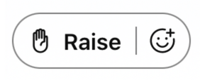

Lab 1: Organization Settings

In this lab, you’ll log in with your instructor provided credentials and update the timeout settings, as well as some Organization Settings.

Log into Control Hub: admin.webex.com
- Use an incognito/private window in your browser
- Instructor provided log in details

You don’t want to be logged out of Control Hub every 20 minutes.
Management > Organization Settings > Control Hub Idle Timeout
- Change the timeout to 12 hours
- Save

Internal extensions have 3 digits
Services > Calling > Settings > Service > Internal Dialing
- Click on edit, and set the Internal Extension Length to 3
- Save

Set call recording for emergency calls
Services > Calling > Settings > Service > Call Recording
- Click on the toggle, to turn on Record emergency calls
- Save

Help article links
Getting started with Control Hub | Configure Emergency Call Notifications | Configure dial plans
Manage call recording for Webex Calling | Configure default voicemail passcode

STOP: End of Lab 1
Raise your hand and leave it raised in the Webex Meeting. Wait for further instruction.

Lab 2: Location Settings

In this lab, you will learn to edit locations, assign PSTN connections, manage PSTN and location settings.

The main location should be renamed appropriately.
Management > Location > dCloud > Location info > Small pencil icon
Rename dCloud Location
- Location name: VitaCrunch

VitaCrunch Foods will use the Cisco Calling Plans as PSTN option.
Management > Locations > Select location > PSTN > PSTN Configuration > PSTN connection > Manage
Assign PSTN Connection to the location
- Location: VitaCrunch
- Connection Type: Cisco Calling Plans
- Contract Information: Charles Holland - Student login email address
- Service Address: location address (already entered)
- Authorized Contact: Charles Holland
- Job title: Admin

The location needs 5 numbers.
Services > PSTN & Routing > Numbers > Add numbers
Order and add numbers
- Location: VitaCrunch
- Number Type: PSTN
- Select an Area Code from the list (if you don’t see this option, be sure to scroll down in the center section of the screen)
- Order 3 numbers
- IMPORTANT: Click view orders
  - Click on the pending order to automatically change the status to provisioned

To make and receive calls the location needs a main number.
Management > Locations > VitaCrunch > PSTN > PSTN Configuration > Main number
Assign a main number to VitaCrunch
- Select one of the available numbers
- Make a note of the number for a subsequent lab

VitaCrunch users will need to use voicemail.
Management > Locations > VitaCrunch > Calling > Calling features settings > Voice portal
Configure the voice portal
- Voice portal name: VM – HQ
- Incoming Call:
  - Phone number: Any number not selected as the main number
  - Extension: 200

Calls coming into the main number need to route to specific options based on the time of day.
Management > Locations > VitaCrunch> Calling > Calling features settings > Schedules
Create a schedule for VitaCrunch
- Name: Open Hours
- Schedule Type: Business Hours
- Monday – Friday 9:00 am – 5 pm
- Make sure to turn off the lunch schedule!

Help articles
Setup Cisco Calling Plan | Assign Location Main Number
Configure Voice Portal

STOP: End of Lab 2
Raise your hand and leave it raised in the Webex Meeting. Wait for further instruction.

Lab 3: Users

In this lab, you will learn how to assign licenses and extensions to users manually and in bulk.

Anita Perez needs a phone number and use calling features.
Management > Users > Anita Perez > Summary > Licenses > Edit Licenses
Assign Webex Calling Professional license and assign a phone number and extension
- Calling
  - Webex Calling Professional
- Location: VitaCrunch
- Number: Unused number
- Extension:101

The existing users need Webex Calling licenses and extensions
Management > Users > Licenses > Organization-based licenses > Set up
Repeat the previous steps for the rest of the users

User | Extension
Charles Holland | 102
Eric Steele | 103
Kellie Melby | 104
Rebekah Barretta | 105
Ricardo Filice | 106
Stefan Mauk | 107
Taylor Bard | 108

Help article links
Set up automatic license assignments | Edit licenses for individual users
Add Users Manually

STOP: End of Lab 3
Raise your hand and leave it raised in the Webex Meeting. Wait for further instruction.

Lab 4: Devices and workspaces

In this lab, you will learn how to assign devices to users and workspaces and create workspaces.

Anita Perez needs a 9861 phone.
Devices > Add device > Personal Usage
Assign devices to users manually or in bulk

Cisco Desk Phone: Cisco 9861

Activation method: Activation Code

VitaCrunch Foods need a phone on the Event Hall .
Management > Workspaces > Add Workspace
Add the workspace with the corresponding device and services. Devices will be added using activation code.
- Workspace name: Event Hall 301
- Location: VitaCrunch
- Device: Cisco Desk Phone: Cisco 9811 – By activation code
- Services
  - Calling – Cisco Webex Calling
  - Disable Hot Desking Sign in
  - Common area workspace
  - Extension: 301

Help articles
Configure & manage Webex Calling devices

STOP: End of Lab 4
Raise your hand and leave it raised in the Webex Meeting. Wait for further instruction.

Lab 5: Configuring Calling Features

In this lab, you will learn how to create a voicemail group, operating mode and announcements

After hours calls need to route to a voice mailbox that all employees can access.
Services > Calling > Features > Voicemail group > Add New
Create a voicemail group
- Location: VitaCrunch
- Name: PR_VmailGroup
- Extension: 600
- Passcode: 258011

During unexpected office closures calls to the auto attendant will need to be routed to voicemail on demand by an end user.
Services > Calling > Features > Operating Mode > Add New
Create an operating mode to route to voicemail
- Location: VitaCrunch
- Name: EmergencyClosure
- No schedule
- Forward destination: PR_VmailGroup Ext 600

Some call routings require announcements.
Services > Calling > Features > Announcements > Add New > Text to speech
Create a greeting to welcome to the VitaCrunch Foods Factory queue
- Level: Organization
- Label: Welcome Factory
- Text: Welcome to the VitaCrunch Foods, soon an agent will be with you.
- Generate and listen to the file before saving.
Create a greeting to welcome to the VitaCrunch Foods Logistics queue
- Level: Organization
- Label: Welcome Logistics
- Text: Welcome to the VitaCrunch Foods, soon a Logistics representative will be with you.
- Generate and listen to the file before saving.

Help articles
Voicemail Group | Operating Modes | Announcement Files

STOP: End of Lab 5
Raise your hand and leave it raised in the Webex Meeting. Wait for further instruction.

Lab 6: Creating Queues

In this lab, you will learn how to create and configure Customer Assist call queues.

Callers to the Reservation number should be placed on hold until an agent is available.
Services > Customer Assist > Queues > Add Queue
Create a Customer Assist Call Queue
- Location: VitaCrunch
- Name: Reservation Queue
- Number: Assign an available number
- Extension 201
- Enable: Allow agents to use call queue number as caller ID
- Number of calls in queue: 15
- External caller ID phone number: Direct Line
- Routing: Priority Based – Longest Idle
- Overflow Settings:
  - Transfer to phone number: Extension 600 PR_VmailGroup
  - Enable overflow after 60 seconds
- Welcome Message:
  - Welcome Message is mandatory: Enabled
    - Custom Greeting: Announcement files
    - Level: Organization
    - Select: Welcome reservation (from previous lab)
  - Comfort Message: Enabled
  - Time between comfort message: 15 seconds
- Hold Music: Enabled
- Agents:
  - Enable: Allow agents on active calls to take additional calls.
  - Enable: Allow agents to join or unjoin the queue.
  - Anita Perez, Taylor Bard, Eric Steele, Kellie Melby

Reservation Queue has additional settings.
Select Reservation Queue to configure additional features.
- Queue Policies - Night Service
  - Enable Night Service:
  - Transfer to Phone number: Extension 600 (VmailGroup)
  - Business Hours: Open Hours schedule
- Queue Policies - Stranded Calls
  - Night Service: selected

Create a Customer Assist queue for the Front Desk.
Services > Customer Assist > Queues > Add Queue
Create a Customer Assist Call Queue for the Front Desk
- Location: VitaCrunch
- Name: Front Desk Queue
- Enable: Allow agents to use call queue number as caller ID
- Extension 202
- Number of calls in queue: 15
- External caller ID phone number: Location number
- Routing: Priority Based – Longest Idle
- Welcome Message:
  - Welcome Message is mandatory: Enabled
    - Custom Greeting: Announcement files
    - Level: Organization
    - Select: Welcome front desk (from previous lab)
  - Comfort Message: Enabled
  - Time between comfort message: 15 seconds
- Hold Music: Enabled
- Agents:
  - Enable: Allow agents on active calls to take additional calls.
  - Enable: Allow agents to join or unjoin the queue.
  - Anita Perez, Stefan Mauk, Rebekah Barretta, Kellie Melby

Front Desk Queue has additional settings.
Select Reservation Queue to configure additional features.
- Bounced Calls
  - Bounce calls after set number of rings: 6 rings
  - Enable Bounce if agent becomes unavailable
- Queue Policies - Stranded Calls
  - Night Service: selected
- Call Recording
  - Always with Pause/Resume (select all)
  - Generate Transcript with Summary and action items

Reservation Queue has additional settings.
Select Reservation Queue to configure additional features.
- Queue Policies - Night Service
  - Enable Night Service:
  - Transfer to Phone number: Extension 600 (VmailGroup)
  - Business Hours: Open Hours schedule
- Queue Policies - Stranded Calls
  - Night Service: selected
- Call Recording
  - Always with Pause/Resume (select all)
  - Generate Transcript with Summary and action items

Help articles
Manage skill profiles | Manage skill definitions | Manage multimedia profiles

STOP: End of Lab 6
Raise your hand and leave it raised in the Webex Meeting. Wait for further instruction.

Lab 7: Setting Customer Assist Supervisors and Features

In this lab, you will learn how assign the supervisor role to a customer assist user, and set additional features.

Charles Holland need to supervise the members of both queues.
Services > Customer Assist > Supervisors > Add Supervisor
- Select Charles Holland as Supervisor
  - Select all Agents to assign to Charles Holland

Create wrap-up reasons for agents to use.
Services > Customer Assist > Desktop Experience > Add Wrap-up Reason
- Name: Booking
  - All queues
- Name: Cancelation
  - All queues
- Name: Complaints
  - All queues

Assign Operating mode to the Reservations Queue.
Services > Customer Assist > Queue > Select Reservation Queue
- Open call Forwarding
  - Forward calls by modes: select Emergency Closures

Set Anita Perez to use Operating modes.
Management > Users > Anita Perez > Calling > Call Handling > Mode Management
  - Add Reservation Queue

Help articles
Manage sites | Idle/Wrap-up codes
Manage teams | Manage desktop layouts

STOP: End of Lab 7
Raise your hand and leave it raised in the Webex Meeting. Wait for further instruction.

Lab 8: Create the AA for the main number

In this lab, you will learn how to create and configure an auto attendant.

Agents should have access only to features necessary for their roles on their desktops.
Services > Calling > Features > Auto attendant > Add New

Create an auto attendant for the main number

Location: VitaCrunch

Name: Main AA

Phone Number: Main Number

Extension: 203

Language: English

Business Hours Schedule: Open Hours

Holiday Schedule: None

Business Hours Menu

Disable extension level dialing

Option 1: Transfer without prompt: Extension 201

Option 2: Transfer with prompt: Extension 202

Option 3: Transfer to operator: Anita Perez

Option 4: Repeat

Option 5: Exit

Menu timeout and repeat configuration

Repeat on no input: 1 time

Action after all repeat attempts: End the call

After Hours Menu

Option 1: Transfer without prompt: – Extension 600 (VmailGroup)

Menu timeout and repeat configuration

Repeat on no input: 1 time

Action after all repeat attempts: End the call

Business Hours Greeting

Custom Greeting: Use TTs (copy and edit the sample script)
- After Hours Greeting

Custom Greeting: Use TTs (copy and edit the sample script)

Help articles
Manage desktop profiles

STOP: End of Lab 8
Raise your hand and leave it raised in the Webex Meeting. Wait for further instruction.

Lab 9: User Configuration

In this lab, you will login in Webex as Charles Holland and use the Supervisor Customer Assist experience. Login in Webex as Anita Perez and use the agent Customer Assist experience. Optional, login as well with the Kelly Melby

Login in Webex as Charles Holland.

In your dCloud Session View, open the Remote Access for Workstation 1

Click on Web RDP

Open Webex and login as cholland

Go to Customer Assist in the Webex app

Login in Webex as Anita Perez.

In your dCloud Session View, open the Remote Access for Workstation 2

Click on Web RDP

Open Webex and login as aperez

Go to Customer Assist in the Webex app

Call the main number, and test routing.

Call the main number, test the AA options, try the Reservation Queue option.

Take the call as Anita Perez in the remote session.

Monitor Anita Perez as Charles Holland from the Agent > Monitoring option in Webex Customer Assist Supervisor view

Test the whisper coach, barge in and pause buttons while monitoring the call.

Test transcript option as Anita in Webex, while the call is open.

As Anita Perez set a wrap-up reason in Webex when the call finish

Check real time and historical dashboards in webex as cholland.

Go back to Collaboration Control Hub, and review:

Customer Assist queue recordings

Analytics dashboard reports for Customer Assist

Help articles
Manage desktop profiles

STOP: End of Lab 9
Raise your hand and leave it raised in the Webex Meeting. Wait for further instruction.

Lab 10: User Experience

In this lab, you will login in Webex as Charles Holland and use the Supervisor Customer Assist experience. Login in Webex as Anita Perez and use the agent Customer Assist experience. Optional, login as well with the Kelly Melby

Login in Webex as Charles Holland.

In your dCloud Session View, open the Remote Access for Workstation 1

Click on Web RDP

Open Webex and login as cholland

Go to Customer Assist in the Webex app

Login in Webex as Anita Perez.

In your dCloud Session View, open the Remote Access for Workstation 2

Click on Web RDP

Open Webex and login as aperez

Go to Customer Assist in the Webex app

Call the main number, and test routing.

Call the main number, test the AA options, try the Reservation Queue option.

Take the call as Anita Perez in the remote session.

Monitor Anita Perez as Charles Holland from the Agent > Monitoring option in Webex Customer Assist Supervisor view

Test the whisper coach, barge in and pause buttons while monitoring the call.

Test transcript option as Anita in Webex, while the call is open.

As Anita Perez set a wrap-up reason in Webex when the call finish

Check real time and historical dashboards in webex as cholland.

Go back to Collaboration Control Hub, and review:

Customer Assist queue recordings

Analytics dashboard reports for Customer Assist

Help articles
Manage desktop profiles

STOP: End of Lab 9
Raise your hand and leave it raised in the Webex Meeting. Wait for further instruction.

Lab 11: Test call routing

In this lab, you will login in Webex as Charles Holland and use the Supervisor Customer Assist experience. Login in Webex as Anita Perez and use the agent Customer Assist experience. Optional, login as well with the Kelly Melby

Login in Webex as Charles Holland.

In your dCloud Session View, open the Remote Access for Workstation 1

Click on Web RDP

Open Webex and login as cholland

Go to Customer Assist in the Webex app

Login in Webex as Anita Perez.

In your dCloud Session View, open the Remote Access for Workstation 2

Click on Web RDP

Open Webex and login as aperez

Go to Customer Assist in the Webex app

Call the main number, and test routing.

Call the main number, test the AA options, try the Reservation Queue option.

Take the call as Anita Perez in the remote session.

Monitor Anita Perez as Charles Holland from the Agent > Monitoring option in Webex Customer Assist Supervisor view

Test the whisper coach, barge in and pause buttons while monitoring the call.

Test transcript option as Anita in Webex, while the call is open.

As Anita Perez set a wrap-up reason in Webex when the call finish

Check real time and historical dashboards in webex as cholland.

Go back to Collaboration Control Hub, and review:

Customer Assist queue recordings

Analytics dashboard reports for Customer Assist

Help articles
Manage desktop profiles

STOP: End of Lab 9
Raise your hand and leave it raised in the Webex Meeting. Wait for further instruction.

Useful links

Webex Contact Center Setup and Administration Guide
Contact Center Documentation
What's New in Contact Center
WxCC Lab Guides
WxCC API Examples
Webex Contact Center Adoption essentials
Webex Community
Webex Academy on Demand

