Admin Login
Login Details:
User: admin_user@gmail.com
Password: Admin@123
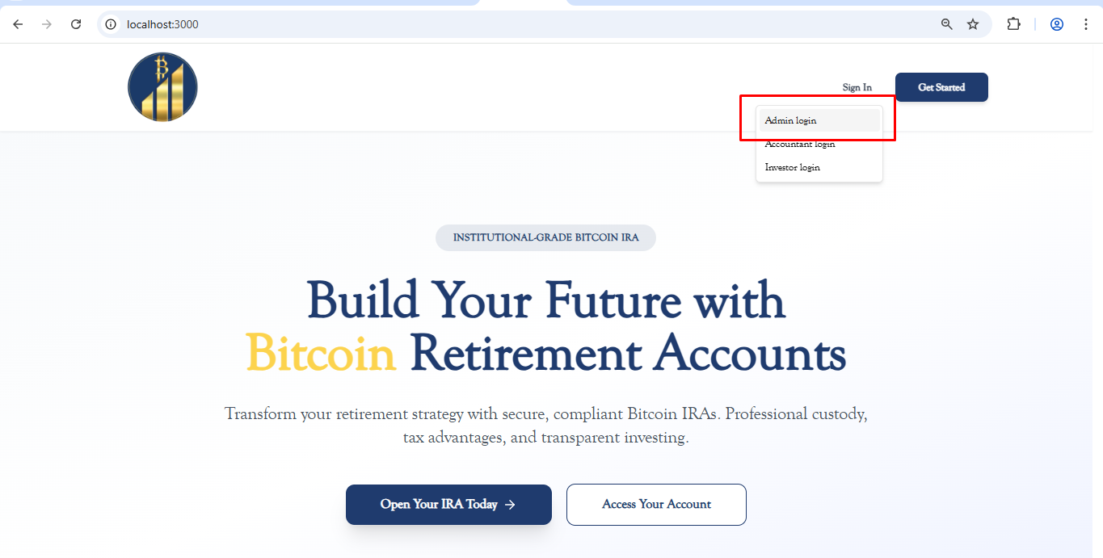
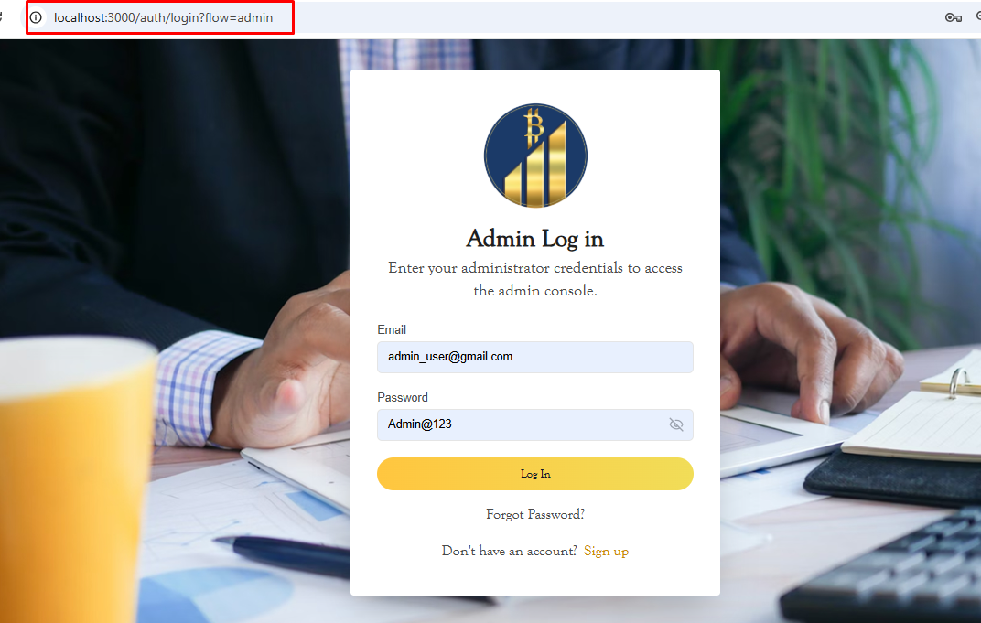
Account Login
Login Details:
user: accountant_user@gmail.com
password: Admin@123
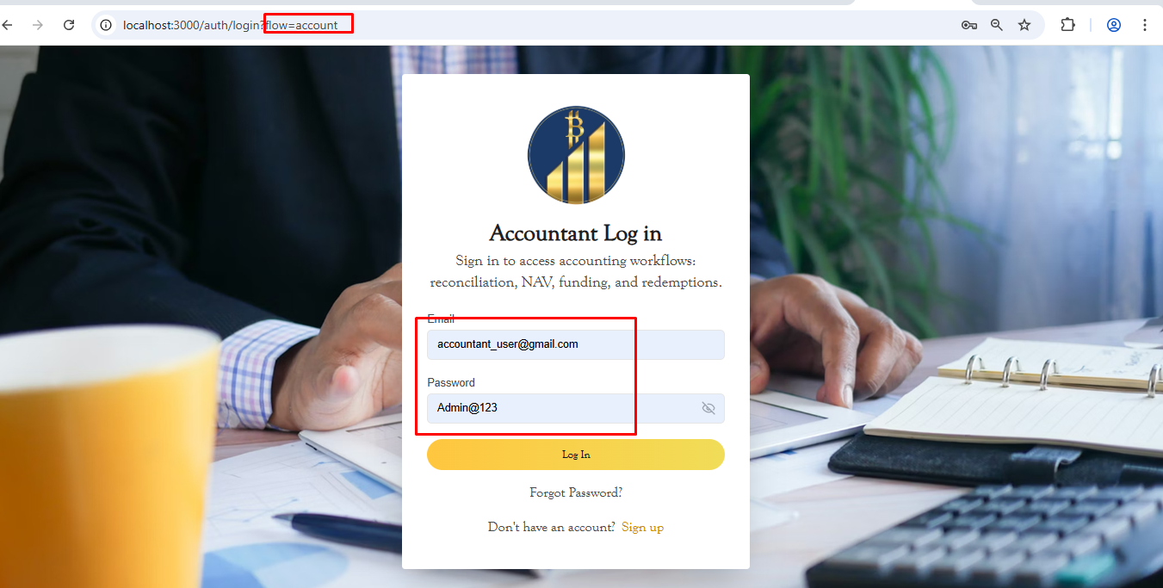
Investor Login
Login Details:
user: accountant_user@gmail.com
password: Admin@123
