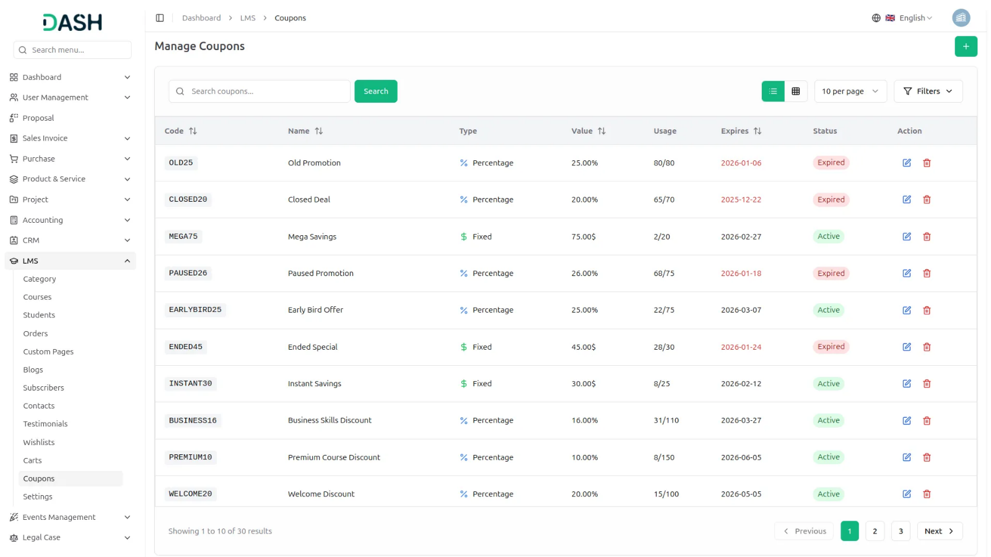

Drive employee development through well-structured training programs designed to improve skills and job performance. This Add-On, connected with your HRM setup, allows you to plan, monitor, and track training sessions for individuals or teams. Whether internal or external, each training is aligned with business goals and designed to deliver maximum value. Track expenses, duration, and training type all in one place.
Dependency Notice: This Add-On works only when the HRM Add-On is enabled. Please activate it first to access all Training features.

Training
Employee Training Coordination Platform
The Training Add-On integrates seamlessly with the HRM system to provide comprehensive employee training management and tracking capabilities. This interconnected system enables organizations to create structured training programs, assign trainers, manage employee participation, and monitor training progress through detailed status tracking.
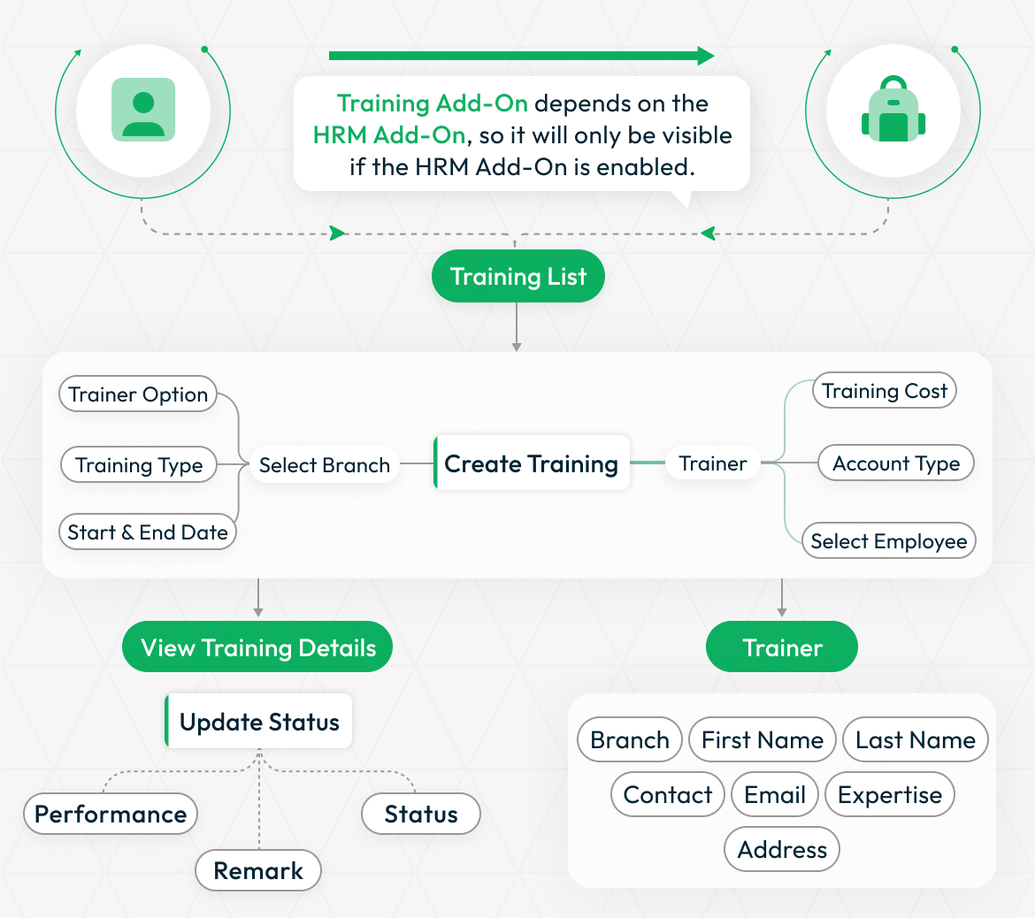
STRONG BRAND
Structured Training Type Classification
Define and manage different categories of training programs tailored to your organization's needs. Create training types with specific names and descriptions, organize them by branch and department, and maintain a structured classification system. This allows you to categorize training sessions effectively - whether technical skills, soft skills, compliance training, or leadership development - ensuring each training type is properly documented and aligned with departmental requirements across your organization.
- Create customizable training categories with names and descriptions
- Organize training types by branch and department structure
- Support technical, soft skills, compliance, and leadership programs
- Maintain centralized database with search and management tools
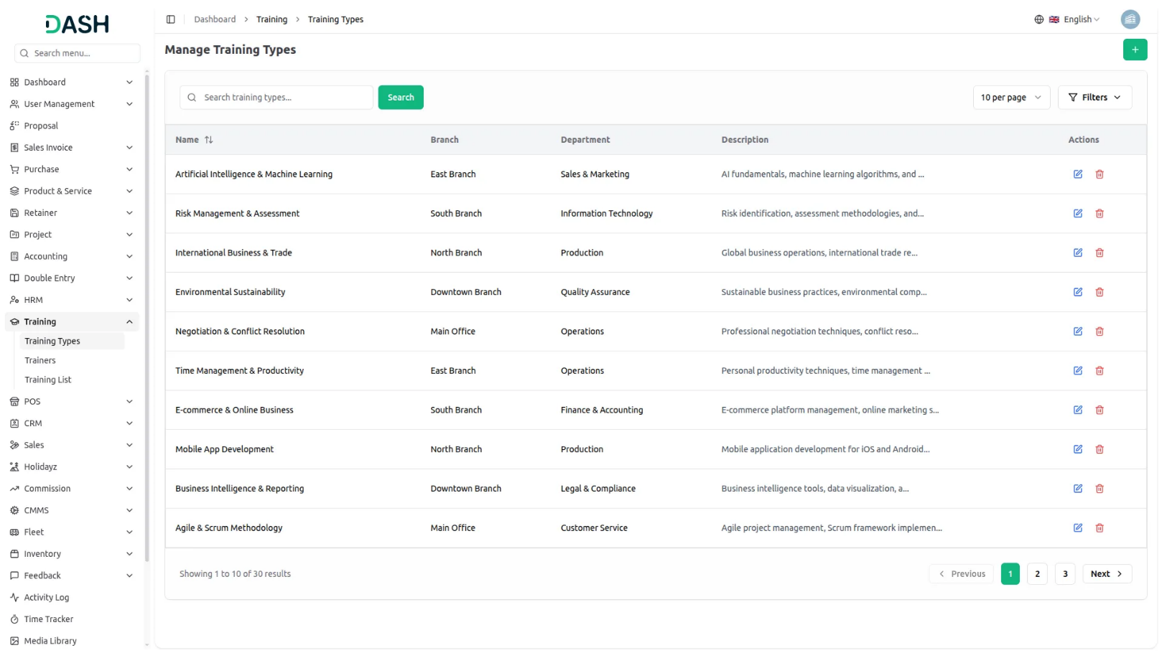

Powerful Training Monitoring
Select the relevant branch to suit your organizational needs, define the training type, choose between internal or external trainers, assign employees, and set specific start and end dates. You can also specify training costs, which are seamlessly linked to the accounting add-on for automatic deductions upon completion. The system tracks the entire lifecycle of each training - from pending to started, completed, or terminated - while providing clear visibility into participating employees, assigned trainers, and training duration. Upon completion, performance reviews and comments can be added to assess effectiveness. This all-in-one feature centralizes every detail, making training management streamlined, insightful, and efficient.
- Track training lifecycle from scheduled to completed status
- Assign internal or external trainers with detailed profiles
- Integrate training costs with accounting for expense tracking
- Manage tasks with assignments, deadlines, and feedback collection
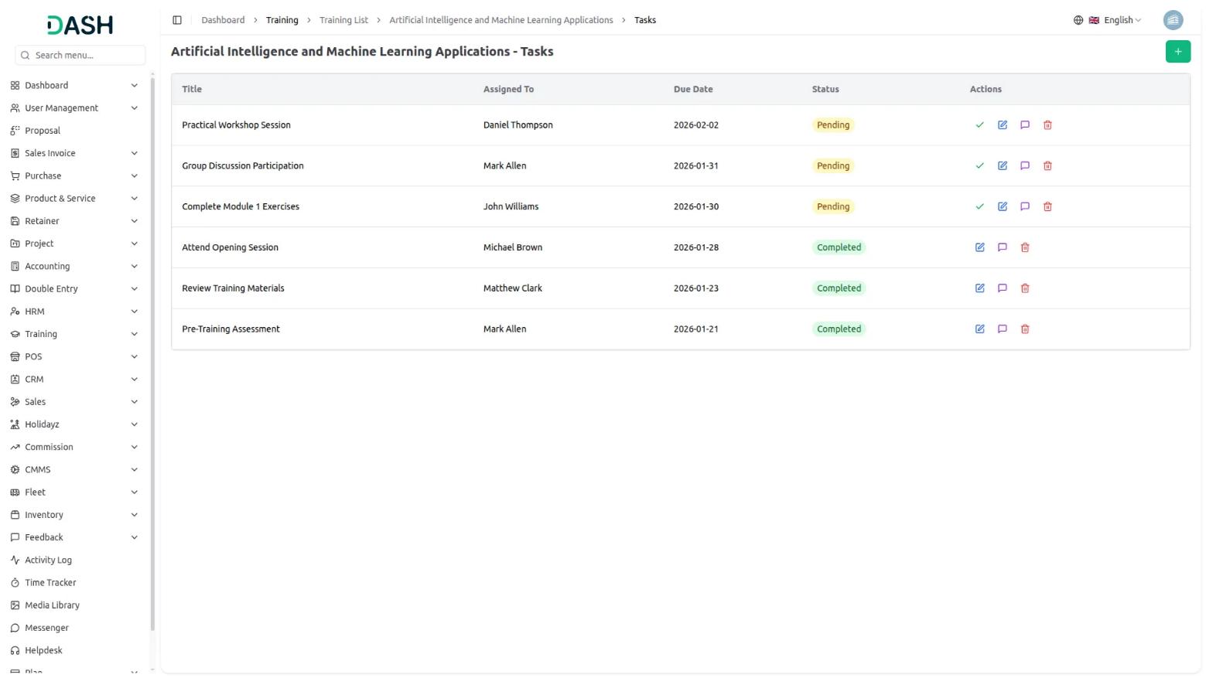

Trainer Management Hub
Easily manage a complete directory of trainers, whether internal staff or external experts. Store detailed contact information, email addresses, physical addresses, and areas of expertise for each trainer. This organized database ensures you can quickly assign the right trainer for any session. Searching, editing, and exporting trainer details is straightforward, allowing you to keep trainer information up to date.
- Store comprehensive profiles with contact and qualification details
- Maintain unified database for internal and external trainers
- Organize trainers by branch and department for allocation
- Search and filter trainers by expertise for assignments
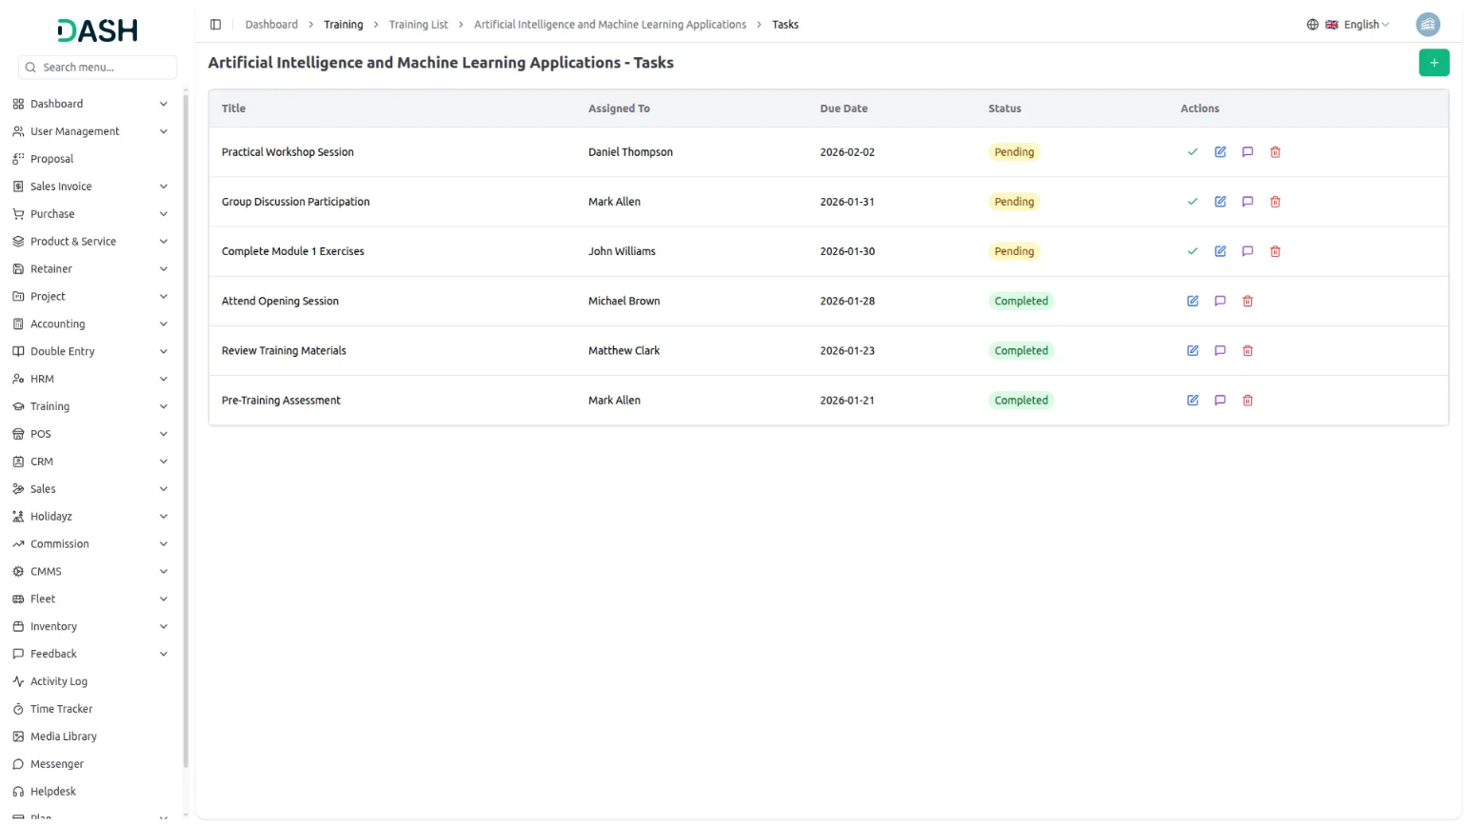

Introduction
The Training software is a comprehensive system designed to manage and track employee training programs within your organization. It allows you to create and monitor training sessions, manage trainers, and define training types. This software integrates with your HRM system and Accounting Add-On to ensure consistent data management across your organization.
Note: This Add-On is based on the HRM Add-On, so you must first activate it.

How To Use The Training Add-On?
Manage Training Type
- To add a new training type, click the “Create” button on the training type page. Enter the name of the training type and provide a description. Select the branch from the dropdown (populated from the HRM System Setup), and the department dropdown will be populated based on the selected branch (comes from the HRM System Setup).
- The training type list page shows all training types with columns for Name, Branch, Department, and Description. You can search for specific training types using the search button at the top. Each training type record has Edit and Delete options in the Actions column.
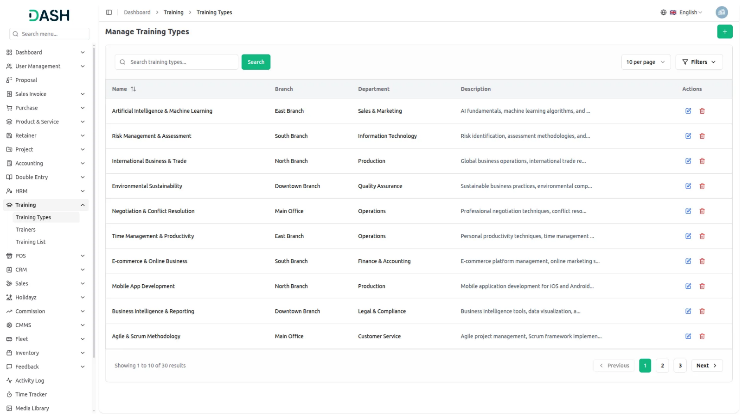
Manage Trainer
- Click the “Create” button on the trainer page. Enter the trainer’s name, contact number, email address, years of experience, expertise, and qualifications. Select the branch from the dropdown (populated from the HRM System Setup), and the department dropdown will be populated based on the selected branch (comes from the HRM System Setup).
- The trainer list page shows all trainers with columns for Name, Contact, Email, Experience, Branch, and Department. You can search for specific trainers using the search button at the top. Each trainer record has Edit and Delete options in the Actions column.
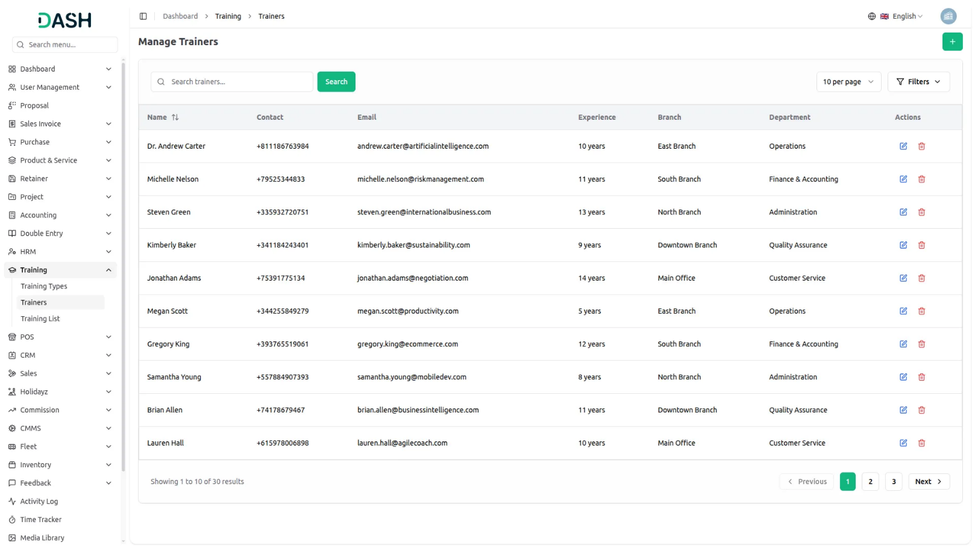
Manage Training List
- To add a new training, click the “Create” button on the training list page. Enter the training title and select the training type from the dropdown (populated from the Training Type module) and trainer from the dropdown (populated from the Trainer module). Select the branch from the dropdown (populated from the HRM System Setup), and the department dropdown will be populated based on the selected branch.
- Enter the start date, end date, start time, and end time using the respective pickers. Specify the maximum participants, location, and cost for the training.
- Provide a description and select the status (Scheduled, Ongoing, Completed, or Cancelled) for the training.
- The training list page shows all trainings with columns for Title, Training Type, Trainer, Start Date, End Date, Status, Branch, and Location. You can search for specific trainings using the search button at the top. For each training record, use the Tasks action to open the Training Tasks page and manage tasks for that specific training, or use the Edit and Delete options as needed.
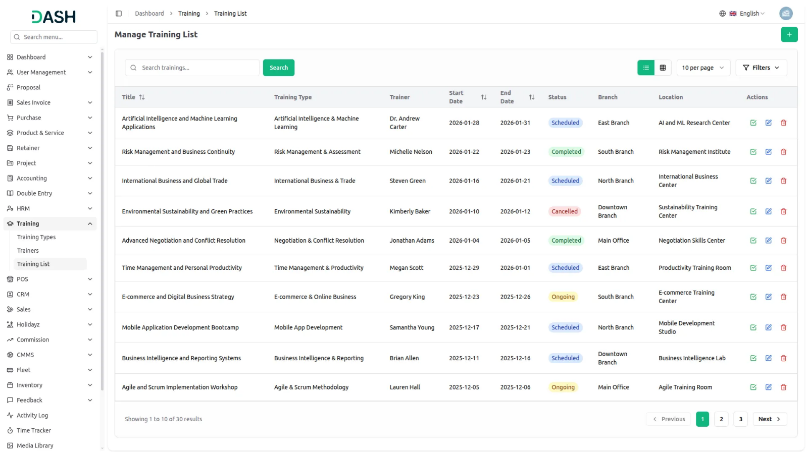
Manage Training Tasks
- Note: This page opens when clicking the Tasks button from the Training List and shows tasks specific to the selected training.
- To add a new training task, click the “Create” button on the training tasks page. Enter the task title, select the employee to assign from the dropdown (populated from HRM employees), set the due date using the date picker, and provide a description.
- The training tasks list page shows all tasks with columns for Title, Assigned To, Due Date, and Status. You can search for specific tasks using the search button at the top. For each task record, use the Mark Complete action to change the status to completed (this button will not display once the task is completed). You can also use the Edit action to update task details, the Feedbacks action to open the Task Feedbacks page and view or add feedback, or Delete the task as needed.
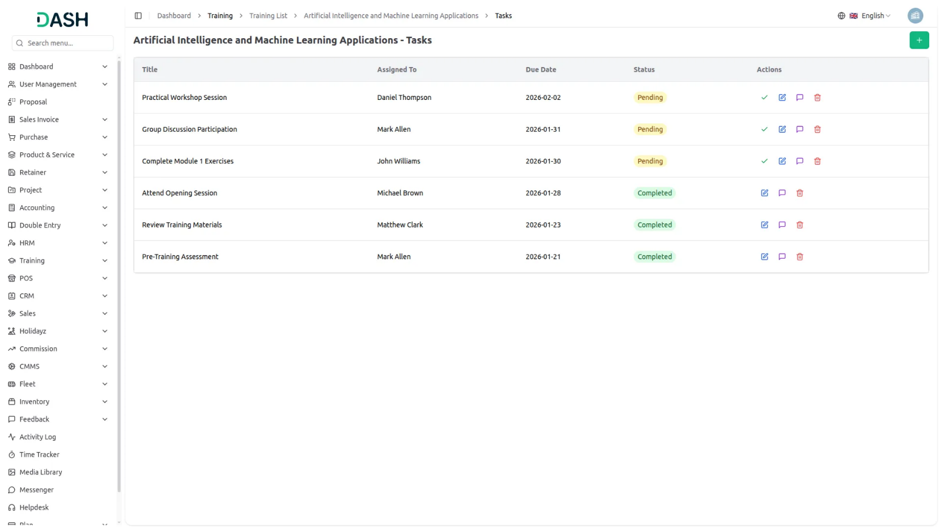
Manage Task Feedbacks
- Note: This page opens when clicking the Feedbacks button from Training Tasks and shows feedback specific to the selected task.
- To add new feedback, click the “Create” button on the task feedback page. Select a rating from 1 to 5 stars and enter your comments about the task.
- The task feedback page displays all feedback in a grid view showing the user name, feedback date, rating, and comments. You can search for specific feedback using the search button at the top. The feedback count is displayed in the Tasks list for easy tracking.

