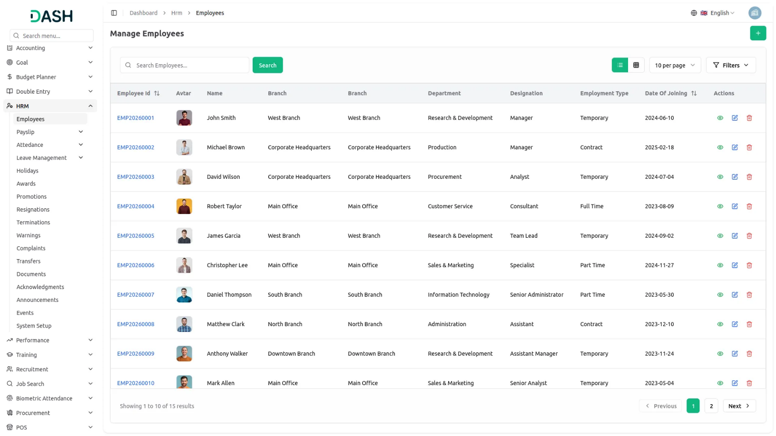
Empower your organization to drive employee growth through structured evaluations and performance benchmarks. Integrated with your HRM setup, this Add-On helps in defining KPIs, measuring output, and enhancing accountability across departments. With customizable performance settings, it enables real-time tracking of employee progress and promotes continuous improvement. Recognize top performers and motivate others to strive for excellence with accurate insights and measurable outcomes.
Dependency Notice: This Add-On works only when the HRM Add-On is enabled. Please activate it first to access all Performance features.

STRONG BRAND
Performance Indicators Management
Set up performance indicators by linking categories from your Performance system setup. Define measurement units, target values, and track status for each indicator. Indicators can be searched and managed from a central listview with actions like view, edit, or delete. This section ensures performance metrics are evaluated with a clear, structured method that aligns with organizational objectives.
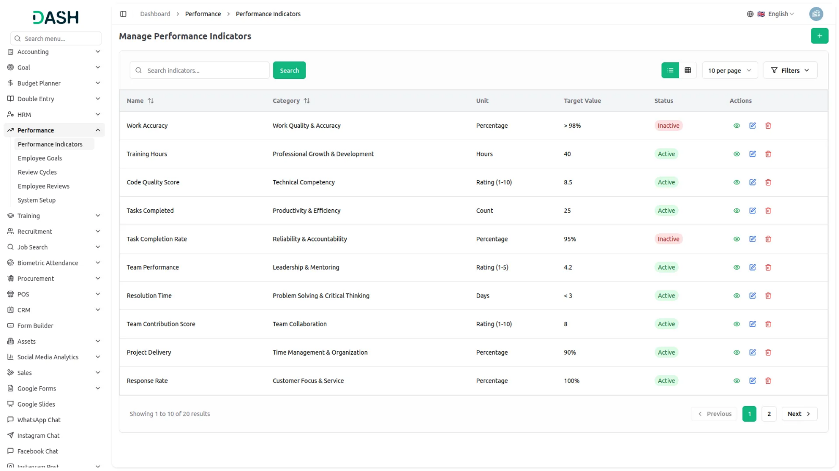
Employee Goals System
Manage employee goals by selecting employees from your HRM data and assigning goal types from the Performance setup. Set timelines with start and end dates, define targets, and track progress with visual indicators. Monitor goal completion status and switch between list and grid views for better visualization. Ensure alignment with company objectives through structured goal tracking and progress monitoring.

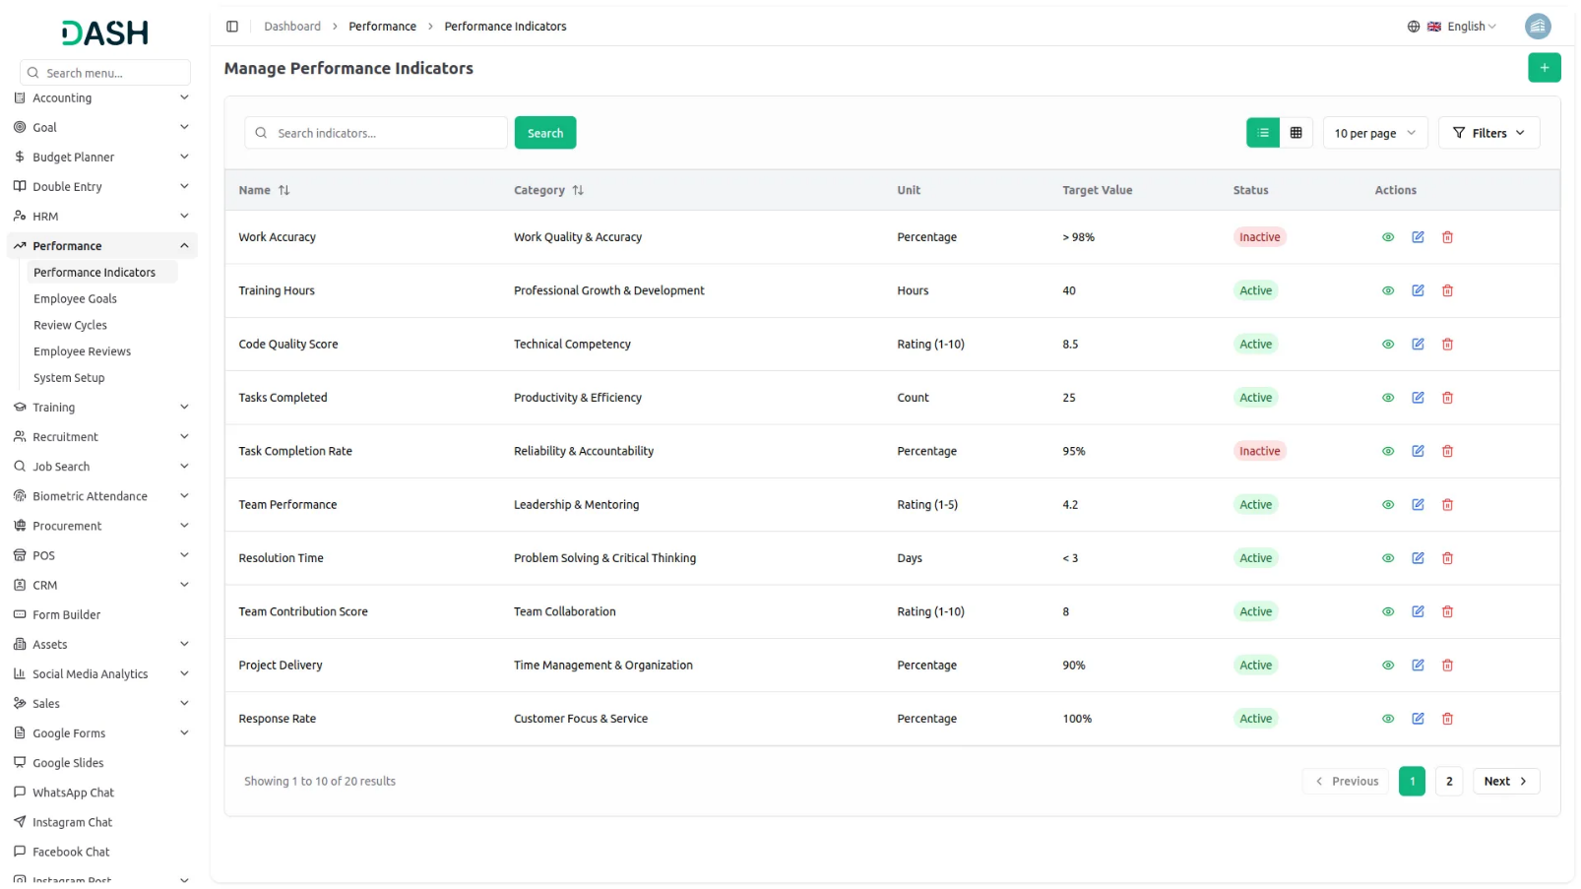
Review Cycles Management
Create and manage performance review cycles with customizable frequencies and descriptions. Define review periods that align with your organizational schedule and track their status. Each review cycle serves as a framework for conducting systematic employee evaluations. Actions like view, edit, and delete make review cycle management fully controllable and adaptable to changing business needs.

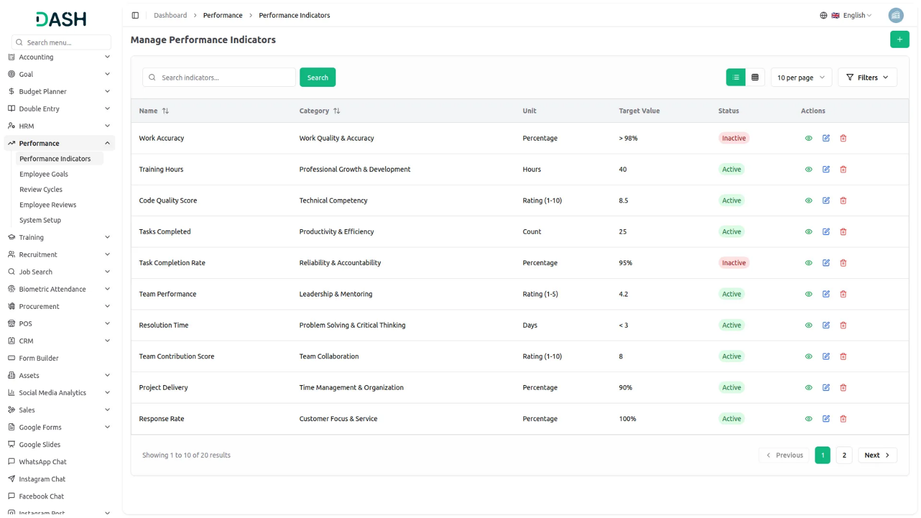

Employee Reviews System
Conduct comprehensive employee reviews by assigning reviewers and linking them to specific review cycles. Set review dates, track completion status, and document both strengths (pros) and areas for improvement (cons). The conduct review feature allows for detailed rating assignments and performance feedback. This systematic approach ensures consistent evaluation standards across all departments and promotes fair performance assessments.

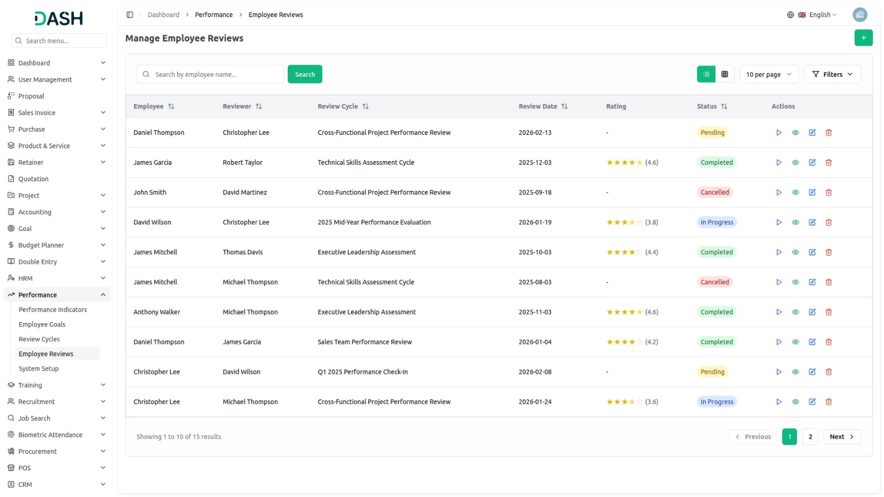

Introduction
The Performance Add-On is a comprehensive system designed to help organizations manage and track employee performance. It enables you to create performance indicators, conduct appraisals, set and monitor goals, and manage the performance types and competencies used in evaluations. This software integrates with your HRM system to ensure consistent employee data across your organization.
Note: This Add-On is based on the HRM add-on, so you will need to activate it first.

How To Use The Performance Add-On?
System Setup
Manage Indicator Categories
- Click the “Create” button on the indicator Category page to add a new type. Enter the indicator Category name, provide a description, and set the status (Active or Inactive).
- The indicator Category list page shows all Categories with columns for Name, Description, and Status. Each indicator Category record has Edit and Delete options in the Actions column.
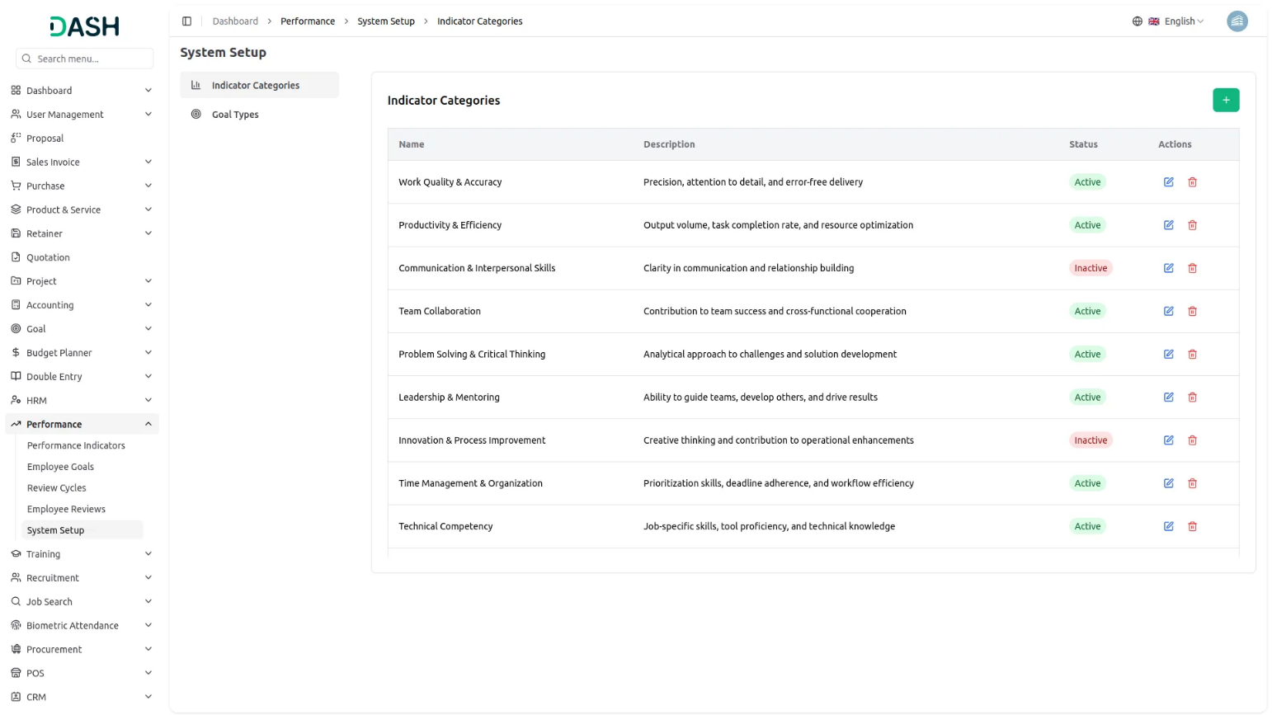
Manage Goal Types
- Click the “Create” button on the goal types page to add a new type. Enter the goal type name, provide a description, and set the status (Active or Inactive).
- The goal types list page shows all types with columns for Name, Description, and Status. Each goal type record has Edit and Delete options in the Actions column.
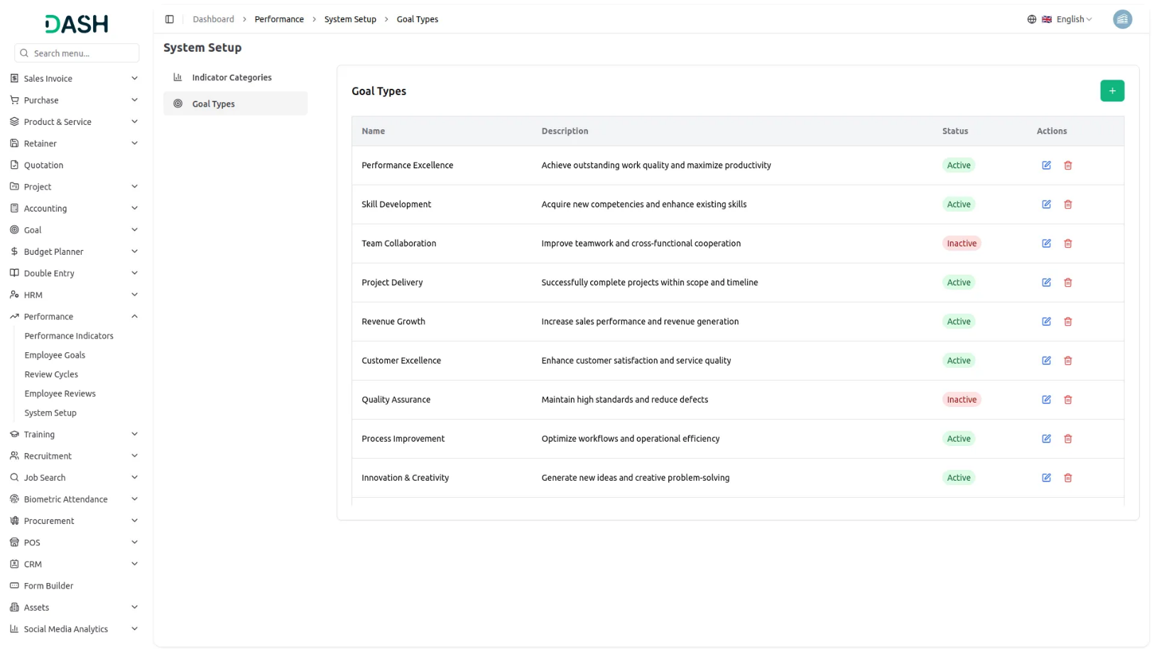
Manage Performance Indicators
- Click the “Create” button on the performance indicators page to add a new indicator. Enter the indicator name and select the category from the dropdown (populated from the Performance System Setup Indicator Categories module). Provide a description, specify the measurement unit, set the target value, and choose the status (Active or Inactive).
- The performance indicators list page shows all indicators with columns for Name, Category, Unit, Target Value, and Status. You can search for specific indicators using the search button at the top. For each indicator record, use the View action to see complete performance indicator details, Edit to update information, or Delete the record as needed.
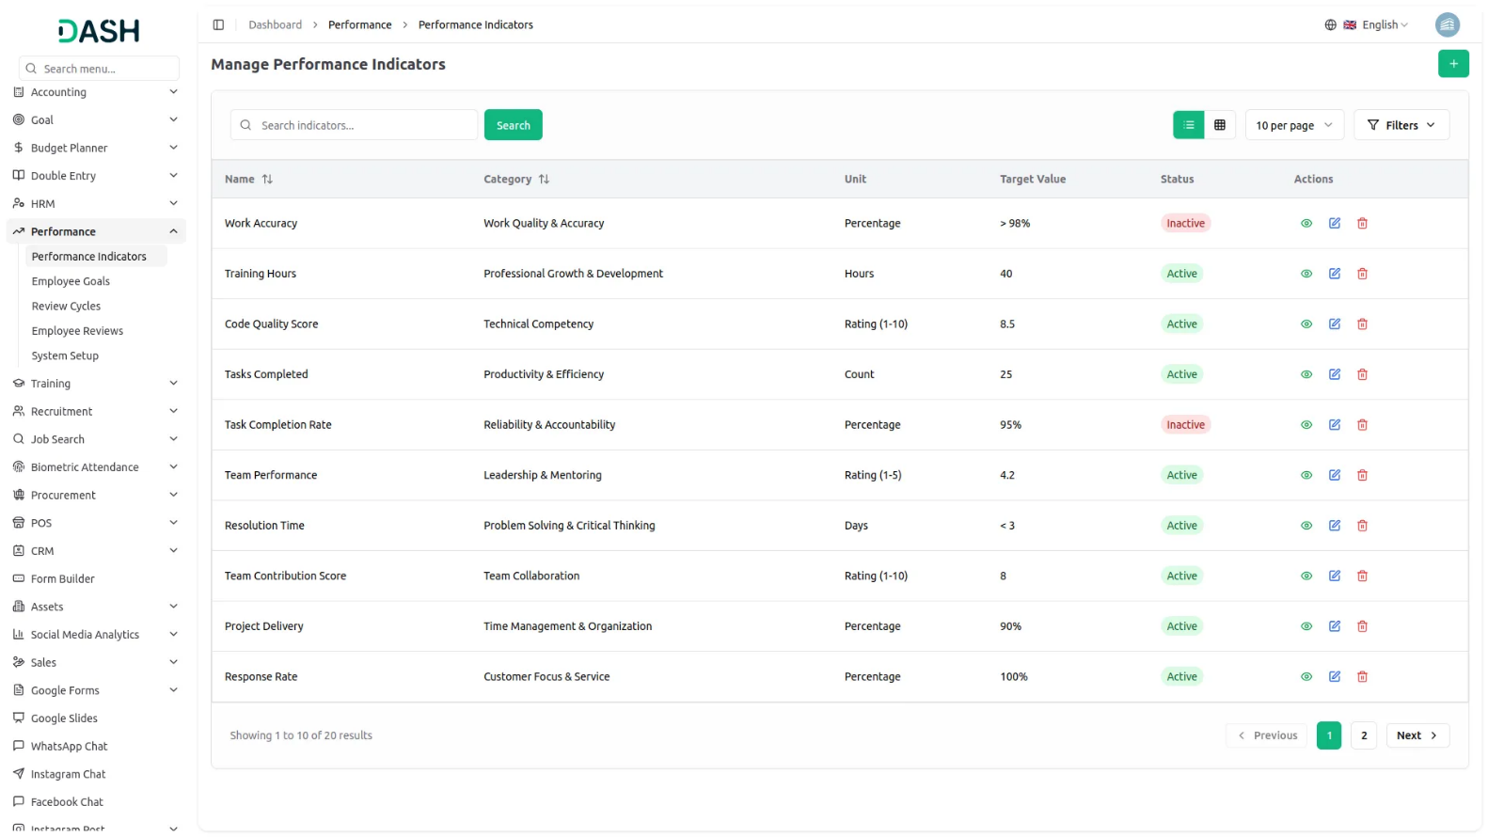
Manage Employee Goals
- Click the “Create” button on the employee goals page to set up a new goal. Select the employee from the dropdown (populated from HRM Add-on employees) and choose the goal type from the dropdown (populated from the Performance System Setup Goal Type section).
- Enter the goal title and provide a description. Set the start date and end date using the date pickers, specify the target, and enter the current progress. Choose the status (Not Started, In Progress, Completed, or Overdue) to track goal progress.
- The employee goals list page shows all goals with columns for Title, Employee, Goal Type, Target, Progress, Start Date, End Date, and Status. You can search for specific goals or switch to Grid View for an alternative display layout using the buttons at the top. For each goal record, use the View action to see complete employee goal details, Edit to update information, or Delete the record as needed.
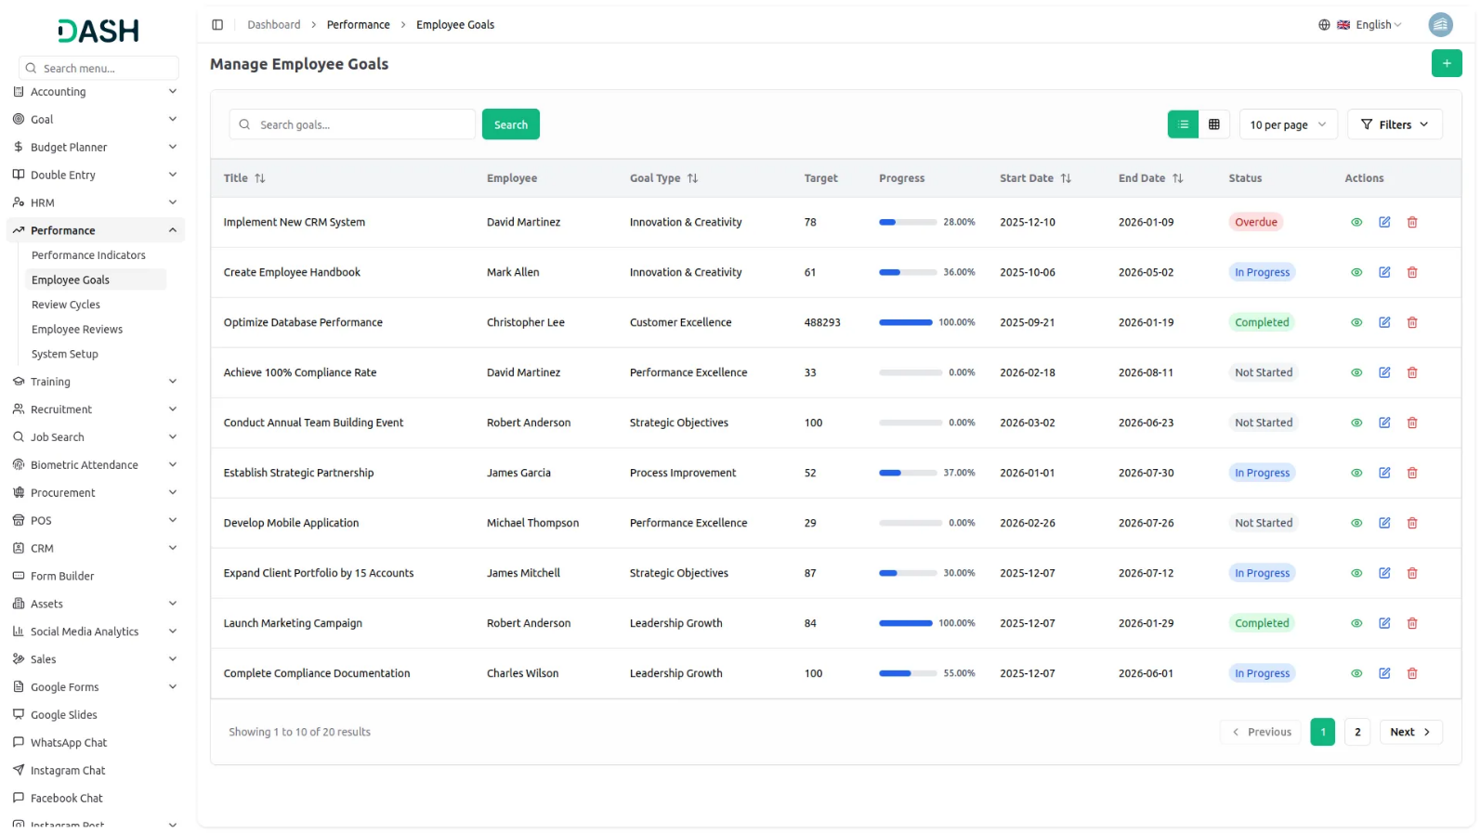
Manage Review Cycles
- Click the “Create” button on the review cycles page to create a new cycle. Enter the cycle name and select the frequency (Monthly, Quarterly, Semi-annual, or Annual) from the dropdown. Provide a description and set the status (Active or Inactive) to control cycle availability.
- The review cycles list page shows all cycles with columns for Name, Frequency, Description, Status, and Created date. You can search for specific review cycles using the search button at the top. For each cycle record, use the View action to see complete review cycle details, Edit to update information, or Delete the record as needed.
Manage Employee Reviews
- Click the “Create” button on the employee reviews page to schedule a new review. Select the employee being reviewed from the dropdown (populated from HRM Add-on employees section) and choose the reviewer from the dropdown (also populated from HRM Add-on employees). Select the review cycle from the dropdown (populated from the Performance Review Cycles section), set the review date using the date picker, and choose the status (Pending, In Progress, Completed, or Cancelled).
- The employee reviews list page shows all reviews with columns for Employee, Reviewer, Review Cycle, Review Date, Rating, and Status. You can search for specific reviews using the search button at the top. For each review record, use the Conduct Review action to open the review form, the View action to see complete employee review details, Edit to update information, or the Delete action to delete the record as needed.
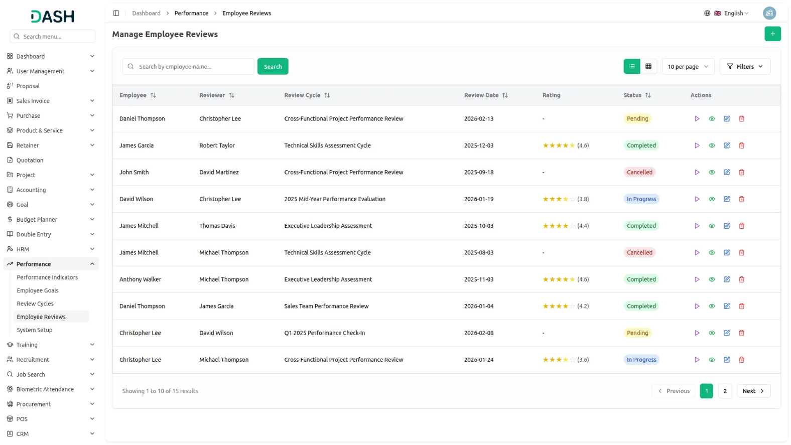
Conduct Review Page:
- The conduct review interface displays review information, including the employee name, reviewer name, and review cycle. In the performance ratings section, provide a rating using the rating field, enter pros and cons for comprehensive feedback, and set the completion date using the date picker to finalize the review.
