Q.Draw the Flow Chart of question:-Take the input from the User and check if it is even positive or even negative or odd positive or odd negative?

Ans:-Flow chart: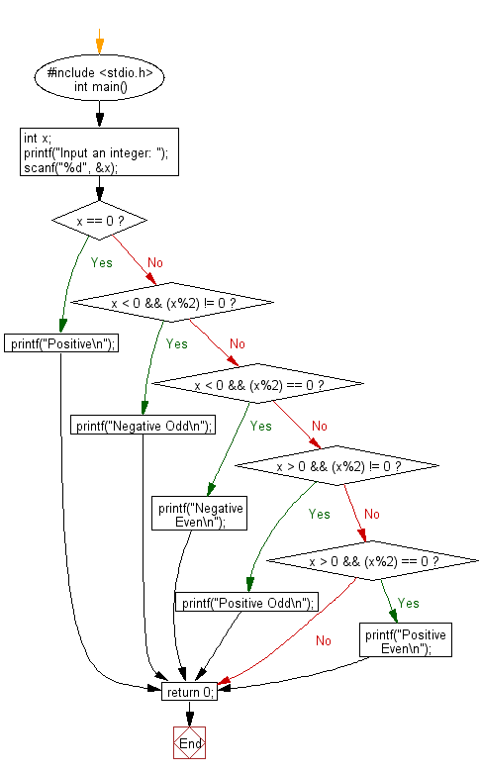

Q.write the steps, flowchart and Pseudocode of question:

Print the table of any number(using for loop)?

Ans:-

Steps:-

ec1.Declaring a variable num.

2.declaring a variable multiple.

3.the user inputs the value of number.

4.for loop where variable i increment by 1 after every iteration.

5.set the value multiple=i*numwill continue till counter reaches 10 .

Ends of loop.

Flow Chart:-

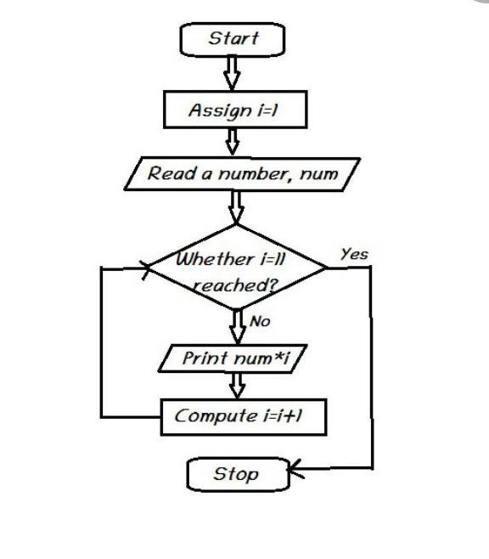

PSEUDOCODE:_

1.DECLARE num as integer.

2.DECLARE multiple integer.

3.Input number

4.For i from 1 to 10.

5.Multiple->num*i

6.Print num ,”*”,i,”=”,multiple.

7.End loop.