If Kubernetes is like writing a program in C, Helm is like using a package manager and templates instead of writing everything from scratch.

🧠 What Helm Really Is
Think of Helm as:
apt for Ubuntu
sudo apt install nginx
or
pip for Python
pip install fastapi
or
npm
npm install express
For Kubernetes:
helm install postgresql

Helm = Package Manager
Helm installs something called a Chart.
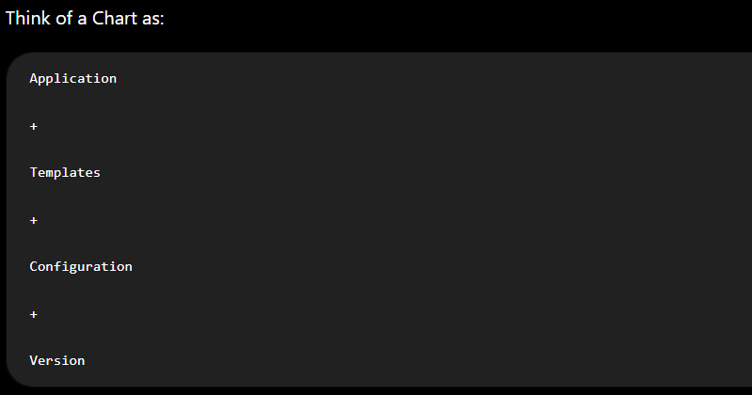
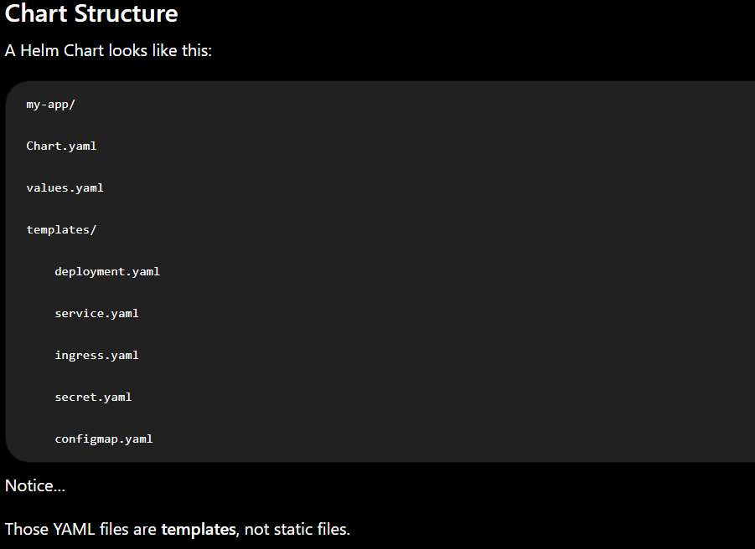

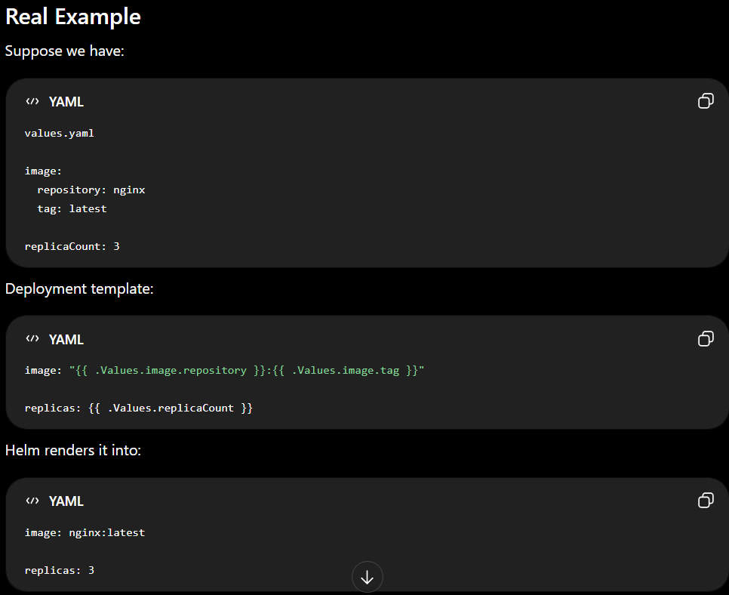

Why Companies Love Helm
Suppose your company has:
- Dev
- QA
- Staging
- Production
Without Helm:
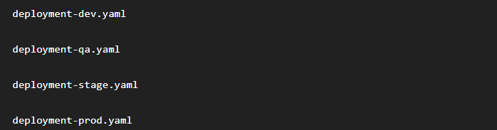
Four almost identical files.
With Helm:
One template. Different values.yaml files.
Example:
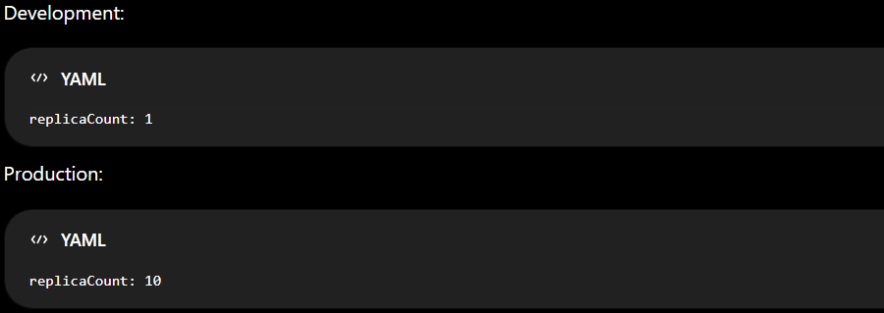Same chart ,Different configuration.

Architecture
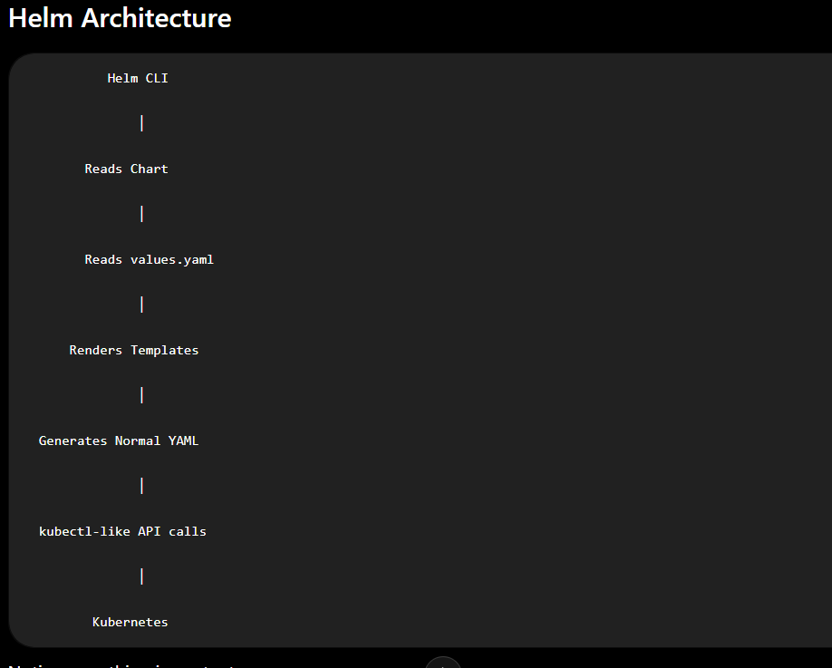
Notice something important. Helm does not replace Kubernetes.It simply generates Kubernetes YAML and applies it.
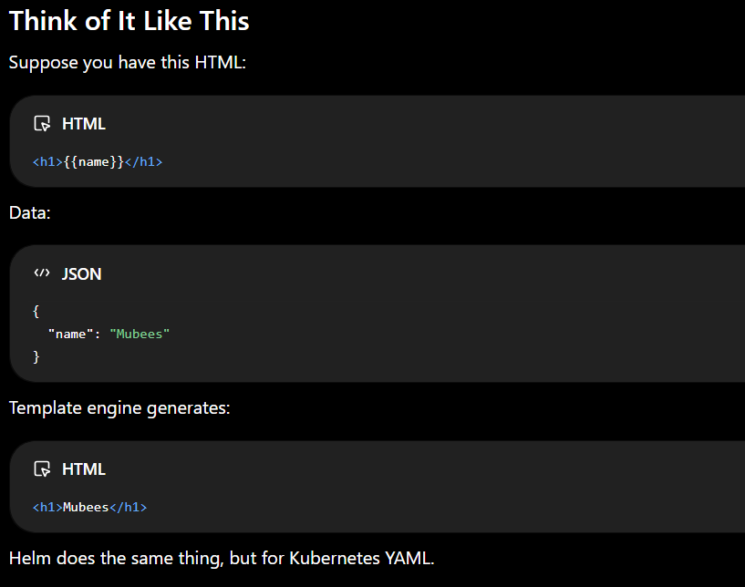
Helm Can Also...
Besides installing applications, Helm can:
- 📦 Install applications
- ⬆️ Upgrade them
- ⬇️ Roll back to previous versions
- ❌ Uninstall cleanly
- 📑 Track release history
- 🔄 Reuse configuration across environments
``````````````````````````````````````````````````````````````````




