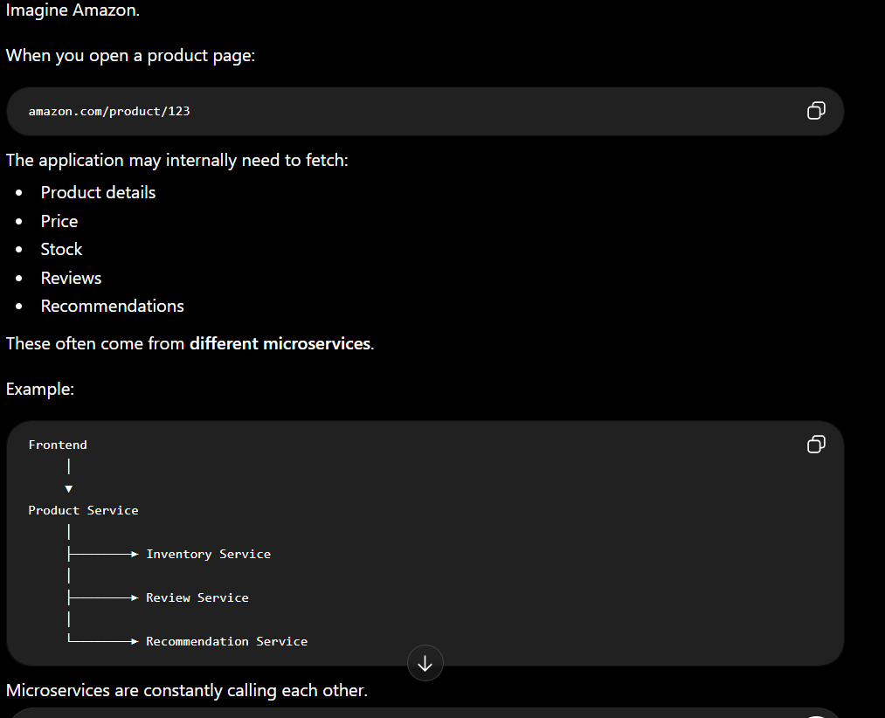
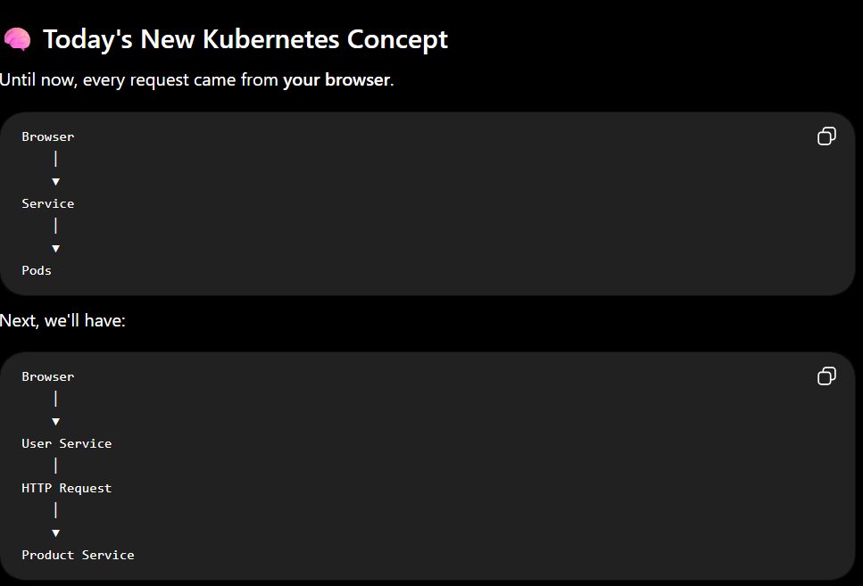
The browser won't talk to the Product Service directly.
Instead, one service becomes the client of another service.
That's how distributed systems work.

```````````````````````````````````````````````````````````````````
KUBERNETS SERVICE DESCOVERY
Every Kubernetes Service gets a DNS name.
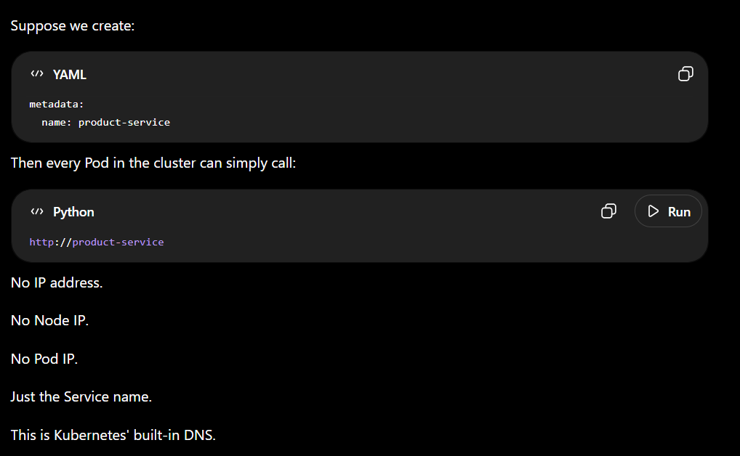
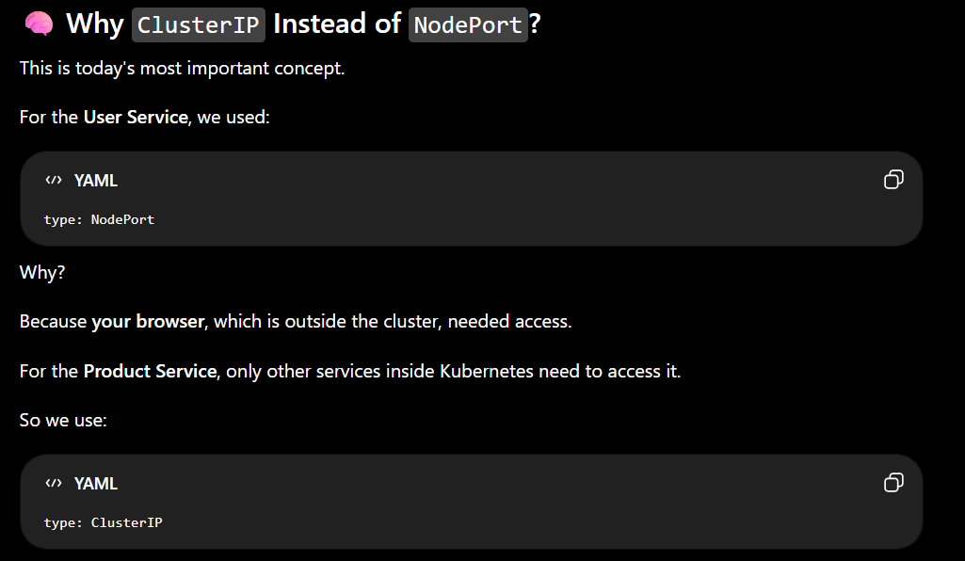
This means:
Outside Browser
│
▼
❌ Cannot Access
But:
User Service
│
▼
Product Service
✅ Can access it.

`````````````````````````````````````````````````````````````````

