Liveness and Readiness

What if your application is stuck?
For example:
- Database connection hangs
- Infinite loop
- Deadlock
- Memory corruption
- Third-party API never responds
The Python process is still alive. The container is still running. Should Kubernetes continue sending traffic to it? 🤔

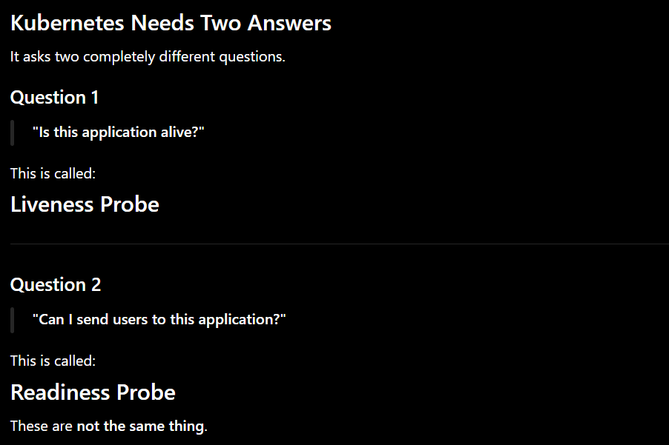

Probe | Kubernetes asks | If it fails
Liveness | "Are you alive?" | Restart the container
Readiness | "Can you serve traffic?" | Stop routing requests to this Pod

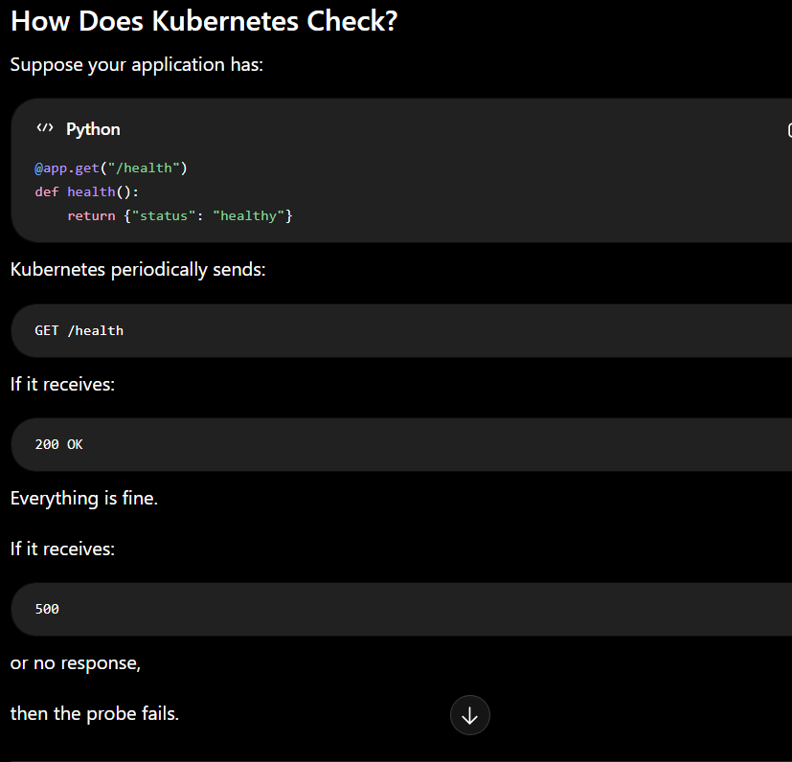

If there is a database connection problem in our fastapi project ?
if we restart that pod . It would keep restarting forever because the real problem isn't the Pod.The real problem is the database connection.Restarting won't magically fix a network outage or a database server that's down.
So Kubernetes Does Something Smarter
“You're still alive.But you're not ready to serve users." So it changes the routing.

Decision Flow
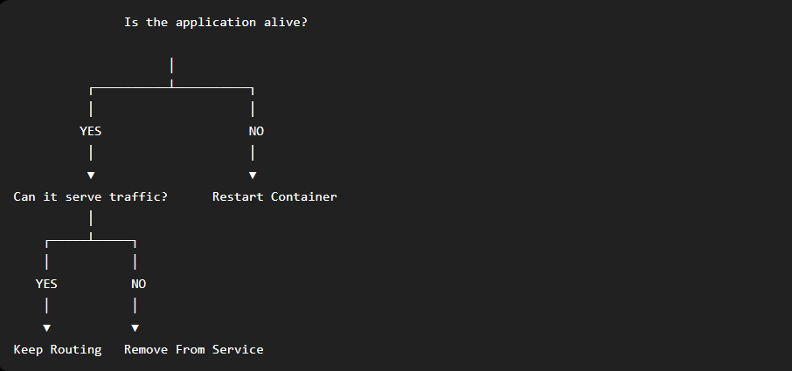

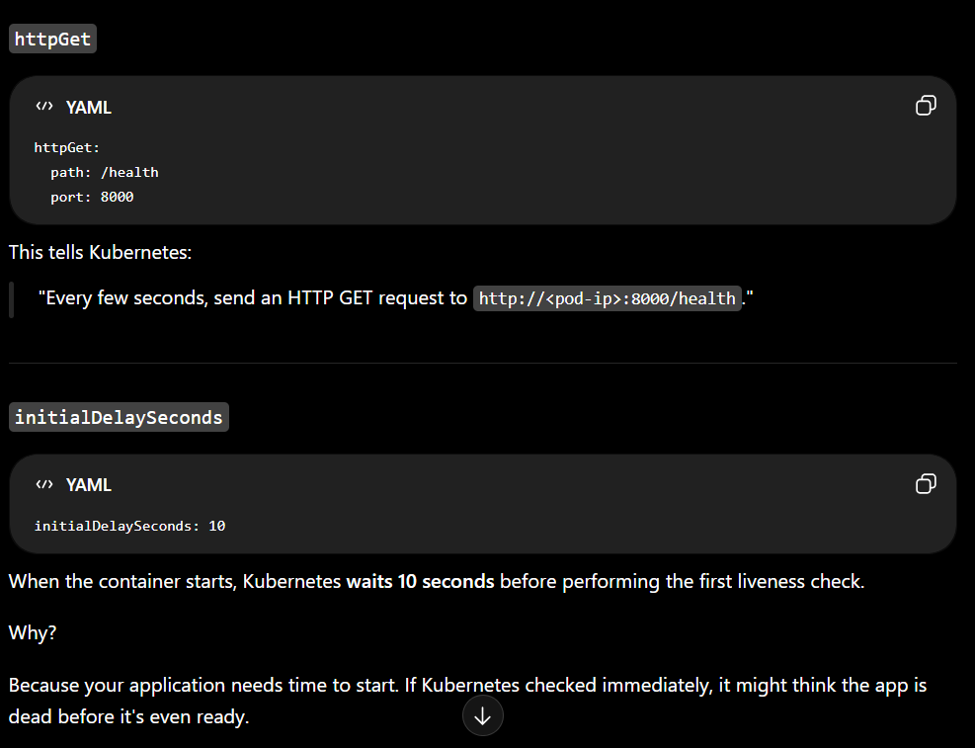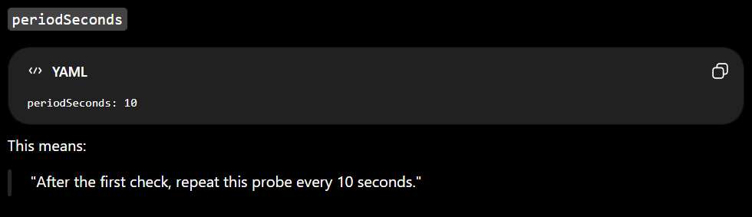

Suppose your FastAPI application takes 30 seconds to start because it loads a large machine learning model.But your liveness probe is initialDelaySeconds: 5
Kubernetes starts checking too early, thinks the app is unhealthy, and may restart it repeatedly.
This is called CrashLoopBackOff One of the most common Kubernetes problems.
Not because your application is broken. Because Kubernetes was too impatient. It checked before the application was ready.
````````````````````````````````````````````````````````````````````
Suppose the application fails once because of a temporary network hiccup.Should Kubernetes restart the container immediately?
Wait for a few consecutive failures before deciding the application is unhealthy.
The failure may be due to some minute problem which may disappear later.That is precisely the reason Kubernetes doesn't panic after one failure.
``````````````````````````````````````````````````````````````````
So Kubernetes Introduced Another Setting
failureThreshold: 3
Read it like English:
"I will only believe the application is unhealthy after 3 consecutive failures."
```````````````````````````````````````````````````````````````````
Suppose a Pod becomes Not Ready because the database went down.
Five minutes later, the database comes back.
Wait for multiple successful health checks before trusting it again

successThreshold: 2
Read it like English:
"I need 2 consecutive successful health checks before I trust you again."
```````````````````````````````````````````````````````````````````

but why other general service pods are running while this pod only stuck due to secret error ?
Because Kubernetes does NOT modify existing Pods. It only applies the new configuration to newly created Pods.
it was just a yester day and today changes
```````````````````````````````````````````````````````````````````
Resource Requests & Limits

"Can this machine actually run this Pod?"
How does Kubernetes know how much CPU or RAM a Pod needs?
Does it magically inspect your Python code?

Two Concepts
Requests
Limits


Request
"Please reserve at least this much CPU and RAM for me."
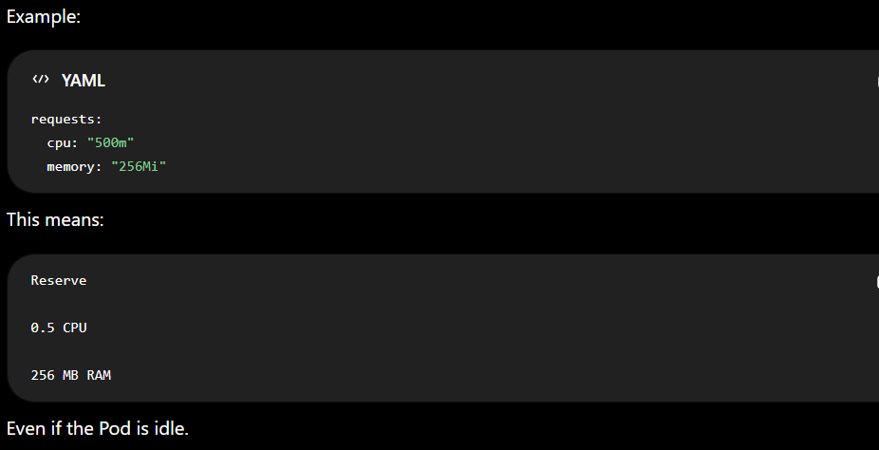
Limit
"Never allow me to use more than this."

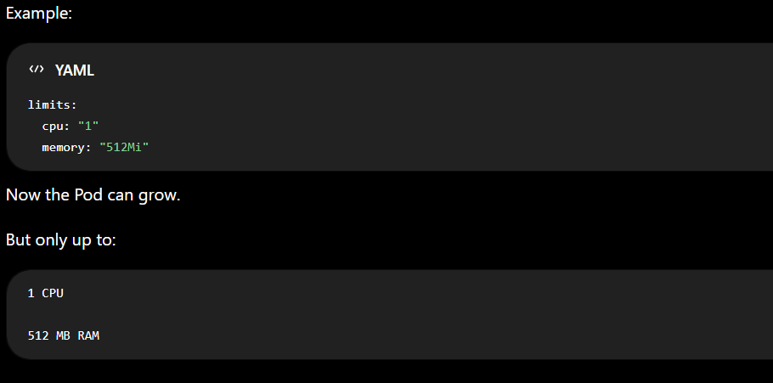
If a new node come but there are no enough resources then
Scheduler says:
"Sorry."
"This node doesn't have enough reserved CPU."
So the Pod stays:
Pending

Requests | Limits
Used by Scheduler | Used by Runtime
Decides where the Pod can run | Decides how much the Pod can consume
Reservation | Maximum allowed

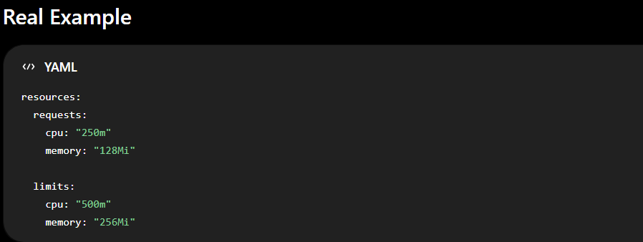
request concept
you're telling Kubernetes:
"I need at least 1 CPU to run properly."
The Scheduler believes you.
It doesn't gamble by saying:
"Maybe you'll only use 0.2 CPU."
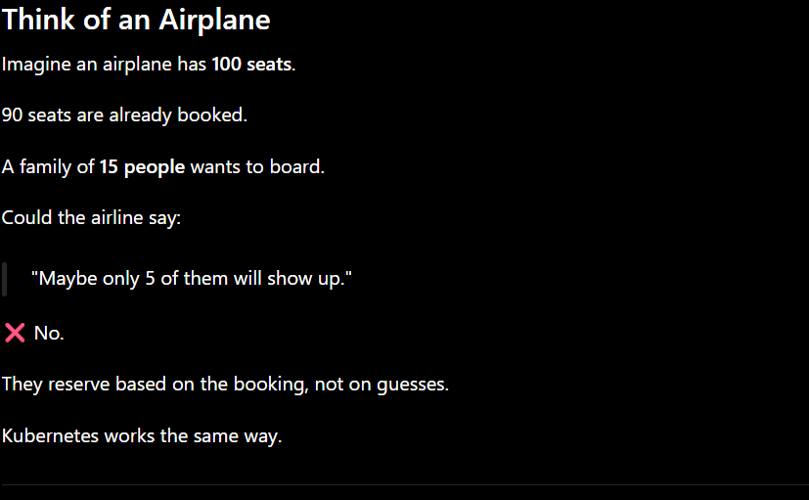
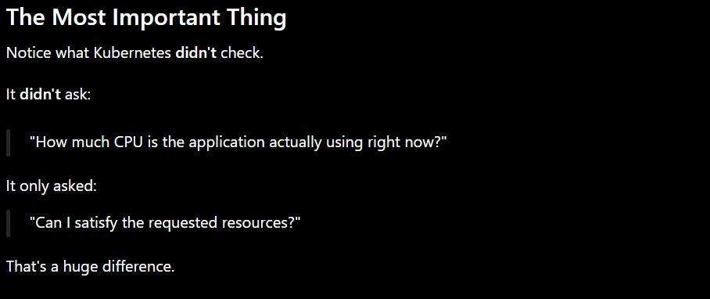
THE DIFFERENCE BETWEEN CPU AND MEMORY LIMITS
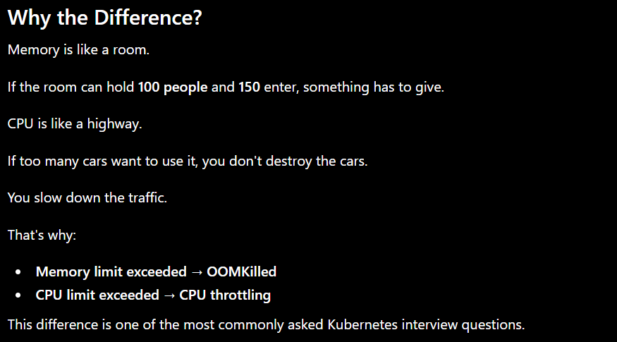

CPU Memory

Exceeded

↓

Throttle Kill Container

↓

Pod Keeps Running OOMKilled

↓

No Restart Kubernetes Restarts
``````````````````````````````````````````````````````````````````
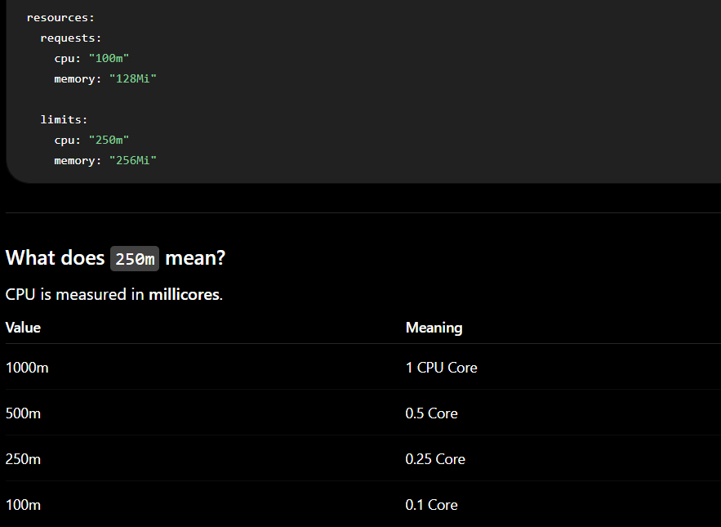

EXPIRIMENT 2
We'll intentionally create a memory leak.
The application will keep consuming memory until it exceeds its configured memory limit.
Kubernetes (actually the Linux kernel) will kill the container, and Kubernetes will restart it.

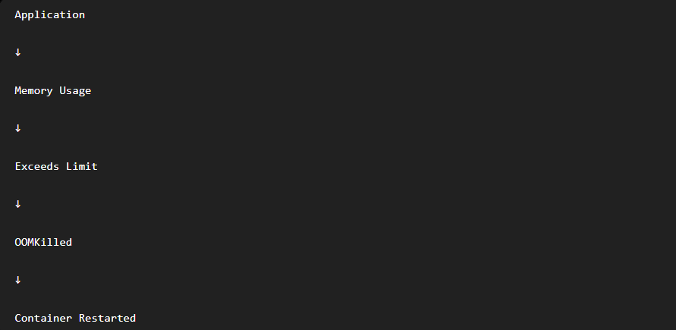
```````````````````````````````````````````````````````````````````

Experiment 3 – Killing PID 1 (Container Lifecycle)
Objective
Understand:
- Why a container exists
- What PID 1 is
- Why killing PID 1 stops the container
- How Kubernetes recovers the application
- Difference between Container, Pod, and Deployment

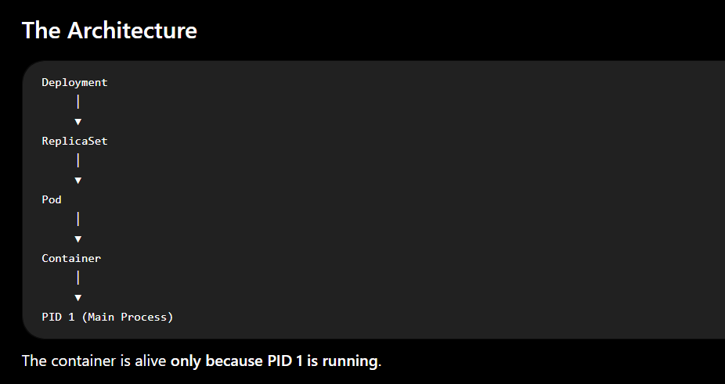
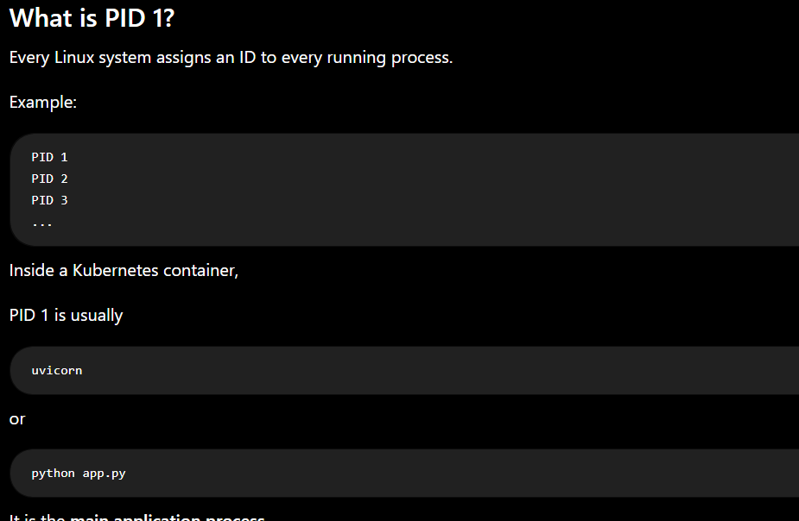
The lifetime of a container is the lifetime of PID 1.
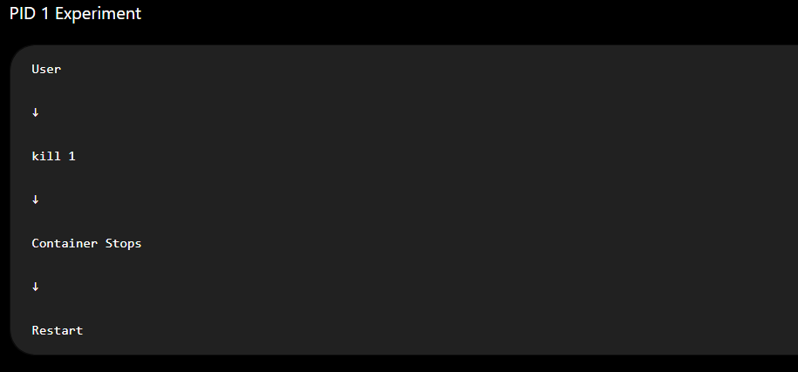````````````````````````````````````````````````````````````````````
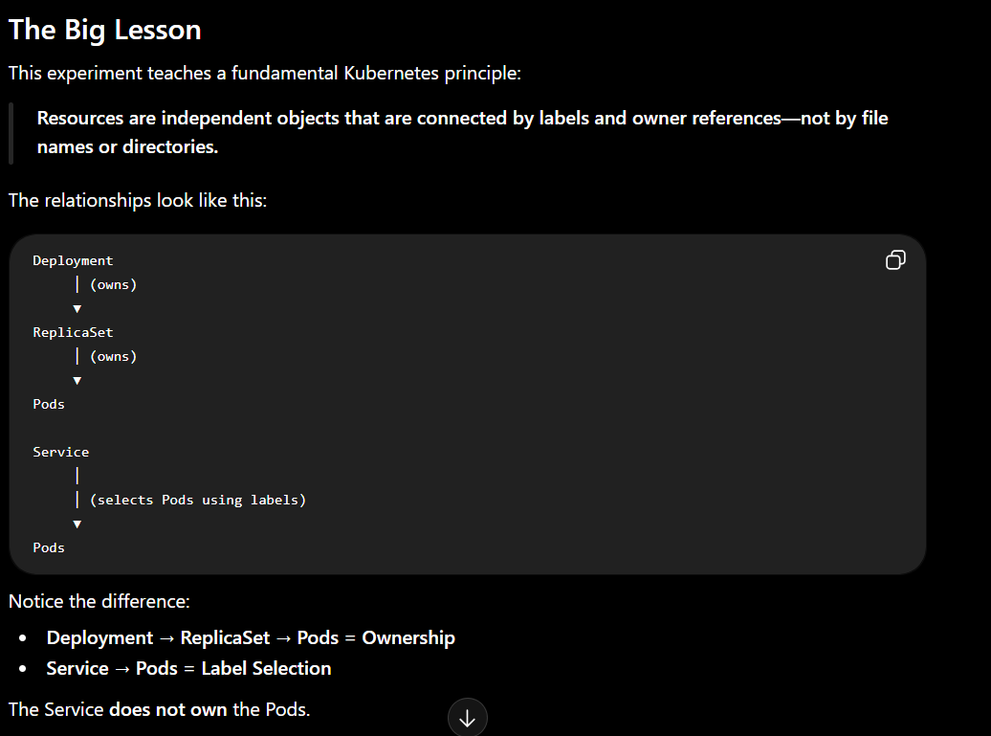
Suppose you recreate only the Deployment “kubectl apply -f general-deployment.yaml”?
What do you think will happen?
A. The new Pods will start, and the existing Service will automatically begin routing traffic to them again.
B. The Pods will start, but the Service won't work until you recreate it.
Answer is A

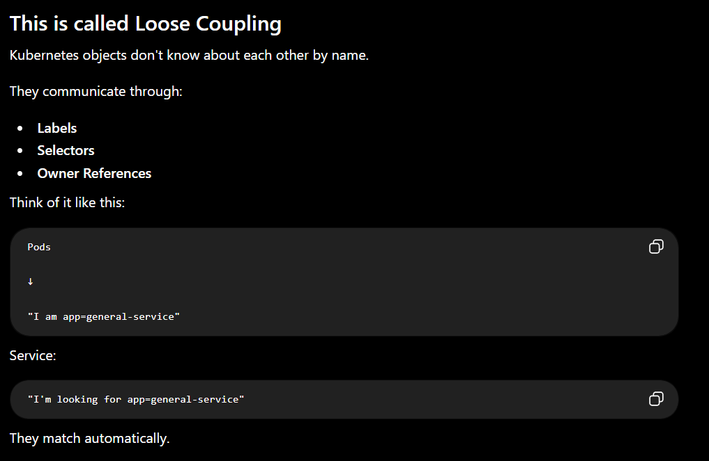
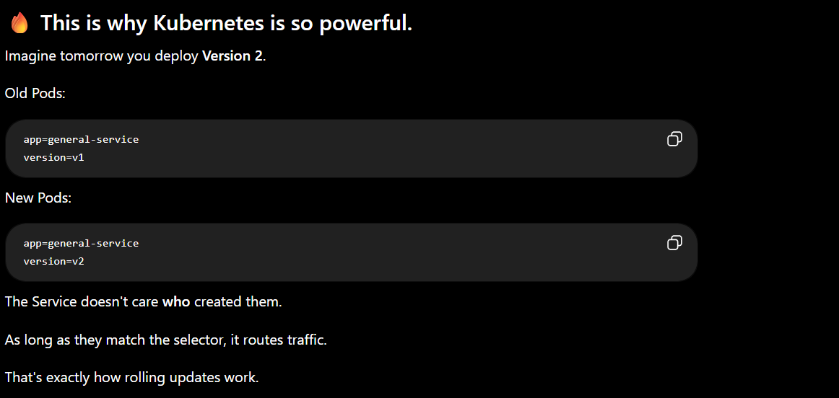
```````````````````````````````````````````````````````````````````
Horizontal Pod Autoscaler (HPA)

Imagine You're Running Amazon
At 3 AM: Users: 50 -> 1 Pod is enough
At 9 PM during a sale: Users: 50,000 -> 1 Pod becomes overloaded

You have two choices
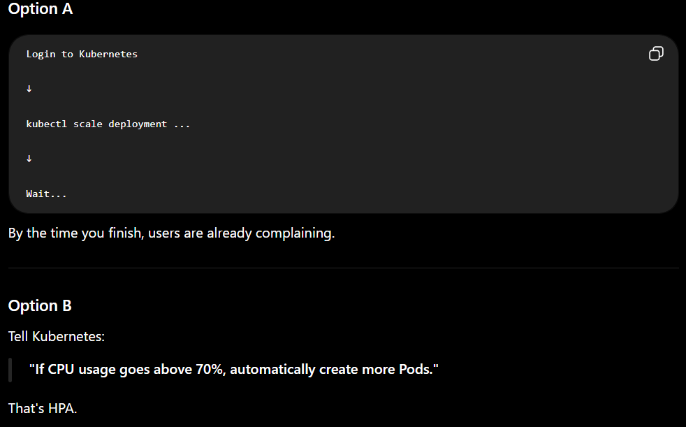
HPA continuously asks:
How busy are my Pods?
If they're busy -> Create more Pods
If they're idle -> Remove extra Pods

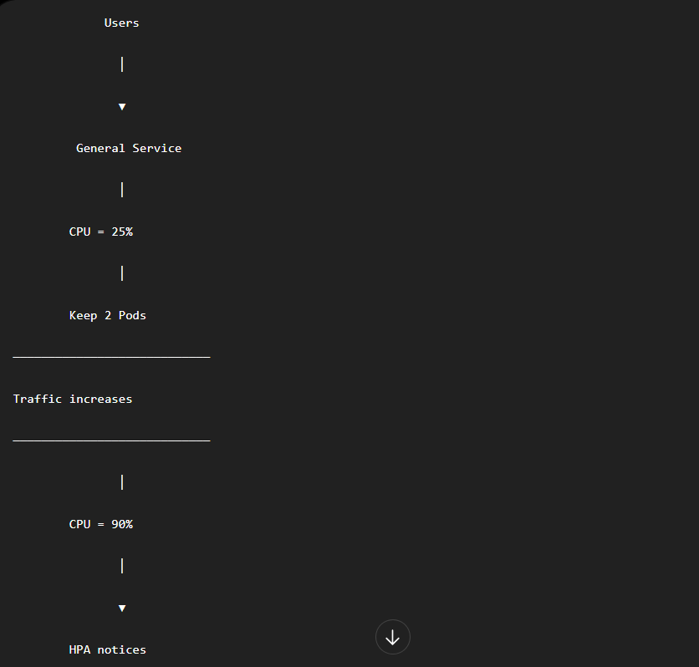

There are two ways to improve capacity.
1.Vertical Scaling
One bigger machine.
2 CPU
↓
4 CPU
↓
8 CPU
The server becomes stronger.

2. Horizontal Scaling
More machines (or more Pods).
1 Pod
↓
2 Pods
↓
4 Pods
↓
8 Pods
Instead of making one Pod stronger, Kubernetes creates more Pods.
That's why it's called Horizontal Pod Autoscaler.
```````````````````````````````````````````````````````````````````
How does it know when to scale?
It reads metrics.
Usually:
- CPU
- Memory
It gets these from the Metrics Server.

Users

│

▼

Ingress

│

▼

Service

│

┌──────────┼──────────┐

▼ ▼ ▼

Pod A Pod B Pod C

↑

│

CPU Usage

│

▼

Metrics Server

│

▼

HPA

│

▼

Deployment

│

Changes replicas

3 → 5 → 8
HPA simply changes:
replicas:
For example:
From
replicas: 3
to
replicas: 7
The Deployment notices the desired state changed and creates more Pods through its ReplicaSet.
``````````````````````````````````````````````````````````````````

Why did we learn Requests before HPA?
Because HPA calculates CPU utilization based on the CPU request, not the CPU limit.
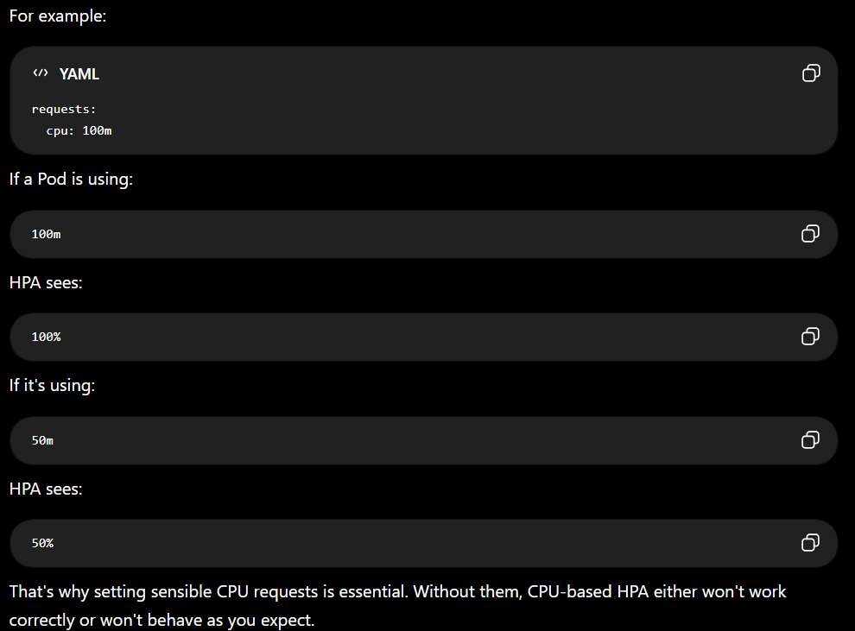
HPA CALCULATES THE AVERAGE(FROM ALL POD) UTILIZATION OF RESOURCES
means if only one pod is busy while others are idle , there is no problem .
it Is problem only when overall all the pods become busy ( average)
``````````````````````````````````````````````````````````````````

