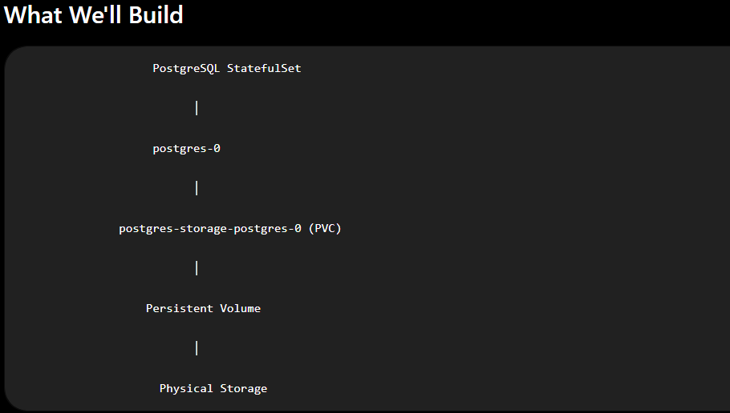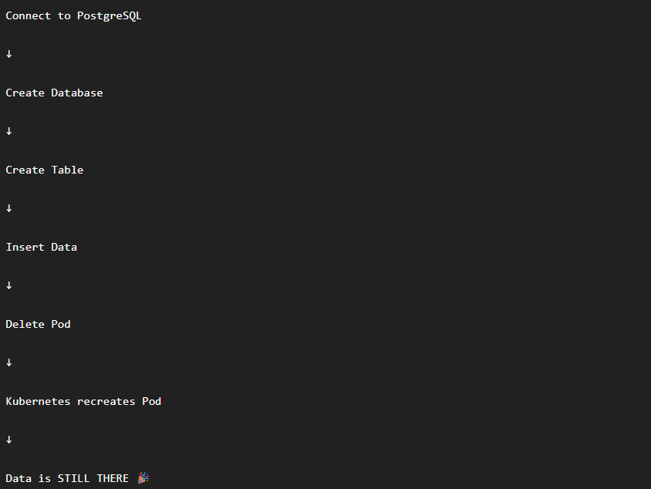
If tomorrow you change:
replica to 3
Kubernetes will automatically create:
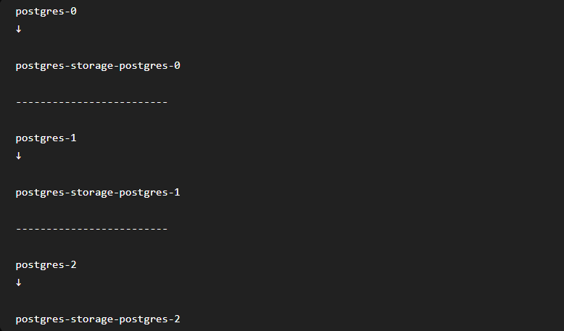
No manual PVC creation.
No manual storage assignment.
Everything is automatic.

Where did PostgreSQL come from?
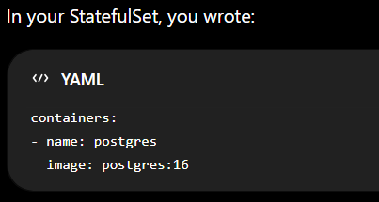
This tells Kubernetes:
"Run a container using the official PostgreSQL 16 image."
When the Pod was created:
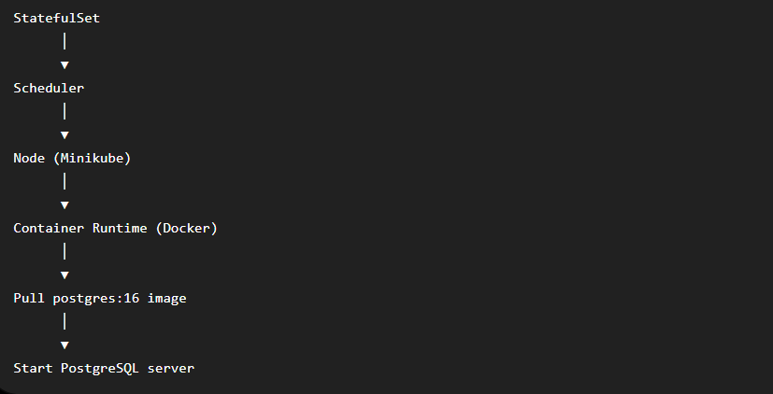
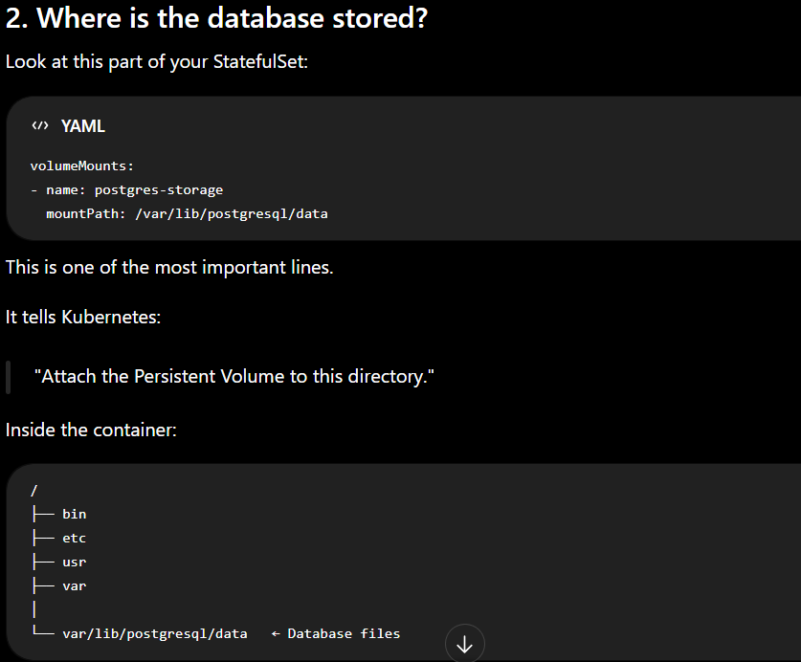
Everything PostgreSQL writes goes here.
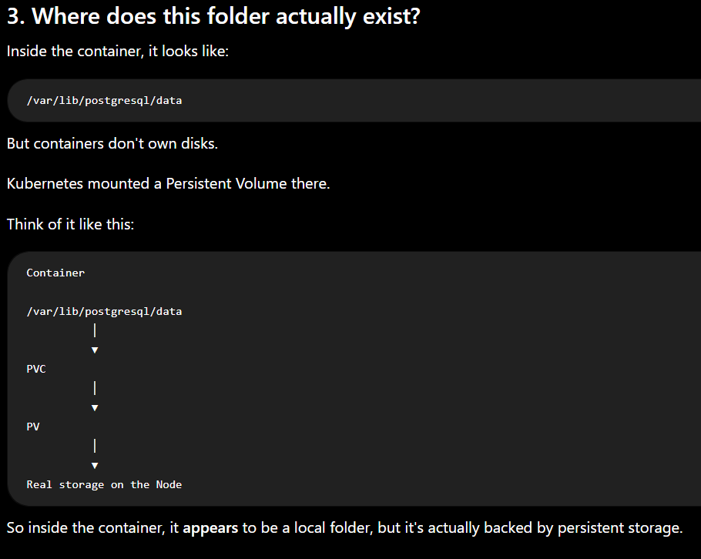
5. Where was the database demo created?
Look at your YAML:
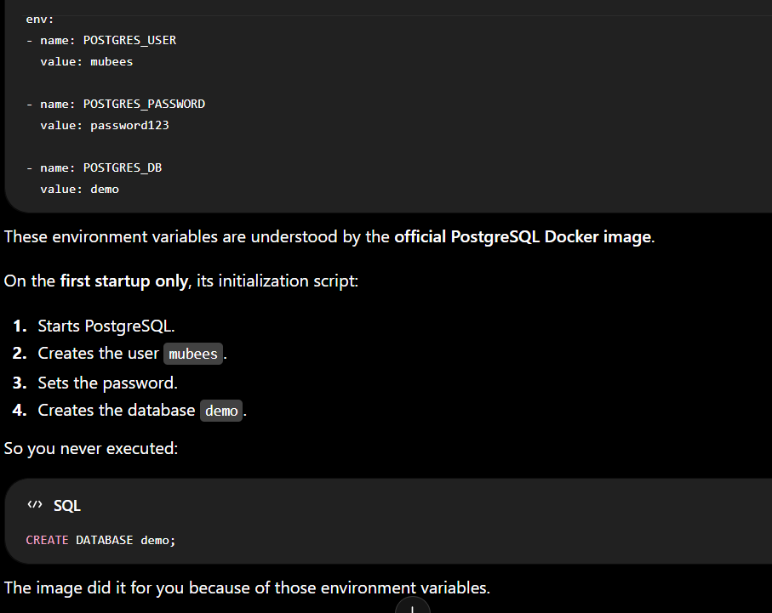
How does Kubernetes remember everything?
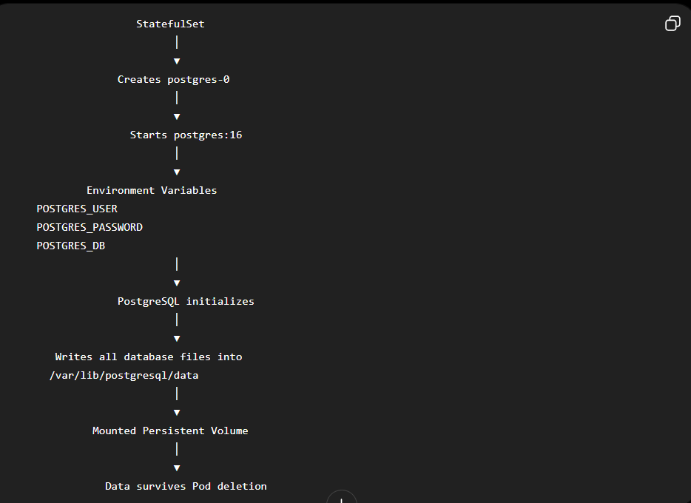

why when we delete the pod(container ) it is not vanished ?
The answer is:
Because the data is not inside the container. The container only has the PostgreSQL program. The data lives on a separate disk (Persistent Volume).

Imagine Your Laptop
Suppose you install PostgreSQL directly on Windows.
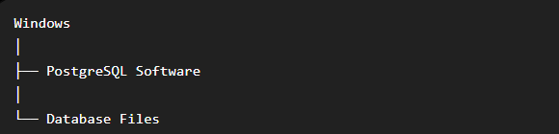
If you uninstall PostgreSQL:
❌ PostgreSQL Software Removed
Sometimes the installer asks:
"Do you also want to delete your database files?"
If you answer No, then:
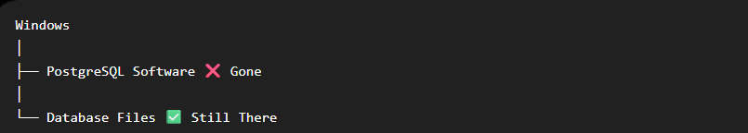
Later, you install PostgreSQL again and point it to the same database folder. Everything comes back.
Kubernetes works in a very similar way.

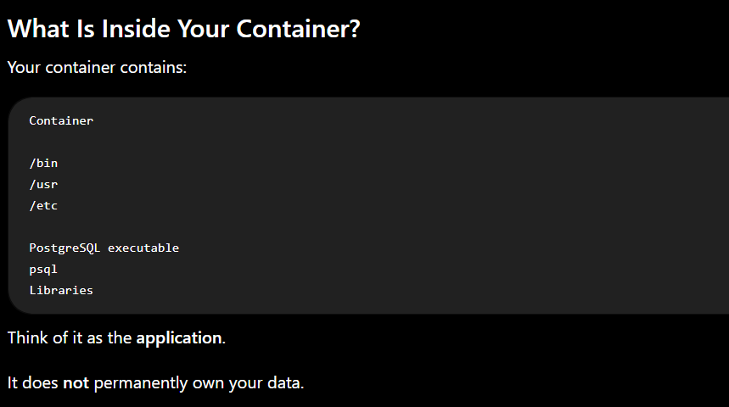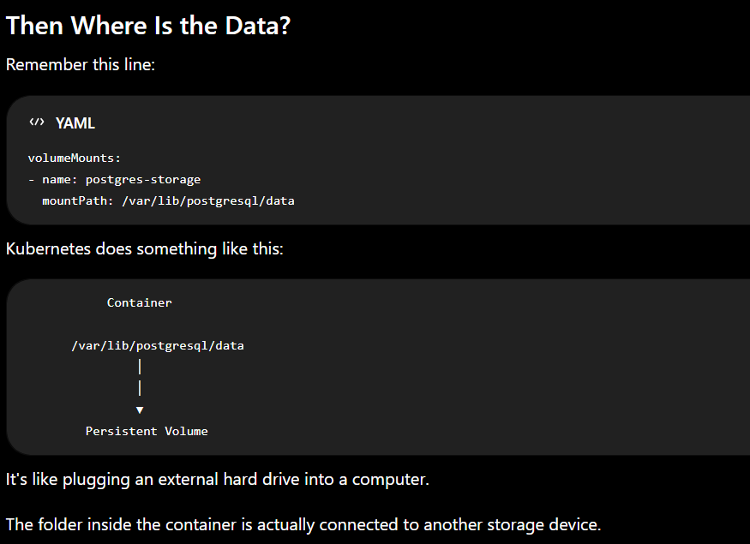
What Happens When You Delete the Pod?
Initially:
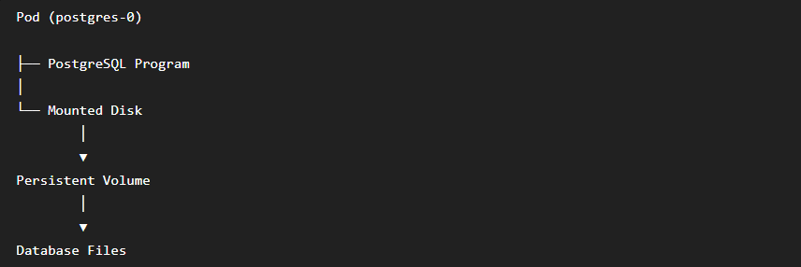
Now you run:
kubectl delete pod postgres-0

Kubernetes deletes:
❌ Container
❌ PostgreSQL Process
❌ Temporary Files
But it does not delete Persistent Volume because the PV is a separate Kubernetes resource.

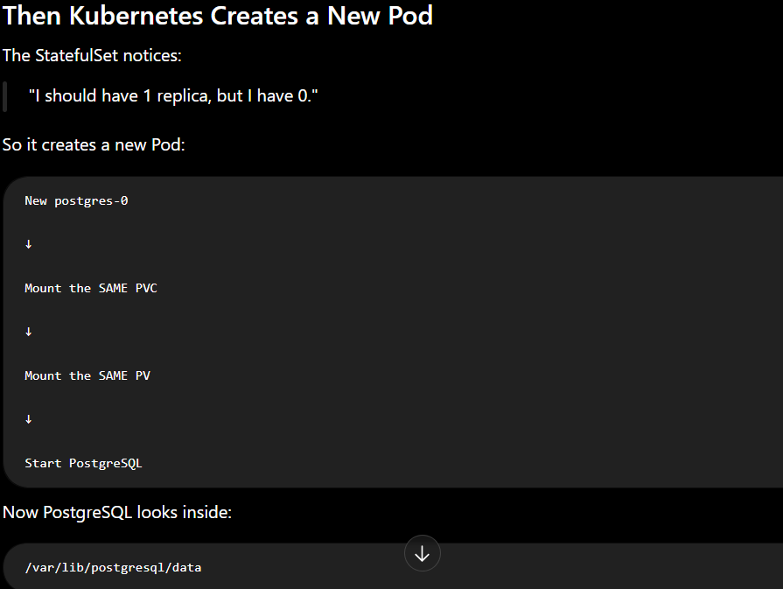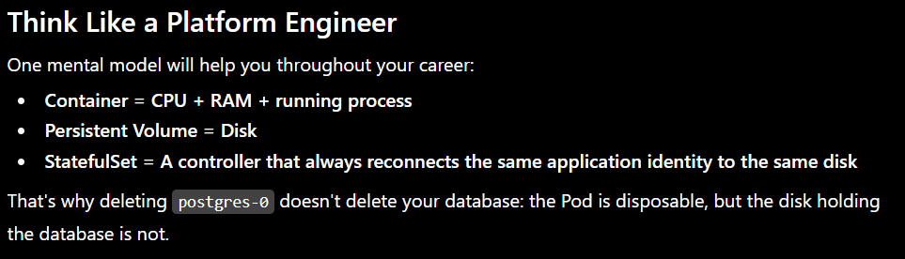

If the Pod is temporary, where is the database physically stored?
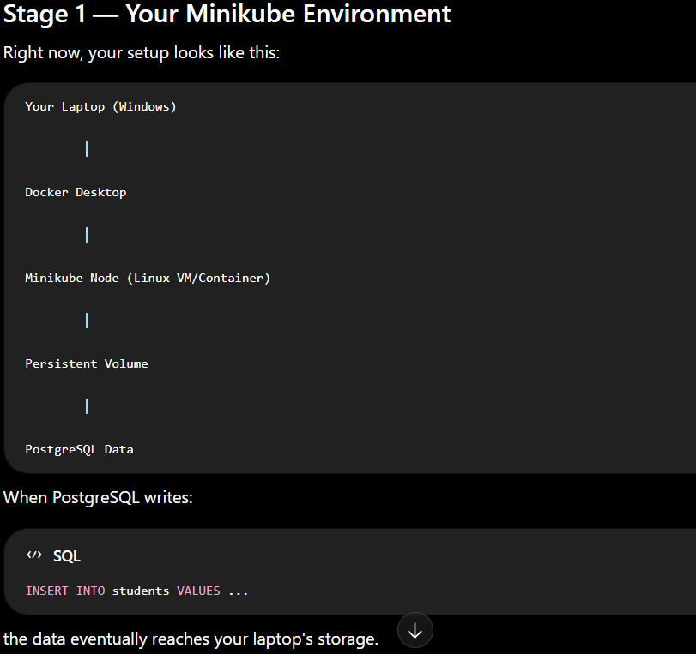
It is not stored inside the container image.
The storage provisioner created a directory on the Minikube node and mounted it into the container.
So although PostgreSQL sees /var/lib/postgresql/data
the actual bytes are stored on the node's disk.

Stage 2 — How Kubernetes Sees It
Kubernetes doesn't think in terms of "hard disks."
It only knows:
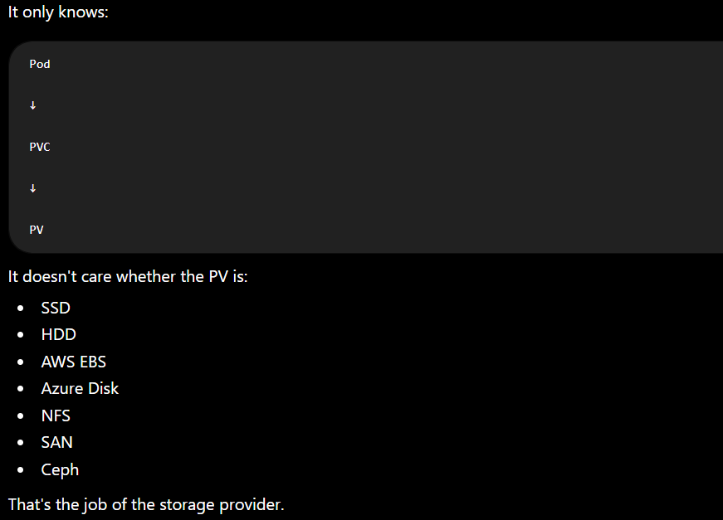

Stage 3 — What Happens in AWS?
Suppose your Kubernetes cluster is running on AWS.
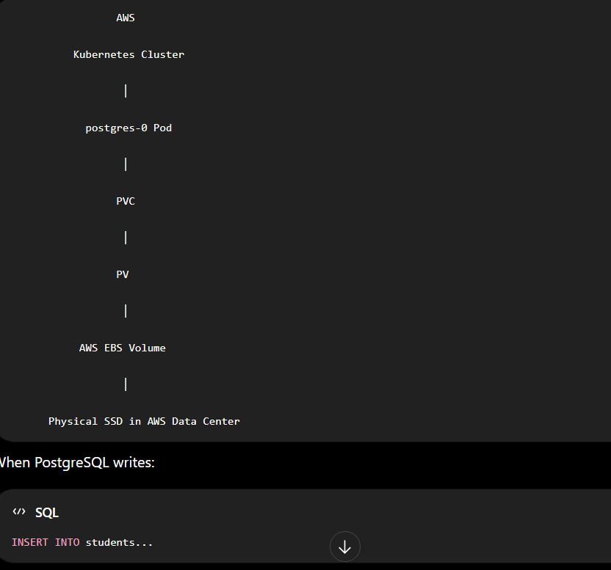
The flow is:




