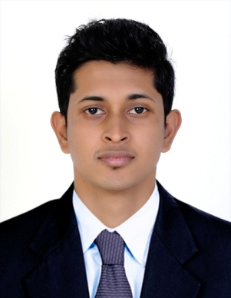  JIMSHAD CH  BUR DUBAI  DUBAI,UAE  Contact Number  Mobile : +971503804612  Email :  jimshadch@gmail.com  Personal Details  Date of Birth : 04/09/1991  Sex : MALE  FATHER’S NAME : HAMZA CS  Nationality : INDIAN  Religion : MUSLIM  Marital Status : SINGLE  Languages : ENGLISH,  MALAYALAM,TAMIL,HINDI  Passport No : K1057036  Passport Expiry: 18/04/2022  VISA : VISIT VISA  (AUGUST 22 TO NOVEMBER 19) | OBJECTIVE  To Work For An Organization Where My Skills, Creativity and knowledge Can Be Utilize In Maximizing The Organization Profits While Providing Career Advancement Opportunities.  SUMMARY OF PROFESSIONAL EXPERIENCE  - Electro Tech Solutions , Kerala, INDIA  ADMINISTRATION EXECUTIVE  ( OCT 2014 - JULY 2016)  - Good Knowledge in MS Office.  - Maintain The Records And Assisting Customers.  - Data Entry Works and Preparing Documents.  - Good Exposure to Customer Communication.  - Fixing Problems, Forwarding Complaints, Comments, Issues To The Management.  - Preparing Presentations and Maintain, Updating the Computer Systems and Soft wares.  - Responsible for controlling all documentation related activities.  - Support and coordinates with administration and control.  - Cybrosys Techno Solution PVT. Ltd, Kerala, INDIA  COMPUTER PROGRAMMER / ADMIN & CUSTOMER SERVICE  (JAN 2014 – JULY 2014)  - Good Knowledge and Experience in Soft wares.  - Maintain And Support Application Programs For Administrative.  - Good Exposure to Customer Communication.  - Maintain The Records And Assisting Customers.  - Solving Customer Problems and Issues.  TECHNICAL SKILLS  Operating systems : Windows 98/XP/7/8, Linux  Programming Languages : C, C++, JAVA, C#.NET  Web Technologies : HTML, Photoshop, Word press  Tools & Utilities : ADOBE,MS OFFICE

EDUCATIONAL QUALIFICATION

COURSE | COLLEGE | UNIVERSITY | YEAR | PERCENTAGE
MASTER OF COMPUTER APPLICATION | NEW HORIZON COLLEGE OF ENGINEERING,  BANGALORE,  INDIA | VISVESVARAYA TECHNOLOGICAL UNIVERSITY (VTU) | 2014 | 68.5%
BACHELOR OF COMPUTER APPLICATION | CHINMAYA INSTITUTE AND TECHNOLOGY, KERALA,INDIA | BHARATHIAR UNIVERSITY | 2011 | 58.4%

EXTRA CURRICULAR ACTIVITIES
- Participated In NATIONAL WORKSHOP ON COMPUTATIONAL INTELLIGENCE At New Horizon College Of Engineering Bangalore 2012.

- Completed A Foundation Program Under The Aegis Of The INFOSYS Campus Connect Program At New Horizon College Of Engineering Bangalore.

- Completed Photoshop Under AKSHAYA E CENTER (A GOVERNMENT OF KERALA PROJECT).

DECLARATION
The Above Stated Facts And Figures Are True And Correct In Best Of My Knowledge And Belief.

PLACE: DUBAI, UAE Sincerely
(JIMSHAD CH)

