PERSONAL INFORMATION | Arua Maini Dabdoub
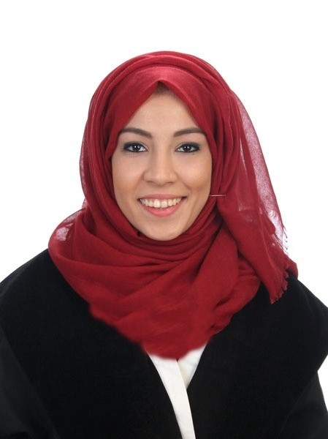 |   Almacil street, nº5, (Mislata) 46920, Valencia, Spain

961093133  +34 697904180

Arua.md92@gmail.com
Sex Female | Date of birth 14/04/1992 | Nationality Spanish | Marital Status: Single

A dedicated pharmacist, but a passionate about Beauty Industry. Eager to start working in an Arab Country with a continuous desire of learning.

WORK EXPERIENCE

Regulatory Affairs Technician, Natural Solter Cosmetics, (Cosmetic Industry), Alicante, Spain / January 2017-Current Job
http://www.naturalsoltercosmetics.com/

- Implement ISO,GMP, and Plant safety standards
- GMP and GDP audits
- Keeping up to date with international legislation
- Natural and Organic Certification
- Contacting with suppliers in order to maintain the necessary documentation
- Project managing teams of colleagues involved with the development of new products
- Specifying storage, labelling and packaging requirements
- Deal with clients
R&D and Quality Control Technician, Guinama / Desarrollo Biotecnológico (Pharmaceutical Laboratory: raw materials and cosmetics), Valencia. April-October 2016 http://www.guinama.com/
- maintaining quality-assurance processes,
- testing raw materials, (HPLC, FT-IR)
- development of new cosmetic products
- Stability tests of new drugs and cosmetics
- Recording and analyzing results data during product development and manufacturing.

Practices in Consorcio Hospital General Universitario de Valencia (July 2014-July 2015): http://chguv.san.gva.es/inicio
- Nutritional Support in Hospitalized Patients
- Clinical investigation
- Drug Dispensing
- Pharmacotechnology
- Drug information center

Stewardess at ceramic fair (February 2014, February 2016) Customer Support, Marketing, Castelana Cerámica http://castelanaceramica.com/
FERIA DE VALENCIA 2014,
FERIA DE VALENCIA 2016,

Arabic Translator in New Mace Gold Valencia (September 2015-September 2016) http://www.newmacegold.com/

EDUCATION AND TRAINING

Master in Cosmetic Industry, Universitat de Valencia (October 2015- October 2016)
- Cosmetic formulation
- Expert en Safety Assessment
- Quality Assurance and Quality Control
- Business management and research
- Training in a cosmetic industry

Final Project: Polyphenols in anti-aging treatment. Research on antioxidants, anti-inflammatory and healing properties of polyphenols applied topically.

→ Evaluator of Safety of cosmetic products certification

Degree in Pharmacy, Universitat de València (2010-2015)
- Specialize in pharmaceutical industry (2015)
Graduation Project: Food intolerances (Department of Nutrition). Focus on Gluten and Lactose Intolerance.

PERSONAL SKILLS

Mother tongue(s) | Spanish, Arabic, Catalán
Other language(s) | UNDERSTANDING |  | SPEAKING |  | WRITING
Other language(s) | Listening | Reading | Spoken interaction | Spoken production
English | C2 | C2 | C2 | C2 | C2
French | A2 | A2 | A2 | A2 | A2
 | Replace with name of language certificate. Enter level if known.
Levels: A1/2: Basic user - B1/2: Independent user - C1/2 Proficient user
Common European Framework of Reference for Languages

Communication skills | -Excellent written and verbal communication skills  -Confident, articulate, and professional speaking abilities (and experience)  -Empathic listener and persuasive speaker  -Speaking in public, to groups, or via electronic media

-Leadership: An experienced team leader
Organisational / managerial skills
-Critical thinking, decision making and problem solving skills.
-Planning and organizing – Organizational abilities
-Result oriented: Ability to achieve the target within given time
-Conflict resolution.
-Adaptability – Efficient under pressure, always meet deadlines

Computer skills | -good command of Microsoft Office™ tools (WordTM, ExcelTM, PowerPointTM e OutlookTM)  -Android/Java  -Adobe Photoshop

Driving licence | - Category B
Conferences | 25 and 26 March, 2015 - 5th Congress of Students of Pharmacy UV (University of Valencia)

ADDITIONAL INFORMATION
Personal interests: Reading books, Photography, Traveling
References:

Pilar Blasco | Head of pharmacy service (Hospital General) | +34 963 131 800  http://chguv.san.gva.es/inicio
Nuria Tenas | Technical director (Guinama laboratorio) | +34 960 62 00 63 /  ntenas@debiotec.es
Octavio Diez | University Lecturer (Universidad de Valencia) | +34 649411928 /  Octavio.diez@uv.es

