First Wave ISAC Beacon User Guide

By Cameron G.

The following is a guide to using the First Wave ISAC Beacon which is a replica of the Integrated Systems Analytic Computer (ISAC) shoulder radio beacon used by SHD Agents in Tom Clancy’s: The Division franchise. The intended purpose of the First Wave ISAC Beacon is to give fans of The Division a way to show off their love of the game through Cosplay at conventions or just wearing it around for fun. Although it took a lot of time and effort to develop the software and circuitry used in the First Wave version of the ISAC beacon, I saw it as a challenge to do something fun and learn new skills along the way. I hope you enjoy and are excited about the result as I am.

-Cameron G.

Contents

Acknowledgements 2

Functionality and Controls 3

Powering the ISAC beacon 3

Volume Control 3

ISAC World Notifications 4

Auto Notification mode 4

Activating SHD Skills 4

Entering the Dark Zone 5

Rogue Protocol 5

FAQ 5

Q: Are you going to continue to release updates? 5

Q: Can I order one? How much? 5

Q: Can I fly with this on my backpack, or will it be confiscated at airport security? 6

Updates and Known Issues 7

# Acknowledgements

I followed the work done by two authors on thingiverse.com and their versions of the ISAC radio beacon. Building off the fine work they did, I created and modified specific parts to fit the functionality of this version and simplify the construction process. I also initially used some of the audio that was provided by a reddit user. I want to acknowledge their efforts and files that gave me a good starting point for my own version.

[MZD471](https://www.thingiverse.com/MZD471) - [Tom Clancy's The Division Functional Comms Module](https://www.thingiverse.com/thing:1327053)  
3D model used as the base of the First Wave version. Modified housing for buttons, shorter radio antenna, and edited to be one printed piece for the top and one separate piece for bottom.

[guido666](https://www.thingiverse.com/guido666) - [The Division - Shoulder Beacon v3](https://www.thingiverse.com/thing:1411233)  
Parts of the 3D antenna were used to crate my own version and well as the code provided for learning how to work with the NeoPixel ring.

[u/KlotziDotCom](https://www.reddit.com/user/KlotziDotCom/) - [Hello Agents, here are some Division 2 ISAC Sound Files!](https://www.reddit.com/r/thedivision/comments/bwwdh8/hello_agents_here_are_some_division_2_isac_sound/)  
Initial audio files I played with. I eventually recorded, edited, and normalized new audio files myself, but some of Klotzi’s work is still in the audio files used.

# Functionality and Controls

The ISAC beacon only has two buttons (+) and (-) on the left side. The following effects, modes, and functionality can be accessed by using these two buttons.

# Powering the ISAC beacon

The ISAC beacon is powered by the USB cable as outlined in the assembly instructions. Simply plug the ISAC beacon into a USB power adapter or portable phone charger that outputs 5V. The bootup on the control module takes a few seconds before the boot-up effect of the ISAC beacon begins to play.

Simply plug in the USB cable and then put the USB battery into the backpack the ISAC beacon is attached to. Some backpacks have headphone slots that you can use to have the USB cable go into the main compartment.

When you are done, simply unplug the USB cable from the power source. The device does not use a lot of power and you can easily get hours (if not days) of use out of a portable phone charger (depending on the size of the charger).

# Volume Control

To turn the volume up, hold the (+) button for a few seconds until the ISAC light ring turns green. Continue to hold the (+) button and the volume will increase in small steps with an audible tick and light up more LEDs. Release the (+) button when the volume is at your desired level, or the ISAC light ring is full green (max volume). If using as cosplay in a crowd or convention with a lot of noise, you will probably want to increase the volume. However, be cautious not to damage your hearing as it is closest to your own ears.

Similarly, to turn down the volume hold the (-) button for a few seconds and continue to hold until the desired volume level is reached.

# ISAC World Notifications

To manually activate a random ISAC notification, tap the (-) button once. Notification clips won’t duplicate until all clips have been played. While ISAC is talking, the ISAC light ring will change brightness based on ISAC’s voice to replicate the ‘chatter’ effect as seen in-game.

## Auto Notification mode

Auto Notification mode fires off the next ISAC notification clip every 60 seconds, this is great for walking around and getting notifications as if you were the in-game world. To turn on or off Auto Notification mode, tap the (-) button sequentially 2 times. If registered correctly you will hear one of two audio sound effects:

1. On – ISAC chirp (sound when mission objectives updated in-game)
2. Off – Drone cancelation (self-destruct sound)

If after tapping the (-) button twice you don’t hear one of the above sound effects but instead get an ISAC Notification affect, try again making sure that your sequential taps are less than a half second apart.

# Activating SHD Skills

The First Wave ISAC beacon is programmed with 4 effects found in the Division 2:

To activate a skill, tap the (+) button once. After a moment, the currently selected skill will activate. To cycle between the skills, sequentially tap the (+) button before the effect activates. The ISAC ring will light up one corner with the corresponding color of the skill as shown above. The color that is displayed on the ISAC ring after the last (+) button tap will be the skill that activates.

If you want to re-activate the same skill, simply tap the (+) button once and the skills will not cycle.

Note: the red colored LEDs during the pulse skill indicate detected hostiles in that direction.

# Entering the Dark Zone

Dark Zone mode changes the ISAC notifications and allows you to become a rogue agent. To enter or exit the Dark Zone, press and hold both the (+) and (-) buttons for a few seconds until you hear ISAC confirm you have entered or exited the Dark Zone.

ISAC notifications in Dark Zone mode are specific to audio only found in the Dark Zone. One of those is the extraction effect of calling in a chopper. When this effect fires, it will continue to play the audio clips of an extraction sequence every 15 seconds until the extraction is complete. This happens regardless of if you exit the Dark Zone or activate other notifications / effects.

## Rogue Protocol

While in the Dark Zone you can also go rogue, which turns the ISAC ring red. To go rogue, tap (not hold) both the (+) and (-) buttons at the same time while in Dark Zone mode. To exit rogue, tap the (+) and (-) buttons again.

# FAQ

## Q: Are you going to continue to release updates?

A: Probably, as I have time. I would like to and I’m very proud of the work and effort that went into making this project, especially the technical coding and circuitry. I have posted the code and files on GitHub (<https://github.com/WedgeTheJedi/First-Wave-ISAC-Beacon>) so that others can also contribute or make recommendations / suggestions. I didn’t just make this for me, I made it for others who want to make one themselves.

## Q: Can I order one? How much?

A: Unfortunately, I can’t accommodate orders or requests for the First Wave ISAC Beacon for the following reasons:

1. I have a full-time job and other responsibilities that prevent me from being able to make or deliver these in a timely manner. I did it as an educational and fun project.
2. The 3D models that I started with and modified were from other authors, using their work to make a profit and not properly compensating them would be inappropriate, disrespectful, and is prohibited by their use agreements.

If there is enough demand to build these, I’ll look at ordering a large batch of the custom circuit board to provide to those building their own, but I would not be able to provide the 3D models. I have provided all of the files to order your own circuit boards using my design (seen below). I have also included links to all parts used in the assembly instructions so you should have what you need to order your own parts.

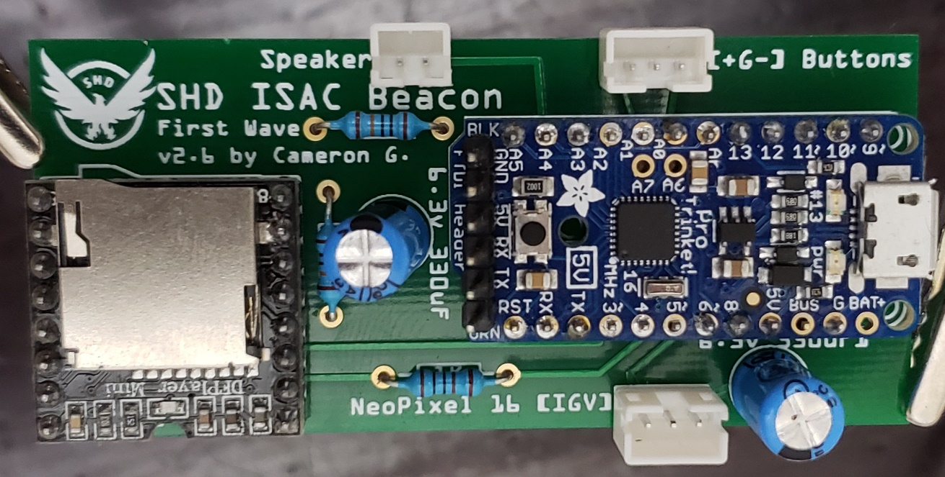

Q: Can I fly with this on my backpack, or will it be confiscated at airport security?

A: I can’t guarantee what the TSA or equivalent airport security personnel will do in your case. However, I did take my prototype ISAC beacon on my backpack through security without incident. As required, I put my backpack through the security scanner with all carry-on luggage and they did not ask any questions about it. They may ask you to power the device as they have with other electronics I have brought through screening in the past, so make sure you can turn it on for them and show them a few of its effects. If you are concerned, you should either leave it at home or place it into your checked baggage with a note that it is a costume prop that makes sound and light effects.

I did take it also into a theme park that required going through security screening as well as a bag check. They were much more curious about it and had multiple security personnel inspect the device and ask me about it. I simply explained that it was a toy that I made to make some light effects and sound effects from a video game I like to play. After they had me open it up and asked a few more questions they let me through. However, the process took some time and I decided that rather than cause a long wait for others in the security line or to possibly cause other concerns at the park I took it off my bag for the remainder of my visit.

# Updates and Known Issues

July 17, 2023

Known Issue: Rarely when you either enter or exit Rogue status the program will stop responding to further button clicks. If this happens simply reboot the device, if you have access to compile the code, you can also try and increase the delay time at the end of the enter and exit Rogue functions.

