Big Rapids Garden Tour 2018

General Federation of Women’s Clubs

Carrie Franklund

## Garden Tour Data

A total of 62 surveys were completed following the 2018 GFWC Garden Tour.

## Advertising Effectiveness

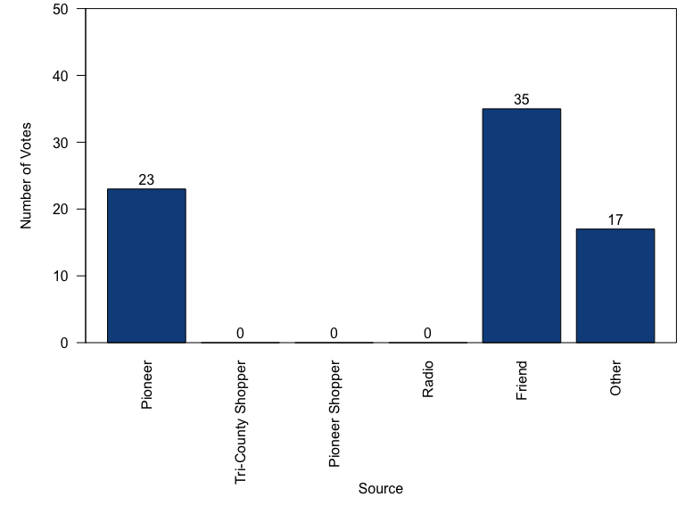

## # A tibble: 17 x 1  
## Other   
## <chr>   
## 1 Senior Center   
## 2 Artworks   
## 3 Facebook   
## 4 Poster in town   
## 5 Wife, Artworks   
## 6 Coalition meeting   
## 7 Garden club member   
## 8 Signs   
## 9 GFWC Heart of the Lakes  
## 10 CL News   
## 11 Senior Center   
## 12 Warmbier Farms   
## 13 Artworks   
## 14 Posters   
## 15 GFWC member   
## 16 Artworks   
## 17 BR Farmers Market

## Day Preference

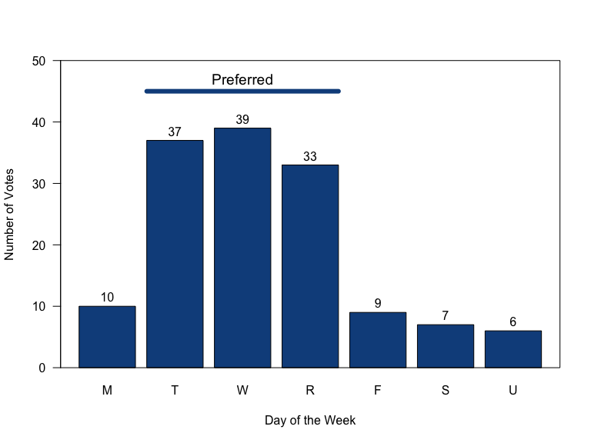

## Time Preference

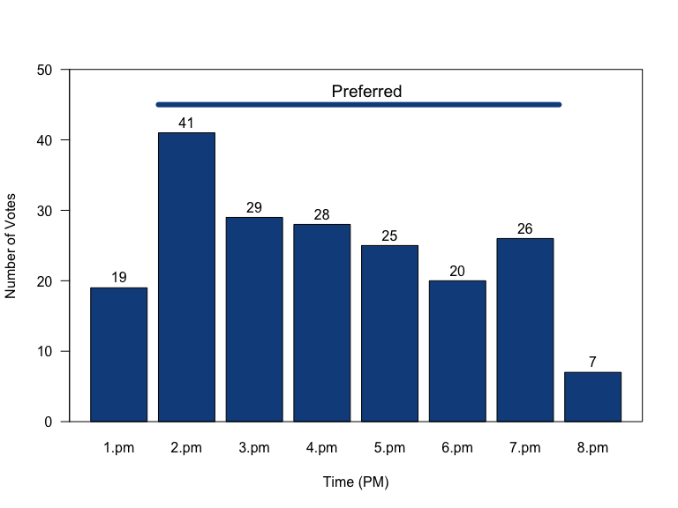

## Best Features

## Opportunities for Improvement

There were only 11 suggestions made in response to the “least favorite part” prompt. Of these…

## Recruiting Effectiveness

A total of 4 people (6.5%) indicated that they would like to learn more about GFWC.