Korea's AI Strategy as Statecraft
Industrial Capacity, Trusted Data, and Middle Power Leverage
Policy research paper for Technology, Power, and Statecraft

Executive Argument
South Korea's AI strategy is best understood as selective stack statecraft rather than a bid for comprehensive technological autonomy. The government's aspiration to become a top three AI power is politically useful, but it is a poor analytical benchmark if read as model parity with the United States or China. Korea's more plausible route to AI power is to make itself difficult to substitute in the layers where it already has leverage: high bandwidth memory and advanced packaging, precision manufacturing, robotics and physical AI, trusted Korean data governance, defense adaptation, and public sector deployment. AI becomes statecraft when these assets produce bargaining leverage abroad, productivity gains under demographic pressure at home, and military adaptation against a proximate threat.^{1,2,3}
The empirical profile gives the strategy a physical center of gravity. The Stanford AI Index identifies Korea as the world leader in AI patents per capita, and the project dashboard records Korea's exceptional manufacturing robot density relative to the comparison set. Samsung Electronics and SK hynix occupy central positions in global DRAM and high bandwidth memory supply. These assets locate Korea inside the material infrastructure of AI rather than only inside its software layer. They also make the country a credible test bed for AI in manufacturing, defense, mobility, health, and public services, where deployment discipline can create advantages that model benchmarks do not capture.^{2,4}
The central weakness is institutional coupling. The Ministry of Science and ICT has moved quickly through the AI Basic Act, the National AI Strategy Committee, the 2026 Action Plan, public GPU procurement, and sovereign foundation model teams, but these instruments do not yet amount to a mission architecture that binds models, compute, data, standards, and procurement to priority national problems. A model centered strategy can produce capable Korean systems while leaving strategic rents in foreign cloud platforms, foreign GPU ecosystems, and foreign application markets. Sovereignty in AI therefore depends on control over the full stack of inputs, channels, legal permissions, assurance practices, and demand.^{5,6,7,8,9}

Argument and Framework
AI becomes a technology of statecraft for Korea when industrial bottlenecks are connected to diplomatic, economic, and military objectives. The National Technology Strategy Framework clarifies this connection by asking why the state commits to a technology, how it organizes science and industry, and how capacity is converted into power. Korea's answer is shaped by five pressures: the North Korean threat, demographic contraction, dependence on external frontier model and GPU ecosystems, the productivity needs of an advanced manufacturing economy, and the opportunity to turn memory chip dominance into geopolitical leverage. These pressures make AI a means of prosperity, deterrence, social resilience, and alliance bargaining.^{10,11,12}
The historical relevance of Korea's developmental state lies less in a direct return to command planning than in the persistence of institutional habits after democratization: presidential agenda setting, ministry coordination, framework legislation, targeted finance, public private consultation, and bargaining with chaebol and platform firms. AI extends this pattern into a harder domain because the state must coordinate compute infrastructure, privacy law, safety obligations, procurement demand, semiconductor supply, and alliance commitments at the same time. The AI Basic Act is therefore significant not as a self executing solution, but as a framework statute whose strategic value depends on subordinate regulations, guidance, enforcement practice, and administrative capacity.^{5,13}
Korea's operating model is hybrid, which gives it flexibility and creates coordination risk. It relies on national champions in semiconductors, telecommunications, internet platforms, automobiles, and electronics. It uses a consortium logic for sovereign foundation models and public compute, a state project logic for defense AI and public services, and a commercial dual use logic because most deployable AI capability will come from firms that need profits, customers, exports, and developer ecosystems. The policy problem is therefore institutional design: Korea must make these models mutually reinforcing rather than allowing each instrument to produce separate constituencies, standards, and procurement channels.^{10,9,14}
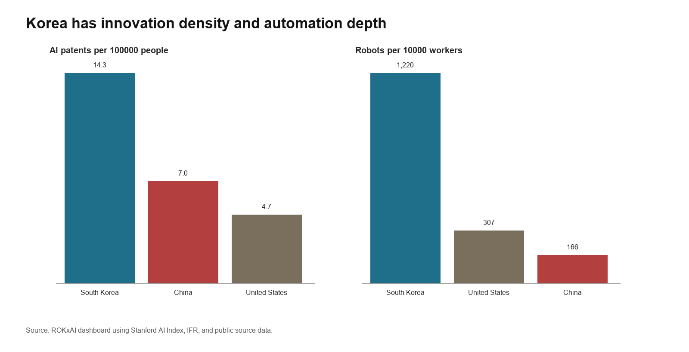
Figure 1. Korea combines high AI patent density with exceptional manufacturing automation.

Strategic Landscape

State of Play: From Digital Catch Up to Sovereign AI
Korea's strategic landscape is best read as a transition from digital modernization to AI stack management. Earlier policy sought to make the state and the economy more digital; the current agenda treats AI as infrastructure for industrial competition, alliance bargaining, demographic resilience, and military adaptation. The 2026 Action Plan's three pillars, twelve strategic areas, ninety nine implementation tasks, and three hundred twenty six policy recommendations show that Seoul is imagining AI as an implementation architecture rather than as a narrow software sector. The transition remains incomplete because MSIT, the Personal Information Protection Commission, the Ministry of National Defense, industrial ministries, the presidential AI strategy body, and the National Assembly govern different pieces of the AI system. Korea is not positioned to match the United States or China in general frontier scale. Its more credible path is to become indispensable in memory, trusted deployment, manufacturing AI, and allied supply assurance.^{10,1,2,6,7}
The policy trajectory shows four phases rather than a single acceleration story. The 2019 National Strategy treated AI as an economy wide modernization agenda organized around AI ecosystem building, AI utilization, and people centered AI. The Digital New Deal and Data Dam phase converted that ambition into data infrastructure and public digital investment. The 2022 National Digital Strategy broadened the agenda to AI chips, data, platform government, talent, and global digital norms. Since the National Assembly passed the AI Basic Act in December 2024 and the presidential AI strategy body was relaunched in 2025, the center of gravity has shifted toward strategic AI through legal authority, GPU procurement, sovereign foundation models, the KRW 1.9067 trillion supplementary AI budget, and the 2026 Work Plan. The Action Plan extends this sequence by assigning AI to ministries, legal reforms, regional programs, sector missions, and public service systems. The result is a more explicit theory of national power in which AI is treated as an infrastructure layer for industry, science, security, and public administration.^{15,16,5,6,8,9,17,7}
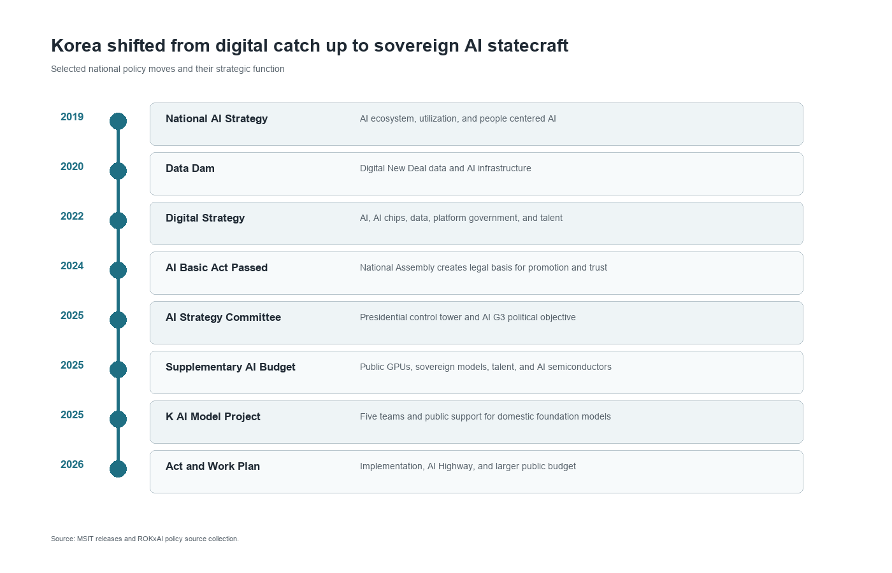
Figure 2. Korea's AI policy evolution shows a shift from digital modernization to stack sovereignty.

Geopolitical Stack Position
The global AI hierarchy is organized through a stack in which states and firms hold different sources of leverage. The United States dominates frontier model companies, cloud platforms, GPUs, and software ecosystems. China supplies scale, state backed deployment, and an alternative platform system. Taiwan is central to advanced foundry capacity. Korea's position is narrower but strategically valuable: it contains world class memory firms, dense manufacturing capability, major digital platforms, and some of the most automation intensive industrial environments in the world. This position creates leverage only if Seoul converts component importance into negotiated access to compute, design tools, export markets, and allied research networks.^{1,2,4}
High bandwidth memory gives Korea a concrete bargaining instrument in the AI race, although that instrument is conditional rather than automatic. TrendForce reported that SK hynix led the DRAM market by revenue in the second quarter of 2025 with 38.7 percent share, while Samsung ranked second with 32.7 percent. Frontier AI systems depend on memory bandwidth, packaging reliability, power efficiency, and stable supply as much as they depend on model design. Korea can therefore use memory and advanced DRAM as alliance assets, linking supply assurance to reciprocal access to GPUs, cloud capacity, trusted data flows, and standards forums. The danger is that memory remains a profitable input while the strategic rents from models, cloud platforms, and developer ecosystems accrue elsewhere.^{4,14}

Domestic Demand and Physical AI
Korea's domestic demand for AI is shaped less by consumer novelty than by structural pressure in manufacturing, logistics, public services, health care, and defense. The OECD and Korea Labor Institute warn that demographic aging could push the old age dependency ratio above 75 percent by 2060 and reduce the working age population by up to 46 percent between 2023 and 2060. In that context, AI is a productivity instrument for an advanced economy whose labor supply is tightening. This gives Korea a stronger rationale for physical AI than many peer economies: models must be embedded in robots, machine tools, shipyards, vehicles, hospitals, grid systems, and public administration rather than remaining primarily as conversational software.^{11,17,18}
The dashboard shows why this adoption layer is both an advantage and a policy problem. Korea recorded robot density of 1,220 robots per 10,000 manufacturing workers in 2024, far above the United States and China in the comparison set, but annual industrial robot installations have been broadly flat at about 31,000 units since 2020. The country also shows rising AI engineering skills diffusion, reaching 16.8 percent in 2025, and worker use of generative AI at work above half of surveyed workers. These figures suggest a strong base for industrial absorption, but they also imply that the next margin of competitiveness will come from software integration, worker redesign, safety assurance, and sector specific deployment rather than additional automation alone.²

Security and Military Adoption
Korea's security environment pushes AI toward force multiplication under demographic and geographic constraint. The North Korean missile, artillery, cyber, and unmanned systems threat demands faster sensing, decision support, logistics, and cyber defense, while manpower decline makes a larger military less plausible over time. The Defense AI Center, launched at the Agency for Defense Development in Daejeon in April 2024, gives institutional form to the Defense Innovation 4.0 agenda by linking civilian and military personnel, manned and unmanned teaming, battlefield awareness, and private sector technology transfer. This is not only a weapons question. It is an organizational question about how to integrate AI into command, maintenance, training, electronic warfare, intelligence analysis, and military exercises while preserving human responsibility for escalation sensitive decisions.^{12,19}

Data Sovereignty and Trust
Sovereign AI requires legitimate data mobilization rather than national ownership alone. Korea's large platforms hold valuable social, search, commerce, communication, and payment data, but democratic legitimacy, competition concerns, and privacy law limit how those assets can be used. The AI Basic Act gives the state a promotion and trust framework, including national governance, support for research and data centers, transparency rules for generative AI, and high impact AI obligations in areas such as energy, drinking water, health care, nuclear facilities, criminal investigations, recruitment, credit, transport, public services, and education. Those rules will become industrial infrastructure only if they work with the Personal Information Protection Act rather than around it.^{5,13}
The Personal Information Protection Act already contains a pathway for data use through pseudonymized information for purposes such as statistics, scientific research, and public interest archiving, while the Personal Information Protection Commission remains the central regulator that gives those pathways practical shape. The commission's prior adequacy review of Kakao Kanana illustrates the mechanism Korea must scale: the regulator permitted innovation while requiring separate storage, encryption, constraints on OpenAI use, consent rules for training, and continuing oversight. Data governance is therefore not simply a brake on industrial policy. Properly designed, it can create trusted data spaces that give firms lawful access to high value data while preserving public confidence. Korea's comparative advantage will weaken if privacy remains a case by case compliance burden; it will strengthen if the state turns privacy review into repeatable institutions for safe data sharing.^{13,20}

How Korea Is Building Capacity
Korea is constructing AI capacity through bottleneck governance rather than through a single technology program. State instruments supply legal authority, finance, compute, procurement, and coordination. Science supplies patents, researchers, benchmarks, domain knowledge, and absorptive capacity. Industry supplies memory, fabs, platforms, robotics, customers, and export channels. The central policy challenge is whether these layers will combine into a national learning system or remain a portfolio of impressive but weakly connected initiatives.^{10,5}

Policy Architecture and Strategic Sequencing
The state pillar has become more operational since 2025 because Korea now combines legal authority with budgetary allocation, subordinate rulemaking, and named implementation vehicles. The AI Basic Act creates the statutory foundation, while its Enforcement Decree, transparency guidelines, grace period, and support desk illustrate Korea's regulatory culture of framework legislation followed by administrative interpretation. The supplementary budget concentrates resources on compute, foundation models, talent, and domestic AI semiconductors. The 2026 Work Plan raises the AI budget from KRW 3.0 trillion to KRW 9.9 trillion and organizes policy around the AI Highway, K AI, AI co scientists, regional AI transformation, and public services. Korea has moved from capability aspiration to bottleneck management.^{5,8,17}
Bottleneck management gives the Korean state leverage only if allocation is connected to performance discipline. Public GPUs should not become a general subsidy for incumbents, and sovereign models should not become symbolic national artifacts. The stronger design is to tie compute, data, and talent support to public benchmarks, industrial deployment targets, open interfaces, security evaluation, privacy compliance, and measurable diffusion into small firms, regional clusters, public services, and defense users. This is where the NTSF state pillar must discipline the industry pillar rather than merely finance it.^{10,8,9,13}
AI capacity crosses statutory boundaries. MSIT leads the industrial and digital agenda, but the Personal Information Protection Commission, the Ministry of National Defense, industrial ministries, and the National Assembly control data legitimacy, military demand, manufacturing adoption, energy intensive facilities, and law. The National AI Strategy Committee adds value only if it turns those authorities into shared milestones and visible tradeoffs.^{6,5,13,12}

Compute and Model Layer
Compute is Korea's most urgent capacity constraint because model development, scientific AI, defense testing, and startup scaling all depend on access to clustered GPUs. The 2025 supplementary budget initially targeted 10,000 advanced GPUs, and the procurement project later selected Naver Cloud, NHN Cloud, and Kakao to secure 13,000 GPUs, including B200 and H200 systems. MSIT's 2026 plan then set a cumulative target of 37,000 GPUs by 2026 through government procurement and Supercomputer Number 6. NVIDIA's October 2025 announcement is larger still, with the Korean government and major firms adding more than 260,000 GPUs across sovereign clouds and AI factories. The scale is significant, but it also reveals dependence on foreign accelerator supply, CUDA centered software, data center power, and allied export control decisions.^{8,21,17,14}
The Sovereign AI Foundation Model project uses a managed tournament to convert scarce inputs into model capability. Naver Cloud, Upstage, SK Telecom, NC AI, and LG AI Research were selected after review, with support in GPUs, data, and talent. Their goals cover omni models, public AI services, industrial models, agents, manufacturing, defense, health, finance, robotics, and public services. The mechanism is a hybrid of the NTSF consortium model and national champion logic: the state pools scarce resources and defines national objectives while firm rivalry supplies technical discipline. The tournament will create public value only if models remain interoperable enough for procurement, safety review, sector adapters, and startup access.^{9,10}
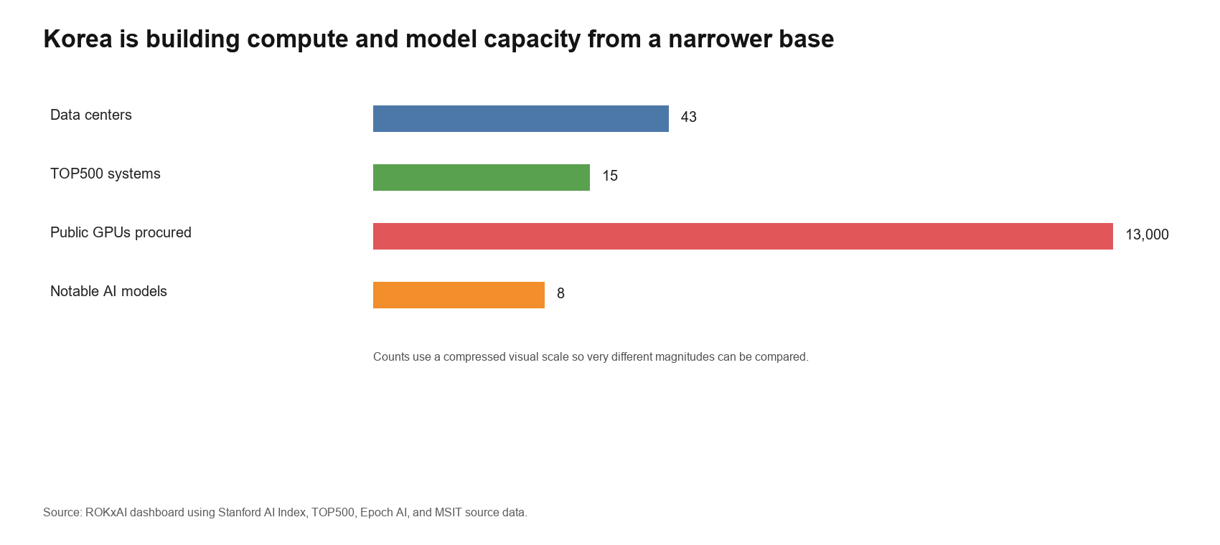
Figure 3. Korea is increasing compute and model capacity, but the base remains narrow compared with superpower scale.

Innovation Layer: Patents, Research, and Models
Korea's innovation layer is dense, technically credible, and unevenly translated into frontier AI power. The dashboard reports 14.3 granted AI patents per 100,000 people in 2024, compared with 7.0 for China and 4.7 for the United States in the same comparison set. AI research publications rose from 14,348 in 2020 to 19,283 in 2025, while notable AI models increased sharply in 2025 after several uneven years. Patent density and publication volume indicate a real knowledge base, but they do not by themselves establish strategic capacity. Jeffrey Ding's diffusion argument suggests that national power follows when invention is absorbed across production systems, institutions, and users. For Korea, the research question is therefore not whether it can produce knowledge, but whether that knowledge changes manufacturing routines, defense validation, public administration, and platform services.^{2,22}
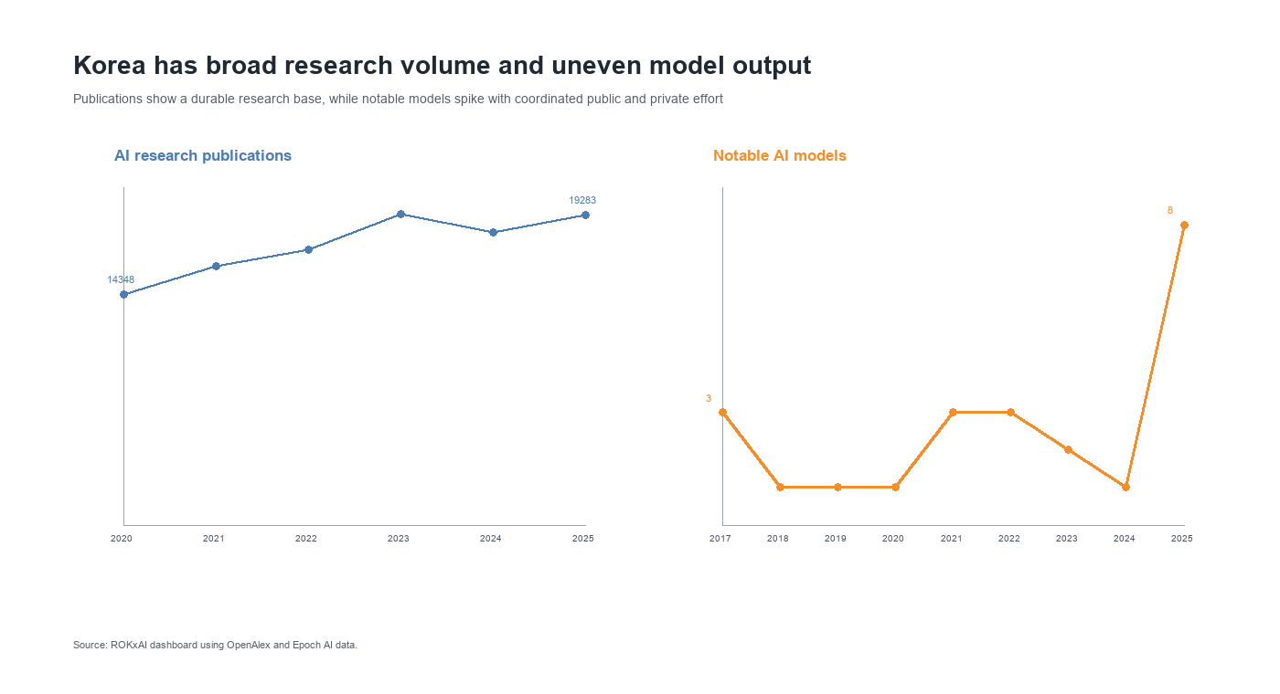
Figure 4. Korea combines broad research volume with uneven but rising model output.
The AI co scientist agenda is strategically important because it directs AI capability into fields where Korea already has industrial and scientific depth. MSIT's 2026 plan targets life sciences, earth sciences, mathematics, materials and chemistry, semiconductors and displays, and secondary batteries. The value of this agenda is not only discovery. It can generate datasets, laboratory routines, benchmarks, and domain specific methods that firms later absorb into production. In Bush's terms, Korea needs basic research as a long horizon national asset; in Ding's terms, that research becomes power only when it improves diffusion capacity.^{17,23,22}

Adoption Layer: Robots, Skills, and Physical Deployment
Korea's adoption layer is the strongest argument for a distinctive AI strategy because the country can connect software intelligence to physical production faster than many competitors. The dashboard shows high robot density, rising AI engineering skills diffusion, broad worker experimentation with generative AI, and measurable AI diffusion across the economy. Yet the flat trend in annual robot installations suggests that adoption is reaching a more difficult stage. Korea must now integrate perception, planning, simulation, safety assurance, and human workflow redesign into already automated environments.²
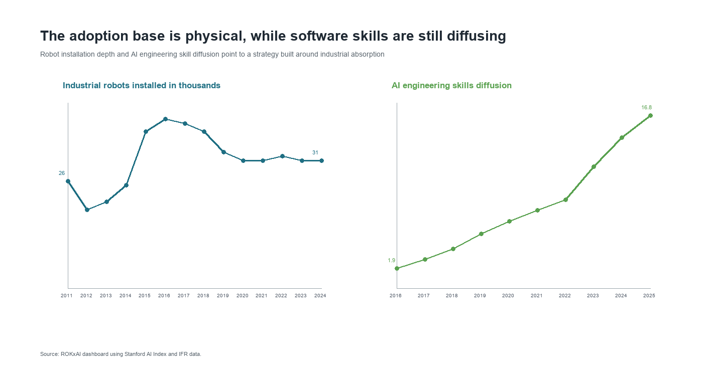
Figure 5. Korea's physical adoption base is deeper than its software skills layer.
The 2026 Work Plan's emphasis on regional AI transformation and Physical AI fits Korea's industrial structure. MSIT's Physical AI Global Alliance, launched in September 2025 with participation from government, industry, universities, research institutes, and demand side firms such as Hyundai Motor, HD Hyundai Heavy Industries, and LG AI Research, shows that the state is trying to organize physical deployment as a national arena rather than a collection of firm projects. Manufacturing, logistics, shipbuilding, mobility, semiconductors, displays, and batteries provide demanding test environments where AI can raise productivity and produce exportable deployment templates. The state should treat these environments as national test beds for safety cases, interoperable tools, and sector benchmarks. If Korea succeeds, its comparative advantage will lie in reliable AI systems that operate in factories, vehicles, hospitals, ports, and defense networks.^{17,18,2}

Startup and Funding Layer
The startup and funding layer is broad enough to matter but not yet deep enough to carry national strategy without public demand creation. The dashboard records about 329 newly funded AI companies from 2013 through 2025 and total AI investment of about USD 10.75 billion over that period, with 2025 private AI investment at about USD 1.78 billion. The domain pattern is concentrated in health care and life sciences, business services, general purpose AI, and consumer services. Defense, public governance, industrial infrastructure, and education receive smaller amounts in the available investment data, even though they are central to the strategic logic of Korean AI.²
This funding pattern is not a market failure in the abstract; it reflects the revenue horizons of private capital. Strategic sectors often require regulated data, public procurement, liability rules, testing infrastructure, and patient reference customers before startups can scale. Korea's policy task is to convert public missions into credible markets without insulating weak firms from competition. Procurement sandboxes, milestone contracts, public data trusts, and access to national compute can link startups to defense, health, manufacturing, and regional transformation while preserving pressure to meet technical and commercial benchmarks.^{10,2}
The political economy of Korean AI makes this design especially important because chaebol and platform firms are necessary for scale but can also become gatekeepers. Samsung, SK, Hyundai, LG, Naver, Kakao, and telecom groups can provide data centers, customer bases, devices, factories, and export channels that smaller firms cannot reproduce. The state should therefore use consortium support to create shared infrastructure while using procurement and interface rules to keep startups from becoming dependent subcontractors. Korea's older developmental bargain between the state and large firms needs a digital supplement that preserves contestability in models, tools, and applications.^{10,9,14}
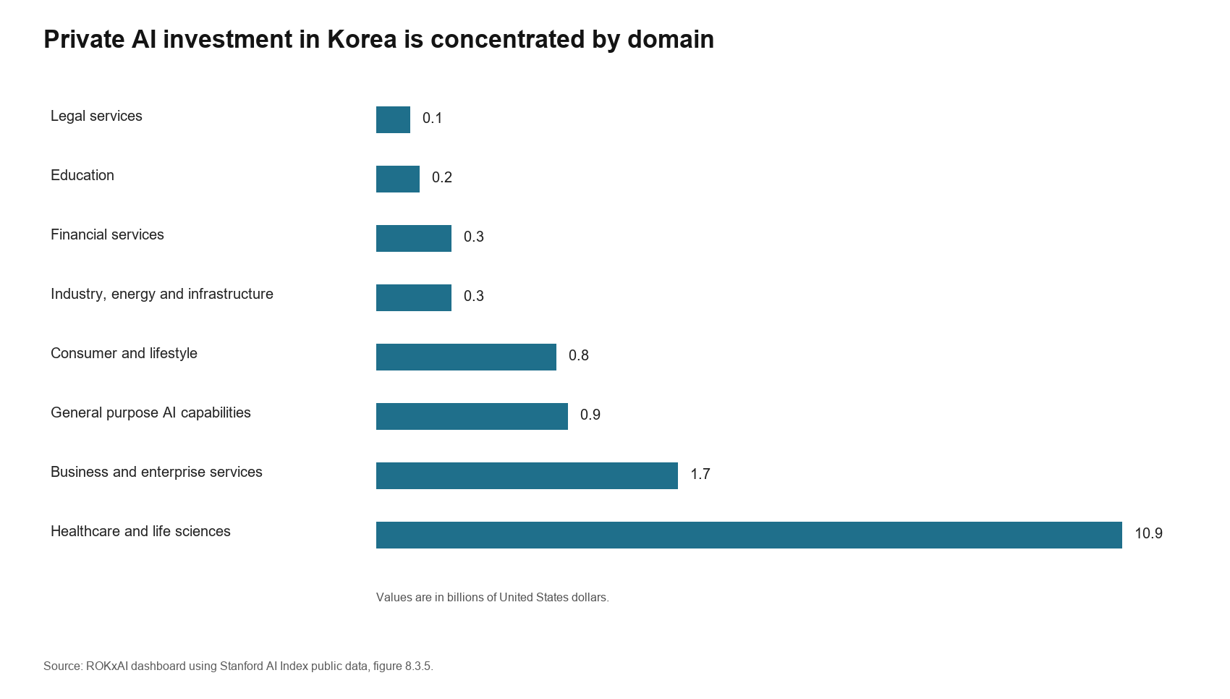
Figure 6. Korea's private AI investment is concentrated in a few domains.

Strategic Assessment of Capacity
Korea's capacity building strategy is strongest where it exploits the interaction of memory, manufacturing, trusted data governance, and applied deployment. It is weakest where it attempts to imitate superpower scale without controlling the full accelerator, cloud, and model ecosystem. A credible Korean strategy should therefore define success as specialized strategic indispensability rather than general AI supremacy. In practical terms, that means becoming the allied supplier of trusted memory and industrial AI deployment, the regional platform for regulated AI services, and a military innovator in sensor rich defense systems.^{10,1,2}
The NTSF pillars also reveal the main institutional risk. The state has begun to coordinate, science produces dense technical output, and industry has world class assets, but each pillar can still optimize for its own metrics. Ministries can count GPUs, researchers can count papers, and firms can count closed customers without producing national strategic power. Korea's next phase should therefore measure capacity by diffusion into strategically important uses: factory productivity, defense readiness, public service efficiency, startup access to compute, trusted data reuse, and leverage in allied technology bargaining.^{10,22}

Historical and Comparative Logic
The course cases are useful only if they identify mechanisms rather than analogies of scale. The United States synthetic rubber program shows how a state can respond when a strategic input becomes scarce and private competition alone cannot solve the bottleneck. After Japan cut off most natural rubber access, the United States used the Rubber Reserve Company, public plant construction, priority allocation, patent sharing, a common GRS formula, and demand assurance to compel cooperation among competing firms. The lesson for Korea is selective pooling. Compute, high quality Korean data, safety evaluation, and sector benchmarks should be treated like scarce strategic inputs where duplication wastes national capacity, while firms still compete downstream in models, applications, and services. The limit is equally important: rubber was a discrete wartime substitute target, whereas AI is a general purpose system with privacy, copyright, and competition concerns.^{24,25}
The Manhattan Project offers a narrower lesson than crash mobilization rhetoric usually suggests. Wellerstein's account emphasizes that the project was not just science. Oak Ridge, Hanford, Los Alamos, universities, industrial contractors, and military administration converted uncertain research into production through systems integration under extraordinary risk. Korea should not imitate secrecy or total war governance. The relevant parallel is the organization of hard infrastructure around bottlenecks. Defense AI, model assurance, critical infrastructure AI, and AI for science require test ranges, evaluation institutions, procurement channels, and data pipelines that absorb risk no single firm can rationally carry alone.^{26,19}
Bush's Science, The Endless Frontier points to the opposite horizon: durable scientific capital. Bush argued that government could promote industrial research by expanding basic knowledge and scientific talent, not by managing every application. Korea's K Moonshot, AI co scientist agenda, semiconductor and materials AI, Korean language benchmarks, and safety research should be interpreted in that tradition. The caution is that Bush's university centered model is incomplete for AI, where capability also comes from deployed systems, open source communities, private labs, and operational data. Korea therefore needs a research base joined to diffusion institutions rather than research funding detached from industrial use.^{23,17,27}
Meiji Japan adds a learning mechanism: progressive absorption rather than imitation. Ohno's account describes a shift from foreign dependent turnkey projects toward Japanese owned operation through technical education, imported machinery, foreign advisers, domestic engineering institutions, and adaptation after failed copying. Korea is not a late industrializer in the Meiji sense, but the mechanism applies to AI dependence. Seoul can import GPUs, cloud services, open models, and foreign partnerships while deliberately localizing the layers where dependence would reduce leverage: Korean data spaces, high bandwidth memory integration, manufacturing AI, defense assurance, and Korean language systems. Comparative cases reinforce this point. Taiwan turns foundry centrality into strategic indispensability; Singapore turns trusted digital infrastructure into governance influence; Israel turns defense demand and venture finance into deep tech formation. Korea's distinctive model must combine all three logics without confusing selective sovereignty with autarky.^{28,29,30,31}

Conclusion
Korea's AI strategy has evolved from digital catch up policy into an attempt to govern a national AI stack. Its strongest path is selective, infrastructural, and adoption centered. It does not require Korea to match the United States or China in frontier model scale. It requires Korea to use its narrower control points to become valuable to allies, productive under demographic constraint, and institutionally credible in trusted deployment.^{22,3}
Success should be measured less by the slogan of AI top three than by concrete indicators of strategic conversion: lawful Korean data reuse, startup and university access to compute, small and medium enterprise participation in manufacturing AI, defense systems validated through realistic testing, productivity gains in shipyards and fabs, credible high impact AI oversight, and allied reliance on Korean memory and production capacity. Korea has the assets to make AI an instrument of statecraft, but only if the control tower turns a broad action plan into a ranked set of bottlenecks and missions.^{7,11,32}

Notes
The notes record the official policy sources, course materials, data sources, and comparative references used to support the factual and analytical claims in the paper.
1. Stanford Institute for Human Centered Artificial Intelligence, The 2026 AI Index Report, 2026.
2. ROKxAI dashboard, consolidated public source dataset, collected May 3, 2026.
3. Darcie Draudt Vejares and Seungjoo Lee, Governing AI in the Shadow of Giants: Korea's Strategic Response to Great Power AI Competition, Carnegie Endowment for International Peace, April 30, 2026.
4. TrendForce, press release on second quarter DRAM revenue and supplier shares, September 2, 2025.
5. Ministry of Science and ICT, press release on the Basic Act on the Development of Artificial Intelligence and the Establishment of a Trustworthy Foundation entering into force, January 22, 2026.
6. Ministry of Science and ICT, press release on establishment of the National AI Strategy Committee, September 16, 2025.
7. National Artificial Intelligence Strategy Committee and Ministry of Science and ICT, Republic of Korea Artificial Intelligence Action Plan, February 2026.
8. Ministry of Science and ICT, press release on the KRW 1.9067 trillion supplementary AI budget, May 19, 2025.
9. Ministry of Science and ICT, press release on the Sovereign AI Foundation Model project, August 18, 2025.
10. National Technology Strategy Framework, Version 2, class discussion document, 2026.
11. OECD and Korea Labor Institute, Artificial Intelligence and the Labour Market in Korea, OECD Publishing, 2025.
12. Yonhap News Agency, report on the launch of the Defense AI Center, April 1, 2024.
13. Personal Information Protection Commission, Personal Information Protection Act materials on pseudonymized information, accessed May 5, 2026.
14. NVIDIA, press release on Korea AI infrastructure with the Korean government and industrial firms, October 30, 2025.
15. Ministry of Science and ICT, National Strategy for Artificial Intelligence, December 17, 2019.
16. Ministry of Science and ICT, National Digital Strategy announcement, September 28, 2022.
17. Ministry of Science and ICT, 2026 Work Plan, December 12, 2025.
18. Ministry of Science and ICT, press release on the Physical AI Global Alliance, September 29, 2025.
19. Michael C. Horowitz, Artificial Intelligence, International Competition, and the Balance of Power, Texas National Security Review 1, no. 3, May 2018.
20. Personal Information Protection Commission, press release on the prior adequacy review of Kakao Kanana, March 13, 2025.
21. Ministry of Science and ICT, press release on GPU Procurement Project participants, July 2025.
22. Jeffrey Ding, Technology and the Rise of Great Powers: How Diffusion Shapes Economic Competition, Princeton University Press, 2024.
23. Vannevar Bush, Science, The Endless Frontier, report to the President, 1945.
24. American Chemical Society, United States Synthetic Rubber Program, 1939 to 1945, National Historic Chemical Landmark booklet, 1998.
25. Alexander J. Field, The World War Two U.S. Rubber Famine, forthcoming in Business History Review, 2026.
26. Alex Wellerstein, Manhattan Project, Encyclopedia of the History of Science, 2019.
27. Kyunghyang Shinmun, report on final approval of the Republic of Korea Artificial Intelligence Action Plan and K Moonshot, February 25, 2026.
28. Kenichi Ohno, Meiji Japan: Progressive Learning of Western Technology, in How Nations Learn: Technological Learning, Industrial Policy, and Catch Up, edited by Arkebe Oqubay and Kenichi Ohno, Oxford University Press, 2019.
29. Taiwan National Development Council, Ten AI Initiatives Promotion Plan, 2025 to 2028, approved January 28, 2026.
30. Government of Singapore, National Artificial Intelligence Strategy 2.0, 2023, and Smart Nation 2.0, 2024.
31. Israel Innovation Authority, The State of High Tech, Annual Report 2025.
32. Sean Hyuk Hyun Kwon and J. James Kim, From Compute to Capacity: South Korea's Approach to Industrial AI Adoption, Stimson Center, February 6, 2026.

Selected Bibliography
The bibliography prioritizes official Korean policy materials, class frameworks, international datasets, and comparative technology strategy sources rather than general commentary on AI.
National Artificial Intelligence Strategy Committee and Ministry of Science and ICT, Republic of Korea Artificial Intelligence Action Plan, February 2026.
American Chemical Society, United States Synthetic Rubber Program, 1939 to 1945, National Historic Chemical Landmark booklet, 1998.
Alexander J. Field, The World War Two U.S. Rubber Famine, forthcoming in Business History Review, 2026.
Ministry of Science and ICT, National Strategy for Artificial Intelligence, December 17, 2019.
Ministry of Science and ICT, National Digital Strategy announcement, September 28, 2022.
Ministry of Science and ICT, press release on the Basic Act on the Development of Artificial Intelligence and the Establishment of a Trustworthy Foundation entering into force, January 22, 2026.
Ministry of Science and ICT, press release on establishment of the National AI Strategy Committee, September 16, 2025.
Ministry of Science and ICT, press release on the KRW 1.9067 trillion supplementary AI budget, May 19, 2025.
Ministry of Science and ICT, press release on GPU Procurement Project participants, July 2025.
Ministry of Science and ICT, press release on the Sovereign AI Foundation Model project, August 18, 2025.
Ministry of Science and ICT, press release on the Physical AI Global Alliance, September 29, 2025.
Ministry of Science and ICT, 2026 Work Plan, December 12, 2025.
OECD and Korea Labor Institute, Artificial Intelligence and the Labour Market in Korea, OECD Publishing, 2025.
Stanford Institute for Human Centered Artificial Intelligence, The 2026 AI Index Report, 2026.
TrendForce, press release on second quarter DRAM revenue and supplier shares, September 2, 2025.
NVIDIA, press release on Korea AI infrastructure with the Korean government and industrial firms, October 30, 2025.
Darcie Draudt Vejares and Seungjoo Lee, Governing AI in the Shadow of Giants: Korea's Strategic Response to Great Power AI Competition, Carnegie Endowment for International Peace, April 30, 2026.
Sean Hyuk Hyun Kwon and J. James Kim, From Compute to Capacity: South Korea's Approach to Industrial AI Adoption, Stimson Center, February 6, 2026.
Sean Hyuk Hyun Kwon, Revolutionizing the Industrial Base: South Korea's AI Integration in Manufacturing, Stimson Center, February 9, 2026.
Personal Information Protection Commission, Personal Information Protection Act materials on pseudonymized information, accessed May 5, 2026.
Michael C. Horowitz, Artificial Intelligence, International Competition, and the Balance of Power, Texas National Security Review 1, no. 3, May 2018.
Jeffrey Ding, Technology and the Rise of Great Powers: How Diffusion Shapes Economic Competition, Princeton University Press, 2024.
Kenichi Ohno, Meiji Japan: Progressive Learning of Western Technology, in How Nations Learn: Technological Learning, Industrial Policy, and Catch Up, edited by Arkebe Oqubay and Kenichi Ohno, Oxford University Press, 2019.
Alex Wellerstein, Manhattan Project, Encyclopedia of the History of Science, 2019.
Vannevar Bush, Science, The Endless Frontier, report to the President, 1945.
Government of Singapore, National Artificial Intelligence Strategy 2.0, 2023, and Smart Nation 2.0, 2024.
Taiwan National Development Council, Ten AI Initiatives Promotion Plan, 2025 to 2028, approved January 28, 2026.
Israel Innovation Authority, The State of High Tech, Annual Report 2025.
ROKxAI dashboard, consolidated public source dataset, collected May 3, 2026.

