ICAP VPN Request Form

General Customer Information:
Request Creation Date:(dd/mm/yr):
Customer Name: | Customer Phone:
Requester Name: Martin Lumsden GSD EMEA | Requester Phone: +44 20 7029 9029
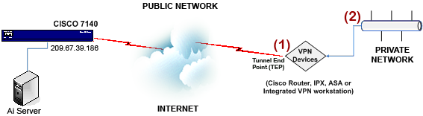

Customer Network Information:
TEP IP Address (Public IP – refer to (1) on illustration):
Developer IP Source or Host IP Address (Private IP – refer to (2) on illustration):

EBS VPN Router Configuration:
EBS Lab VPN Gateway TEP IP Address: | 209.67.39.186
ISAKMP Parameters:
Authentication Type: | Pre-shared key
Hash Algorithm: | SHA/HMAC-160 or SHA1
Encryption Algorithm: | 3DES
Diffie-Helman Group: | 2
Pre-shared Key: | (TBD)
IKE SAs: | 86400 seconds (24 Hours)
IPSEC Parameters:
IPSEC Protocol: | ESP
Mode: | Tunnel
Authentication Hash:  Group: | SHA/HMAC-160 or SHA1  1024-bit
Encryption Protocol: | 3DES
EBS Encryption Domain: | (determined by lab group)
IPSEC SAs Lifetime: | 28800 seconds (8hours)
Perfect Forward Secrecy (PFS): | Disabled

