Part 1 Selected Exhibits

Table 1.1 Factor premiums before and after publication
Factor | Period | N | Mean monthly return | t-stat
Mkt-RF | 1927–1992 | 792 | 0.655% | 3.219*
SMB | 1927–1992 | 792 | 0.240% | 2.126*
HML | 1927–1992 | 792 | 0.435% | 3.333*
Mkt-RF | 1993–Jul 2023 | 367 | 0.719% | 3.091*
SMB | 1993–Jul 2023 | 367 | 0.100% | 0.599
HML | 1993–Jul 2023 | 367 | 0.146% | 0.830
Source and scope: Kenneth R. French Data Library; US monthly factor returns, Jan 1927–Jul 2023. Arithmetic mean monthly returns; t-statistics without autocorrelation adjustment. * = significant at 5% (two-sided, approximate critical value |t| > 1.96).

Table 1.2 Annualized performance of MSCI factor indexes
Strategy | Annualized return | Annualized volatility | Sharpe ratio
MSCI USA | 11.22% | 15.44% | 0.587
Value | 9.87% | 15.27% | 0.505
Minimum volatility | 10.42% | 12.09% | 0.683
Equal weight | 11.81% | 17.13% | 0.563
Momentum | 13.38% | 16.34% | 0.686
Multi-factor | 11.37% | 14.40% | 0.639
Risk-free | 2.16% | 0.61% | —
Source and scope: MSCI and Kenneth French Data Library. MSCI USA large- and mid-cap equity universe; MSCI USA and four factor indexes, gross total returns in USD, Jan 1995–Jul 2023 (343 months). Multi-factor: equal-weighted across four factor indexes, rebalanced monthly. Annualized arithmetic returns = monthly mean × 12; annualized volatility = monthly sample standard deviation × sqrt(12). Sharpe ratios use the Fama-French risk-free rate.

Figure 1.1 Annualized arithmetic returns by strategy
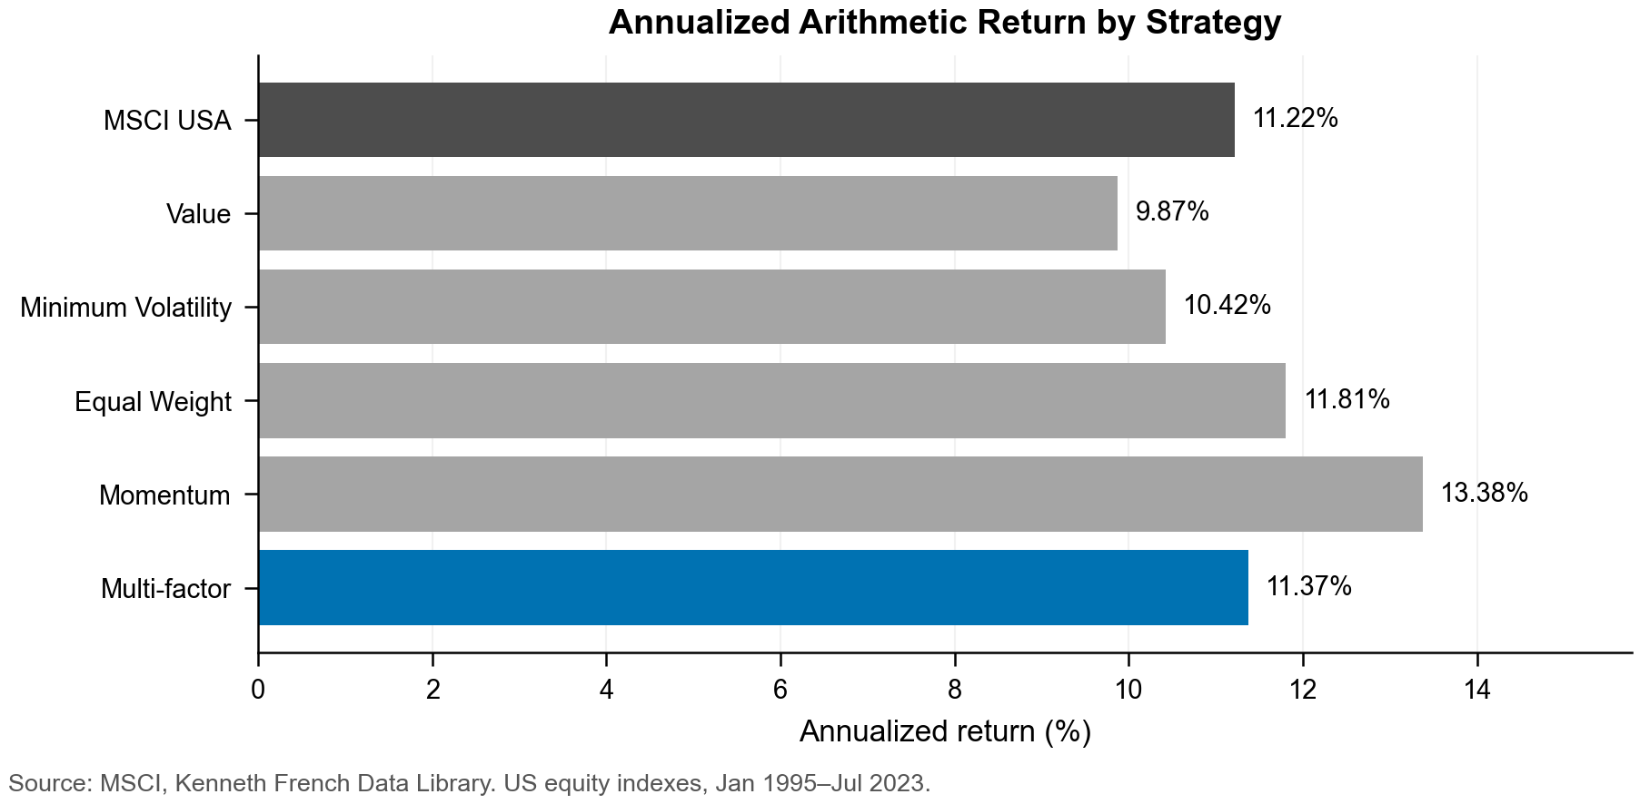

Figure 1.2 Risk-adjusted performance by strategy
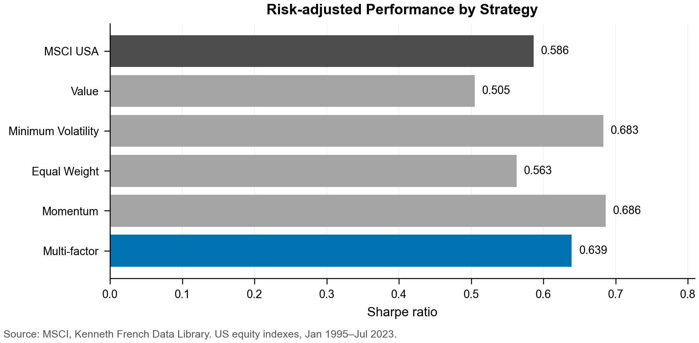

Table 1.3 Correlation between MSCI and academic factor spreads
MSCI spread | HML | SMB | Momentum | Low-beta
Value | 0.728 | -0.177 | -0.244 | 0.415
Minimum volatility | 0.232 | -0.307 | 0.303 | 0.815
Equal weight | 0.431 | 0.322 | -0.449 | -0.200
Momentum | -0.223 | 0.079 | 0.642 | 0.140
Source and scope: MSCI and Kenneth French Data Library. MSCI USA large- and mid-cap equity universe; monthly US factor return spreads, Jan 1995–Jul 2023 (343 months). MSCI spreads are factor index returns minus MSCI USA returns. Academic spreads are HML, SMB, high-minus-low momentum and low-minus-high beta. Pearson correlations; corresponding factor pairs are highlighted in green.

Table 1.4 Momentum performance by market volatility regime
Regime | Months | Mean market vol. | Mean momentum
Low | 111 | 8.21% | +1.04%
Medium | 110 | 14.19% | +1.86%
High | 111 | 21.53% | -1.03%
Source and scope: Kenneth French Data Library, US value-weighted momentum decile portfolios, Dec 1995–Jul 2023 (332 months). Market volatility is the annualized standard deviation of trailing 12 monthly Mkt-RF observations. Regimes are sample terciles. Momentum is the value-weighted highest-minus-lowest decile return spread. High-minus-low Welch test: p = 0.103.
Regression: beta = -0.267; OLS p = 0.001; HAC(12) t = -2.297, p = 0.022; R-squared = 3.15%.

Figure 1.3 Momentum returns across volatility regimes
