Part 3 Selected Exhibits

Table 3.1 Optimal industry weights as of 31 December 2004
Industry | Min-var (shorts) | Min-var (long-only) | Inverse vol | Industry | Min-var (shorts) | Min-var (long-only) | Inverse vol
Agriculture | 6.4% | 10.7% | 2.2% | Defense | 13.7% | 9.3% | 1.7%
Food products | 19.5% | 9.1% | 2.9% | Precious metals | -1.1% | 0.7% | 1.0%
Candy & soda | -5.1% | 0.0% | 1.5% | Non-precious mining | 5.2% | 0.0% | 2.0%
Beer & liquor | -1.8% | 0.0% | 2.1% | Coal | -1.7% | 0.0% | 1.0%
Tobacco | 0.1% | 0.0% | 1.4% | Petroleum & natural gas | 19.3% | 1.6% | 2.5%
Recreation | -0.5% | 0.0% | 2.0% | Utilities | 21.5% | 16.7% | 2.8%
Entertainment | 1.3% | 0.0% | 1.8% | Communication | 0.2% | 2.9% | 2.0%
Printing & publishing | 41.3% | 7.7% | 2.7% | Personal services | -13.5% | 0.0% | 2.2%
Consumer goods | 21.2% | 12.3% | 2.7% | Business services | -32.3% | 0.0% | 2.4%
Apparel | 2.3% | 0.0% | 2.0% | Computer hardware | 2.0% | 0.0% | 1.2%
Healthcare services | -4.9% | 0.0% | 1.8% | Computer software | 10.3% | 0.0% | 1.3%
Medical equipment | 25.2% | 5.9% | 2.9% | Electronic equipment | 1.3% | 0.0% | 1.2%
Pharmaceuticals | -1.2% | 9.5% | 2.5% | Measuring & control equip. | -4.2% | 0.0% | 1.6%
Chemicals | -28.4% | 0.0% | 2.4% | Business supplies | 26.0% | 0.0% | 2.5%
Rubber & plastics | 9.4% | 0.0% | 2.2% | Shipping containers | -3.3% | 0.0% | 1.9%
Textiles | 0.1% | 0.0% | 2.1% | Transportation | 7.8% | 0.0% | 2.4%
Construction materials | -3.8% | 0.0% | 2.4% | Wholesale | -5.3% | 0.0% | 2.6%
Construction | -17.8% | 0.0% | 1.9% | Retail | 0.6% | 0.0% | 2.3%
Steel works | 6.8% | 0.0% | 1.5% | Restaurants & hotels | 13.9% | 0.0% | 2.5%
Fabricated products | -2.4% | 0.0% | 1.7% | Banking | -16.6% | 0.0% | 2.3%
Machinery | -2.3% | 0.0% | 1.8% | Insurance | -4.0% | 0.0% | 2.5%
Electrical equipment | -8.1% | 0.0% | 2.0% | Real estate | 23.0% | 13.7% | 2.8%
Autos & trucks | 6.3% | 0.0% | 1.8% | Trading | -4.5% | 0.0% | 1.6%
Aircraft | -20.6% | 0.0% | 1.8% | Other | -0.3% | 0.0% | 1.8%
Ships & rail equipment | -0.7% | 0.0% | 1.9% | Sum of weights | 100.0% | 100.0% | 100.0%

Source and scope: Kenneth French Data Library; MSCI. 49 Fama-French industries, value-weighted total returns; covariance estimated Jan 1995 - Dec 2004. Fully invested. Green = 5 largest weights per portfolio; red = 5 smallest (long-only: all 37 zero-weight industries). Industries in Fama-French order.

Table 3.2 Portfolio characteristics as of 31 December 2004
Characteristic | Min-var (shorts allowed) | Min-var (long-only) | Inverse volatility
Sum of weights | 100.0% | 100.0% | 100.0%
Non-zero positions | 49 | 12 | 49
Short positions | 24 | 0 | 0
Largest weight | 41.3% | 16.7% | 2.9%
Smallest weight | -32.3% | 0.0% | 1.0%
Top-5 weight | 137.0% | 62.8% | 14.1%
Effective N = 1/Σw² | 1.1 | 9.1 | 46.3

Source and scope: Kenneth French Data Library; MSCI. Weights from Table 3.1. Effective N equals 49 for equal weights; it is not meaningful for the portfolio with short positions.

Table 3.3 In-sample versus out-of-sample annualized volatility
Portfolio | In-sample vol, Jan 1995 - Dec 2004 | Out-of-sample vol, Jan 2005 - Jul 2023 | Ratio OOS / in-sample
Min-var (shorts allowed) | 7.6% | 16.7% | ×2.21
Min-var (long-only) | 10.3% | 14.3% | ×1.39
Inverse volatility | 14.0% | 17.2% | ×1.23
Equal weight (49 industries) | 14.6% | 17.5% | ×1.19
Lowest-vol industry in 1995–2004 (Food products) | 15.2% | 12.7% | ×0.83

Source and scope: Kenneth French Data Library; MSCI. Weights from Table 3.1 held constant and rebalanced monthly. Reference rows (equal weight; lowest-volatility industry in 1995-2004, Food products) use the same data and only information available at Dec 2004.

Table 3.4 Out-of-sample volatility by sub-period
Out-of-sample sub-period | Min-var (shorts) | Min-var (long-only) | Inverse vol | Equal weight
2005–2014 | 16.9% | 14.4% | 17.3% | 17.6%
2015–2023/07 | 16.7% | 14.2% | 17.2% | 17.4%
2005–2007 (pre-GFC) | 10.0% | 7.5% | 8.9% | 9.3%
2008–2009 (GFC) | 31.6% | 24.3% | 28.7% | 29.0%

Source and scope: Kenneth French Data Library; MSCI. Annualized volatility of monthly returns within each sub-period; 3A weights, no re-estimation. The long-only portfolio is the lowest of the three in every sub-period.

Table 3.5 Long-only minimum-variance weights before and after re-optimization
Industry | Weights as of Dec 2004 | Weights as of Dec 2015 | Change
Food products | 9.1% | 37.4% | +28.3 pp
Utilities | 16.7% | 23.3% | +6.6 pp
Beer & liquor | 0.0% | 21.2% | +21.2 pp
Retail | 0.0% | 13.4% | +13.4 pp
Precious metals | 0.7% | 4.8% | +4.0 pp
Real estate | 13.7% | 0.0% | -13.7 pp
Consumer goods | 12.3% | 0.0% | -12.3 pp
Agriculture | 10.7% | 0.0% | -10.7 pp
Pharmaceuticals | 9.5% | 0.0% | -9.5 pp
Defense | 9.3% | 0.0% | -9.3 pp
Printing & publishing | 7.7% | 0.0% | -7.7 pp
Medical equipment | 5.9% | 0.0% | -5.9 pp
Communication | 2.9% | 0.0% | -2.9 pp
Petroleum & natural gas | 1.6% | 0.0% | -1.6 pp
Turnover (½Σ|Δw|) |  |  | 73.5%

Source and scope: Kenneth French Data Library; MSCI. Dec 2004: covariance Jan 1995 - Dec 2004 (Table 3.1). Dec 2015: same method, covariance Jan 2006 - Dec 2015. Industries with a non-zero weight in at least one portfolio.

Table 3.6 Annualized volatility, January 2016 - July 2023
Period | Dec 2004 weights | Dec 2015 weights | Equal weight | New − old
Full: Jan 2016 - Jul 2023 | 14.5% | 12.8% | 17.8% | -1.7 pp
Pre-COVID: 2016 - 2019 | 10.8% | 10.3% | 12.9% | -0.5 pp
COVID and after: 2020 - Jul 2023 | 17.9% | 15.2% | 22.2% | -2.7 pp
Cumulative return, Feb - Mar 2020 | -21.2% | -15.1% | -24.6% | +6.2 pp

Source and scope: Kenneth French Data Library; MSCI. Both portfolios out-of-sample; weights held constant and rebalanced monthly. Last row: compounded return over Feb - Mar 2020 (two months are too few for a volatility estimate).

Table 3.7 Performance of the Dec 2004 long-only minimum-variance portfolio and MSCI USA
Jan 2005 - Jul 2023 | Long-only min-var | MSCI USA
Final value of $1 (Jul 2023) | $4.79 | $5.53
Annualized return (geometric) | 8.8% | 9.6%
Annualized volatility | 14.3% | 15.3%
Maximum drawdown | -45.7% | -50.6%
Cumulative return, GFC (Sep 2008 - Feb 2009) | -40.3% | -41.8%
Cumulative return, COVID (Feb - Mar 2020) | -21.2% | -19.8%

Source and scope: Kenneth French Data Library; MSCI. Fama-French 49 industries (all CRSP stocks, value-weighted) and MSCI USA Standard (large + mid cap), gross, USD. Annualized return is geometric (compound growth). Crisis returns compounded over the stated months.

Table 3.8 Crisis returns of the portfolio's holdings
Industry held | Weight | GFC return | GFC contribution | COVID return | COVID contribution
Utilities | 16.7% | -33% | -5.5% | -22% | -3.6%
Real estate | 13.7% | -67% | -9.2% | -42% | -5.8%
Consumer goods | 12.3% | -35% | -4.3% | -15% | -1.8%
Agriculture | 10.7% | -33% | -3.6% | -17% | -1.8%
Pharmaceuticals | 9.5% | -24% | -2.3% | -7% | -0.7%
Defense | 9.3% | -44% | -4.1% | -20% | -1.8%
Food products | 9.1% | -24% | -2.2% | -13% | -1.2%
Printing & publishing | 7.7% | -56% | -4.4% | -28% | -2.2%
Medical equipment | 5.9% | -42% | -2.5% | -18% | -1.1%
Communication | 2.9% | -37% | -1.1% | -19% | -0.5%
Petroleum & natural gas | 1.6% | -38% | -0.6% | -45% | -0.7%
Precious metals | 0.7% | -12% | -0.1% | -3% | -0.0%

Source and scope: Kenneth French Data Library; MSCI. GFC: Sep 2008 - Feb 2009; COVID: Feb - Mar 2020. Contribution ≈ weight × industry crisis return (approximate, as the portfolio is rebalanced monthly). Real estate (shaded) was among the five worst industries in both crises.

Table 3.9 Ten best-performing industries in each crisis
Industry (GFC) | Return | Vol rank | Weight | Industry (COVID) | Return | Vol rank | Weight
Precious metals | -12% | 48 / 48 | 0.7% | Precious metals | -3% | 48 / 48 | 0.7%
Beer & liquor | -22% | 22 / 11 | – | Pharmaceuticals | -7% | 8 / 9 | 9.5%
Personal services | -24% | 21 / 20 | – | Retail | -10% | 17 / 10 | –
Pharmaceuticals | -24% | 8 / 4 | 9.5% | Tobacco | -13% | 44 / 23 | –
Food products | -24% | 1 / 2 | 9.1% | Food products | -13% | 1 / 4 | 9.1%
Restaurants & hotels | -26% | 11 / 13 | – | Computer software | -15% | 45 / 14 | –
Candy & soda | -29% | 42 / 42 | – | Consumer goods | -15% | 5 / 2 | 12.3%
Tobacco | -30% | 44 / 43 | – | Measuring & control equip. | -16% | 41 / 20 | –
Retail | -30% | 17 / 17 | – | Shipping containers | -16% | 31 / 22 | –
Utilities | -33% | 3 / 5 | 16.7% | Business supplies | -16% | 10 / 16 | –

Source and scope: Kenneth French Data Library; MSCI. Vol rank = rank of annualized volatility among 49 industries (1 = lowest): Jan 1995 - Dec 2004 / ten years before the crisis. Weight = Dec 2004 long-only minimum-variance weight (– = not held).

Figure 3.1 Sorted industry weights of the three portfolios (3A)
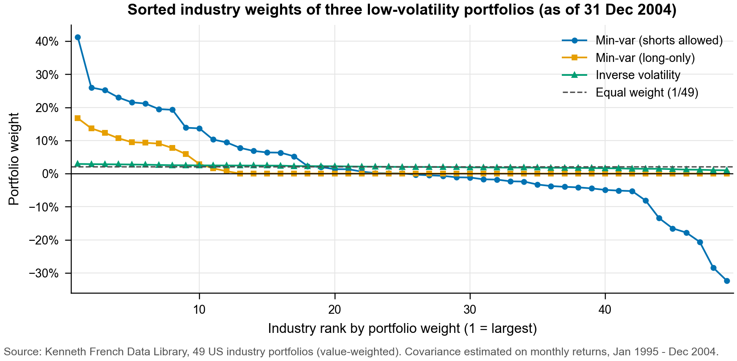

Figure 3.2 In-sample volatility, Jan 1995 - Dec 2004 (3B)
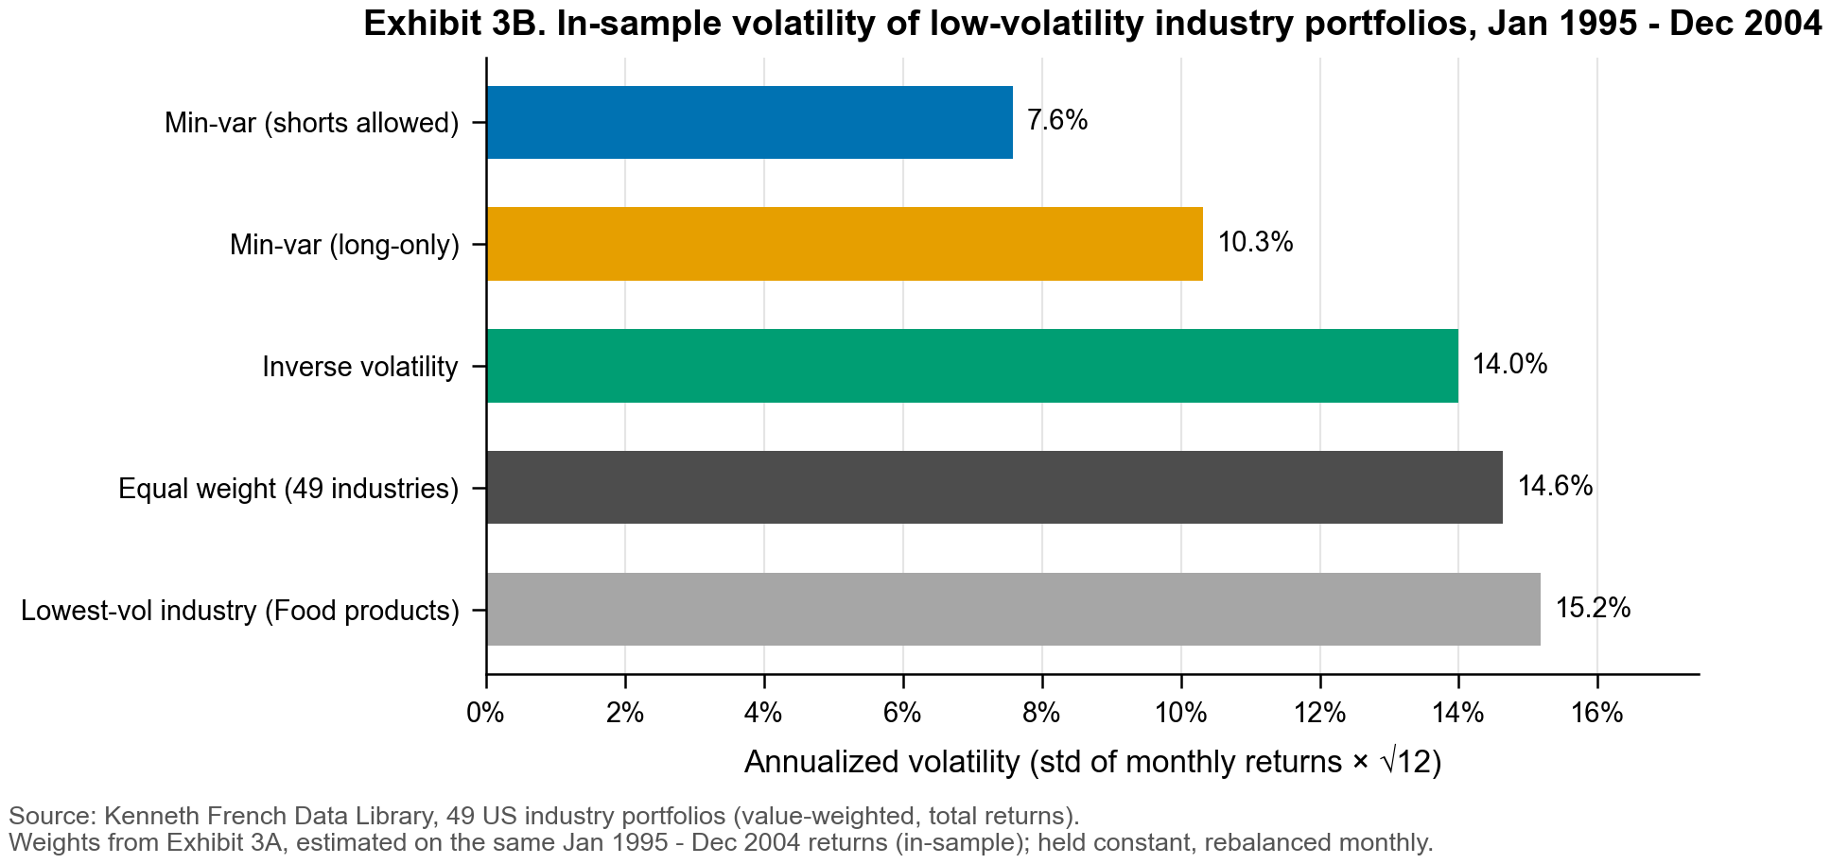

Figure 3.3 In-sample versus out-of-sample volatility (3B-3C)
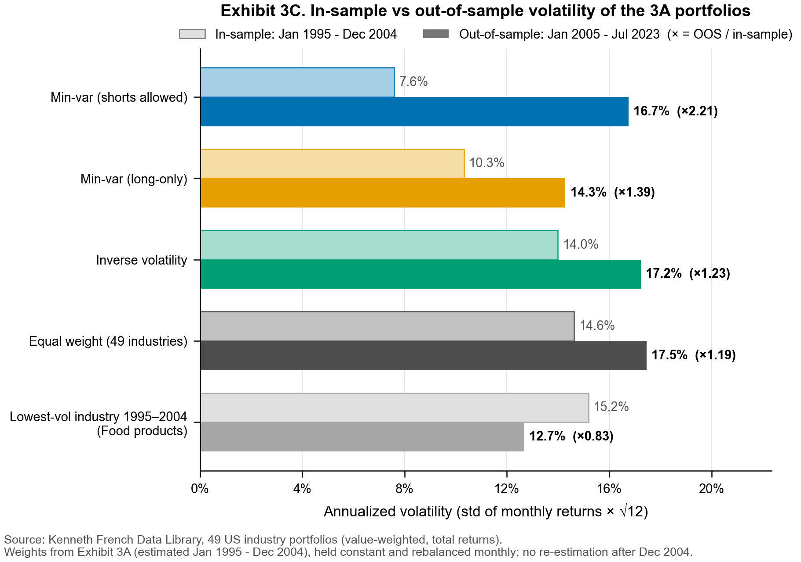

Figure 3.4 Rolling 36-month out-of-sample volatility (3C)
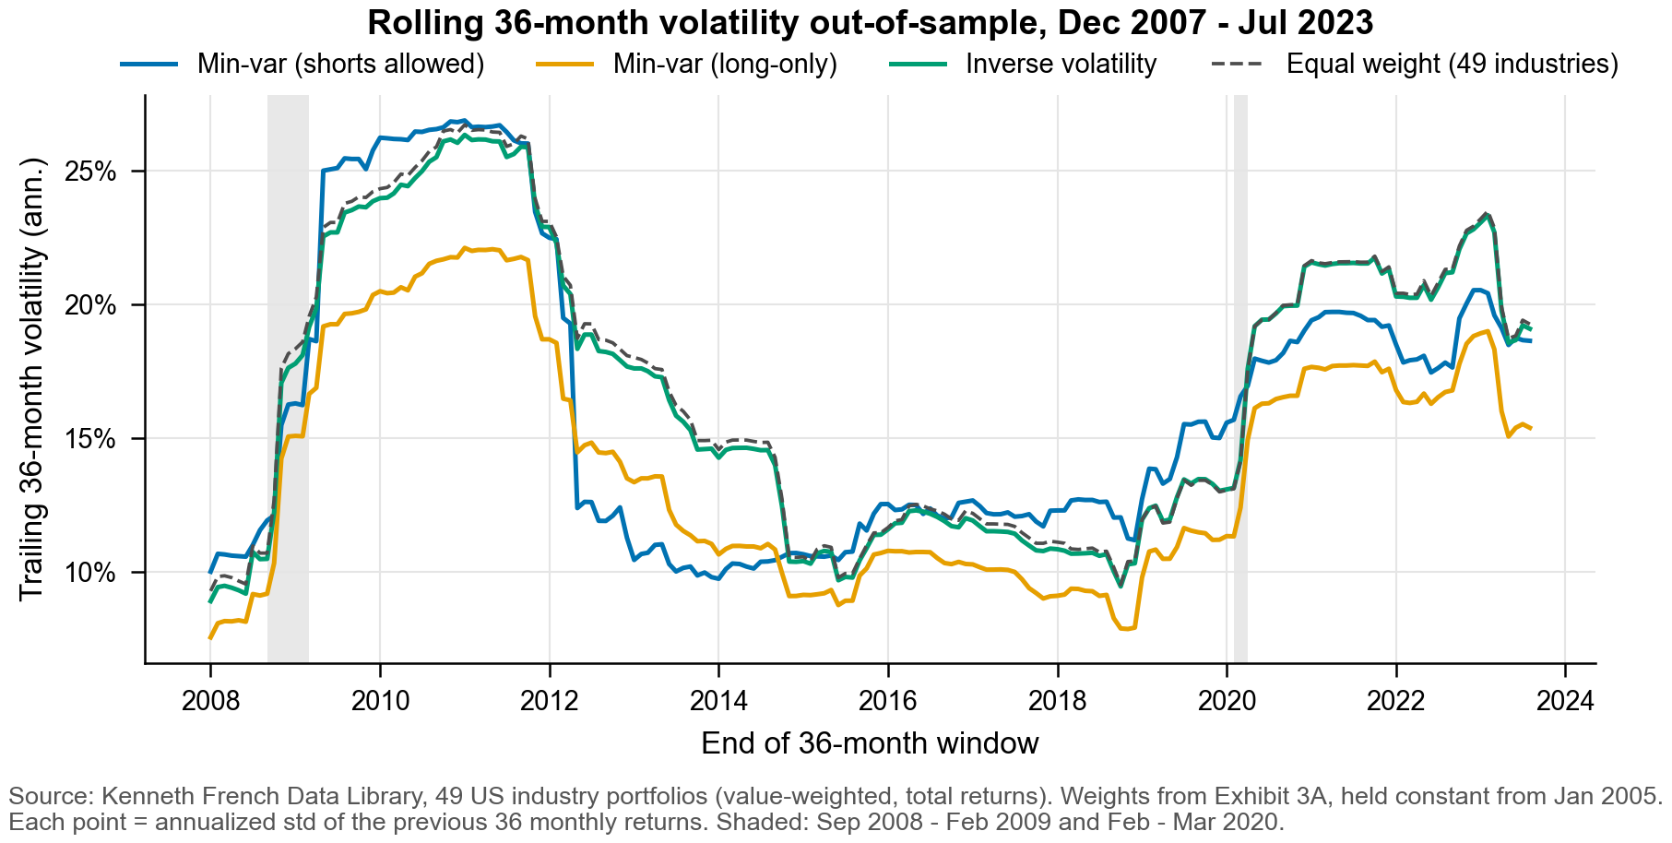

Figure 3.5 Value of re-optimization: volatility, Jan 2016 - Jul 2023 (3D)
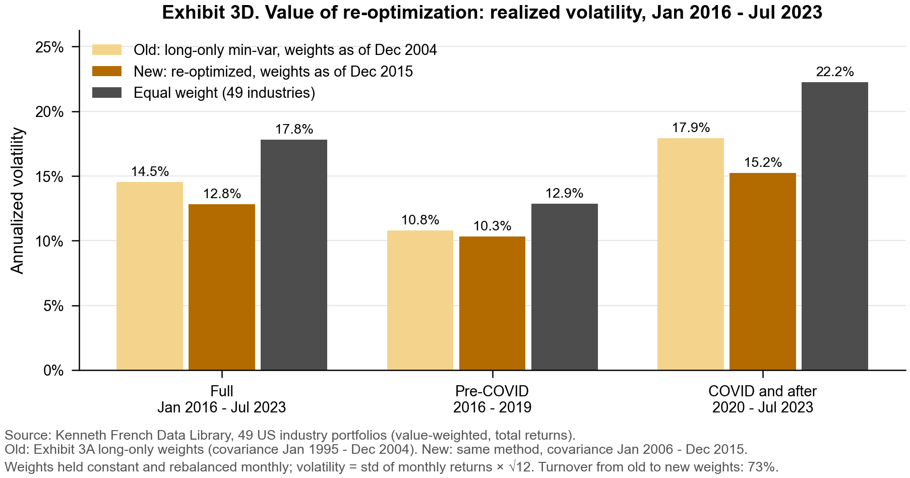

Figure 3.6 Weights before and after re-optimization (3D)
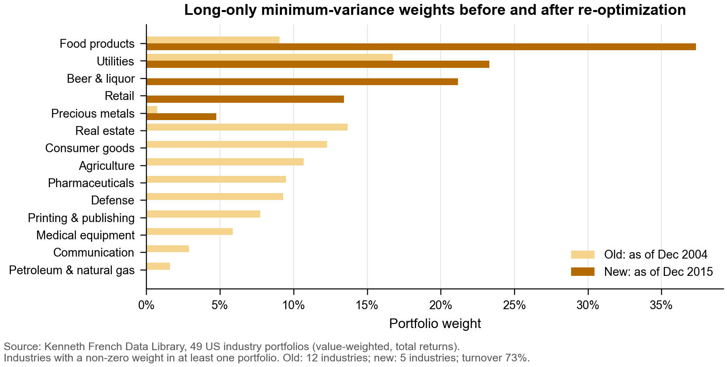

Figure 3.7 Growth of $1 invested on 31 Dec 2004, log2 scale (3E)
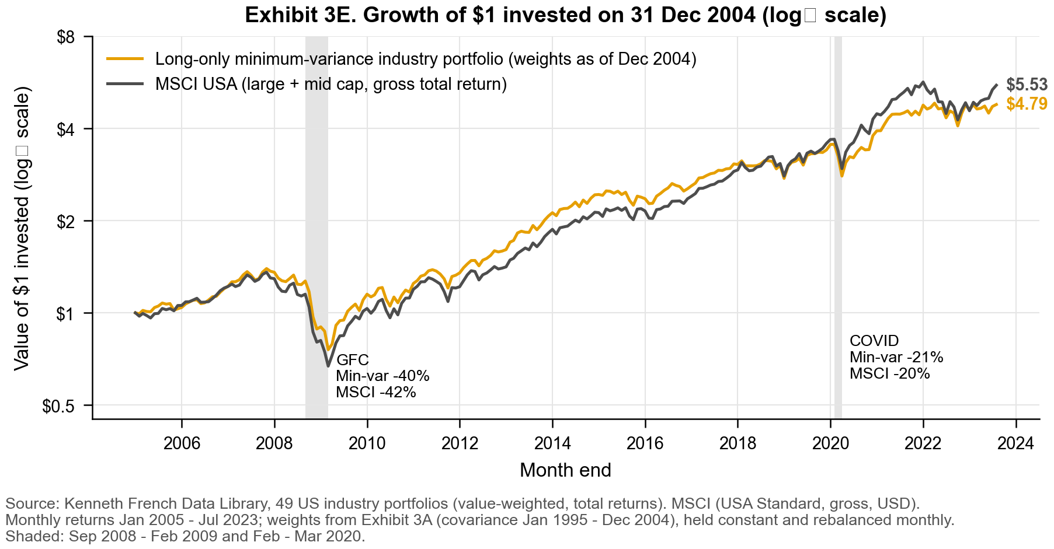

Figure 3.8 Ten best-performing industries in each crisis (3E)
