Part 2 Selected Exhibits

Table 2.1 Data quality and cleaning
Diagnostic | Saved finding
Full 2A scope | 283,380 stock-months; 1,207 securities; 245 formation months
Membership anomalies | Apr 1999: 182 departures / 166 arrivals; Dec 2018: -17.9%; Feb 2019: -38.8%
Return fields versus absent rows | 100% observed-row return coverage; 1,514 interior gaps in 205 securities
Raw return range | -92.2% to +3,017.6%
Main clipping rule | Monthly 1st/99th percentiles; linear interpolation; 5,723 changed rows; no deletions
Alternative interpretation | 0.5th/99.5th percentiles: 2,883 changed rows; main remains 1/99
P/B midpoint and flag | Pb=0.50: 10,197 rows; Pb=0.50 & Bv<=0.03 flag: 5,720 (5,630 in 2B-2D window)

Source and scope: Full 2A history; supplied Part 2 CSV. Formation Nov 1998-Mar 2019; all securities. Missing rows are diagnostic, not imputed returns.

Table 2.2a Price to book midpoint conditional frequencies
Bv score | Rows | Pb=0.50 rows | Conditional frequency
0.01 | 2918 | 2906 | 99.59%
0.02 | 2909 | 2100 | 72.19%
0.03 | 2781 | 714 | 25.67%
0.04 | 2812 | 183 | 6.51%

Source and scope: Same full history. Frequency denominator: all rows at the exact Bv score. Neither score identifies equity sign.

Table 2.2b Ordinal sanity checks for price to book
Rank diagnostic | All observations | Without exact provisional flags
P/B vs log(cap rank / book rank) | 0.8287 | 0.8503
P/B vs cap rank within book-rank bins | 0.8239 | 0.8251
P/B vs book rank within cap-rank bins | -0.7768 | -0.7986

Source and scope: Saved 2A5 results, exact provisional flag. Proxy medians use 245 months; conditional medians use month-bin cells. Two singleton cells per sample in the book association are undefined and retained in the source audit.

Table 2.3 Main performance
Portfolio | Arithmetic annual return | Geometric CAGR | Annual volatility | Ending $1
EW top 20% | 18.30% | 17.15% | 22.03% | $23.715
Value score | 14.31% | 13.32% | 18.74% | $12.185
Value score x cap | 11.10% | 10.02% | 17.32% | $6.751
2B broad market | 9.81% | 8.77% | 16.48% | $5.372
MSCI USA gross USD | 6.42% | 5.48% | 14.58% | $2.909

Source and scope: Investment Jan 1999-Dec 2018, 240 months. Supplied stock CSV and MSCI gross USD workbook. Main stock returns monthly 1/99 clipped; all flags retained; decimal inputs displayed as percentages. CAGR and arithmetic annualization differ.

Table 2.4 Final formation concentration
Portfolio | Holdings | Maximum weight | Effective N | Top 10 weight
EW top 20% | 222 | 0.4505% | 222.0 | 4.5045%
Value score | 1109 | 0.1763% | 846.2 | 1.7626%
Value score x cap | 1109 | 0.3761% | 651.4 | 3.5841%
2B broad market | 1109 | 0.1817% | 825.6 | 1.8170%

Source and scope: Formation Nov 2018; supplied stock CSV. All observations, main weights. Holdings count positive weights; effective N = 1/sum(w squared).

Table 2.5 Arithmetic return sensitivities
Portfolio | All clipped | All original | No flags clipped | No flags original
EW top 20% | 18.30% | 24.85% | 18.42% | 25.11%
Value score | 14.31% | 17.24% | 14.14% | 16.79%
Value score x cap | 11.10% | 12.12% | 11.01% | 11.88%

Source and scope: Jan 1999-Dec 2018. Same Value score and tie rule. Exclusion removes 5,630 flagged in-window stock-months only; full-universe benchmark remains fixed. No excluded observations are deleted from source files.

Table 2.6 Tracking error and HML sensitivity
Portfolio | Main TE | Original TE | Main HML rho | Original HML rho
EW top 20% | 9.51% | 11.38% | 0.5539 | 0.4727
Value score | 4.90% | 5.42% | 0.5806 | 0.5239
Value score x cap | 2.74% | 2.95% | 0.8533 | 0.8256

Source and scope: Jan 1999-Dec 2018, 240 aligned observations. TE = sample standard deviation of Value-minus-2B market times sqrt(12). Both Value and market switch to original returns in sensitivity; HML unchanged.

Table 2.7 Complete active return correlation matrix
Series | S1 active | S2 active | S3 active | HML
S1 active | 1.0000 | 0.9581 | 0.7590 | 0.5539
S2 active | 0.9581 | 1.0000 | 0.7670 | 0.5806
S3 active | 0.7590 | 0.7670 | 1.0000 | 0.8533
HML | 0.5539 | 0.5806 | 0.8533 | 1.0000

Source and scope: Pearson correlations, main clipped returns. S1 EW top 20%; S2 Value score; S3 Value times cap. Saved 2B/2C and supplied monthly FF HML, Jan 1999-Dec 2018, all flags retained.

Figure 2.1 Monthly stock counts
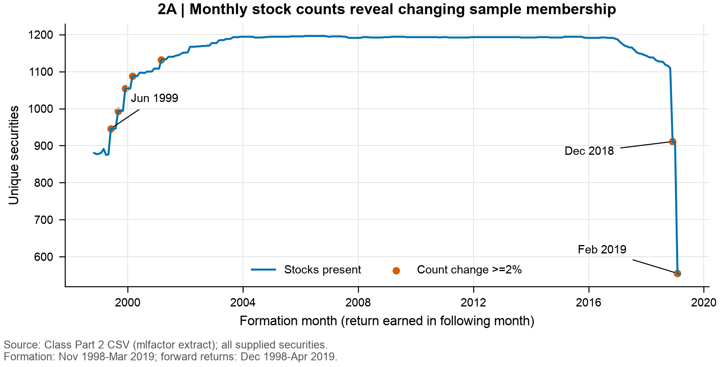

Figure 2.2 Forward return distribution
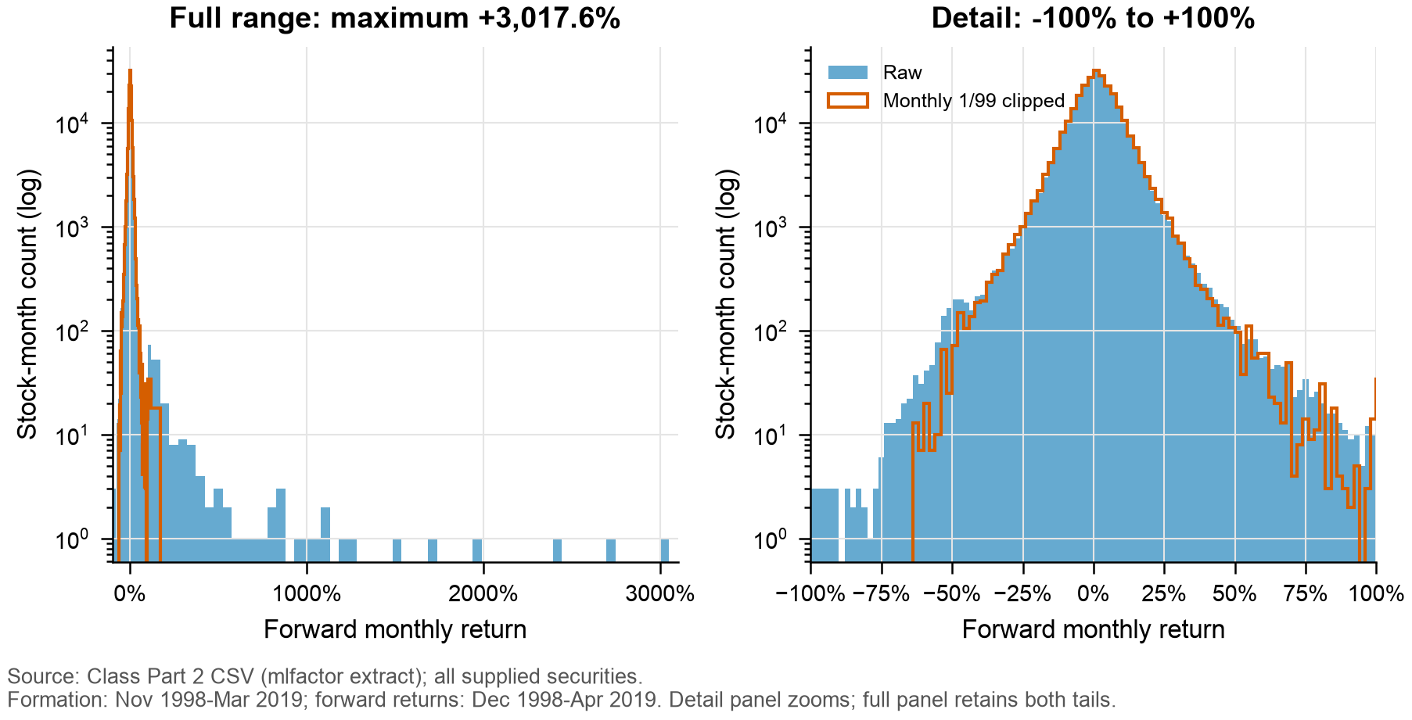

Figure 2.3 Return coverage and sample presence
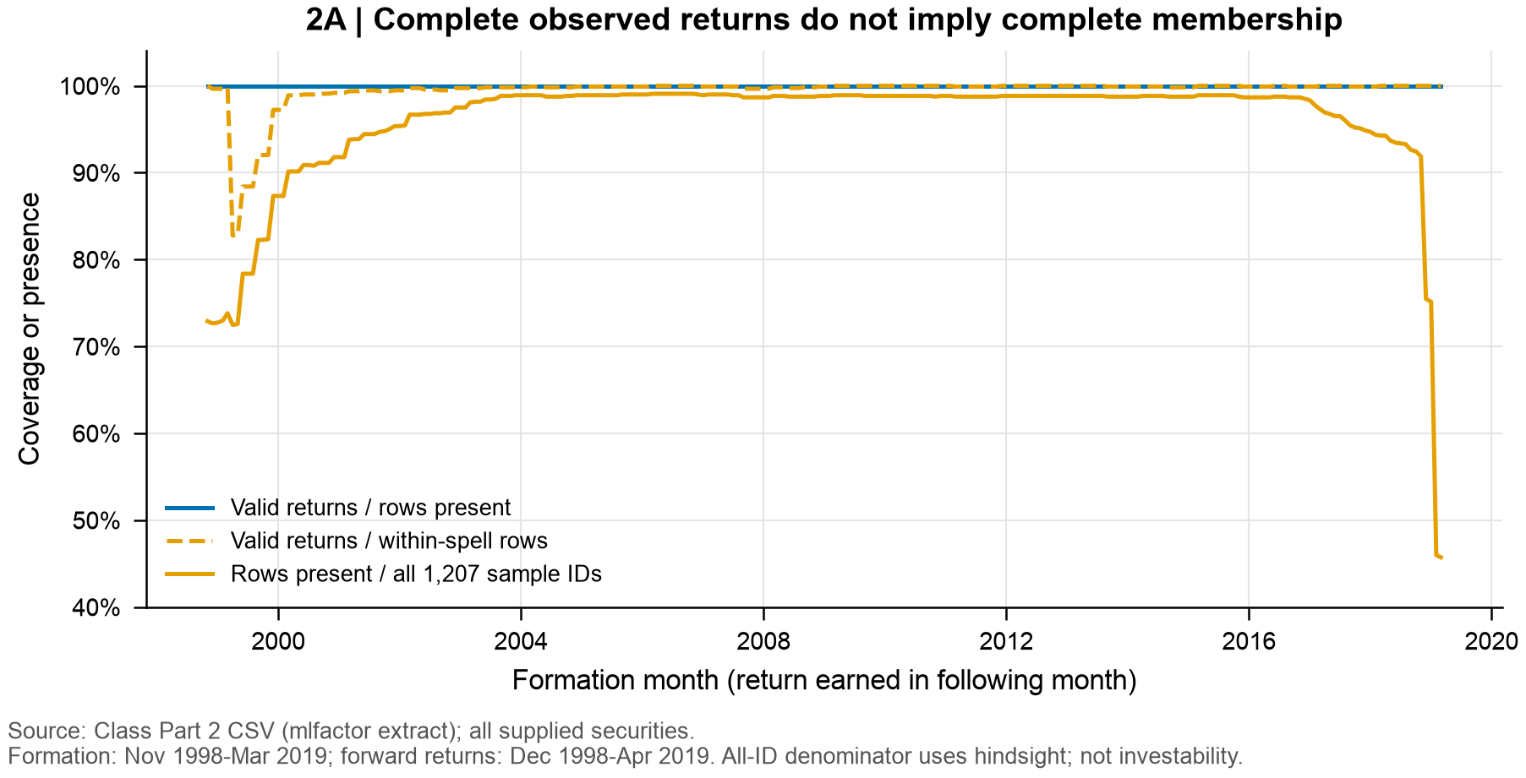

Figure 2.4 Price to book distribution and low book ranks
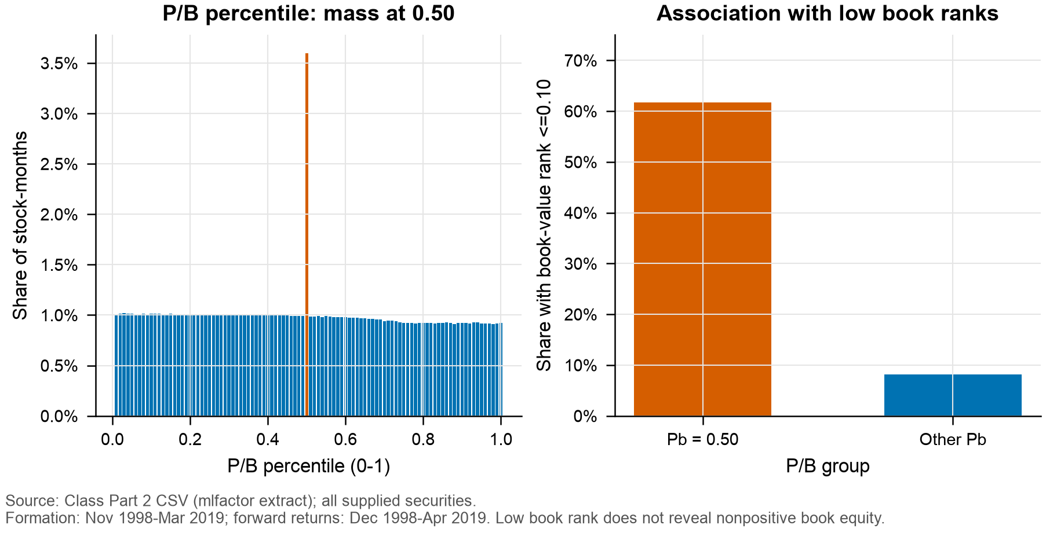

Figure 2.5 Rank sanity comparison for the exact provisional flag
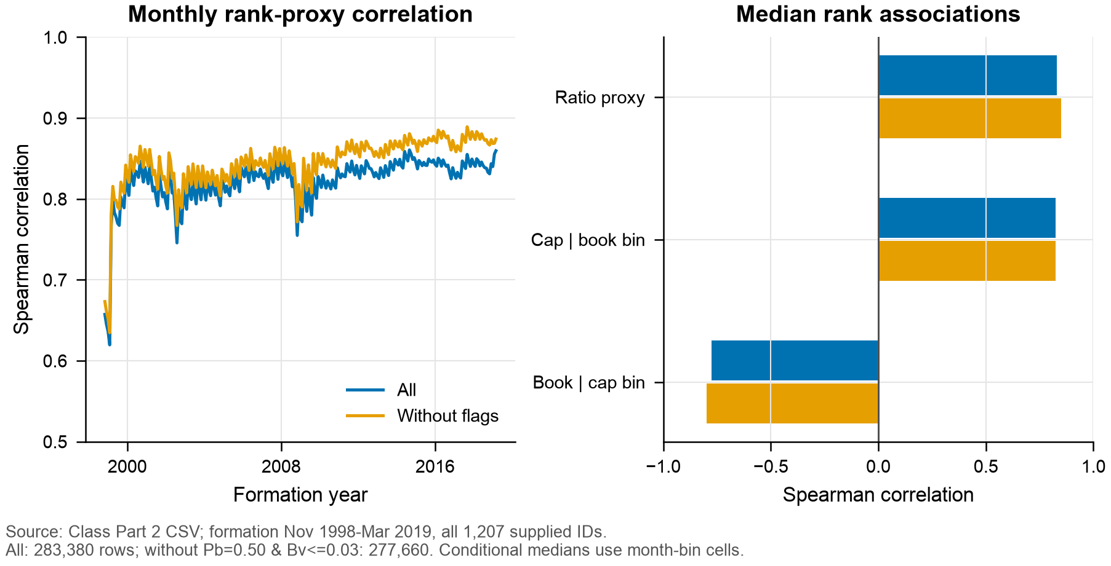

Figure 2.6 Market proxy and MSCI USA cumulative wealth
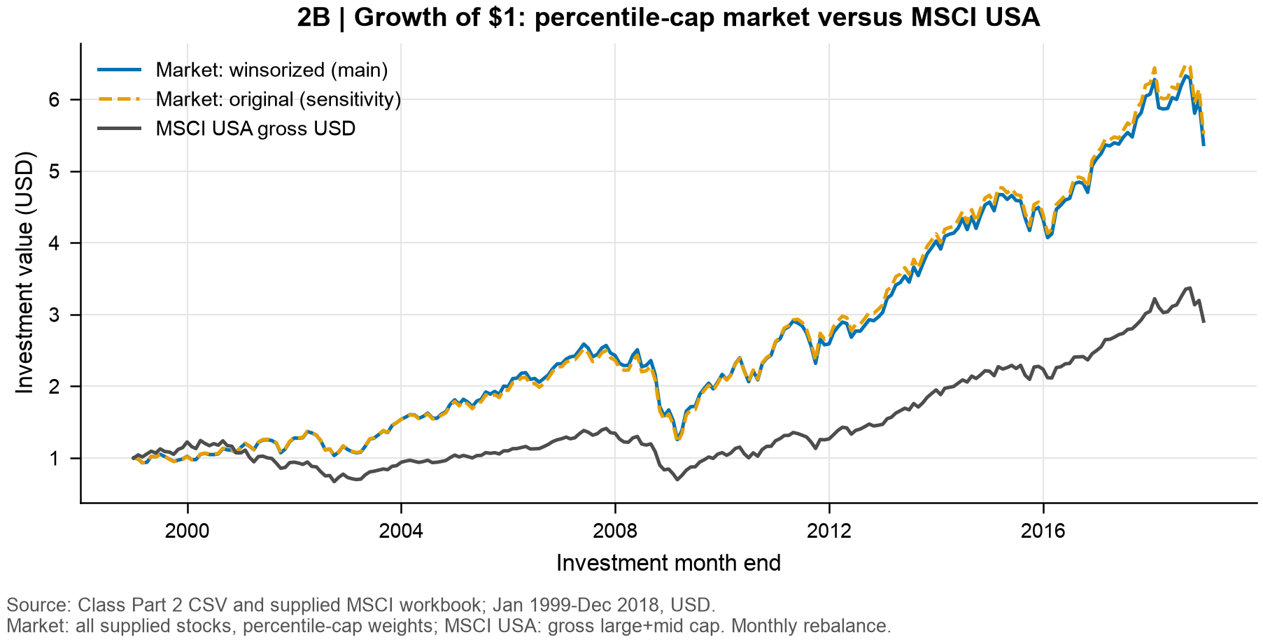

Figure 2.7 Value strategy cumulative wealth
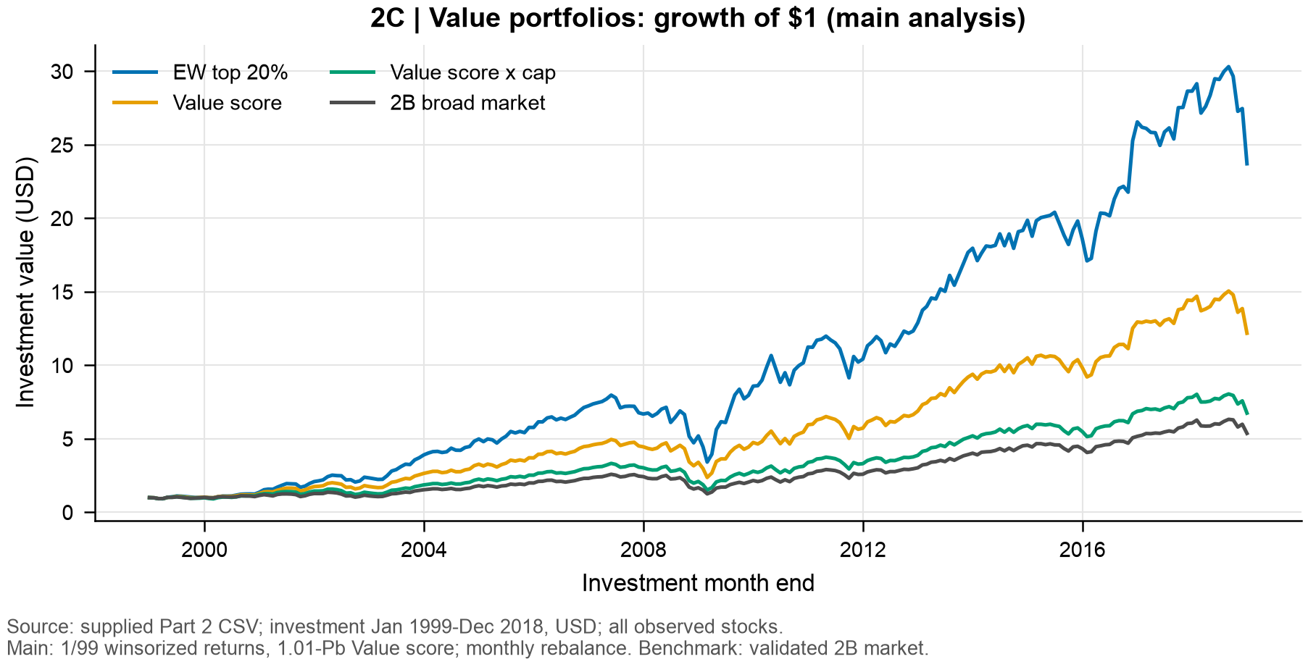

Figure 2.8 Active return and HML correlations
