Part 5 Selected Exhibits
These exhibits evaluate value-index replication and benchmark-relative multi-factor risk. The factor fit explains most Value variation, while the multi-factor portfolio earns little per unit of tracking error.

Table 5.1 MSCI Value factor attribution
Term | Coefficient | Std error | t statistic | p value
Intercept (decimal/month) | -0.000713 | 0.000787 | -0.906 | 0.366
RF | 0.864636 | 0.310077 | 2.788 | 0.0056
Mkt-RF | 0.948032 | 0.012314 | 76.986 | 2.28e-216
HML | 0.321642 | 0.016342 | 19.682 | 5.31e-58
SMB | -0.174374 | 0.017605 | -9.905 | 1.79e-20
Source and scope: supplied MSCI / Kenneth French workbook; US large/mid-cap MSCI indexes (gross total returns, USD) and US academic factors where applicable; Jan 1995 - Jul 2023 (343 months). OLS on total returns with an intercept. Slopes are dimensionless; the intercept is a monthly decimal return. N = 343, residual df = 338, R² = 0.948414, adjusted R² = 0.947804. Standard errors and two-sided Student t tests are conventional, without HAC/Newey-West adjustment. Annual arithmetic alpha = -0.86%; 95% interval [-2.71%, 1.00%].

Table 5.2 Replication and original index performance
Strategy | Annual return  arithmetic | Annual  volatility | Sharpe  ratio | Annual return  geometric
MSCI USA Value | 9.87% | 15.27% | 0.505 | 9.05%
Factor replication | 10.73% | 14.87% | 0.576 | 10.05%
Source and scope: supplied MSCI / Kenneth French workbook; US large/mid-cap MSCI indexes (gross total returns, USD) and US academic factors where applicable; Jan 1995 - Jul 2023 (343 months). Correlation = 0.973866. Replication excludes alpha and uses full-sample slopes. Annual mean RF = 2.16%. Return = 12 × monthly mean; volatility = sample std × √12; Sharpe = (annual arithmetic return - annual mean RF) / annual volatility. Geometric return is compounded wealth^(12/343) - 1. All results are gross of costs; replication is an in-sample statistical portfolio, not an investability claim.

Figure 5.1 Growth of one dollar
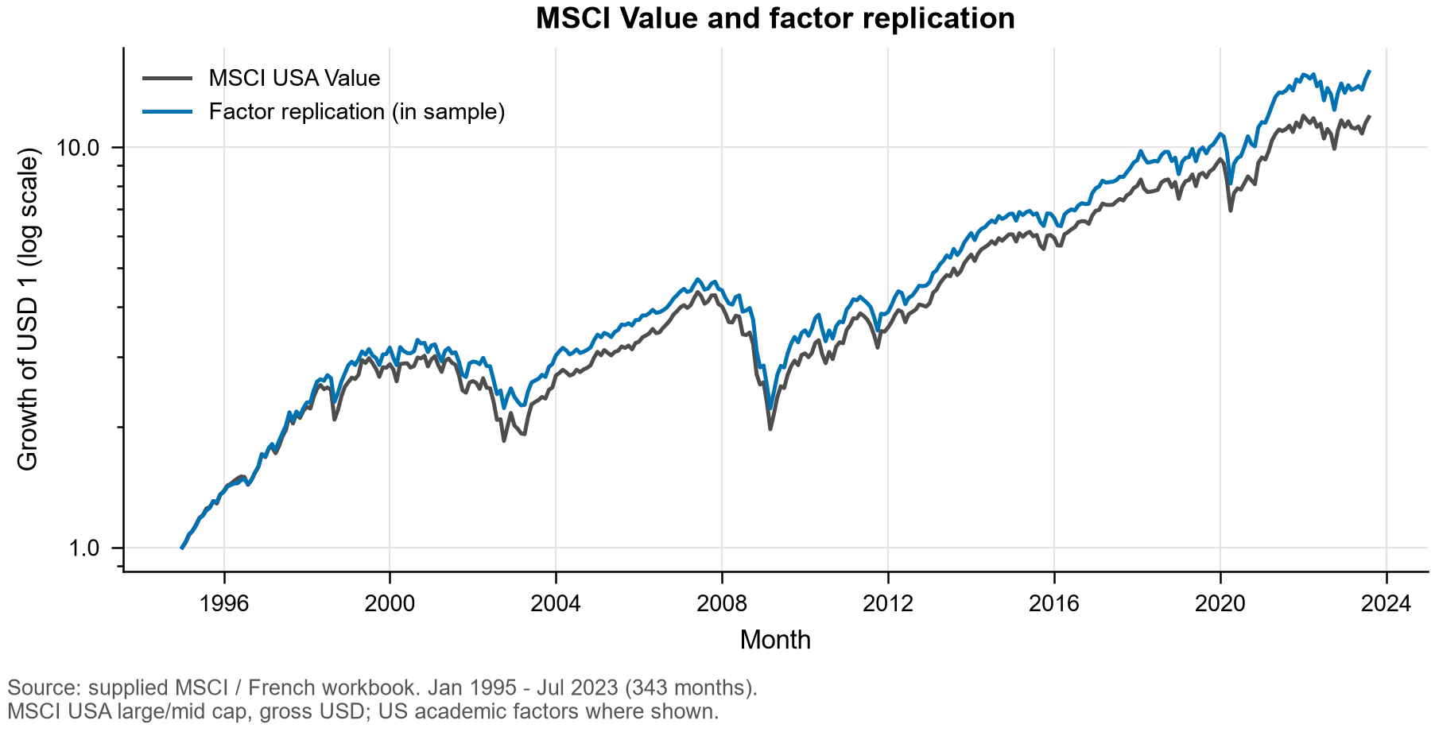

Table 5.3 Benchmark relative performance
Strategy | Annual active  return | Annual tracking  error | Information  ratio | Cumulative relative  wealth gain
Value | -1.343% | 5.15% | -0.261 | -31.24%
Minimum volatility | -0.796% | 6.38% | -0.125 | -8.93%
Equal weight | 0.588% | 5.40% | 0.109 | 9.02%
Momentum | 2.158% | 7.73% | 0.279 | 76.98%
Multi-factor | 0.152% | 3.39% | 0.045 | 9.08%
Source and scope: supplied MSCI / Kenneth French workbook; US large/mid-cap MSCI indexes (gross total returns, USD) and US academic factors where applicable; Jan 1995 - Jul 2023 (343 months). Benchmark: MSCI USA Standard. All strategies hold long-only MSCI indexes. Multi-factor weights are 25% each, reset monthly. Monthly active return = strategy return - benchmark return; annual active return = 12 × mean(active); tracking error = sample std(active) × √12; information ratio = annual active return / tracking error. These annualizations do not adjust for serial correlation.

Figure 5.2 Compounded performance relative to the benchmark
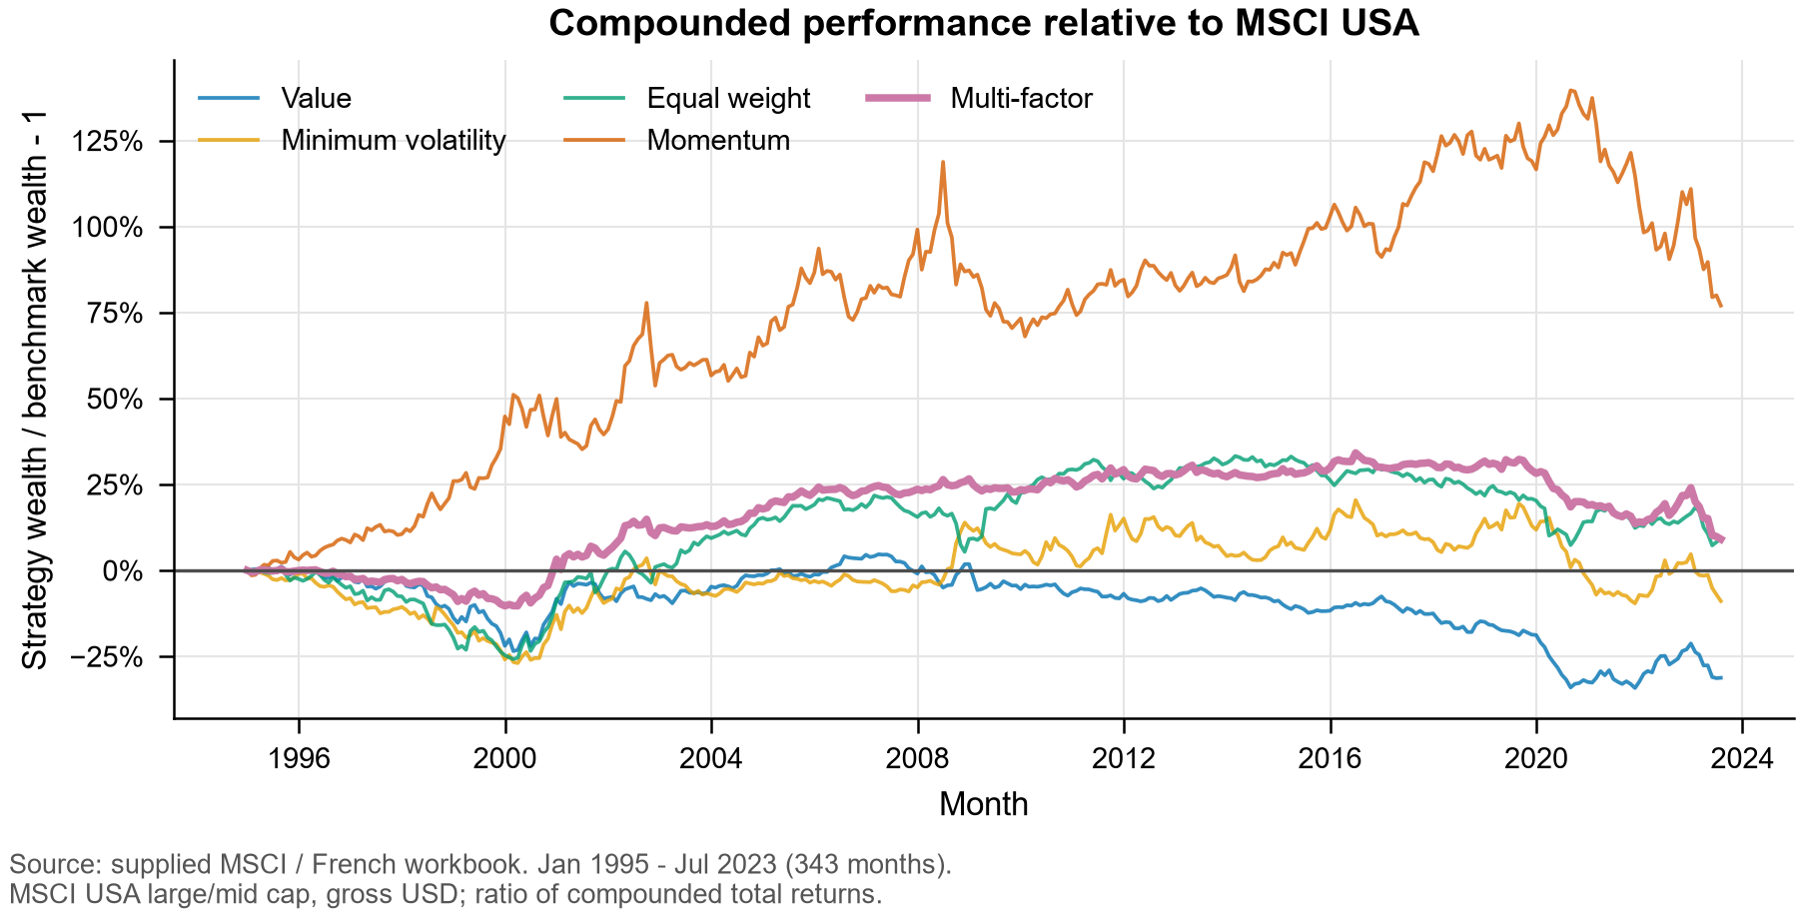
Relative wealth = product(1 + strategy return) / product(1 + benchmark return) - 1. It is neither the sum nor the compounded product of monthly active returns. For the multi-factor portfolio, the cumulative gain is 9.08% and the annual relative-wealth growth rate is 0.304%, versus 0.152% annualized arithmetic active return.

Data precision and alignment
The workbook labels the MSCI levels Gross and USD. December 1994 levels provide the base for January 1995 returns; all 343 months are present and aligned with monthly FF percentage data divided by 100. Annual FF rows and MSCI copyright footers are excluded. Part 1C's exported monthly CSV rounds to four decimals. Every recovered return differs from its saved value by at most 0.5 basis point. Its rounded multi-factor column can differ from the mean of rounded components by 0.75 basis point. We therefore recover Part 1C's full-precision calculation without changing its inputs, algorithm or files. All original Part 1 performance statistics reconcile to saved-table rounding. Raw input hashes and numerical checks are saved separately.

Table 5.4 Contributions to multi factor active variance
Component | Weight | Monthly variance  contribution | Annual variance  contribution | Variance  share
Value | 25% | 0.000022230 | 0.000266756 | 23.26%
Minimum volatility | 25% | 0.000032571 | 0.000390850 | 34.08%
Equal weight | 25% | 0.000017067 | 0.000204804 | 17.86%
Momentum | 25% | 0.000023714 | 0.000284566 | 24.81%
Total | 100% | 0.000095581 | 0.001146976 | 100.00%
Source and scope: supplied MSCI / Kenneth French workbook; US large/mid-cap MSCI indexes (gross total returns, USD) and US academic factors where applicable; Jan 1995 - Jul 2023 (343 months). All covariances use benchmark-relative active returns and sample ddof = 1. Absolute contributions are in squared decimal-return units. Annual variance contributions = 12 × monthly contributions. Percentages use monthly multi-factor active variance as denominator.
$aₘ = 0.25(aᵥ + aₗ + aₑ + aₚ)$
$Cᵢ = 0.25 Cov(aᵢ, aₘ) Σᵢ Cᵢ = Var(aₘ) Shareᵢ = Cᵢ / Var(aₘ)$
Here a denotes a monthly strategy-minus-benchmark return; subscripts v, l, e and p denote Value, Minimum Volatility, Equal Weight and Momentum. Covariance contributions may be negative and must not be clipped. This is a decomposition of tracking-error squared. Contributions to tracking error itself would instead equal annual variance contributions divided by annual tracking error and would have return, not squared-return, units.

Figure 5.3 Allocation of benchmark relative risk
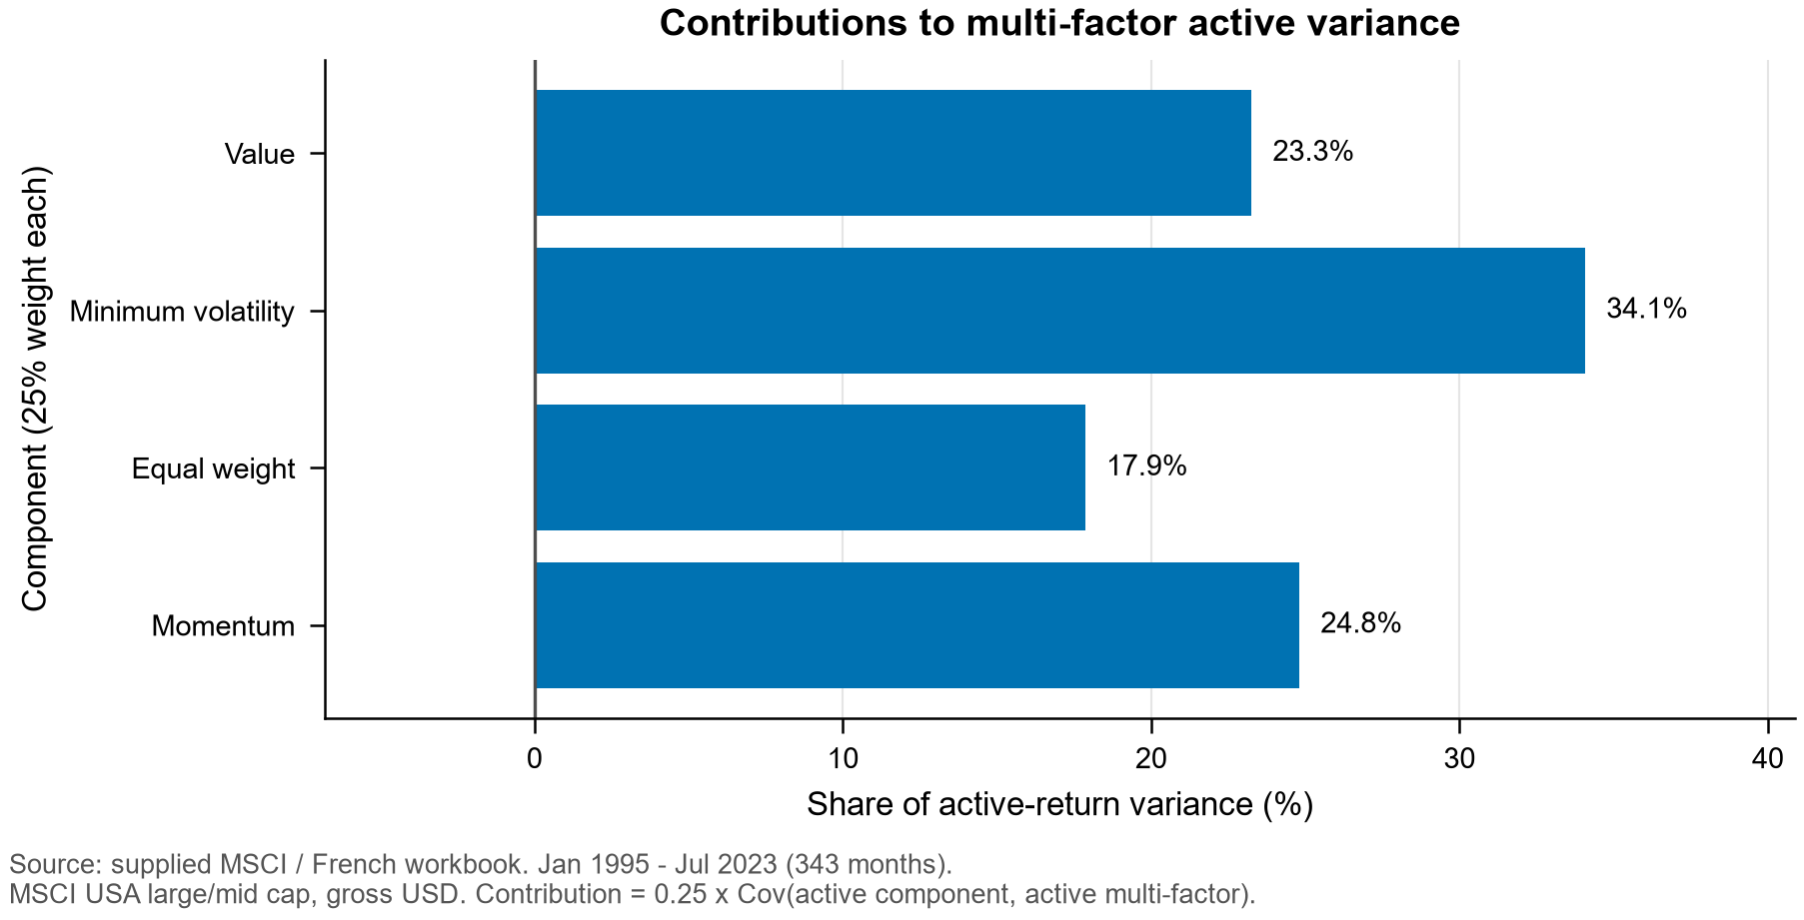

Sources and interpretation
MSCI (February 2021), Global Investable Market Value and Growth Index Methodology, Sections 1.2, 2.1-2.3 and Appendix I.
Kenneth R. French Data Library, Description of Fama/French Factors.
Shleifer, A. and Vishny, R. W. (1997), The Limits of Arbitrage, Journal of Finance 52(1), 35-55.
Sources accessed 1 November 2026. The assignment specifies the February 2021 MSCI methodology; we do not assume its rules were unchanged across the historical return sample. The limits-to-arbitrage interpretation applies the cited capital-constraint mechanism; class lecture slides were not included in the repository.

