FE5108 Portfolio Theory and Investments
Practitioner segment class project, Fall 2026
Group report
NUS Risk Management Institute
Instructor: Sanne de Boer
Submitted 8 November 2026

Team members and contributions
Member | Contribution
Zhang Jiaxin | Part 1 Factor investing: Fama-French factor premia and t-statistics before and after 1993, review of the MSCI Momentum index methodology, multi-factor index and Sharpe ratio comparison, correlations between MSCI and Fama-French factor spreads, and momentum across market-volatility regimes. Code, exhibits and write-up.
Sato Yuki | Part 2 Security-level data: data cleaning and validation (universe, winsorization, return coverage, price-to-book checks), market proxy versus MSCI USA, three Value portfolio constructions, tracking error and correlation with HML. Code, exhibits and write-up.
Zhou Mo (Weekey) | Part 3 Portfolio construction: minimum-variance (with and without short sales) and inverse-volatility portfolios, in-sample and out-of-sample volatility, re-optimization, and performance in the GFC and COVID crises. Code, exhibits and write-up. Also set up the GitHub repository and shared code conventions, allocated the work among members, and integrated the final report.
Zhang Yin | Part 4 Product innovation: risk metrics (standard deviation, VaR, CVaR) of NVDL and NVDA, regression of NVDL on NVDA and performance drag, monthly and two-day compounding examples, and the trader versus long-term investor choice. Code, exhibits and write-up.
Wu Shuhan | Part 5 Portfolio analytics: MSCI versus Fama-French value definitions, factor regression and alpha of the MSCI Value index, replicating portfolio, active return, tracking error and information ratio of the multi-factor index, and risk decomposition. Code, exhibits and write-up.

Structure: the main text (Parts 1-5) is followed by an appendix of exhibits. Exhibits are numbered by part (Table 3.1 is the first table of Part 3) and each states its data source, period and universe. Supporting code, data and generated exhibits are available in the project repository: https://github.com/WeekeyZhou/fe5108-final. The README describes how to reproduce each part.

Part 1 Factor Investing

1A Factor Premiums and Factor Decay
The Fama-French factors show different patterns before and after 1993. The market premium remains statistically significant in both periods, while the average monthly SMB premium declines from 0.240% to 0.100% and HML from 0.435% to 0.146%. Neither SMB nor HML remains significant after 1993 (Table 1.1).
Greater investor attention may partly explain this decline. As factor strategies become more widely adopted, increased demand for stocks with certain characteristics could raise prices and reduce subsequent returns. For example, demand for undervalued stocks may gradually reduce the value premium. However, the analysis neither tests this mechanism nor establishes whether the changes in average premiums are statistically significant.
The weaker post-1993 evidence makes SMB and HML less convincing as standalone strategies, unlike the persistently significant market premium. This highlights the importance of evaluating factors across different periods. Value-weighted momentum and low-beta decile spreads are also constructed for Sections 1D and 1E.

1B Factor Index Construction in Practice
Unlike academic long-short momentum strategies, investable indexes must consider liquidity, trading costs, and concentration. The MSCI USA Momentum Index draws from large- and mid-cap US stocks in the MSCI USA parent index.
Under its December 2013 methodology, the index combines 6- and 12-month momentum signals, excluding the latest month. Each signal is adjusted for local risk-free rates, scaled by three-year annualized weekly-return volatility, and standardized. The signals are equally combined and standardized again. The final z-score is winsorized at ±3 and converted into a positive Momentum Score. Stocks with the highest positive unwinsorized z-scores are selected, subject to a target constituent count.
Weights reflect both Momentum Scores and parent-index market capitalization. Larger companies may receive higher weights despite similar momentum signals, improving investment capacity and reducing trading impact through generally greater liquidity. However, smaller stocks with strong momentum may be underweighted, weakening factor exposure.
The index normally rebalances in May and November, using buffers to limit turnover. An additional rebalance is triggered when the monthly relative rise in volatility exceeds the historical 95th percentile of changes for the MSCI World reference index. It uses only 6-month momentum to respond faster and potentially limit losses. A 5% issuer cap further controls concentration.
Source: MSCI Momentum Indexes Methodology (December 2013), Sections 2-3 and Appendices II-III.

1C Benefits of Factor Diversification
Momentum has the highest annualized return (13.38%) and Sharpe ratio (0.686), while Value performs worst (9.87%; Sharpe 0.505). However, selecting Momentum based on its historical ranking involves hindsight bias.
An equally weighted, monthly rebalanced portfolio of Value, Minimum Volatility, Equal Weight, and Momentum improves the Sharpe ratio from 0.587 for MSCI USA to 0.639. Its annualized return rises slightly from 11.22% to 11.37%, while volatility falls from 15.44% to 14.40% (Table 1.2).
Although its Sharpe ratio remains below Momentum and Minimum Volatility, the portfolio reduces dependence on any single factor. The results suggest diversification benefits relative to the market benchmark, without guaranteeing future outperformance (Figures 1.1-1.2).

1D Sensitivity to Factor Portfolio Construction
To assess construction differences, monthly MSCI factor spreads relative to MSCI USA are correlated with value-weighted academic factor spreads over January 1995-July 2023.
Minimum Volatility correlates strongly with low-beta (0.815), as does MSCI Value with HML (0.728). MSCI Momentum also correlates positively with academic momentum (0.642). These results suggest recognizable factor characteristics despite differences in stock selection and weighting (Table 1.3).
Equal Weight has a weaker correlation with SMB (0.322) than with HML (0.431). Although equal weighting increases smaller stocks' influence, it does not explicitly select by size, so other characteristics may affect returns.
Consequently, the four indexes in Section 1C may have overlapping factor exposures despite their different labels. Factor regressions would be needed to measure these exposures more directly.

1E Regime Sensitivity of Factor Premia
Daniel and Moskowitz (2016) document momentum crashes during sharp market rebounds, including 2009, when previous losers recover faster than winners. This analysis instead examines the relationship between momentum returns and recent market volatility.
Momentum earns its highest average monthly return in medium-volatility periods (1.86%), compared with 1.04% in low-volatility and -1.03% in high-volatility periods (Table 1.4). The pattern is not strictly monotonic, and the high-minus-low difference is not statistically significant under the Welch test (p = 0.103).
A regression using 332 monthly observations from December 1995 to July 2023 finds a negative volatility coefficient (-0.267), significant with Newey-West HAC(12) standard errors (p = 0.022). However, the R-squared is only 3.15%, indicating limited explanatory power.
Overall, the regression suggests a negative association, while the regime comparison is less conclusive. Volatility alone cannot reliably indicate momentum performance. The analysis does not identify momentum crashes, and because the volatility measure includes the current month, predictive ability remains untested (Figure 1.3).
Reference: Daniel, K., and Moskowitz, T. J. (2016). Momentum Crashes. Journal of Financial Economics, 122(2), 221-247.

Part 2 Hands-on Analysis of Security-level Data
We study how data cleaning and portfolio design affect a Value strategy. The backtests use 240 investment months from January 1999 to December 2018, formed one month earlier. Arithmetic annualized return compares average monthly performance; geometric CAGR describes compounded investor growth. All main portfolios use the established winsorized returns and retain the provisional P/B flags.

2A Data validation
The full extract has 283,380 stock-months for 1,207 securities over 245 formation months, November 1998-March 2019. Monthly membership ranges from 552 to 1,196. April 1999 combines 182 departures with 166 arrivals; the departing IDs subsequently reappear. Counts fall sharply in December 2018 and February 2019, outside the later formation window. These patterns question historical universe consistency. Return coverage is 100% among supplied rows, but 1,514 interior stock-month rows are absent across 205 securities. Portfolios use only supplied formation-month rows and normalize the strategy weights within that observed cross-section; next-month presence is not required. Absent rows are not inserted. Zero-return imputation would assume unchanged investment value for an unobserved outcome, and disappearance does not identify delisting. Dependence on supplied membership still leaves selection and survivorship bias unresolved. Raw returns span -92.2% to +3,017.6%. Monthly linear-interpolated 1st/99th-percentile clipping changes 5,723 observations (2.02%), preserves every row, and uses ex-post cutoffs. This retains the central 98%; a central-99% alternative is documented. See Table 2.1 and Figures 2.1-2.3.
P/B has an unusual mass at percentile 0.50: 10,197 observations (3.60%). Conditional midpoint frequency is 99.59% at book-value rank 0.01 but 6.51% at 0.04. The provisional rule Pb=0.50 and Bv<=0.03 flags 5,720 observations, including 5,630 in the investment sample. It may reflect special coding or nonpositive equity, but percentile ranks reveal neither the cause nor equity signs. Median monthly Spearman correlation between P/B and log(cap-score/book-score) is 0.829, rising to 0.850 without these exact flags. Conditional cap/book-rank checks have the expected signs. These are ordinal consistency checks, not verification of P/B = Market Cap / Book Equity: nonlinear ranks do not preserve ratios, and cap scores use a three-month average. See Tables 2.2a-2.2b and Figures 2.4-2.5.

2B Market proxy
Normalizing market-cap scores creates a fully invested market proxy. Its correlation with MSCI USA gross USD is 0.9075. Arithmetic annual return is 9.81% versus 6.42%; tracking error is 6.93%. An initial $1 becomes $5.37 versus $2.91. This supports aggregate US-market-like co-movement, while percentile weights compress size differences and cannot reconstruct actual capitalization weights. Anonymized selection and unknown corporate-event treatment prevent proving complete coverage or individual-return accuracy. See Table 2.3 and Figure 2.6.

2C Value portfolios
We reverse the supplied grid using Value score v=1.01-Pb: the cheapest bucket receives 1.00 and the most expensive 0.01, preserving ties. This does not take reciprocals of percentile scores. The three portfolios equally weight ceil(20% of N) cheapest stocks, weight proportionally to v, or weight proportionally to v times the cap score. Cutoff ties in the first portfolio are resolved by stock ID and audited separately. The concentrated cheap-stock selection has the highest mean return and volatility; cap modulation moves the observed score mix closer to the market. See Table 2.3 and Figure 2.7.
At November 2018 formation, EW top 20% has both the fewest holdings and the largest single-stock weight: 222 and 0.4505%. Value-score and Value-times-cap each hold 1,109 stocks, with maxima of 0.1763% and 0.3761%. This is expected here: concentrating on one fifth of the universe assigns about 1/222 to each selected stock, while both score methods spread weights across the full universe. The maximum-weight ordering need not hold in every sample. Lower cap-rank exposure does not establish a causal small-cap premium. Original-return sensitivity raises performance substantially, especially for EW top 20%; provisional-flag exclusions preserve the strategy ordering. Neither result validates the flag or proves a Value premium free of selection bias and costs. See Tables 2.4-2.5.

2D Tracking error and HML
Value-minus-market annualized tracking errors are 9.51%, 4.90%, 2.74%. Value times cap has the lowest deviation, plausibly because it retains broad holdings and uses the market cap score in its tilt. Pairwise active-return correlations range from 0.759 to 0.958; correlations with HML are 0.554, 0.581, 0.853. The cap-modulated strategy is closest to HML, consistent with value weighting within its component portfolios. HML, however, averages small and big high-minus-low book-to-market portfolios, uses positive book equity, and is long-short; our strategies are monthly-rebalanced long-only portfolios measured against a rank-weighted market. A common subtracted benchmark also contributes to active co-movement. Correlations support a shared Value-related component, not identical exposures or causation. Original-return sensitivity preserves the rankings. See Tables 2.6-2.7 and Figure 2.8.

Part 3 Portfolio Construction

3A Minimum-variance and inverse-volatility portfolios
We use value-weighted monthly total returns of the 49 Fama-French industry portfolios, January 1995 to July 2023; the -99.99/-999 missing-value codes do not occur in this window. Weights are set once at the close of 31 December 2004 from the sample covariance matrix of January 1995-December 2004 (120 months) and then held constant, rebalanced monthly to target. Volatility is the sample standard deviation of monthly returns times √12.
The long-only minimum-variance portfolio solves: minimise w′Σw subject to Σᵢwᵢ = 1 and wᵢ ≥ 0 for all 49 industries. Σ is positive definite (condition number 711), so this convex quadratic programme has a unique solution. We solve it with cvxpy (CLARABEL interior-point solver), confirm it with SciPy SLSQP (largest weight difference below 10⁻⁷) and verify the KKT conditions: every held industry has the same marginal contribution to portfolio variance and every excluded industry a higher one. The minimum-variance portfolio with shorting uses the closed form w = Σ⁻¹1/(1′Σ⁻¹1); the inverse-volatility portfolio sets wᵢ proportional to 1/σᵢ. Code is in the appendix.
Allowing shorts produces an extreme portfolio: 25 long and 24 short positions, 284% long and -184% short, led by Printing & publishing (41.3%) and Business services (-32.3%). The long-only solution is a corner solution with only 12 industries, led by Utilities (16.7%), Real estate (13.7%) and Consumer goods (12.3%); the other 37 weights are zero. Inverse volatility holds all 49 industries at 1.0%-2.9%. Utilities and Real estate are among the five largest weights under all three methods. See Tables 3.1-3.2 and Figure 3.1.

3B In-sample effectiveness
In-sample annualized volatility is 7.6% with shorts, 10.3% long-only and 14.0% for inverse volatility, against 14.6% for an equally weighted portfolio. The ordering is as expected and in fact guaranteed: because Σ was estimated on these same returns, realized in-sample volatility equals the optimizer's objective, and each restriction (no shorting) or simplification (ignoring correlations) can only raise the attainable minimum. The figure therefore rewards fitting the sample, including its estimation error: 120 observations are few for a 49×49 covariance matrix, and the unconstrained optimizer exploits that error most aggressively. See Table 3.3 and Figure 3.2.

3C Out-of-sample effectiveness
Out-of-sample, January 2005-July 2023, the long-only portfolio is lowest at 14.3%, followed by shorts allowed at 16.7% and inverse volatility at 17.2% (equal weight 17.5%). The deterioration follows how freely each method uses the estimated covariances: volatility rises ×2.21, ×1.39 and ×1.23, versus ×1.19 for equal weight. This is the error-maximization effect discussed in class. With 4.7× gross leverage, a small drop in the correlation between the long and short legs (0.980 to 0.965) more than doubles risk. The long-only constraint acts as shrinkage of the covariance estimate (Jagannathan and Ma, 2003). Average pairwise industry correlation also rose from 0.40 to 0.59, while median industry volatility was unchanged (21.9% vs 21.8%), weakening diversification for every portfolio. The long-only portfolio is lowest in all four sub-periods and in 85% of 188 rolling 36-month windows; in 2008-2009 the unconstrained portfolio (31.6%) was even riskier than equal weight (29.0%). See Tables 3.3-3.4 and Figures 3.3-3.4.

3D The value of re-optimization
Re-optimizing at end-2015 on January 2006-December 2015 returns gives a portfolio of 5 industries: Food products 37.4%, Utilities 23.3%, Beer & liquor 21.2%, Retail 13.4%, Precious metals 4.8%. Turnover from the 2004 weights is 73.5% and Real estate is dropped entirely. Over January 2016-July 2023 its volatility is 12.8% versus 14.5% for the 2004 portfolio (17.8% equal weight), a 12% relative reduction. This is expected because covariances are not stable: over 2006-2015 the stale 2004 weights had 14.7% volatility against 10.3% for the re-optimized ones. The gain is concentrated in the COVID period, however: before 2020 the two are close (10.3% vs 10.8%), whereas in February-March 2020 the new portfolio lost 15.1% against 21.2%. Re-optimization is no free lunch: estimation error remains (out-of-sample volatility 24% above in-sample), 37.4% sits in one industry, and transaction costs are ignored. See Tables 3.5-3.6 and Figures 3.5-3.6.

3E Performance expectations
$1 invested on 31 December 2004 grew to $4.79, versus $5.53 in the MSCI USA index, with lower volatility (14.3% vs 15.3%) and a smaller maximum drawdown (-45.7% vs -50.6%). The defensive strategy did not, however, deliver as expected in the two crises: it lost 40.3% in the GFC against 41.8% for the market, and 21.2% in February-March 2020, more than the market's 19.8%. The main reason is the 13.7% weight in Real estate, a low-volatility industry in 1995-2004 but among the five worst in both crises (-67% and -42%), costing roughly 9.2% and 5.8% of portfolio return. Utilities, the largest weight, fell 22% in the COVID sell-off. See Tables 3.7-3.8 and Figure 3.7.
The industries that held up best in the GFC were mostly traditional defensives (food, beverages, pharmaceuticals, tobacco, utilities, retail), plus Precious metals, the best performer (-12%) although it ranked 48 of 49 by volatility: a safe haven is not a low-volatility asset. The COVID list adds stay-at-home beneficiaries such as Computer software, Retail, Shipping containers and Measuring & control equipment. Software ranked 45 and Measuring & control equipment 41 of 49 by 1995-2004 volatility, so a minimum-variance portfolio excludes them by design; only 4 of the ten best industries in each crisis were held. Historical low volatility is therefore no guarantee of crisis protection: which industries are defensive depends on the nature of the shock, and both covariances and the set of low-volatility industries change over time. See Table 3.9 and Figure 3.8.
Reference: Jagannathan, R. and Ma, T. (2003). Risk reduction in large portfolios: Why imposing the wrong constraints helps. Journal of Finance, 58(4).

Part 4 Product Innovation

4A Risk metrics
The three risk measures of NVDL are about twice those of NVDA (Table 4.1). On typical bad days (the worst 5% of trading days), NVDL loses at least about 12%, while NVDA loses at least about 6%. On these worst days, the average loss is about 14% for NVDL and 7% for NVDA.
This is exactly what we expect from a fund designed to provide double daily returns. Every daily move is doubled and the whole return distribution is stretched by about a factor of two. Therefore, these measures confirm that leverage increases risk, and the amplification is very close to the stated 2x leverage multiple.

4B Regression of NVDL on NVDA
The estimated slope is about 1.996, and the 95% confidence interval is approximately 1.987 to 2.005 (Table 4.2). The interval contains 2, and the test of beta = 2 does not reject the null hypothesis (p-value about 0.35). R-squared is about 0.999, indicating that almost all of the daily movements of NVDL can be explained by the daily return of NVDA. Overall, in terms of daily performance, NVDL has achieved its set goal of about twice the daily rate of return of NVDA.
However, regression analysis does not reflect the cost of achieving this goal. The intercept term is slightly negative (about -0.06% per day), and its confidence interval does not contain zero; this means that the average daily return of NVDL is slightly less than twice the NVDA rate of return. In addition, because it uses daily data, the regression cannot explain multi-day returns.

4C Performance drag
The annualized intercept is about -15% per year, and the 95% confidence interval is roughly -24% to -7%. This is far higher than the published 1.15% net expense ratio, and also greater than the 0.99% management fee and the 1.57% total expense ratio, and 1.15% is clearly outside the confidence interval (Table 4.3). The noise of the regression intercept is relatively large, because only seven months of daily data are used, but even the least negative end of the interval is several times the published expense ratio. Therefore, this drag does not match the published cost.
The expense ratio is only a part of the cost of a leveraged fund that rebalances every day. The following two costs may be reflected in the estimated drag.
First of all, the financing (borrowing) cost of the leverage. To maintain an exposure of about 2x, the fund must add about one dollar of NVDA exposure for each dollar of assets, usually through swaps or margin, and the interest rate is a short-term rate plus a spread. The short-term interest rate in 2024 was about 5%, which alone is several times the expense ratio and is not included in it.
Second is the trading and rebalancing costs. The fund must adjust its exposure on NVDA every day to restore the 2x leverage level - that is, buy after the stock price rises and sell after the stock price falls. The buying and selling spreads, market shock costs, and swap or futures contract rollover costs generated by these transactions will weaken the return on investment; and most of the costs are not included in the cost ratio.
Smaller factors include the tracking difference caused by the timing of the fund's rebalancing and the closing prices used, as well as the estimation noise of the intercept itself.

4D Monthly and full-window returns
Over the whole window, NVDA gained about 94.0%, and NVDL gained about 181.5%. Therefore, the return of NVDL is about 1.93 times that of NVDA, which is lower than the 188.1% that exactly twice the cumulative return of NVDA would give as shown in Table 4.4. Month by month, the situation is uneven, not a clean 2x.
In the months with large gains (February and May), NVDL is slightly higher than twice the NVDA return, because the compounding of strong gains outweighs the volatility drag. In the months with a small increase (March and June), the volatility drag effect dominated, resulting in the performance of NVDL less than twice that of NVDA. In the falling months (April and July), the decline of NVDL was more than twice that of NVDA. The situation in August was the most typical: NVDA rose by about 2.0%, while NVDL fell by about 1.6%.
In general, the data confirms the warning in the product description. Although the "double" relationship is established at the daily level (4B), it is not necessarily so over a longer period of time. This is because the foundation calculates compound interest on the daily doubled income and rebalances it every day; therefore, its multi-day income depends on the price path, volatility and cost, not just on the final price level of NVDA. The data in the product manual also shows the same pattern. Its 1-year net value (NAV) rate of return (about 449%) and the rate of return from the beginning to the present (about 366%) are both more than twice the return rate of NVDA in the same period (192% and 150% respectively); and its 1-month and 3-month rate of return It is less than twice the rate of return of NVDA in the same period as seen in Table 4.5. Therefore, this multiple relationship is not fixed to 2.

4E Two-day example
NVDA rises 10% on the first day and falls 9% on the second day, so its two-day return is 1.10 × 0.91 − 1 = +0.1%. NVDL earns +20% and then −18%, so its two-day return is 1.20 × 0.82 − 1 = −1.6%, even before any fees or financing costs (Table 4.6). The stock ends slightly higher, but the ETF loses money. This is exactly the situation described in the factsheet warning. If NVDA ended the two days flat, NVDL would still lose about 1.8%.
The reason is that the leverage is reset every day. Over two days, the return of NVDL minus twice the return of NVDA equals 2 × r1 × r2, which is negative whenever the two daily moves have opposite signs. The larger the swings, the larger the loss relative to the stock. Therefore, this example supports the factsheet warning that the Fund can lose money even when the stock is flat or rises over a period longer than one day.

4F Trader versus long-term investor
A trader who holds the position for only one day should choose the ETF. In a single trading day, NVDL provides about twice the NVDA return (see 4B, R-squared about 0.999), and the daily cost, financing and rebalancing drag is small compared with the large move the trader expects (the estimated drag is only about 0.06% per day, far below 0.1%). It allows the trader to get about 2x exposure through an ordinary brokerage account without having to borrow money, and the loss is limited to the amount invested. The trade-off is that if the stock falls because of the news, the loss will also be doubled, and the trader should close the position on the same day, not hold it overnight, because the 2x relationship is only valid for each day.
A long-term investor should choose the stock. Over a period of one year, the return of the ETF depends on the path and is no longer 2x (see 4D and 4E). There are three reasons not to hold NVDL for a year:
First of all, volatility is a drag. A product with daily reset leverage loses value when the stock fluctuates, and NVDA fluctuates greatly (the daily standard deviation is about 3.7%). In this sample, the volatility drag of an ideal 2x daily-reset fund, before any costs, is about 34% per year in log-return terms (see the note under Figure 4.5).
Next is the cost. The estimated drag effect is about 15% per year (as presented in 4C), which is much higher than the disclosed rate of 1.15%. And the cost of NVDL will rise further once the fee reduction period ends.
In addition, the risk exposure of the product does not match the expectations of investors. Investors may be optimistic about NVDA's performance, but it is expected to fluctuate during the year; if the stock price rises overall in the fluctuation, the ETF itself may be flat or even fall. For investors who want to benefit from the rise of NVDA in the long term, it is usually wiser to hold the stock directly or use leverage tools that can be self-managed for a long time than to choose the product that resets the leverage every day.

Part 5 Portfolio Analytics

5A Factor composite definitions
MSCI averages book value/price, forward 12-month earnings/price and dividend-yield z-scores to define value. Growth uses long- and short-term forecast EPS growth, internal growth (ROE times earnings retention), and historical EPS and sales-per-share trends. Standard indexes double-weight long-term forecast growth. Value and growth are separate dimensions, so a security may have both characteristics and partial inclusion in both indexes. Small Cap omits long-term forecast growth. Banks and Diversified Financials omit sales growth, except Multi-Sector Holdings and Financial Exchanges & Data. Missing signals are excluded and remaining weights renormalized; share-class dividend differences can change internal growth. Economically, these exceptions accommodate differences in accounting relevance and data availability. Fama-French HML instead uses book-to-market alone: average small- and big-value returns minus average small- and big-growth returns. HML is a long-short spread; MSCI USA Value is a long-only, free-float-weighted large/mid-cap style index (MSCI, 2021, Sections 1.2, 2.1–2.3; French Data Library). MSCI's methodology evolved over the sample period: before May 2003, style classification was primarily based on price-to-book, whereas the subsequent framework incorporated multiple value and growth indicators (MSCI, 2021).

5B Identifying strategy factor exposures
Using all 343 months from January 1995 to July 2023, we regress gross USD MSCI Value total returns on an intercept, RF, Mkt-RF, HML and SMB, in decimal units. One index provides a time series, so the assignment's pooled-panel wording is implemented as time-series OLS. Conventional standard errors are used without Newey-West adjustment. Market exposure is 0.948, HML 0.322, and SMB -0.174, all significant at 1%. The positive value tilt and large-cap bias are as advertised (R² = 94.84%). RF exposure is 0.865; it is estimated rather than fixed at one (Table 5.1).

5C Enhancing factor performance
The intercept is -0.071% monthly, or -0.86% per year arithmetically (-85.5 basis points). It equals the mean return gap between MSCI Value and its intercept-excluding replication. With t = -0.906 and p = 0.366, it is not statistically significant; the annualized 95% interval is [-2.71%, 1.00%]. The estimate is economically unfavorable, but the uncertainty does not establish underperformance. The results provide no statistically significant evidence that MSCI's more elaborate value methodology generates additional returns beyond the selected Fama-French factor exposures. This does not establish that the methodology has no investment value.

5D Fund replication
We sum each same-month factor return times its estimated slope, excluding alpha. Correlation with MSCI Value is 0.974, indicating effective in-sample replication (Figure 5.1). Replication earns 10.73% annually versus 9.87%, with volatility of 14.87% versus 15.27% and Sharpe ratios of 0.576 versus 0.505 (Table 5.2). Arithmetic returns are monthly means times 12; volatility is sample monthly standard deviation times √12. Sharpe subtracts the aligned FF risk-free mean and divides by total-return volatility, following assignment footnote 2. The factor replication performs better in sample before implementation costs, although the fitted coefficients use the full historical sample and do not establish out-of-sample superiority. Selection still requires evaluating turnover and fees, shorting/financing and liquidity, and out-of-sample stability. These unconstrained loadings on academic spreads do not define an automatically tradable, fully invested portfolio.

5E Relative performance analysis
We reuse Part 1C's monthly-rebalanced average of Value, Minimum Volatility, Equal Weight and Momentum, restoring unrounded values from the original levels and reconciling the rounded CSV. Active returns subtract MSCI USA. The multi-factor portfolio earns 0.152% per year actively, with 3.39% tracking error and information ratio 0.045 (Table 5.3). The reward is small relative to benchmark risk despite the improved absolute Sharpe in Part 1C. Compounded relative wealth gains 9.08% over the full sample (Figure 5.2); this wealth ratio is distinct from annualized mean active return.

5F Risk decomposition
For each component, active-variance contribution equals 0.25 times its covariance with multi-factor active returns. Minimum Volatility contributes the most (34.1%), followed by Momentum (24.8%), Value (23.3%) and Equal Weight (17.9%). Contributions sum exactly to sample active variance within floating-point tolerance; all are positive here (Table 5.4; Figure 5.3). These allocate variance, not volatility. Minimum Volatility accounts for the largest share of active-return variance (34.1%), despite its defensive objective. This highlights the distinction between absolute volatility and benchmark-relative risk. It may be more suitable as a standalone defensive equity allocation for investors prioritizing absolute risk reduction than as a tightly benchmark-constrained strategy. Prolonged benchmark underperformance can trigger redemptions or manager termination, illustrating limits to arbitrage (Shleifer and Vishny, 1997). Suitability nevertheless depends on the investor's mandate and implementation costs.

Appendix 1. Part 1 Factor Investing - exhibits

Table 1.1 Factor premiums before and after publication
Factor | Period | N | Mean monthly return | t-stat
Mkt-RF | 1927–1992 | 792 | 0.655% | 3.219*
SMB | 1927–1992 | 792 | 0.240% | 2.126*
HML | 1927–1992 | 792 | 0.435% | 3.333*
Mkt-RF | 1993–Jul 2023 | 367 | 0.719% | 3.091*
SMB | 1993–Jul 2023 | 367 | 0.100% | 0.599
HML | 1993–Jul 2023 | 367 | 0.146% | 0.830
Source and scope: Kenneth R. French Data Library; US monthly factor returns, Jan 1927–Jul 2023. Arithmetic mean monthly returns; t-statistics without autocorrelation adjustment. * = significant at 5% (two-sided, approximate critical value |t| > 1.96).

Table 1.2 Annualized performance of MSCI factor indexes
Strategy | Annualized return | Annualized volatility | Sharpe ratio
MSCI USA | 11.22% | 15.44% | 0.587
Value | 9.87% | 15.27% | 0.505
Minimum volatility | 10.42% | 12.09% | 0.683
Equal weight | 11.81% | 17.13% | 0.563
Momentum | 13.38% | 16.34% | 0.686
Multi-factor | 11.37% | 14.40% | 0.639
Risk-free | 2.16% | 0.61% | —
Source and scope: MSCI and Kenneth French Data Library. MSCI USA large- and mid-cap equity universe; MSCI USA and four factor indexes, gross total returns in USD, Jan 1995–Jul 2023 (343 months). Multi-factor: equal-weighted across four factor indexes, rebalanced monthly. Annualized arithmetic returns = monthly mean × 12; annualized volatility = monthly sample standard deviation × sqrt(12). Sharpe ratios use the Fama-French risk-free rate.

Figure 1.1 Annualized arithmetic returns by strategy
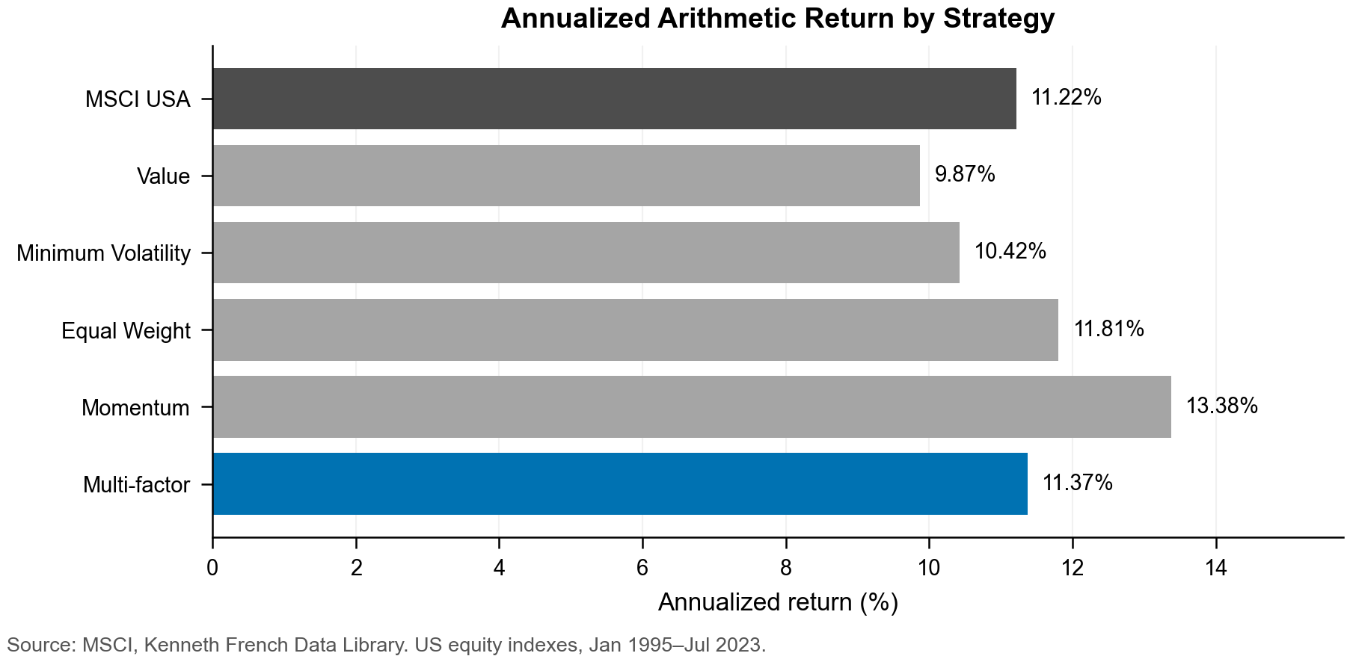

Figure 1.2 Risk-adjusted performance by strategy
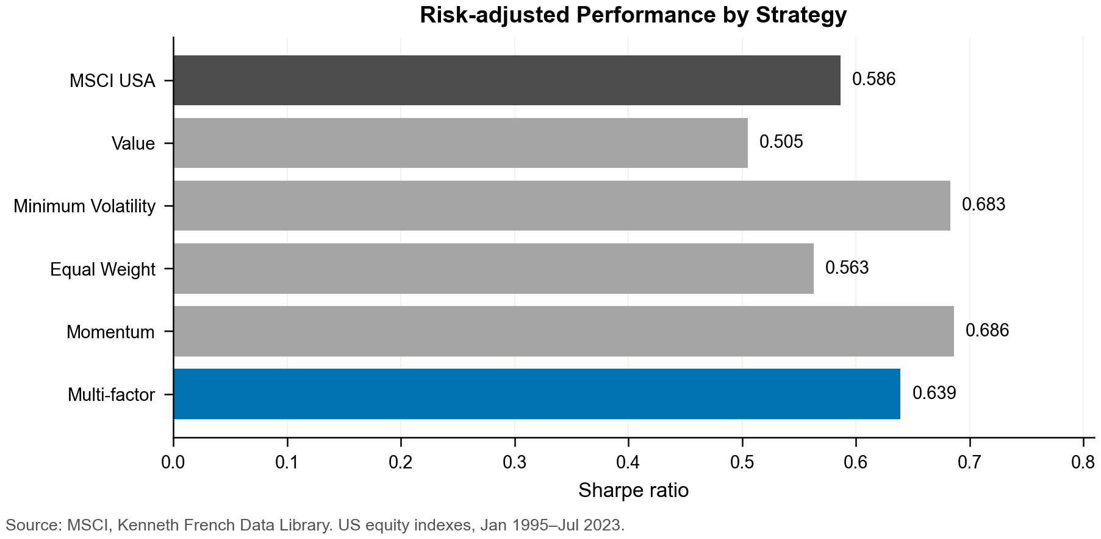

Table 1.3 Correlation between MSCI and academic factor spreads
MSCI spread | HML | SMB | Momentum | Low-beta
Value | 0.728 | -0.177 | -0.244 | 0.415
Minimum volatility | 0.232 | -0.307 | 0.303 | 0.815
Equal weight | 0.431 | 0.322 | -0.449 | -0.200
Momentum | -0.223 | 0.079 | 0.642 | 0.140
Source and scope: MSCI and Kenneth French Data Library. MSCI USA large- and mid-cap equity universe; monthly US factor return spreads, Jan 1995–Jul 2023 (343 months). MSCI spreads are factor index returns minus MSCI USA returns. Academic spreads are HML, SMB, high-minus-low momentum and low-minus-high beta. Pearson correlations; corresponding factor pairs are highlighted in green.

Table 1.4 Momentum performance by market volatility regime
Regime | Months | Mean market vol. | Mean momentum
Low | 111 | 8.21% | +1.04%
Medium | 110 | 14.19% | +1.86%
High | 111 | 21.53% | -1.03%
Source and scope: Kenneth French Data Library, US value-weighted momentum decile portfolios, Dec 1995–Jul 2023 (332 months). Market volatility is the annualized standard deviation of trailing 12 monthly Mkt-RF observations. Regimes are sample terciles. Momentum is the value-weighted highest-minus-lowest decile return spread. High-minus-low Welch test: p = 0.103.
Regression: beta = -0.267; OLS p = 0.001; HAC(12) t = -2.297, p = 0.022; R-squared = 3.15%.

Figure 1.3 Momentum returns across volatility regimes
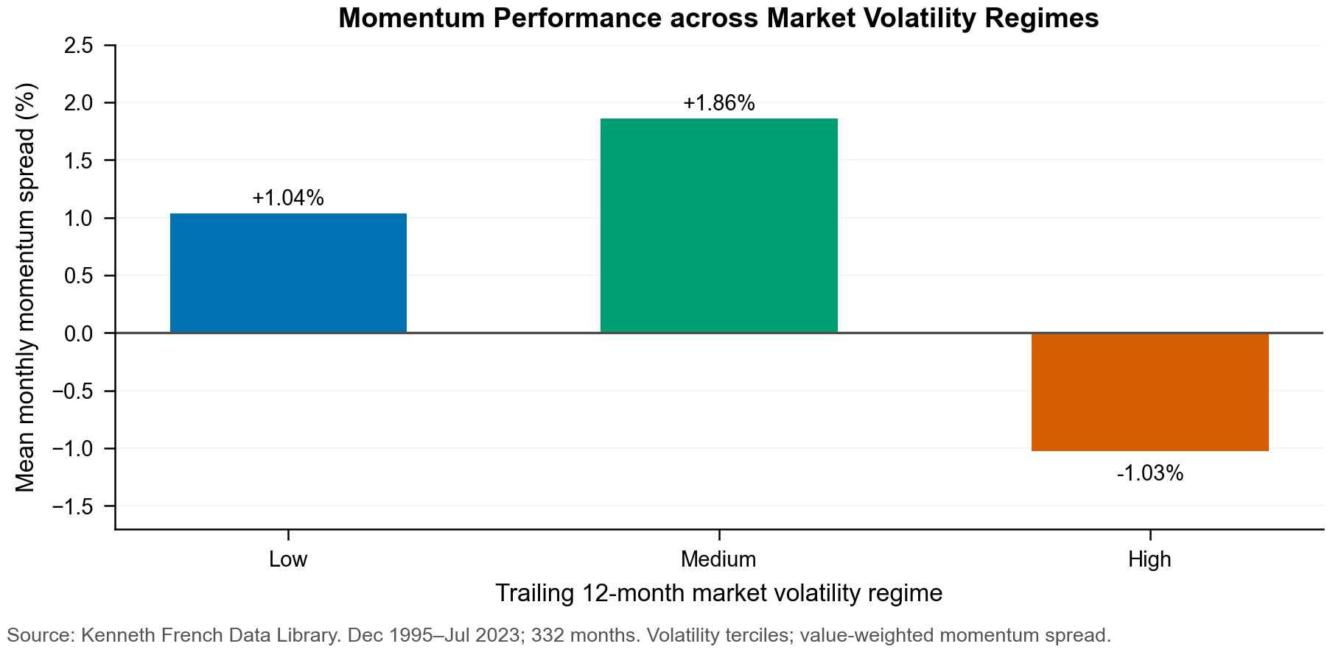

Appendix 2. Part 2 Hands-on Analysis of Security-level Data - exhibits

Table 2.1 Data quality and cleaning
Diagnostic | Saved finding
Full 2A scope | 283,380 stock-months; 1,207 securities; 245 formation months
Membership anomalies | Apr 1999: 182 departures / 166 arrivals; Dec 2018: -17.9%; Feb 2019: -38.8%
Return fields versus absent rows | 100% observed-row return coverage; 1,514 interior gaps in 205 securities
Raw return range | -92.2% to +3,017.6%
Main clipping rule | Monthly 1st/99th percentiles; linear interpolation; 5,723 changed rows; no deletions
Alternative interpretation | 0.5th/99.5th percentiles: 2,883 changed rows; main remains 1/99
P/B midpoint and flag | Pb=0.50: 10,197 rows; Pb=0.50 & Bv<=0.03 flag: 5,720 (5,630 in 2B-2D window)

Source and scope: Full 2A history; supplied Part 2 CSV. Formation Nov 1998-Mar 2019; all securities. Missing rows are diagnostic, not imputed returns.

Table 2.2a Price to book midpoint conditional frequencies
Bv score | Rows | Pb=0.50 rows | Conditional frequency
0.01 | 2918 | 2906 | 99.59%
0.02 | 2909 | 2100 | 72.19%
0.03 | 2781 | 714 | 25.67%
0.04 | 2812 | 183 | 6.51%

Source and scope: Same full history. Frequency denominator: all rows at the exact Bv score. Neither score identifies equity sign.

Table 2.2b Ordinal sanity checks for price to book
Rank diagnostic | All observations | Without exact provisional flags
P/B vs log(cap rank / book rank) | 0.8287 | 0.8503
P/B vs cap rank within book-rank bins | 0.8239 | 0.8251
P/B vs book rank within cap-rank bins | -0.7768 | -0.7986

Source and scope: Saved 2A5 results, exact provisional flag. Proxy medians use 245 months; conditional medians use month-bin cells. Two singleton cells per sample in the book association are undefined and retained in the source audit.

Table 2.3 Main performance
Portfolio | Arithmetic annual return | Geometric CAGR | Annual volatility | Ending $1
EW top 20% | 18.30% | 17.15% | 22.03% | $23.715
Value score | 14.31% | 13.32% | 18.74% | $12.185
Value score x cap | 11.10% | 10.02% | 17.32% | $6.751
2B broad market | 9.81% | 8.77% | 16.48% | $5.372
MSCI USA gross USD | 6.42% | 5.48% | 14.58% | $2.909

Source and scope: Investment Jan 1999-Dec 2018, 240 months. Supplied stock CSV and MSCI gross USD workbook. Main stock returns monthly 1/99 clipped; all flags retained; decimal inputs displayed as percentages. CAGR and arithmetic annualization differ.

Table 2.4 Final formation concentration
Portfolio | Holdings | Maximum weight | Effective N | Top 10 weight
EW top 20% | 222 | 0.4505% | 222.0 | 4.5045%
Value score | 1109 | 0.1763% | 846.2 | 1.7626%
Value score x cap | 1109 | 0.3761% | 651.4 | 3.5841%
2B broad market | 1109 | 0.1817% | 825.6 | 1.8170%

Source and scope: Formation Nov 2018; supplied stock CSV. All observations, main weights. Holdings count positive weights; effective N = 1/sum(w squared).

Table 2.5 Arithmetic return sensitivities
Portfolio | All clipped | All original | No flags clipped | No flags original
EW top 20% | 18.30% | 24.85% | 18.42% | 25.11%
Value score | 14.31% | 17.24% | 14.14% | 16.79%
Value score x cap | 11.10% | 12.12% | 11.01% | 11.88%

Source and scope: Jan 1999-Dec 2018. Same Value score and tie rule. Exclusion removes 5,630 flagged in-window stock-months only; full-universe benchmark remains fixed. No excluded observations are deleted from source files.

Table 2.6 Tracking error and HML sensitivity
Portfolio | Main TE | Original TE | Main HML rho | Original HML rho
EW top 20% | 9.51% | 11.38% | 0.5539 | 0.4727
Value score | 4.90% | 5.42% | 0.5806 | 0.5239
Value score x cap | 2.74% | 2.95% | 0.8533 | 0.8256

Source and scope: Jan 1999-Dec 2018, 240 aligned observations. TE = sample standard deviation of Value-minus-2B market times sqrt(12). Both Value and market switch to original returns in sensitivity; HML unchanged.

Table 2.7 Complete active return correlation matrix
Series | S1 active | S2 active | S3 active | HML
S1 active | 1.0000 | 0.9581 | 0.7590 | 0.5539
S2 active | 0.9581 | 1.0000 | 0.7670 | 0.5806
S3 active | 0.7590 | 0.7670 | 1.0000 | 0.8533
HML | 0.5539 | 0.5806 | 0.8533 | 1.0000

Source and scope: Pearson correlations, main clipped returns. S1 EW top 20%; S2 Value score; S3 Value times cap. Saved 2B/2C and supplied monthly FF HML, Jan 1999-Dec 2018, all flags retained.

Figure 2.1 Monthly stock counts
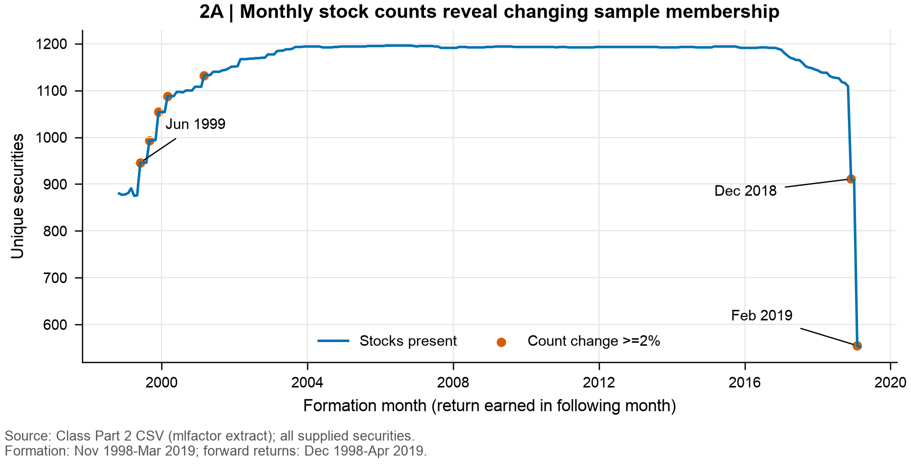

Figure 2.2 Forward return distribution
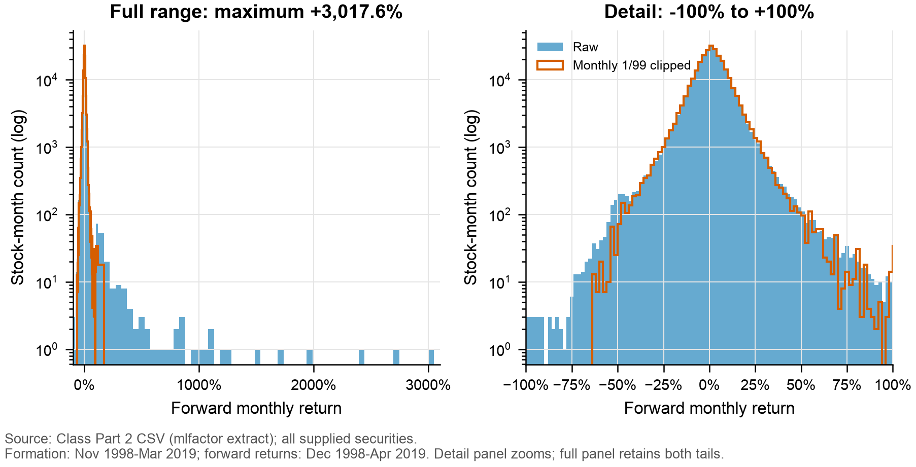

Figure 2.3 Return coverage and sample presence
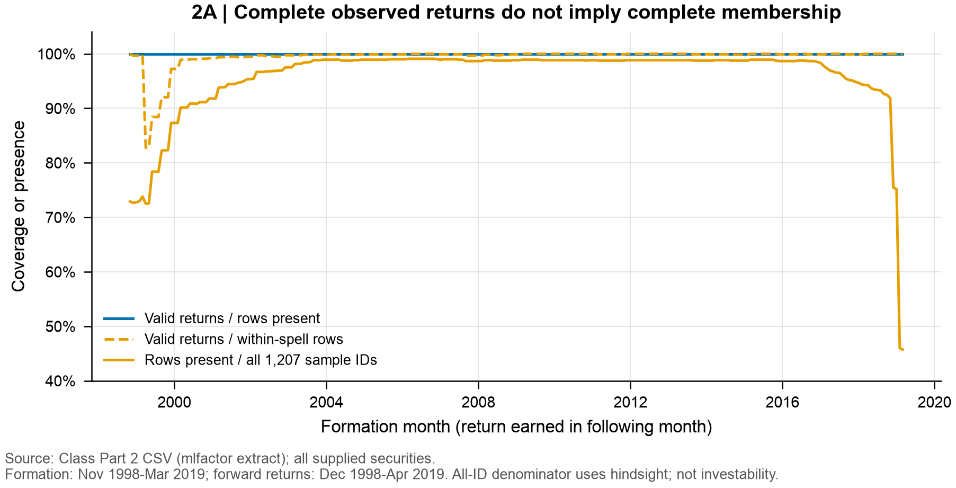

Figure 2.4 Price to book distribution and low book ranks
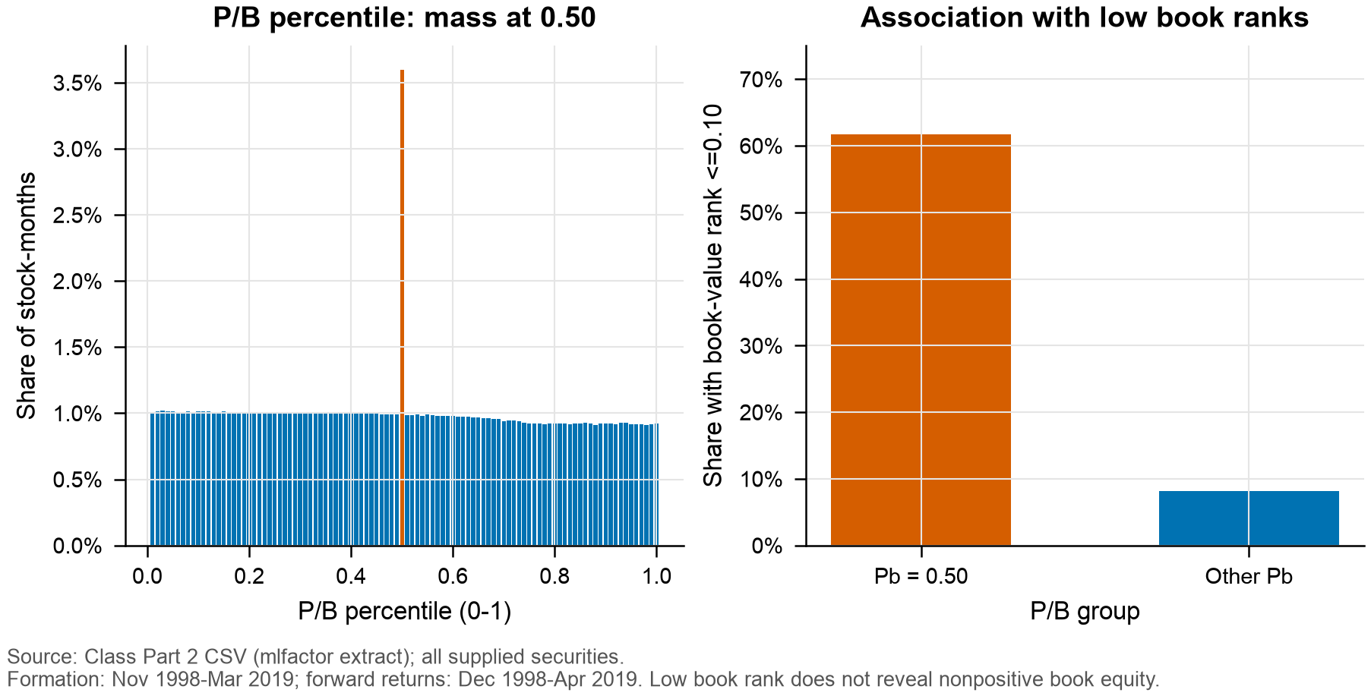

Figure 2.5 Rank sanity comparison for the exact provisional flag
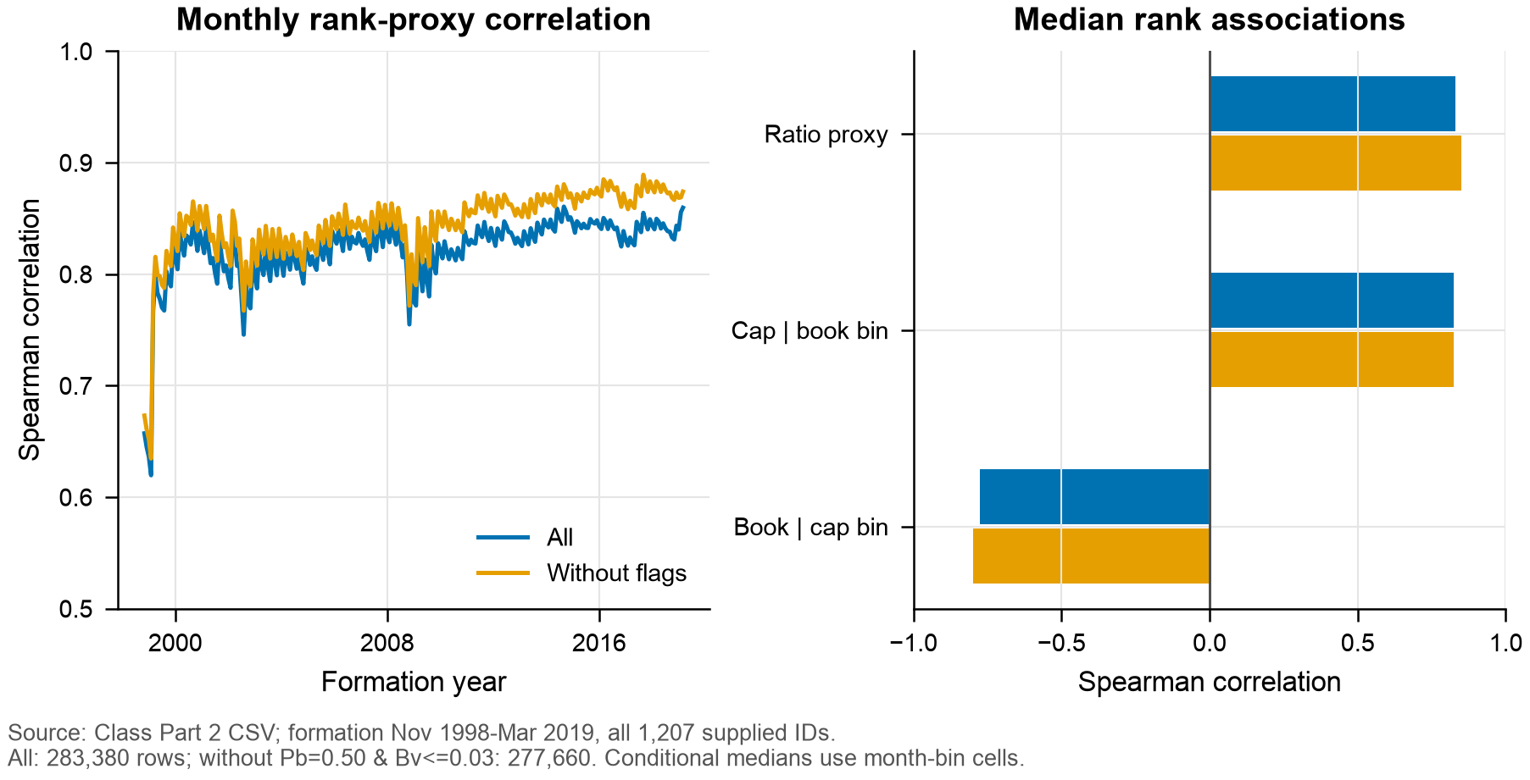

Figure 2.6 Market proxy and MSCI USA cumulative wealth
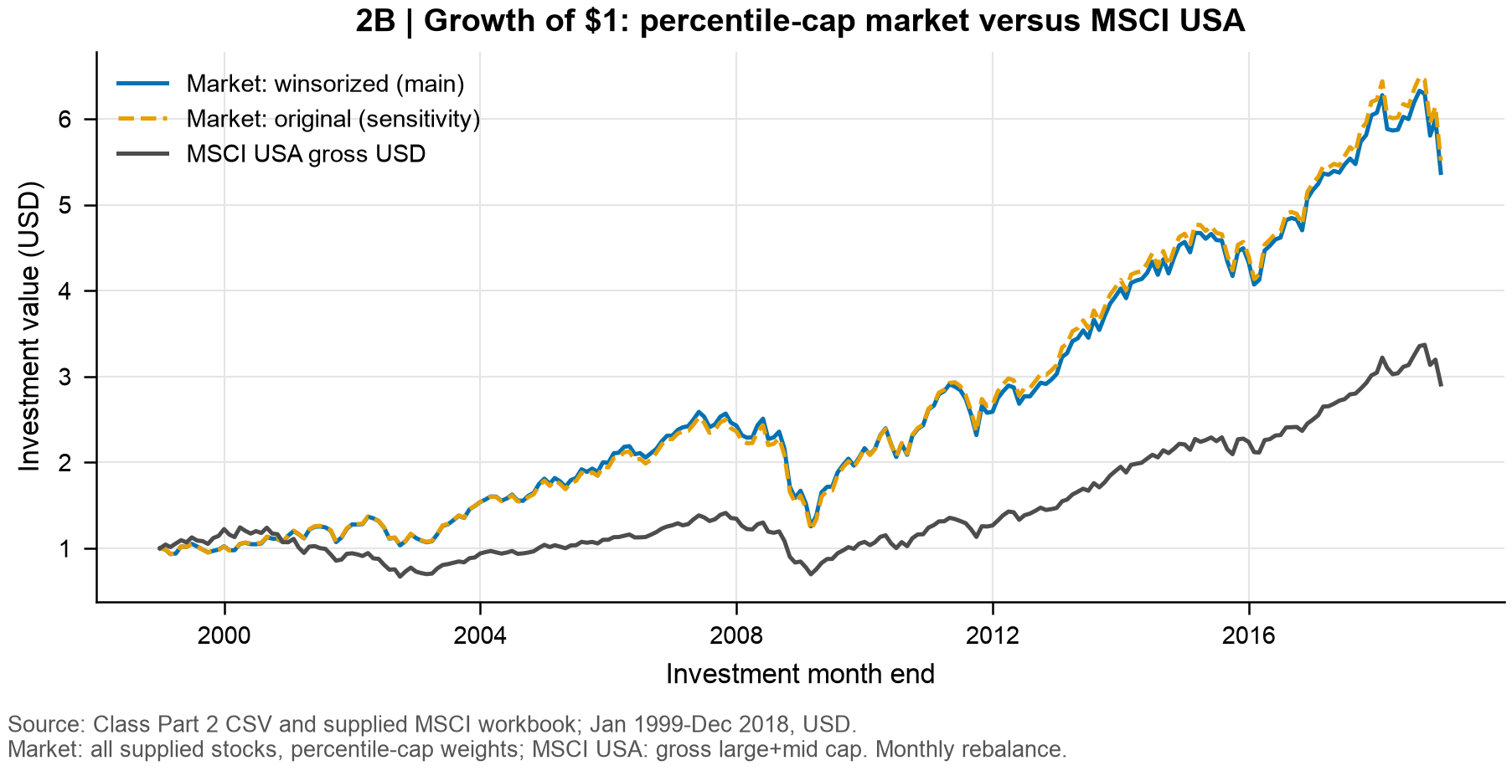

Figure 2.7 Value strategy cumulative wealth
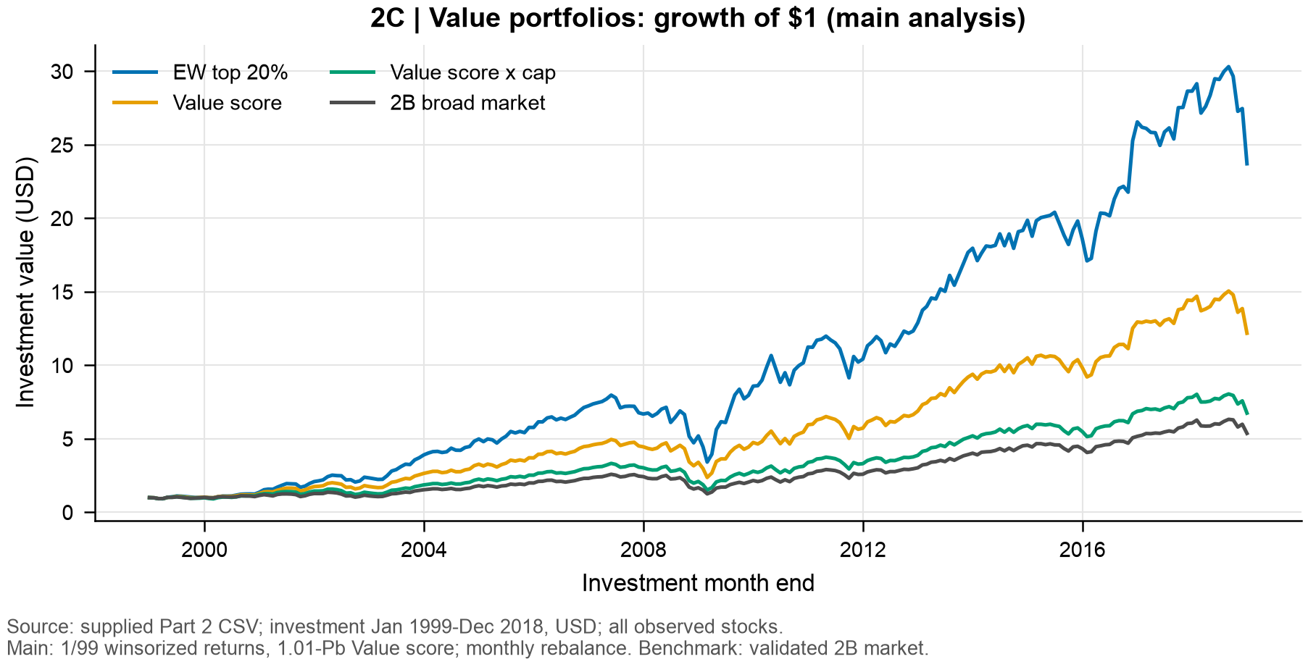

Figure 2.8 Active return and HML correlations
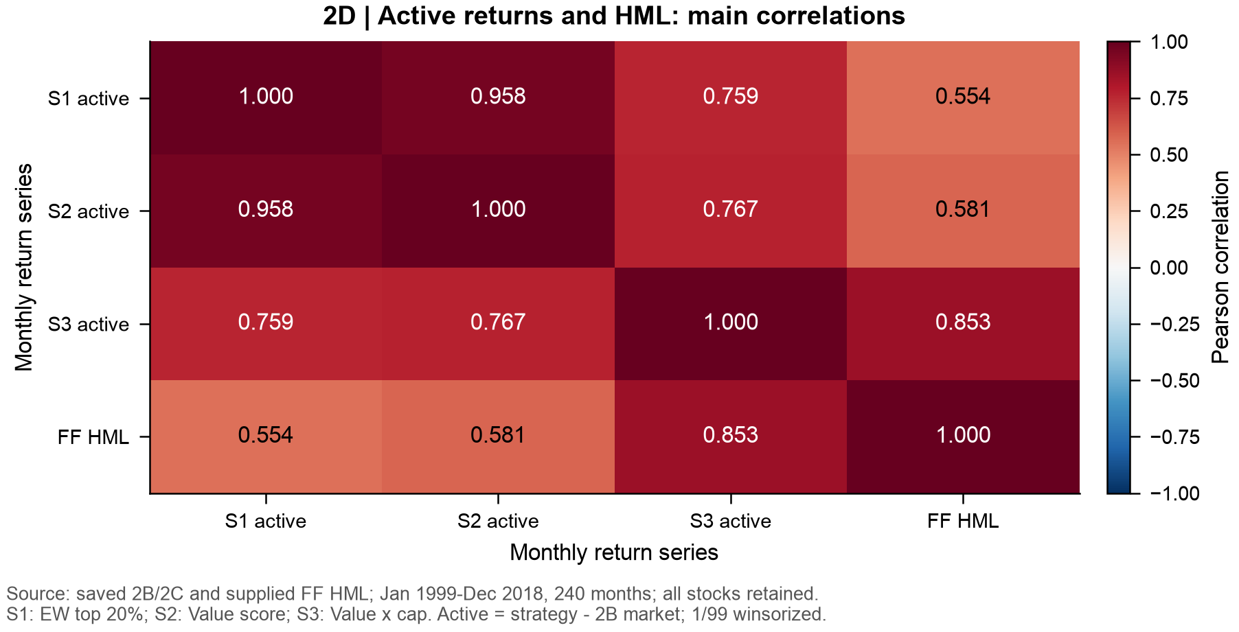

Appendix 3. Part 3 Portfolio Construction - exhibits

Table 3.1 Optimal industry weights as of 31 December 2004
Industry | Min-var (shorts) | Min-var (long-only) | Inverse vol | Industry | Min-var (shorts) | Min-var (long-only) | Inverse vol
Agriculture | 6.4% | 10.7% | 2.2% | Defense | 13.7% | 9.3% | 1.7%
Food products | 19.5% | 9.1% | 2.9% | Precious metals | -1.1% | 0.7% | 1.0%
Candy & soda | -5.1% | 0.0% | 1.5% | Non-precious mining | 5.2% | 0.0% | 2.0%
Beer & liquor | -1.8% | 0.0% | 2.1% | Coal | -1.7% | 0.0% | 1.0%
Tobacco | 0.1% | 0.0% | 1.4% | Petroleum & natural gas | 19.3% | 1.6% | 2.5%
Recreation | -0.5% | 0.0% | 2.0% | Utilities | 21.5% | 16.7% | 2.8%
Entertainment | 1.3% | 0.0% | 1.8% | Communication | 0.2% | 2.9% | 2.0%
Printing & publishing | 41.3% | 7.7% | 2.7% | Personal services | -13.5% | 0.0% | 2.2%
Consumer goods | 21.2% | 12.3% | 2.7% | Business services | -32.3% | 0.0% | 2.4%
Apparel | 2.3% | 0.0% | 2.0% | Computer hardware | 2.0% | 0.0% | 1.2%
Healthcare services | -4.9% | 0.0% | 1.8% | Computer software | 10.3% | 0.0% | 1.3%
Medical equipment | 25.2% | 5.9% | 2.9% | Electronic equipment | 1.3% | 0.0% | 1.2%
Pharmaceuticals | -1.2% | 9.5% | 2.5% | Measuring & control equip. | -4.2% | 0.0% | 1.6%
Chemicals | -28.4% | 0.0% | 2.4% | Business supplies | 26.0% | 0.0% | 2.5%
Rubber & plastics | 9.4% | 0.0% | 2.2% | Shipping containers | -3.3% | 0.0% | 1.9%
Textiles | 0.1% | 0.0% | 2.1% | Transportation | 7.8% | 0.0% | 2.4%
Construction materials | -3.8% | 0.0% | 2.4% | Wholesale | -5.3% | 0.0% | 2.6%
Construction | -17.8% | 0.0% | 1.9% | Retail | 0.6% | 0.0% | 2.3%
Steel works | 6.8% | 0.0% | 1.5% | Restaurants & hotels | 13.9% | 0.0% | 2.5%
Fabricated products | -2.4% | 0.0% | 1.7% | Banking | -16.6% | 0.0% | 2.3%
Machinery | -2.3% | 0.0% | 1.8% | Insurance | -4.0% | 0.0% | 2.5%
Electrical equipment | -8.1% | 0.0% | 2.0% | Real estate | 23.0% | 13.7% | 2.8%
Autos & trucks | 6.3% | 0.0% | 1.8% | Trading | -4.5% | 0.0% | 1.6%
Aircraft | -20.6% | 0.0% | 1.8% | Other | -0.3% | 0.0% | 1.8%
Ships & rail equipment | -0.7% | 0.0% | 1.9% | Sum of weights | 100.0% | 100.0% | 100.0%

Source and scope: Kenneth French Data Library; MSCI. 49 Fama-French industries, value-weighted total returns; covariance estimated Jan 1995 - Dec 2004. Fully invested. Green = 5 largest weights per portfolio; red = 5 smallest (long-only: all 37 zero-weight industries). Industries in Fama-French order.

Table 3.2 Portfolio characteristics as of 31 December 2004
Characteristic | Min-var (shorts allowed) | Min-var (long-only) | Inverse volatility
Sum of weights | 100.0% | 100.0% | 100.0%
Non-zero positions | 49 | 12 | 49
Short positions | 24 | 0 | 0
Largest weight | 41.3% | 16.7% | 2.9%
Smallest weight | -32.3% | 0.0% | 1.0%
Top-5 weight | 137.0% | 62.8% | 14.1%
Effective N = 1/Σw² | 1.1 | 9.1 | 46.3

Source and scope: Kenneth French Data Library; MSCI. Weights from Table 3.1. Effective N equals 49 for equal weights; it is not meaningful for the portfolio with short positions.

Table 3.3 In-sample versus out-of-sample annualized volatility
Portfolio | In-sample vol, Jan 1995 - Dec 2004 | Out-of-sample vol, Jan 2005 - Jul 2023 | Ratio OOS / in-sample
Min-var (shorts allowed) | 7.6% | 16.7% | ×2.21
Min-var (long-only) | 10.3% | 14.3% | ×1.39
Inverse volatility | 14.0% | 17.2% | ×1.23
Equal weight (49 industries) | 14.6% | 17.5% | ×1.19
Lowest-vol industry in 1995–2004 (Food products) | 15.2% | 12.7% | ×0.83

Source and scope: Kenneth French Data Library; MSCI. Weights from Table 3.1 held constant and rebalanced monthly. Reference rows (equal weight; lowest-volatility industry in 1995-2004, Food products) use the same data and only information available at Dec 2004.

Table 3.4 Out-of-sample volatility by sub-period
Out-of-sample sub-period | Min-var (shorts) | Min-var (long-only) | Inverse vol | Equal weight
2005–2014 | 16.9% | 14.4% | 17.3% | 17.6%
2015–2023/07 | 16.7% | 14.2% | 17.2% | 17.4%
2005–2007 (pre-GFC) | 10.0% | 7.5% | 8.9% | 9.3%
2008–2009 (GFC) | 31.6% | 24.3% | 28.7% | 29.0%

Source and scope: Kenneth French Data Library; MSCI. Annualized volatility of monthly returns within each sub-period; 3A weights, no re-estimation. The long-only portfolio is the lowest of the three in every sub-period.

Table 3.5 Long-only minimum-variance weights before and after re-optimization
Industry | Weights as of Dec 2004 | Weights as of Dec 2015 | Change
Food products | 9.1% | 37.4% | +28.3 pp
Utilities | 16.7% | 23.3% | +6.6 pp
Beer & liquor | 0.0% | 21.2% | +21.2 pp
Retail | 0.0% | 13.4% | +13.4 pp
Precious metals | 0.7% | 4.8% | +4.0 pp
Real estate | 13.7% | 0.0% | -13.7 pp
Consumer goods | 12.3% | 0.0% | -12.3 pp
Agriculture | 10.7% | 0.0% | -10.7 pp
Pharmaceuticals | 9.5% | 0.0% | -9.5 pp
Defense | 9.3% | 0.0% | -9.3 pp
Printing & publishing | 7.7% | 0.0% | -7.7 pp
Medical equipment | 5.9% | 0.0% | -5.9 pp
Communication | 2.9% | 0.0% | -2.9 pp
Petroleum & natural gas | 1.6% | 0.0% | -1.6 pp
Turnover (½Σ|Δw|) |  |  | 73.5%

Source and scope: Kenneth French Data Library; MSCI. Dec 2004: covariance Jan 1995 - Dec 2004 (Table 3.1). Dec 2015: same method, covariance Jan 2006 - Dec 2015. Industries with a non-zero weight in at least one portfolio.

Table 3.6 Annualized volatility, January 2016 - July 2023
Period | Dec 2004 weights | Dec 2015 weights | Equal weight | New − old
Full: Jan 2016 - Jul 2023 | 14.5% | 12.8% | 17.8% | -1.7 pp
Pre-COVID: 2016 - 2019 | 10.8% | 10.3% | 12.9% | -0.5 pp
COVID and after: 2020 - Jul 2023 | 17.9% | 15.2% | 22.2% | -2.7 pp
Cumulative return, Feb - Mar 2020 | -21.2% | -15.1% | -24.6% | +6.2 pp

Source and scope: Kenneth French Data Library; MSCI. Both portfolios out-of-sample; weights held constant and rebalanced monthly. Last row: compounded return over Feb - Mar 2020 (two months are too few for a volatility estimate).

Table 3.7 Performance of the Dec 2004 long-only minimum-variance portfolio and MSCI USA
Jan 2005 - Jul 2023 | Long-only min-var | MSCI USA
Final value of $1 (Jul 2023) | $4.79 | $5.53
Annualized return (geometric) | 8.8% | 9.6%
Annualized volatility | 14.3% | 15.3%
Maximum drawdown | -45.7% | -50.6%
Cumulative return, GFC (Sep 2008 - Feb 2009) | -40.3% | -41.8%
Cumulative return, COVID (Feb - Mar 2020) | -21.2% | -19.8%

Source and scope: Kenneth French Data Library; MSCI. Fama-French 49 industries (all CRSP stocks, value-weighted) and MSCI USA Standard (large + mid cap), gross, USD. Annualized return is geometric (compound growth). Crisis returns compounded over the stated months.

Table 3.8 Crisis returns of the portfolio's holdings
Industry held | Weight | GFC return | GFC contribution | COVID return | COVID contribution
Utilities | 16.7% | -33% | -5.5% | -22% | -3.6%
Real estate | 13.7% | -67% | -9.2% | -42% | -5.8%
Consumer goods | 12.3% | -35% | -4.3% | -15% | -1.8%
Agriculture | 10.7% | -33% | -3.6% | -17% | -1.8%
Pharmaceuticals | 9.5% | -24% | -2.3% | -7% | -0.7%
Defense | 9.3% | -44% | -4.1% | -20% | -1.8%
Food products | 9.1% | -24% | -2.2% | -13% | -1.2%
Printing & publishing | 7.7% | -56% | -4.4% | -28% | -2.2%
Medical equipment | 5.9% | -42% | -2.5% | -18% | -1.1%
Communication | 2.9% | -37% | -1.1% | -19% | -0.5%
Petroleum & natural gas | 1.6% | -38% | -0.6% | -45% | -0.7%
Precious metals | 0.7% | -12% | -0.1% | -3% | -0.0%

Source and scope: Kenneth French Data Library; MSCI. GFC: Sep 2008 - Feb 2009; COVID: Feb - Mar 2020. Contribution ≈ weight × industry crisis return (approximate, as the portfolio is rebalanced monthly). Real estate (shaded) was among the five worst industries in both crises.

Table 3.9 Ten best-performing industries in each crisis
Industry (GFC) | Return | Vol rank | Weight | Industry (COVID) | Return | Vol rank | Weight
Precious metals | -12% | 48 / 48 | 0.7% | Precious metals | -3% | 48 / 48 | 0.7%
Beer & liquor | -22% | 22 / 11 | – | Pharmaceuticals | -7% | 8 / 9 | 9.5%
Personal services | -24% | 21 / 20 | – | Retail | -10% | 17 / 10 | –
Pharmaceuticals | -24% | 8 / 4 | 9.5% | Tobacco | -13% | 44 / 23 | –
Food products | -24% | 1 / 2 | 9.1% | Food products | -13% | 1 / 4 | 9.1%
Restaurants & hotels | -26% | 11 / 13 | – | Computer software | -15% | 45 / 14 | –
Candy & soda | -29% | 42 / 42 | – | Consumer goods | -15% | 5 / 2 | 12.3%
Tobacco | -30% | 44 / 43 | – | Measuring & control equip. | -16% | 41 / 20 | –
Retail | -30% | 17 / 17 | – | Shipping containers | -16% | 31 / 22 | –
Utilities | -33% | 3 / 5 | 16.7% | Business supplies | -16% | 10 / 16 | –

Source and scope: Kenneth French Data Library; MSCI. Vol rank = rank of annualized volatility among 49 industries (1 = lowest): Jan 1995 - Dec 2004 / ten years before the crisis. Weight = Dec 2004 long-only minimum-variance weight (– = not held).

Figure 3.1 Sorted industry weights of the three portfolios (3A)
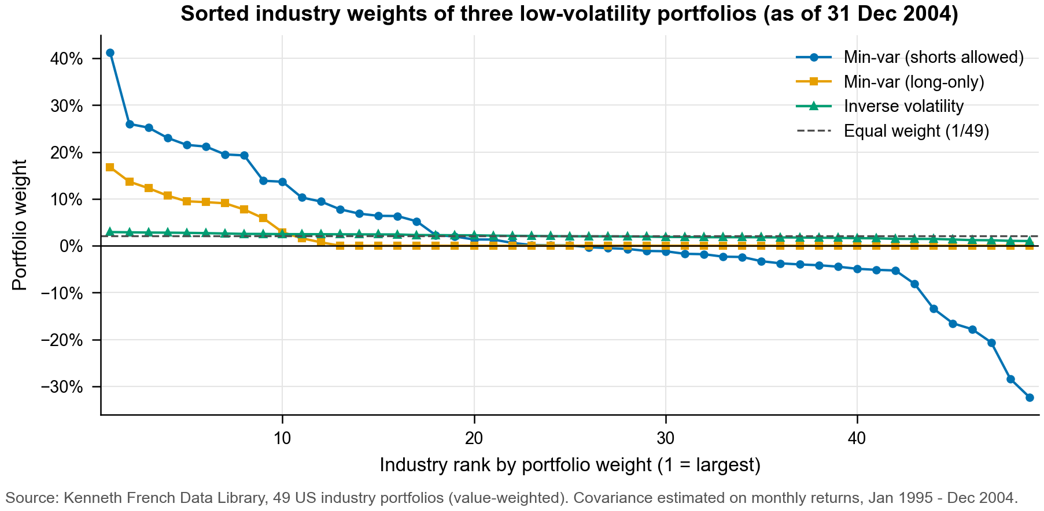

Figure 3.2 In-sample volatility, Jan 1995 - Dec 2004 (3B)
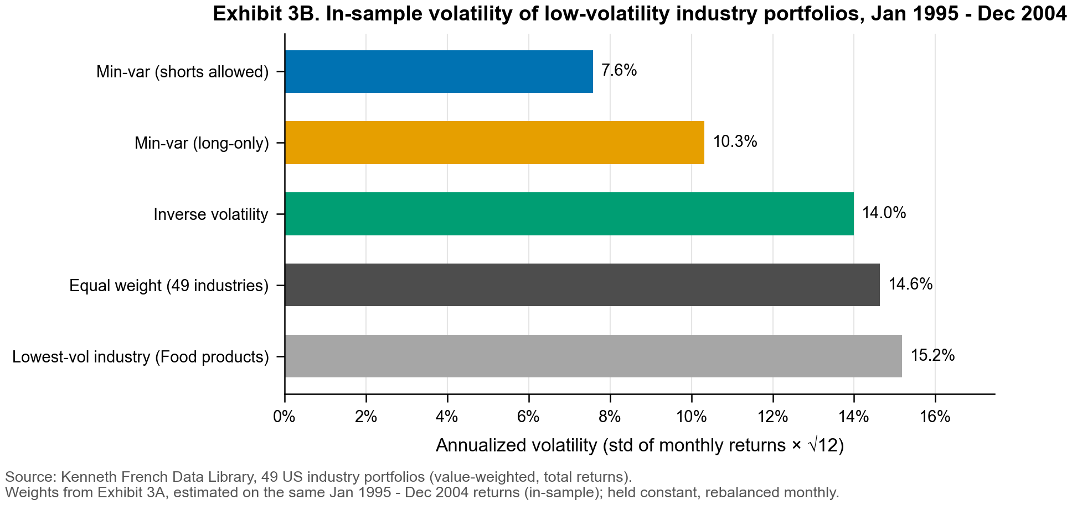

Figure 3.3 In-sample versus out-of-sample volatility (3B-3C)
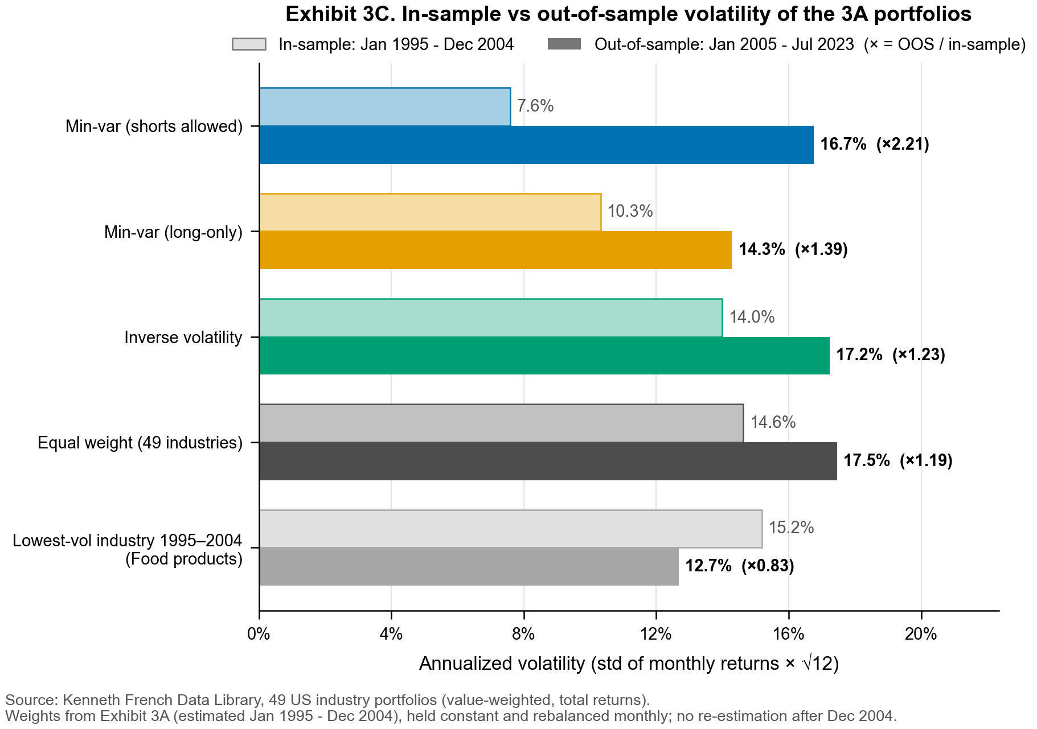

Figure 3.4 Rolling 36-month out-of-sample volatility (3C)
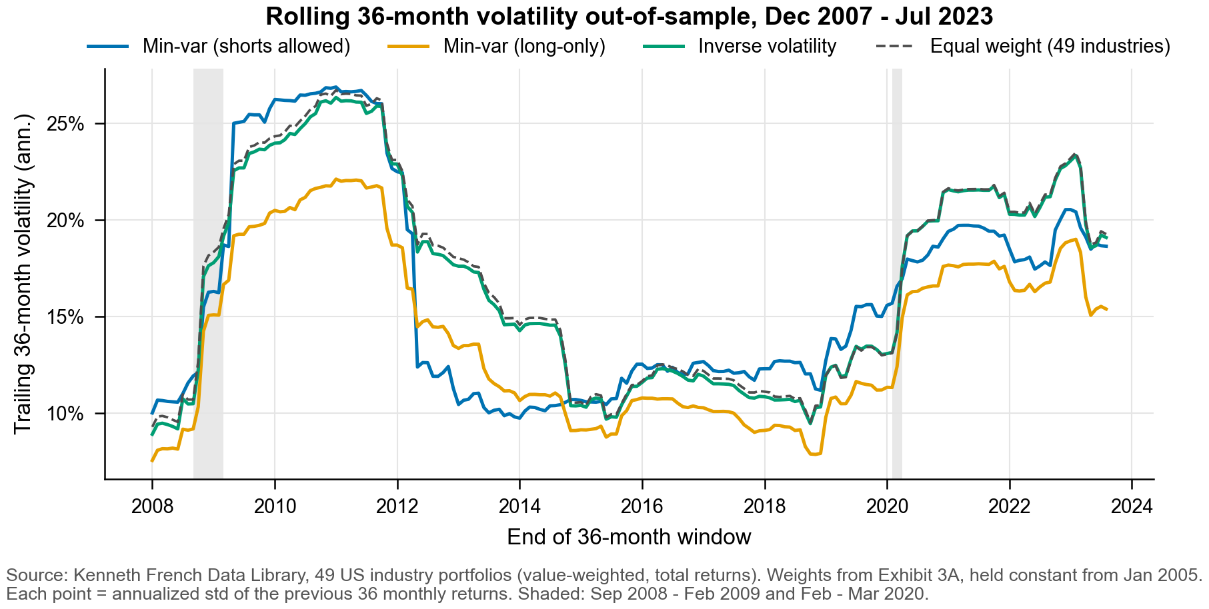

Figure 3.5 Value of re-optimization: volatility, Jan 2016 - Jul 2023 (3D)
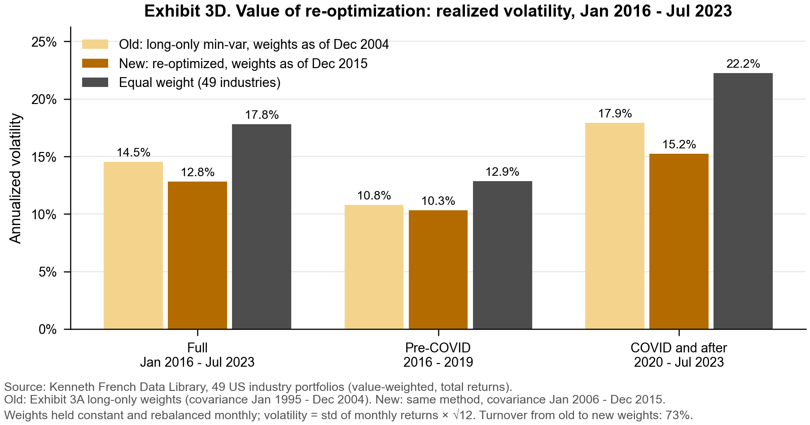

Figure 3.6 Weights before and after re-optimization (3D)
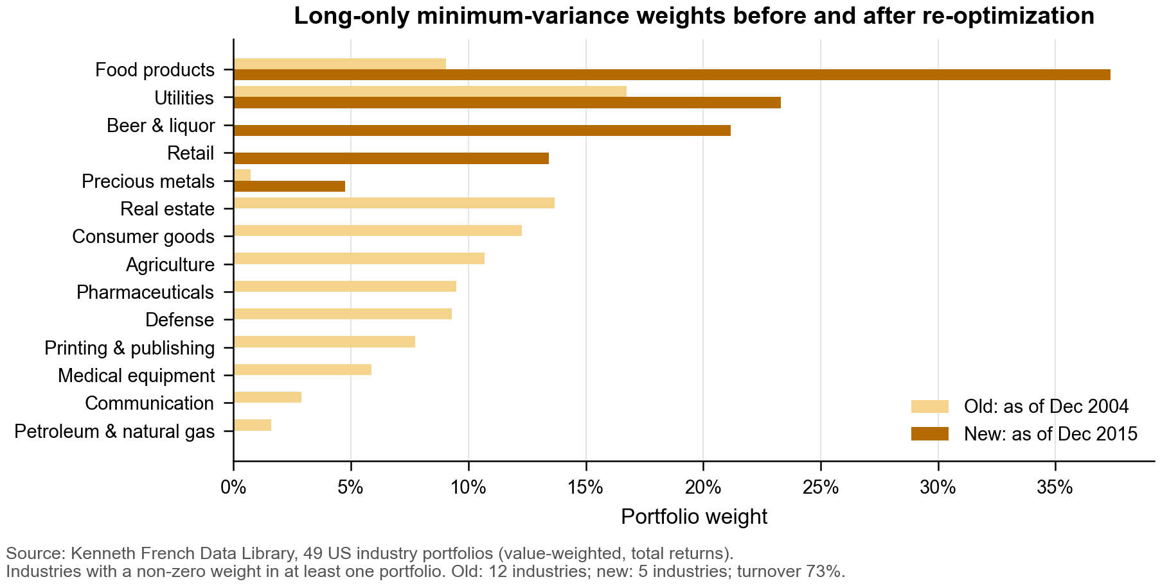

Figure 3.7 Growth of $1 invested on 31 Dec 2004, log2 scale (3E)
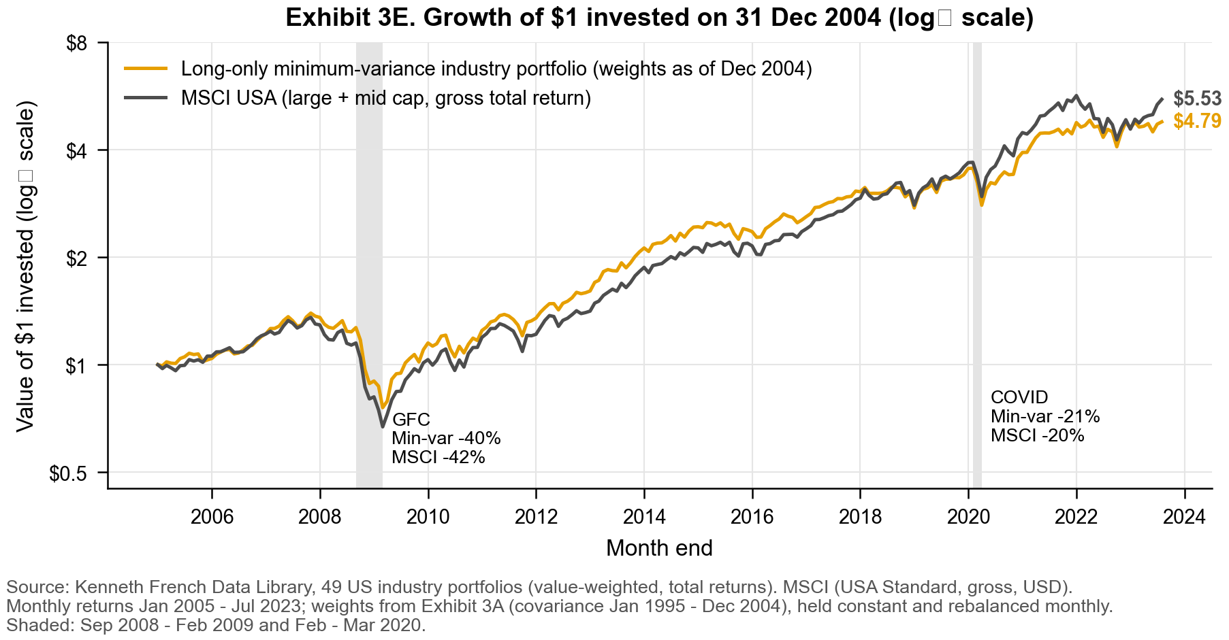

Figure 3.8 Ten best-performing industries in each crisis (3E)
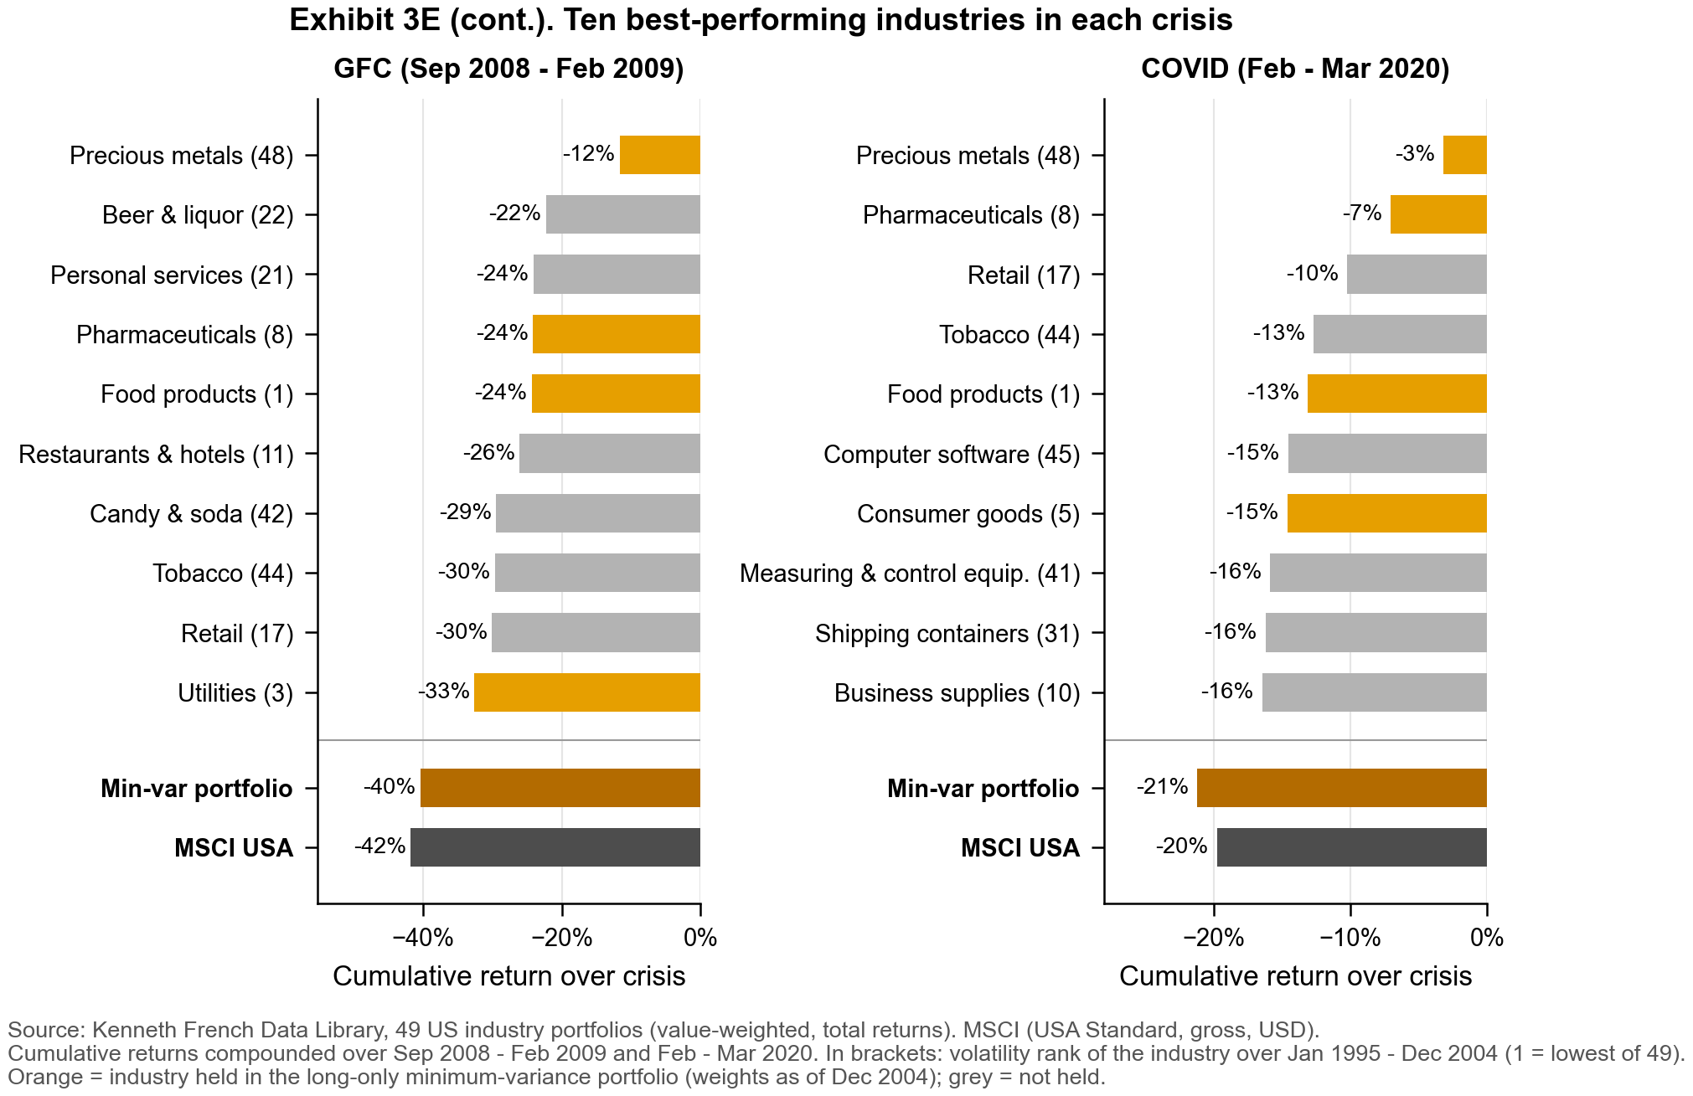

Appendix 4. Part 4 Product Innovation - exhibits
These exhibits test whether NVDL delivers twice NVDA's return. It does so day by day, but not over longer periods, and its estimated annual drag (about 15%) is far larger than its stated expense ratio.

Table 4.1 Daily risk metrics
Metric | NVDA | NVDL | NVDL / NVDA
Standard deviation (daily) | 3.75% | 7.48% | 2.00
95% Value at Risk (daily loss) | 6.12% | 12.03% | 1.97
95% Conditional VaR (daily loss) | 7.07% | 14.16% | 2.00
Source and scope: supplied class project data (part 4); daily total returns of NVDA and the GraniteShares 2x Long NVDA Daily ETF (NVDL); 1 Feb 2024 - 30 Aug 2024 (147 trading days). Returns are decimals (0.01 = 1%) sorted oldest to newest before any compounding. Not annualized. Standard deviation uses ddof = 1. Historical (empirical) method: VaR is the 5th percentile of daily returns, shown as a positive loss; CVaR is the average return on the days at or below that percentile, also shown as a loss.

Figure 4.1 Distribution of daily returns
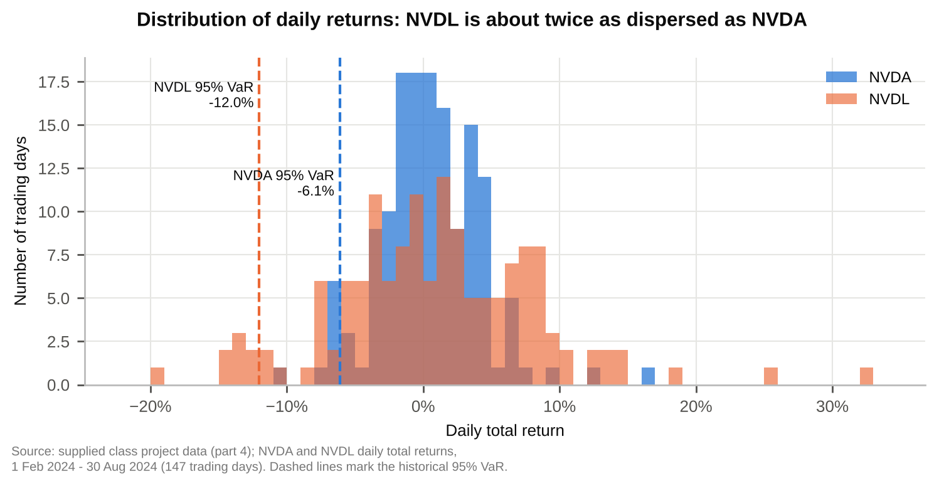

Table 4.2 Regression of NVDL on NVDA daily returns
Term | Coefficient | Std error | t statistic | p value | 95% confidence interval
Intercept (decimal/day) | -0.000612 | 0.000163 | -3.743 | 0.000261 | [-0.000935, -0.000289]
NVDA (slope) | 1.995975 | 0.004335 | 460.4 | 2.20e-231 | [1.9874, 2.0045]
Test of slope = 2 | 1.995975 | 0.004335 | -0.928 | 0.355 | contains 2
Source and scope: supplied class project data (part 4); daily total returns of NVDA and the GraniteShares 2x Long NVDA Daily ETF (NVDL); 1 Feb 2024 - 30 Aug 2024 (147 trading days). Returns are decimals (0.01 = 1%) sorted oldest to newest before any compounding. OLS of daily NVDL return on daily NVDA return with an intercept. N = 147, residual df = 145, R² = 0.99932, adjusted R² = 0.99931, residual standard deviation = 0.196% per day. Standard errors and two-sided Student t tests are conventional, without HAC/Newey-West adjustment. The last row tests H0: slope = 2 using the same estimate.

Figure 4.2 NVDL vs NVDA daily returns
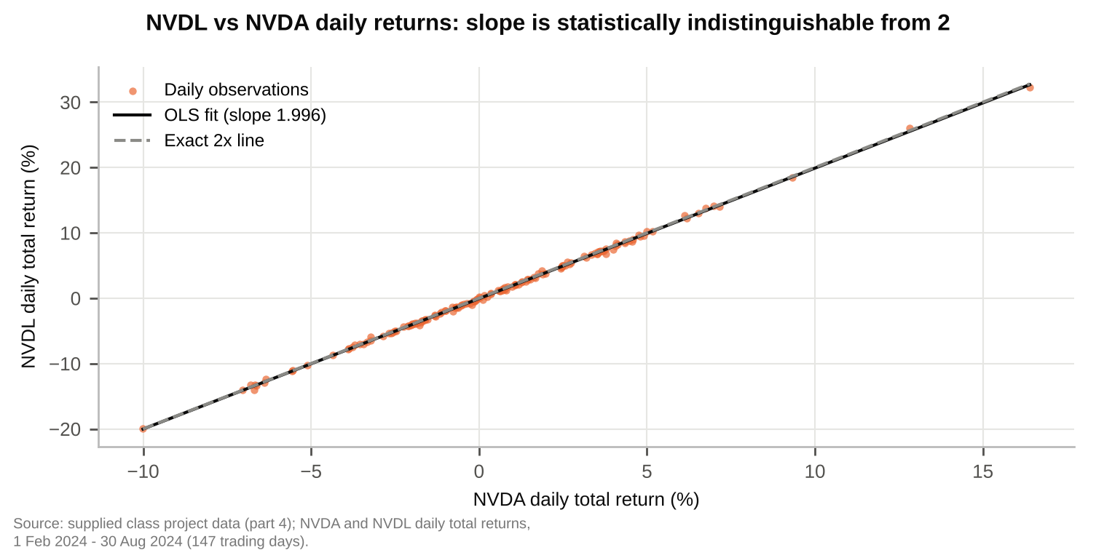

Table 4.3 Annualized intercept (performance drag) vs stated expenses
Measure | Annual rate | Basis
Estimated drag: -intercept x 252 | 15.41% | Table 4.2 intercept, annualized
95% confidence interval of the drag | [7.27%, 23.55%] | Table 4.2 interval x 252
Cross-check: -mean(NVDL - 2 x NVDA) x 252 | 15.94% | Model-free, same data
Management fee | 0.99% | NVDL factsheet, 30 Jun 2024
Net annual operating expense ratio | 1.15% | Factsheet; fee waiver to 31 Dec 2024
Total annual operating expense ratio | 1.57% | Factsheet, before waiver
Source and scope: supplied class project data (part 4); daily total returns of NVDA and the GraniteShares 2x Long NVDA Daily ETF (NVDL); 1 Feb 2024 - 30 Aug 2024 (147 trading days). Returns are decimals (0.01 = 1%) sorted oldest to newest before any compounding. Annualization multiplies the daily intercept by 252 trading days and does not compound it. The factsheet figures are per annum and are not estimated from the return data. The data cannot separate the fund's financing and daily trading costs from the expense ratio; the assignment notes that the fund borrows and trades NVDA daily.

Figure 4.3 Estimated drag vs stated expenses
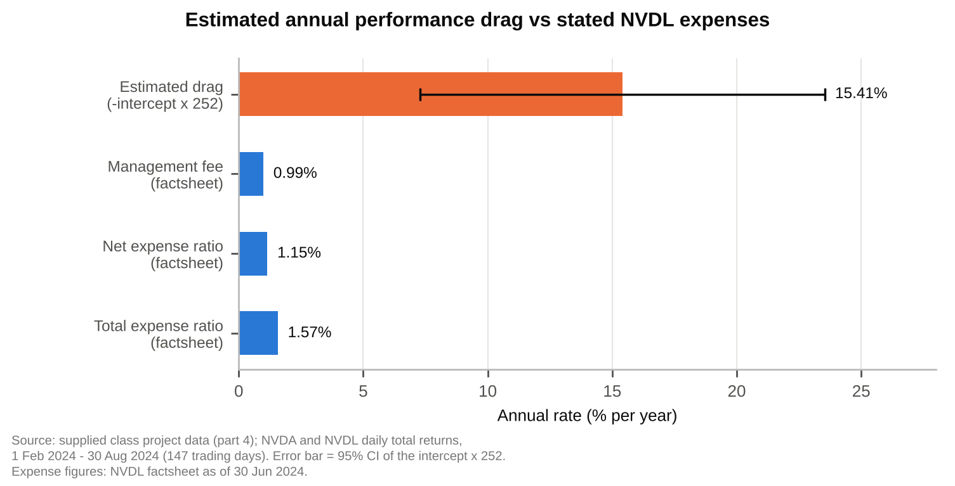

Table 4.4 Monthly and full-window total returns
Period | NVDA  total return | NVDL  total return | 2 x NVDA | NVDL minus  2 x NVDA
Feb 2024 | 28.60% | 59.11% | 57.19% | 1.92%
Mar 2024 | 14.21% | 25.76% | 28.42% | -2.66%
Apr 2024 | -4.37% | -12.22% | -8.74% | -3.47%
May 2024 | 26.88% | 55.72% | 53.76% | 1.97%
Jun 2024 | 12.70% | 22.60% | 25.40% | -2.80%
Jul 2024 | -5.28% | -14.68% | -10.56% | -4.12%
Aug 2024 | 2.01% | -1.60% | 4.02% | -5.62%
Feb - Aug 2024 (full window) | 94.05% | 181.53% | 188.10% | -6.57%
Source and scope: supplied class project data (part 4); daily total returns of NVDA and the GraniteShares 2x Long NVDA Daily ETF (NVDL); 1 Feb 2024 - 30 Aug 2024 (147 trading days). Returns are decimals (0.01 = 1%) sorted oldest to newest before any compounding. Total return = product(1 + daily return) - 1 within each calendar month and over the full window; daily returns are not summed. Full window NVDL / NVDA = 1.93. Trading days per month: Feb 20, Mar 20, Apr 22, May 22, Jun 19, Jul 22, Aug 22.

Figure 4.4 Monthly total returns
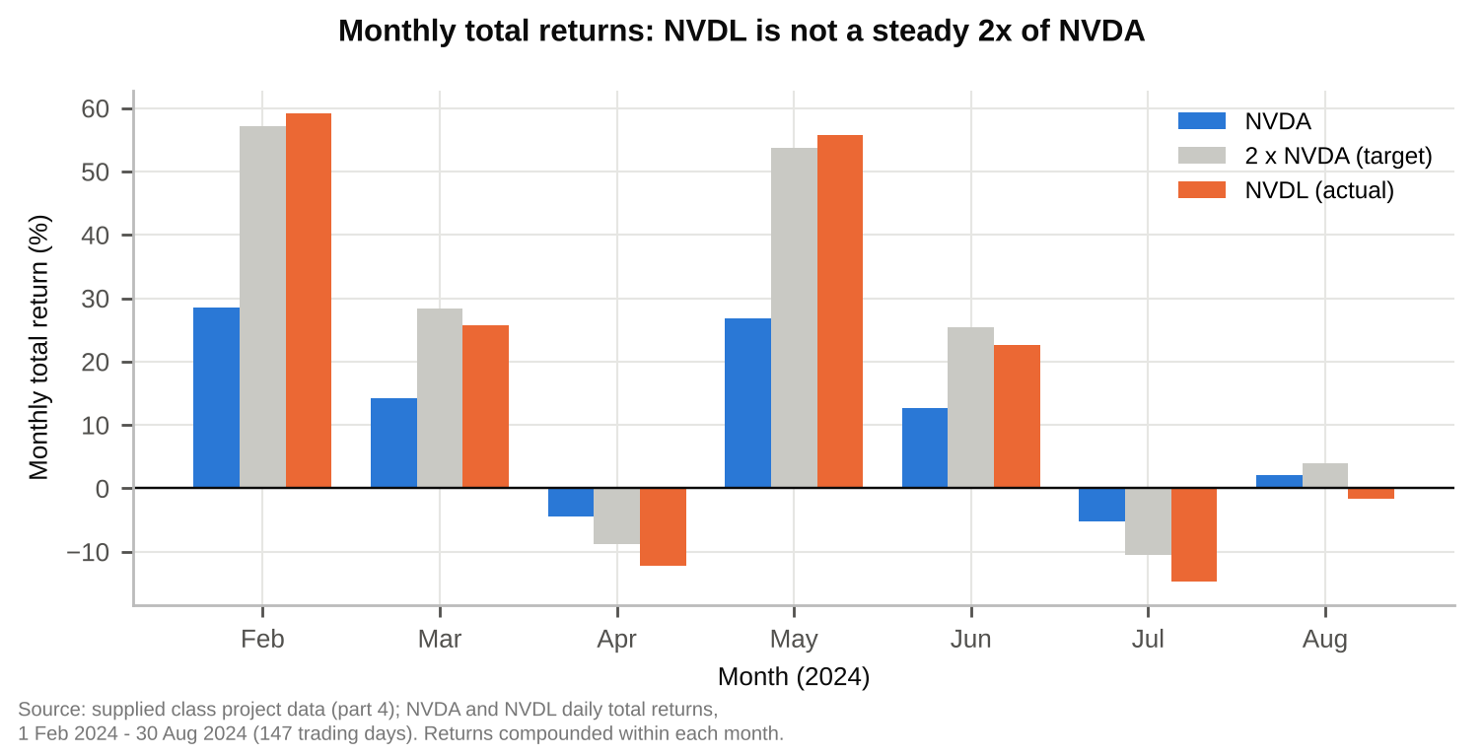

Table 4.5 Factsheet performance of NVDL vs NVDA
Period to 30 Jun 2024 | NVDL NAV  return | NVDA  return | 2 x NVDA | NVDL minus  2 x NVDA
1 month | 22.60% | 12.69% | 25.38% | -2.78 pp
3 months | 67.59% | 36.74% | 73.48% | -5.89 pp
Year to date | 365.74% | 149.50% | 299.00% | +66.74 pp
1 year | 448.66% | 192.13% | 384.26% | +64.40 pp
Source and scope: GraniteShares 2x Long NVDA Daily ETF factsheet, performance as of 30 June 2024 (NVDL NAV and NVDA returns as printed; not recomputed). Returns shorter than one year are not annualized. 'pp' = percentage points. The 1-year and year-to-date NVDL returns exceed 2 x NVDA, while the 1-month and 3-month returns fall short, so the multi-day ratio is not fixed at 2.

Table 4.6 Two-day example: NVDA +10% then -9%
Case | NVDA  day 1 / day 2 | NVDL  day 1 / day 2 | NVDA  two-day return | NVDL  two-day return
Assignment example | +10% / -9% | +20% / -18% | 0.10% | -1.60%
NVDA ends flat | +10% / -9.09% | +20% / -18.18% | 0.00% | -1.82%
Source and scope: illustrative calculation, no market data. NVDL is assumed to earn exactly 2 x NVDA's return each day, with no fees, financing or other drag. Two-day return = (1 + r1)(1 + r2) - 1 for NVDA and (1 + 2 r1)(1 + 2 r2) - 1 for NVDL. NVDL minus 2 x NVDA over two days equals 2 x r1 x r2, which is -1.80% in the assignment example.

Figure 4.5 Cumulative return: NVDL vs twice NVDA
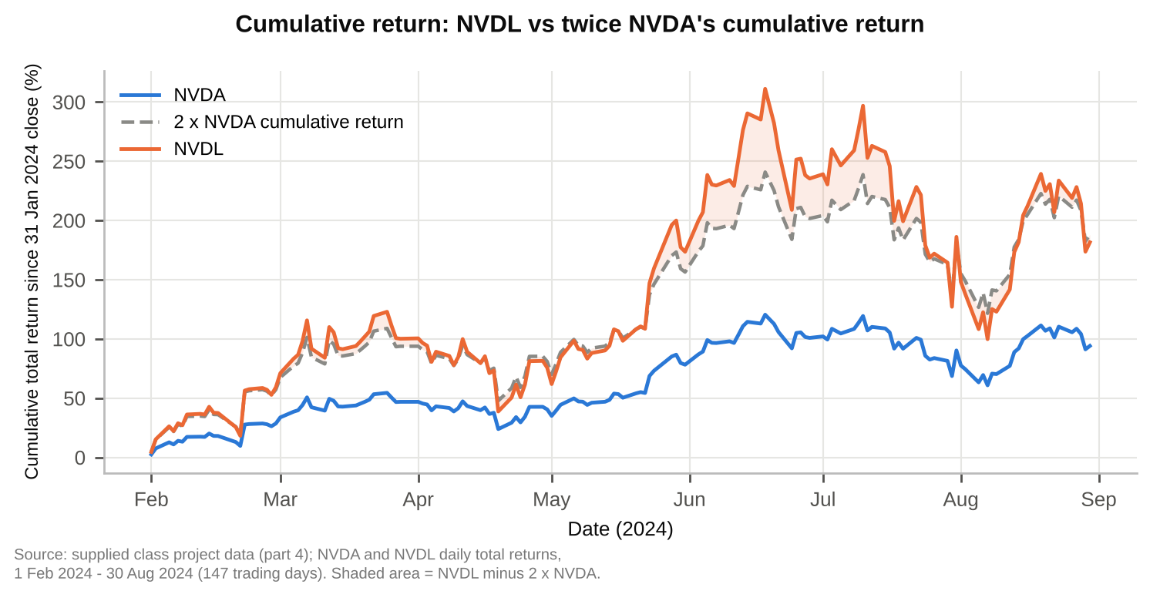
Cumulative return = product(1 + daily return) - 1 since the 31 Jan 2024 close. Volatility drag: for an ideal costless 2x daily-reset fund, the sum of daily log returns over the window is 0.200 below twice NVDA's (34% a year, close to NVDA's annualized daily variance of 35%). This is measured in log returns, so it is not the same quantity as the gap in Table 4.4, which also reflects compounding along a strong uptrend and the fund's costs.

Sources and interpretation
GraniteShares, 2x Long NVDA Daily ETF (NVDL) product page, as referenced in the assignment.
GraniteShares, GraniteShares 2x Long NVDA Daily ETF (NVDL) factsheet, performance and expenses as of 30 June 2024, supplied with the assignment.
Supplied class project data (part 4): daily total returns for NVDA and NVDL, February to August 2024, supplied with the assignment.
Before 22 January 2024 NVDL targeted 1.5 times NVDA's daily return, so every day in this sample is under the 2x objective. Regression, risk and return statistics describe this seven-month sample only. The intercept is a crude, noisy estimate of daily drag; financing and trading costs are plausible contributors but are not separately identified here.

Appendix 5. Part 5 Portfolio Analytics - exhibits
These exhibits evaluate value-index replication and benchmark-relative multi-factor risk. The factor fit explains most Value variation, while the multi-factor portfolio earns little per unit of tracking error.

Table 5.1 MSCI Value factor attribution
Term | Coefficient | Std error | t statistic | p value
Intercept (decimal/month) | -0.000713 | 0.000787 | -0.906 | 0.366
RF | 0.864636 | 0.310077 | 2.788 | 0.0056
Mkt-RF | 0.948032 | 0.012314 | 76.986 | 2.28e-216
HML | 0.321642 | 0.016342 | 19.682 | 5.31e-58
SMB | -0.174374 | 0.017605 | -9.905 | 1.79e-20
Source and scope: supplied MSCI / Kenneth French workbook; US large/mid-cap MSCI indexes (gross total returns, USD) and US academic factors where applicable; Jan 1995 - Jul 2023 (343 months). OLS on total returns with an intercept. Slopes are dimensionless; the intercept is a monthly decimal return. N = 343, residual df = 338, R² = 0.948414, adjusted R² = 0.947804. Standard errors and two-sided Student t tests are conventional, without HAC/Newey-West adjustment. Annual arithmetic alpha = -0.86%; 95% interval [-2.71%, 1.00%].

Table 5.2 Replication and original index performance
Strategy | Annual return  arithmetic | Annual  volatility | Sharpe  ratio | Annual return  geometric
MSCI USA Value | 9.87% | 15.27% | 0.505 | 9.05%
Factor replication | 10.73% | 14.87% | 0.576 | 10.05%
Source and scope: supplied MSCI / Kenneth French workbook; US large/mid-cap MSCI indexes (gross total returns, USD) and US academic factors where applicable; Jan 1995 - Jul 2023 (343 months). Correlation = 0.973866. Replication excludes alpha and uses full-sample slopes. Annual mean RF = 2.16%. Return = 12 × monthly mean; volatility = sample std × √12; Sharpe = (annual arithmetic return - annual mean RF) / annual volatility. Geometric return is compounded wealth^(12/343) - 1. All results are gross of costs; replication is an in-sample statistical portfolio, not an investability claim.

Figure 5.1 Growth of one dollar
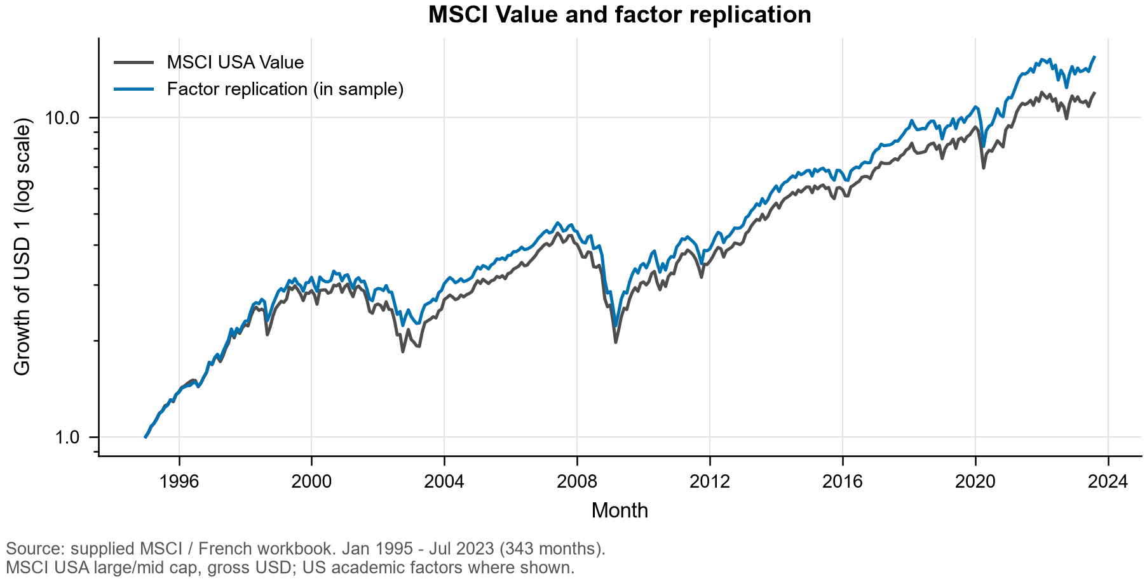

Table 5.3 Benchmark relative performance
Strategy | Annual active  return | Annual tracking  error | Information  ratio | Cumulative relative  wealth gain
Value | -1.343% | 5.15% | -0.261 | -31.24%
Minimum volatility | -0.796% | 6.38% | -0.125 | -8.93%
Equal weight | 0.588% | 5.40% | 0.109 | 9.02%
Momentum | 2.158% | 7.73% | 0.279 | 76.98%
Multi-factor | 0.152% | 3.39% | 0.045 | 9.08%
Source and scope: supplied MSCI / Kenneth French workbook; US large/mid-cap MSCI indexes (gross total returns, USD) and US academic factors where applicable; Jan 1995 - Jul 2023 (343 months). Benchmark: MSCI USA Standard. All strategies hold long-only MSCI indexes. Multi-factor weights are 25% each, reset monthly. Monthly active return = strategy return - benchmark return; annual active return = 12 × mean(active); tracking error = sample std(active) × √12; information ratio = annual active return / tracking error. These annualizations do not adjust for serial correlation.

Figure 5.2 Compounded performance relative to the benchmark
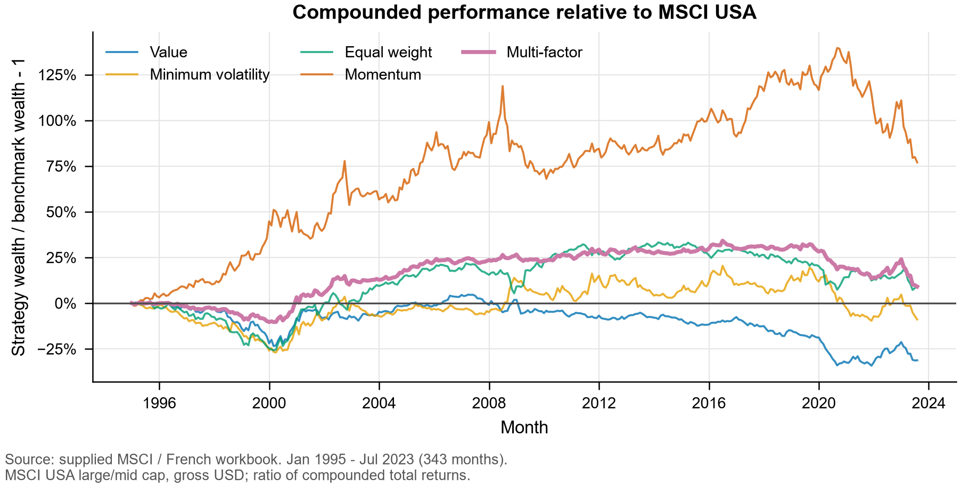
Relative wealth = product(1 + strategy return) / product(1 + benchmark return) - 1. It is neither the sum nor the compounded product of monthly active returns. For the multi-factor portfolio, the cumulative gain is 9.08% and the annual relative-wealth growth rate is 0.304%, versus 0.152% annualized arithmetic active return.

Data precision and alignment
The workbook labels the MSCI levels Gross and USD. December 1994 levels provide the base for January 1995 returns; all 343 months are present and aligned with monthly FF percentage data divided by 100. Annual FF rows and MSCI copyright footers are excluded. Part 1C's exported monthly CSV rounds to four decimals. Every recovered return differs from its saved value by at most 0.5 basis point. Its rounded multi-factor column can differ from the mean of rounded components by 0.75 basis point. We therefore recover Part 1C's full-precision calculation without changing its inputs, algorithm or files. All original Part 1 performance statistics reconcile to saved-table rounding. Raw input hashes and numerical checks are saved separately.

Table 5.4 Contributions to multi factor active variance
Component | Weight | Monthly variance  contribution | Annual variance  contribution | Variance  share
Value | 25% | 0.000022230 | 0.000266756 | 23.26%
Minimum volatility | 25% | 0.000032571 | 0.000390850 | 34.08%
Equal weight | 25% | 0.000017067 | 0.000204804 | 17.86%
Momentum | 25% | 0.000023714 | 0.000284566 | 24.81%
Total | 100% | 0.000095581 | 0.001146976 | 100.00%
Source and scope: supplied MSCI / Kenneth French workbook; US large/mid-cap MSCI indexes (gross total returns, USD) and US academic factors where applicable; Jan 1995 - Jul 2023 (343 months). All covariances use benchmark-relative active returns and sample ddof = 1. Absolute contributions are in squared decimal-return units. Annual variance contributions = 12 × monthly contributions. Percentages use monthly multi-factor active variance as denominator.
$aₘ = 0.25(aᵥ + aₗ + aₑ + aₚ)$
$Cᵢ = 0.25 Cov(aᵢ, aₘ) Σᵢ Cᵢ = Var(aₘ) Shareᵢ = Cᵢ / Var(aₘ)$
Here a denotes a monthly strategy-minus-benchmark return; subscripts v, l, e and p denote Value, Minimum Volatility, Equal Weight and Momentum. Covariance contributions may be negative and must not be clipped. This is a decomposition of tracking-error squared. Contributions to tracking error itself would instead equal annual variance contributions divided by annual tracking error and would have return, not squared-return, units.

Figure 5.3 Allocation of benchmark relative risk
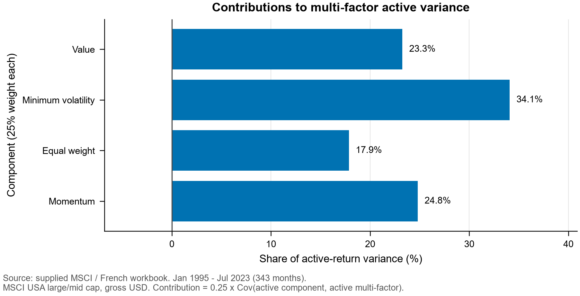

Sources and interpretation
MSCI (February 2021), Global Investable Market Value and Growth Index Methodology, Sections 1.2, 2.1-2.3 and Appendix I.
Kenneth R. French Data Library, Description of Fama/French Factors.
Shleifer, A. and Vishny, R. W. (1997), The Limits of Arbitrage, Journal of Finance 52(1), 35-55.
Sources accessed 1 November 2026. The assignment specifies the February 2021 MSCI methodology; we do not assume its rules were unchanged across the historical return sample. The limits-to-arbitrage interpretation applies the cited capital-constraint mechanism; class lecture slides were not included in the repository.

