Part 4 Selected Exhibits
These exhibits test whether NVDL delivers twice NVDA's return. It does so day by day, but not over longer periods, and its estimated annual drag (about 15%) is far larger than its stated expense ratio.

Table 4.1 Daily risk metrics
Metric | NVDA | NVDL | NVDL / NVDA
Standard deviation (daily) | 3.75% | 7.48% | 2.00
95% Value at Risk (daily loss) | 6.12% | 12.03% | 1.97
95% Conditional VaR (daily loss) | 7.07% | 14.16% | 2.00
Source and scope: supplied class project data (part 4); daily total returns of NVDA and the GraniteShares 2x Long NVDA Daily ETF (NVDL); 1 Feb 2024 - 30 Aug 2024 (147 trading days). Returns are decimals (0.01 = 1%) sorted oldest to newest before any compounding. Not annualized. Standard deviation uses ddof = 1. Historical (empirical) method: VaR is the 5th percentile of daily returns, shown as a positive loss; CVaR is the average return on the days at or below that percentile, also shown as a loss.

Figure 4.1 Distribution of daily returns
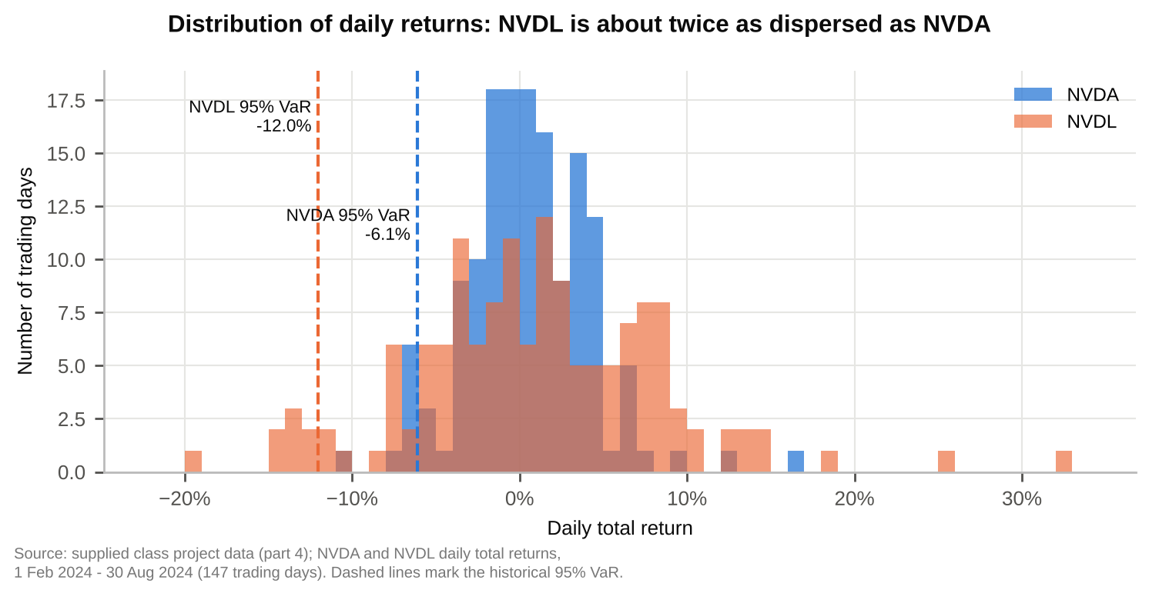

Table 4.2 Regression of NVDL on NVDA daily returns
Term | Coefficient | Std error | t statistic | p value | 95% confidence interval
Intercept (decimal/day) | -0.000612 | 0.000163 | -3.743 | 0.000261 | [-0.000935, -0.000289]
NVDA (slope) | 1.995975 | 0.004335 | 460.4 | 2.20e-231 | [1.9874, 2.0045]
Test of slope = 2 | 1.995975 | 0.004335 | -0.928 | 0.355 | contains 2
Source and scope: supplied class project data (part 4); daily total returns of NVDA and the GraniteShares 2x Long NVDA Daily ETF (NVDL); 1 Feb 2024 - 30 Aug 2024 (147 trading days). Returns are decimals (0.01 = 1%) sorted oldest to newest before any compounding. OLS of daily NVDL return on daily NVDA return with an intercept. N = 147, residual df = 145, R² = 0.99932, adjusted R² = 0.99931, residual standard deviation = 0.196% per day. Standard errors and two-sided Student t tests are conventional, without HAC/Newey-West adjustment. The last row tests H0: slope = 2 using the same estimate.

Figure 4.2 NVDL vs NVDA daily returns
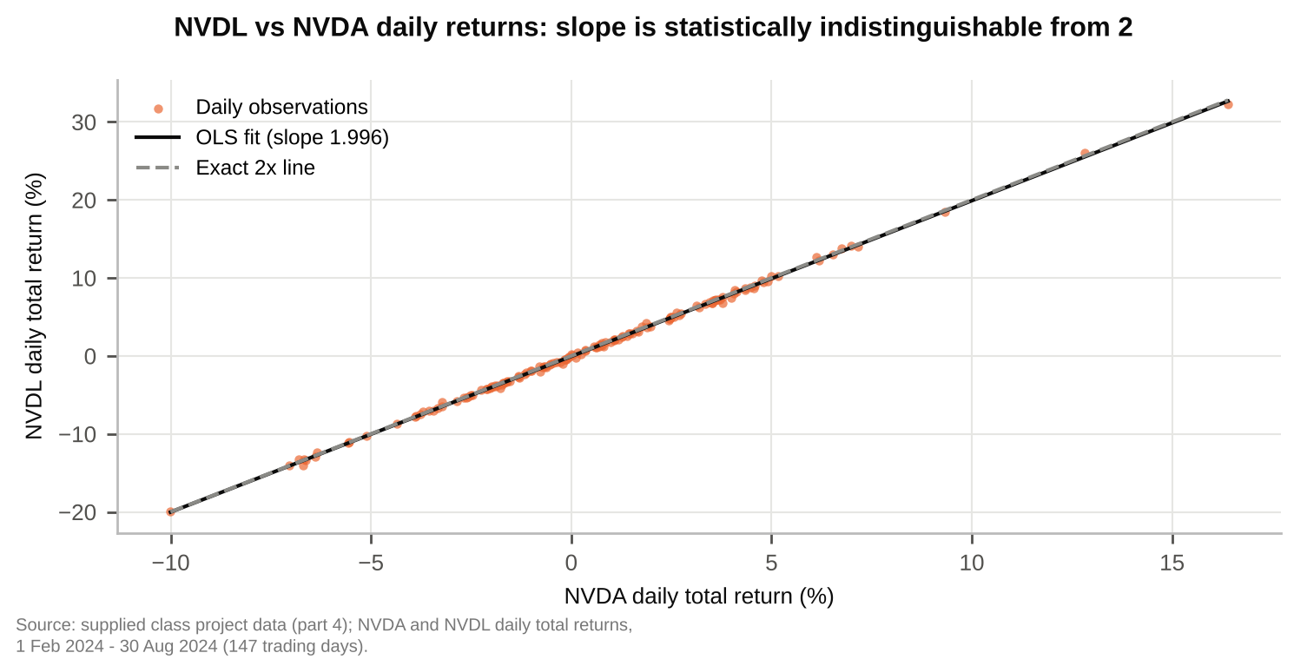

Table 4.3 Annualized intercept (performance drag) vs stated expenses
Measure | Annual rate | Basis
Estimated drag: -intercept x 252 | 15.41% | Table 4.2 intercept, annualized
95% confidence interval of the drag | [7.27%, 23.55%] | Table 4.2 interval x 252
Cross-check: -mean(NVDL - 2 x NVDA) x 252 | 15.94% | Model-free, same data
Management fee | 0.99% | NVDL factsheet, 30 Jun 2024
Net annual operating expense ratio | 1.15% | Factsheet; fee waiver to 31 Dec 2024
Total annual operating expense ratio | 1.57% | Factsheet, before waiver
Source and scope: supplied class project data (part 4); daily total returns of NVDA and the GraniteShares 2x Long NVDA Daily ETF (NVDL); 1 Feb 2024 - 30 Aug 2024 (147 trading days). Returns are decimals (0.01 = 1%) sorted oldest to newest before any compounding. Annualization multiplies the daily intercept by 252 trading days and does not compound it. The factsheet figures are per annum and are not estimated from the return data. The data cannot separate the fund's financing and daily trading costs from the expense ratio; the assignment notes that the fund borrows and trades NVDA daily.

Figure 4.3 Estimated drag vs stated expenses
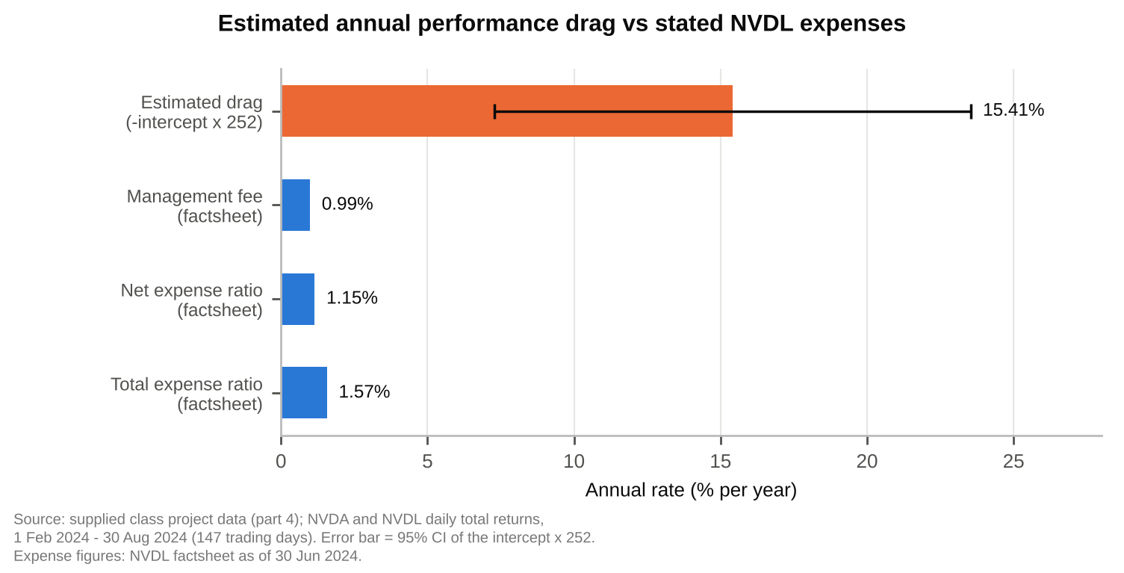

Table 4.4 Monthly and full-window total returns
Period | NVDA  total return | NVDL  total return | 2 x NVDA | NVDL minus  2 x NVDA
Feb 2024 | 28.60% | 59.11% | 57.19% | 1.92%
Mar 2024 | 14.21% | 25.76% | 28.42% | -2.66%
Apr 2024 | -4.37% | -12.22% | -8.74% | -3.47%
May 2024 | 26.88% | 55.72% | 53.76% | 1.97%
Jun 2024 | 12.70% | 22.60% | 25.40% | -2.80%
Jul 2024 | -5.28% | -14.68% | -10.56% | -4.12%
Aug 2024 | 2.01% | -1.60% | 4.02% | -5.62%
Feb - Aug 2024 (full window) | 94.05% | 181.53% | 188.10% | -6.57%
Source and scope: supplied class project data (part 4); daily total returns of NVDA and the GraniteShares 2x Long NVDA Daily ETF (NVDL); 1 Feb 2024 - 30 Aug 2024 (147 trading days). Returns are decimals (0.01 = 1%) sorted oldest to newest before any compounding. Total return = product(1 + daily return) - 1 within each calendar month and over the full window; daily returns are not summed. Full window NVDL / NVDA = 1.93. Trading days per month: Feb 20, Mar 20, Apr 22, May 22, Jun 19, Jul 22, Aug 22.

Figure 4.4 Monthly total returns
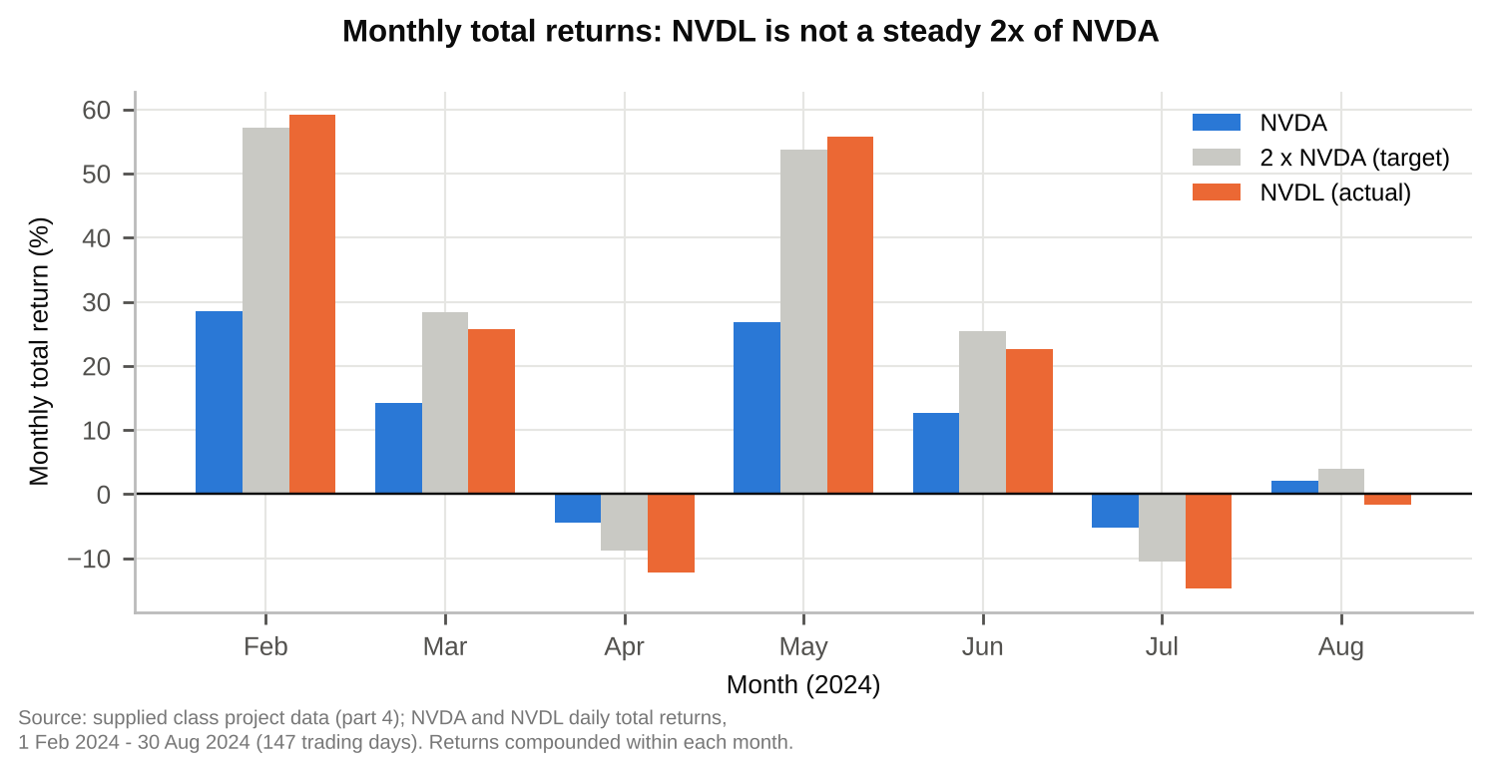

Table 4.5 Factsheet performance of NVDL vs NVDA
Period to 30 Jun 2024 | NVDL NAV  return | NVDA  return | 2 x NVDA | NVDL minus  2 x NVDA
1 month | 22.60% | 12.69% | 25.38% | -2.78 pp
3 months | 67.59% | 36.74% | 73.48% | -5.89 pp
Year to date | 365.74% | 149.50% | 299.00% | +66.74 pp
1 year | 448.66% | 192.13% | 384.26% | +64.40 pp
Source and scope: GraniteShares 2x Long NVDA Daily ETF factsheet, performance as of 30 June 2024 (NVDL NAV and NVDA returns as printed; not recomputed). Returns shorter than one year are not annualized. 'pp' = percentage points. The 1-year and year-to-date NVDL returns exceed 2 x NVDA, while the 1-month and 3-month returns fall short, so the multi-day ratio is not fixed at 2.

Table 4.6 Two-day example: NVDA +10% then -9%
Case | NVDA  day 1 / day 2 | NVDL  day 1 / day 2 | NVDA  two-day return | NVDL  two-day return
Assignment example | +10% / -9% | +20% / -18% | 0.10% | -1.60%
NVDA ends flat | +10% / -9.09% | +20% / -18.18% | 0.00% | -1.82%
Source and scope: illustrative calculation, no market data. NVDL is assumed to earn exactly 2 x NVDA's return each day, with no fees, financing or other drag. Two-day return = (1 + r1)(1 + r2) - 1 for NVDA and (1 + 2 r1)(1 + 2 r2) - 1 for NVDL. NVDL minus 2 x NVDA over two days equals 2 x r1 x r2, which is -1.80% in the assignment example.

Figure 4.5 Cumulative return: NVDL vs twice NVDA
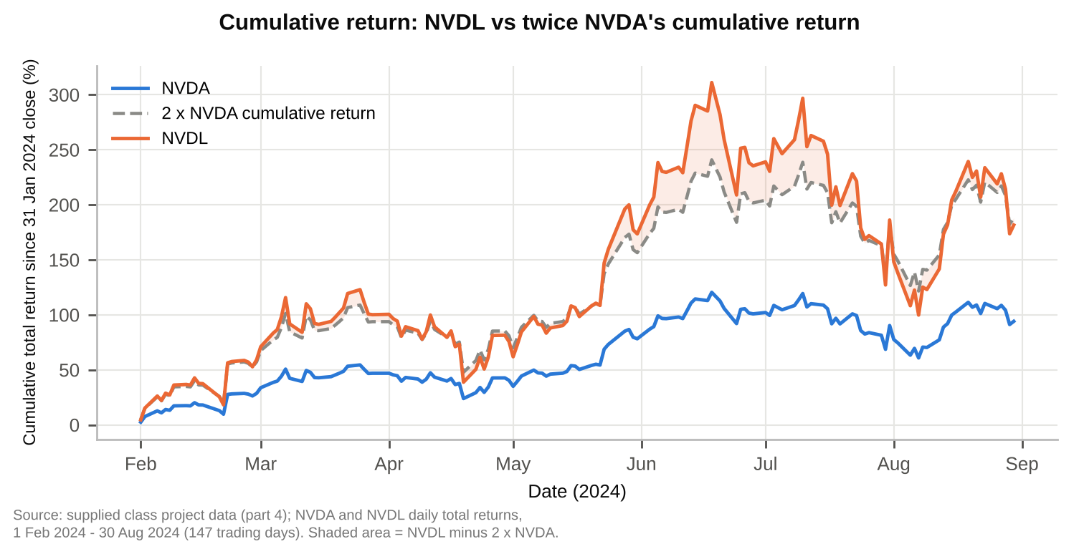
Cumulative return = product(1 + daily return) - 1 since the 31 Jan 2024 close. Volatility drag: for an ideal costless 2x daily-reset fund, the sum of daily log returns over the window is 0.200 below twice NVDA's (34% a year, close to NVDA's annualized daily variance of 35%). This is measured in log returns, so it is not the same quantity as the gap in Table 4.4, which also reflects compounding along a strong uptrend and the fund's costs.

Sources and interpretation
GraniteShares, 2x Long NVDA Daily ETF (NVDL) product page, as referenced in the assignment.
GraniteShares, GraniteShares 2x Long NVDA Daily ETF (NVDL) factsheet, performance and expenses as of 30 June 2024, supplied with the assignment.
Supplied class project data (part 4): daily total returns for NVDA and NVDL, February to August 2024, supplied with the assignment.
Before 22 January 2024 NVDL targeted 1.5 times NVDA's daily return, so every day in this sample is under the 2x objective. Regression, risk and return statistics describe this seven-month sample only. The intercept is a crude, noisy estimate of daily drag; financing and trading costs are plausible contributors but are not separately identified here.

