**Steps.**

**Run the original code.**

Make edits to the initial conditions to see if the trimmed velocity changes. Keeping it simple, changed them from 25,000 t0 35,000ft in altitude and increased the thrust to 6000 pounds. This was to get data on whether the linearization gets affected at different conditions and works. (Trim_f18fullDU_a_edits.m)

The code shows the same results, this was done for two other initial conditions, and the data shows that the trimmed values and linearization results in the same trimmed equilibrium.

The code results were:  
inputnames =

'Aileron (rad)'

'Rudder (rad)'

'Stabilator (rad)'

'T (lbf)'

initial values

ans =

500

ans =

0

10

0

0

0

0

10

0

ans =

0

0

ans =

35000

ans =

0

0

0

ans =

6000

Warning: The command linoptions is obsolete. Use linearizeOptions or findopOptions instead.

> In linoptions (line 131)

In Trim_f18fullDU_a_Edits (line 157)

Local minimum found that satisfies the constraints.

Optimization completed because the objective function is non-decreasing in

feasible directions, to within the default value of the function tolerance,

and constraints are satisfied to within the default value of the constraint tolerance.

<stopping criteria details>

Operating Point Search Report:

---------------------------------

Operating Report for the Model f18full_DUtrim.

(Time-Varying Components Evaluated at time t=0)

Operating point specifications were successfully met.

States:

----------

(1.) f18full_DUtrim/Integrator a1

x: 436 dx: 1.05e-08 (0)

(2.) f18full_DUtrim/Integrator a2

x: 0 dx: 0 (0)

(3.) f18full_DUtrim/Integrator a3

x: 0.175 dx: -2.69e-07 (0)

(4.) f18full_DUtrim/Integrator b1

x: 0 dx: 0 (0)

(5.) f18full_DUtrim/Integrator b2

x: 0 dx: -6.09e-09 (0)

(6.) f18full_DUtrim/Integrator b3

x: 0 dx: 0 (0)

(7.) f18full_DUtrim/Integrator c1

x: 0 dx: 0 (0)

(8.) f18full_DUtrim/Integrator c2

x: 0.175 dx: 0 (0)

(9.) f18full_DUtrim/Integrator c3

x: 0 dx: 0 (0)

(10.) f18full_DUtrim/Integrator d1

x: 0 dx: 436

(11.) f18full_DUtrim/Integrator d2

x: 0 dx: 0

(12.) f18full_DUtrim/Integrator d3

x: 3.5e+04 dx: -1.42e-14

Inputs:

----------

(1.) f18full_DUtrim/dAil

u: 0 [-Inf Inf]

(2.) f18full_DUtrim/dRud

u: 0 [-Inf Inf]

(3.) f18full_DUtrim/dStab

u: -0.022 [-Inf Inf]

(4.) f18full_DUtrim/T

u: 5.47e+03 [0 3.8e+04]

Outputs:

----------

(1.) f18full_DUtrim/V

y: 436 [-Inf Inf]

(2.) f18full_DUtrim/beta

y: 0 [-Inf Inf]

(3.) f18full_DUtrim/alpha

y: 0.175 [-Inf Inf]

(4.) f18full_DUtrim/p

y: 0 [-Inf Inf]

(5.) f18full_DUtrim/q

y: 0 [-Inf Inf]

(6.) f18full_DUtrim/r

y: 0 [-Inf Inf]

(7.) f18full_DUtrim/phi

y: 0 [-Inf Inf]

(8.) f18full_DUtrim/theta

y: 0.175 [-Inf Inf]

(9.) f18full_DUtrim/psi

y: 0 [-Inf Inf]

(10.) f18full_DUtrim/pN

y: 0 [-Inf Inf]

(11.) f18full_DUtrim/pE

y: 0 [-Inf Inf]

(12.) f18full_DUtrim/h

y: 3.5e+04 [-Inf Inf]

Model: 'f18full_DUtrim'

States: [12x1 opcond.StatePoint]

Inputs: [4x1 opcond.InputPoint]

Time: 0

Version: 2

x_trim =

1.0e+04 *

0.0436

0

0.0000

0

0

0

0

0.0000

0

3.5000

u_trim =

1.0e+03 *

0

0

-0.0000

5.4705

Trimmed Value

ans =

435.9226

ans =

0

10

0

0

0

0

10

0

ans =

35000

ans =

0

0

-1.2616

ans =

5.4705e+03

**Go ahead and build code that perturbs the system and see if the linearization remains stable (this is done in ‘statevariables.m’)**

Based on this perturbation as well we computed the eigenvalues of the system, its frequencies and damping ratio which we can compare to the original as well.  
  
Trimmed Airspeed (V): 435.92 ft/s

Trimmed Alpha (Angle of Attack): 10.00 deg

Trimmed Theta (Pitch Angle): 10.00 deg

Trimmed Altitude (h): 35000.00 ft

Trimmed Thrust: 5470.45 lbf

Trimmed Stabilator Deflection: -1.26 deg

Warning: Model 'f18full_DUtrim' is using a default value of 0.2 for maximum step size. You can disable this diagnostic

by setting 'Automatic solver parameter selection' diagnostic to 'none' in the Diagnostics page of the configuration

parameters dialog

> In dlinmod (line 195)

In linmod (line 59)

In Sate_variables (line 18)

Warning: Extra states are being set to zero.

> In DAStudio.warning (line 28)

In dlinmod (line 217)

In linmod (line 59)

In Sate_variables (line 18)

Perturbed A Matrix:

-0.0246 0 -30.0257 0 0 0 0 -32.2000 0 0 0 0

0 -0.0377 0 0.1754 0 -0.9845 0.0720 0 0 0 0 0

-0.0003 0 -0.3639 0 1.0000 0 0 0.0000 0 0 0 0

0 -8.7564 0 -0.8960 0 0.8870 0 0 0 0 0 0

-0.0000 0 -2.2626 0 -0.2566 0 0 0 0 0 0 0

0 0.9029 0 0.0403 0 -0.1915 0 0 0 0 0 0

0 0 0 1.0000 0 0.1781 0 0 0 0 0 0

0 0 0 0 1.0000 0 0 0 0 0 0 0

0 0 0 0 0 1.0157 0 0 0 0 0 0

1.0000 0 0 0 0 0 0 0 0 0 0 0

0 440.2819 0 0 0 0 -77.2108 0 440.2819 0 0 0

0.0000 0 -440.2819 0 0 0 0 440.2819 0 0 0 0

Perturbed B Matrix:

0 0 -3.9477 0.0010

-0.0150 0.0209 0 0

0 0 -0.0519 -0.0000

8.4847 0.9733 0 0

0 0 -2.9370 0

-0.0431 -0.6387 0 0

0 0 0 0

0 0 0 0

0 0 0 0

0 0 0 0

0 0 0 0

0 0 0 0

Perturbed C Matrix:

1 0 0 0 0 0 0 0 0 0 0 0

0 1 0 0 0 0 0 0 0 0 0 0

0 0 1 0 0 0 0 0 0 0 0 0

0 0 0 1 0 0 0 0 0 0 0 0

0 0 0 0 1 0 0 0 0 0 0 0

0 0 0 0 0 1 0 0 0 0 0 0

0 0 0 0 0 0 1 0 0 0 0 0

0 0 0 0 0 0 0 1 0 0 0 0

0 0 0 0 0 0 0 0 1 0 0 0

0 0 0 0 0 0 0 0 0 1 0 0

0 0 0 0 0 0 0 0 0 0 1 0

0 0 0 0 0 0 0 0 0 0 0 1

Perturbed D Matrix:

0 0 0 0

0 0 0 0

0 0 0 0

0 0 0 0

0 0 0 0

0 0 0 0

0 0 0 0

0 0 0 0

0 0 0 0

0 0 0 0

0 0 0 0

0 0 0 0

Perturbed A Matrix Reduced:

-0.0246 0 -30.0257 0 0 0 0 -32.2000

0 -0.0377 0 0.1754 0 -0.9845 0.0720 0

-0.0003 0 -0.3639 0 1.0000 0 0 0.0000

0 -8.7564 0 -0.8960 0 0.8870 0 0

-0.0000 0 -2.2626 0 -0.2566 0 0 0

0 0.9029 0 0.0403 0 -0.1915 0 0

0 0 0 1.0000 0 0.1781 0 0

0 0 0 0 1.0000 0 0 0

Perturbed B Matrix Reduced:

0 0 -3.9477 0.0010

-0.0150 0.0209 0 0

0 0 -0.0519 -0.0000

8.4847 0.9733 0 0

0 0 -2.9370 0

-0.0431 -0.6387 0 0

0 0 0 0

0 0 0 0

Norm of Delta A: 61.6193

Norm of Delta B: 9.7781

Longitudinal Modes:

Eigenvalue Damping_Ratio Frequency_rad_s

__________________ _____________ __________________

-0.30945+1.4799i 1 -0.051833+0i

-0.30945-1.4799i 0.10005 -0.010132+0.10077i

-0.010132+0.10077i 0.10005 -0.010132-0.10077i

-0.010132-0.10077i 1 -0.48877+0i

-0.28732+1.453i 0.19399 -0.28732+1.453i

-0.28732-1.453i 0.19399 -0.28732-1.453i

-0.48877+0i 0.20468 -0.30945+1.4799i

-0.051833+0i 0.20468 -0.30945-1.4799i

Lateral Modes:

Eigenvalue Damping_Ratio Frequency_rad_s

________________ _____________ ________________

-0.28732+1.453i 1 -0.051833+0i

-0.28732-1.453i 1 -0.48877+0i

-0.48877+0i 0.19399 -0.28732+1.453i

-0.051833+0i 0.19399 -0.28732-1.453i

Longitudinal Modes with Periods:

Nat_Freq_rad_s Damping_Ratio Damped_Freq_rad_s Period_s

__________________ _____________ __________________ ________________

-0.051833+0i 1 0+0i -Inf+0i

-0.010132+0.10077i 0.10005 -0.010082+0.10026i -6.2382-62.04i

-0.010132-0.10077i 0.10005 -0.010082-0.10026i -6.2382+62.04i

-0.48877+0i 1 0+0i -Inf+0i

-0.28732+1.453i 0.19399 -0.28186+1.4254i -0.8389-4.2423i

-0.28732-1.453i 0.19399 -0.28186-1.4254i -0.8389+4.2423i

-0.30945+1.4799i 0.20468 -0.3029+1.4485i -0.86903-4.1559i

-0.30945-1.4799i 0.20468 -0.3029-1.4485i -0.86903+4.1559i

Lateral Modes with Periods:

Nat_Freq_rad_s Damping_Ratio Damped_Freq_rad_s Period_s

________________ _____________ _________________ _______________

-0.051833+0i 1 0+0i -Inf+0i

-0.48877+0i 1 0+0i -Inf+0i

-0.28732+1.453i 0.19399 -0.28186+1.4254i -0.8389-4.2423i

-0.28732-1.453i 0.19399 -0.28186-1.4254i -0.8389+4.2423i

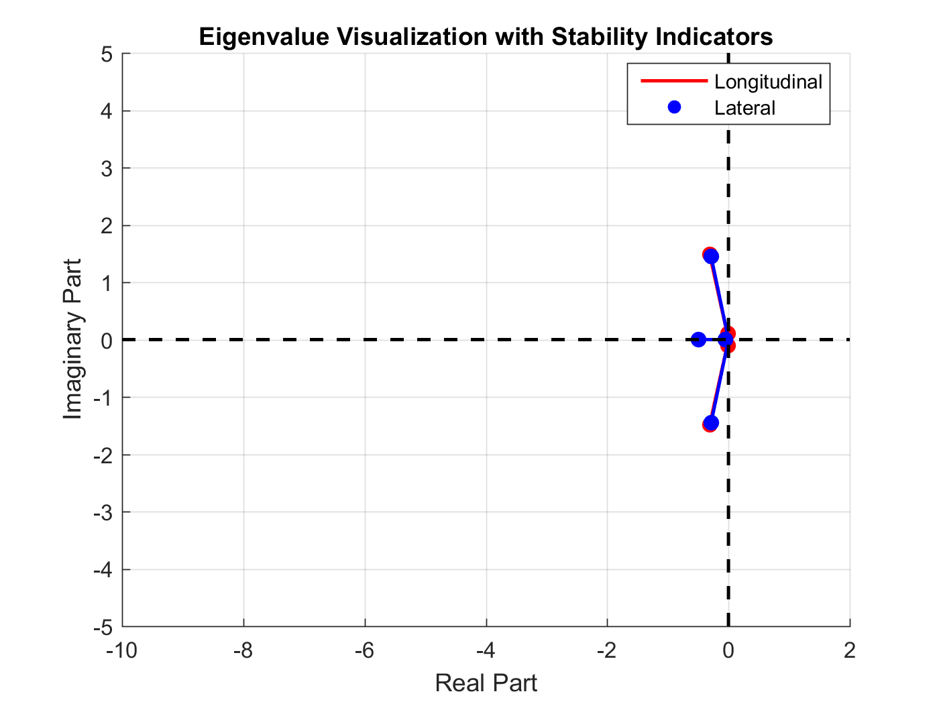

**I did on the initial with this block of code:**  
% Compute eigenvalues of the longitudinal and lateral dynamics

eigenvalues_A_longltrl = eig(A_longltrl);

eigenvalues_A_longltrl9 = eig(A_longltrl9);

eigenvalues_A_x = eig(A_x);

eigenvalues_A5_x = eig(A5_x);

eigenvalues_A_y = eig(A_y);

% Function to compute damping ratio, natural frequency, frequency, and period

compute_modal_properties = @(eigenvalues) arrayfun(@(lambda) struct( ...

'DampingRatio', -real(lambda)/abs(lambda), ...

'NaturalFrequency', abs(lambda), ...

'Frequency', abs(imag(lambda))/(2*pi), ...

'Period', 2*pi/abs(imag(lambda)) ...

), eigenvalues);

% Compute modal properties for each system

modal_properties_A_longltrl = compute_modal_properties(eigenvalues_A_longltrl);

modal_properties_A_longltrl9 = compute_modal_properties(eigenvalues_A_longltrl9);

modal_properties_A_x = compute_modal_properties(eigenvalues_A_x);

modal_properties_A5_x = compute_modal_properties(eigenvalues_A5_x);

modal_properties_A_y = compute_modal_properties(eigenvalues_A_y);

% Display results

disp('Modal Properties for A_longltrl:')

disp(modal_properties_A_longltrl)

disp('Modal Properties for A_longltrl9:')

disp(modal_properties_A_longltrl9)

disp('Modal Properties for A_x:')

disp(modal_properties_A_x)

disp('Modal Properties for A5_x:')

disp(modal_properties_A5_x)

disp('Modal Properties for A_y:')

disp(modal_properties_A_y)

The results were originally:  
Modal Properties for A_longltrl:

Eigenvalue 1:

Damping Ratio: 0.2047

Natural Frequency: 1.5119 rad/s

Frequency: 0.2355 Hz

Period: 4.2458 s

Eigenvalue 2:

Damping Ratio: 0.2047

Natural Frequency: 1.5119 rad/s

Frequency: 0.2355 Hz

Period: 4.2458 s

Eigenvalue 3:

Damping Ratio: 0.1000

Natural Frequency: 0.1013 rad/s

Frequency: 0.0160 Hz

Period: 62.3530 s

Eigenvalue 4:

Damping Ratio: 0.1000

Natural Frequency: 0.1013 rad/s

Frequency: 0.0160 Hz

Period: 62.3530 s

Eigenvalue 5:

Damping Ratio: 0.1940

Natural Frequency: 1.4811 rad/s

Frequency: 0.2312 Hz

Period: 4.3244 s

Eigenvalue 6:

Damping Ratio: 0.1940

Natural Frequency: 1.4811 rad/s

Frequency: 0.2312 Hz

Period: 4.3244 s

Eigenvalue 7:

Damping Ratio: 1.0000

Natural Frequency: 0.4888 rad/s

Frequency: 0.0000 Hz

Period: Inf s

Eigenvalue 8:

Damping Ratio: 1.0000

Natural Frequency: 0.0518 rad/s

Frequency: 0.0000 Hz

Period: Inf s

Modal Properties for A_longltrl9:

Eigenvalue 1:

Damping Ratio: NaN

Natural Frequency: 0.0000 rad/s

Frequency: 0.0000 Hz

Period: Inf s

Eigenvalue 2:

Damping Ratio: 0.2047

Natural Frequency: 1.5119 rad/s

Frequency: 0.2355 Hz

Period: 4.2458 s

Eigenvalue 3:

Damping Ratio: 0.2047

Natural Frequency: 1.5119 rad/s

Frequency: 0.2355 Hz

Period: 4.2458 s

Eigenvalue 4:

Damping Ratio: 0.1000

Natural Frequency: 0.1013 rad/s

Frequency: 0.0160 Hz

Period: 62.3530 s

Eigenvalue 5:

Damping Ratio: 0.1000

Natural Frequency: 0.1013 rad/s

Frequency: 0.0160 Hz

Period: 62.3530 s

Eigenvalue 6:

Damping Ratio: 0.1940

Natural Frequency: 1.4811 rad/s

Frequency: 0.2312 Hz

Period: 4.3244 s

Eigenvalue 7:

Damping Ratio: 0.1940

Natural Frequency: 1.4811 rad/s

Frequency: 0.2312 Hz

Period: 4.3244 s

Eigenvalue 8:

Damping Ratio: 1.0000

Natural Frequency: 0.4888 rad/s

Frequency: 0.0000 Hz

Period: Inf s

Eigenvalue 9:

Damping Ratio: 1.0000

Natural Frequency: 0.0518 rad/s

Frequency: 0.0000 Hz

Period: Inf s

Modal Properties for A_x:

Eigenvalue 1:

Damping Ratio: 0.2047

Natural Frequency: 1.5119 rad/s

Frequency: 0.2355 Hz

Period: 4.2458 s

Eigenvalue 2:

Damping Ratio: 0.2047

Natural Frequency: 1.5119 rad/s

Frequency: 0.2355 Hz

Period: 4.2458 s

Eigenvalue 3:

Damping Ratio: 0.1000

Natural Frequency: 0.1013 rad/s

Frequency: 0.0160 Hz

Period: 62.3530 s

Eigenvalue 4:

Damping Ratio: 0.1000

Natural Frequency: 0.1013 rad/s

Frequency: 0.0160 Hz

Period: 62.3530 s

Modal Properties for A5_x:

Eigenvalue 1:

Damping Ratio: NaN

Natural Frequency: 0.0000 rad/s

Frequency: 0.0000 Hz

Period: Inf s

Eigenvalue 2:

Damping Ratio: 0.2047

Natural Frequency: 1.5119 rad/s

Frequency: 0.2355 Hz

Period: 4.2458 s

Eigenvalue 3:

Damping Ratio: 0.2047

Natural Frequency: 1.5119 rad/s

Frequency: 0.2355 Hz

Period: 4.2458 s

Eigenvalue 4:

Damping Ratio: 0.1000

Natural Frequency: 0.1013 rad/s

Frequency: 0.0160 Hz

Period: 62.3530 s

Eigenvalue 5:

Damping Ratio: 0.1000

Natural Frequency: 0.1013 rad/s

Frequency: 0.0160 Hz

Period: 62.3530 s

Modal Properties for A_y:

Eigenvalue 1:

Damping Ratio: 0.1940

Natural Frequency: 1.4811 rad/s

Frequency: 0.2312 Hz

Period: 4.3244 s

Eigenvalue 2:

Damping Ratio: 0.1940

Natural Frequency: 1.4811 rad/s

Frequency: 0.2312 Hz

Period: 4.3244 s

Eigenvalue 3:

Damping Ratio: 1.0000

Natural Frequency: 0.4888 rad/s

Frequency: 0.0000 Hz

Period: Inf s

Eigenvalue 4:

Damping Ratio: 1.0000

Natural Frequency: 0.0518 rad/s

Frequency: 0.0000 Hz

Period: Inf s

**After this, for just an exercise in building pole placement controllers, use the real parts of the system to build a closed loop controller for the system and compare the results with the original**

**The results were:**  
**> controller_for_open_loop_trim**

**Trimmed States (x_trim):**

**1.0e+04 \***

**0.0436**

**0**

**0.0000**

**0**

**0**

**0**

**0**

**0.0000**

**0**

**2.5000**

**Trimmed Inputs (u_trim):**

**1.0e+03 \***

**0**

**0**

**-0.0000**

**5.4705**

**Trimmed Airspeed (V): 435.92 ft/s**

**Trimmed Alpha (Angle of Attack): 10.00 deg**

**Trimmed Theta (Pitch Angle): 10.00 deg**

**Trimmed Altitude (h): 25000.00 ft**

**Trimmed Thrust: 5470.51 lbf**

**Trimmed Stabilator Deflection: -1.26 deg**

**New Longitudinal Eigenvalues:**

**-8.0000**

**-7.0000**

**-6.0000**

**-1.0000**

**-5.0000**

**-2.0000**

**-3.0000**

**-4.0000**

**New Lateral Eigenvalues:**

**-1.0000**

**-4.0000**

**-2.0000**

**-3.0000**

**Longitudinal Mode Step Response and Eigenvalues Adjusted.**

**Lateral Mode Step Response and Eigenvalues Adjusted.**

**Longitudinal Mode:**

**Frequencies (Hz):**

**Periods (s):**

**Lateral Mode:**

**Frequencies (Hz):**

**Periods (s):**

